Rapido App - Test Cases
Test Case Document for Rapido Passenger App
Date: 16 Aug 2026
Tester: Nik
Location: Ahmedabad, Gujarat, India

Test Case: Ride Booking - Auto Search
Test Case ID | TC_RAP_001
Scenario | Ride Booking - Auto Search
Preconditions | User is logged into Rapido app, GPS location is enabled, and user has a saved home address.
Test Steps | 1. Open Rapido app  2. Enter pickup location: 623-C-1, Vastral Road, Prem Nagar, Amraiwardi, Ahmedabad  3. Enter drop location: ESIC Model Hospital Bapunagar, Naroda, near Hardasnagar Police chowky, Rajiv Nagar, Bapunagar, Ahmedabad  4. Select "Auto" as vehicle type  5. Verify fare estimate is displayed  6. Verify payment method shows "Paying via cash"
Expected Result | Auto ride search is initiated successfully. Total fare of ₹51 is displayed. Pickup and drop locations are correctly shown. Payment method is set to Cash.
Actual Result | PASS - Auto ride search initiated. Fare ₹51 displayed correctly. Locations and payment method verified.
Screenshot | See below

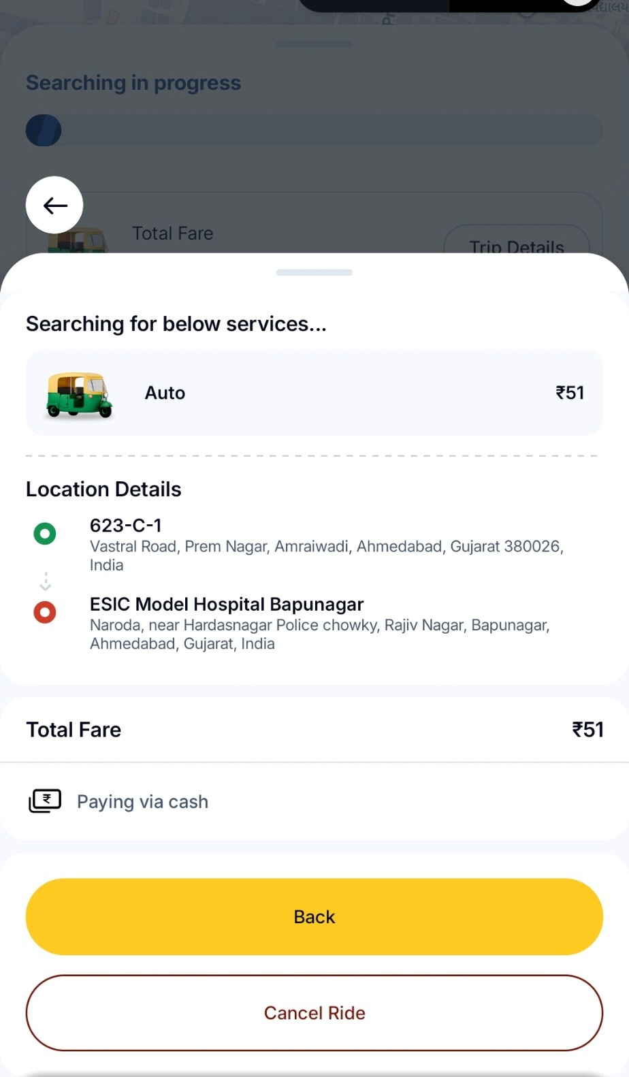
Figure: Auto Ride Search - Searching for services with fare ₹51

Test Case: Location Selection - Drop Location Entry
Test Case ID | TC_RAP_002
Scenario | Location Selection - Drop Location Entry
Preconditions | User is on the ride booking screen and pickup location needs to be entered.
Test Steps | 1. Tap on "Drop" location field  2. Observe the location input screen  3. Check for saved locations (Home, recent rides)  4. Verify recent locations include: harvani clinic, ESIC Model Hospital Bapunagar, General Hospital Road  5. Verify Home address shows: 623-A-1, Vastral Road, Prem Nagar, Amraiwardi, Ahmedabad
Expected Result | Drop location screen opens successfully. Saved Home location is displayed with heart icon. Recent locations are listed with clock icons. Multiple stop options (Add Stop 1, Add Stop 2) are available.
Actual Result | PASS - Drop location screen displays correctly. Home and recent locations visible. Multiple stop functionality available.
Screenshot | See below

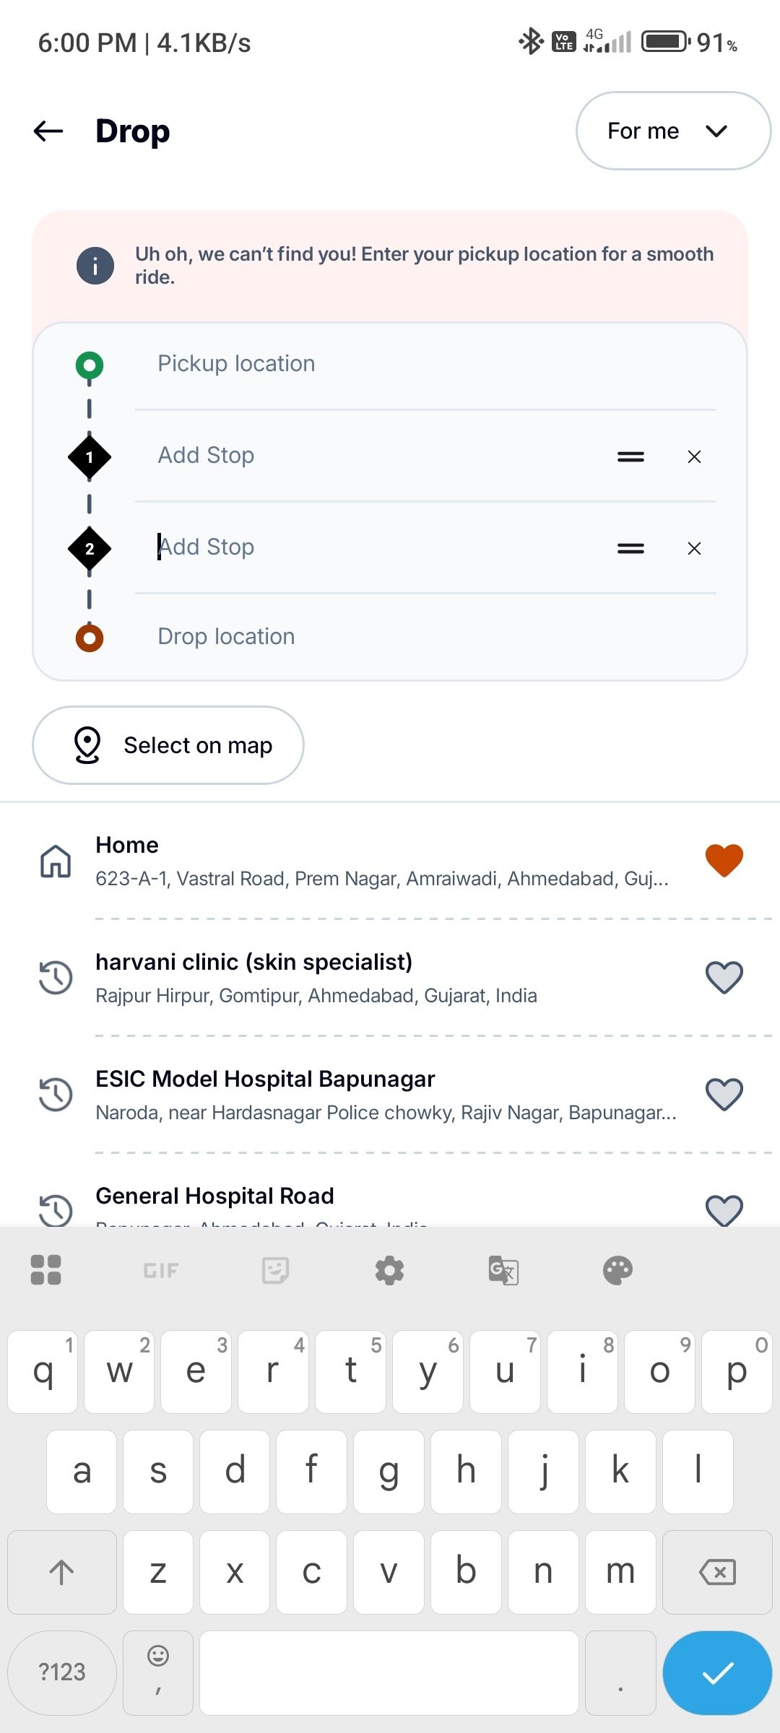
Figure: Drop Location Screen - Showing saved Home and recent locations

Test Case: Ride History - View Past Rides
Test Case ID | TC_RAP_003
Scenario | Ride History - View Past Rides
Preconditions | User has taken multiple rides in the past including parcel and bike rides.
Test Steps | 1. Navigate to Ride History screen  2. Verify Parcel rides are listed separately  3. Check ride details: 623-A-1, Vastral Road (16 Aug 2026, 12:27 PM, ₹51.0, Completed)  4. Check ride details: BLOCK-A (16 Aug 2026, 11:51 AM, ₹51.0, Completed)  5. Check ride details: eInfochips (27 Jul 2026, 09:26 AM, ₹0.0, Cancelled)  6. Check ride details: Late Shri Manu Bhai (08 Jul 2026, 02:11 PM, ₹28.0, Completed)  7. Verify "Request Ride History" option for rides older than 90 days
Expected Result | Ride history displays all past rides chronologically. Each ride shows date, time, fare, and status. Parcel and bike rides are distinguishable by icons. Option to request older ride history is available.
Actual Result | PASS - Ride history displays correctly with all details. Parcel and bike icons distinguish ride types. Status (Completed/Cancelled) clearly shown.
Screenshot | See below

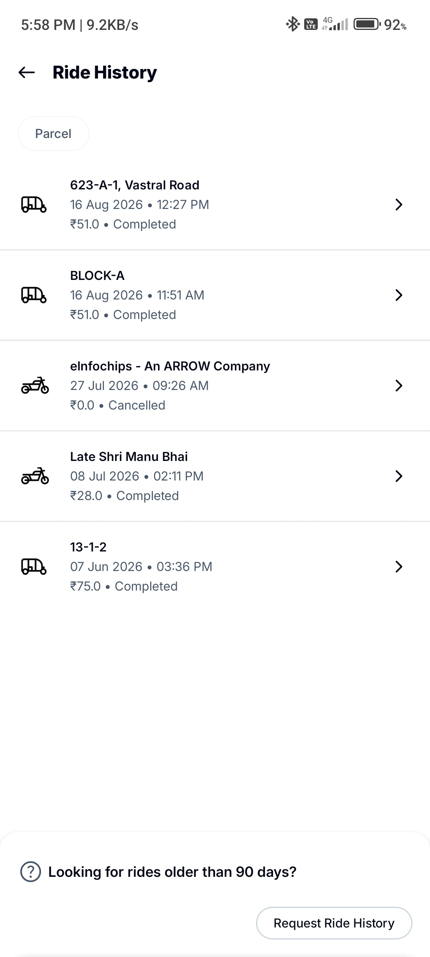
Figure: Ride History Screen - Showing past rides with details

Test Case: Support - FAQs for Parcel Related Issues
Test Case ID | TC_RAP_004
Scenario | Support - FAQs for Parcel Related Issues
Preconditions | User has navigated to Support/Help section of the app.
Test Steps | 1. Open FAQs section  2. Verify "Parcel Related Issues" category is displayed  3. Check available FAQ options:  - My order was not delivered  - Items are damaged  - Few items are missing from my order  - I am unable to contact the captain  - I have an issue with the payment  - My issue is not mentioned above  4. Verify "Tickets" button is available in top right
Expected Result | FAQs screen loads successfully. All parcel-related issue categories are listed. Each option has a navigation arrow. Tickets button is accessible for viewing existing support tickets.
Actual Result | PASS - FAQs screen displays all parcel-related issue categories. Navigation arrows present. Tickets button visible.
Screenshot | See below

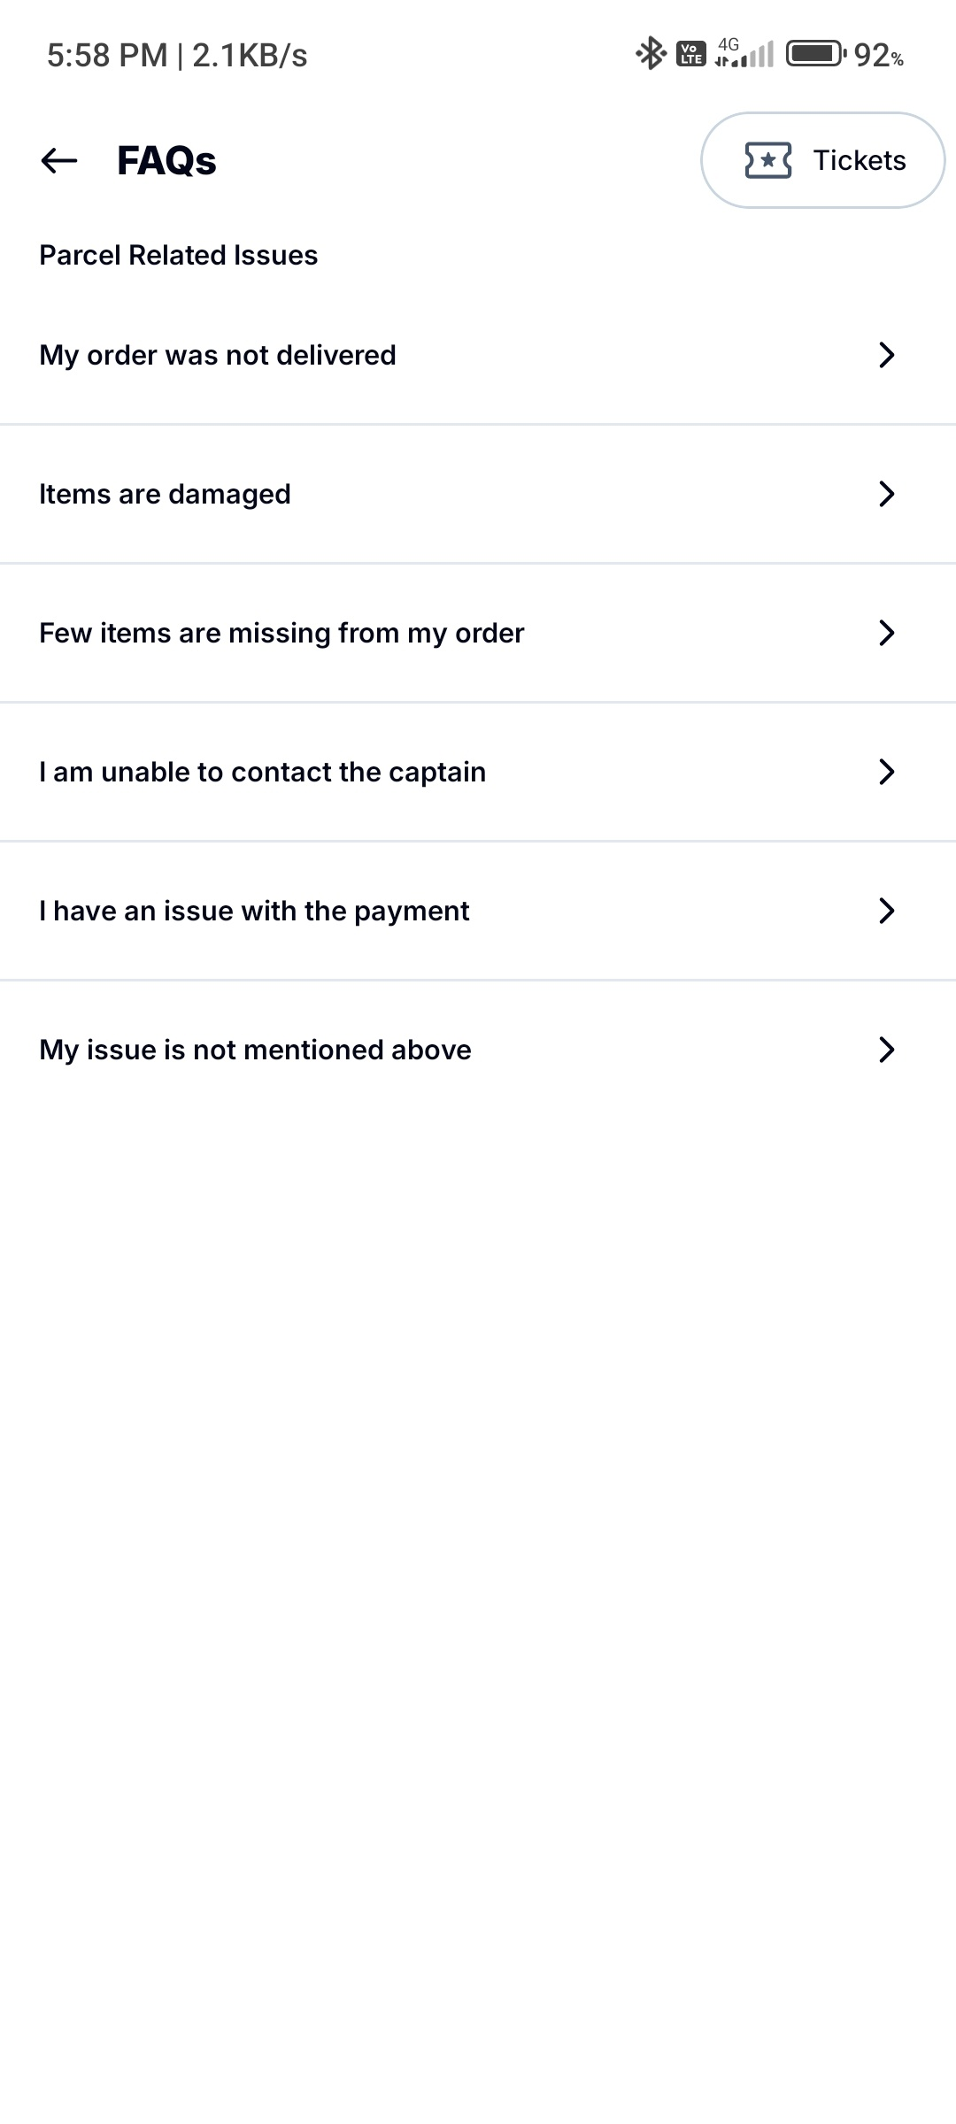
Figure: FAQs Screen - Parcel Related Issues section

Test Case: Support Chat - Automated Support Flow
Test Case ID | TC_RAP_005
Scenario | Support Chat - Automated Support Flow
Preconditions | User is on the Support Chat screen after completing or during a ride.
Test Steps | 1. Open Support Chat  2. Verify welcome message: "Hi nik, Welcome to Rapido Support!"  3. Verify prompt: "Please select your issue below"  4. Check available quick-select options:  - I'm charged higher than estimate  - I had a safety concern in my ride  - I want to report an issue about the captain or ride  - I left an item in the vehicle  - List more issues
Expected Result | Support chat opens with automated welcome messages. Quick-select issue buttons are displayed for common problems. User can select an issue or request more options.
Actual Result | PASS - Support chat loads with welcome messages. All quick-select options are visible and clickable.
Screenshot | See below

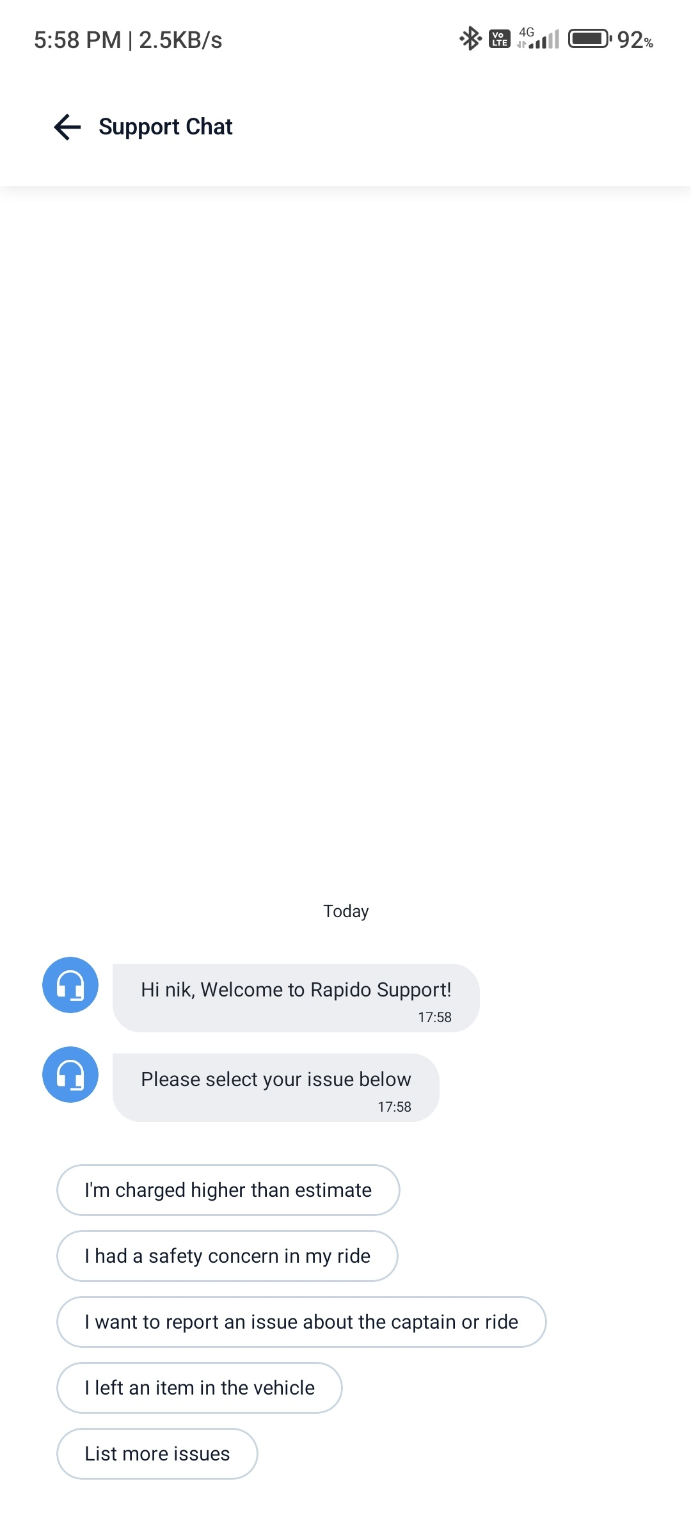
Figure: Support Chat - Automated issue selection options

Test Case: Ride Rating & Feedback - Post-Ride Experience
Test Case ID | TC_RAP_006
Scenario | Ride Rating & Feedback - Post-Ride Experience
Preconditions | Ride with Captain Thakor Arjun (GJ27WB4344) has been completed and fare of ₹51 has been paid.
Test Steps | 1. Complete the ride  2. Verify rating screen appears with captain photo  3. Check captain details: Thakor Arjun, Vehicle: GJ27WB4344, Speaks Hindi, Badge: Never Cancels  4. Verify star rating system (1-5 stars)  5. Check issue tags: Demanded extra cash, Different vehicle, Unprofessional behaviour, Unsafe ride  6. Verify "Tell us more..." text input field  7. Check "Need Help?" section with "We are just a tap away"  8. Verify "Done" button
Expected Result | Rating screen appears post-ride. Captain details are accurate. Star rating is interactive. Issue tags are relevant to ride problems. Help section is accessible. Done button completes the flow.
Actual Result | PASS - Rating screen displays correctly. Captain info accurate. 3-star rating selected (OK, but had an issue). Issue tags and help section visible.
Screenshot | See below

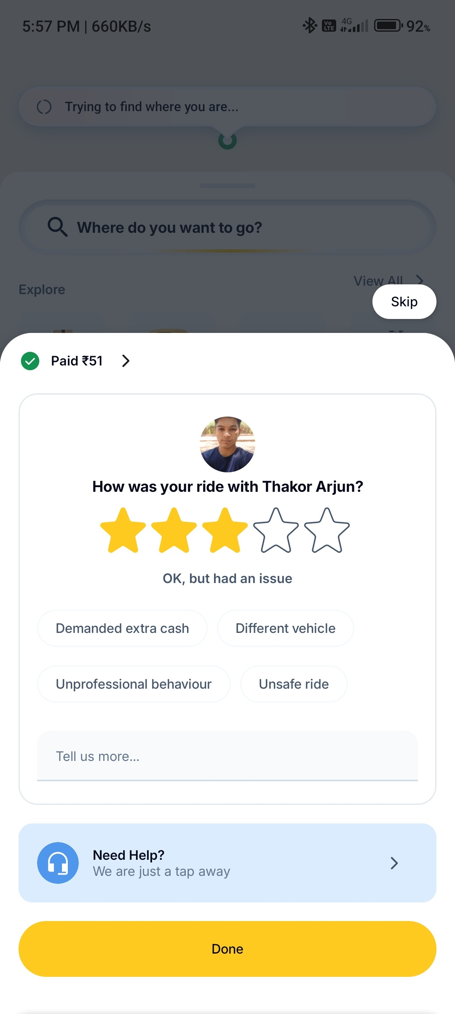
Figure: Post-Ride Rating Screen - Captain Thakor Arjun feedback

Test Case: Payment Methods - Cash Selection
Test Case ID | TC_RAP_007
Scenario | Payment Methods - Cash Selection
Preconditions | User is on the payment selection screen during ride booking.
Test Steps | 1. Navigate to Payments screen  2. Verify Total Fare: ₹51  3. Check info message: "Pay directly to your Captain through cash or UPI."  4. Verify "Others" section with Cash option (selected)  5. Check "Wallets" section:  - Rapido Wallet (disabled/unlinked)  - AmazonPay (LINK option)  6. Check "Pay Later" section:  - Pay at drop (disabled)  7. Verify Cash is selected as default payment method
Expected Result | Payment screen shows all available methods. Cash is selected by default. Wallet options are visible but may require linking. Pay Later option is available. Total fare is correctly displayed.
Actual Result | PASS - Payment methods screen displays correctly. Cash selected. Wallets and Pay Later options visible. Total fare ₹51 shown.
Screenshot | See below

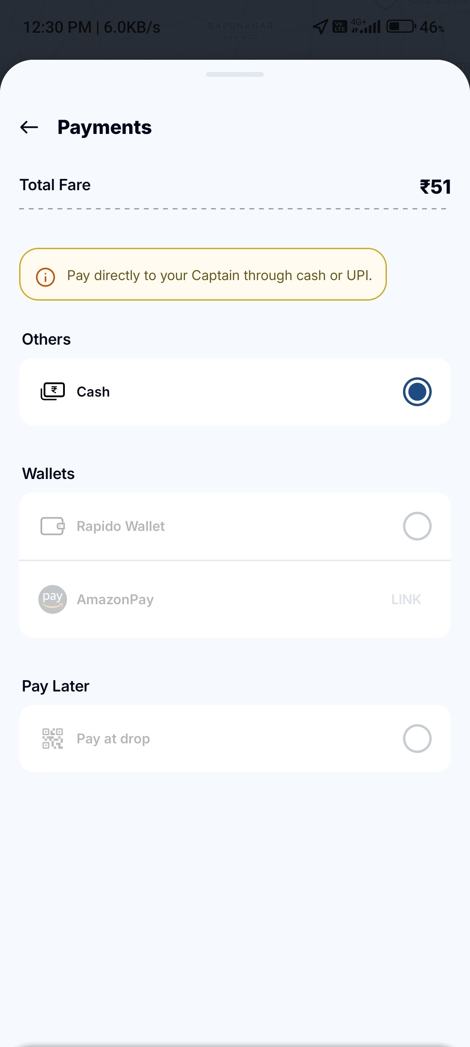
Figure: Payments Screen - Cash payment method selected

Test Case: Live Ride Tracking - In-Progress Ride
Test Case ID | TC_RAP_008
Scenario | Live Ride Tracking - In-Progress Ride
Preconditions | Ride has been booked and captain is en route or ride is in progress.
Test Steps | 1. View live ride tracking screen  2. Verify map shows current location and route  3. Check ETA: "Reaching drop location in 7 mins"  4. Verify distance: "Destination is 3.4 km away"  5. Check drop location: 623-A-1, Vastral Road, Prem Nagar, Amraiwardi...  6. Verify "Trip Details" button  7. Check issue reporting options: Demanded extra cash, Rash driving, Wrong Vehicle, No issues  8. Verify captain details: Thakor Arjun, GJ27WB4344, Speaks Hindi, Never Cancels badge  9. Verify Safety button and Share button are accessible
Expected Result | Live tracking displays accurate route and ETA. Captain details are visible. Safety and share features are accessible. Issue reporting is available during the ride.
Actual Result | PASS - Live tracking works correctly. ETA and distance accurate. Captain info visible. Safety and issue reporting features accessible.
Screenshot | See below

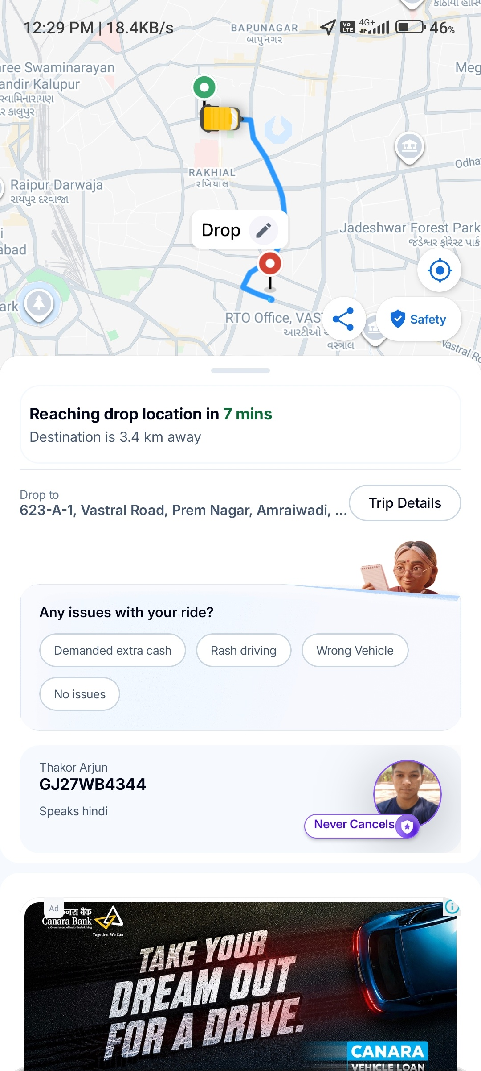
Figure: Live Ride Tracking - Map view with ETA and captain details

Test Case: Pickup Point Selection - Confirm Pickup Location
Test Case ID | TC_RAP_009
Scenario | Pickup Point Selection - Confirm Pickup Location
Preconditions | User has entered pickup location and app is showing nearby pickup points.
Test Steps | 1. View pickup point selection screen  2. Verify map shows nearby landmarks (ESIC Model Hospital Bapunagar, Ganesh Electric Stores)  3. Check instruction: "Check your pickup point - Select a nearby point for easier pickup"  4. Verify suggested pickup point: 2-12/23, Rajiv Nagar, Rakhial, Ahmedabad, Gujarat 380024, India  5. Tap "Confirm pickup" button  6. Verify pickup point is set correctly
Expected Result | Pickup point selection screen shows map with nearby points. Suggested pickup location is accurate. Confirm pickup button finalizes the selection.
Actual Result | PASS - Pickup point selection works correctly. Map shows accurate location. Suggested point is relevant. Confirm pickup button functional.
Screenshot | See below

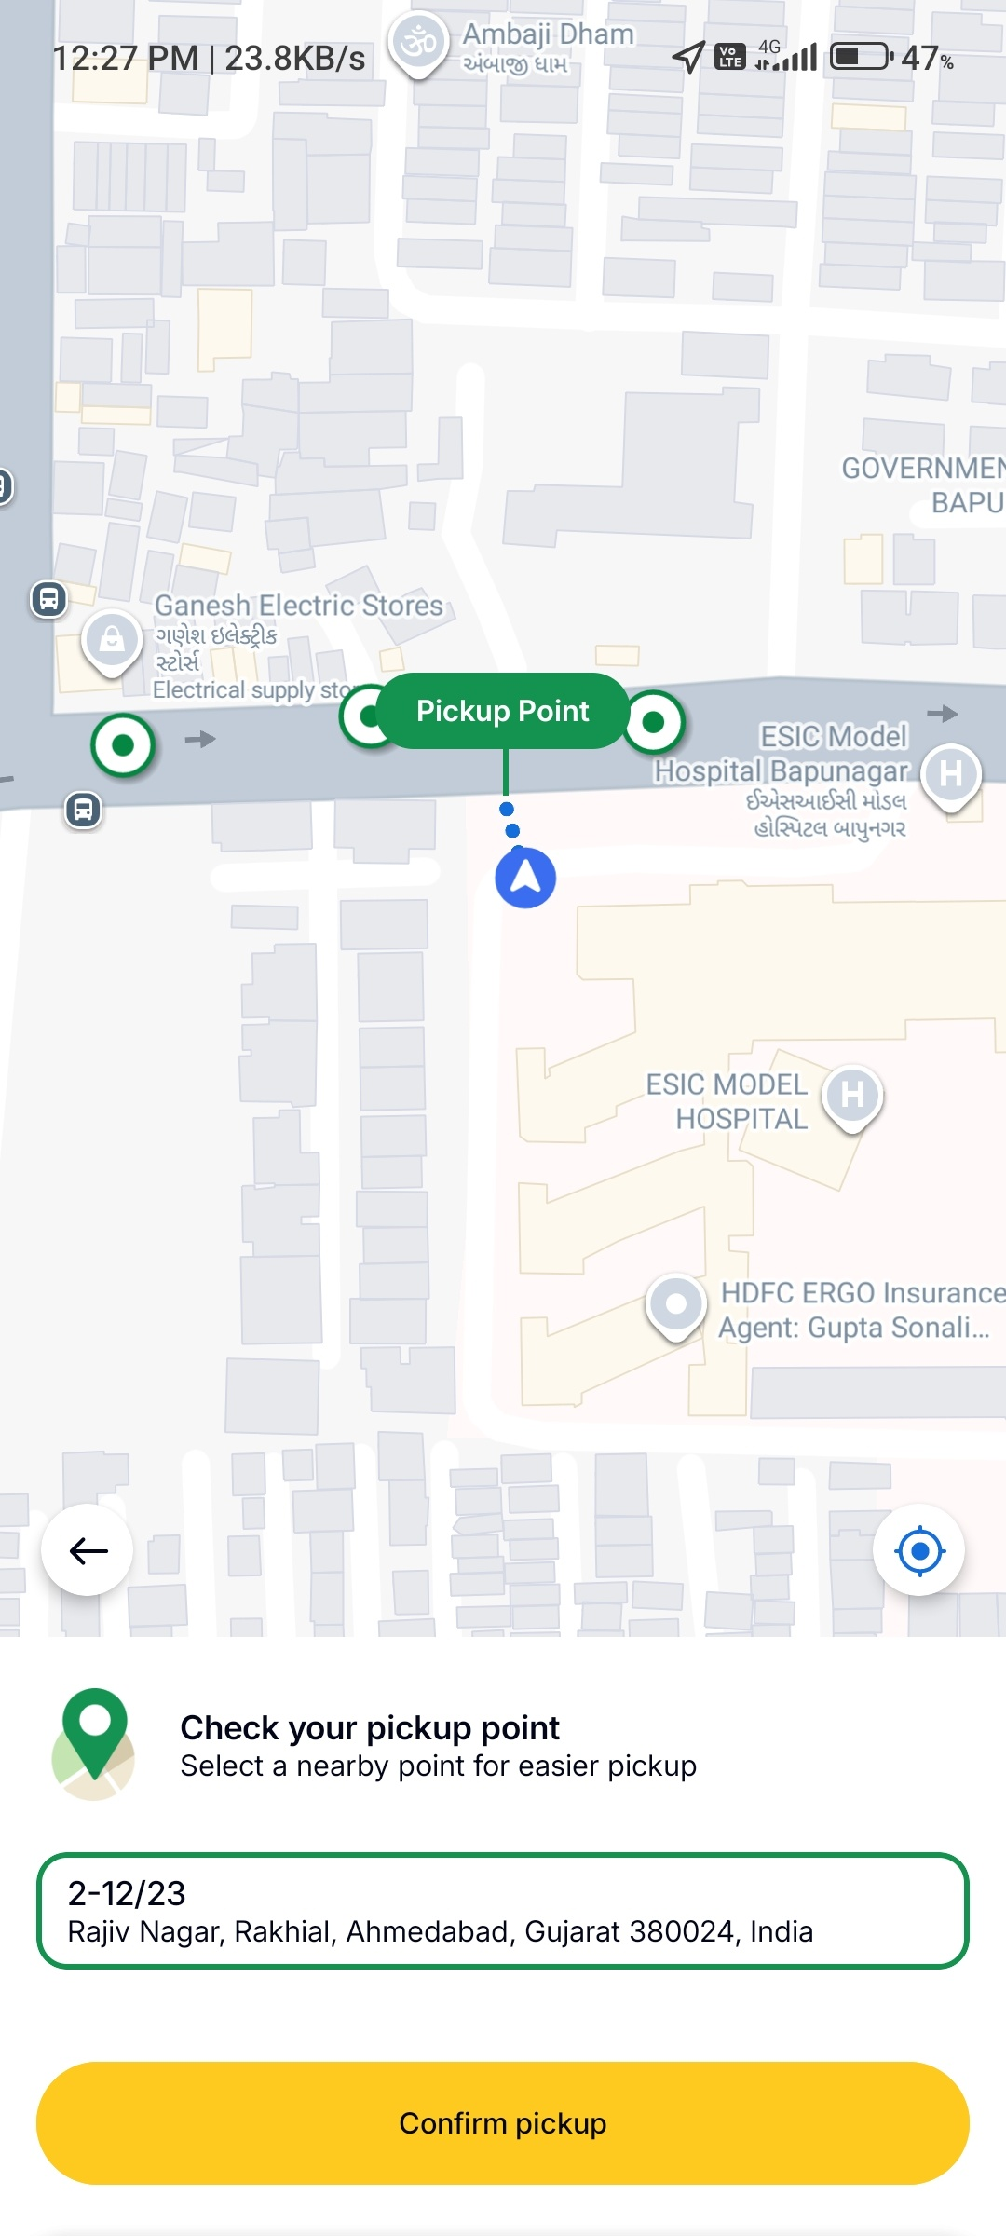
Figure: Pickup Point Selection - Map view with confirm button

Test Case: Ride Search - Background Video Call Handling
Test Case ID | TC_RAP_010
Scenario | Ride Search - Background Video Call Handling
Preconditions | User is on a video call (Google Meet with participant "Pooja") while searching for a ride.
Test Steps | 1. Initiate ride search  2. Verify video call overlay appears (Google Meet with "You" and "Pooja")  3. Check that ride search continues in background  4. Verify ride details are still accessible:  - Auto service, ₹51 fare  - Pickup: 623-C-1, Vastral Road, Prem Nagar, Amraiwardi, Ahmedabad  - Drop: ESIC Model Hospital Bapunagar  5. Verify "Back" button is available  6. Confirm app remains responsive during video call
Expected Result | App handles video call overlay gracefully. Ride search continues uninterrupted. All ride details remain visible and accessible. App remains responsive.
Actual Result | PASS - Video call overlay displays without affecting ride search. All ride details visible. App remains responsive.
Screenshot | See below

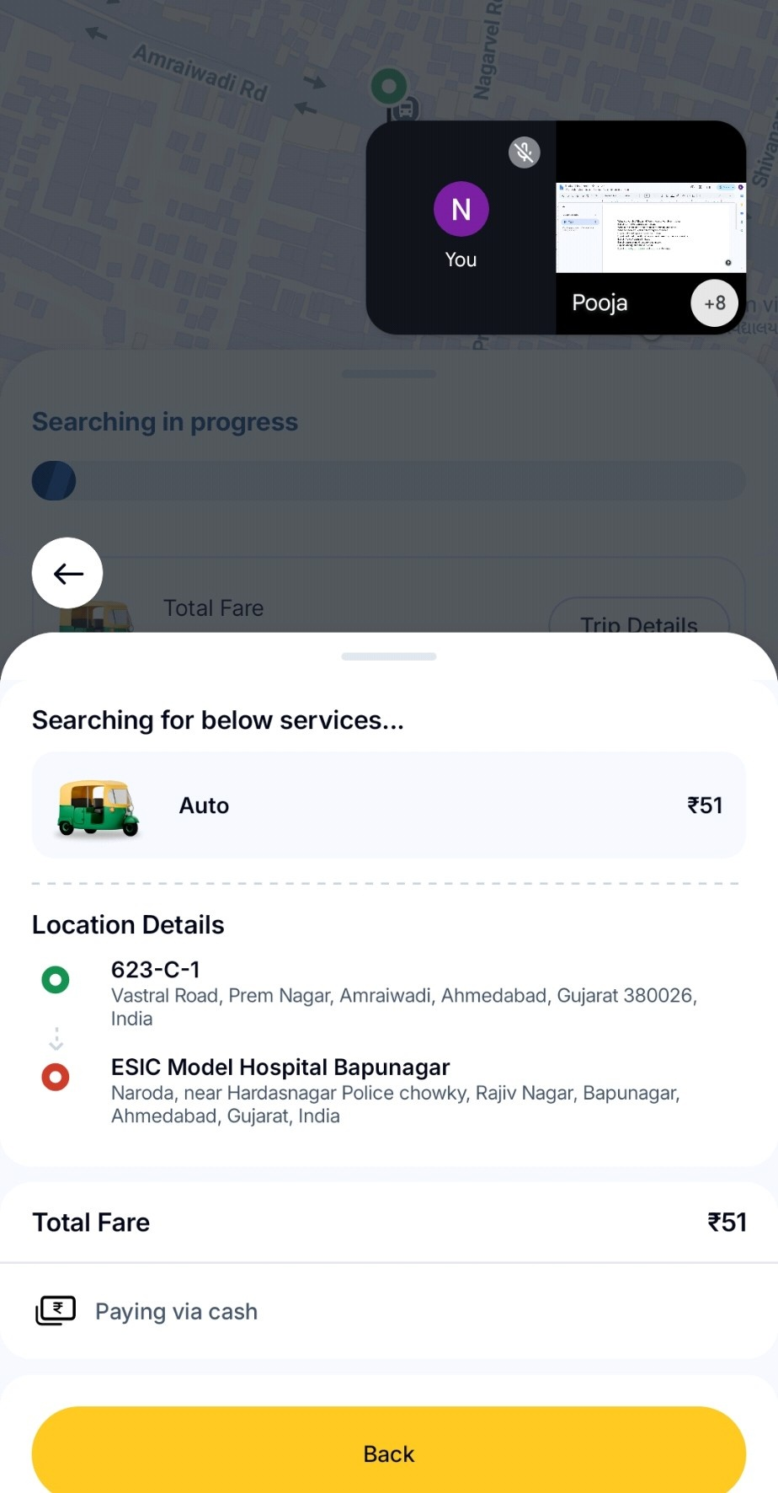
Figure: Ride Search with Video Call Overlay - Google Meet in background

Test Case: Trip Details - View Ride Summary
Test Case ID | TC_RAP_011
Scenario | Trip Details - View Ride Summary
Preconditions | Ride is in progress or has been booked. User taps on Trip Details.
Test Steps | 1. Tap on "Trip Details" button  2. Verify vehicle type: Auto  3. Check location details:  - Home (Drop): 623-A-1, Vastral Road, Prem Nagar, Amraiwardi, Ahmedabad, Gujarat 380026, India  4. Verify Total Fare: ₹51  5. Check payment method: "Paying via cash"  6. Verify "Change" option for payment method  7. Check "Cancel Ride" button is available
Expected Result | Trip details modal shows complete ride summary. Vehicle type, locations, fare, and payment method are accurate. User can change payment or cancel ride.
Actual Result | PASS - Trip details display correctly. All information accurate. Payment change and cancel options available.
Screenshot | See below

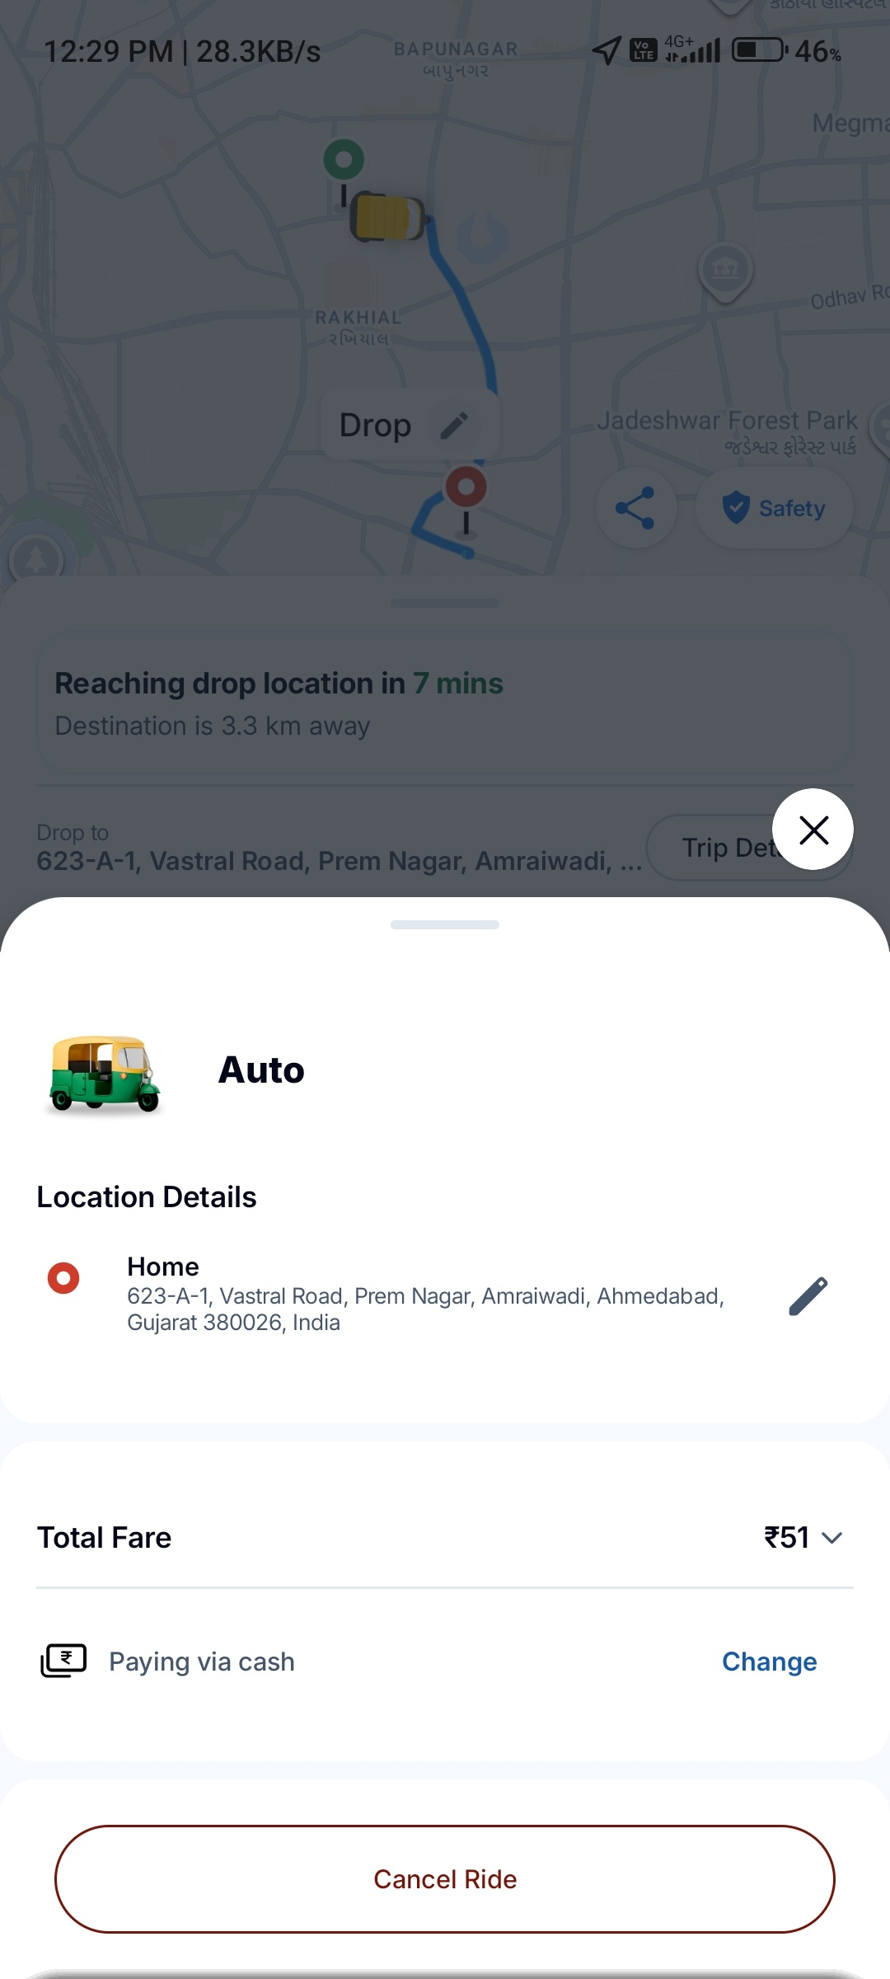
Figure: Trip Details Modal - Ride summary with cancel option

Test Case: Payment Method - Power Pass Eligibility
Test Case ID | TC_RAP_012
Scenario | Payment Method - Power Pass Eligibility
Preconditions | User is on payment method selection screen for a different ride (Total Amount ₹240).
Test Steps | 1. Open Payment Method screen  2. Verify Power Pass eligibility message: "Yay! You are eligible for Power Pass"  3. Check Total Amount: ₹240  4. Verify "Other Payment Methods" section  5. Check Cash option with description: "You can pay via cash or UPI for your ride"  6. Verify "Personal Wallet" section:  - Rapido Wallet (disabled)  - Paytm (disabled)  - AmazonPay (disabled)  7. Check UPI option with "Select App" dropdown  8. Verify wallet not applicable message when attempting to select disabled wallet
Expected Result | Payment method screen shows Power Pass eligibility. Cash is the primary available option. Wallet options are visible but disabled until linked. UPI option allows app selection.
Actual Result | PASS - Payment methods display correctly. Power Pass eligibility shown. Cash available. Wallets disabled with appropriate messaging.
Screenshot | See below

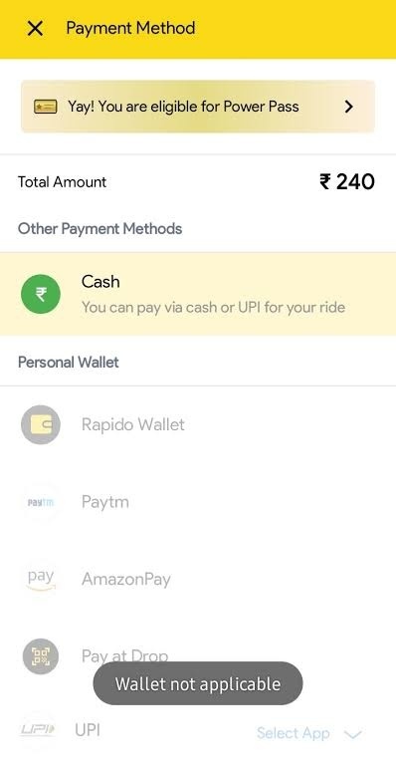
Figure: Payment Method Screen - Power Pass eligibility and wallet options

Test Case: Ride Search - Video Call Overlay (Duplicate Verification)
Test Case ID | TC_RAP_013
Scenario | Ride Search - Video Call Overlay (Duplicate Verification)
Preconditions | Same as TC_RAP_010 - Video call is active during ride search.
Test Steps | 1. Verify ride search screen with video overlay  2. Confirm all ride details remain visible:  - Auto service selected  - Fare: ₹51  - Pickup: 623-C-1, Vastral Road, Prem Nagar, Amraiwardi, Ahmedabad, Gujarat 380026, India  - Drop: ESIC Model Hospital Bapunagar, Naroda, near Hardasnagar Police chowky, Rajiv Nagar, Bapunagar, Ahmedabad, Gujarat, India  3. Verify "Back" button functionality  4. Confirm no UI elements are obscured by overlay
Expected Result | Consistent behavior with TC_RAP_010. All ride details visible. No UI obstruction. App remains functional.
Actual Result | PASS - Consistent behavior confirmed. All details visible. UI not obstructed.
Screenshot | See below

Figure: Ride Search with Video Call - Verification screenshot

Test Case: Captain Communication - In-App Chat
Test Case ID | TC_RAP_014
Scenario | Captain Communication - In-App Chat
Preconditions | Ride has been assigned to a captain. User opens chat interface.
Test Steps | 1. Open chat with captain  2. Verify safety message: "Do not share any personal details with captain over call or chat"  3. Send message: "Are you coming ?"  4. Verify captain response: "No"  5. Send message: "Then cancel it"  6. Check "Quick chat" options:  - Are you coming ?  - Waiting at pickup 📍  - My location is as per map 🗺️  - Message when reached 💬  7. Verify text input field and send button
Expected Result | Chat interface opens successfully. Safety warning is displayed. Messages are delivered and received. Quick chat options provide convenient communication. Text input works correctly.
Actual Result | PASS - Chat functionality works correctly. Messages delivered. Quick chat options available. Captain responded appropriately.
Screenshot | See below

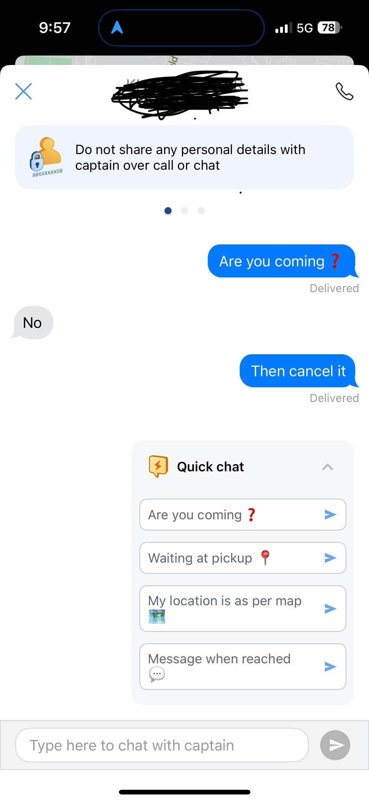
Figure: Captain Chat - Quick chat options and message exchange

Test Execution Summary
Test Case ID | Scenario | Status | Priority
TC_RAP_001 | Ride Booking - Auto Search | PASS | High
TC_RAP_002 | Location Selection - Drop Location Entry | PASS | High
TC_RAP_003 | Ride History - View Past Rides | PASS | Medium
TC_RAP_004 | Support - FAQs for Parcel Related Issues | PASS | Medium
TC_RAP_005 | Support Chat - Automated Support Flow | PASS | High
TC_RAP_006 | Ride Rating & Feedback - Post-Ride Experience | PASS | High
TC_RAP_007 | Payment Methods - Cash Selection | PASS | High
TC_RAP_008 | Live Ride Tracking - In-Progress Ride | PASS | High
TC_RAP_009 | Pickup Point Selection - Confirm Pickup Location | PASS | High
TC_RAP_010 | Ride Search - Background Video Call Handling | PASS | Low
TC_RAP_011 | Trip Details - View Ride Summary | PASS | Medium
TC_RAP_012 | Payment Method - Power Pass Eligibility | PASS | Medium
TC_RAP_013 | Ride Search - Video Call Overlay (Duplicate) | PASS | Low
TC_RAP_014 | Captain Communication - In-App Chat | PASS | High

Overall Result: 14/14 Test Cases PASSED (100% Pass Rate)

Notes:
- • All test cases executed on Rapido Passenger App (com.rapido.passenger)
- • Test device: Android mobile with 4G/5G connectivity
- • Test location: Ahmedabad, Gujarat, India
- • All screenshots captured during actual app usage on 16 Aug 2026
- • Video call overlay test confirms app stability during multitasking
- • Captain chat test reveals potential issue: captain refused ride but did not cancel (see TC_RAP_014)

