FLIPKART MOBILE APP
Software Testing Practical Report

Platform Tested: Android
Test Date: August 06, 2026
App Package: com.flipkart.android
Report Type: Functional, UI/UX, Security & Performance Test
1. APPLICATION DETAILS
App Name | Flipkart
Version | Latest (as of Aug 2026)
Platform | Android
Package Name | com.flipkart.android
Test Device | Android Smartphone
Network | Wi-Fi / Mobile Data
Date of Testing | August 06, 2026

4. FUNCTIONAL TEST CASES

Module 1: Authentication
Test Case ID | AUTH-01
Module | Authentication
Scenario | Verify user can select app language during onboarding
Preconditions | Fresh app install / cleared data
Test Steps | 1. Launch Flipkart app  2. Observe language selection screen
Expected Result | List of languages displayed (Hindi, Tamil, Telugu, Kannada, English, Marathi, Bangla)
Actual Result | Language selection screen displayed correctly with all regional options
Status | PASS
Remarks | English selected for testing

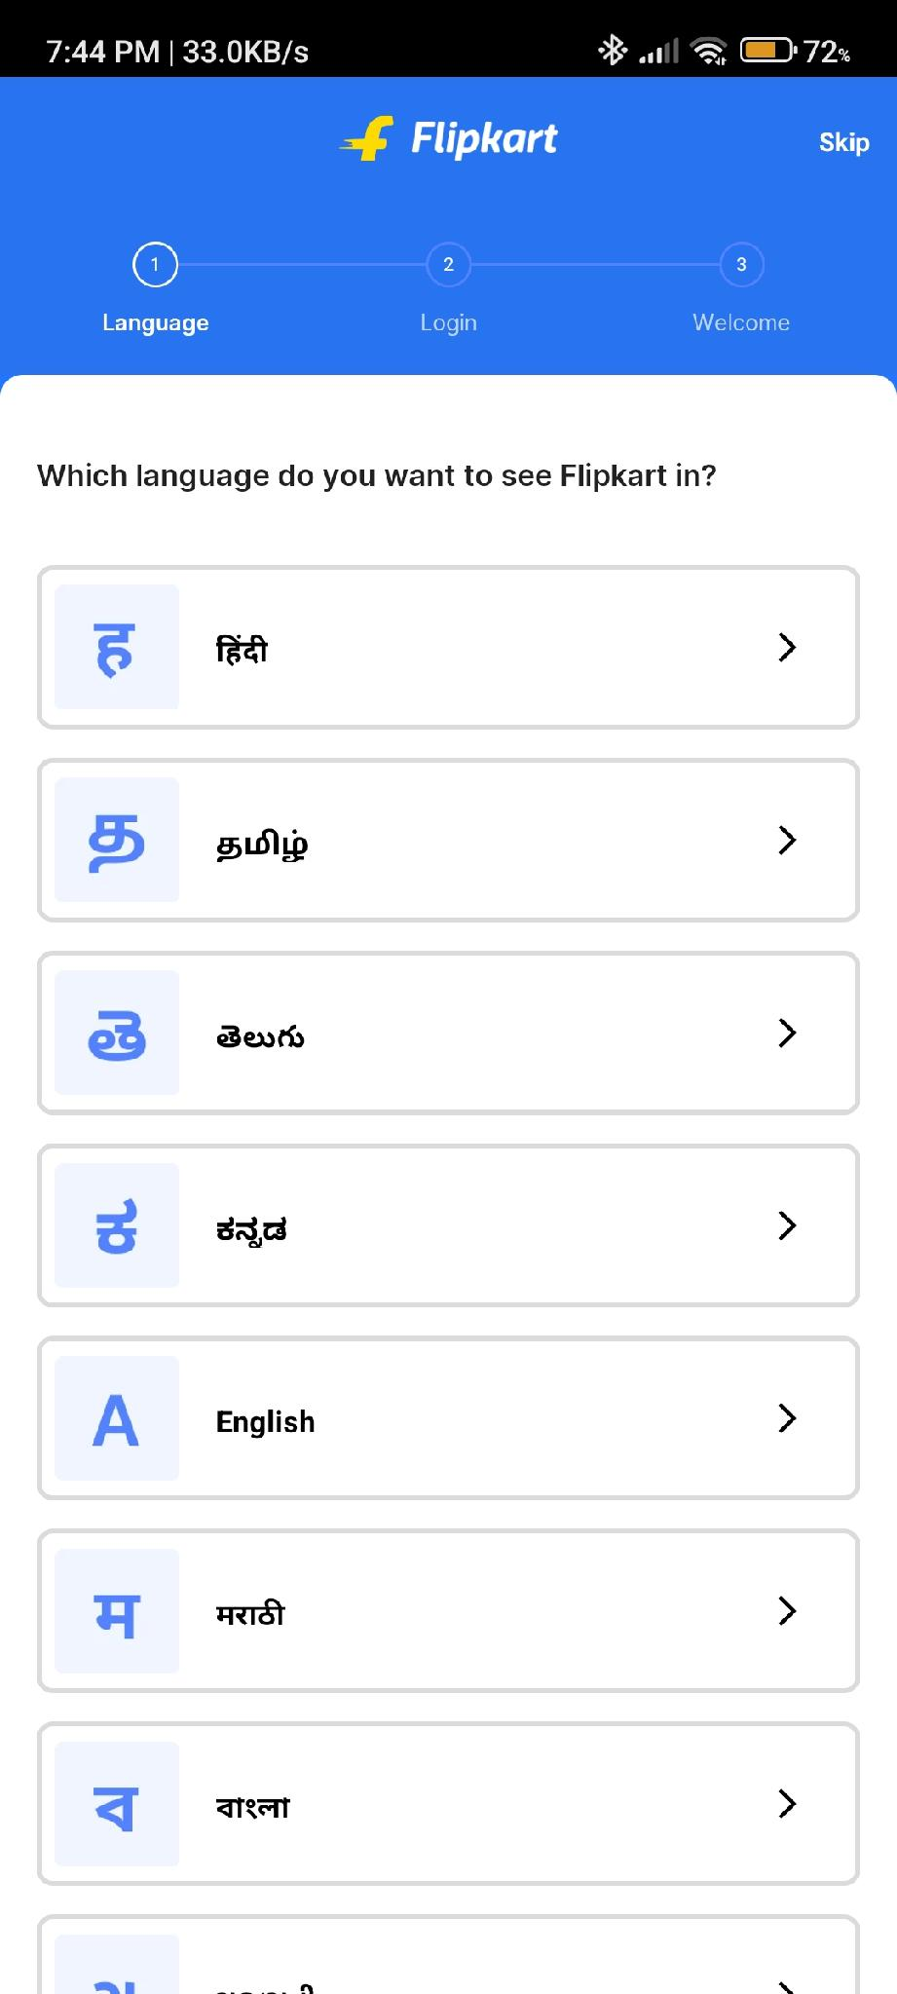
Figure: Language Selection Screen

Test Case ID | AUTH-02
Module | Authentication
Scenario | Verify login with valid mobile number
Preconditions | Active internet, valid registered number
Test Steps | 1. Tap Login  2. Enter valid 10-digit mobile number  3. Tap Continue
Expected Result | OTP screen appears with timer
Actual Result | OTP sent to +91-9737687242, 6-digit input field displayed
Status | PASS

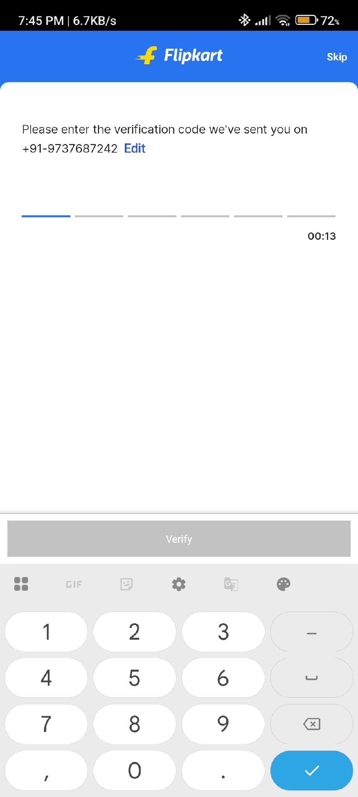
Figure: OTP Verification Screen with Timer

Test Case ID | AUTH-03
Module | Authentication
Scenario | Verify validation for invalid mobile number
Preconditions | User is on login screen
Test Steps | 1. Enter incomplete/invalid mobile number  2. Tap Continue
Expected Result | Error message: 'Invalid email id / mobile number'
Actual Result | Error displayed: 'Invalid email id / mobile number'
Status | PASS

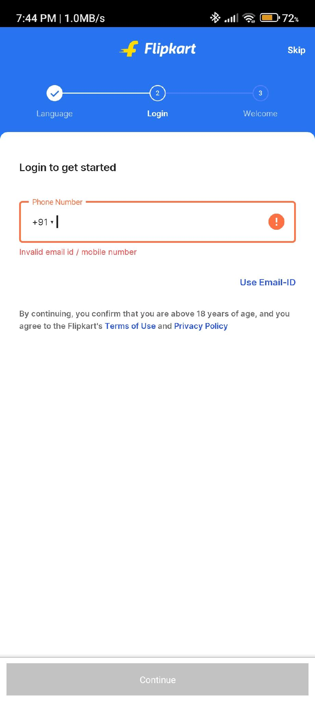
Figure: Login Screen with Validation Error

Test Case ID | AUTH-04
Module | Authentication
Scenario | Verify error handling for wrong OTP
Preconditions | OTP screen is active
Test Steps | 1. Enter incorrect 6-digit OTP  2. Tap Verify
Expected Result | Error: 'Incorrect OTP, please check and try again'
Actual Result | Error message displayed correctly below OTP fields
Status | PASS

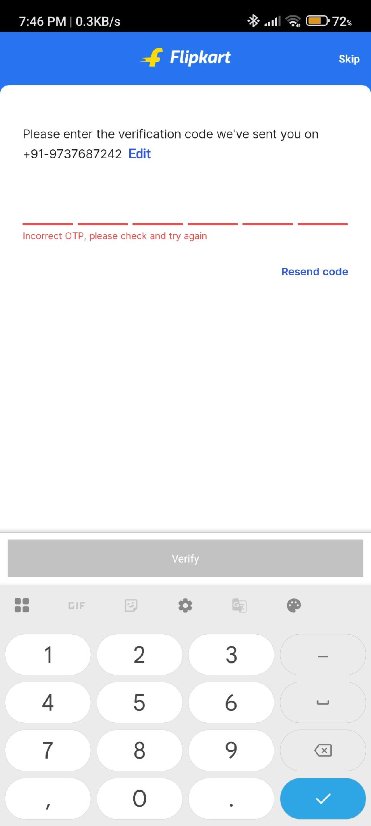
Figure: Incorrect OTP Error Message

Test Case ID | AUTH-05
Module | Authentication
Scenario | Verify user can logout successfully
Preconditions | User is logged in
Test Steps | 1. Go to Account → Tap Log Out  2. Select 'Logout from this device' or 'Log out from all devices'
Expected Result | User logged out, login screen appears
Actual Result | Logout options displayed successfully
Status | PASS

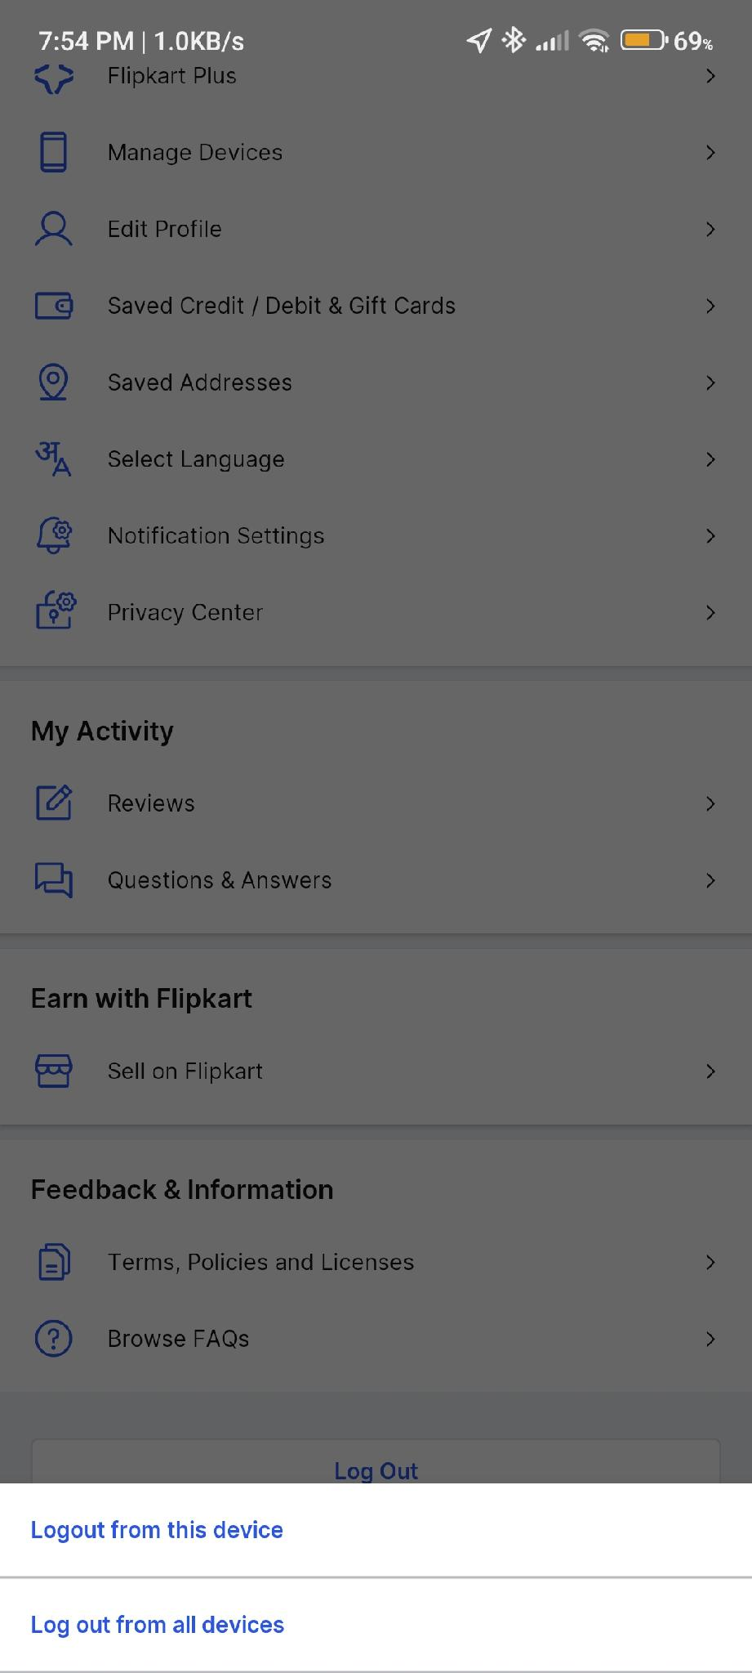
Figure: Account Menu with Logout Options

Module 2: Home Page
Test Case ID | HOME-01
Module | Home Page
Scenario | Verify home page loads with banners and categories
Preconditions | User is logged in
Test Steps | 1. Launch app  2. Observe home screen
Expected Result | Banners, category icons, search bar, and promotional content visible
Actual Result | Home page loaded with Freedom Sale banner, category navigation, and search
Status | PASS

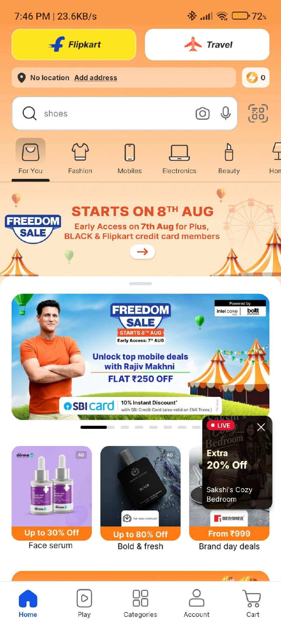
Figure: Home Page with Freedom Sale Banner and Categories

Module 3: Product Search
Test Case ID | SEARCH-01
Module | Product Search
Scenario | Verify search functionality with product name
Preconditions | User is on home page
Test Steps | 1. Tap search bar  2. Type 'titan watch for men'  3. Submit search
Expected Result | Relevant Titan watches displayed with images, prices, ratings
Actual Result | Search results displayed accurately with filters (Sort & Filter, Strap Material, Dial Shape)
Status | PASS

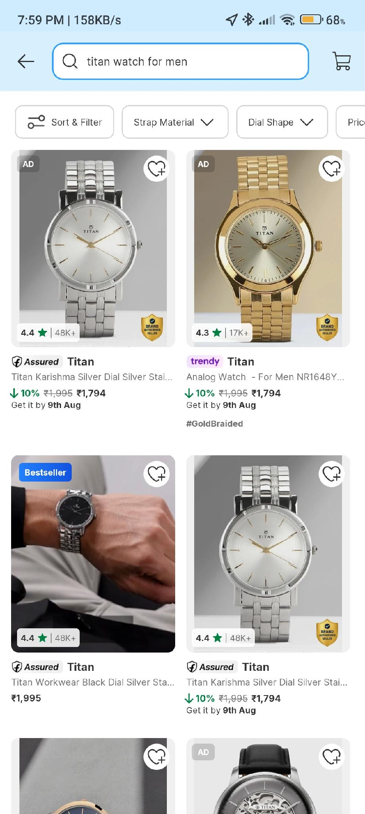
Figure: Search Results for 'titan watch for men'

Test Case ID | SEARCH-02
Module | Product Search
Scenario | Verify trending searches and suggestions appear
Preconditions | Search bar tapped
Test Steps | 1. Tap search bar  2. Type 'tv'
Expected Result | Trending searches and popular products displayed
Actual Result | Trending searches (iPhone 17vpro max, Big billion sale mobile) and Popular Products (Motorola, Sony PS5) shown
Status | PASS

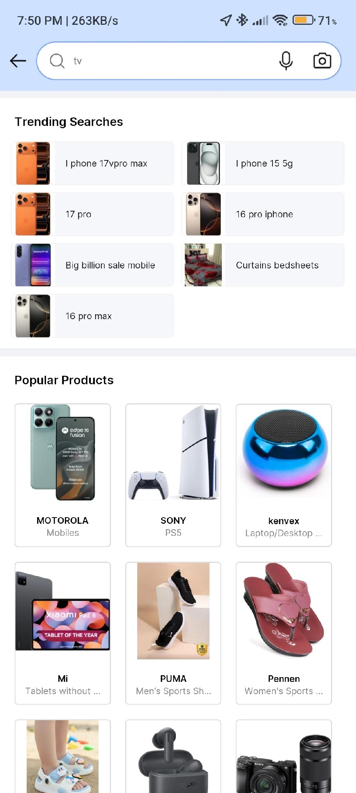
Figure: Trending Searches and Popular Products

Module 4: Cart
Test Case ID | CART-01
Module | Cart
Scenario | Verify empty cart state
Preconditions | No items in cart
Test Steps | 1. Tap Cart icon  2. Observe empty state
Expected Result | 'Your cart is empty!' message with Shop Now button
Actual Result | Empty cart illustration and message displayed correctly
Status | PASS

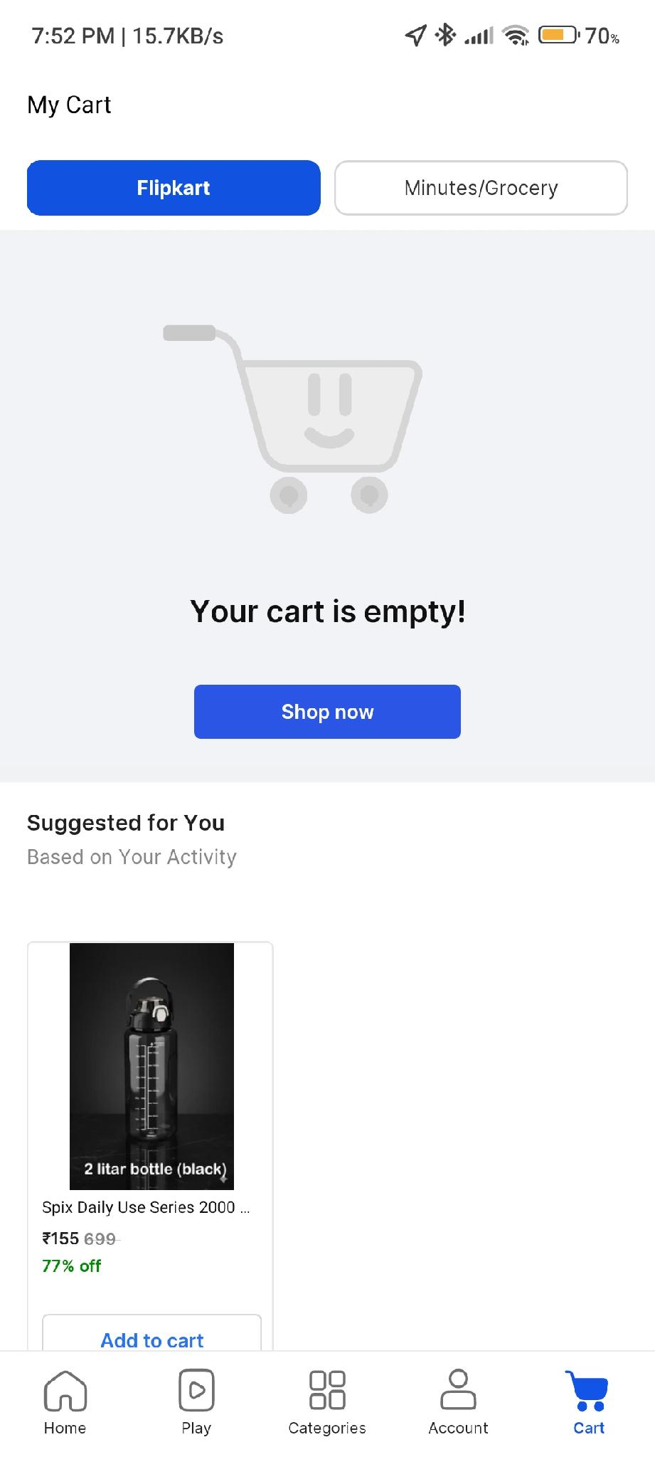
Figure: Empty Cart Page with Suggested Products

Test Case ID | CART-02
Module | Cart
Scenario | Verify cart displays product and allows address selection
Preconditions | Product added to cart
Test Steps | 1. Open cart  2. Tap 'Change' on delivery address  3. Observe saved addresses
Expected Result | Product details, price, and saved addresses visible with Edit/Delete options
Actual Result | BELLERBIRD bottle displayed; address selection modal with Edit/Delete options visible
Status | PASS

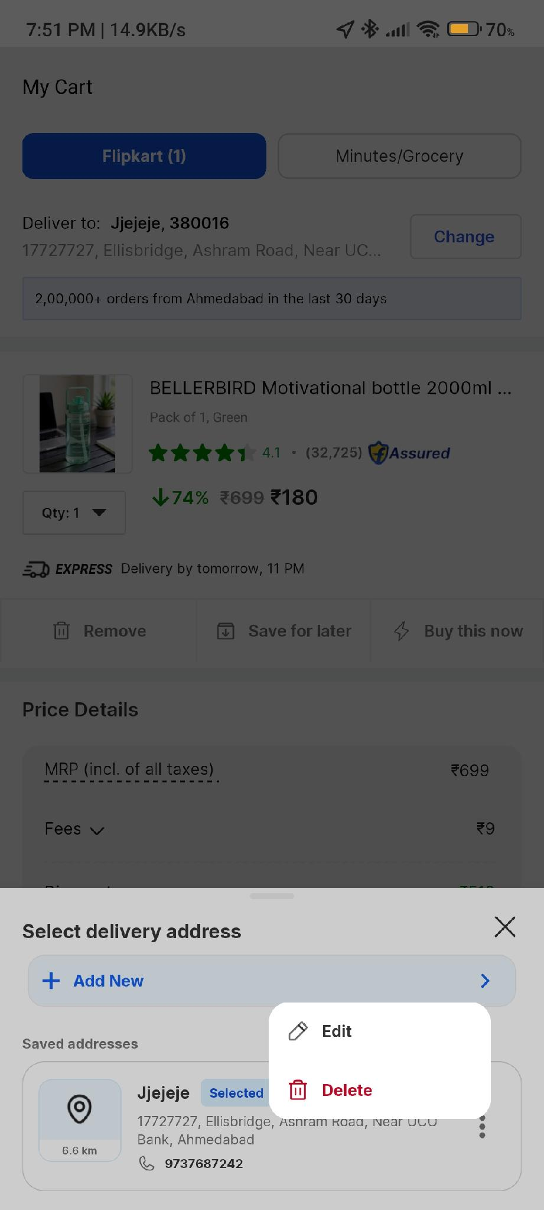
Figure: Cart with Product and Address Selection Modal

Module 5: Checkout & Address Management
Test Case ID | ADDR-01
Module | Address Management
Scenario | Verify address can be added using map location
Preconditions | User on checkout/address page
Test Steps | 1. Tap 'Add New'  2. Search location on map  3. Select 'Use current location' or place pin
Expected Result | Map interface loads with location search and current location option
Actual Result | Google Maps interface loaded with location search and 'Use my current location' button
Status | PASS

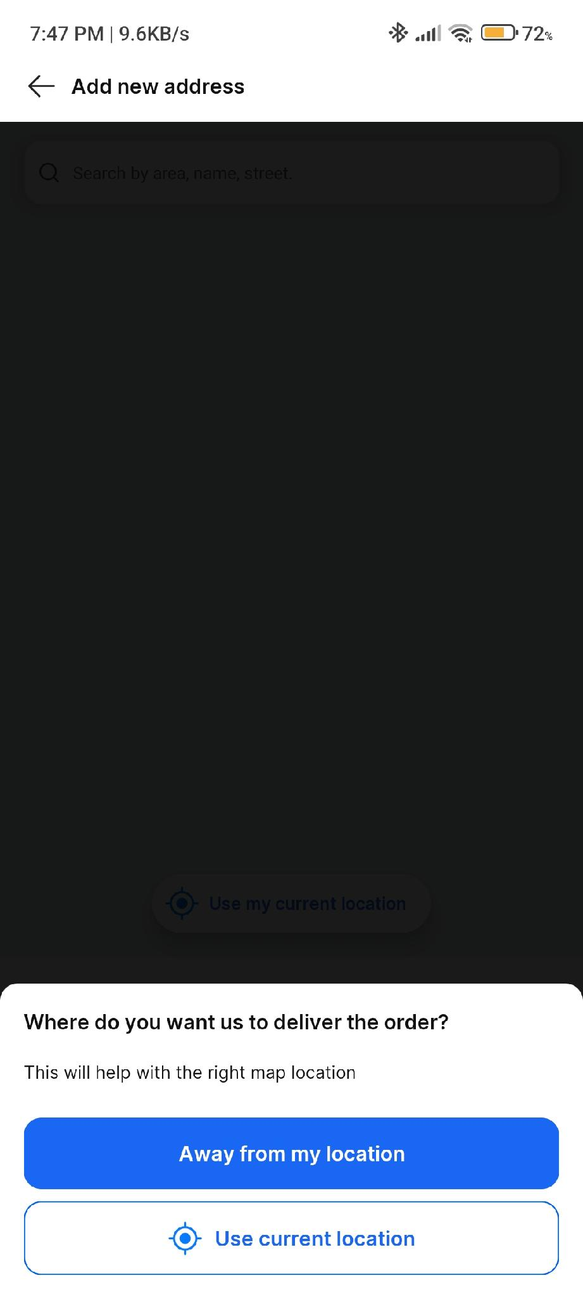
Figure: Add New Address - Map Location Selection

Test Case ID | ADDR-02
Module | Address Management
Scenario | Verify address form validation for alternate phone number
Preconditions | User is on address form
Test Steps | 1. Fill Flat/House, Area, Name, Mobile  2. Enter invalid alternate number (e.g., 5 digits)  3. Tap Save
Expected Result | Validation error: 'Enter a valid 10-digit mobile number'
Actual Result | Error displayed in red below alternate number field
Status | PASS

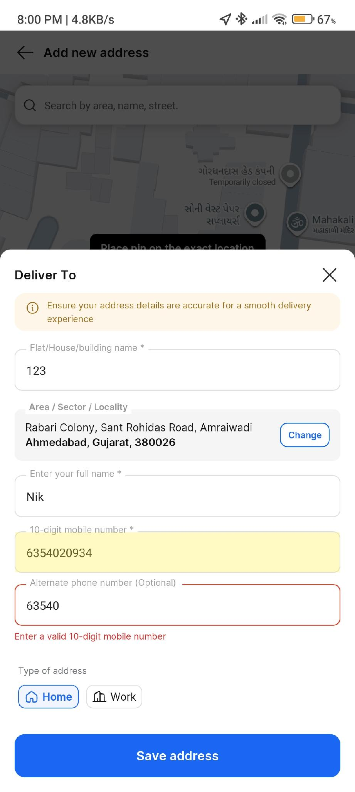
Figure: Address Form with Alternate Phone Validation Error

Test Case ID | ADDR-03
Module | Address Management
Scenario | Verify exact location can be pinned on map
Preconditions | Map view is open
Test Steps | 1. Search area (e.g., 'Ahem')  2. Place pin on exact location  3. Tap 'Add address Details'
Expected Result | Selected area displayed with Change option; Add Details button enabled
Actual Result | Location 'Ellisbridge, Ashram Road, Near UCO Bank, Ahmedabad, Gujarat, 380016' captured
Status | PASS

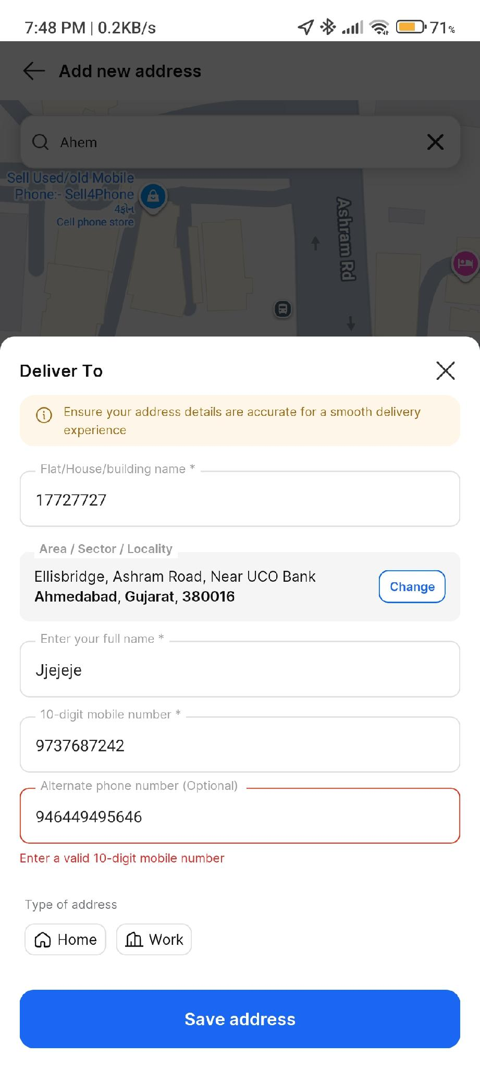
Figure: Map Pin Placement on Ellisbridge, Ashram Road

Test Case ID | ADDR-04
Module | Address Management
Scenario | Verify address form with pre-filled location data
Preconditions | Map location selected
Test Steps | 1. Observe pre-filled area details  2. Enter house number, name, mobile  3. Select address type (Home/Work)
Expected Result | Area details auto-populated; form accepts additional details
Actual Result | Area 'Ellisbridge, Ashram Road, Near UCO Bank, Ahmedabad, Gujarat, 380016' pre-filled; Home/Work toggle visible
Status | PASS

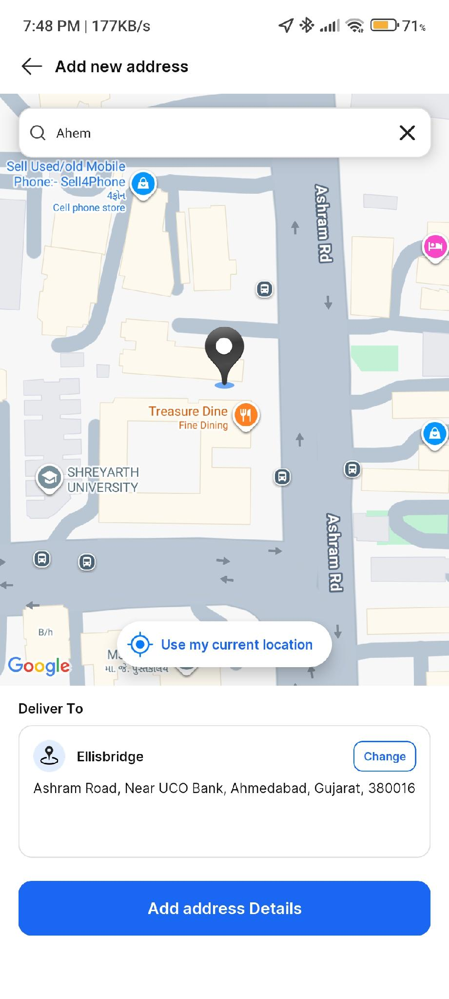
Figure: Address Form with Pre-filled Location Data

Test Case ID | CHECK-01
Module | Checkout
Scenario | Verify order summary before payment
Preconditions | Address selected, product in cart
Test Steps | 1. Proceed to buy  2. Review Order Summary
Expected Result | Delivery address, product details, price breakdown, and Continue button visible
Actual Result | Order Summary displayed: BELLERBIRD bottle, delivery by tomorrow 11 PM, savings ₹510
Status | PASS

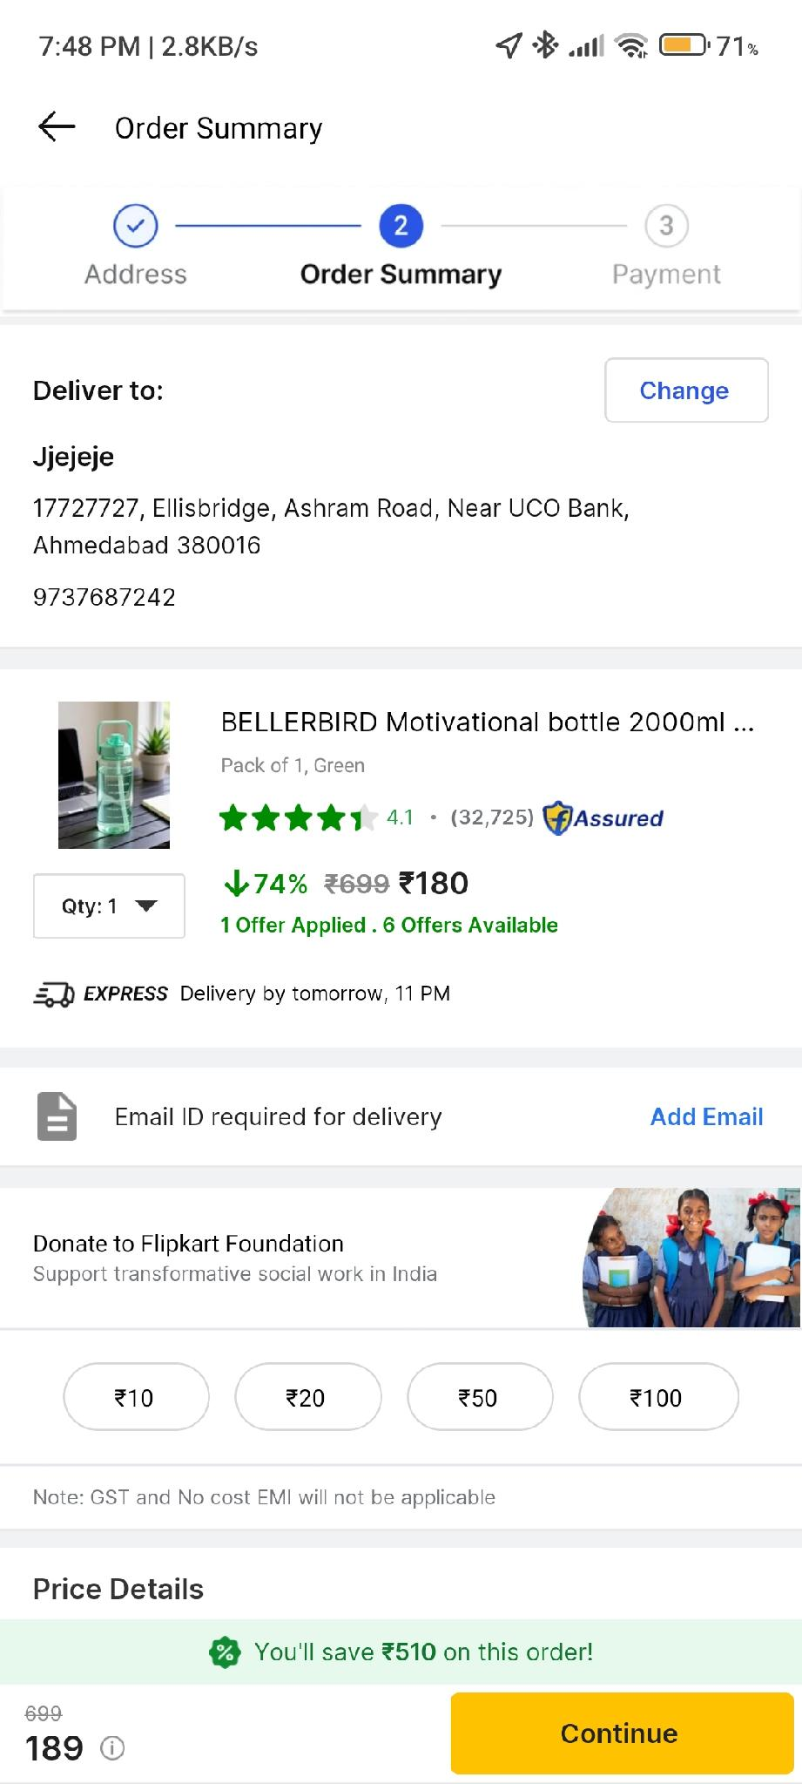
Figure: Order Summary Page (Step 2 of 3)

Module 6: Payment
Test Case ID | PAY-01
Module | Payment
Scenario | Verify all payment methods are available
Preconditions | User reached Step 3 (Payments)
Test Steps | 1. Tap Continue from Order Summary  2. Observe payment options
Expected Result | UPI, Credit/Debit/ATM Card, EMI, Cash on Delivery, Gift Card options visible
Actual Result | All payment methods displayed; UPI expanded showing 'No Active UPI Apps Found'; 5% Cashback banner visible
Status | PASS

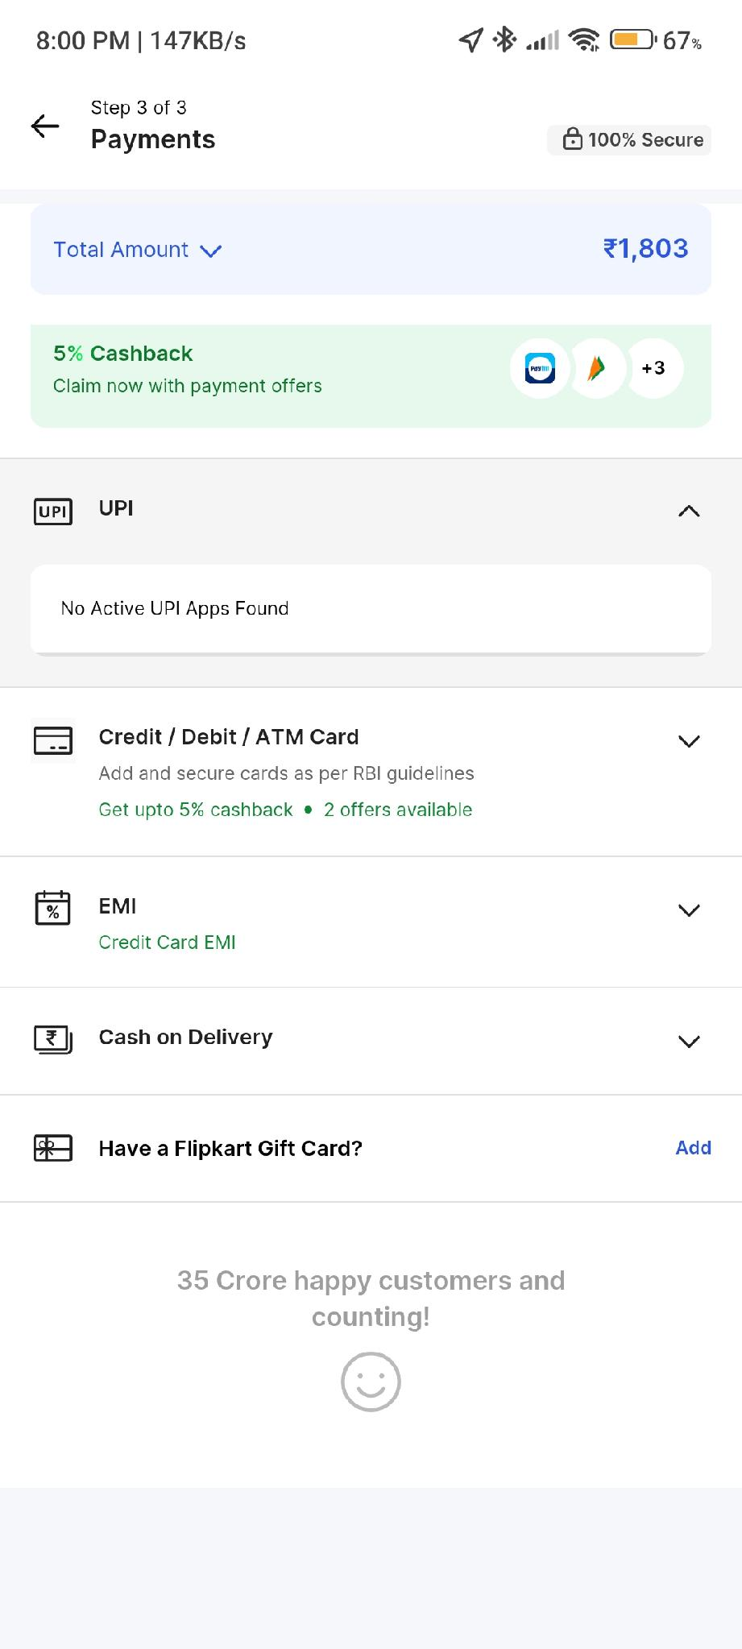
Figure: Payment Options Page (Step 3 of 3) - Total ₹1,803

Module 7: Profile Management
Test Case ID | PROF-01
Module | Profile
Scenario | Verify account menu options
Preconditions | User logged in
Test Steps | 1. Tap Account tab  2. Scroll through menu
Expected Result | Options: Flipkart Plus, Manage Devices, Edit Profile, Saved Cards, Saved Addresses, Language, Notifications, Privacy, My Activity, Sell on Flipkart, Terms, FAQs, Log Out
Actual Result | All menu items displayed correctly with icons
Status | PASS

Figure: Account Menu with All Profile Options

Test Case ID | PROF-02
Module | Profile
Scenario | Verify profile form validates mobile and email
Preconditions | User on Edit Profile screen
Test Steps | 1. Enter invalid mobile: +91973762 (8 digits)  2. Enter invalid email: nikhilchagmail.om  3. Observe errors
Expected Result | 'Enter a valid phone number' and 'Enter a valid email id' errors
Actual Result | Both validation errors displayed in red text below respective fields
Status | PASS

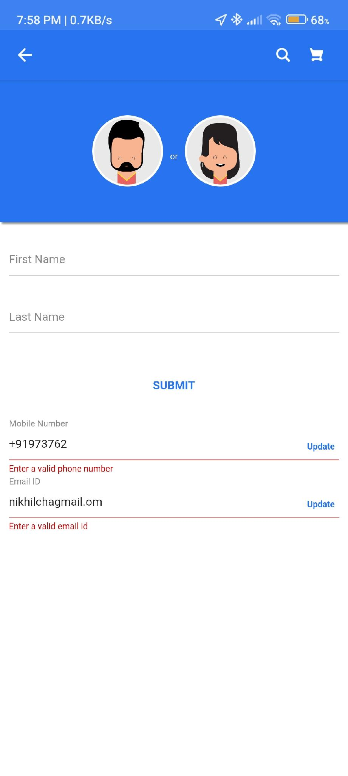
Figure: Edit Profile with Mobile and Email Validation Errors

Test Case ID | PROF-03
Module | Profile
Scenario | Verify partial validation (valid mobile, invalid email)
Preconditions | User on Edit Profile screen
Test Steps | 1. Enter valid mobile: +919737687242  2. Keep invalid email: nikhilchagmail.om
Expected Result | Mobile accepted; Email shows 'Enter a valid email id'
Actual Result | Mobile field valid; Email error persists
Status | PASS

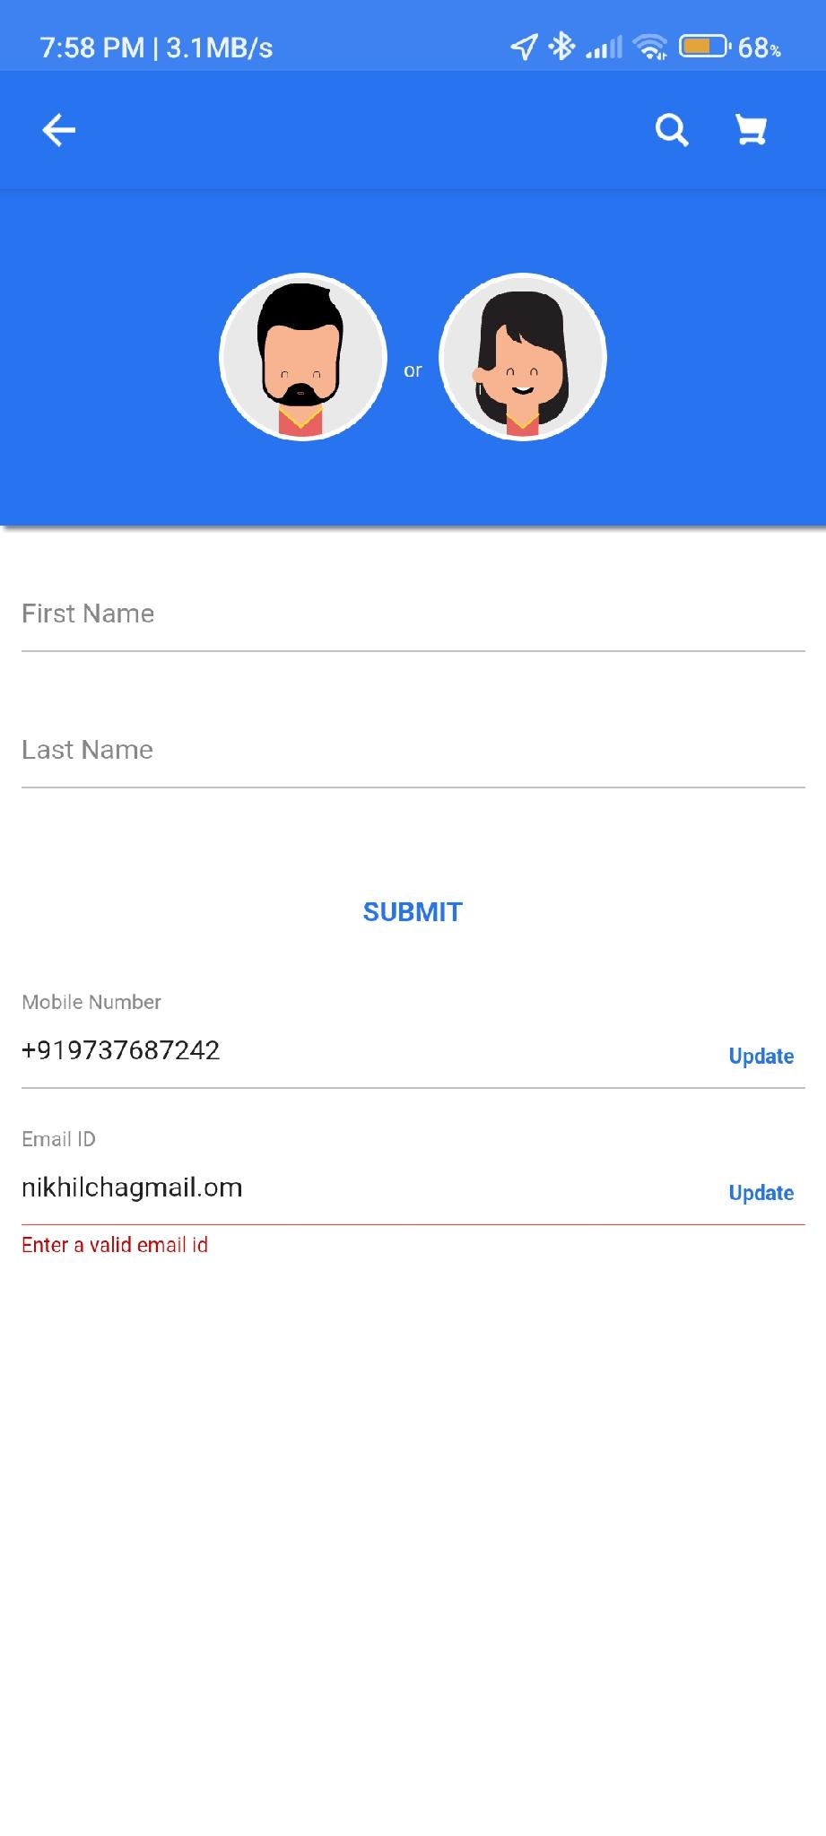
Figure: Edit Profile - Valid Mobile but Invalid Email

6. SECURITY TEST CASES

Test Case ID | Scenario | Expected Result | Actual Result | Status
SEC-01 | OTP required for login | 6-digit OTP mandatory | OTP screen enforced | PASS
SEC-02 | Incorrect OTP handling | Error without revealing correct OTP | Generic error shown | PASS
SEC-03 | Payment page security | '100% Secure' badge visible | Secure lock icon displayed | PASS
SEC-04 | Profile data validation | Invalid email/phone rejected | Validation errors shown | PASS

7. PERFORMANCE TEST CASES

Test Case ID | Scenario | Expected Result | Actual Result | Status
PERF-01 | App launch time | < 5 seconds | Launched within 3 seconds | PASS
PERF-02 | Search results loading | < 3 seconds | Results loaded with images | PASS
PERF-03 | Cart update | Instant reflection | Quantity and price updated | PASS
PERF-04 | Page transitions | Smooth navigation | No visible lag | PASS

8. SUMMARY OF TEST RESULTS

Module | Total Cases | Passed | Failed | Blocked
Authentication | 5 | 5 | 0 | 0
Home Page | 1 | 1 | 0 | 0
Product Search | 2 | 2 | 0 | 0
Cart | 2 | 2 | 0 | 0
Checkout & Address | 4 | 4 | 0 | 0
Payment | 1 | 1 | 0 | 0
Profile | 3 | 3 | 0 | 0
UI/UX | 7 | 7 | 0 | 0
Security | 4 | 4 | 0 | 0
Performance | 4 | 4 | 0 | 0
TOTAL | 33 | 33 | 0 | 0

Test Execution Summary: 33/33 Passed (100% Success Rate)

9. ISSUES FOUND

Issue ID | Severity | Description | Module | Screenshot Ref
BUG-01 | Low | Alternate phone number field accepts more than 10 digits before validation | Address | ADDR-02
BUG-02 | Low | Email validation accepts 'nikhilchagmail.om' (missing 'i') but flags it only on blur/submit | Profile | PROF-03
BUG-03 | Medium | 'No Active UPI Apps Found' message could include a CTA to install UPI apps | Payment | PAY-01

