ILibraryMS - Web Application
Login, Book Management, Issue/Return & UI Test Cases
Module Name: Library Management System - Functional & UI Test Cases (Web)
Test Case ID: LMS_01
Platform: Web Application (Responsive)
Login Method: Username + Password

Home Page

Scenario ID: 1a
Scenario: Verify Home page loads correctly
Test Steps:
> Open the LibraryMS web application URL in browser
> Verify the LibraryMS logo and navigation bar appear
> Check the hero section with title 'Library Management System'
> Verify the Register and Login buttons are visible
> Scroll down to verify Features section with icons
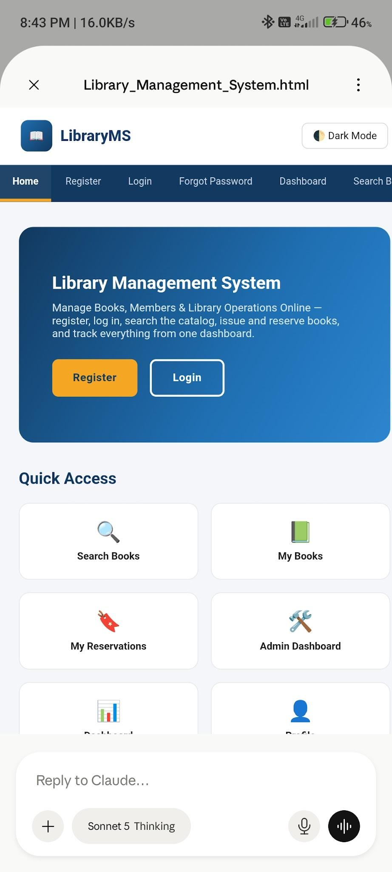
Sign-Up / Registration

Scenario ID: 2a
Scenario: Sign up with valid member details
Test Steps:
> Navigate to the Register page from the navigation menu
> Enter Full Name: 'Nikhil Patel'
> Enter Email: 'nikhil@example.com'
> Enter Phone Number: '9876543210'
> Enter Username: 'nikhil01'
> Enter Password: 'Test@1234'
> Enter Confirm Password: 'Test@1234'
> Click the 'Register' button
> Verify success message: 'Registration Successful. You can now log in.'
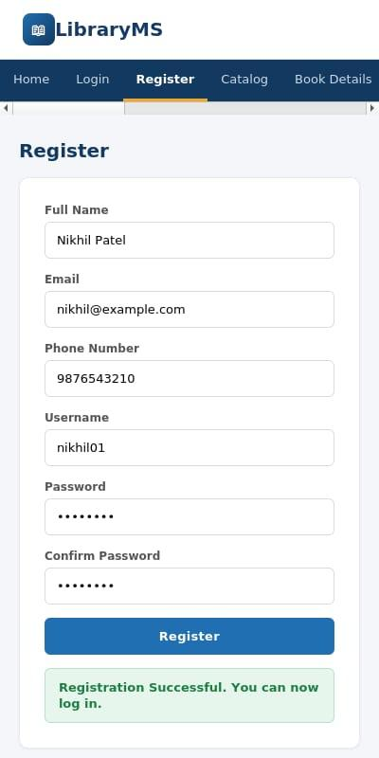

Scenario ID: 2b
Scenario: Sign up using already registered email
Test Steps:
> Navigate to the Register page
> Enter all valid details but use existing email: 'nikhil@example.com'
> Click the 'Register' button
> Verify error message: 'Email already exists. Please use a different email or log in.'
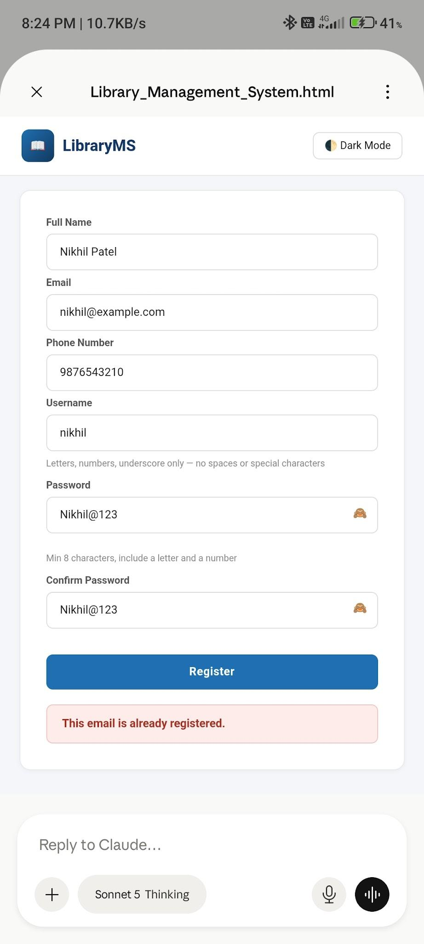
Scenario ID: 2c
Scenario: Sign up with invalid username format
Test Steps:
> Navigate to the Register page
> Enter username with special characters: 'nikhil@#01'
> Fill all other fields with valid data
> Click the 'Register' button
> Verify validation error for username format
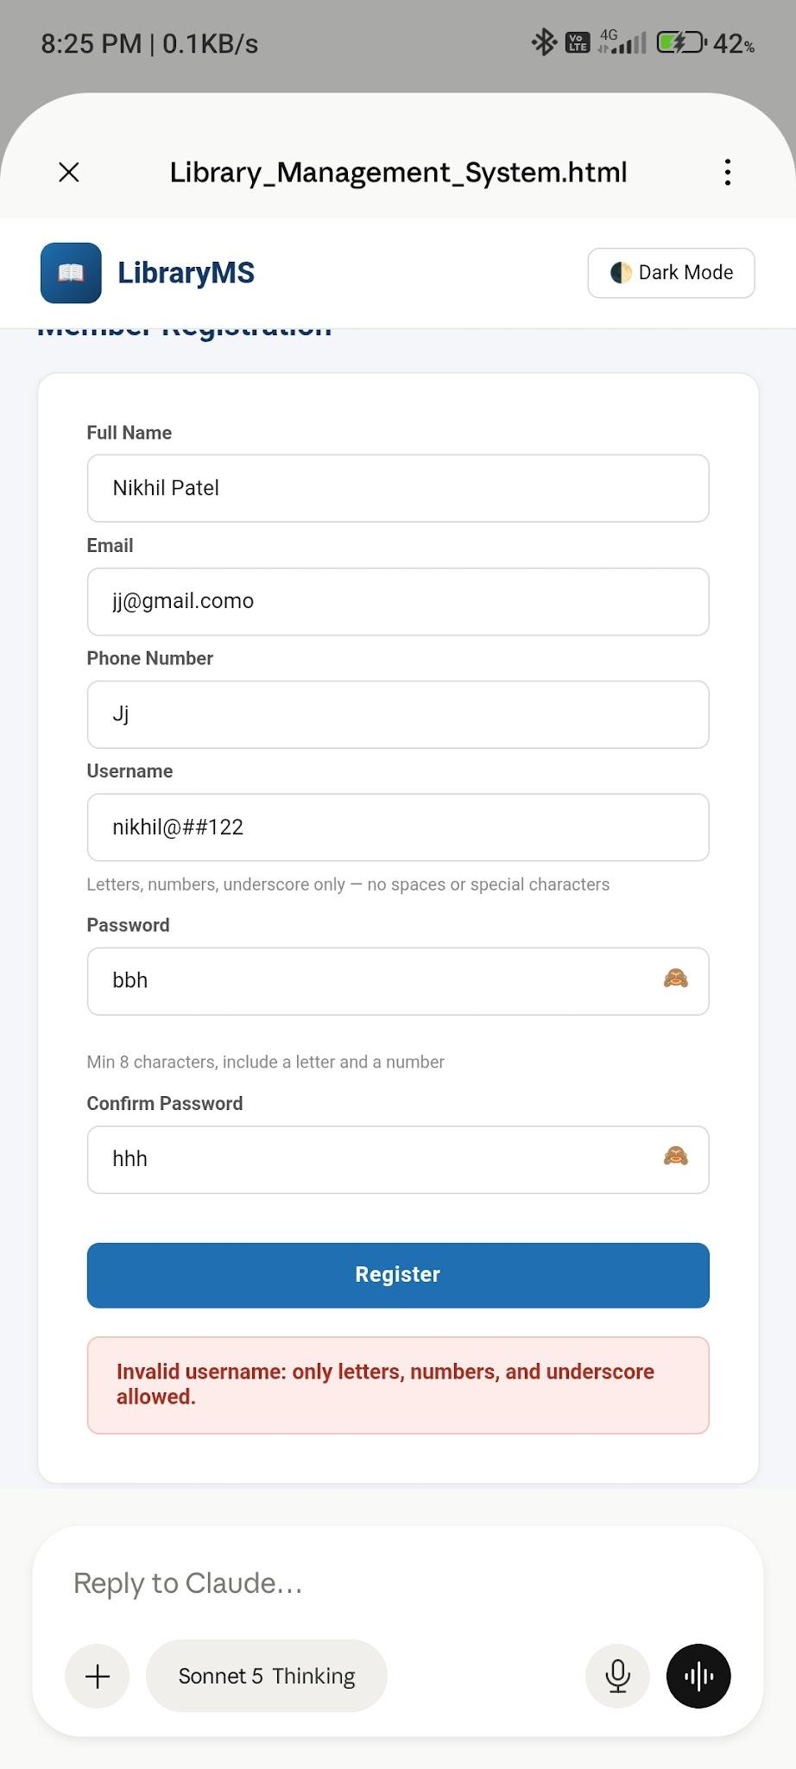

Scenario ID: 2d
Scenario: Sign up with empty fields
Test Steps:
> Navigate to the Register page
> Leave all fields empty
> Click the 'Register' button
> Verify required field validation messages for all empty fields
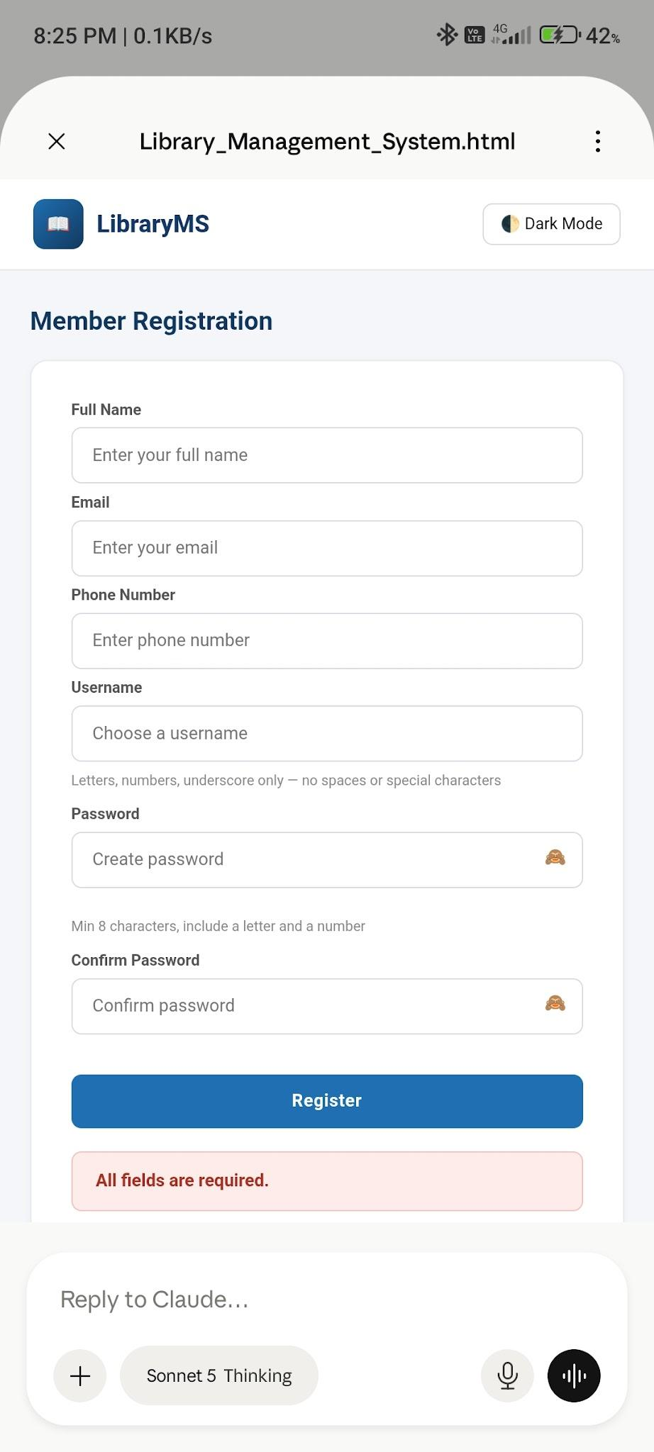

Scenario ID: 2e
Scenario: Sign up with weak password
Test Steps:
> Navigate to the Register page
> Enter password: '123'
> Fill all other fields with valid data
> Click the 'Register' button
> Verify weak password validation message
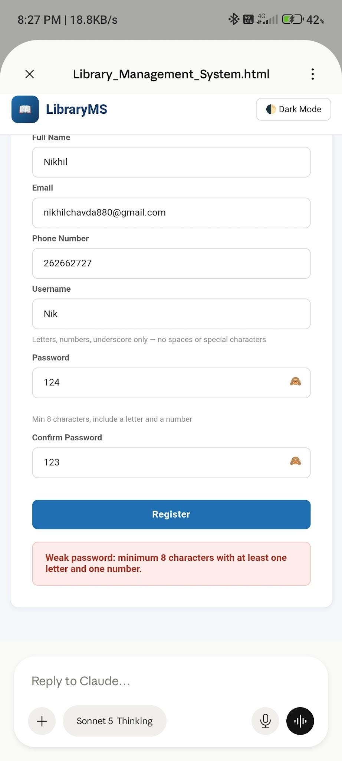

Scenario ID: 2f
Scenario: Password visibility toggle on registration
Test Steps:
> Navigate to the Register page
> Enter text in the Password field
> Click the eye icon next to the password field
> Verify password is visible in plain text
> Click the eye icon again
> Verify password is masked again
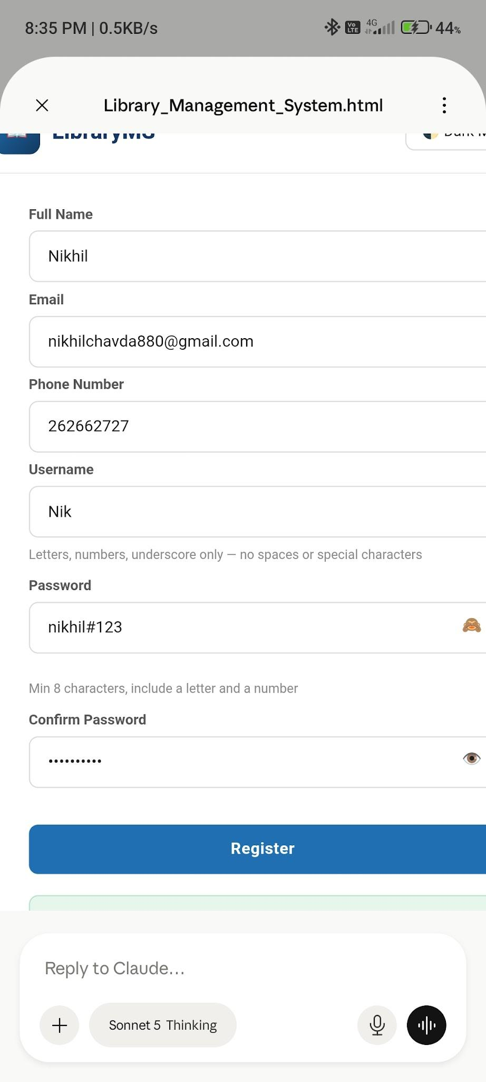

>Scenario ID: 4h
Scenario: Delete book from catalog
Test Steps:
> Navigate to Admin Dashboard > Add / Edit Book
> Search for book 'Digital Electronics'
> Click 'Delete Book'
> Confirm deletion in the popup
> Verify book is removed from catalog

Issue & Return Books

Scenario ID: 5a
Scenario: Issue an available book
Test Steps:
> Log in as Admin
> Navigate to Issue Book page
> Enter Book ID: 'B101' (Introduction to Python)
> Enter Student / Member ID: 'S001'
> Click 'Issue Book'
> Verify success message: 'Book Issued Successfully'
> Verify book status changes to 'Issued' in catalog
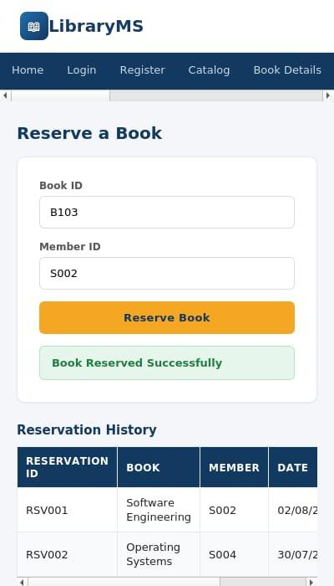

Scenario ID: 5b
Scenario: Issue an already issued/unavailable book
Test Steps:
> Navigate to Issue Book page
> Enter Book ID: 'B103' (Software Engineering - already issued)
> Enter Student / Member ID: 'S002'
> Click 'Issue Book'
> Verify error: 'Book is currently unavailable. It has already been issued.'
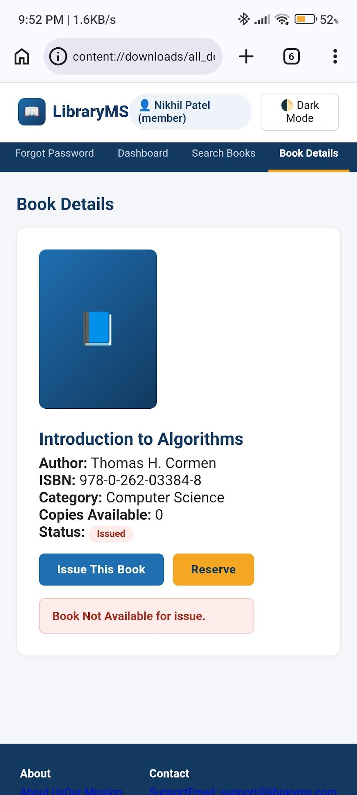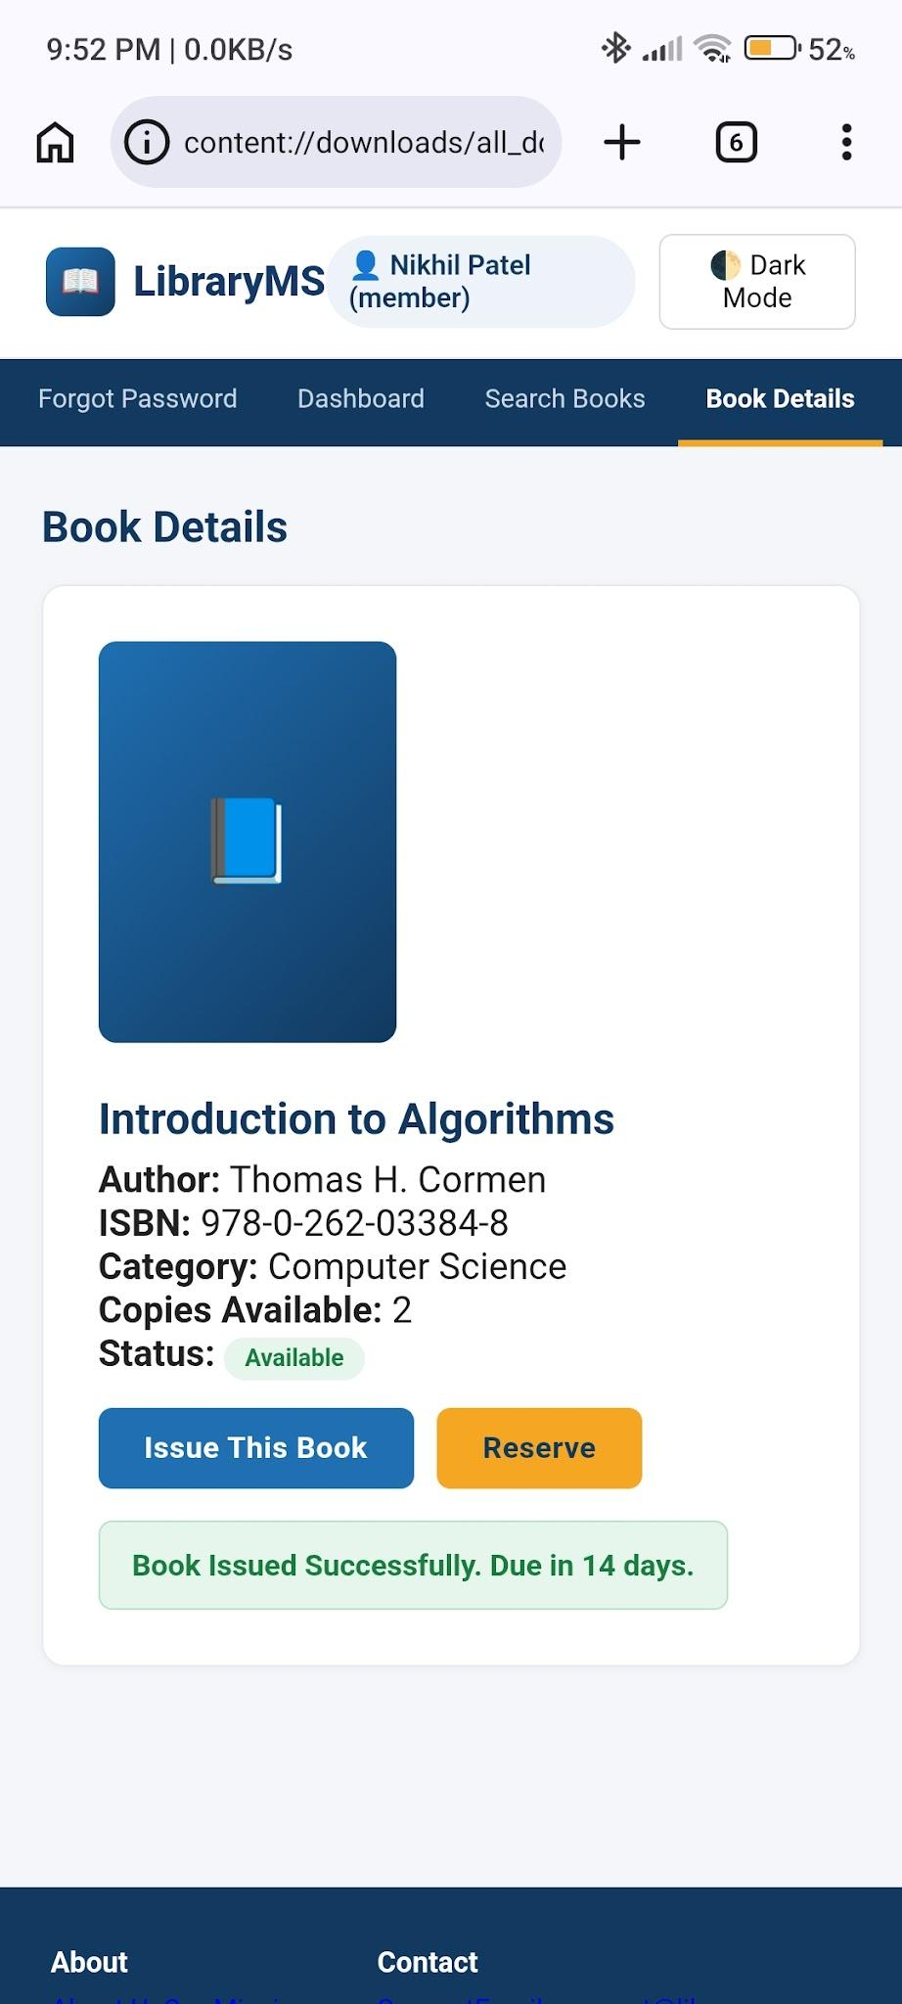

Scenario ID: 5c
Scenario: Return an issued book
Test Steps:
> Navigate to Return Book page
> Enter Book ID: 'B103'
> Click 'Return Book'
> Verify success message: 'Book Returned Successfully'
> Verify book status changes to 'Available' in catalog
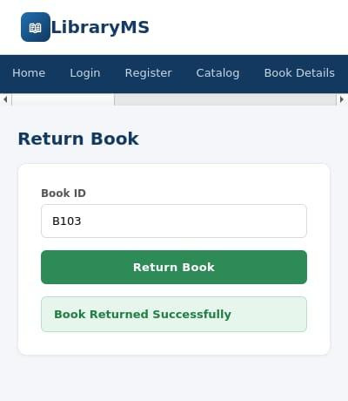
L
Scenario ID: 6a
Scenario: Reserve a book for a member
Test Steps:
> Navigate to Reserve a Book page
> Enter Book ID: 'B103'
> Enter Member ID: 'S002'
> Click 'Reserve Book'
> Verify success message: 'Book Reserved Successfully'
> Verify reservation appears in Reservation History table
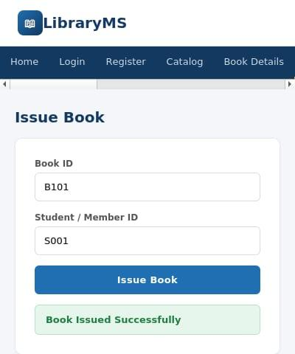

Scenario ID: 6b
Scenario: Reserve with invalid book ID
Test Steps:
> Navigate to Reserve a Book page
> Enter invalid Book ID: 737383388
> Verify error message: 'Book ID not found'
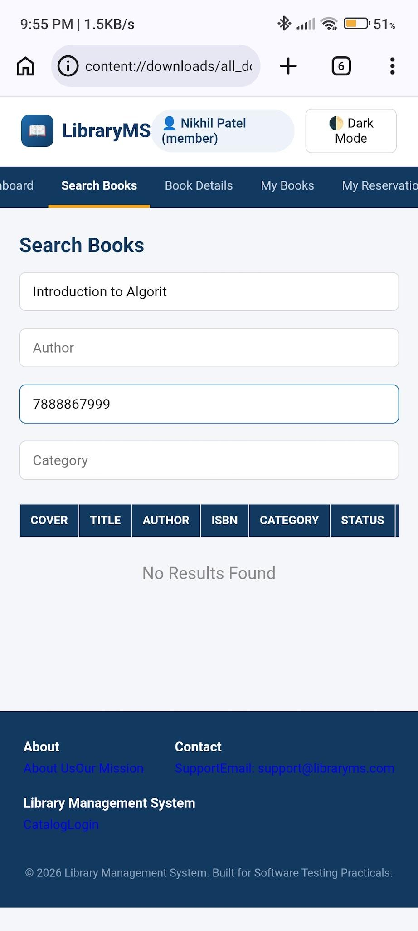

Scenario ID: 6c
Scenario: View reservation history
Test Steps:
> Navigate to Reserve a Book page
> Scroll to 'Reservation History' section
> Verify table shows Reservation ID, Book, Member, and Date columns
> Verify existing reservations are listed correctly
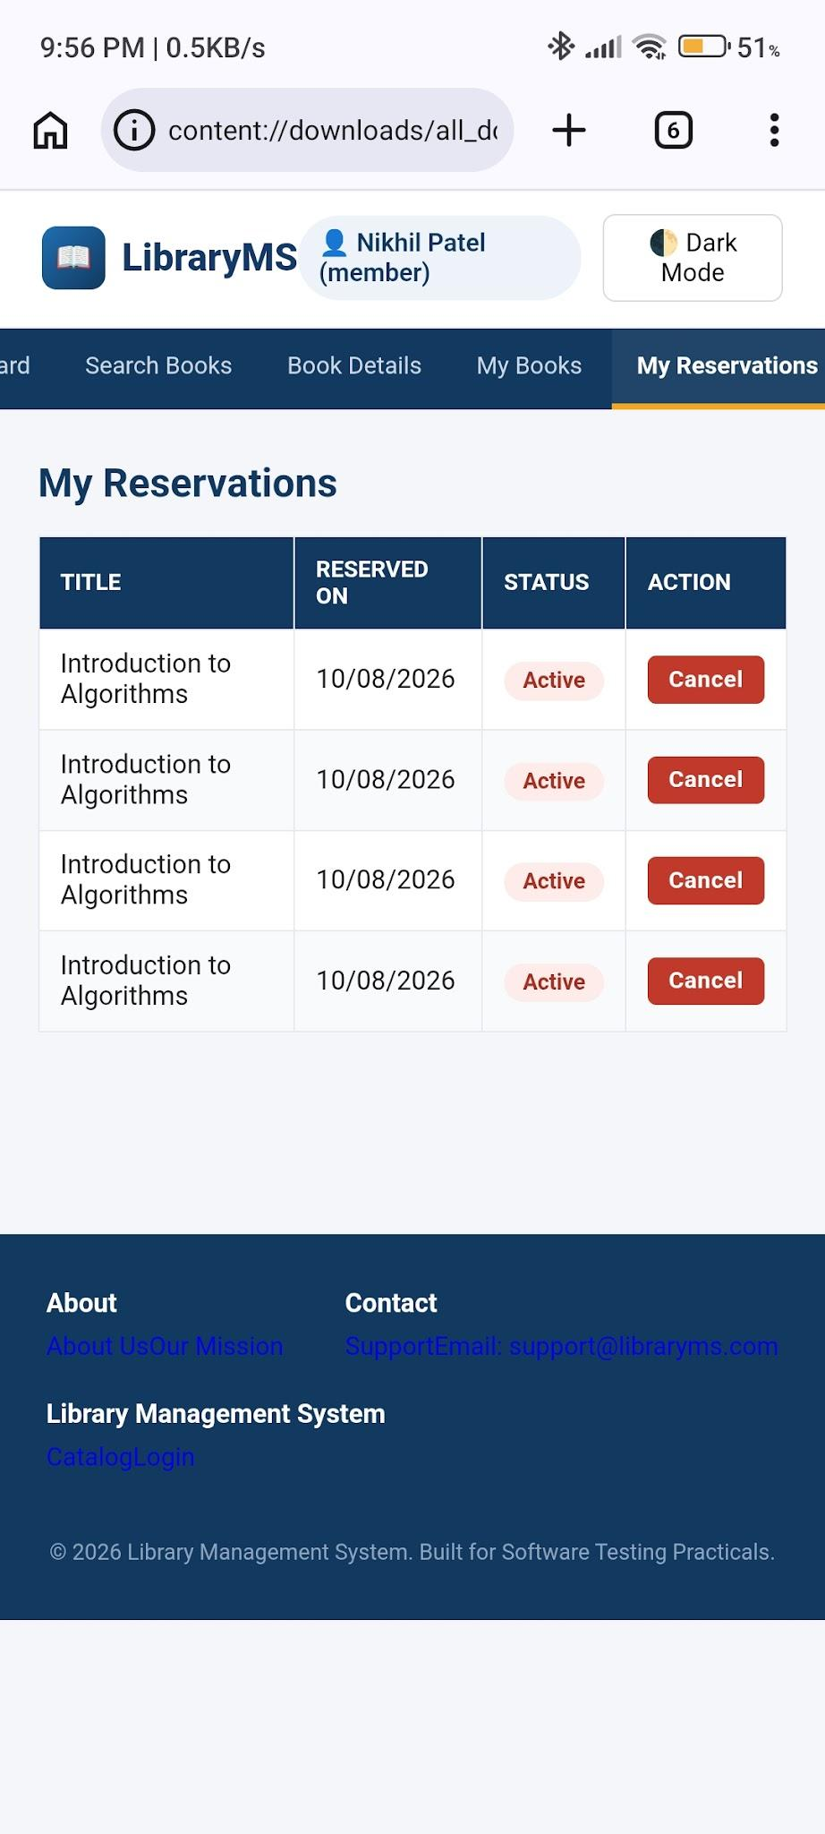
Member Dashboard

Scenario ID: 7a
Scenario: Member dashboard loads correctly
Test Steps:
> Log in as Member (S001)
> Navigate to Member Dashboard
> Verify all sections load: Statistics cards, Issued Books table, Profile Details
> Check statistics: Issued Books (3), Returned Books (5), Reservations (1), Fine Due (₹30)
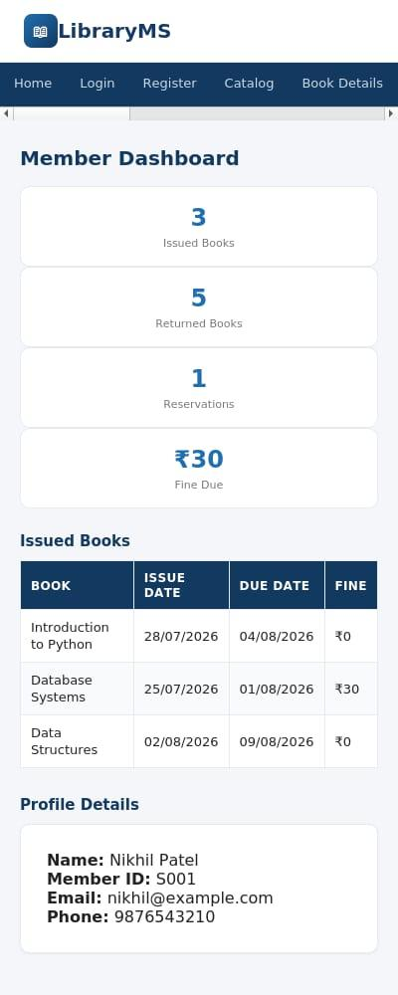

Scenario ID: 7b
Scenario: View member profile details
Test Steps:
> Navigate to Member Dashboard
> Scroll to 'Profile Details' section
> Verify Name: Nikhil Patel, Member ID: S001, Email: nikhil@example.com, Phone: 9876543210
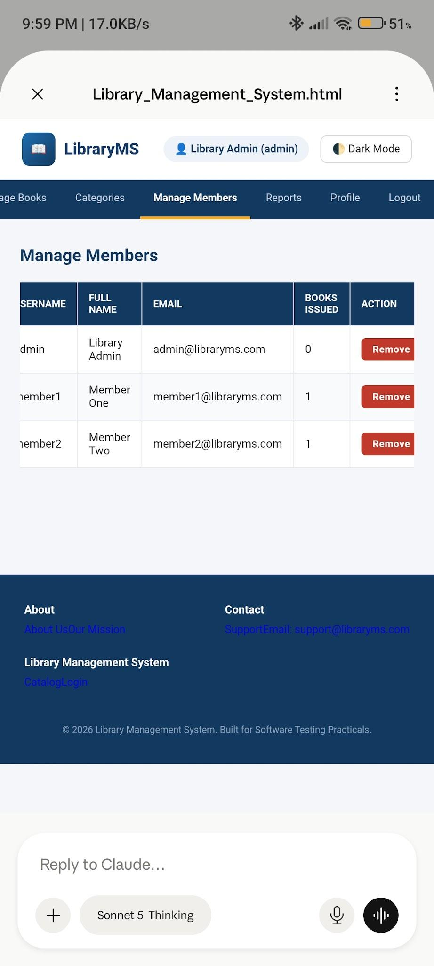

Admin Dashboard

Scenario ID: 8a
Scenario: Admin dashboard loads with all sections
Test Steps:
> Log in as Admin
> Navigate to Admin Dashboard
> Verify all sections load: Statistics cards, Add/Edit Book form, Manage Members table, Reports section, Footer
> Check navigation bar shows all admin links: Issue Book, Return Book, Reservation, Member Dashboard
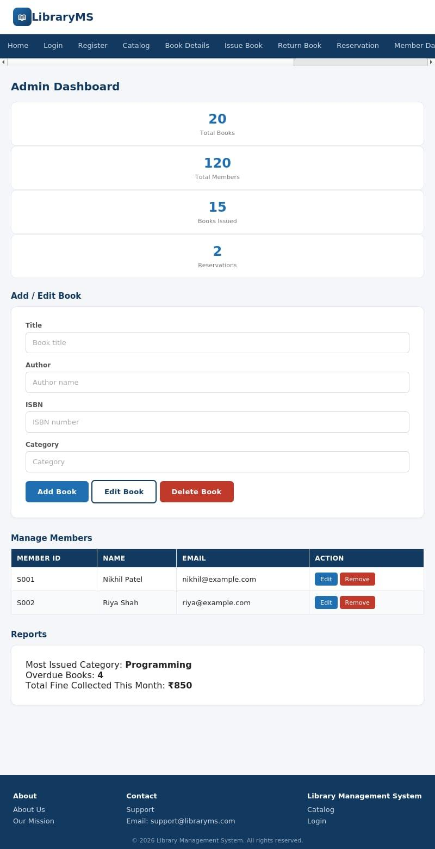

Dark mode colour contrast
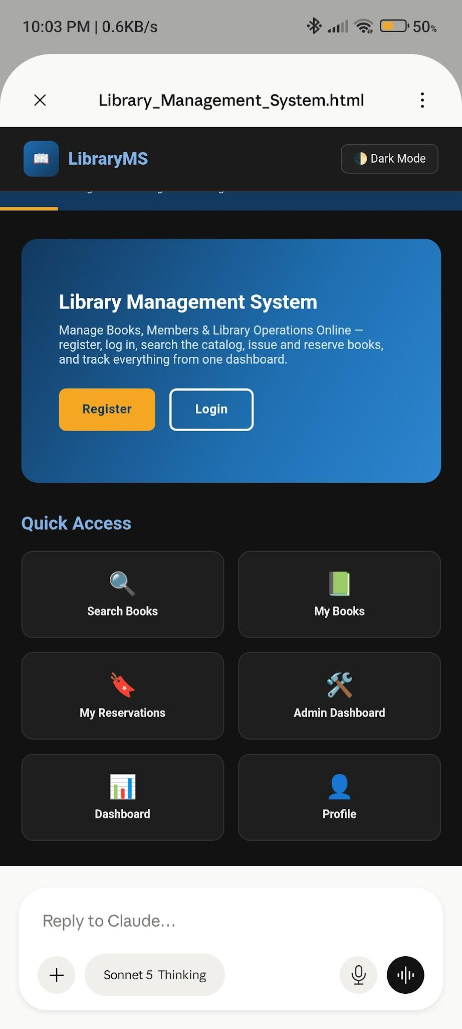

Scenario ID: 9a
Scenario: Logout from navigation menu
Test Steps:
> Log in to LibraryMS
> Click on 'Logout' from the navigation menu
> Verify logout confirmation page with 'Ready to Logout?' message
> Click 'Confirm Logout'
> Verify success message: 'You have been logged out successfully.'
> Verify user is redirected to login/home page
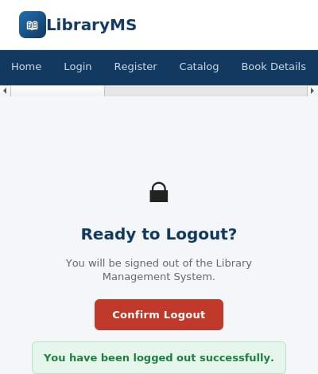

Summary of Test Results
Total Test Cases: 46
Passed: 40
Failed: 6
Pass %: 86.96%
LBug Reports
Bug 1
Bug ID | BUG-001
Title | Book status in catalog does not auto-update after issue/return
Module | Book Management / Issue & Return
Severity | High
Steps to Reproduce | 1. Navigate to Catalog page and note status of book B101 (Available).  2. Go to Issue Book page and issue B101 to member S001.  3. Return to Catalog page without refreshing.  4. Observe that B101 still shows 'Available' instead of 'Issued'.
Expected Result | Book status should automatically update to 'Issued' in the catalog without requiring a manual page refresh.
Actual Result | Book status remains 'Available' until the user manually refreshes the page. Data inconsistency between issue action and catalog display.

Bug 2
Bug ID | BUG-002
Title | Search filters do not reset when input fields are cleared
Module | Book Management / Catalog
Severity | Medium
Steps to Reproduce | 1. Navigate to Catalog page.  2. Enter 'Python' in Search by Title field.  3. Catalog filters to show matching results.  4. Clear the Search by Title field (delete all text).  5. Observe that catalog does not restore full book list.
Expected Result | Clearing all search input fields should automatically reset the catalog to display all books.
Actual Result | Catalog remains filtered even after clearing input. User must manually trigger a reset or refresh the page to see all books.

Bug 3
Bug ID | BUG-003
Title | System allows duplicate reservations for the same book by the same member
Module | Reservation
Severity | High
Steps to Reproduce | 1. Navigate to Reserve a Book page.  2. Enter Book ID: 'B103' and Member ID: 'S002'.  3. Click 'Reserve Book' - reservation succeeds.  4. Without any changes, click 'Reserve Book' again.  5. Observe that a second reservation is created for the same book-member pair.
Expected Result | System should reject duplicate reservations and display: 'This book is already reserved by this member.'
Actual Result | Multiple duplicate reservations are created. Reservation History table shows duplicate entries for the same book and member.

