CAPSTONE FINAL REPORT
(Sprint – 1)

Project Title : Fracto - Doctor Appointment Booking System
Student Name : Nikhil Kumar Sahu
Date : 16 March 2026
Instructor Details : Mr. Ramesh Nediyadath
Batch Name : WIPRO NGA - .Net Full Stack Angular - FY26 - C4

Table of Contents :
Problem Definition and Objectives
Frontend & Backend Architecture
Database Design & Storage Optimization
Admin Login & CRUD Operations
User Registration & Login Operations
Angular Front-End Template & Structure
Code Sanitization - Components, Services & Modules
CRUD Functionalities - Admin & User
Advanced Features -Ratings & Real-Time Notifications
Responsiveness & Client-Side Validation
Session Handling
Angular–Backend Integration & JWT Security
Testing -Component & End-to-End
GitHub Repository & Version Control

1. Problem Definition and Objectives:
In India, patients face significant friction when trying to book appointments with specialist doctors. The process is manual, phone-based, and error-prone leading to double bookings, missed appointments, and no visibility into appointment status.
Objectives:
- Build a full-stack web application that allows patients to browse doctors, view specializations, and book time-slot-based appointments online.
- Provide an Admin panel with complete control over doctors, users, appointments, and specializations.
- Implement secure authentication using JWT tokens and salted password hashing (via ASP.NET Core Identity IPasswordHasher) so that users and admins have role-based access control.
- Deliver real-time notifications to users (appointment approved/cancelled) and admins (new booking) via SignalR WebSockets.
- Enable users to rate and review doctors after completing an appointment.

2. Frontend & Backend Architecture
Technology Stack
Layer | Technology
Frontend | Angular 18 (standalone components, signals)
Backend | ASP.NET Core 8 Web API
Database | Microsoft SQL Server (via EF Core 8)
Authentication | JWT Bearer Tokens
Real-Time | SignalR (WebSockets)
ORM | Entity Framework Core 8 (Code-First)
Styling | Styling: Tailwind CSS (utility-first), responsive layout using flexbox and CSS grid

System Architecture Diagram
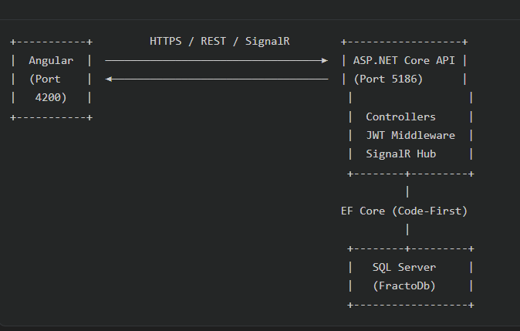

API Overview
The backend exposes the following route groups:

Route Prefix | Purpose | Auth Required
POST /api/auth/register | User Registration | No
POST /api/auth/login | User Login | No
GET /api/auth/me | Get Current user profile | JWT
GET /api/doctors | Browse all doctors | No
GET /api/doctors/{id}/available-slots | Get available time slots | No
GET /api/appointments/my | My appointments | JWT (User)
POST /api/appointments | Book appointment | JWT (User)
DELETE /api/appointments/{id} | Cancel appointment | JWT (User)
GET /api/ratings | Doctor ratings | No
POST /api/ratings | Submit a rating | JWT (User)
GET /api/admin/stats | Dashboard stats | JWT (Admin)
GET/POST/PUT/DELETE /api/admin/users | Manage users | JWT (Admin)
GET/POST/PUT/DELETE /api/admin/doctors | Manage doctors | JWT (Admin)
GET /api/admin/appointments | All appointments | JWT (Admin)
PUT /api/admin/appointments/{id}/approve | Approve appointment | JWT (Admin)
PUT /api/admin/appointments/{id}/complete | Mark Complete | JWT (Admin)
PUT /api/admin/appointments/{id}/cancel | Cancel appointment | JWT (Admin)
/hubs/notifications | Real-time SignalR hub | JWT

3. Database Design & Storage Optimization

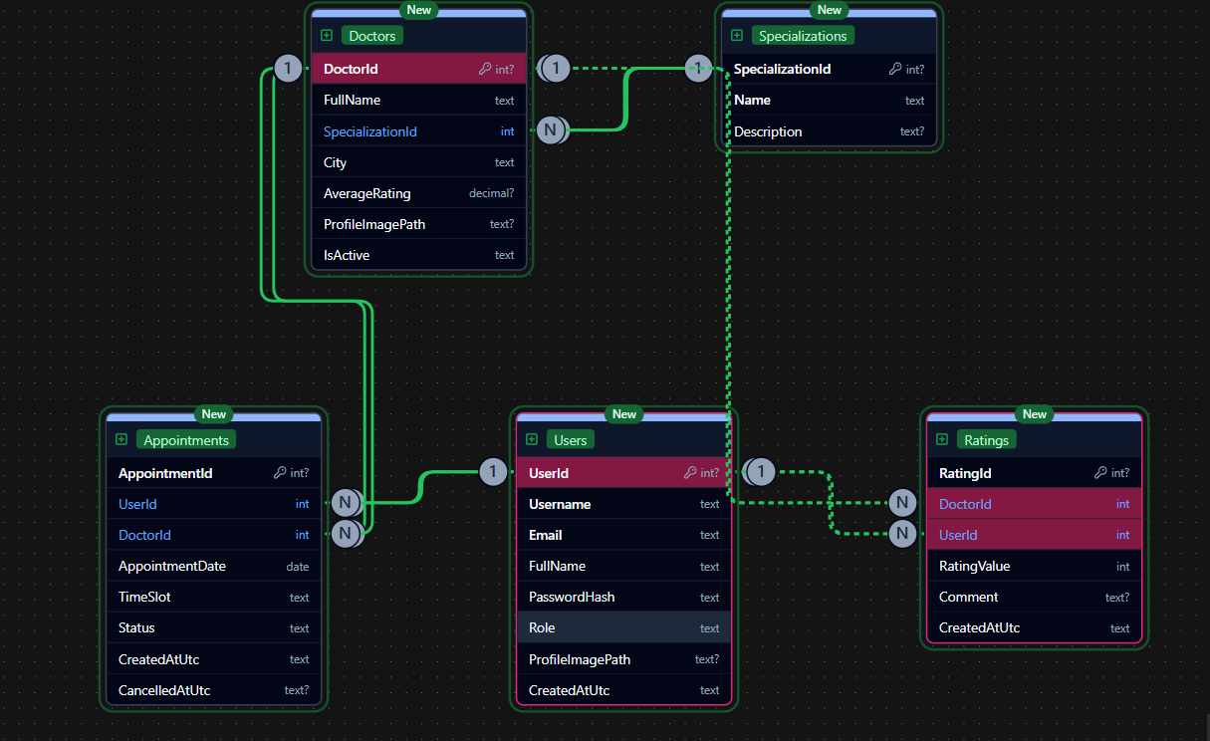
Tables and Relationships
Users Table
- Primary Key: Id (auto-increment int)
- Stores: username, email, full name, bcrypt-hashed password, role (enum: User=1, Admin=2), optional profile image path, and UTC creation timestamp
- Relationships: One user has many Appointments and many Ratings
Doctors Table
- Primary Key: Id (auto-increment int)
- Foreign Key: SpecializationId → Specializations.Id
- Stores: full name, city, computed average rating, optional profile image, and an IsActive flag for soft-deactivation
- Relationships: One doctor belongs to one Specialization; has many Appointments and Ratings
Specializations Table
- Primary Key: Id (auto-increment int)
- Stores: name (e.g., "Cardiologist") and description
- Relationship: One specialization has many Doctors
Appointments Table
- Primary Key: Id (auto-increment int)
- Foreign Keys: UserId → Users.Id; DoctorId → Doctors.Id
- Stores: appointment date (DateOnly), time slot string (e.g., "10:00–10:30"), status enum (Booked=1/Approved=2/Completed=3/Cancelled=4), created and cancelled timestamps
Ratings Table
- Primary Key: Id (auto-increment int)
- Foreign Keys: UserId → Users.Id; DoctorId → Doctors.Id
- Stores: rating value (1–5), optional comment, timestamp
- Business Rule: A user can only rate a doctor after having a non-cancelled appointment

Code - Entity Models
1.User.cs
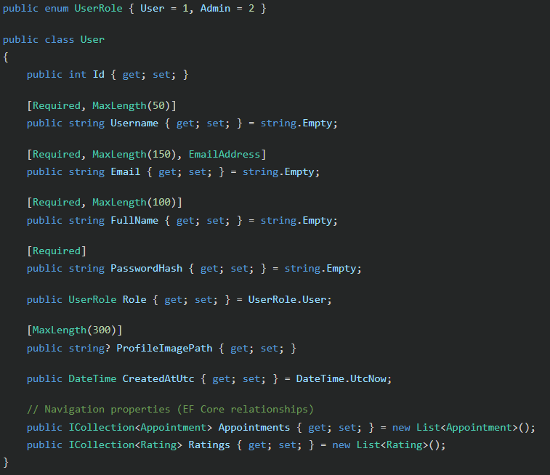

2.Doctor.cs
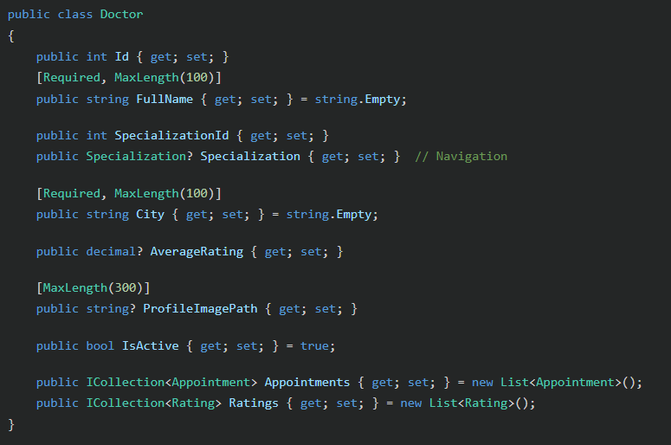
3.Appointment.cs
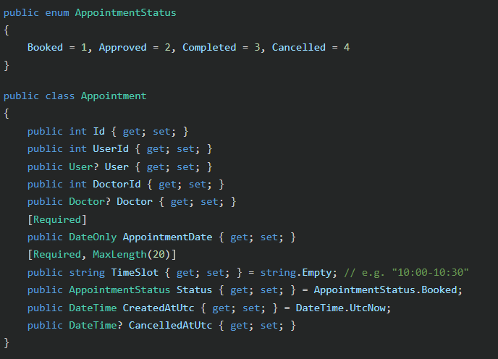

Database Seeding (Program.cs)
On application startup, the database is automatically seeded with:
- Default Admin: username nikhil11012, email nikhil11012@gmail.com, password hashed using ASP.NET Identity PasswordHasher
- Specializations: Cardiologist, Dermatologist, Neurologist, Orthopedic etc.
- Sample Doctors: Dr. A. Sharma (Delhi), Dr. B. Verma (Mumbai), Dr. C. Gupta (Delhi), Dr. D. Iyer (Bengaluru), Dr. E. Khan (Kolkata) etc.

Optimization Techniques
- AsNoTracking() is used on all read-only queries to avoid EF Core change tracking overhead.
- Selective column projections (.Select(u => new { u.Id, u.Username, ... })) avoid fetching the PasswordHash column in admin user listings.
- Eager loading (Include) is used only when navigation properties are needed (e.g., doctor's specialization name in appointment listings).
- AnyAsync() is used for existence checks (duplicate username/email, slot conflict) instead of fetching full entities.

4. Admin Login & CRUD Operations
Admin Authentication
The admin account is seeded at startup. Admin login uses the same /api/auth/login endpoint. The difference is in the JWT token. when an admin logs in, their token contains ClaimTypes.Role = "Admin". All admin controllers are decorated with [Authorize(Roles = "Admin")], so the backend enforces role-based access automatically.
Code - AuthController (Login & Register)
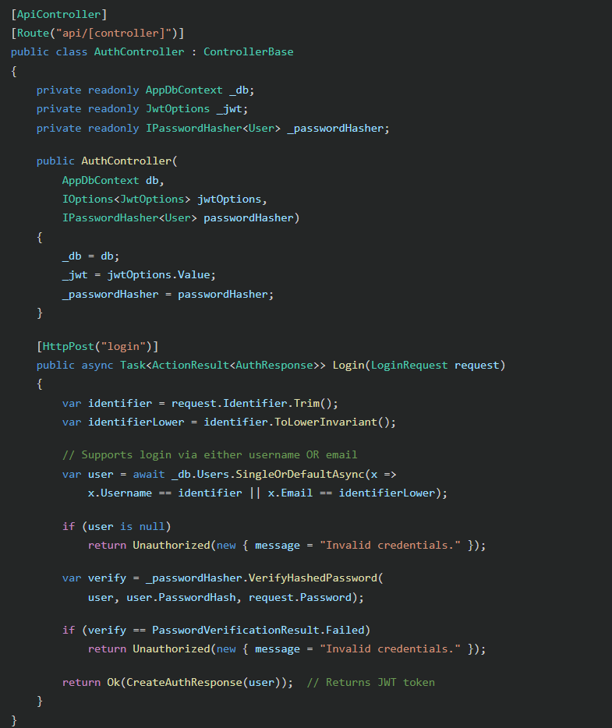
Explanation: The login method accepts either a username or email as the identifier, trims whitespace, checks if the user exists, then uses ASP.NET Identity's PasswordHasher.VerifyHashedPassword() to safely compare the hashed password, no plain-text comparison ever occurs.

Code - Admin Dashboard Stats
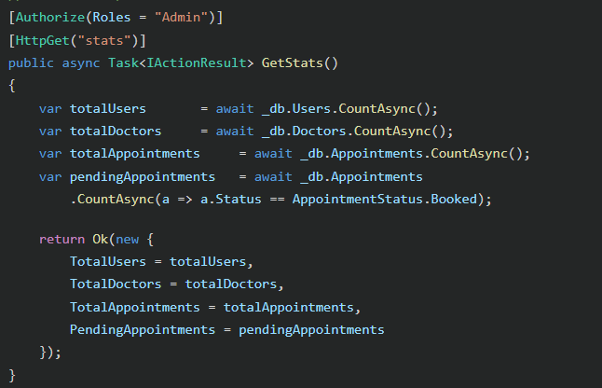

5. User Registration & Login Operations
Registration Flow
- User submits { username, email, fullName, password } to POST /api/auth/register
- Backend checks if username or email already exists (returns 400 Bad Request if so)
- Password is hashed using IPasswordHasher<User> (BCrypt-based, salted)
- User is saved to the database with Role = UserRole.User
- A JWT token is immediately returned, logging the user in right after registration
Code – Register Endpoint
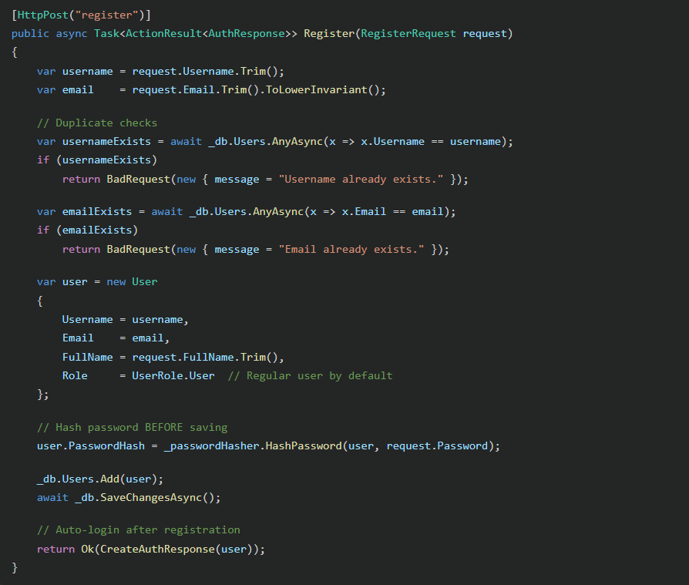

JWT Token Generation
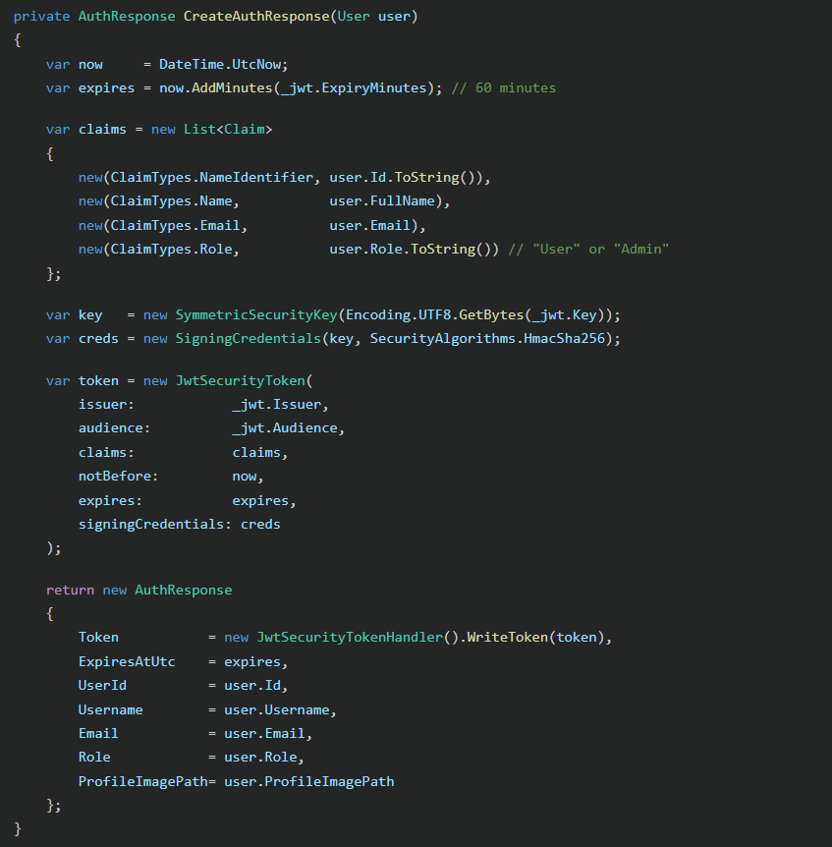

Explanation: The JWT contains four claims: the user's database ID (used to look up ownership for appointments/ratings), full name, email, and role. The role claim is what ASP.NET Core uses to enforce [Authorize(Roles = "Admin")] on protected endpoints. The token is signed with HMAC-SHA256, making it tamper-evident.

6. Angular Front - End Template & Structure
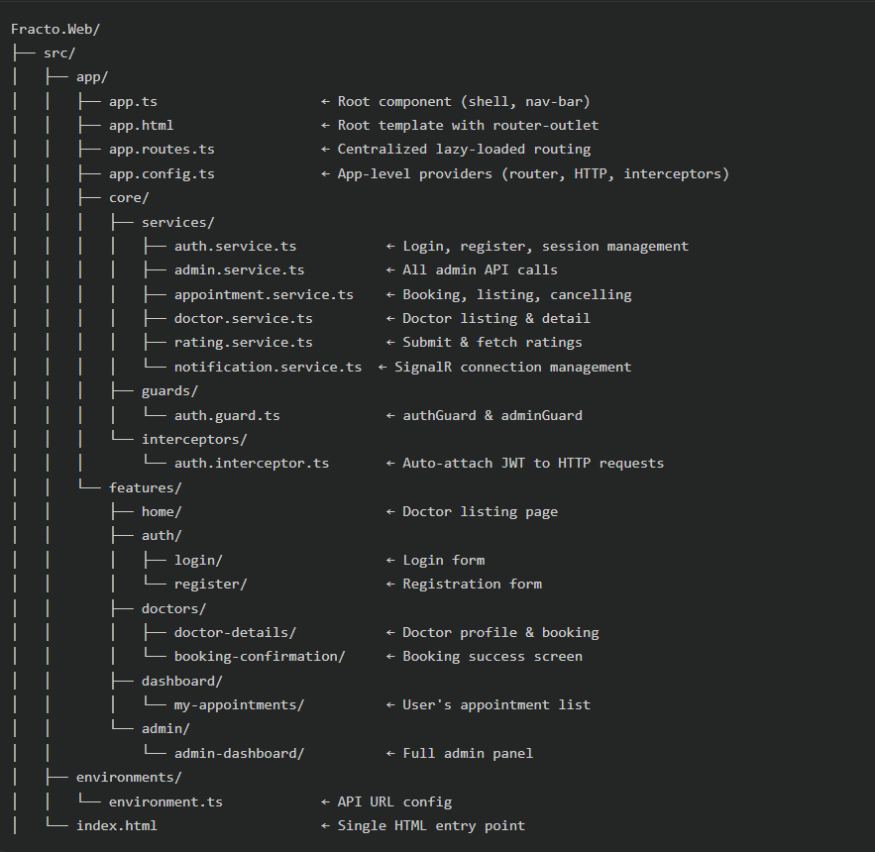

Core Routing (app.routes.ts)
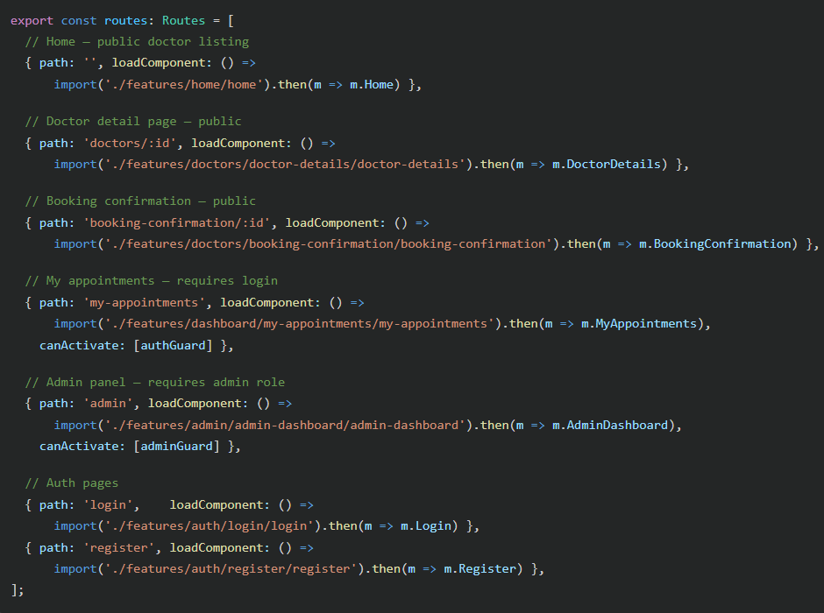

Explanation: All routes use Angular's loadComponent() for lazy loading - meaning each feature's code is only downloaded when the user navigates to that route. This significantly reduces the initial bundle size and improves startup performance.

App Config (app.config.ts)

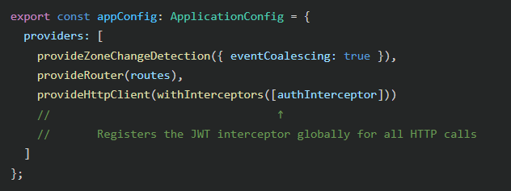

7. Code Sanitization - Components, Services & Modules
Architecture Principles Followed
The project follows Angular's recommended feature + core folder pattern:
- core/ — Application-wide singletons only (services, guards, interceptors). Never imports from features/.
- features/ — Each feature (auth, admin, doctors, dashboard) is self-contained with its own component, template, and styles.
- Standalone Components — Angular 18's standalone API is used throughout; there are no NgModule declarations. Each component declares its own imports in the @Component decorator.

Services (core/services)

Service | Responsibility
AuthService | Login, register, logout, session restore, profile image upload
AdminService | All admin API calls: users, doctors, appointments, specializations, stats
AppointmentService | Book, list, cancel appointments; fetch available slots
DoctorService | List doctors with filters, fetch single doctor detail
RatingService | Submit and fetch doctor ratings
NotificationService | Manage the SignalR WebSocket connection and notification state

All services are providedIn: 'root' meaning they are application-wide singletons, created once and destroyed when the app closes.

Guards (core/guards/auth.guard.ts)
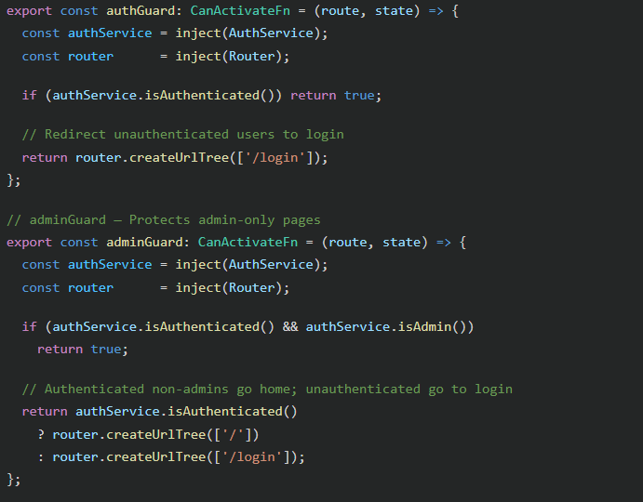

Explanation: Two guards are defined in one file: authGuard blocks unauthenticated users from protected routes (like /my-appointments), while adminGuard additionally checks the user's role (stored in sessionStorage) before allowing access to /admin.

Interceptor (core/interceptors/auth.interceptor.ts)

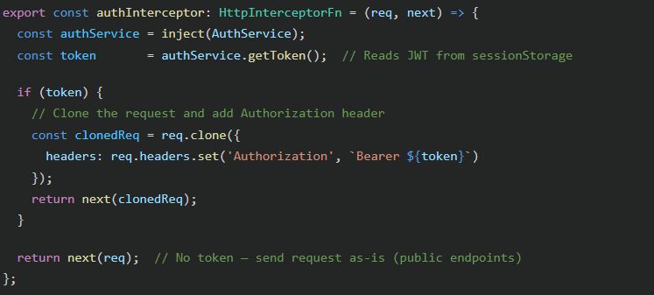
Explanation: The HTTP interceptor intercepts every outgoing HTTP request. If a JWT token is present in session storage, it clones the request and adds the Authorization: Bearer <token> header before forwarding the request. This replaces the need to manually attach headers in every service method.

8. CRUD Functionalities - Admin & User
Admin: Doctor Management (Full CRUD)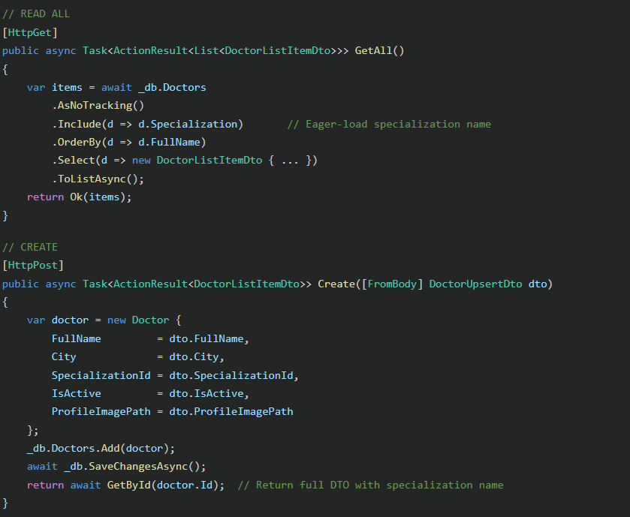
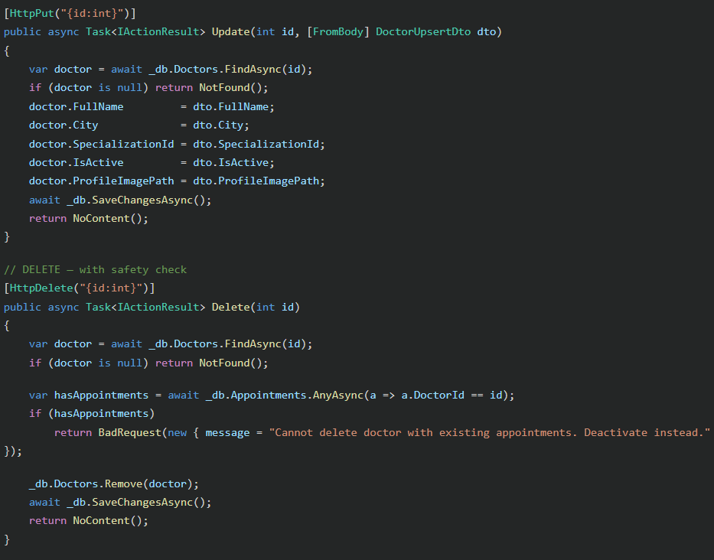

Admin: User Management (CRUD)
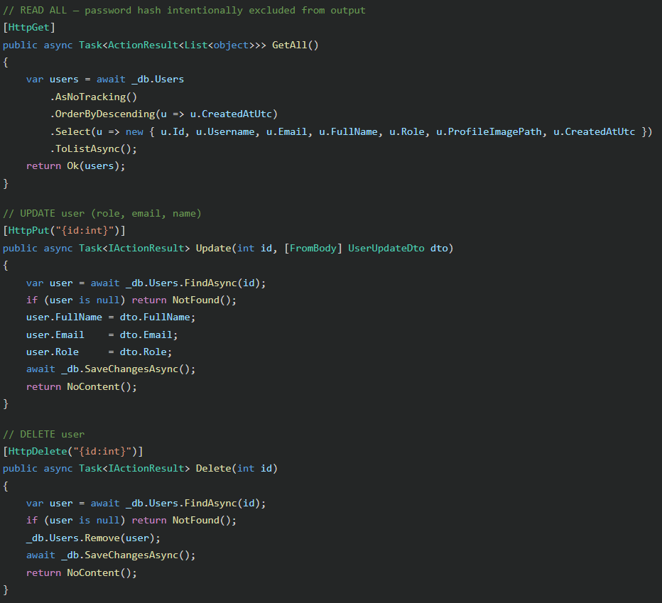

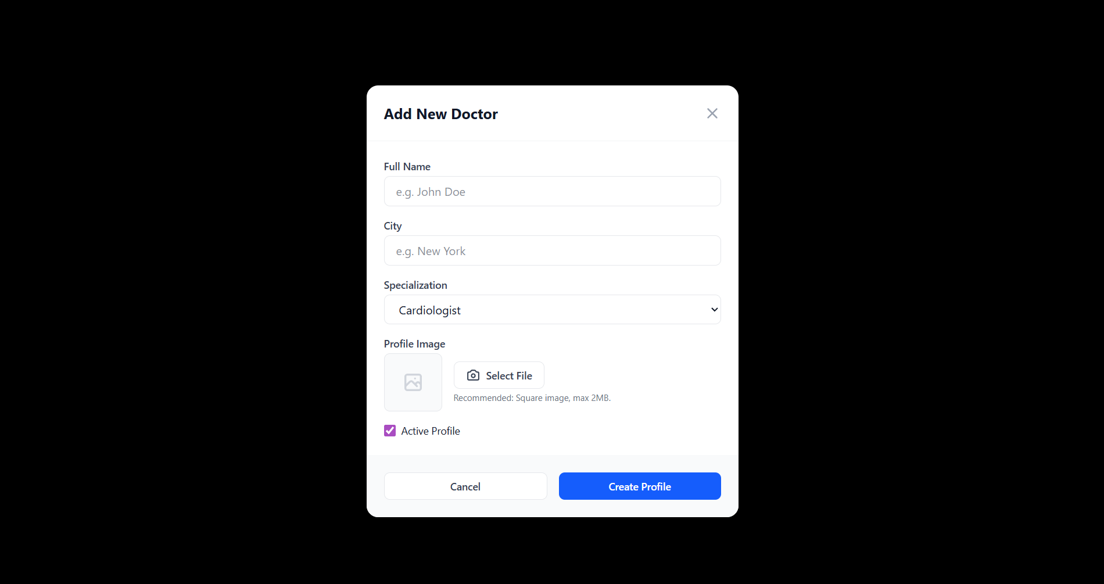
Admin: Appointment Management (Approve / Complete / Cancel)

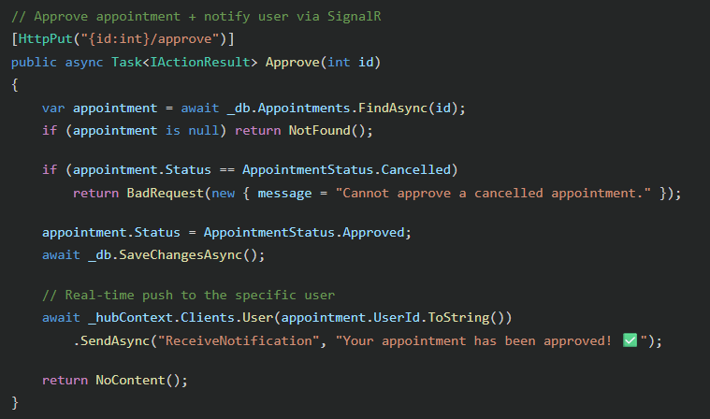

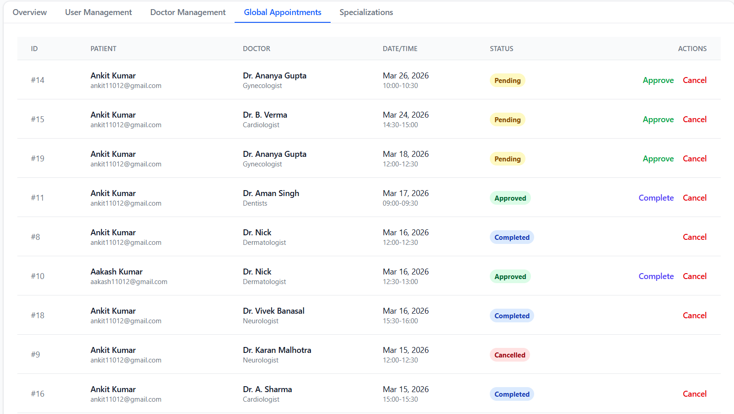

User: Book & Cancel Appointments
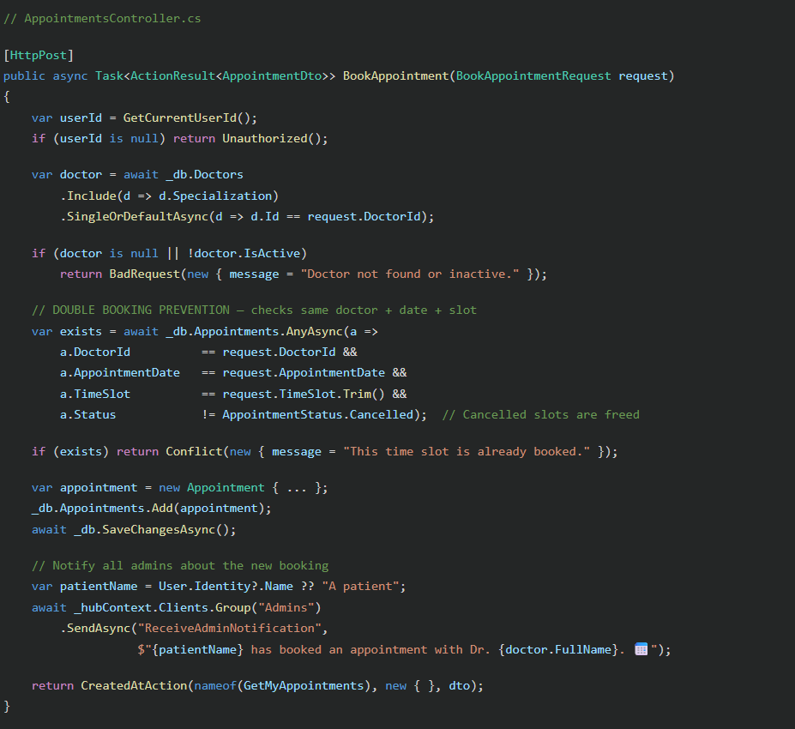

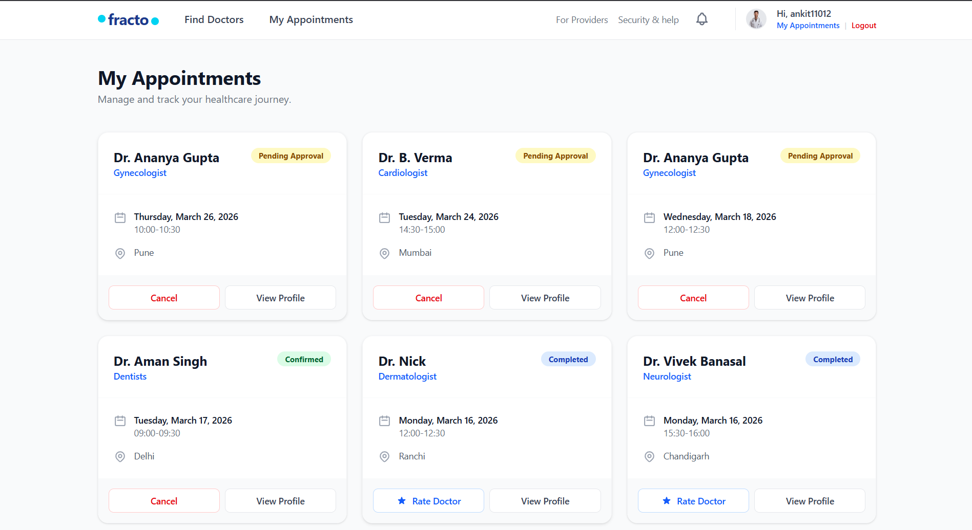
9. Advanced Features - Ratings & Real-Time Notifications
Feature 1: Doctor Ratings & Reviews
The ratings system enforces the business rule that a user can only rate a doctor after having a non-cancelled appointment with them.

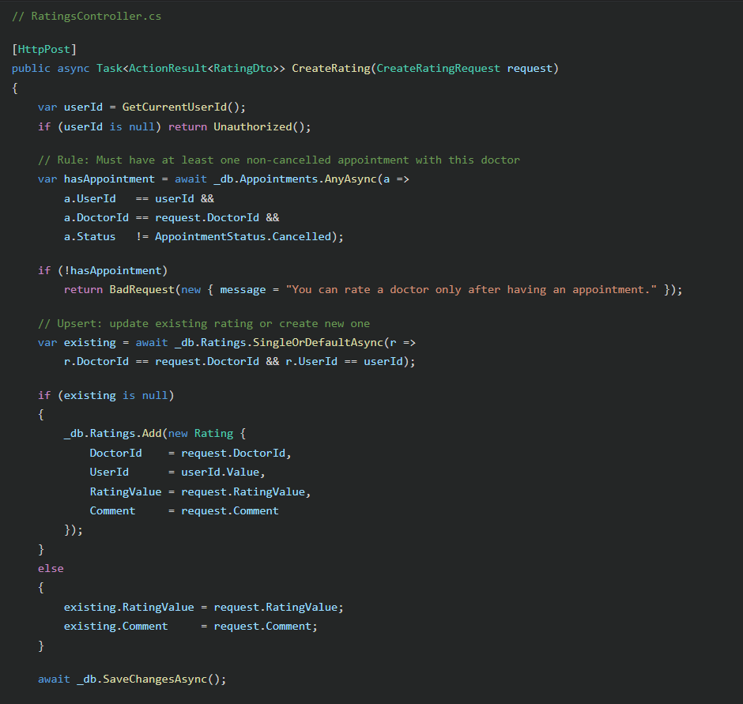
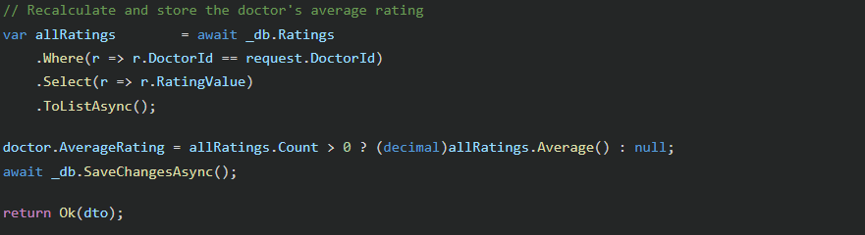
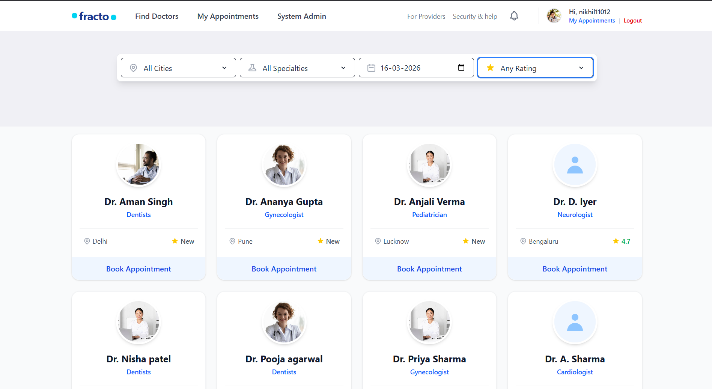

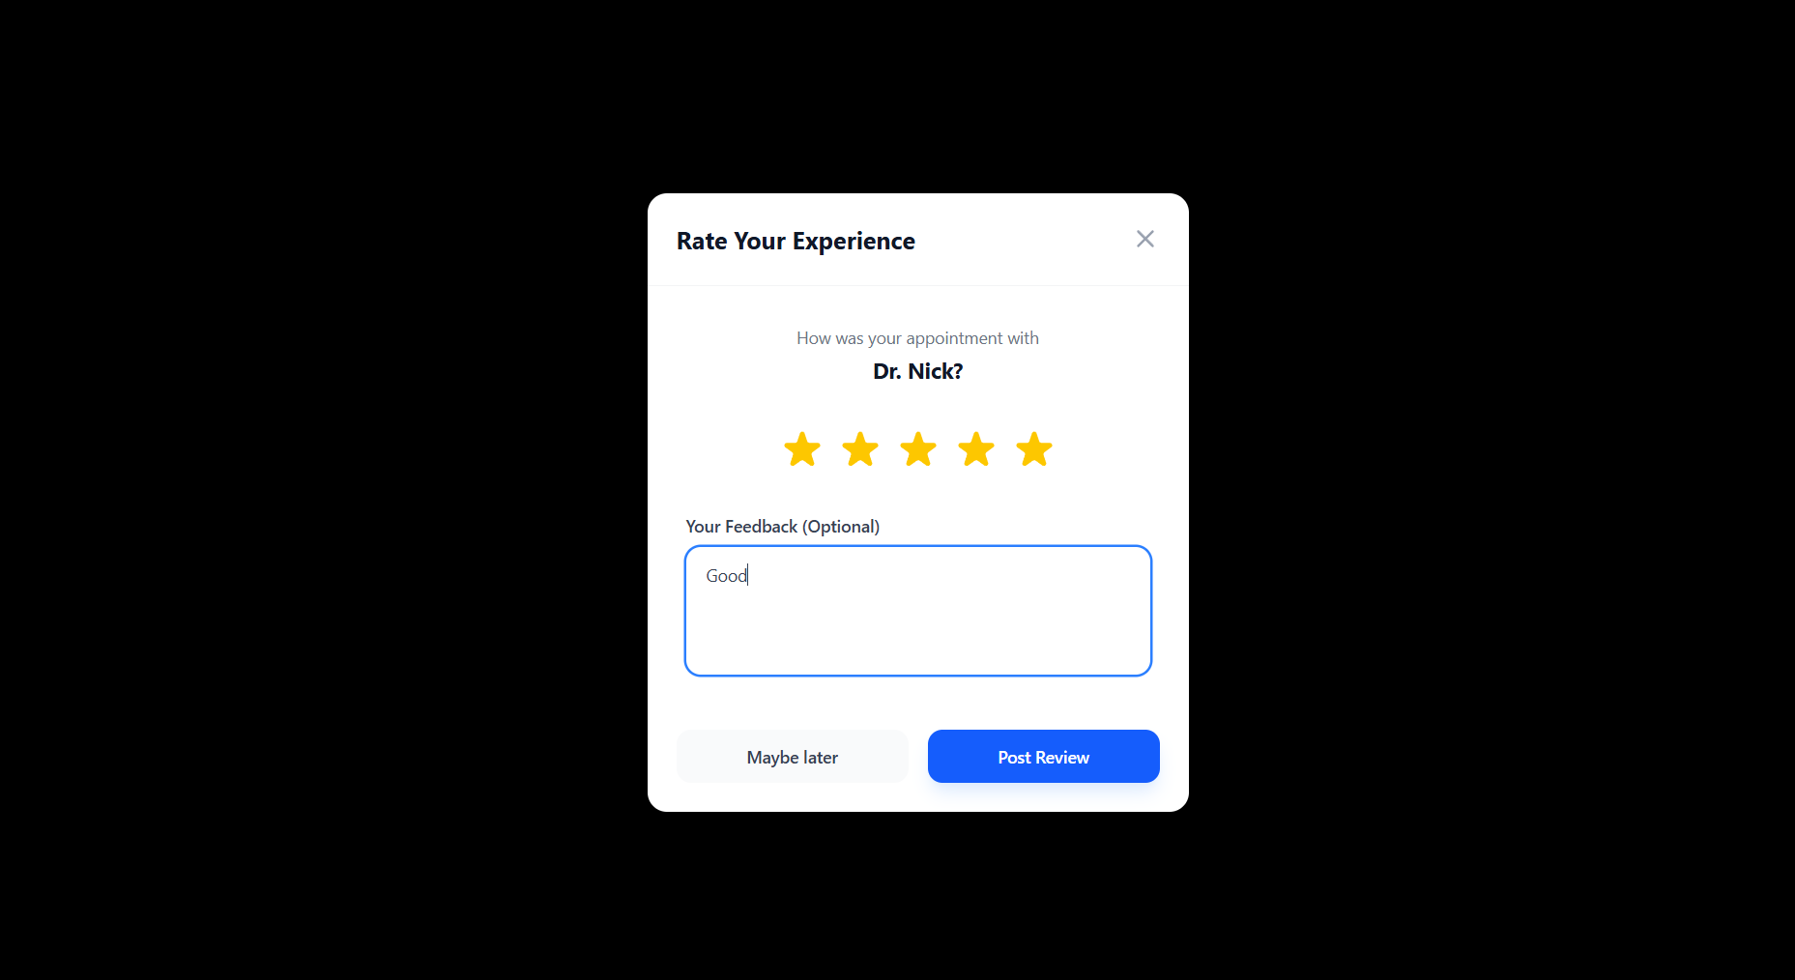

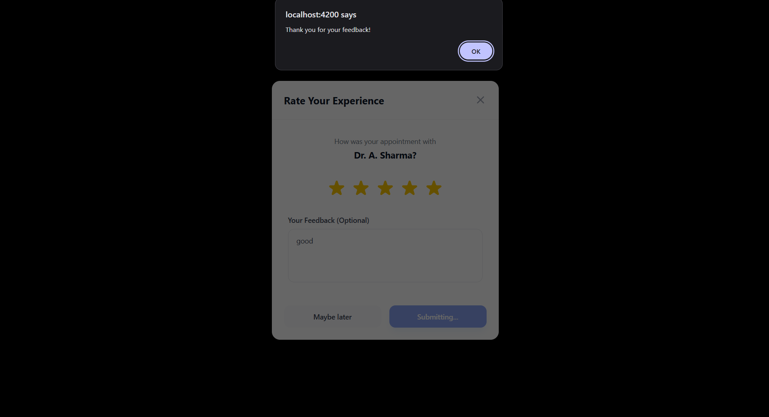
Feature 2 : Real-Time SignalR Notifications
SignalR provides a persistent WebSocket connection so users receive instant notifications without polling.
Backend Hub Configuration (Program.cs):
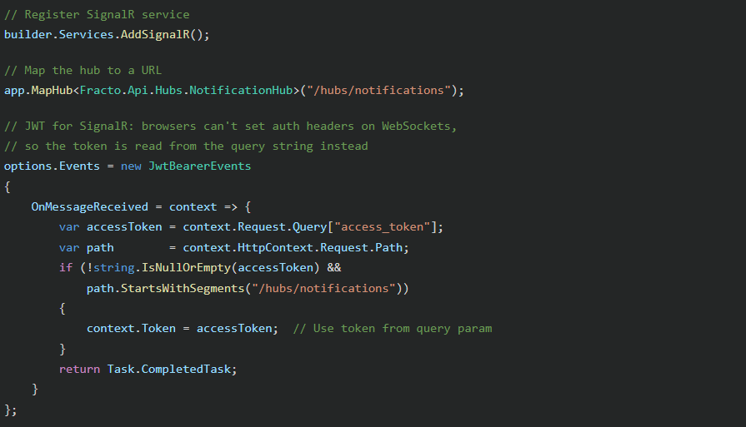

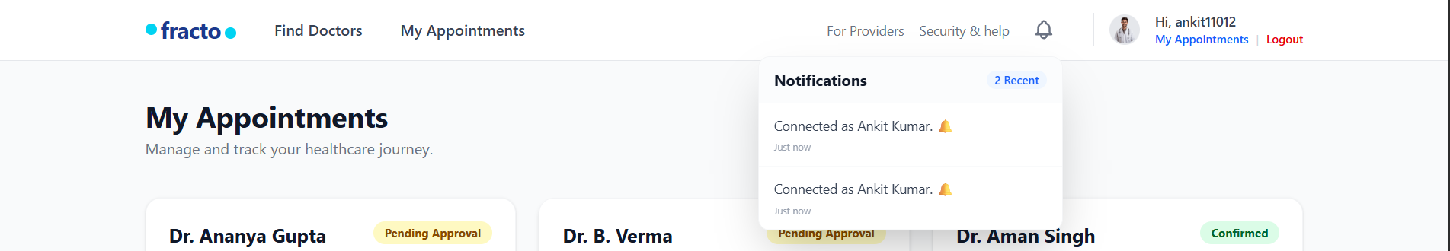

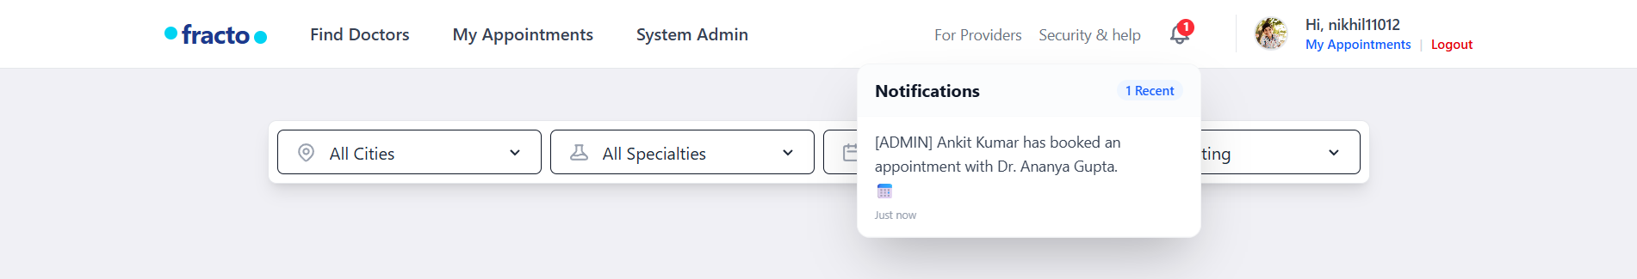

Notification Triggers:
User Action | Who Gets Notified | Message
User books appointment | All Admins | "{PatientName} has booked an appointment with Dr. {DoctorName}. 📅"
Admin approves appointment | Specific User | "Your appointment has been approved! ✅"
Admin marks completed | Specific User | "Your appointment is complete! You can now rate your doctor. ⭐"
Admin cancels appointment | Specific User | "Your appointment has been cancelled by the administrator. ❌"

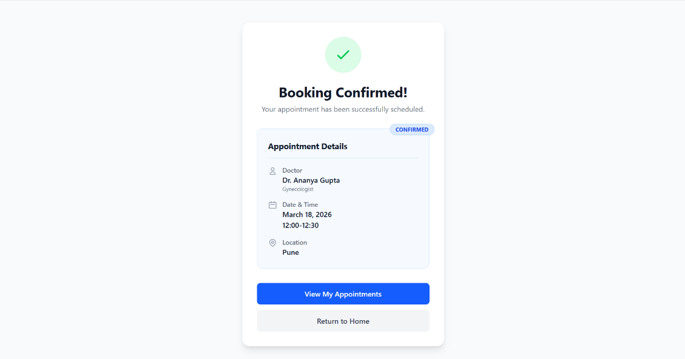
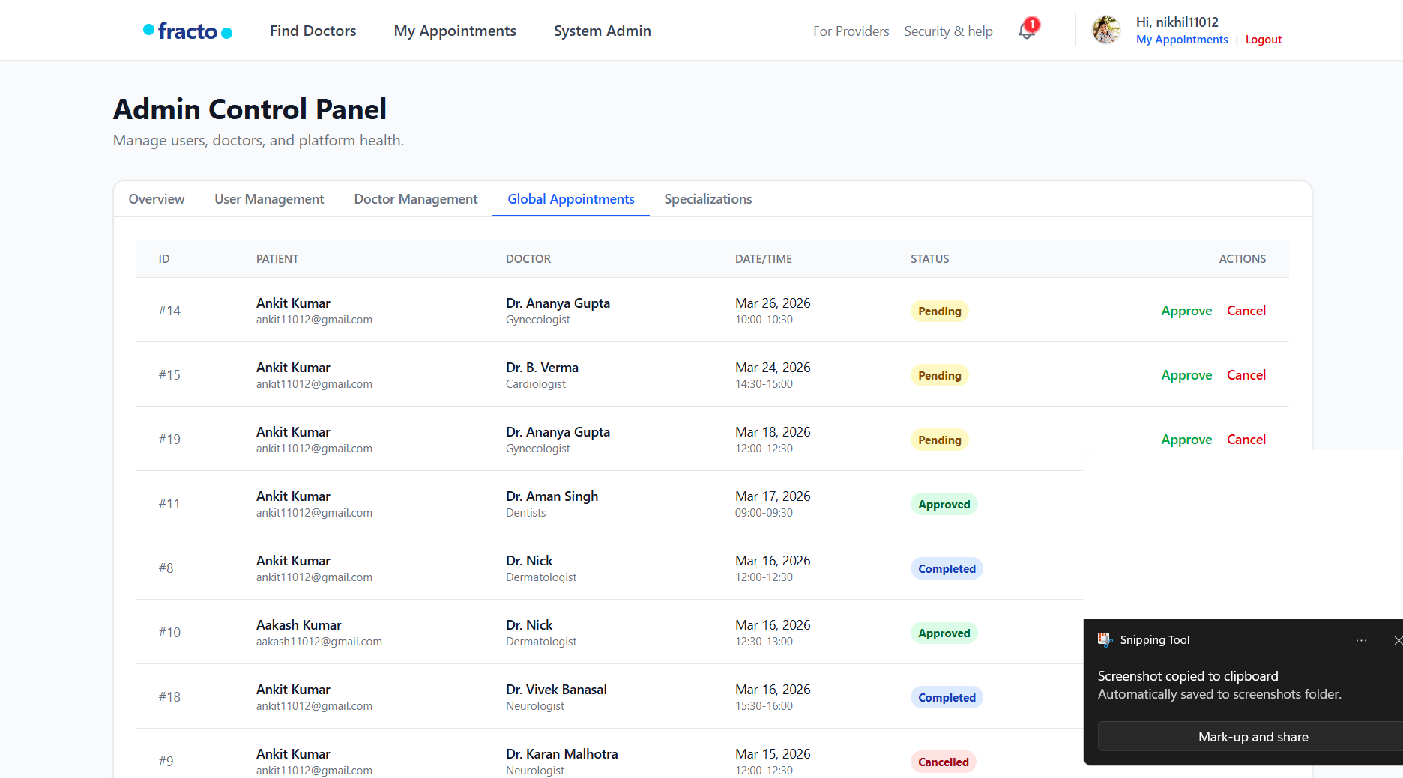
Responsiveness (Page-wise, Tailwind CSS)
- Global layout (Header + Footer + Content)
  - The app uses a responsive container pattern (max-w-7xl mx-auto px-4 sm:px-6 lg:px-8) so content has proper margins on all screens.
  - Header is sticky (sticky top-0) and stays accessible on scroll, while footer uses a responsive grid.
- Header / Navigation (Header)
  - Desktop navigation is shown only on medium+ screens using hidden md:flex.
  - On mobile, the layout stays compact with flex alignment (flex justify-between items-center h-16) and spacing utilities (gap-*) so it doesn’t overflow.
- Home / Doctor Search (Home)
  - Search filters use a responsive grid: grid grid-cols-1 md:grid-cols-4, so filters stack in 1 column on mobile and become 4 columns on desktop.
  - Doctor listing uses responsive columns: grid grid-cols-1 md:grid-cols-2 lg:grid-cols-3 xl:grid-cols-4, scaling from 1 → 2 → 3 → 4 columns based on viewport size.
  - The “Specialties” section uses a responsive flex row that supports horizontal scrolling on small screens (flex overflow-x-auto) so items don’t shrink unreadably.
- Login Page (Login)
  - The main layout switches from stacked to split view using flex flex-col md:flex-row.
  - The illustration section is hidden on small screens (hidden md:flex) to keep the login form centered and readable.
  - The form container uses w-full md:w-1/2 max-w-md so it remains full width on mobile but doesn’t stretch too wide on desktop.
- Register Page (Register)
  - Same responsive pattern as Login: flex flex-col md:flex-row with the illustration hidden on mobile (hidden md:flex).
  - Form stays readable using w-full md:w-1/2 max-w-md and consistent spacing (space-y-6, px-4 sm:px-6 lg:px-8).
- Doctor Details + Booking (Doctor Details)
  - Doctor details card uses flex flex-col md:flex-row so the image and info stack on mobile and align side-by-side on larger screens.
  - Booking time slots use a responsive grid: grid grid-cols-3 sm:grid-cols-4 md:grid-cols-5, increasing available columns as screen size grows.
- Booking Confirmation (Booking Confirmation)
  - Uses a centered responsive container (max-w-md w-full) with padding utilities (px-4 sm:px-6 lg:px-8) to maintain consistent spacing across devices.
  - Action buttons stack vertically (flex flex-col space-y-3) for easy tapping on mobile.
- My Appointments (My Appointments)
  - Appointment cards use responsive grid columns: grid grid-cols-1 md:grid-cols-2 lg:grid-cols-3, showing 1 column on mobile and scaling up on larger screens.
  - Each card uses flexible layout (flex flex-col, flex-grow) to keep button sections aligned even when text wraps.
- Admin Dashboard (Admin Dashboard)
  - Tabs use flex overflow-x-auto so the tab bar remains usable on smaller screens without breaking layout.
  - The “stats” tiles are responsive: grid grid-cols-1 md:grid-cols-2 lg:grid-cols-4.
  - Data tables are wrapped in overflow-x-auto, enabling horizontal scroll on mobile rather than squeezing columns.
- Footer (Footer)
  - Footer links use a responsive grid: grid grid-cols-2 md:grid-cols-4 lg:grid-cols-6, scaling from 2 → 4 → 6 columns based on viewport width.

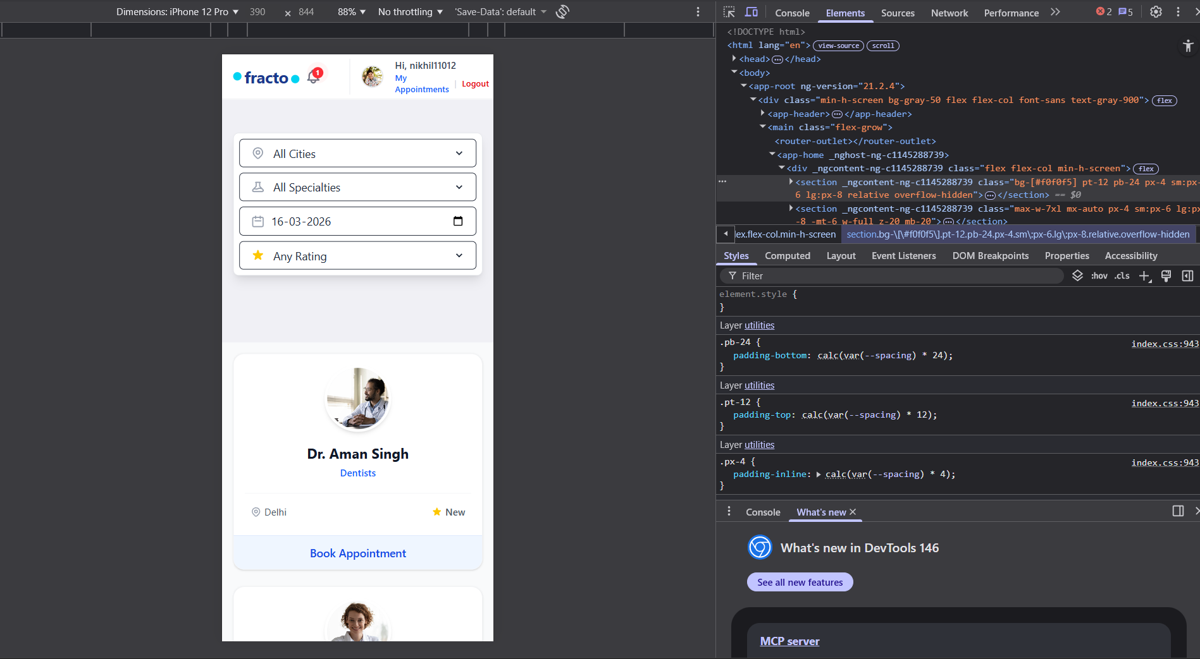

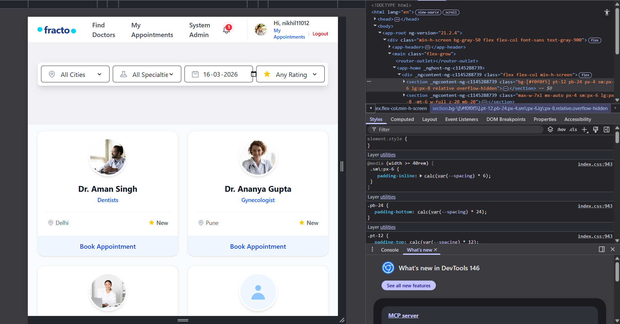

11. Session Handling
Session management is handled entirely by the AuthService
How Session is Stored
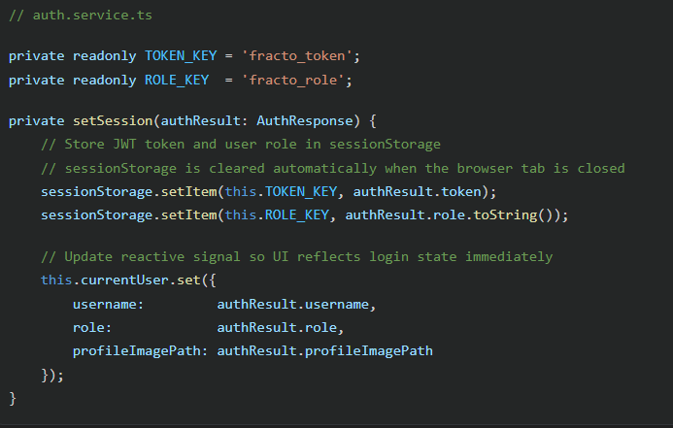
Session Restoration on Refresh
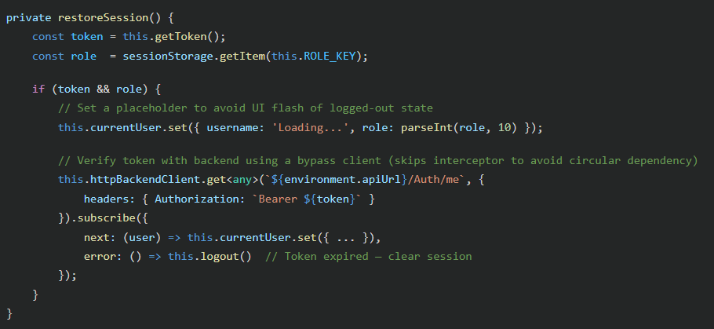
Logout
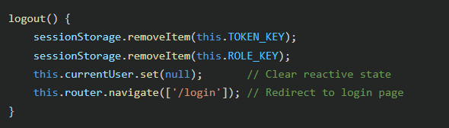
Why session Storage instead of localStorage?
sessionStorage is automatically cleared when the browser tab is closed, providing a natural session boundary. This prevents stale tokens from persisting across different sessions on a shared computer, making it a more secure default.

12. Angular – Backend Integration & JWT Security
Backend JWT Configuration (appsettings.json)
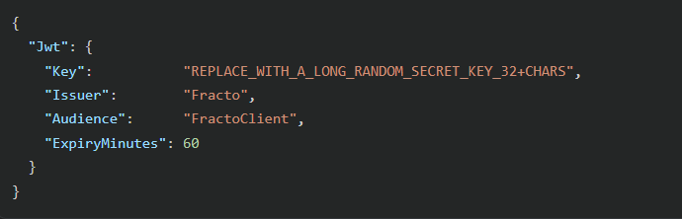
Token Validation Parameters (Program.cs)
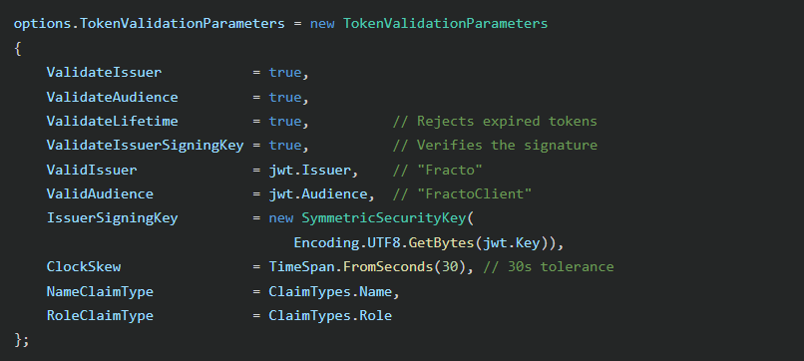
CORS Configuration
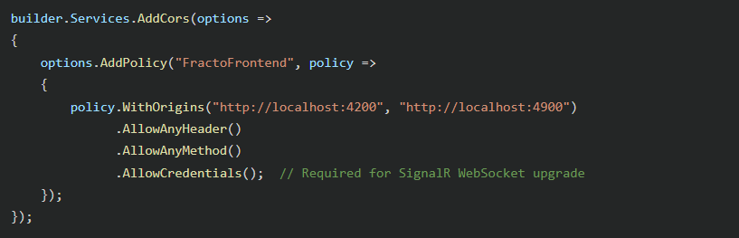
End-to-End Flow: User Login to Protected API Call
1. User types credentials → Angular Login Component
2. LoginComponent calls authService.login()
3. authService sends POST /api/auth/login with { identifier, password }
4. Backend verifies credentials, returns JWT token
5. authService.setSession() stores token in sessionStorage
6. User navigates to /my-appointments (guarded by authGuard)
7. authGuard checks authService.isAuthenticated() → true → allows navigation
8. MyAppointments component calls appointmentService.getMyAppointments()
9. authInterceptor reads token from sessionStorage, adds Authorization header
10. Backend validates JWT → extracts UserId from claims → returns only that user's appointments

13. Testing - Component & End-to-End
Unit Test — Root App Component (app.spec.ts)
The Angular project includes an initial unit test for the root App component using the Angular Testing Utilities:
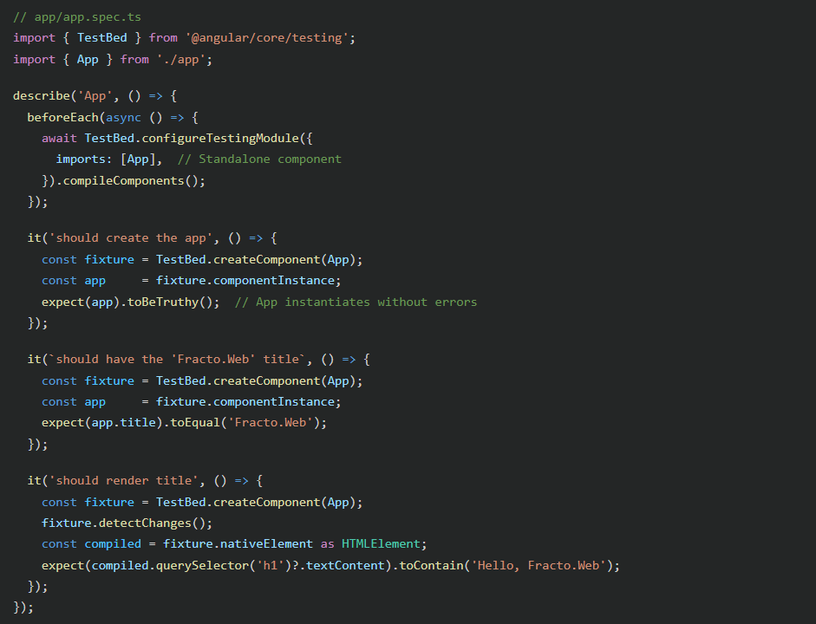
How to Run Tests
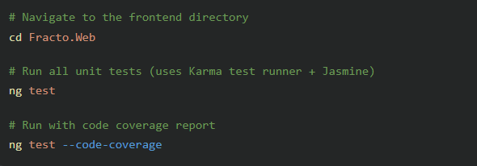
Testing Tools Used
Tool | Purpose
Karma | Test runner (launches Chrome headless)
Jasmine | Testing framework (describe/it/expect syntax)
TestBed | Angular's testing module for component instantiation

14. GitHub Repository & Version Control
- Repository Type: Public GitHub Repository
- Backend Project: Fracto.Api — ASP.NET Core 8 Web API
- Frontend Project: Fracto.Web — Angular 18
Repository Structure
