ReactJs
A single-page application is an application that loads a single HTML page and all the necessary assets (such as JavaScript and CSS). No reload for page redirection.
_______________________________________________________________
React portals
SSR
SEO
SSG
NextJs
Storybook
Atomic design
React 19
- react compiler

Fetch API vs. axios
Internationalization - different languages
Interceptors in axios
Cancel an API call - AbortCom

const controller = new AbortController
In cleanup of useEffect, controller.abort() to cancel the API call

createElement vs. cloneElement
SOLID principles

cloneElement- pass additional props and children to a component

When there are lakhs of records coming to show in a table/list, how to improve ance?

createRoot()
root.render()
index.js index.html App.js

Conditionally useEffect

Tree shaking
________________________________________

Unidirectional data flow
-Parent component passes data as props to the child component. These props are immutable by the child. But the child can’t send it directly. Benefit: Easy to debug.

Data binding
- Data being in sync between model and view.
- React follows one-way data binding (model to view) whereas Angular follows two-way data binding.

Lifting up the state
- Maintaining the common state in the parent so that children can access it through props.
- Scenario: A is the parent. B and C are its children. B and C are siblings. B has text box, C needs to display the data of text box
- Data sharing between B and C components (sibling)?
- Sending functions as callbacks through props for updating the state
- Benefit: Data stays in sync
- remove state from both of them, move it to their closest common parent, and then pass it down to them via props

* Advantages of React over Angular:
- In Angular, updating DOM is expensive. This is because it works on the real DOM unlike React, which works on Virtual DOM.
- In React, it's easier to debug. This is because it follows unidirectional data flow unlike Angular, which follows bi-directional.
- React consumes less memory, unlike Angular.

* Angular vs. React:
- Two-way data binding. - One-way data binding.
- Bi-directional data flow. - Unidirectional data flow.
- Real DOM. - Virtual DOM.
- MVC. - V

Package vs package lock

We can pass key prop to the Fragment.

Infinite re-rendering of component - cause: state setter function call inside loop

Downsides of React: It's just a library, not a framework. External third-party overload

JSX JavaScript Extension/XML. Babel transpiles JSX to JavaScript
Webpack - Module bundler

props
- It's a way of passing data from parent component to child component.
- It establishes the communication channel between the parent and child components.
- It's read-only (immutable).

state
- It's just a JS object.
- It's the local scope a react component.
- It stores the data of a react component.
- It's mutable.
- private to a component

* props vs. state:
- immutable. - mutable (using setState).

What is the difference between state and props?
props (short for “properties”) and state are both plain JavaScript objects.
props get passed to the component (similar to function parameters) whereas state is managed within the component (similar to variables declared within a function).

super(props)
- In JS, for class inheritance to get into effect super() is required inside constructor of child class
- super() calls parent component’s constructor method and the child component gets access to all the functions of the parent component.
-JS enforces that if you want to use “this” in a constructor, you have to call super first
-React: super() call is mandatory before using ‘this’ inside the constructor.
-super(props) call is mandatory before using "this.props" inside the constructor.
“super” keyword eg. super.getName()
constructor() method is optional in React
____________________________________________________________________________

Binding event handlers
In JS, class methods are not bound by default. If you forget to bind this.handleClick and pass it to onClick, this will be undefined when the function is actually called.

Approaches for binding manually:
1. Using bind() method inline manner.
Eg. <button onClick={this.handleClick.bind(this)}>Click Me</button>
Downside of inline binding: Called when the component re-renders.
2. Using bind() method in the constructor
this.handleClick = this.handleClick.bind(this);
Drawback: we cannot pass dynamic parameters.
3. Class fields syntax:
handleClick = () => {
console.log('Click happened');
}

3. Using arrow function.
<button onClick={() => this.handleClick()}>Click Me</button>
This is not recommended since it may re-rendering of the child components.

By using arrow functions for class methods, we don’t need to bind “this” - Class fields
Reason: “this” in arrow function points to parent scope.

SyntheticEvent
- purpose: Cross-browser consistency
It's a wrapper around browser’s native event
native event system may differ from browser to browser (possibility of issues)

Phases of component

Mounting phase: component gets created and inserted into the browser DOM.
constructor() => getDerivedStateFromProps() => render() => componentDidMount()

Updation phase: component gets updated in this phase. state update/props update. re-render
getDerivedStateFromProps() => shouldComponentUpdate() => render() => getSnapshotBeforeUpdate() => componentDidUpdate()

Unmounting phase:- The component will get removed from the DOM. componentWillUnmount

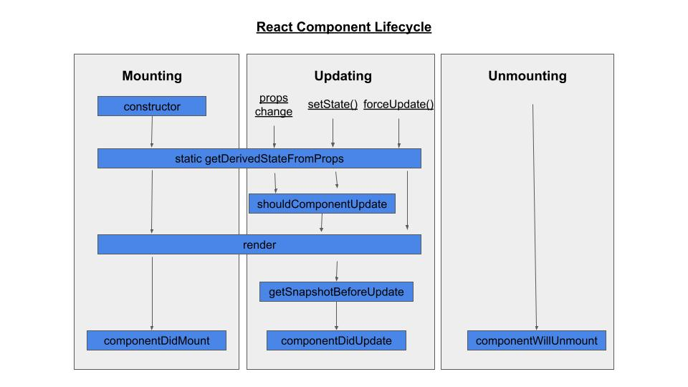
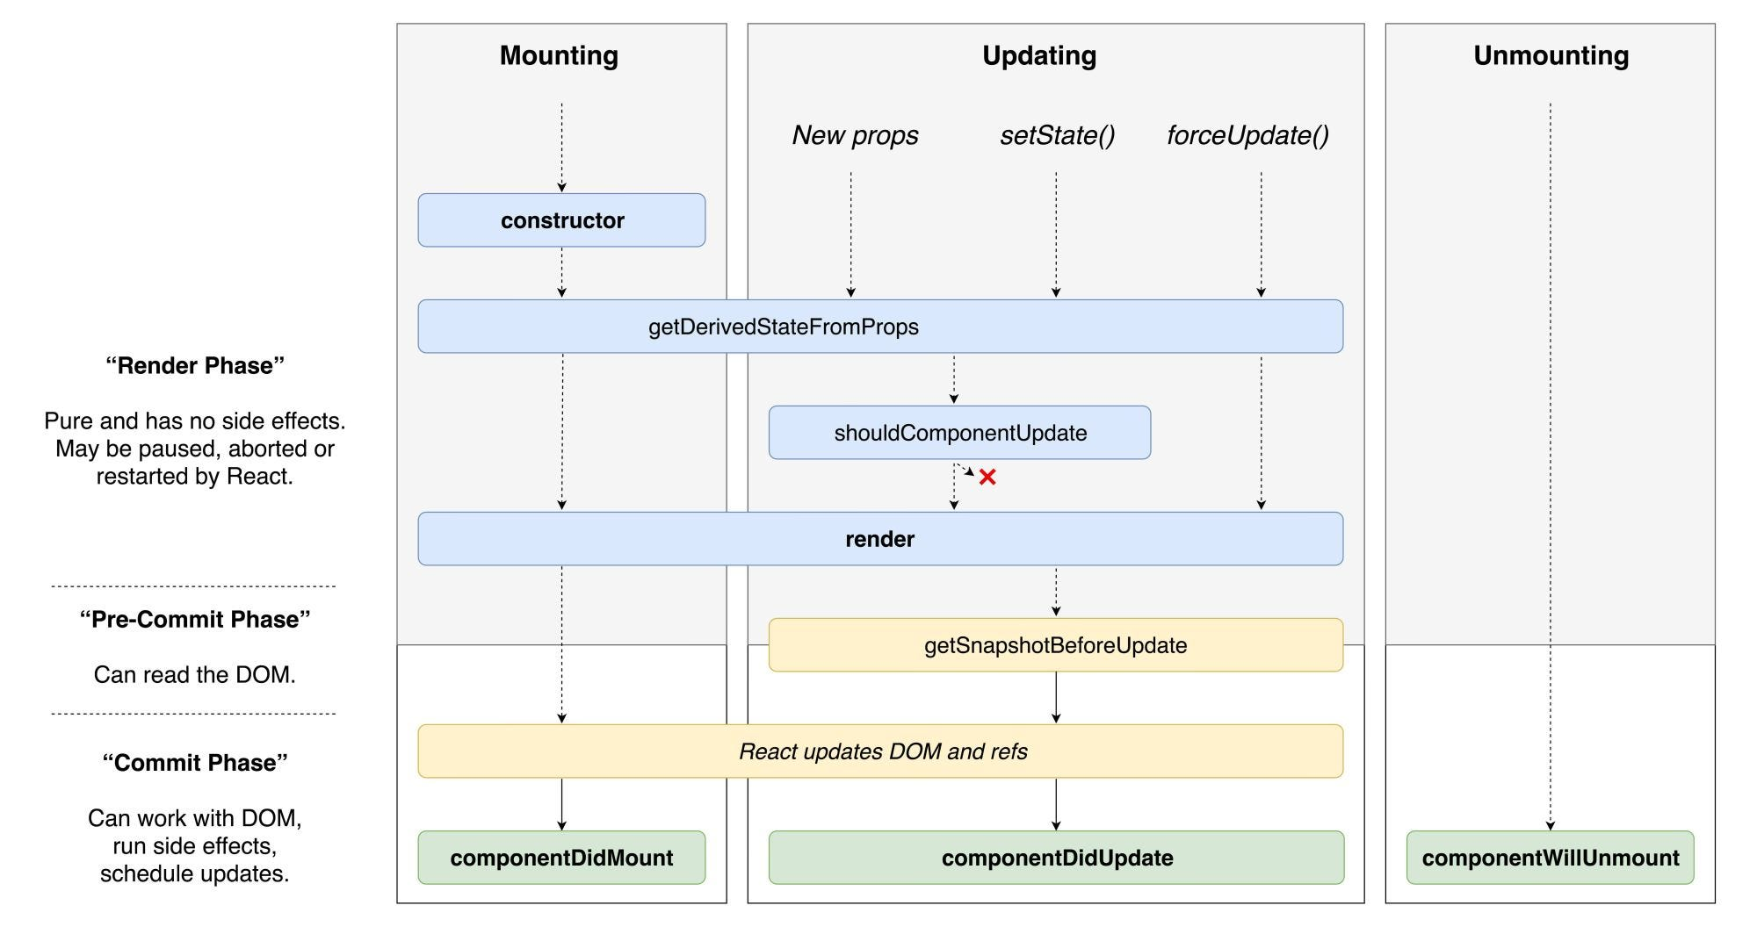

Life cycle methods
v16.3:
Note: componentWillReceiveProps(), componentWillUpdate(), componentWillMount() are scrapped. getDerivedStateFromProps(), getSnapshotBeforeUpdate() are added.

constructor()
First method to be called. Initialization of component state, binding of event handlers.

getDerivedStateFromProps()
Gets called just before mounting. before updating.
static getDerivedStateFromProps(props, state). Returns state object.
-makes sure that the props and state are in sync
-as it’s a static method, it doesn’t have access to “this”
Mounting phase: Used for setting the state based on the initial props.
Update phase:
-With getDerivedStateFromProps, before the component was even re-rendered, its state can reflect those changes and can be shown (if applicable) to the newly updated component

render() This method mounts the component in the DOM tree.

componentDidMount()
gets called right after the component is mounted.Network requests can be placed in this method
Register event handlers

shouldComponentUpdate()
- determines if the component should be re-rendered. (nextProps?, nextState?)
- returns a boolean value. - By default, it returns true.
- It can prevent the re-rendering of a component, thereby optimizing the ance.
- gets ignored when forceUpdate() is invoked.

getSnapshotBeforeUpdate()
-getSnapshotBeforeUpdate(prevProps, prevState). Gets called after the update/re-render
-With this, even after the update, you can check what the values were before the update.
-If the getSnapshotBeforeUpdate() method is present, you should also include the componentDidUpdate() method, otherwise you will get an error.
-returned value will be sent as an argument to the next method

componentDidUpdate()
gets executed after the next render.after the update. componentDidUpdate(prevProps, prevState, snapshot)

componentWillUnmount()
-gets executed when the component is about to be removed from the DOM.
- used for clean-up; unsubscribe, detach event handlers; avoid memory leaks; optimize ance

Error-handling
-Error boundaries are React components that catch JS errors anywhere in their child component tree, log those errors, and display a fallback UI instead of the component tree that crashed.
-A class component becomes an error boundary if it has any of the following lifecycle methods
static getDerivedStateFromError(err) - renders a fallback UI after an error has been thrown.
-returns state(updated) object
- updates the state by return new state, to re-render the component to show fallback UI
componentDidCatch(err, info) logs error information.
-wrap the error boundary component
-error boundaries only catch errors in the components below them in the tree.
- these can be possible only in class components
Limitation: can’t catch errors of event handlers(use try catch for those), can catch only errors during rendering
A class component having one or both these life cycle methods is called as error boundary component.

forceUpdate
skips shouldComponentUpdate
Re-renders the component using render() method

React Fiber

useState vs useReducer immutable

Add count that gets incremented by 1 for every second.

Tree shaking:
Process of removing dead code or unused code or unused modules

setState()
Used to update the state object. Whenever a component's state gets changed, the component gets re-rendered. (render() method)
-setState() enqueues changes to the component state and tells React that this component and its children need to be re-rendered with the updated state.
-merges the object you provide into the current state unlike useState’s setter
-It's an asynchronous operation.
-If there are many setState() calls one after the other, we won't get the expected result.
-So, to avoid this race condition, setState((prevState => {}) should be used.
setState({isChecked: true}, callback)
-It gets batched to the last. Last in the “queue”.
setState triggers re-render even when called with same state
Callback will have two parameters - first one is the state and second one is the props.
setState(updater, callback?)
Optional callback function of setState method - The second parameter to setState() is an optional callback function that will be executed once setState is completed and the component is re-rendered. Generally we recommend using componentDidUpdate() for such logic instead.

Code Reuse - Composition, Inheritance

Composition
- it’s a pattern with which code reusability can be achieved. make common components generic… children could be anything. We can create reusable components.
- Doesn’t inherit properties, but just adds behavior
- Now we can nest the JSX inside that component and place JSX with children prop
- Easy to maintain/extend (add new features or fix bugs). Easy to read/understand. Changes needed only at one place (Single source) in future but not at multiple places.
- This technique prevents us from building too many similar components containing duplicate code.
- HOCs, render props are a type of composition

Inheritance
- Not recommended. extends Parent Child components. Child component Inherits properties of the parent component.

Virtual DOM
- In general, updating DOM is expensive (time-taking) i.e. slow.
- Virtual DOM is a copy of Real DOM.
- React doesn't update the Real DOM directly. First, it updates the Virtual DOM, then it makes the updates to the Real DOM all at once.
- Whenever the setState() method is called, a new Virtual DOM is created.
- ReactJS maintains two virtual DOMs, one with the updated state Virtual DOM and other with the previous state Virtual DOM.
- Reconciliation: ReactJS uses a 'diff' algorithm to compare both the Virtual DOMs to find the minimum number of steps to update the Real DOM.
- Batch Update: During the event loop, there is exactly one time when the Real DOM is being painted.

React uses the Virtual DOM to render an HTML tree virtually first, and then, every time a state changes and we get a new HTML tree that needs to be taken to the browser’s DOM, instead of writing the whole new tree React will only write the difference between the new tree and the previous tree (since React has both trees in memory). This process is known as Tree Reconciliation.

Akshay Saini - React's Virtual DOM is a lightweight copy of the actual DOM. When state changes, React creates a new Virtual DOM and compares it with the previous one. Only the differences are updated in the real DOM, reducing the need for expensive DOM manipulations.

Reconciliation: process of syncing the real DOM with VDOM.
Virtual DOM manipulation is faster than normal DOM manipulation because ….
normal DOM manipulation is expensive in terms of time complexity
DOM is in the form of a tree of nodes.
Virtual DOM is a copy of real DOM in the memory.
With VDOM, whole DOM won’t be repainted, instead
Entire DOM won’t be rendered
Only the attributes of the element get updated.
Least part of DOM will get updated. React is fast because of this VDOM concept.
Least number of steps to update. Updates only what needs to get updated.
Diff algorithm
React compares the latest version of VDOM with its previous version
Only that particular node will be updated instead of repainting/rendering the whole DOM (other elements)
This process is naturally fast since only one node needs to be repainted
With real DOM, even for a small change to a node, the whole DOM will be repainted. But with VDOM, only that change will be repainted (synced) to the real DOM.
Real DOM - direct update; VDOM - Indirect update
When there’s an update, React creates a new copy of VDOM and compares it with the previous copy of VDOM.

Keys of list of components
- Keys make the reconciliation more efficient - Keys help React identify which items have changed, are added, or are removed
- It's useful when there are dynamically created components.
- It boosts the ance, by avoiding unnecessary re-renders.
-Keys allow React to keep track of elements. This way, if an item is updated, only that item will be re-rendered instead of the entire list.
____________________________________________________________________________

* Uncontrolled elements: fields
- Initial value is not set.
- refs are used.
- no onChange handler.

* Controlled elements: fields
- Set the initial value as a prop.
- onChange handler.
- Synchronized with the state always.

Controlled components - no local state, influenced by parent component’s props
Uncontrolled components - components with local state
____________________________________________________________________________

Higher order components
- It's a function that takes a component as an argument and returns a component. Eg. withRouter(Users)
- It transforms the sent component, by adding new props. It's a pure function.
- Share the same functionality across multiple components (Reusability). Eg. state abstraction.
Same thing can be achieved using custom hooks.
Custom hook example- useCounter
increment, decrement, count
____________________________________________________________________________

React.PureComponent
- Usually components re-render when the parent comp re-render. To stop this. ance optimization. extends React.PureComponent. Only for class components.
-comparison of new state, props with old ones. Implements shouldComponent() for us.
-Use this when you don’t want a component to rerender if the state and props don’t change. skips re-renders for same props and state

Memoization is a form of caching used to store results of expensive functions and avoid repeated calls, leading to repetitive computation of results.

React.memo
- Problem: when a component re-renders, its child component also gets re-rendered.
- prevents unnecessary re-renders of a child component when props are unchanged. React.memo(Component). ance optimization.
-Higher order component. Used to skip unnecessary re-renders.
-When a component is wrapped in React.memo(), React renders the component and memoizes the result. Before the next render, if the new props are the same, React reuses the memoized result, skipping the next rendering.

PureComponent vs. memo
Comparison of old with new.
PureComponent - compares both state and props
memo - compares only props, does not compare new state with the old state

Fragment
React Fragments allow you to group multiple components without introducing an additional parent element in the DOM. <Fragment>, <>
____________________________________________________________________________
ance optimisations in React

Props drilling
It is the process of passing down props through multiple layers of a component hierarchy. passing data from a parent component to its children and then from the children to their own children and so on. intermediate components, even if those components don't actually use the data themselves
Downsides: Code duplication, Difficult to maintain, debug
Solution: State management library, Context

Context
- Context provides a technique to pass/share data through the component tree without having to pass/thread props down manually/explicitly at every level (“props drilling”).
- Used for state management just like redux.
- Broadcasts the context and its updates to the consumers. Global state.
- Consumers subscribe to the context changes using useContext() hook.
- Consumer components get re-rendered on the change of context.
- Consumers can even update the context using an update function.
- Create the context => Provide the context => Consume the context
- With Context API, you can store data at the top level of the component tree and make it available to all other components that need it without passing props.
- Context API allows data to be passed through a component tree without having to pass props manually at every level. This makes it easier to share data between components.
- createContext(), <ThemeContext.Provider value={state}>
- Small projects don’t need redux. React context will suffice.
- Disadvantages of react context?
- Not feasible in case of complex applications
- Redux vs. React Context ?

React.cloneElement()
- Handy when some prop needs to be passed at - {props.children}
- Eg. React.cloneElement(props.children, {...props.children.props, newProp=”newValue”})
- Preserves ref prop
Technique of HOCs and render props?

React.Children
React.Children.toArray
_______________________________________________________________

Static Type Checking
Before running, during compilation
-PropTypes
-Flow Types - achieve strong typing
-TypeScript
Benefit: Better intellisense in editors.

React.Children
- React.Children.toArray() - assigns keys to the elements

Class comp. vs. Function comp.
Before React 16.8, Class components were the only way to track state and lifecycle on a React component.v16.8 introduction of hooks

Diff. between class components and function components before hooks and after hooks
Confusing “this” keyword’s behavior.
Advantages of function components
Any advantages of class components?

Diff. between class components and function components and after hooks
Comparison of life cycle methods with hooks

Advantage of class components - Error boundaries can only be used with classes

Hooks
Why Hooks? (Functional components with hooks vs. Class components)
- Reuse “stateful logic” in components via custom hooks. Reusing the state of a custom hook in multiple components. Don’t have to create a new state for the components. Just reuse the state of the custom hook. Stateful logic means function with isolated state - custom hook. Previously, it used to be achieved using HOCs higher order components and “render props”. Downsides of those two techniques. Wrapper hell in profiler tab. So much of nesting.
- Splitting: Hooks let you split one component into smaller functions based on what pieces are related (such as setting up a subscription or ing data). Unnecessary code gets executed in componentDidUpdate(). Use useEffect() multiple times with each dependency. Separating the logic in componentDidUpdate(). Cleaning up code also doesn’t require a new life cycle method like componentWillUnmount. Just return a function in useEffect().
- Confusing nature of “this” keyword because its behavior is different from other languages
- Minification: Classes don’t minify very well. So, it takes a long time to load.
- Need to bind the event handlers in classes.
- Better readability (concise code) (clean code).

useState
- allows you to have state variables in functional components. The setter function is used to update the state which can trigger re-render of the component.
- React batches the state updates - delays the state updates (it s all other operations in the event handler and then at last updates the state)
- React maintains a queue and the state update will be the last one in the queue.
- setter function is asynchronous in nature
- setter function called with same state doesn’t trigger a re-render
- What happens in onClick={() => {
setCount(count + 1)
console.log(count)
}
- Setter doesn’t automatically merge the object you provide into the current state unlike setState()
- What happens below?
- 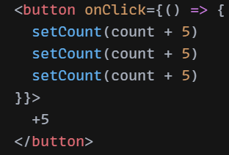
- React processes in a queue manner, the last one will get executed.
- What to do when we want to update the state multiple times in an event handler? The solution is updater function: setCount(count => count + 5)
- React processes the updater function at last in the queue and calls it on the updated state’s value.
- 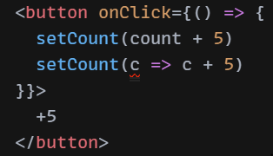
-Updater callback function - When the new state is calculated using the previous state, you can update the state with a callback. Eg. setToggled(toggled => !toggled);. It’ll have only one parameter which is the current value.
-Lazy initialization with a callback function on useState. When the initial value is the result of an expensive computation. Callback gets executed only at first render and in subsequent renders, the argument of the useState Hook will be ignored, and the latest value will be used. ance optimization.
-Difference between useState’s update function and class’s setState() method?
setState vs. useState
  - No second callback function
  - Merging the state object updates

useReducer hook is similar to useState, to be used when the state object is complex. Redux like.

useEffect
-Allows to side effects (API calls, timers, DOM manipulations) asynchronous operations
-useEffect is asynchronous in nature. It doesn’t block the DOM updates.
-Without dependency array: effect fn gets executed in every re-render
-With an empty dependency array: effect fn gets called only during first render
-non-empty dependency array: gets called on 1st render and runs on every re-render if there’s a change in dependencies
-Similar to componentDidMount, componentDidUpdate, componentWillUnmount. But the difference is Async - Non-blocking - after browser paints the UI
-clean-up: Effect function returns another function which is called after component unmount. Used for clean-up operations like unsubscriptions, detach event handlers, resetting input fields, socket disconnect. To avoid memory leaks. Similar to componentWillUnmount.
First render scenario - gets called
After every re-render with changed dependencies, React will first run the cleanup function (if you provided it) with the old values, and then run your setup function with the new values.
After your component is removed from the DOM, React will run your cleanup function.

Example of setInterval in useEffect, problem, fix it.

Problem - race condition in useEffect, fix it using a flag in clean up function

useLayoutEffect Synchronous version of useEffect - before the browser paints the UI
hurts ance

useMemo()
Memoization is a pattern to cache/store result of an expensive calculation and avoid repeated calls, leading to repetitive computation of results.
- ance optimization: memoizes/caches the return value of a function call and calls that function again only when there’s a change in one of its dependencies.
- Reduces the component’s load time during multiple renders.
-caches (memoizes) the result of a calculation between re-renders.
-the callback fn gets executed in 1st render. In the next renders, it gets executed only if dependencies are changed, else useMemo returns the value that was returned value in the previous render.
-During next renders, it will either return an already stored value from the last render (if the dependencies haven’t changed), or call calculateValue again, and return the result that calculateValue has returned.
- prevents unnecessary re-rendering of child components. Scenario: an array being passed to child component as a prop. return it in callback fn of useMemo.
- solves problem with referential equality… when a reference type is passed as prop -> unnecessary useEffect fn triggering

useCallback()
- Memoizes/caches some function. It’ll return the same (memoized) function on every re-render
- Prevents unnecessary renders. Solves the problem with referential equality - a component re-renders even when its props don’t change, but when its callback function changes (updater function). Updater function of useState() gets recreated on every render.
Child gets re-rendered because the parent is getting re-rendered even when there’s no change in props. ance optimization.
-Problem: passing a function as a prop to a memo child component. For every re-render, even the child component gets re-rendered. Reason: functions are re-created on every render by default even if they’re same. Solution: Make that fn a useCallback.
- solves problem with referential equality… when a function is passed as prop

useRef()
- Persists some data for the full lifetime of the component (across re-renders). Stores data that is not related to render. For render related, useState
- Creates an object with current property and can initialize this property. By changing the current property, there’s no re-render.
- Gets access to the DOM node. Focus an element programmatically.
- Doesn’t trigger a re-render on its update unlike useState().
- createRef() vs. useRef()
- createdRef doesn’t persist the value between re-renders

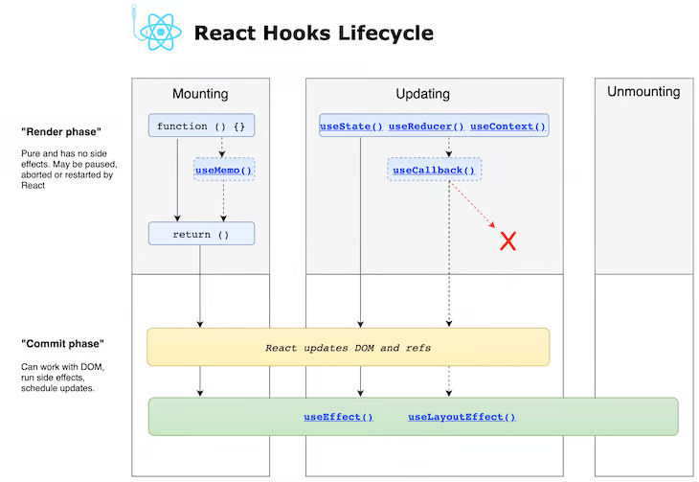

Lazy Loading
- Lazy loading is a design pattern that allows you to load parts of your application on-demand to reduce the initial load time.
- Lazy components get loaded only when it’s required/on demand/dynamically.
- Code splitting: splits the single bundle file into separate multiple modules/chunks and loads them dynamically.
- Reduces the initial load time of the application by reducing the bundle size. Improve ance.
- Dynamic import is used to load a module on demand - returns promise.
- React.lazy() is used to create a lazy component by making use of dynamic imports. When the component is rendered, it will automatically load the bundle that contains the rendered component. React.lazy(() => import('./AboutComponent ').then());
- When we use lazy loading, components are rendered as we navigate through app
- <Suspense> displays some placeholder while the lazy component is being loaded/until the promise is fulfilled. Wrapper for lazy components. <Suspense fallback ={}>
- Route based code splitting - only when the route is being rendered, that corresponding “chunk” file will be downloaded.
- Error boundaries: components that display some error message if the lazy component fails to load. Wrapped over Suspense. If the promise is rejected.

Render props

Refs
- These are the attributes that are used to store the reference to a particular node of the DOM tree.
- Get the access to a DOM element.

* Uses of refs *
- Managing the focus of something programmatically.
createRef(), useRef

forwardRef
For example, if you replace a <button> with a custom <FancyButton> component, the ref attribute on it will start pointing at the wrapper component instead of the DOM node (and would be null for function components). Expose DOM nodes.
This way, components using FancyButton can get a ref to the underlying button DOM node and access it if necessary

SPA

React 18
Changes, new things?

Styled components in React

createElement() vs. cloneElement()

react-router vs. history API

Strict Mode
strict mode component
<StrictMode>
<Aooo
</StrictMode>
helps to detect errors/warnings during development phase
only in development mode
detect problems and show warnings deprecations
Renders every component twice. Effects run twice.
Rules - hooks can't be placed inside loops, hook won't return, they should be placed at the top

Routing
react-router, react-router-dom
<Switch> is used to render only one route that first matches the path.

* Four ways:
<Route path="/news">
<NewsFeed />
</Route>
1. <Route path="/users" component={Users} />.
- Gets access to route details
2. <Route path="/users" render={() => <Users />} />
- We can pass props to a component.
- No access to route details
3. <Route path="/users" children={} />.
- route will always be rendered, regardless of matching.

* Difference between component and render.
- render is slower than the component.
- component uses React.createElement().
- render uses function calls.

Route props
- match - params object
- location - pathname property
- history - push(), goBack(), goForward()

Nested Routes.

* <Link to=" " /> or <Link to={{ }}> (location object goes here):
- Navigate between pages without reloading.

* <NavLink to=" " />
- Link highlighting.

Lazy routing

withRouter()
- Problem: only the components rendered using <Route component={Users}> have access to the route details.
- Solution: This higher order component enables a component to access the route details through props. Route details - location, match, history objects.

connected-react-router
- redux binding for react-router which maintains the router state in redux store.
- Enables a component to access the history methods as redux actions.

useHistory(), useLocation(), useParams(), useRouteMatch() hooks

Unit Testing
Jest, Enzyme

Redux

Why is a state manager required?
- Component-to-component communication, where there is no direct parent-child relationship is error prone.
- Components "dispatch" state changes to the store, not directly to other components. The components that need to be aware of state changes can "subscribe" to the store.

- Scenario: Data to be passed from parent component to grand child component where child component doesn't need that data. Alternative: React Context.

State management library.- State is immutable in Redux.- Redux follows Unidirectional data flow. Redux is based on flux pattern. Flux can have multiple stores, whereas redux can have only one store. Store - Global object

Unidirectional data flow:
Flow of data: Component -> Action -> Reducer -> Store
Data update doesn’t follow the same flow. Components get the data update only by subscribing to the redux state.

Principles of Redux
1. Single source of truth: The state of the application is stored in an object tree within a single store.
2. State is read-only: State is immutable. The only way to change the state is to dispatch an action.
3. Changes are made with pure functions - reducers.

** Components of Redux **
* Action:
- It describes what has happened.
- It's a JS object that has a "type" property.
- When we want to change the state, we should dispatch an action. We're notifying the store.
- It’s an JS object that describes what has happened.
- It has type and payload properties.
- It can be wrapped in a action creator function.

* Action creator:- It's a function in which an action is wrapped. * Action creators return actions.

Store Methods: getState(), dispatch(), and subscribe()
* store.subscribe(listener):
- listener gets called when the store's state is changed.

* Three helper methods of store object are:
- store.getState() - It returns the current state of the application.
- store.dispatch(action) - It's used to dispatch an action.
- store.subscribe(listener) - It provides a callback function which gets executed when the state changes.

* Reducer:
- It's a pure function that takes currentState and action as the arguments and returns the newState.
- It doesn't mutate the currentState.
- It has a switch statement.
- It is a function that changes the state, based on the action.
- It's a pure function that takes previous state and action as arguments and returns the next state.
- It doesn't mutate the previous state, since the state is immutable in Redux.
- It has a switch statement on action's type property.
- returns Object.assign() or object spread syntax.
- API calls must not be placed inside this. Reducer must not have side effects.
___________________________________________________________________________

react-redux
It's a Redux UI binding library that connects React with Redux.

connect(mapStateToProps, mapDispatchToProps)(componentName)
- It connects a react component to the redux store.- It takes at least one argument.

mapStateToProps():
- It passes a part of store's state to the props of a react component.
- It connects a part of redux state
- React component'll have the access to the exact part of redux store, it needs.
- It connects an exact part of redux state to the props of a react component, what it needs.
- A react component gets the access to a part of redux store, it needs.

* mapDispatchToProps():
- It passes redux actions to the props of a react component.
- With this, a react component can dispatch actions.
- It connects redux actions to the props of a react component.
- With this, a react component can dispatch the actions.

Provider- higher order component which makes the Redux store available to the application.

useSelector, useDispatch hooks

this.props.dispatch() ---- achieved using connect() of react-redux

Redux Saga
- middleware library ** redux-thunk
**redux-saga
- side effect manager
- easy to manage the side effects
- pause the execution using generators - makes asynchronous look synchronous -- kind of async, await
- it has the access to redux store's state and can dispatch actions to it

- side effects: asynchronous operations like data ing

- easy to test

- uses ES6 generators, function* myFunc(), yield, next()
basics of this concept
these generator functions make asynchronous flows easy to read, easy to write and easy to test

- make the API calls "blocking"

- tackle parallel execution, racing

- redux thunk vs. redux saga

- take()
take('TEST_ACTION') wait for an action to be dispatched

------------- takeEvery() - allows concurrent calls -------------

- takeLatest(): allows only one (latest) call
it cancels any previous calls
can be useful to handle AJAX requests where we want to only have the response to the latest request.
- takeLatest allows only one Data task to run at any moment. And it will be the latest started task. If a previous task is still running when another Data task is started, the previous task will be automatically canceled.

- race()

- all(): start/execute the sagas in parallel
just like Promise.all()

- call(): call something indirectly
pause the execution

- fork()

- effects

- declarative effects

- blocking vs. non-blocking
- sequence vs. parallel

- Watcher/Worker

why generators? - pause the execution
generator functions can return muliple values unlike normal functions
these can be exited and later re-entered. by retaining the context

Redux Thunk

Redux Toolkit
useSelector()
useDispatch()
createSlice() - reducers

