Compiling the RFM client code using qtcreator
- Create a new folder for downloading the RFM client application from DS Tool
- Navigate to the newly created folder. Open git bash window and clone the working code from git repository
- Open the application in qtcreator as shown in following figure (select the projectname.pro file )
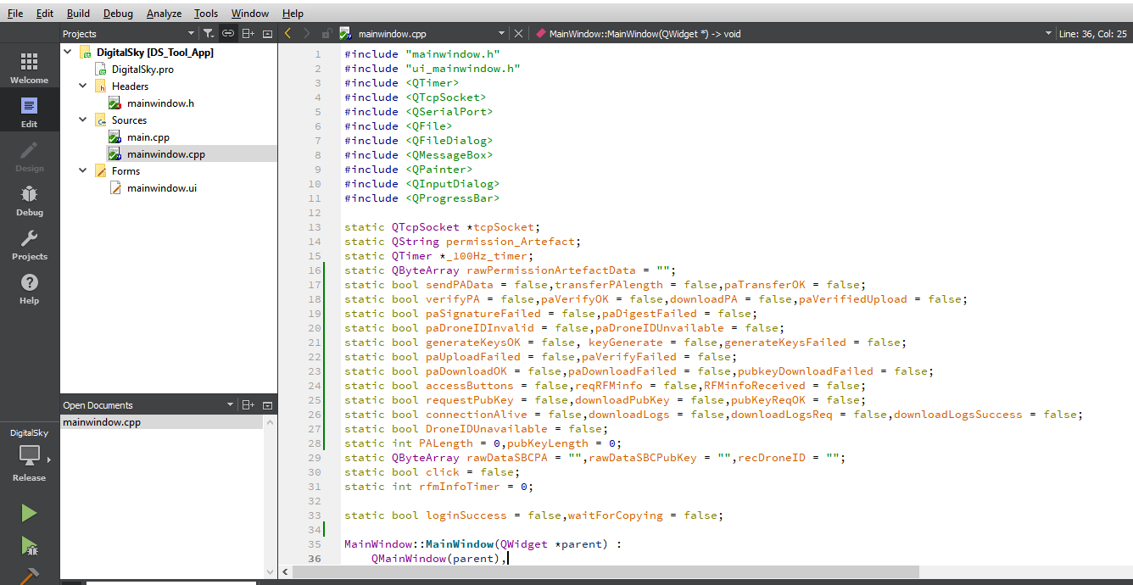
- Once the project is opened, navigate to the Projects tab in the left sidebar. Window should look like as shown in the below image (shown in green coloured box).
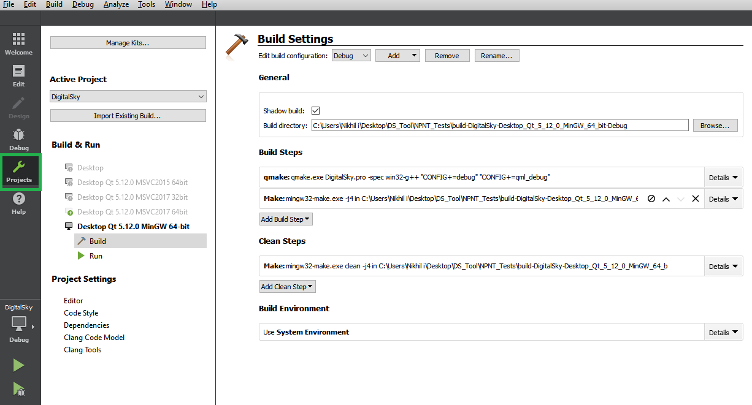
- In Edit build configuration, select the release configuration as debug configuration adds lot of debugging information which in turn creates larger size of the executables. Once release configuration is selected shadow build option is tick marked and it shows the path where it must be created. But it shows the path in red colour complaining about it’s unavailability in release mode.
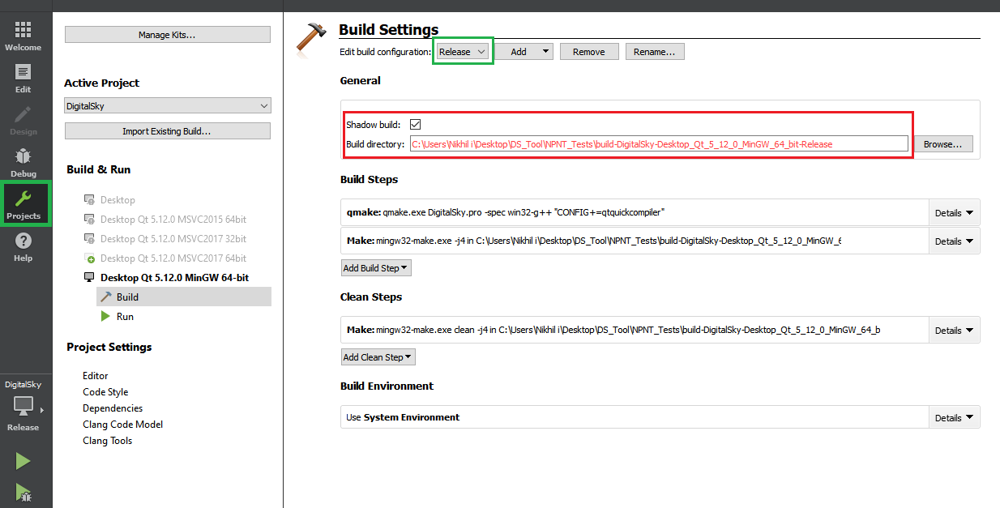
- Untick the shadow build option and once it is deselected, it will show the path of the executable to be created. The same is as shown in the figure below.
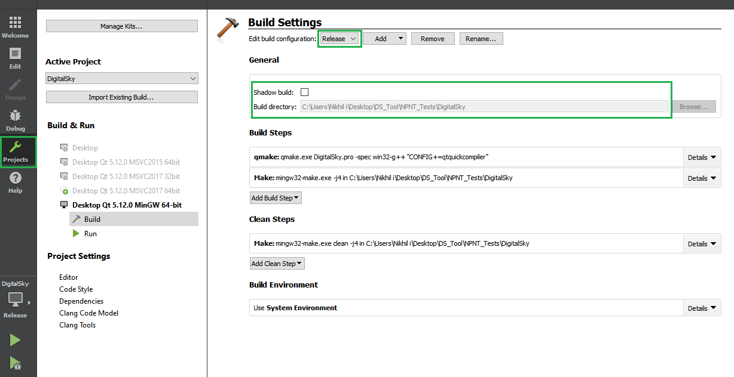
- Build the project using ctrl+B to create the executable in the release folder as shown in the following figure. As it can be seen DigitalSky.exe executable is created after compiling the code. It also creates few more files which are unnecessary for releasing the application. So, delete all the files from release folder except DigitalSky.exe.
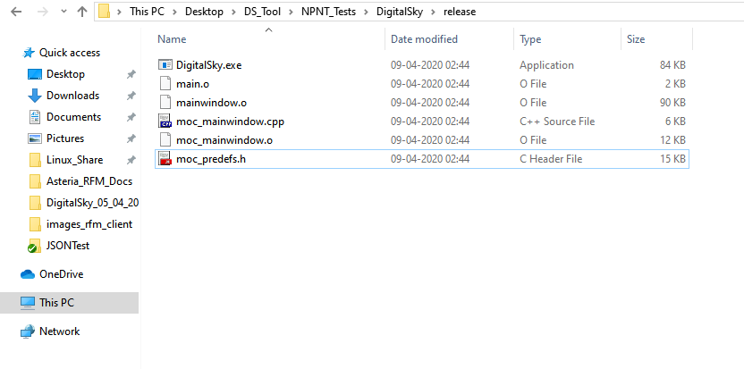
- Copy the two files pscp.exe and icon.png (find this in one of the earlier released versions of RFM client) in release folder. The file pscp. exe is required to perform downloading logs from RFM server and the file icon.png sets the icon for the RFM client in toolbar. Now the release folder should look like as shown below.
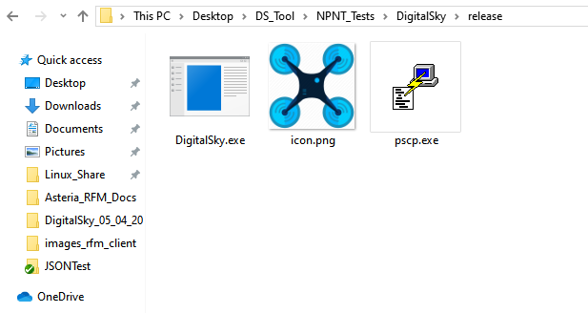

Deploying a Qt application for windows
- Check for the installed version of the qtcreator. It should be Qt 5.12.0 for desktop (MinGW 7.3.0 for 64-bit).
- Run the Qt 5.12.0 for desktop (MinGW 7.3.0 for 64-bit) application. It should look like as shown in the figure below.
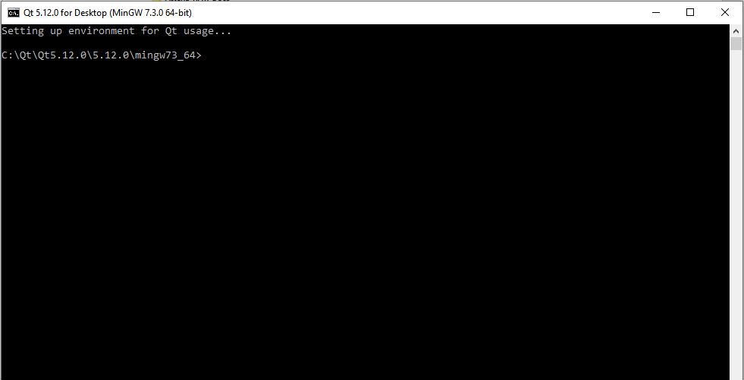
- In this command prompt window type windeployqt.exe and enter to check whether this tool is installed properly or not. If the results are like the way as shown in the following figure then windeployqt.exe is installed properly.
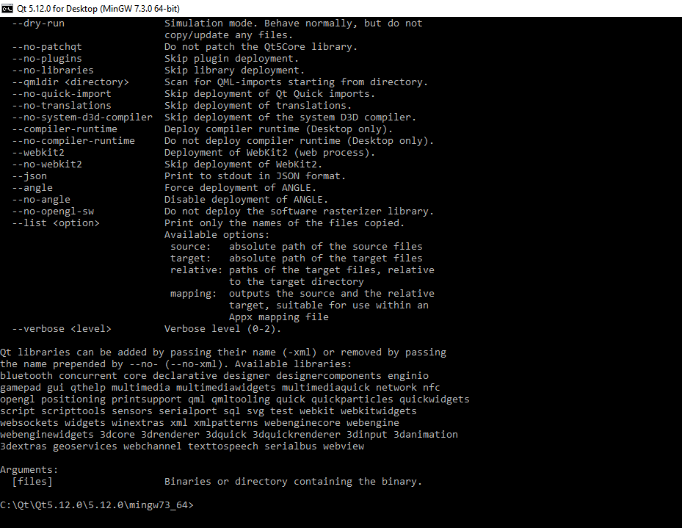
- In the same window navigate to the release folder where executable created by qtcreator is residing by typing the command as shown in the figure below.
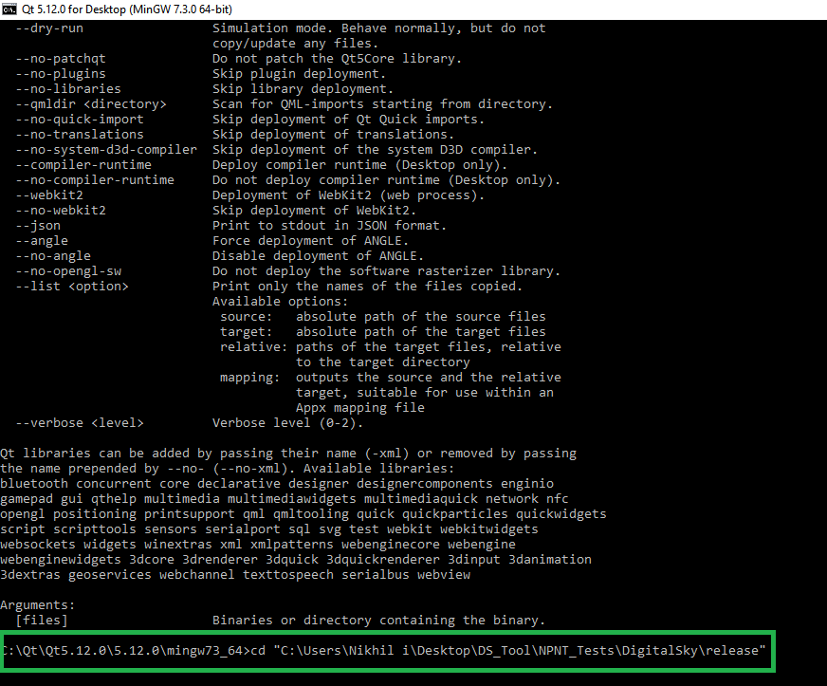
- Type the “windeployqt.exe –quick .” command and hit enter. Make sure “.” (dot) is present in the command which specifies the location of the GUI tool to be deployed. Following image shows result of the operation.
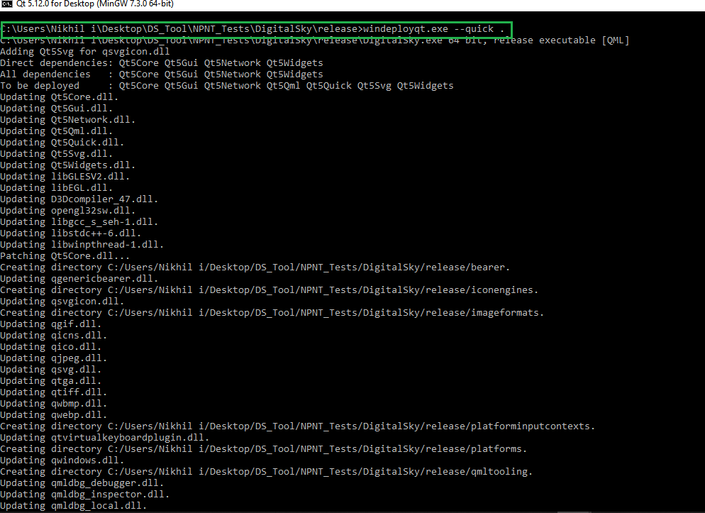
- Navigate to the release folder of the application. It should look like as shown in the figure below. To use the application just double click on the DigitalSky.exe as shown in the image below.
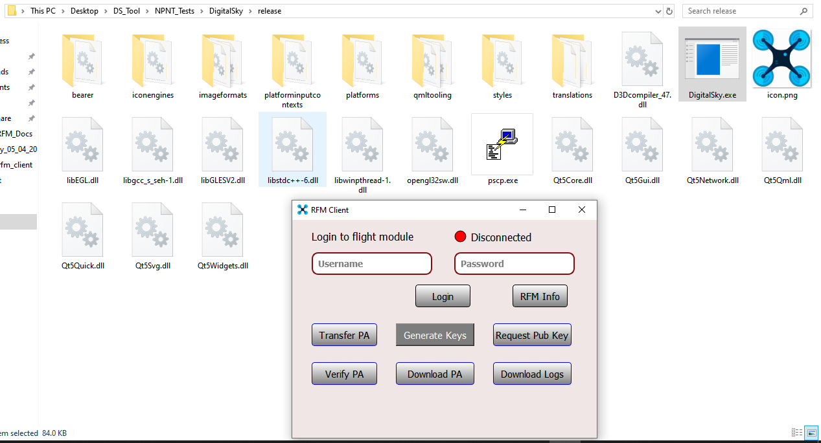

- RFM Client Tool look like as shown in the figure below. It’s functioning and explanation about the various buttons is mentioned in its architecture document. The entire release folder can be copied in another folder with different name and also across different machines to use it as standalone GUI application.
