**MADE BY-NIKHIL KUMAR SINGH**

**QUESTION1-WINDOWS INSTANCE**

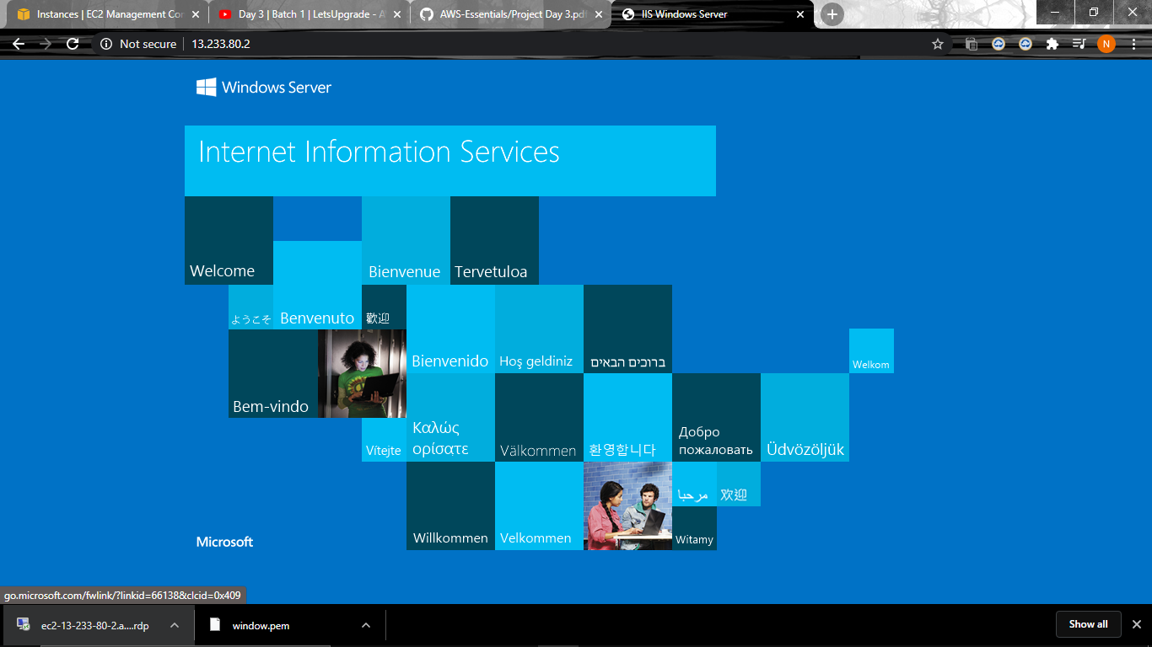

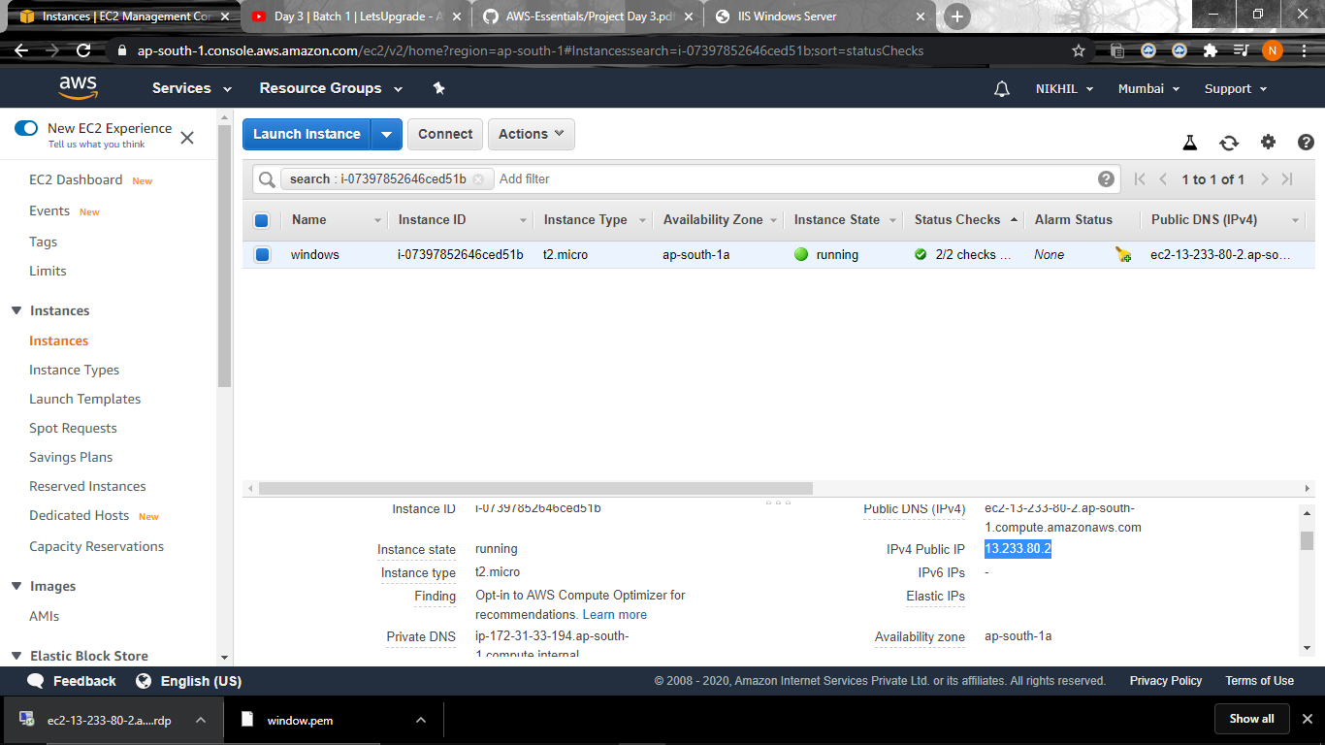

**QUESTION2-UBUNTU INSTANCE**

