**Advanced Wireless Networks**

**Nikhil Chavan (U00969241),** [**chavan.10@wright.edu**](mailto:chavan.10@wright.edu)

**LAB 1: Mixed 11g/11n WLAN Performance**

**SYNOPSIS**

The purpose of this lab is to understand the network performance when access points are changed from 802.11g to 802.11n WLAN network. The throughput, data drop and media access delay are the main features to check upon for the performance. To achieve this, Riverbed software is used to emulate the WLAN network by creating access points and nodes with 802.11n standards. Later packets are being sent to results are drawn accordingly. In order to compare with the inclusion of a legacy node and 802.11g node is included in the WLAN network and results are drawn. The below plots compare and explain that the 11n network will have no issues or low network performance when compared in the 2 scenarios. Despite, the assumption that it doesn’t perform well when legacy nodes include the graphs plots shows that throughput bits/sec is high when the legacy node is included, and media access delay and data drops are surprisingly less when the legacy node is included. Besides, this experiment depicts the packets loss due to contention are almost the same, hence a WLAN network can be formed with 11n nodes along with the 11g nodes without any performance degradation, indeed it outperforms some contention issues when 11g nodes are included in the network. Usually, IEEE 802.11n increases the bit rate up to 150 Mbps with a single spatial stream.

**802.11n vs 802.11g**

The IEEE 802.xx are basically networking standards, to specify the network performance, speed of data exchange, throughputs, frequency bandwidth when applied on a WLAN network. This information is indeed helpful for finalizing and configuring the hardware to support the frequency and speed. Wi-Fi and routers, Bluetooth and mobiles and laptops all these are equipped with IEEE 802.1x supported hardware to meet the standards. However, there are several standards developed over the course to meet the high users with secured and high-performance wireless networks. The industry standards are always improved to achieve and support many users over wireless networks. IEEE 802.1x, x ranging from ‘a’ to ‘n’. The 802.11n gives in reverse similarity to gadgets in utilizing prior variants of Wi-Fi, this adds a noteworthy overhead to any trades, subsequently diminishing the information move limit. To give the greatest data exchange speeds when all devices in the wireless network are working on the 802.11n standard, the backward compatibility can be expelled. The primary standard to indicate MIMO, 802.11n was affirmed in October 2009 and considers utilization in two frequencies - 2.4GHz and 5GHz, with speeds up to 600Mbps. At the point when you hear remote LAN merchants utilize the expression "double band", it alludes to having the option to convey information over these two frequencies, while 802.11g approved in 2003, 802.11g was the successor to 802.11b, ready to accomplish up to 54Mbps rates in the 2.4GHz band, coordinating 802.11a speed however inside the lower recurrence go.

**GOAL**

The principle thought process of this lab is to for all intents and purposes to comprehend the improvement in arranging execution in the wake of refreshing the passage from 802.11g passageway to 802.11n passage. Likewise, the system head needs to do research to check the effect of 11g inheritance gadgets in 11n BSS and see whether 11n clients found any system execution and degree of debasement assuming any.

**IMPLEMENTATION**

The Wireless LAN network for this lab is set up with the creation of an 802.11n-based wireless LAN network using the Wireless Deployment Wizard, configuring a network in the current subnet, later by setting up 2.4 GHz 802.11n network with data rates on nodes ranging between 26Mbps to 240Mbps. As discussed above the 802.11n is setup with the Multiple-Input Multiple-Output (MIMO) technology where the bit rate is usually up to 600 Mbps with four spatial streams. However, we are confined to 2 spatial streams which lead to the higher physical data rate. The network uses Geographical overlay and node placement algorithm to setup nodes within the hexagonal cell with radius up to 0.25km, wlan_eth_bridge_adv is used to set up an access point. Finally, 8 nodes are used in our 802.11n network setup with 1 access point. After the network is created, we configure the nodes and access by setting up High throughput parameters i.e. spatial streams to 2, guard interval to 2 and enabling Greenfield Operation makes an 802.11n AP communicate only with 802.11n devices. All pre-802.11n communications are perceived as noise. While Greenfield mode does optimize the performance of 802.11n devices, its inability to play nicely with legacy devices is a major downfall to this mode. thereby the wireless nodes will be able to use a shorter physical layer header HT –Greenfield format which will increase the wireless LAN throughput. In order to direct the traffic to the Destination, we set the destination address on the nodes generating traffic to the MAC address of the Destination. The MAC address of the destination is configured as 1 under Ethernet\ Ethernet Parameters\ Address attribute. Secondly, to introduce an 11g node in the 11n BSS network we add an 11g with the configurations like data rate set to 18Mbps. Finally, the simulation results compare the performance based on each pattern, with respect to security, reliability, and scalability and considering also their extensibility, because paths are transformed as the number of liked nodes increases and so it the energy consumption. Below are the few simulation results graphs for the comparison of different parameters.

**SIMULATION RESULTS**

The “Wireless LAN. Throughput (bits/sec)” graphs shows that performance of the above configured network improves when an 11g legacy node is added in the network when already 11n nodes are present. This proves that when an 11g node is included it outperforms eliminating contention issues, data packets loss.

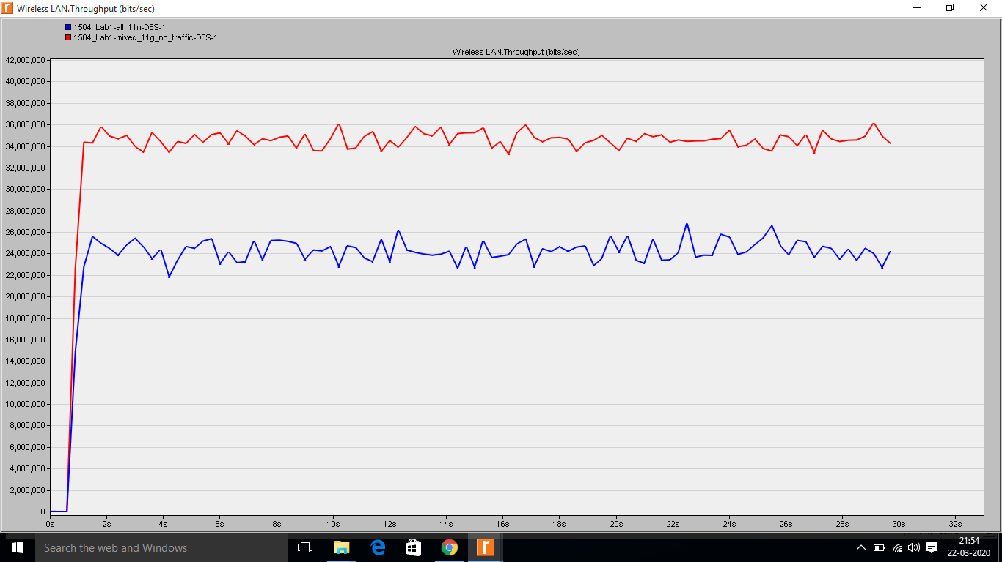

**Figure #1: Wireless LAN. Throughput (bits/sec)**

The below figure “Wireless LAN. Data Dropped (Retry Threshold Exceeded) (bits/sec)” in the 11g node addition scenario seems to be less or almost similar when compared to the 11n BSS network, thus improving the overall throughput and network performance. The loss of packets due contention conditions is the same across both scenarios.

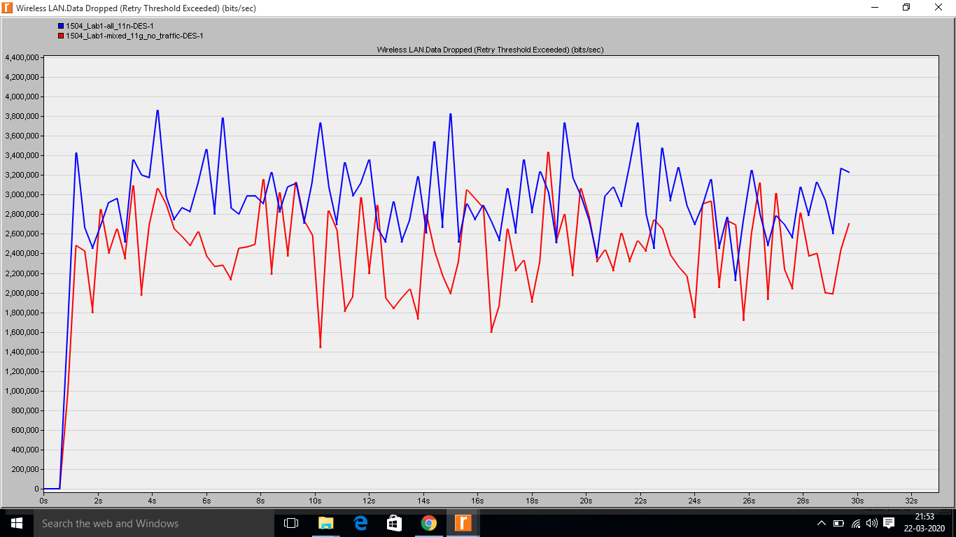

**Figure #2: Wireless LAN. Data Dropped (Retry Threshold Exceeded) (bits/sec)**

The below figure on Wireless LAN. Data Dropped (Buffer Overflow) (bits/sec) shows that buffer overflow is less in the 11n BSS network with the legacy node included than in the network without legacy 11g node. The buffer overflow happens when a program or procedure endeavours to write more information to a fixed length square of memory, or buffer, than the memory is allotted to hold. Since buffer memory is made to contain a characterized measure of information, the additional information can overwrite information to adjacent memory addresses to destination which could be prevented by a flag to discard data when an excessive data is sent to memory buffer. This lab experiment proves that addition of 11g will lessen the writing more information to a fixed length of a memory buffer.

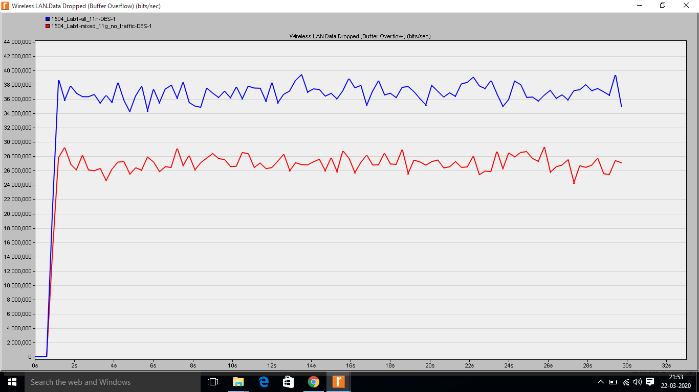

**Figure #3: Wireless LAN. Data Dropped (Buffer Overflow) (bits/sec)**

The below simulation result on “Wireless LAN. Media Access Delay (sec)” shows that there is 0.02 sec of media access delay i.e. when 11g node is included the delay is lessen thus improving the throughput of the network. Besides the data speed, contention, packets loss is integral calculation of the graph for both the scenarios.

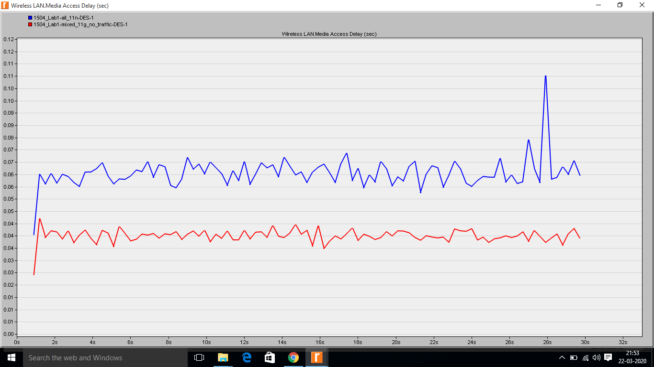**Figure #4: Wireless LAN. Media Access Delay (sec)**

**CONCLUSION**

The lab simulation results from Figure 1,2,3,4 proves that there is higher throughput or almost same throughput when an 11g node is being included with 8-11n nodes in WLAN network. It rather improves the performance, lessen the Media Access Delay, and Wireless LAN. Data Dropped (Buffer Overflow and Retry Threshold Exceeded) (bits/sec) shows that higher layer packets are sent at a much faster rate and loss of packets are almost same. we see a situation where it improves the 11n throughput when CTS-to-self-protection is enabled

**LAB 2: Improving Performance with QoS Aware Wireless LAN Layer**

**SYNOPSIS**

The system administrator of an undertaking has been approached to measurement the organization's remote system to help voice clients. At present, the remote system is an 802.11n system and the most utilized applications are HTTP and Email. The executive chooses to contemplate the attainability of utilizing the present system to help voice clients. On the off chance that the system doesn't perform reasonably he intends to tune QoS includes in the system to organize voice clients. For which, we are including two different scenarios to compare the results obtained and analyse them. The necessary results are drawn to check the network feasibility and its performance before and after tuning the QoS features.

**GOAL**

This lab is helpful in understanding the behaviour of 11n WLAN BSS network with a bandwidth of 7.2Mbps of data exchange frequency when an top notch voice application is exhibited with HTTP application, calculating its performance and analysing the simulation results of the network by changing the 802.11e parameters dependent on the application load and topology conditions in the system to improve the network throughput.

**IMPLEMENTATION**

To achieve the goal of this lab we setup the foundation BSS working at 7.2 Mbps WLAN network workstation running voice and HTTP applications. To compare the results, we first measure the simulation results of application layer with default 11e settings. In the subsequent situation, the EDCA parameters dependent on system and traffic conditions and change the affirmation strategies for the traffic classes comparing to application layer traffic. Finally, observing the simulation results application layer against the results estimated with default parameters. To explore the EDCA execution, the recreations depicted beneath were executed utilizing OPNET Simulator to gauge the accompanying measurements: Network Delay, Network Load, Throughput and Media Access Delay. Every remote station was situated so that each station had the option to recognize a transmission from some other station, and there was no versatility in the frameworks. This implies the outcomes were not affected by versatility and marvel, for example, the shrouded hub issue. For this lab, the network is set up with 8 workstations designed as voice application as the voice information source and calling 5 workstations arranged as voice goals. All voice source and goal hubs have a place with the equivalent BSS and thus all voice traffic must move through AP. The voice application is arranged to produce G.711 encoded voice traffic at 64kbps. There are 4 workstations running HTTP web perusing application. This lab is divided into 2 scenarios one to understand the default HTTP customer performance and second is with the default parameter settings and tuning of the EDCA parameters, the results are compared in the below shows graphs for the performance and feasibility.

With EDCA, QoS is given through the utilization Access Categories (AC) where every AC or traffic line is relegated diverse QoS parameters to empower it get progressively particular treatment while challenging for assets. The activity of EDCA was from that point explored utilizing Riverbed modeler. The simulation results demonstrated no distinction as far as throughput, deferral and parcel misfortune among low and high need traffic like voice. The other situation examined the effect of the WLANs MAC QoS convention in a combined domain where both low need and high-need traffic had similar assets. Though the 802.11e performs massively well in arrangement of separated administrations, the low-need traffic then again experiences lessening assets with can prompt starvation. The situation included changing the default EDCA parameters to progressively ideal qualities for voice and thusly less great for the low need traffic.

**SIMULATION RESULTS**

**Scenario 1:** The below simulation results for the default parameters on Global (HTTP) Application performance, WLAN Best Effort AC Data Drop, Global HTTP Traffic Sent/Received shows that the performance of HTTP application is poor. Only one page is downloaded before 60 seconds and no object or page information is downloaded after 60 seconds, due to increasing voice traffic in the network. Indeed, this will specify that this network would not be feasible in sending voice data wirelessly since the traffic is high and the application performance will degrade if an 11e BSS application is configured with the voice AC

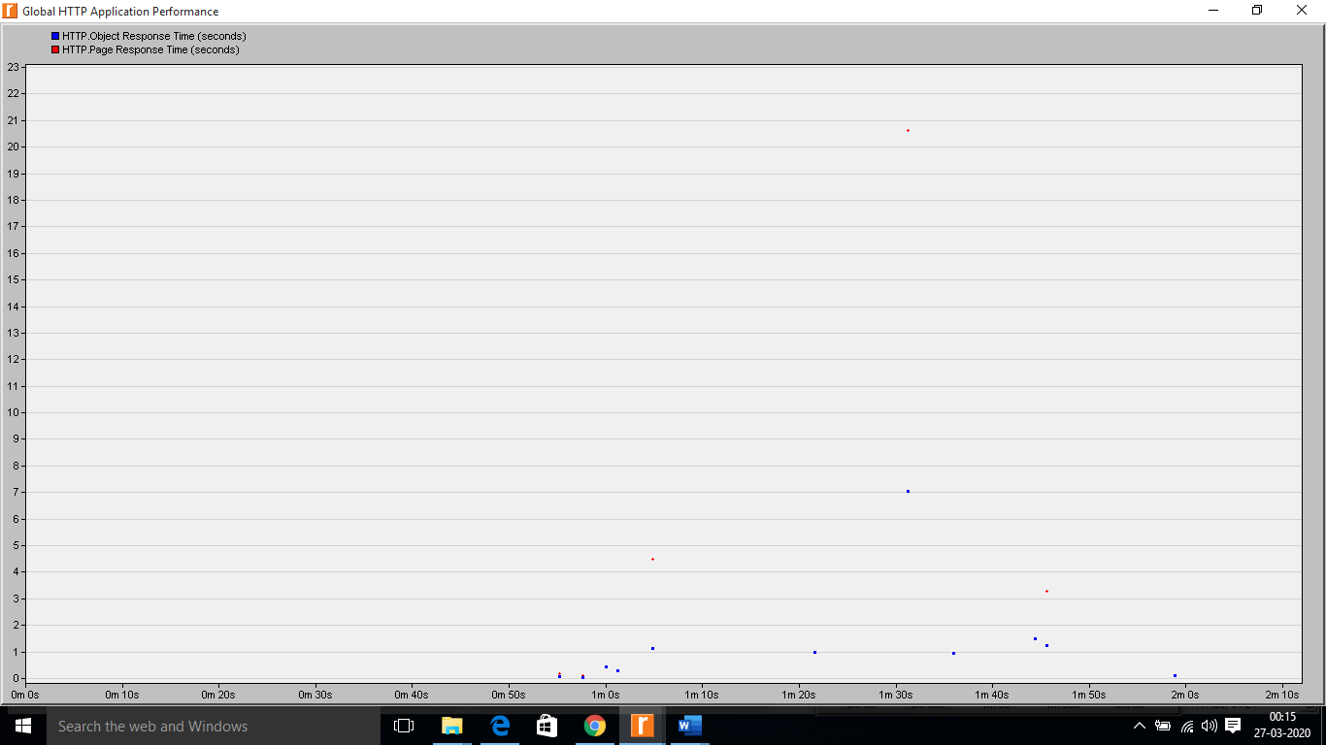 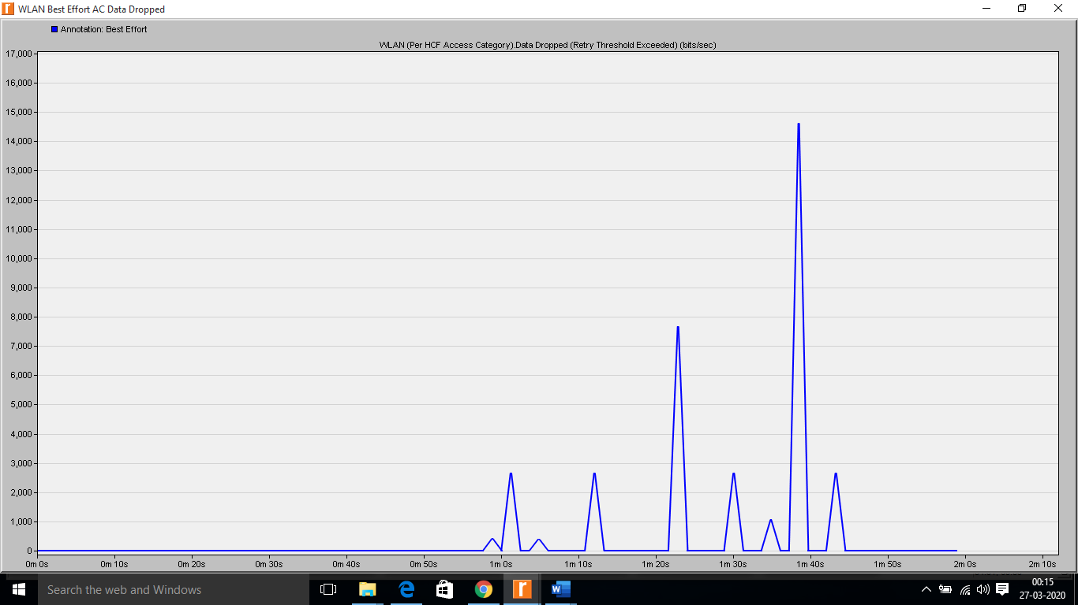

**Fig1: Global (HTTP) Application performance Fig2: WLAN Best Effort AC Data Drop**

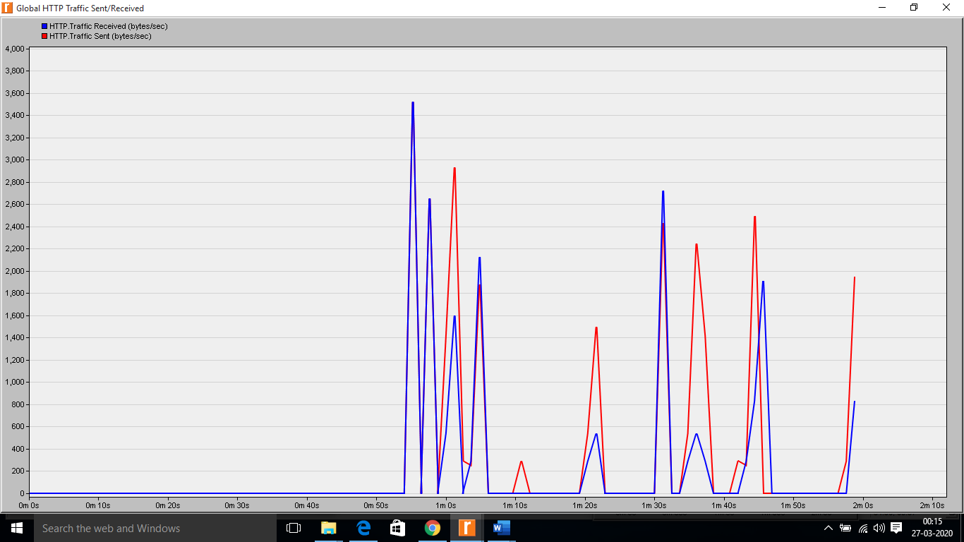

**Fig3: Global HTTP Traffic Sent/Received**

The below simulation results on Global Voice Traffic Sent/Received, Global WLAN Data Dropped (Retransmission), Global WLAN Data Dropped (Buffer Overflow), Global WLAN Performance, Global Average Voice Packet Delay Variation(secs), Global Average Voice End to End Delay(secs) shows that the Data Dropped due to buffer overflow is low. Considerable amount of data drops due to excessive retransmissions indicating tough contention conditions and possibly a “too-small” contention window used by contending stations. In conclusion, with default 11e parameters it is observed that voice application has a better throughput than the HTTP but still has some losses and longer delays while secondary application, HTTP, is still not networkable. High number of WLAN layer retransmissions implies the main bottleneck at layer-2 needs to be tackled for further improvement. The network administrator decides that using QoS would be beneficial and has potential to address the requirements but realizes that he would have to fine tune parameters to satisfy performance constraints before deployment

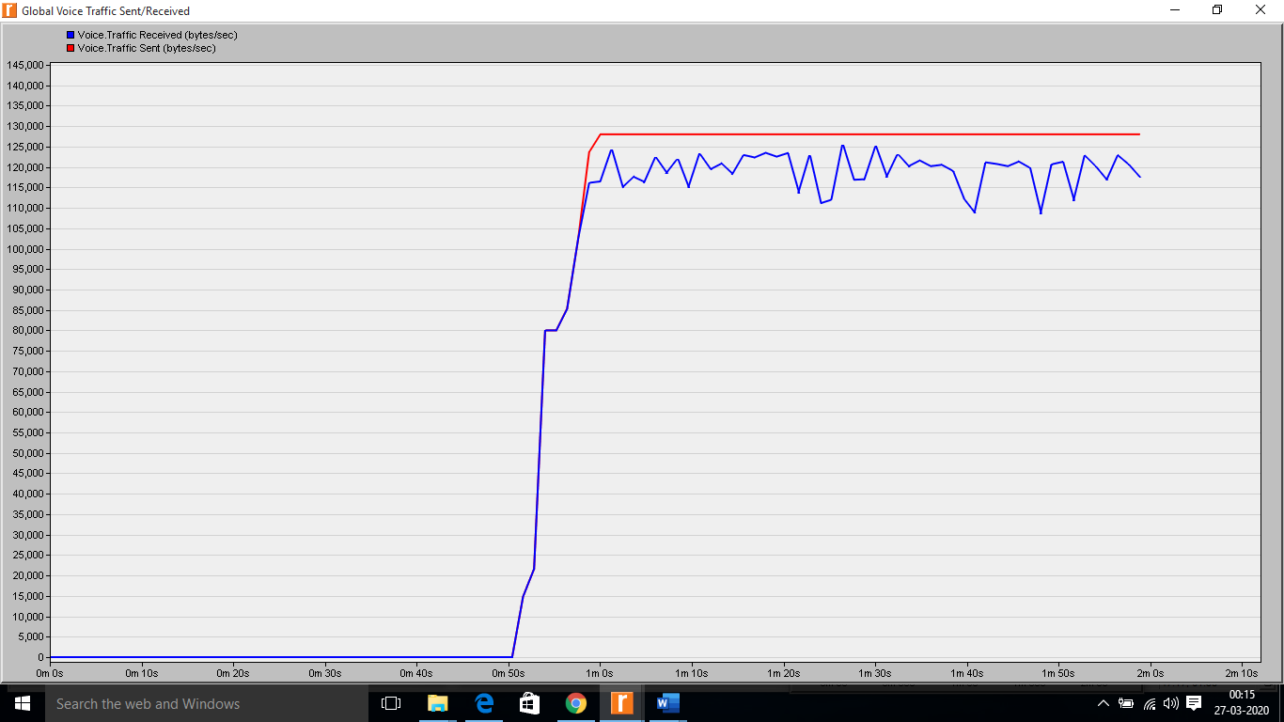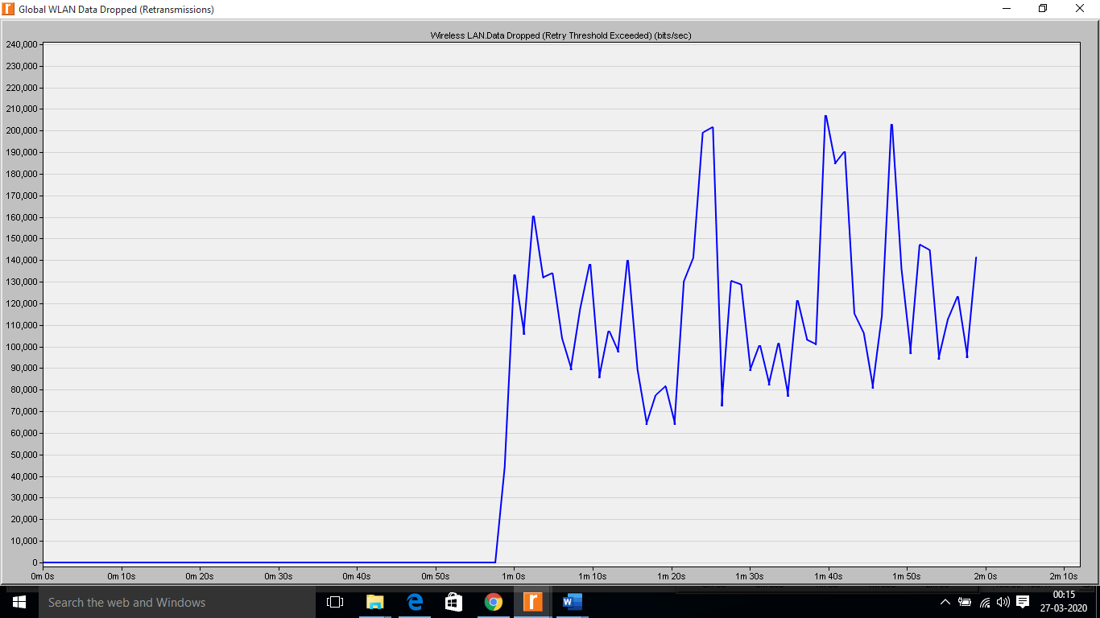

**Fig4: Global Voice Traffic Sent/Received Fig5: Global WLAN Data Dropped (Retransmission)**

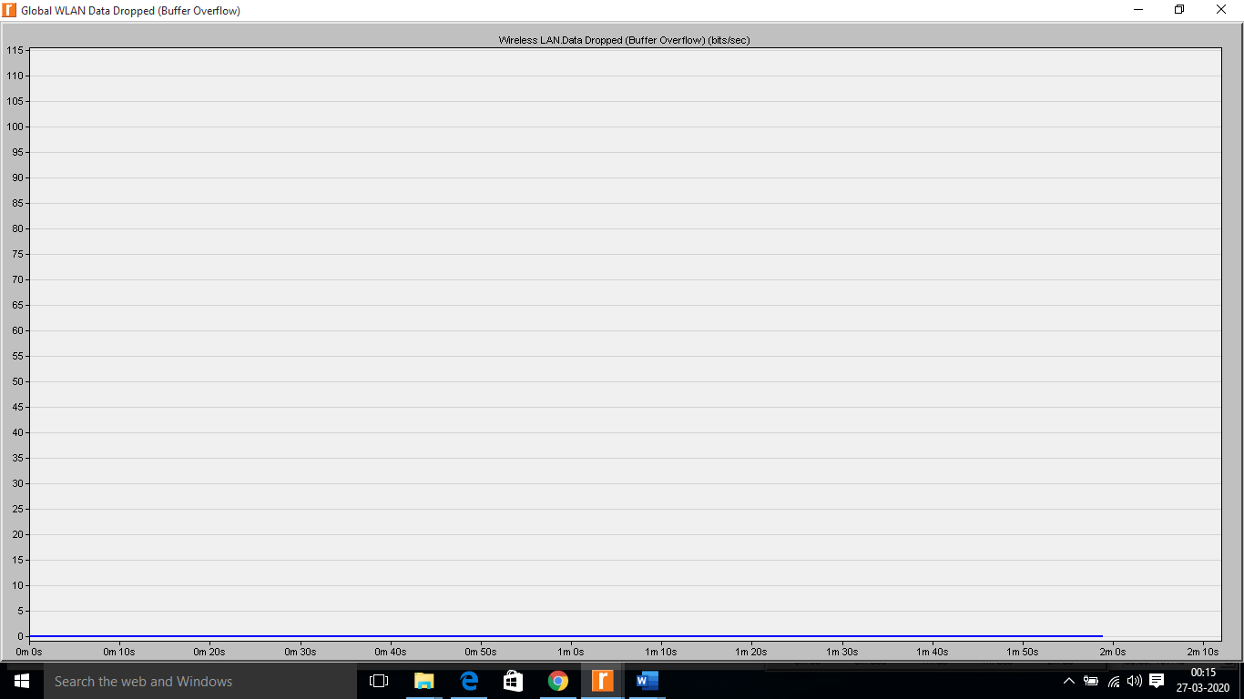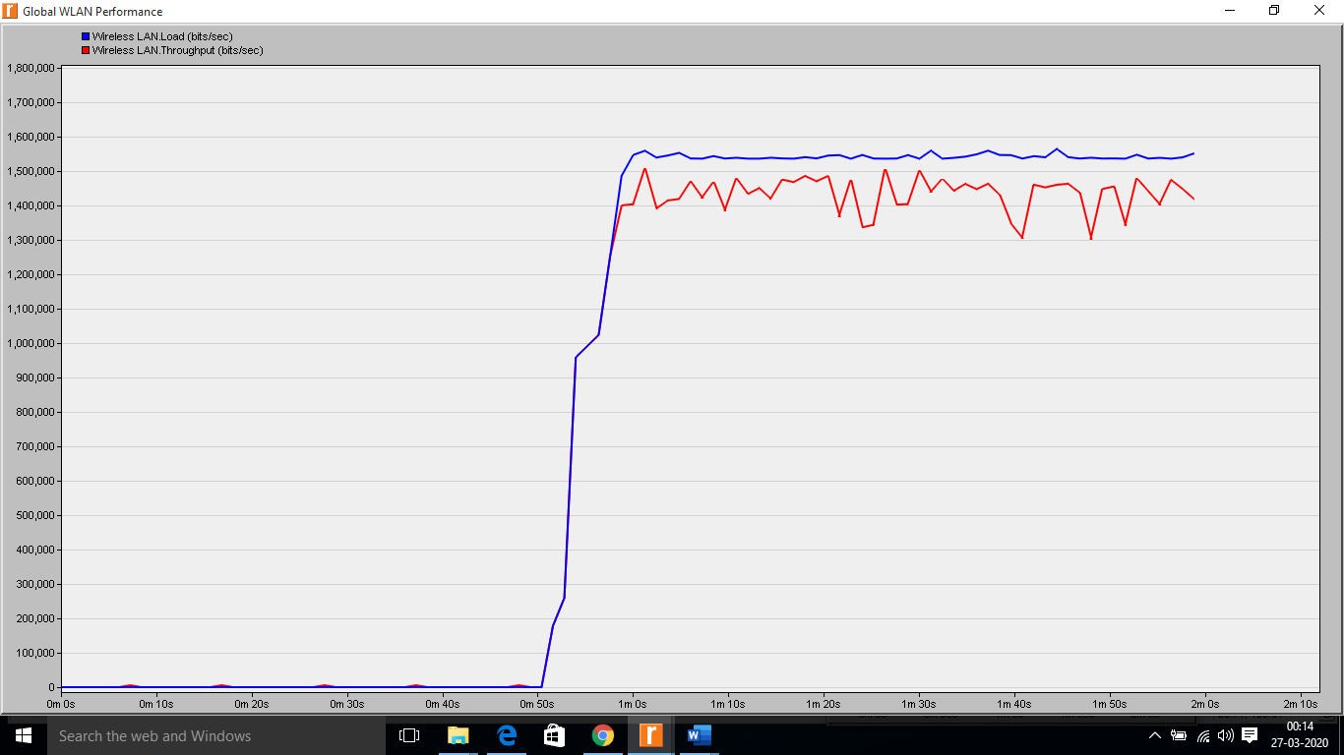

**Fig6: Global WLAN Data Dropped (Buffer Overflow) Fig7: Global WLAN Performance**

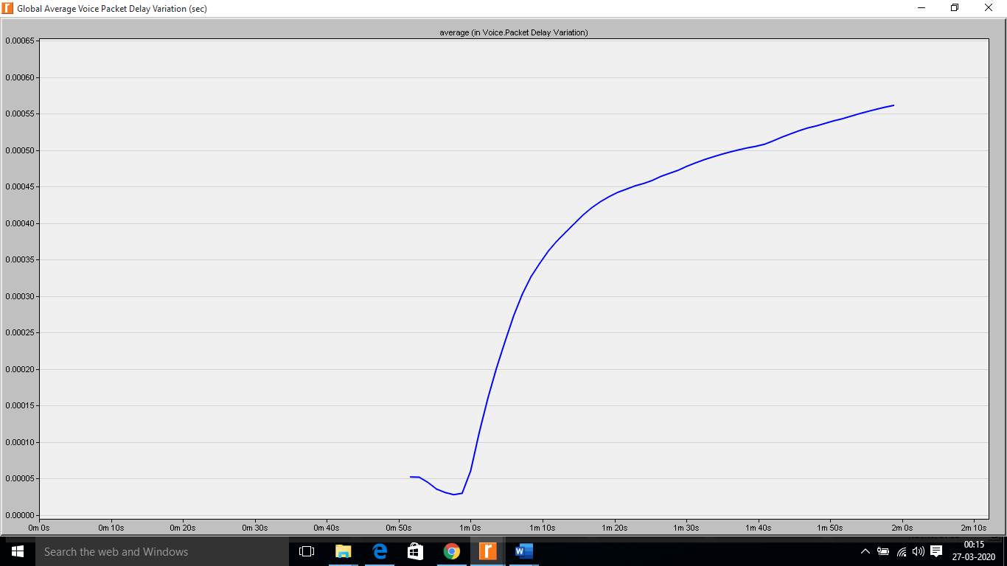 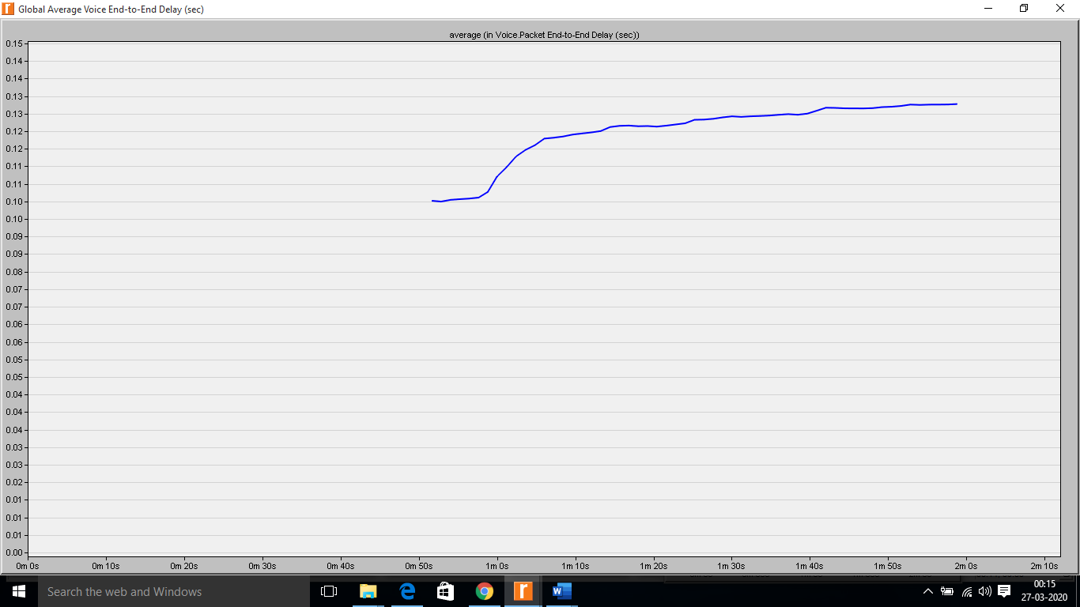

**Fig8:Global Avg Voice Packet Delay Variation(secs) Fig9: Global Average Voice End to End Delay(secs)**

**Scenario 2:** The below simulation result after tuning the 11e default parameters by adjusting the EDCA parameters shows that there is considerable increase in the performance when compared to the same network workstation with the default parameters we could see that Data dropped and Load can be reduced when EDCA parameters are tuned, thus improving the overall throughput.

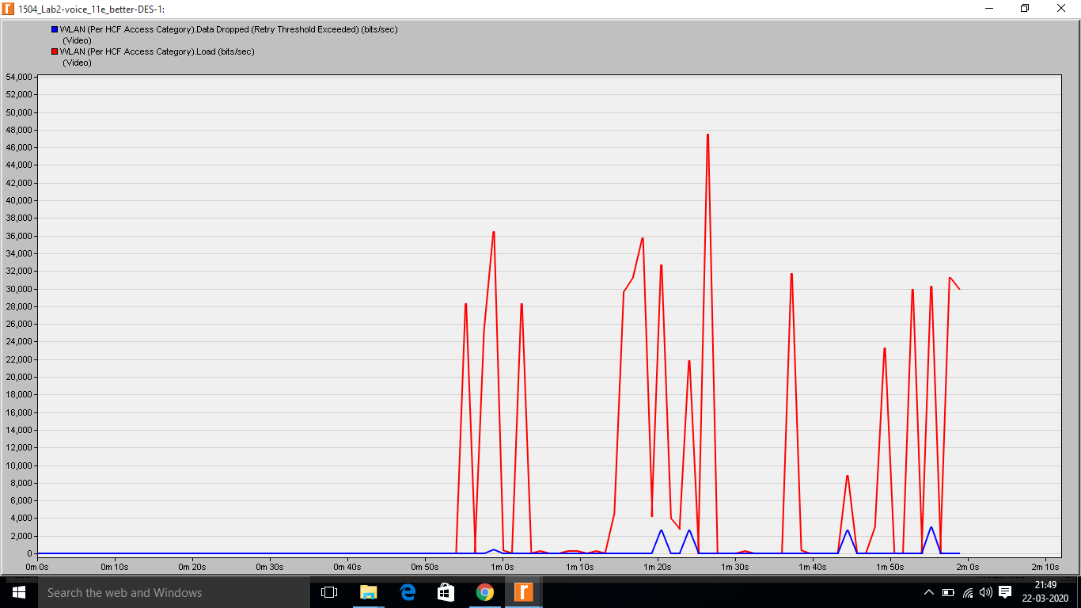

**Figure #1: voice_11e_better-DES-1**

The below simulation result on HTTP. Page Response Time (seconds) is improved when EDCA parameters are tuned according to the traffic when compared to the default parameters.

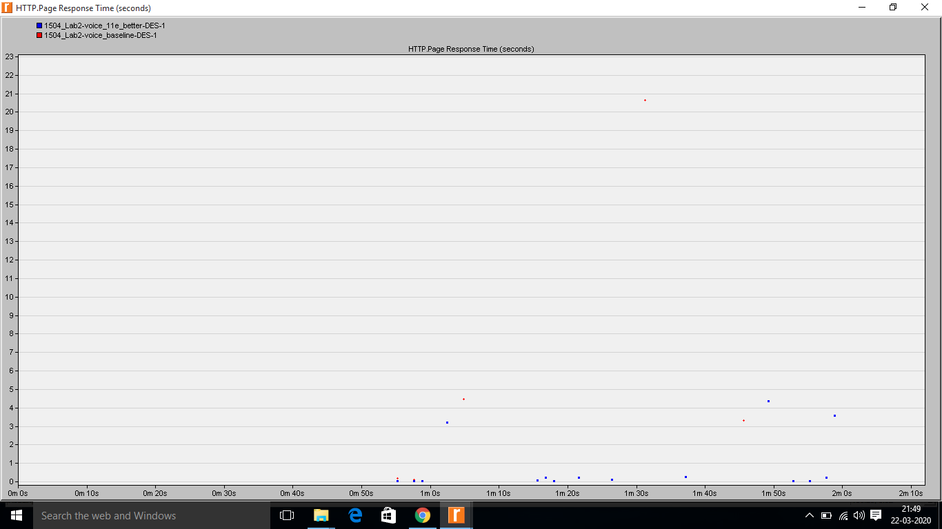

**Figure #2: HTTP. Page Response Time (seconds)**

The below simulation result on Global Voice Traffic Sent and Received (bytes/sec) shows that voice traffic sent and received are almost same overall. However, the adjustment of EDCA parameters lets voice users to imbibe into the wireless network without degrading the network performance and thus increasing the feasibility of the network, besides we also achieved a decrease in amount of dropped Voice AC data due to reaching retry limit

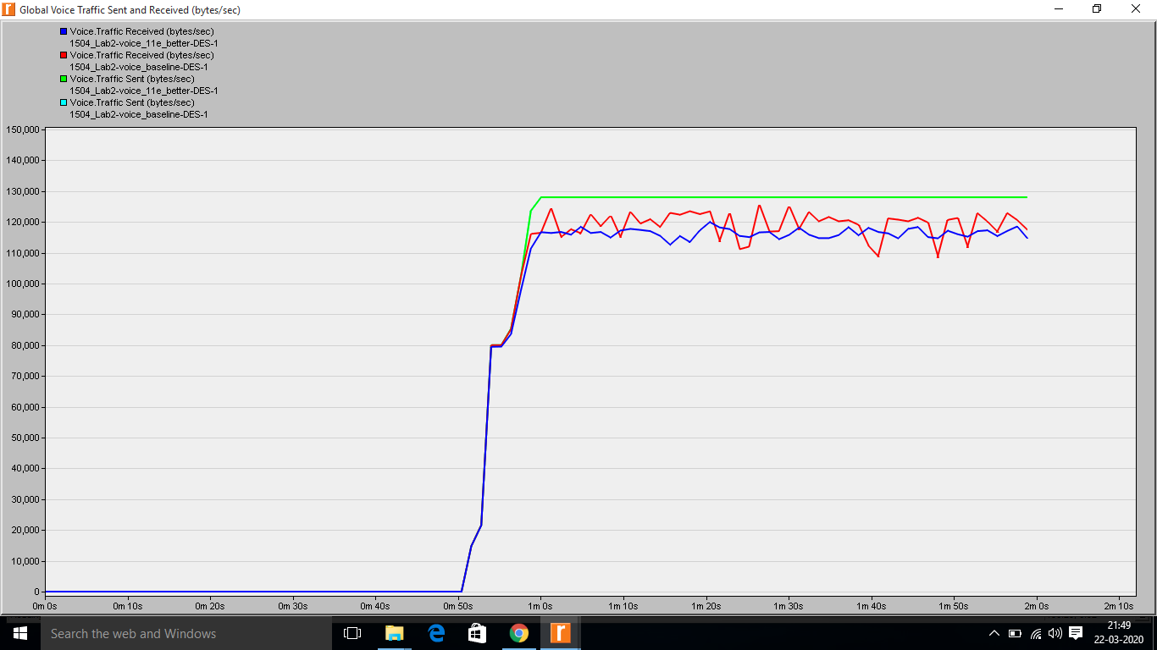

**Figure #3: Global Voice Traffic Sent and Received (bytes/sec)**

The below simulation result on Global Average Voice End-to-End Delay (secs) shows that with the default settings we get higher delay and with adjusting the related EDCA parameters based on network and traffic conditions and change the acknowledgement policies for the traffic categories corresponding to application traffic we find lesser voice end to end delay, thus improving the overall throughput of the network and concluding that voice application has a better throughput than the HTTP but still has some losses and longer delays.

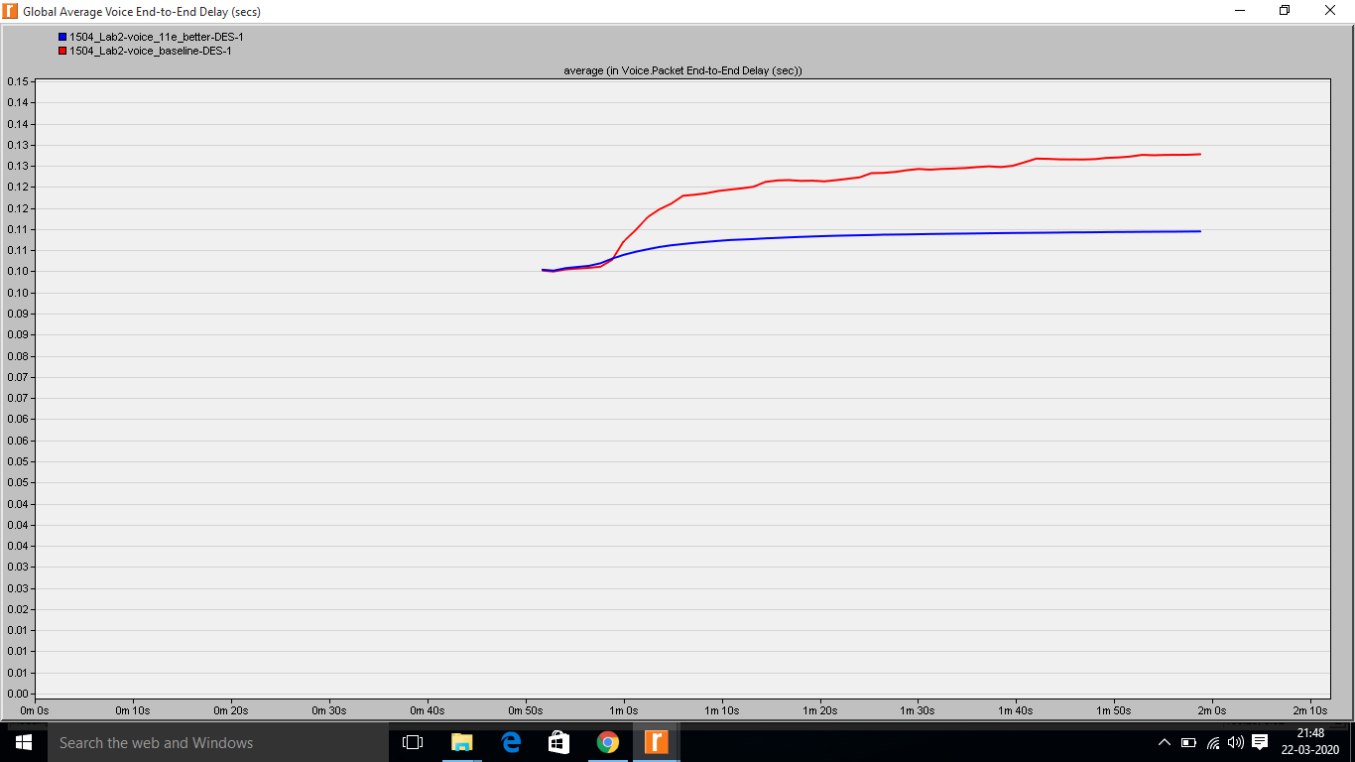

**Figure #4: Global Average Voice End-to-End Delay (secs)**

The below simulation result on Global Average Voice Packet Delay Variation (secs) shows that difference of packet delay in the both the scenarios are varied by 0.0005 secs i.e. retransmissions (of RTS frames instead of data frames) and packets due to reaching retry limit varies by 0.0005 secs. This result is due to change in the configuration and WLAN convention will begin performing RTS/CTS outline trade before the principal casing of Voice AC TXOPs (transmission openings) to give security to the unacknowledged voice traffic at layer-2 by saving the medium in an affirmed way.

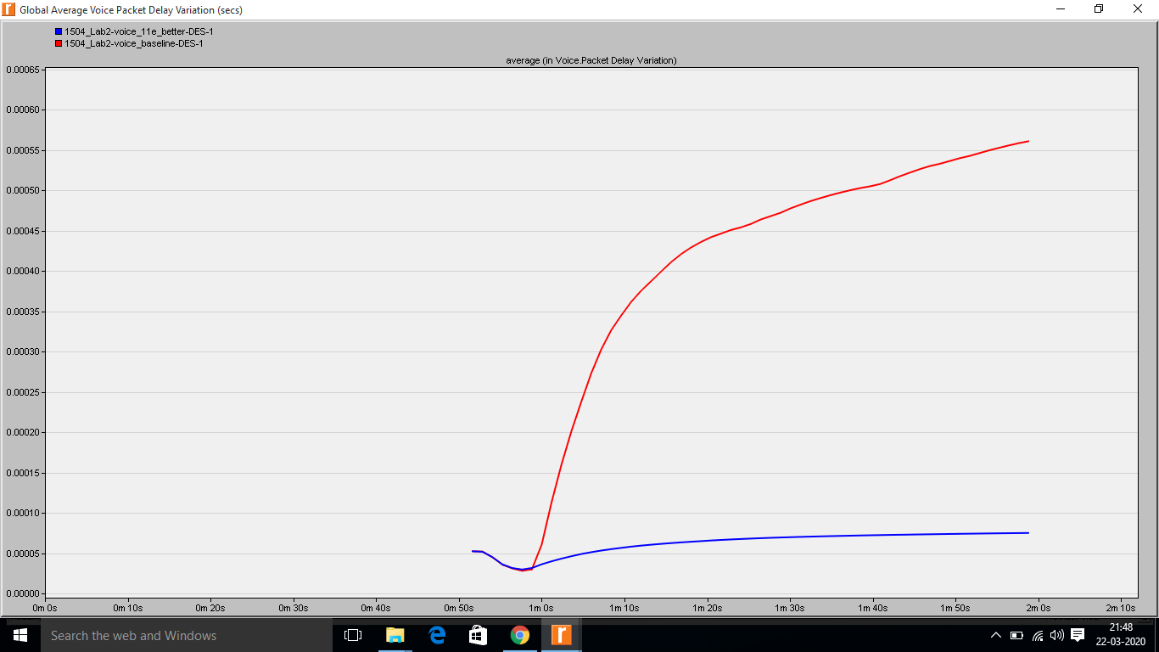

**Figure #5: Global Average Voice Packet Delay Variation (secs)**

The below graph on Global Average Voice Jitter (secs) when 11e parameters are tuned seems to perfume good with less jitters and by comparing it with the default parameters configuration settings, thus shows that voice users could be rather use the network with more performance.

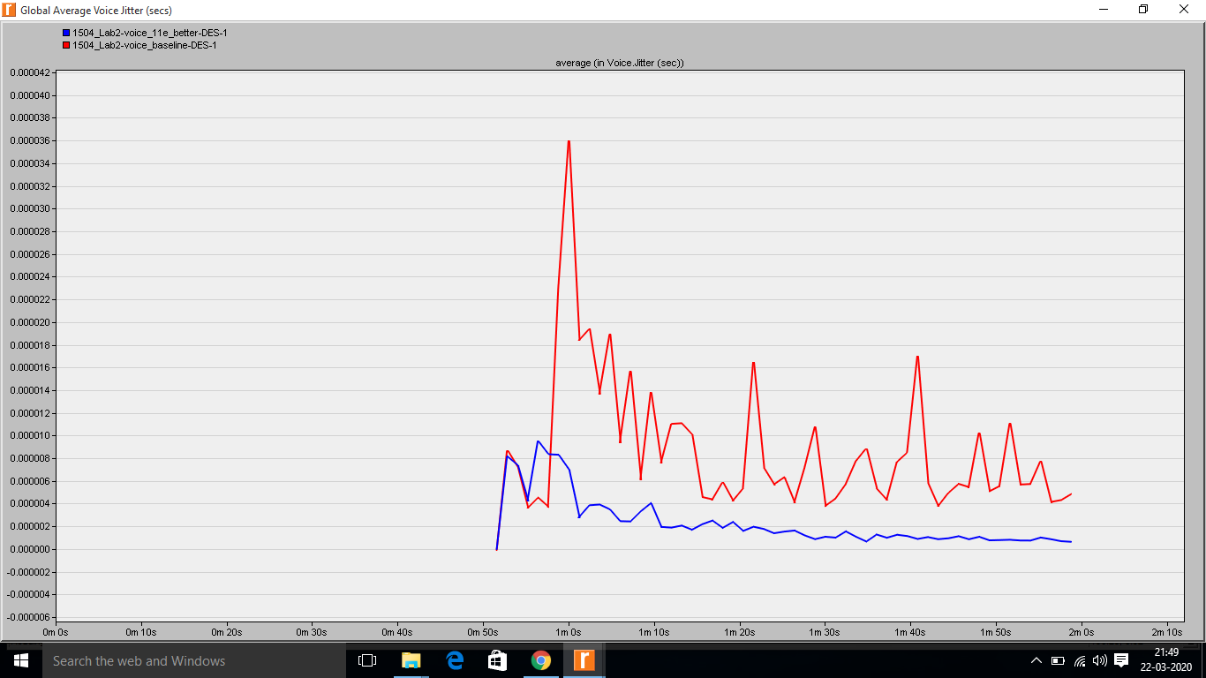

**Figure #6: Global Average Voice Jitter (secs)**

The below simulation result WLAN (Per HCF Access Category) Data Dropped (Retry Threshold Exceeded) (bits/sec) shows a little variation in the data dropped in scenario 2 when compared with the default parameters in the wireless network which was setup to check the feasibility of the voice users in the 11n wireless network.

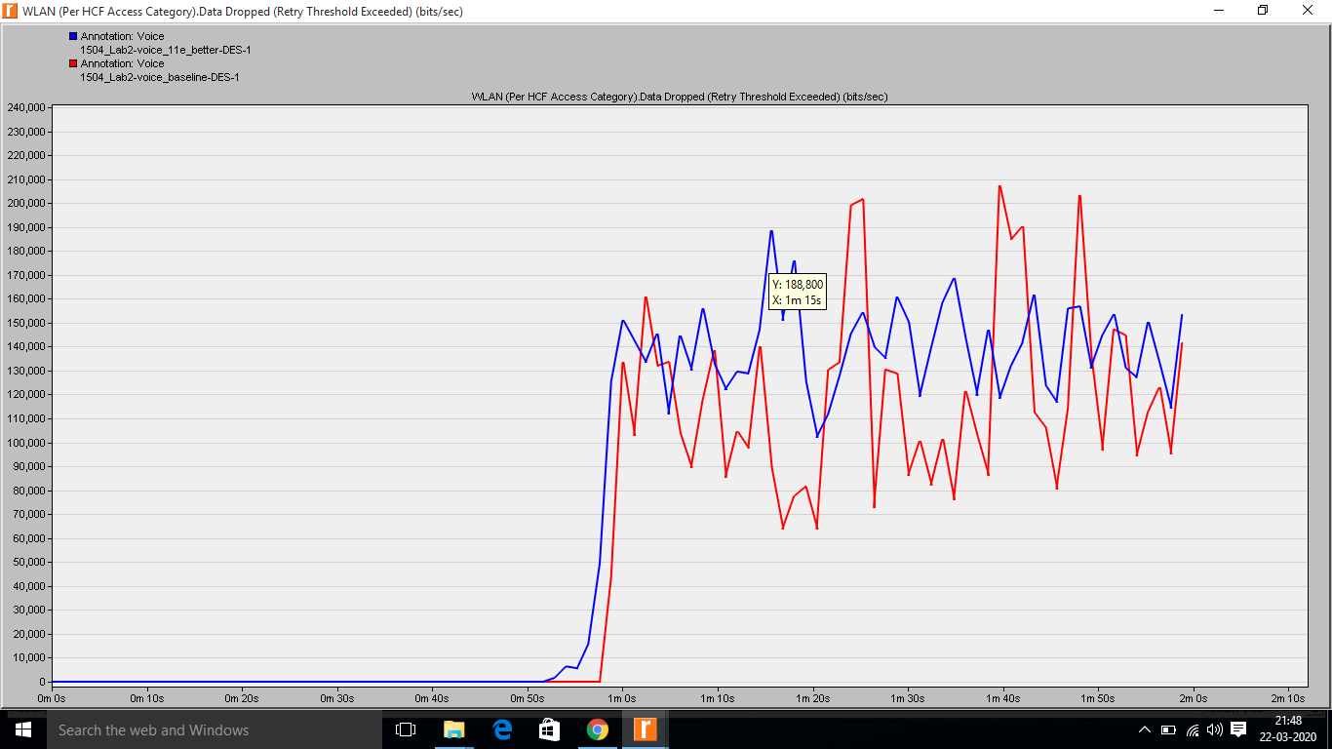

**Figure #7: WLAN (Per HCF Access Category) Data Dropped (Retry Threshold Exceeded) (bits/sec)**

The below simulation result on Overall throughput performance of the Wireless LAN Throughput (bits/sec) when EDCA parameters adjusted according to the network and traffic conditions it proves that network performance would is almost same when compared to the default settings. However, this lab results shows that we increased the quality of voice calls across our network by reducing end-to-end, delay variation and jitter values as well as increasing the percentage of voice traffic that could be successfully delivered from source to destination.

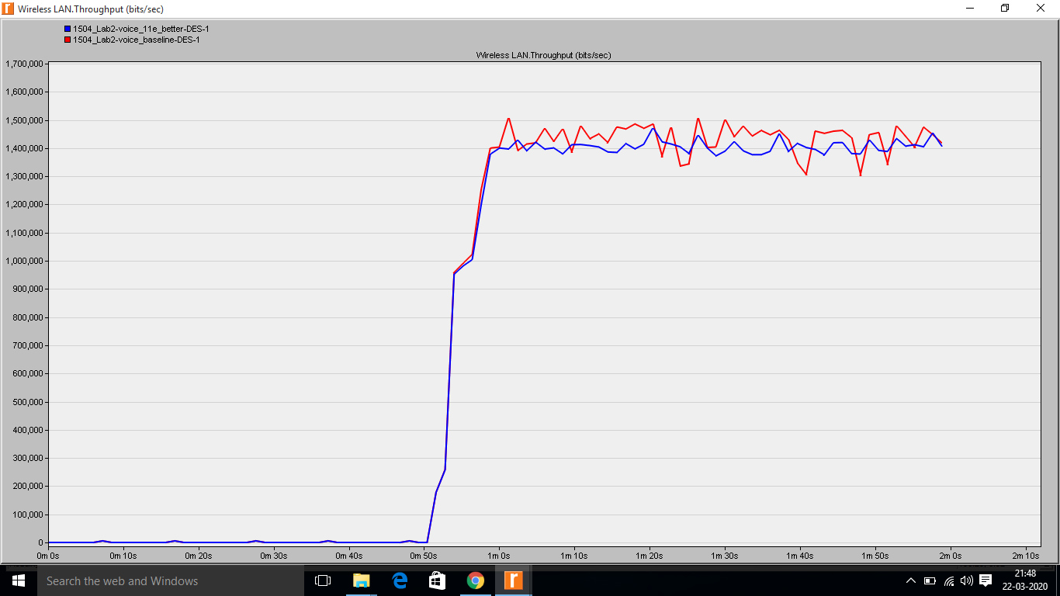

**Figure #8: Wireless LAN Throughput (bits/sec)**

The below simulation result on WLAN (Per HCF Access Category) Throughput (bits/sec) shows that the effect of that change in terms of throughput. As the throughput for the Voice improves a direct inverse effect on the Best Effort traffic is experienced, thus concluding that voice application has a better throughput. Besides, by changing Traffic Category parameters and EDCA parameters utilized in organized medium access dependent on the conditions in our system, we designed the WLAN layer, with the end goal that now it performs at a level that gives worthy quality to all applications running in our system.

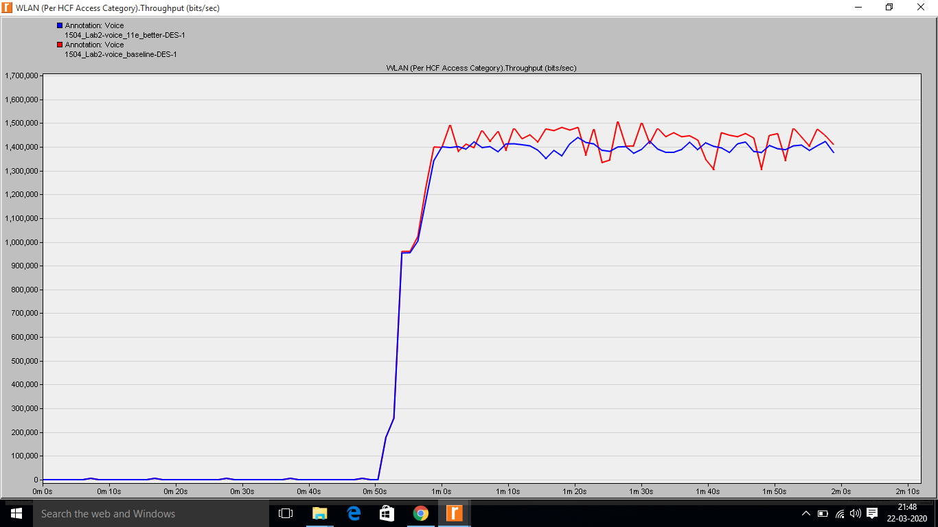

**Figure #9: WLAN (Per HCF Access Category) Throughput (bits/sec)**

**CONCLUSION**

The simulation results in both the scenarios shows that its feasible to have voice users in 11n network without degradation of the through which can be seen in Figure 9 and Fig 5 in the both scenario 2 and 1. Thus this lab concludes that by tuning EDCA parameters it always helpful in adding a voice user to the WLAN 11n BSS network. The simulations included with a similar number of stations and the one Access Point. With HCF empowered working with the default QoS parameters for AIFS, CWmin, CWmax and TXOP , examination included creating equivalent measure of both intuitive and best exertion traffic. QoS pointers were later investigated in charts. The considerable increase in global WLAN layer throughput with the same physical layer also confirms the positive outcome of our parameter adjustments. It tends to be inferred that throughput for applications like Voice over IP and video conferencing, EDCA gives better throughput by giving them greater need over different administrations like basic HTTP and FTP.