OUTPUT OF MY TERRAFORM REPO CODE

1. Output of validation of code

2. Output of apply of code

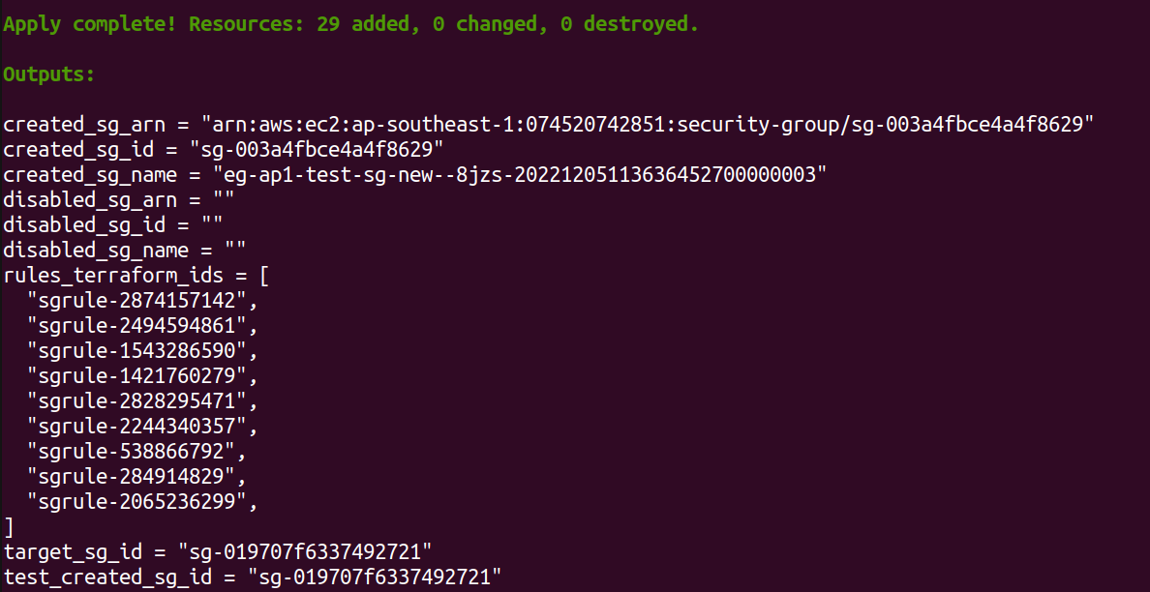

3. Current State list

