# db-assignment

Set up express backend.
cd express-bk
npm install
npm start

Set up react UI
cd react-ui
npm install
npm start

Check and console should look like below for express server.

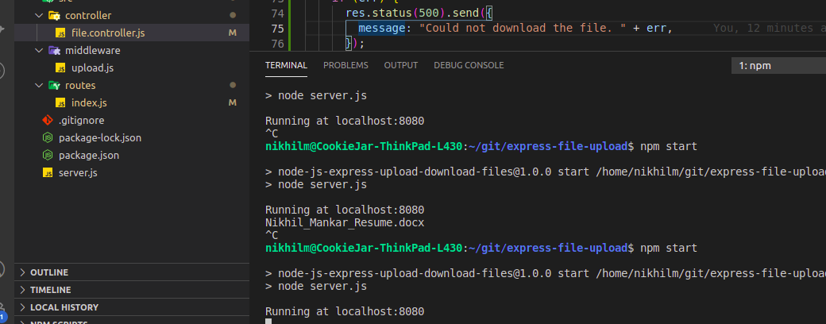

Below is for React Js ui

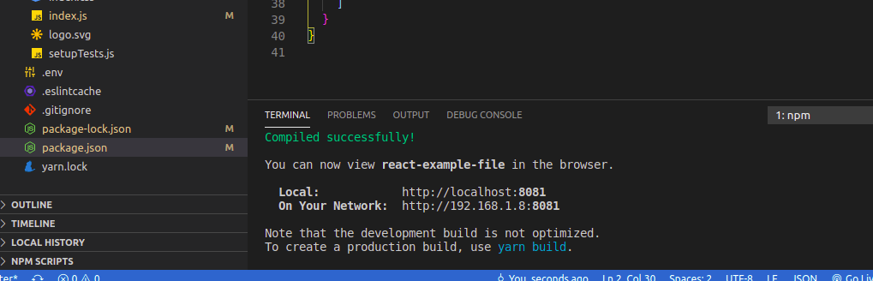

UI Should looks like below.

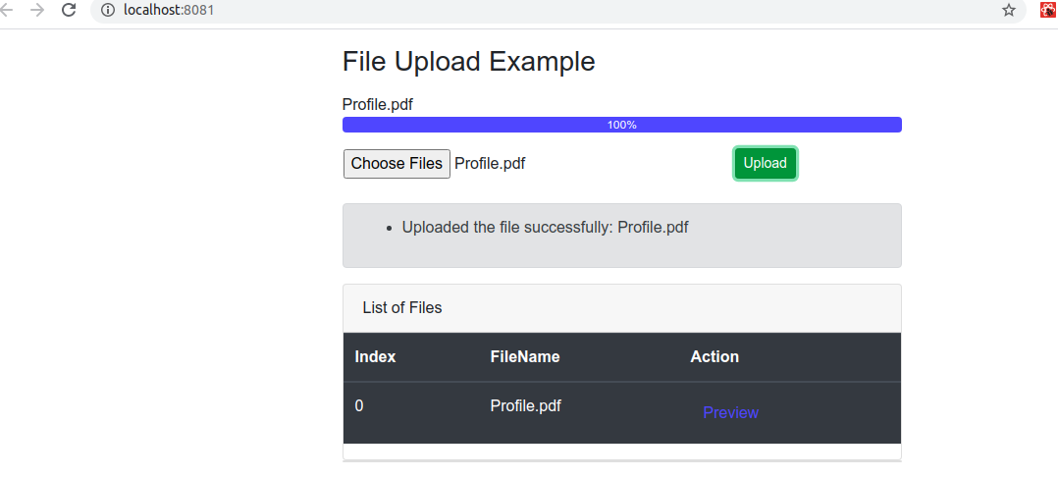

Set up for Spring boot trading system.

cd trade-spring-boot
mvn install
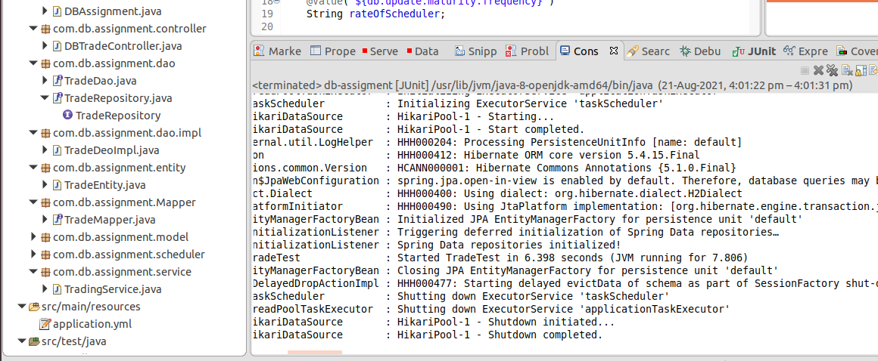

Check for Lombok and Mapstruct plugin.
If any error try adding lombok in your IDE class path.
For Map struct , disable maven worksapce resolution.

