

SSO SAML integration with ProPhish

Application

Prepared by: Lakshmi Prasath (Director – Engineering) &
Nikhil Jayakar (Csm)
Prepared on: Jul 12, 2024



Contents
- Overview 3
- Requirement 3
- Procedure 3

Overview

This document contains the procedure to be followed by the Azure AD administrator to Single Sign On with SAML integration to the prophish applicaiton.

Requirement

  - Azure AD / Entra administrator access

Procedure

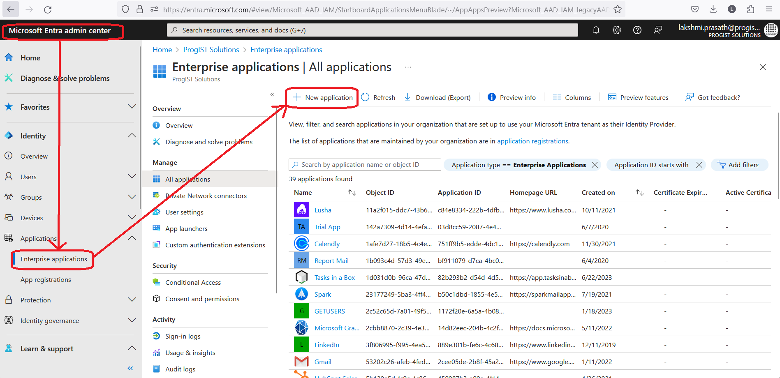
- Login to Microsoft Entra admin centre and create a new enterprise application.

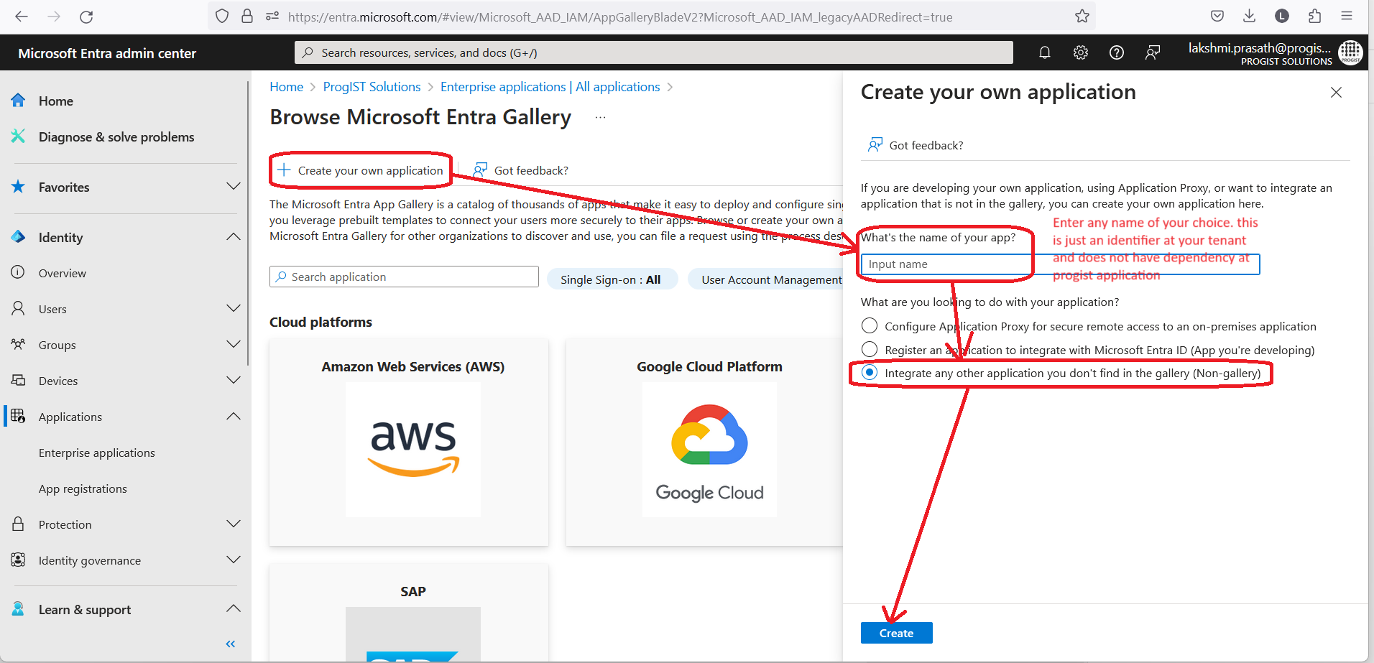
- Enter the name of the application and choose non-gallery application and create.

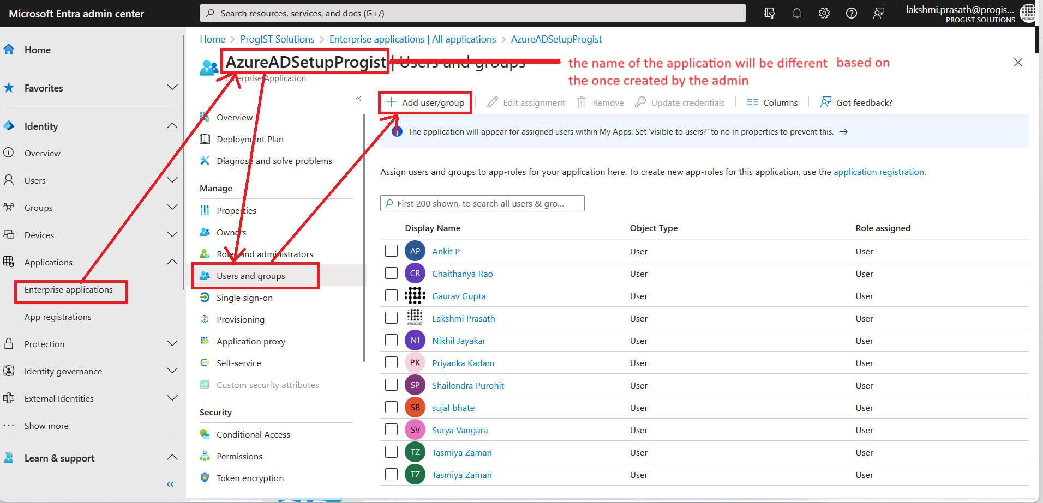
- Select and add the Users that require to access the Progist application using SSO

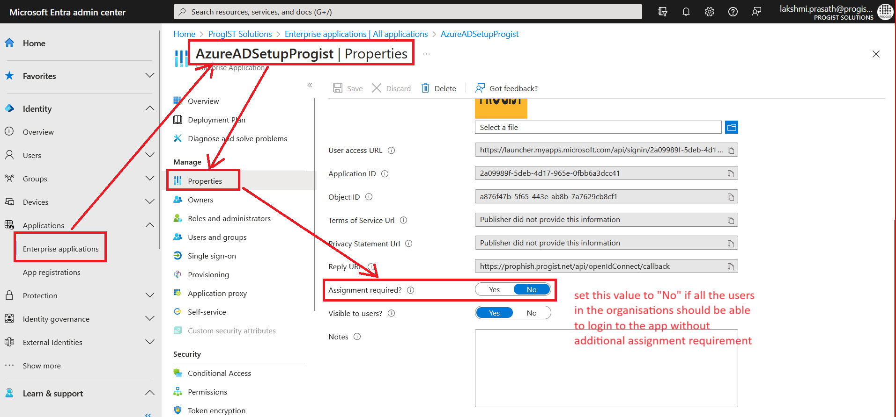
- If all the users in the tenant need to access the application, you can disable user assignment requirement for this application
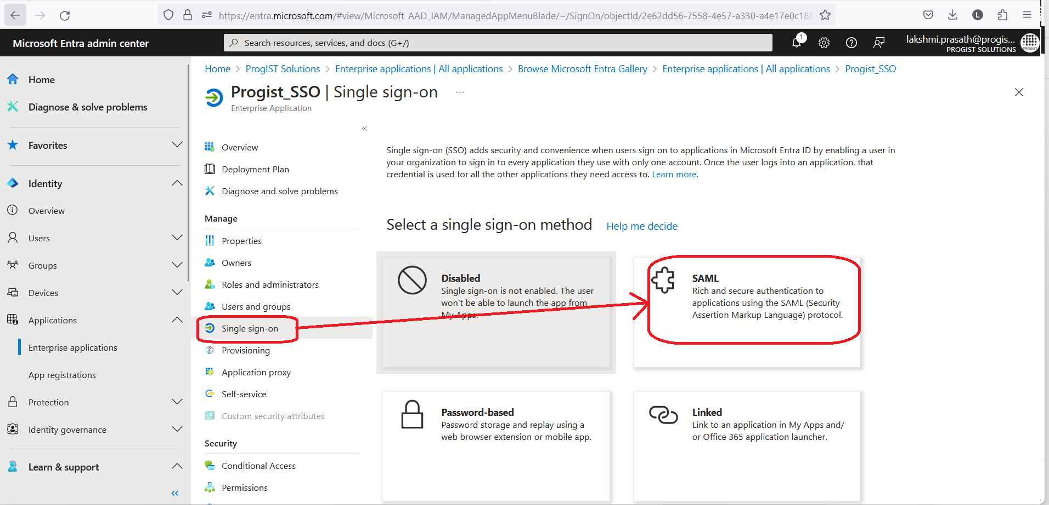
- Go to SSO menu and select SAML

- Click on edit and add the SAML configuration details provided by Progist team
- Identifier (Entity ID): https://(Domain)_progist.progist.net
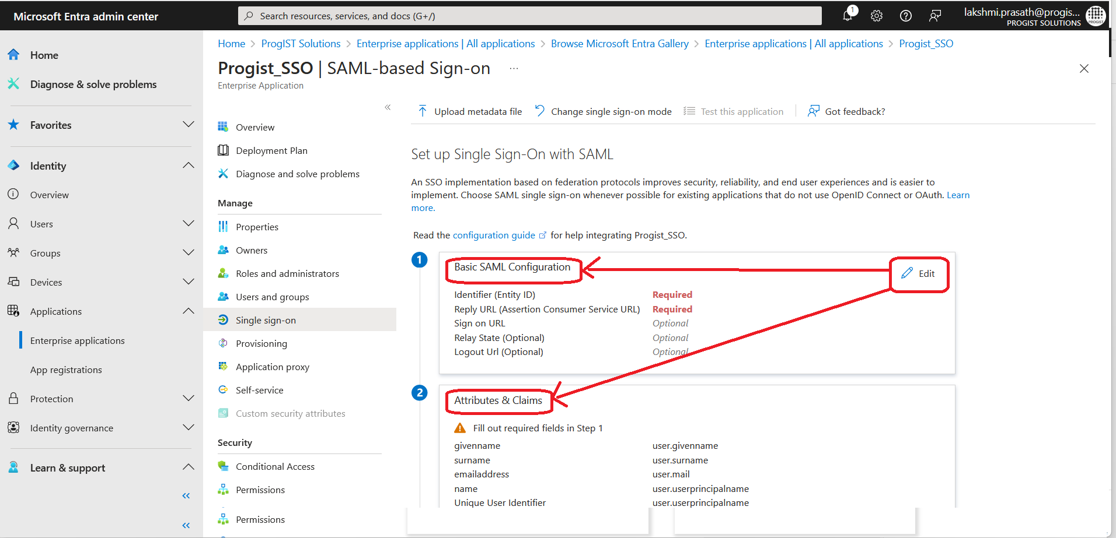
- Reply URL (Assertion Consumer Service URL): https://prophish.progist.net/api/openldConnect/callback

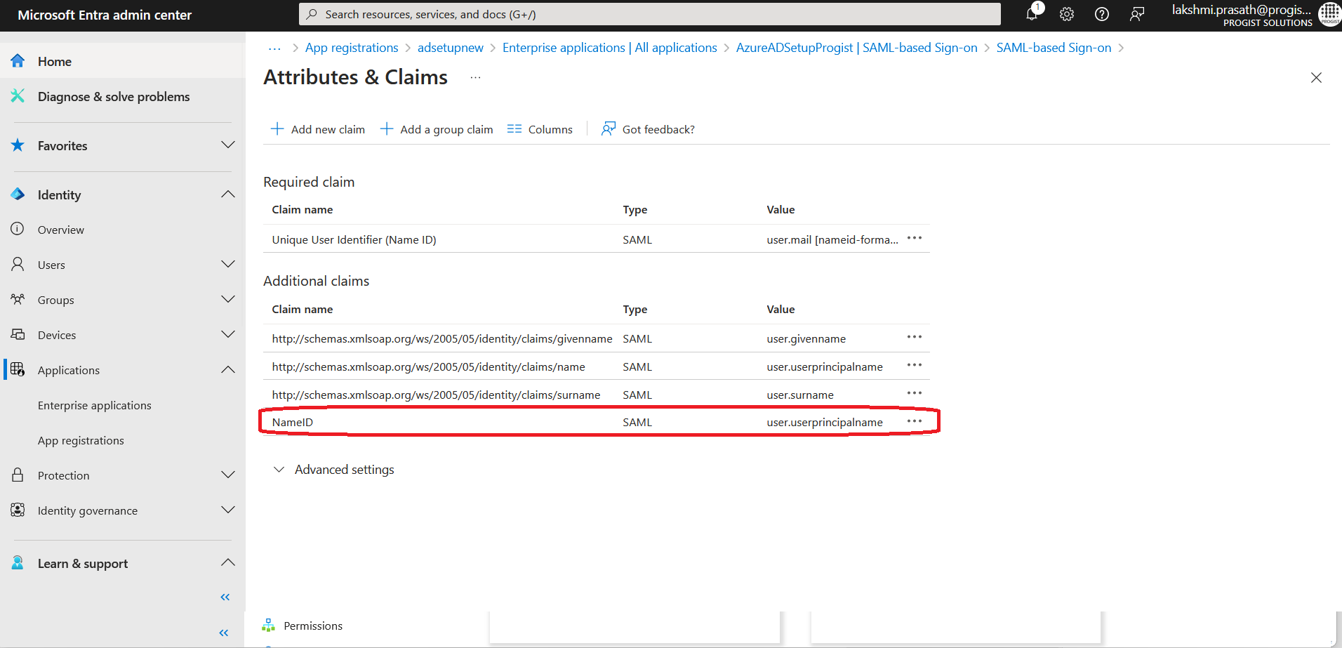
- In the attributes and claims Add the parameter for NameID

