Front-end:



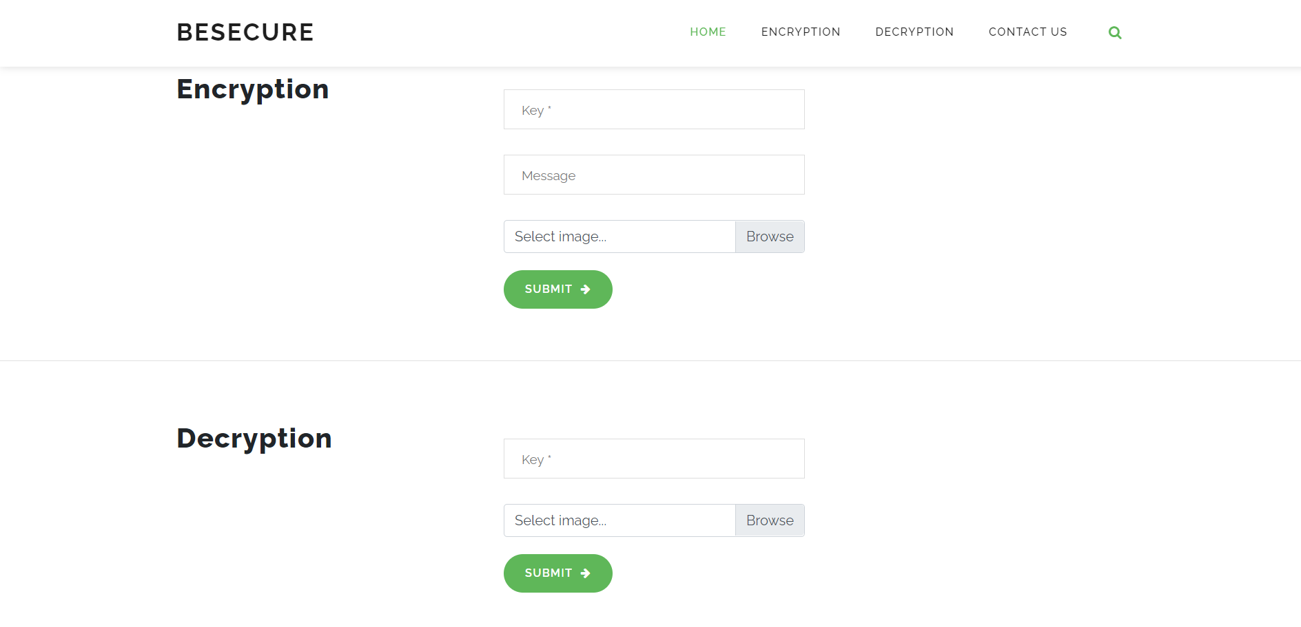

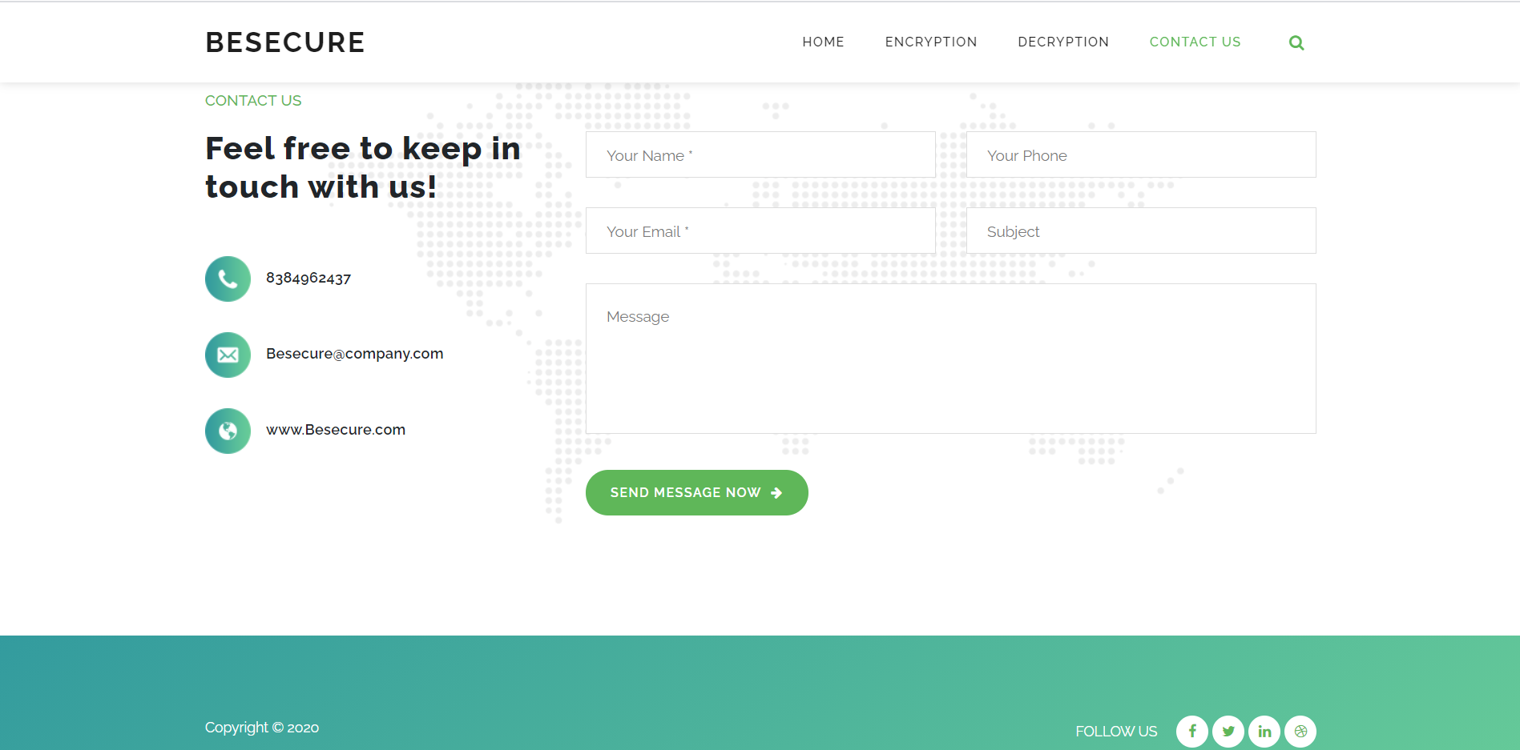

Results:

Image before hidden message:

Basically you cant see any change and that’s only the trick here and ya if you see on boundaries you will find the trick.

Flowchart:

