**Automated Distributed Performance Test Execution**

Name – Nikhil N Panchghare

Date – October 2021

# Objective

# Automate lengthy process of Performance Test Execution in JMeter with Distributed Test Setup

# Why Automation

* Minimize prone to Human errors while interacting with multiple JMeter instances
* Update JMeter property for slave machine IP
* Missed to update copy of Test plan on JMeter Master
* Copying supported files on multiple JMeter instances
* Keep note of IP Addresses of JMeter instances
* Internet or VPN issue during the long process of performance test execution
* Generate HTML Summary Report at the end and share with the Team

## Typical JMeter Distributed Testing Flow

## 

What is being done in this Automation

* Minimum or zero interaction with JMeter instances
* Used Jenkins to control Start and Stop JMeter process on Master or as many Slave(s)
* Use of GitHub for JMeter Test Plan
* Parameterized Threads, Rampup, IP's of JMeter instances, User Data file
* JMeter Summary Report screenshot over Email
* Maintained history of Test Artifacts for each run

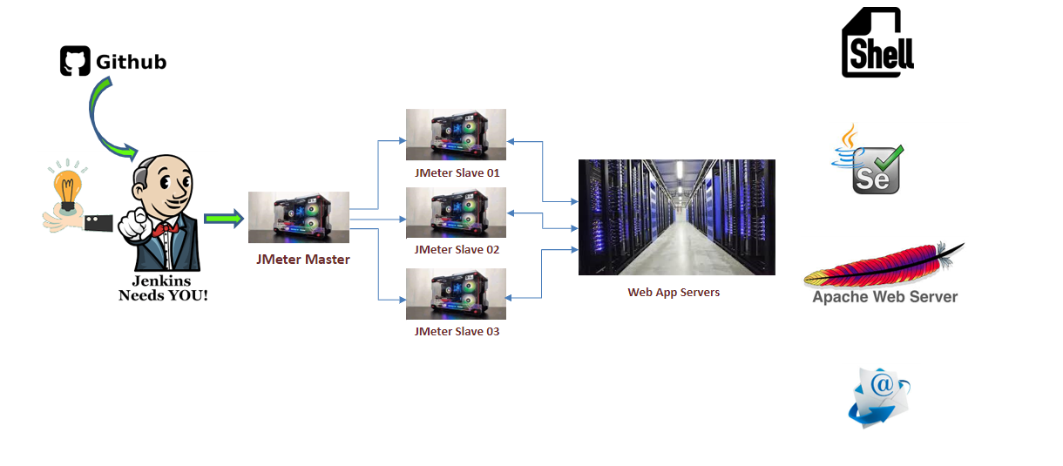

**JMeter Master added as Slave in QA Jenkins**

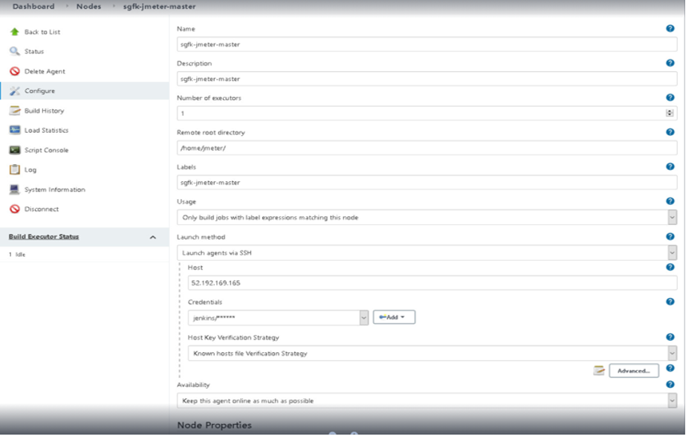

**Parameterize Test Plan for Threads and Rampup**

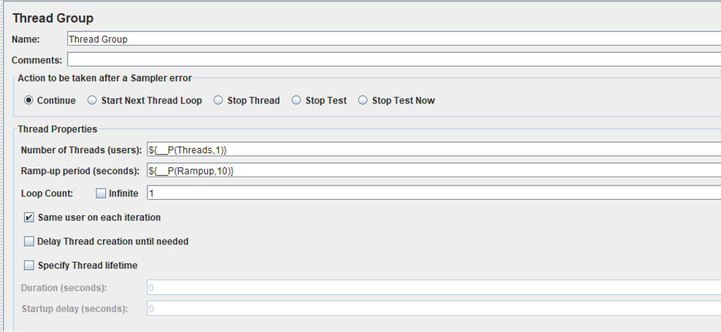

**Configure CSV Data Config in Jmeter Test Plan**

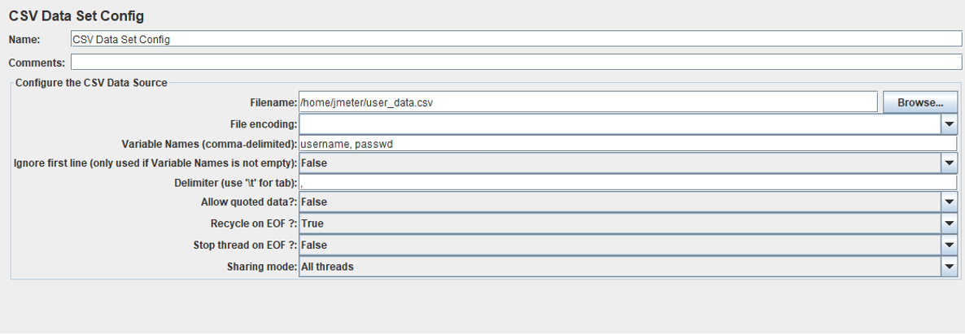

**SCRIPT USED**

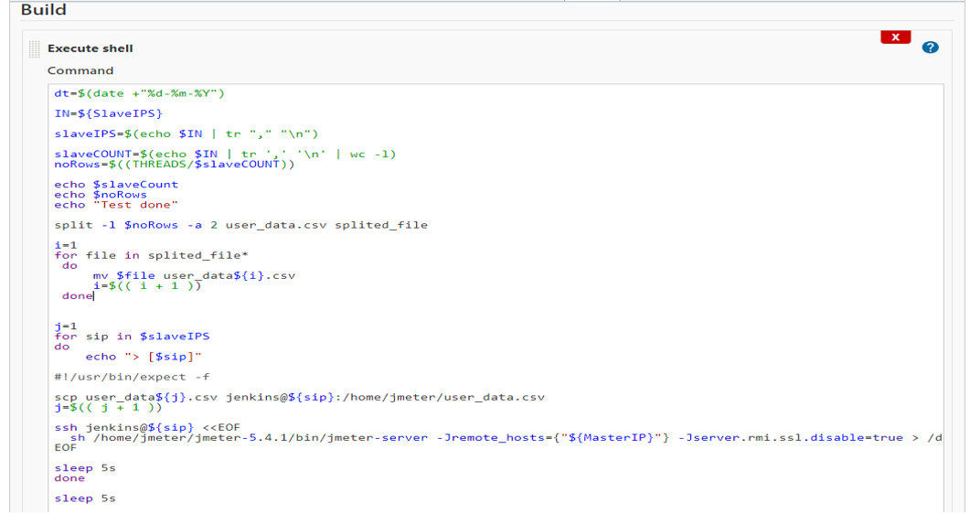

**Jenkins Job Execution**

* In MP4 file Name - Jenkins_Job_Execution.mp4
* Setup (JMeter, Apache Web Server, Jenkins JOB) in Mp4 File NAme - Setup - Jmeter_ApacheWebServer_JenkinsJob_0.mp4