**Project Flow**

**To accomplish this, we have to complete all the activities listed below,**

* **Define Problem / Problem Understanding**
  + **Specify the business problem**
  + **Business requirements**
  + **Literature Survey**
* **Data Collection** 
  + **Collect the dataset,**
  + **Connect Data with Qlik Sense**
* **Data Preparation**
* **Prepare the Data for Visualization**
* **Data Visualizations**
  + **Visualizations**
* **Dashboard**
  + **Responsive and Design of Dashboard**
* **Story**
  + **Story Creation**
* **Performance Testing** 
  + **Amount of Data Rendered to DB ‘**
  + **Utilization of Data Filters**
* **Project Demonstration & Documentation**
  + **Record explanation Video for project end to end solution**
  + **Project Documentation-Step by step project development procedure**

**Define Problem / Problem Understanding**

**Specify The Business Problem**

**The specific business problem revolves around the inadequacy of the current lending strategy, which is not sufficiently informed by comprehensive insights derived from LendingClub loan data. The institution struggles to assess borrower behavior and market dynamics effectively, resulting in challenges such as inaccurate risk identification, difficulties in predicting loan default rates, and the inability to dynamically adjust lending criteria to respond to evolving market conditions.**

The lending industry faces numerous challenges that can affect profitability, risk management, and customer satisfaction. These problems range from credit risk assessment to regulatory compliance and technological integration. Addressing these issues is crucial for financial institutions to maintain competitive advantage and financial stability.

**Key Business Problems**

1. **Credit Risk Assessment**
   * **Problem**: Accurately assessing the creditworthiness of borrowers is critical. Incorrect assessments can lead to high default rates and significant financial losses.
   * **Solution**: Implement advanced analytics and machine learning models to improve the accuracy of credit risk evaluations, leveraging both traditional financial data and alternative data sources.
2. **Loan Default Rates**
   * **Problem**: High loan default rates can severely impact the profitability of lending institutions and increase the cost of capital.
   * **Solution**: Develop robust predictive models to identify potential defaulters early and implement proactive measures such as customized repayment plans or targeted financial counseling.
3. **Fraud Detection**
   * **Problem**: Fraudulent activities in loan applications and repayments pose a significant risk, leading to financial losses and reputational damage.
   * **Solution**: Utilize real-time data analysis and anomaly detection systems to identify and prevent fraudulent transactions. Machine learning algorithms can help in recognizing patterns indicative of fraud.
4. **Regulatory Compliance**
   * **Problem**: Compliance with constantly evolving regulations is both complex and costly. Non-compliance can result in hefty fines and legal challenges.
   * **Solution**: Implement comprehensive compliance management systems that are regularly updated to reflect current regulations. Employ AI-driven solutions to monitor compliance in real-time.
5. **Customer Experience**
   * **Problem**: Poor customer experience can lead to customer attrition and loss of market share. Factors such as slow loan processing times, lack of transparency, and inadequate customer support contribute to this issue.
   * **Solution**: Enhance digital platforms for faster and more transparent loan processing. Use customer feedback to continuously improve service quality and support.
6. **Data Management**
   * **Problem**: Effective management of large volumes of data from various sources is challenging. Poor data quality can lead to inaccurate analyses and decision-making.
   * **Solution**: Implement robust data management frameworks that ensure data accuracy, completeness, and security. Employ advanced data integration tools to consolidate and analyze data efficiently.
7. **Economic Fluctuations**
   * **Problem**: Economic downturns and fluctuations can impact borrowers' ability to repay loans, leading to increased default rates.
   * **Solution**: Develop adaptive risk management strategies that consider economic indicators and trends. Diversify the loan portfolio to spread risk across different sectors.
8. **Competition**
   * **Problem**: The lending market is highly competitive, with numerous traditional banks, fintech companies, and peer-to-peer lending platforms vying for market share.
   * **Solution**: Differentiate offerings through innovative financial products, personalized lending solutions, and superior customer service. Leverage technology to streamline operations and reduce costs.
9. **Operational Efficiency**
   * **Problem**: Inefficient loan processing and operational workflows can lead to higher operational costs and reduced profitability.
   * **Solution**: Automate repetitive tasks and streamline workflows using technologies like robotic process automation (RPA) and AI. Continuous process improvement initiatives can also enhance efficiency.
10. **Interest Rate Management**
    * **Problem**: Setting appropriate interest rates that balance competitiveness with profitability is challenging, especially in a fluctuating economic environment.
    * **Solution**: Use dynamic pricing models that adjust interest rates based on risk assessment, market conditions, and individual borrower profiles.

**Conclusion**

The lending industry must navigate a complex landscape of risks and challenges to maintain profitability and growth. By leveraging advanced technologies, implementing robust risk management strategies, and focusing on customer-centric solutions, financial institutions can address these business problems effectively. Continuous innovation and adaptation to changing market conditions are key to sustaining competitive advantage in the lending market.

4o

**Business Requirements**

**The business requirements involve the establishment of a robust data analytics framework that can extract meaningful insights from LendingClub issued loans data. This framework should enable the financial institution to gain a deep understanding of borrower behavior, identify high-risk segments, predict default rates accurately, and provide the necessary foundation for real-time adjustments to lending criteria. Additionally, the solution should be scalable, adaptable, and capable of integrating with existing systems to ensure seamless implementation.**

Lending loan analysis has become an integral part of financial institutions' risk management and decision-making processes. With advancements in data science and machine learning, analyzing lending data to predict loan default risk, determine creditworthiness, and optimize loan portfolios has gained significant attention in academic and professional circles.

**Key Areas of Study**

1. **Credit Risk Modeling**
   * **Traditional Methods**: Early methods for credit risk assessment involved statistical models such as logistic regression and linear discriminant analysis. These models typically used a set of financial ratios and credit scores to predict the likelihood of default.
   * **Machine Learning Approaches**: Recent studies have leveraged machine learning algorithms, including decision trees, random forests, support vector machines, and neural networks, to improve the accuracy of credit risk models. These models can handle larger datasets and capture non-linear relationships between variables.
   * **Hybrid Models**: Some research combines traditional statistical methods with machine learning techniques to create hybrid models that benefit from the strengths of both approaches.
2. **Feature Selection and Engineering**
   * The selection of relevant features (variables) is crucial for building effective loan analysis models. Features can include borrower demographics, financial history, macroeconomic indicators, and behavioral data.
   * Advanced techniques such as feature importance analysis and principal component analysis (PCA) are often employed to identify and reduce the dimensionality of the feature space.
3. **Data Sources and Quality**
   * The accuracy of lending loan analysis models heavily depends on the quality and comprehensiveness of the data used. Data sources can include internal bank records, credit bureaus, social media, and alternative data providers.
   * Ensuring data quality involves addressing issues like missing values, data imputation, and normalization.
4. **Loan Default Prediction**
   * Predicting loan defaults is a primary application of lending loan analysis. Various models aim to estimate the probability that a borrower will default on a loan within a specific time frame.
   * Techniques such as survival analysis have been employed to model time-to-default and understand the dynamics of loan default over time.
5. **Explainability and Interpretability**
   * With the rise of complex machine learning models, there is an increasing need for explainable AI (XAI) to ensure that loan decisions are transparent and interpretable by stakeholders.
   * Methods such as SHAP (SHapley Additive exPlanations) and LIME (Local Interpretable Model-agnostic Explanations) are used to explain model predictions and build trust in automated decision-making systems.
6. **Regulatory and Ethical Considerations**
   * Lending practices are subject to strict regulatory frameworks to prevent discrimination and ensure fairness. Studies have explored how to build fair and unbiased models that comply with regulations like the Equal Credit Opportunity Act (ECOA).
   * Ethical considerations include ensuring that models do not perpetuate existing biases and that they provide equal opportunities to all applicants.

**Key Findings from Recent Studies**

* **Improvement in Accuracy**: Machine learning models have been found to significantly improve the accuracy of loan default predictions compared to traditional methods .
* **Importance of Alternative Data**: Incorporating alternative data sources, such as transaction history and social media activity, can enhance model performance, especially for borrowers with limited credit histories .
* **Challenges in Interpretability**: While machine learning models offer high accuracy, their complexity can make them difficult to interpret. There is ongoing research to develop models that balance accuracy with interpretability .
* **Impact of Economic Cycles**: Macroeconomic conditions play a crucial role in loan performance. Models that integrate economic indicators tend to be more robust and reliable .

**Conclusion**

Lending loan analysis is a dynamic and evolving field that integrates statistical methods, machine learning, and domain expertise to assess credit risk and predict loan performance. As data availability and computational techniques continue to advance, the development of more accurate, interpretable, and fair models will remain a focal point for researchers and practitioners alike.

**Understand The Data**

**Data contains all the meta information regarding the columns described in the CSV files**

**Column Description of the Dataset:**

**member_id: Contains unique member id of the members**  
**loan_amnt: Contains the loan amount taken by members**  
**term: Contains the tenure for the loan_amount**  
**int_rate: Rate of Interest for the loan_amount**  
**grade: Grades of the members**

**Data Preparation**

**Prepare The Data For Visualization**

**Preparing the data for visualization involves cleaning the data to remove irrelevant or missing data, transforming the data into a format that can be easily visualized, exploring the data to identify patterns and trends, filtering the data to focus on specific subsets of data, preparing the data for visualization software, and ensuring the data is accurate and complete. This process helps to make the data easily understandable and ready for creating visualizations to gain insights into the performance and efficiency. Since the data is already cleaned, we can move to visualization.**

**Data Visualization**

**Data visualization is the process of creating graphical representations of data to help people understand and explore the information. The goal of data visualization is to make complex data sets more accessible, intuitive, and easier to interpret. By using visual elements such as charts, graphs, and maps, data visualizations can help people quickly identify patterns, trends, and outliers in the data.**

**Loan Amount Analysis**

**This visualization contains the average loan amount taken by members for the tenure such as 36 months or 60 months. Some common types of visualizations that can be used to analyze the performance and efficiency of banks include bar charts, line charts, heat maps, scatter plots, pie charts, Maps etc.**

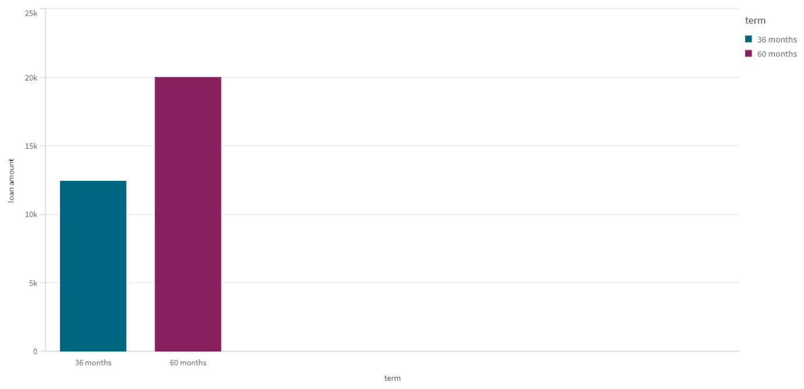

**Average Loan Amount For The Account_Type**

This pi chart shows the average loan amount for the account type of individual/joint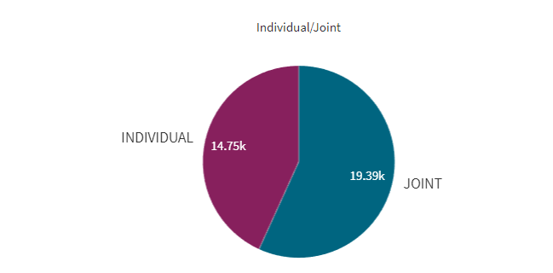

**Total Loan Amount**

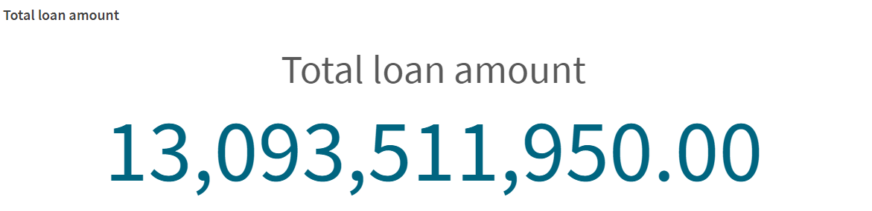

this kpi shows the total loan amount

**Total Number Of Loan Account**

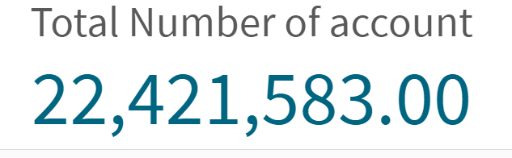

**Average Loan Amount – State Wise**

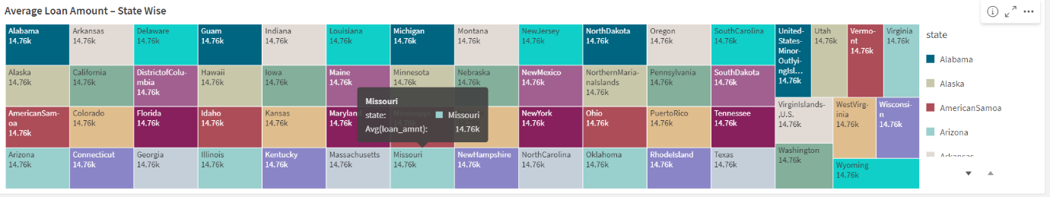This tree map shows the average loan amount state wise

**Grade Wise – Count Of Members**

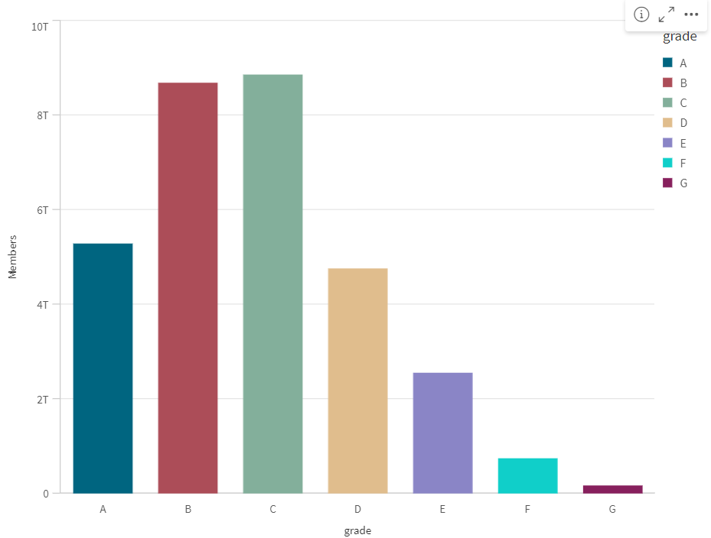this bar chart shows the Grade wise-count of members

**Verification Status**

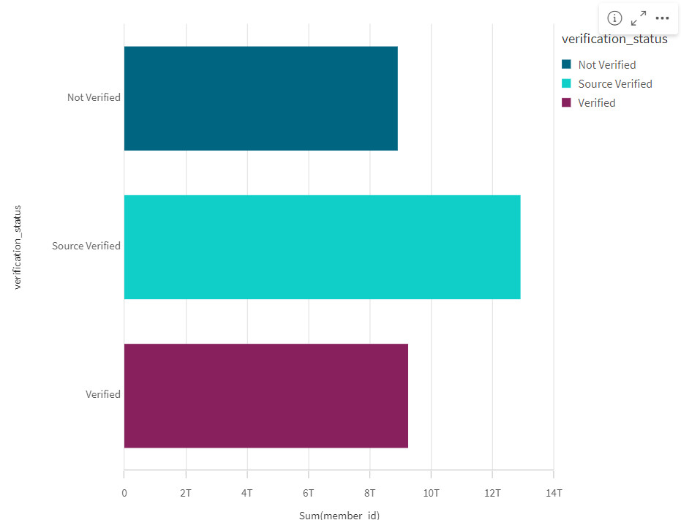This vertical chart shows the how much members are verified there are three bar that  is given below.

1)not verified

2)source verified

3)verified

**Dashboard**

**A dashboard is a graphical user interface (GUI) that displays information and data in an organized, easy-to-read format. Dashboards are often used to provide real-time monitoring and analysis of data and are typically designed for a specific purpose or use case. Dashboards can be used in a variety of settings, such as business, finance, manufacturing, healthcare, and many other industries. They can be used to track key performance indicators (KPIs), monitor performance metrics, and display data in the form of charts, graphs, and tables**.

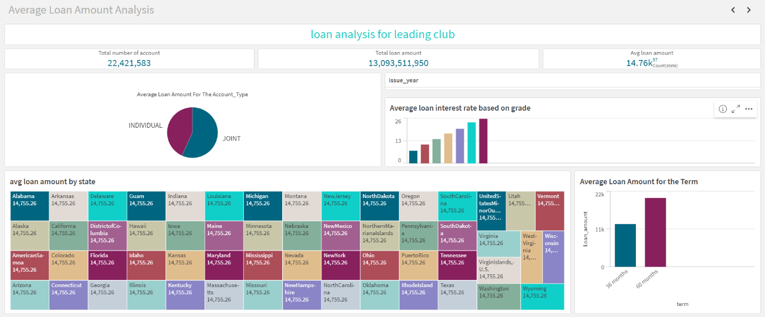

2007 data of loan issue year

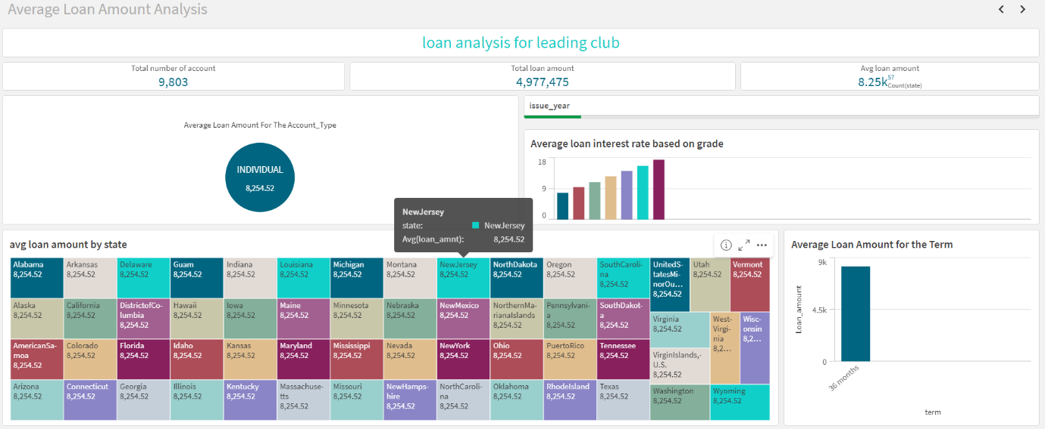

2008 data of loan issue year

2009 data of loan issue year

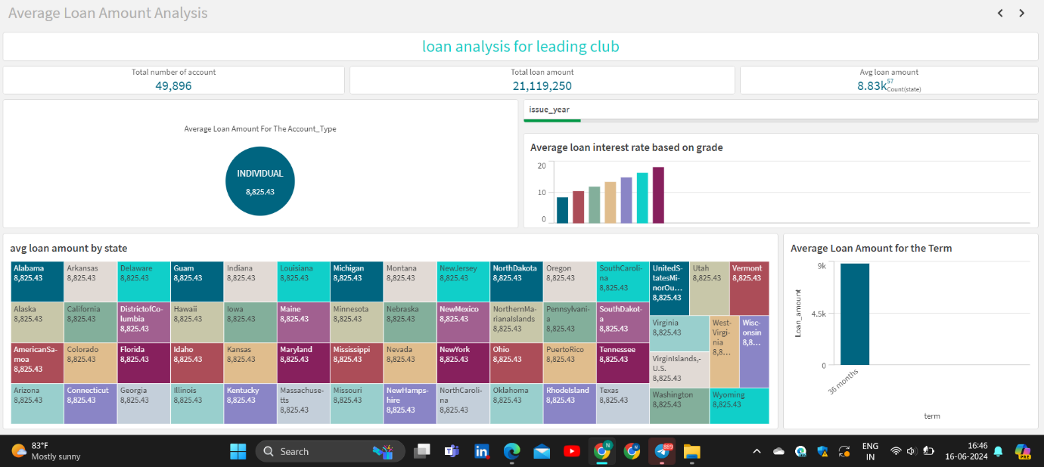

2010 data of loan issue year

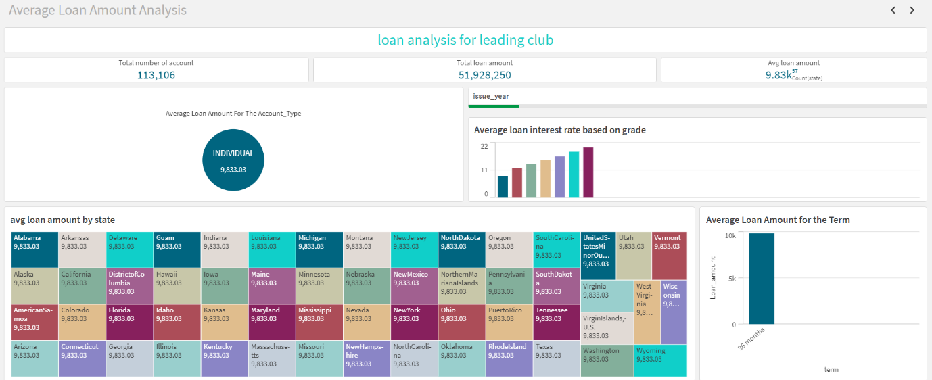

Count analysis on loan lending club

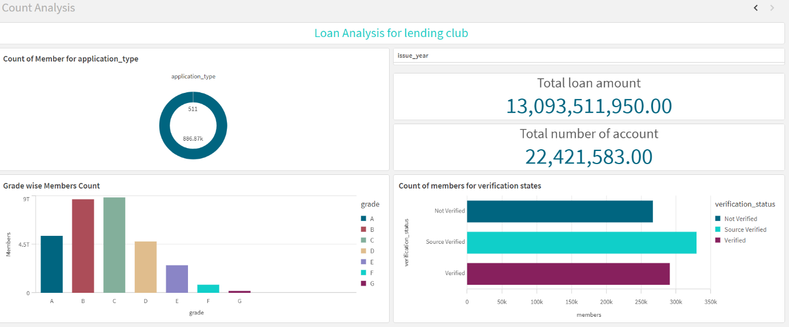

if issue year is 2007 then

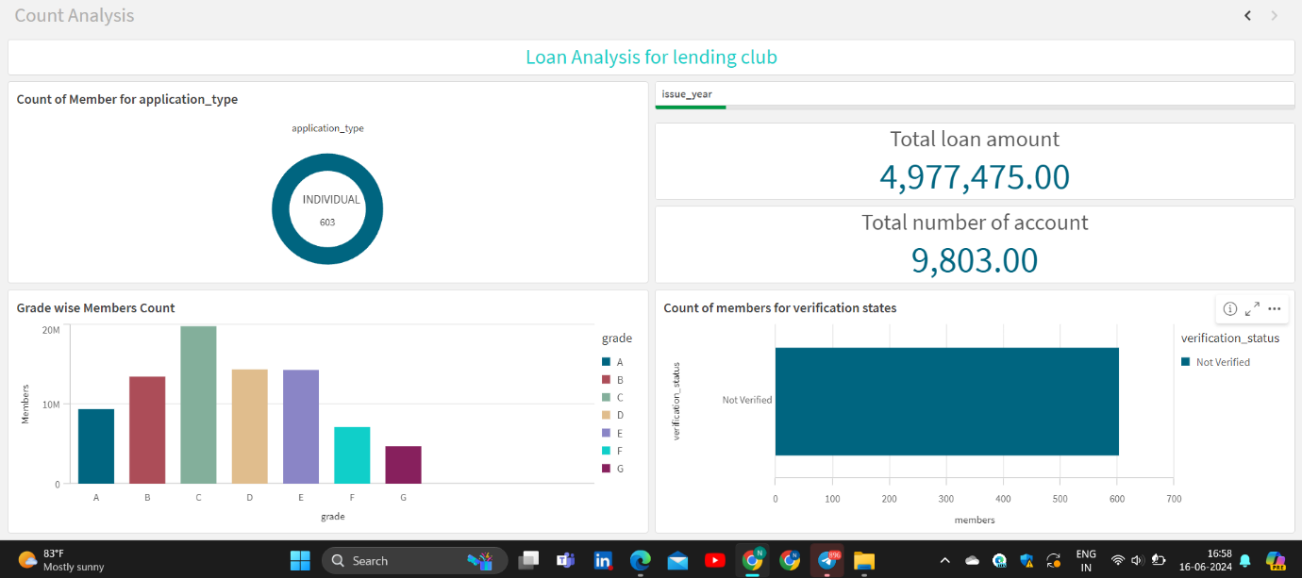

if issue year is 2008 then

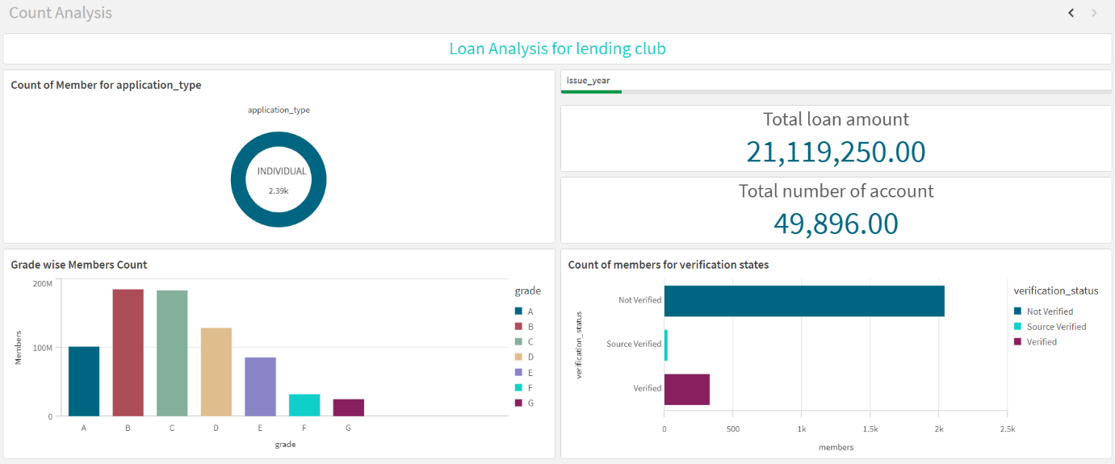

if issue year is 2009 then we get

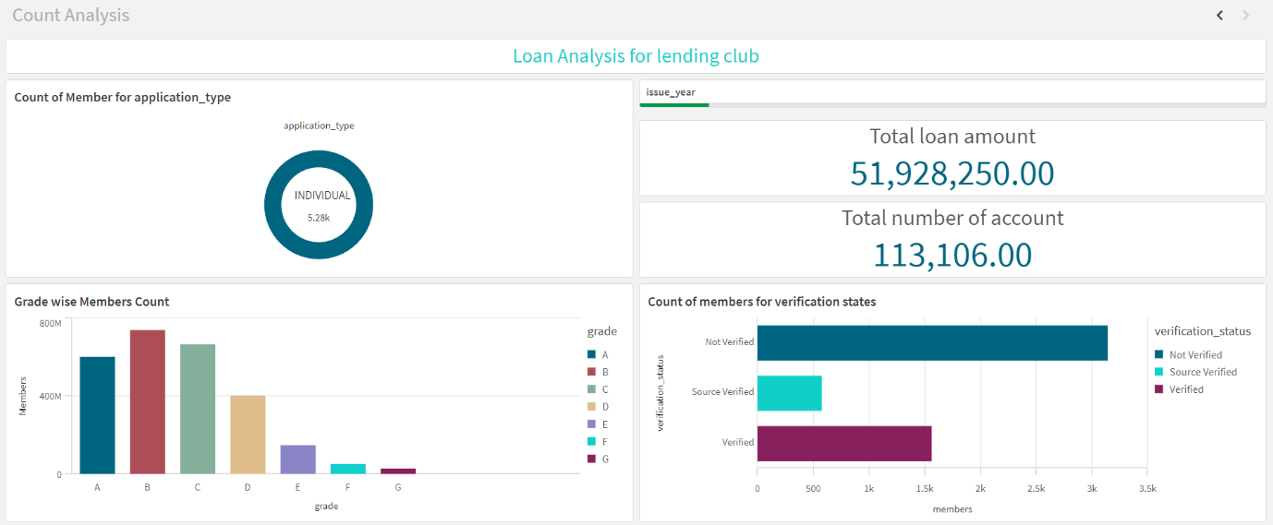

**Design Of Story**

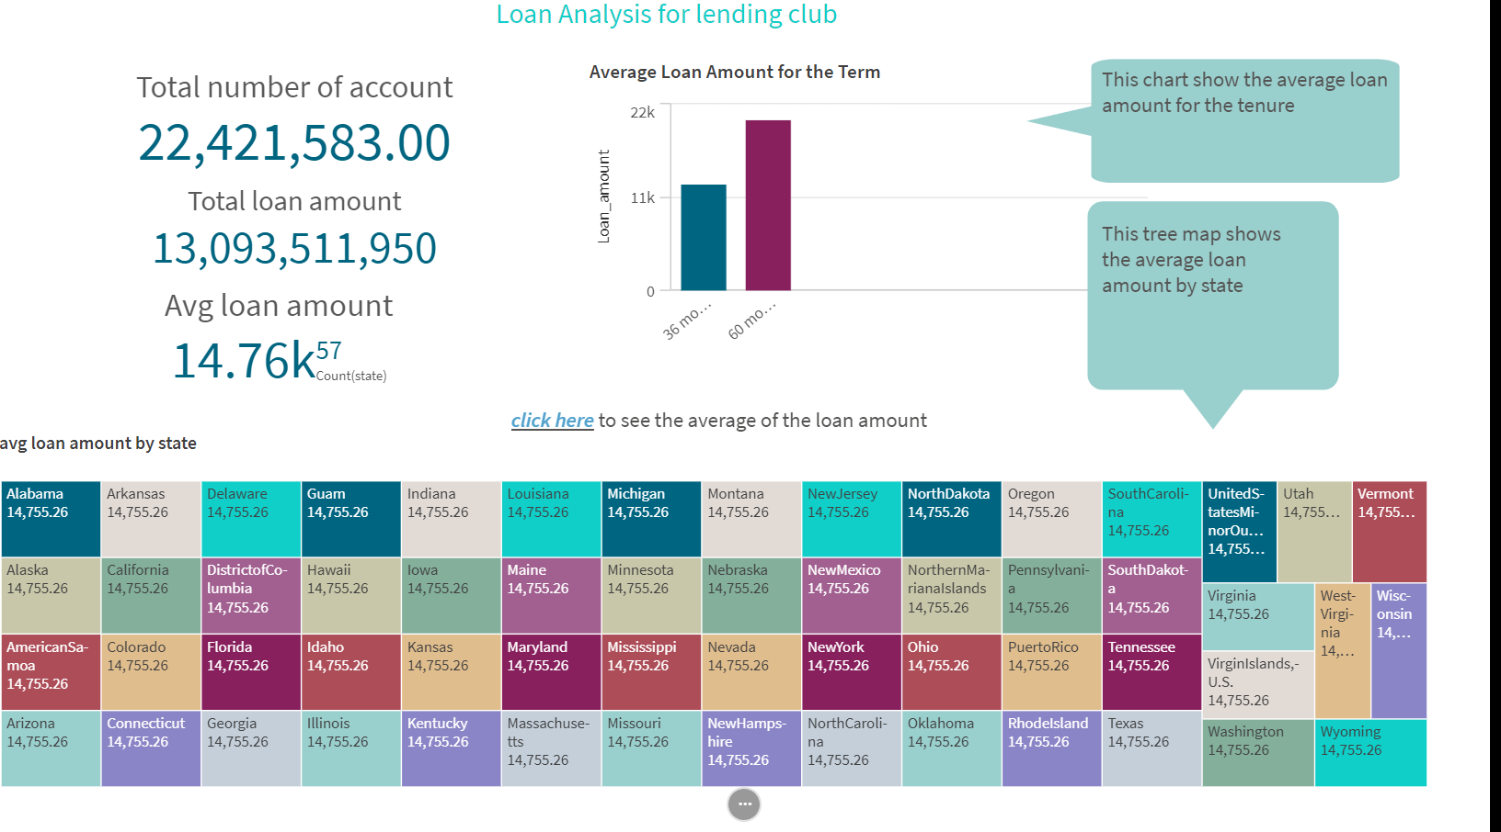

sheet 2

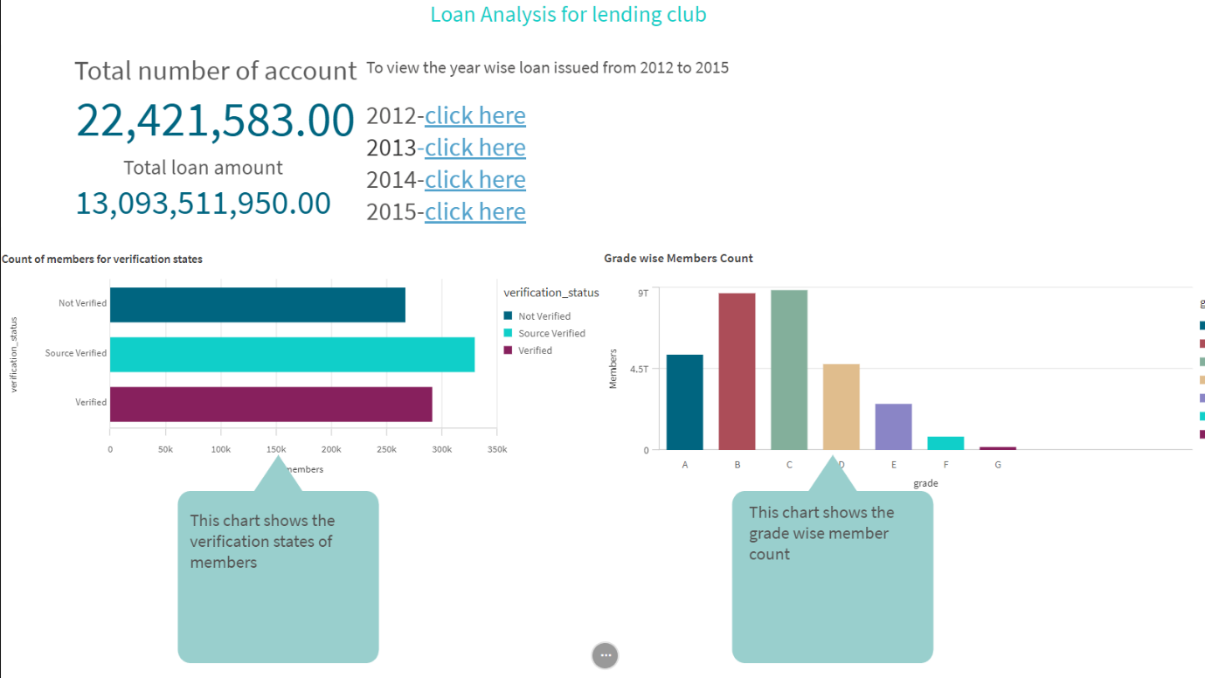

**Performance Testing**

**Amount Of Data Loaded**

**"Amount of Data Loaded" refers to the quantity or volume of data that has been imported, retrieved, or loaded into a system, software application, database, or any other data storage or processing environment. It's a measure of how much data has been successfully processed and made available for analysis, manipulation, or use within the system**

**Utilization Of Filters**

**"Utilization of Filters" refers to the application or use of filters within a system, software application, or data processing pipeline to selectively extract, manipulate, or analyze data based on specified criteria or conditions. Filters are used to narrow down the scope of data, focusing only on the relevant information that meets certain predefined criteria.**

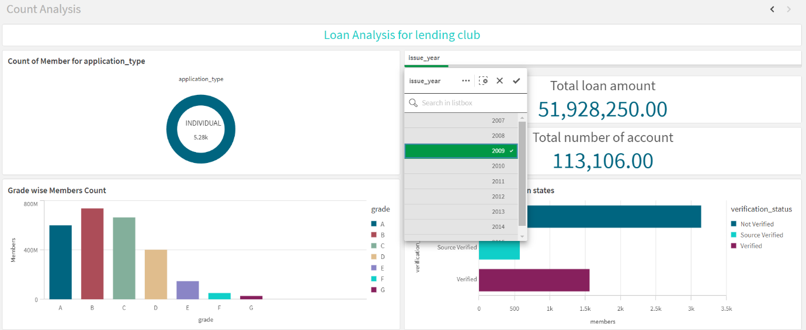

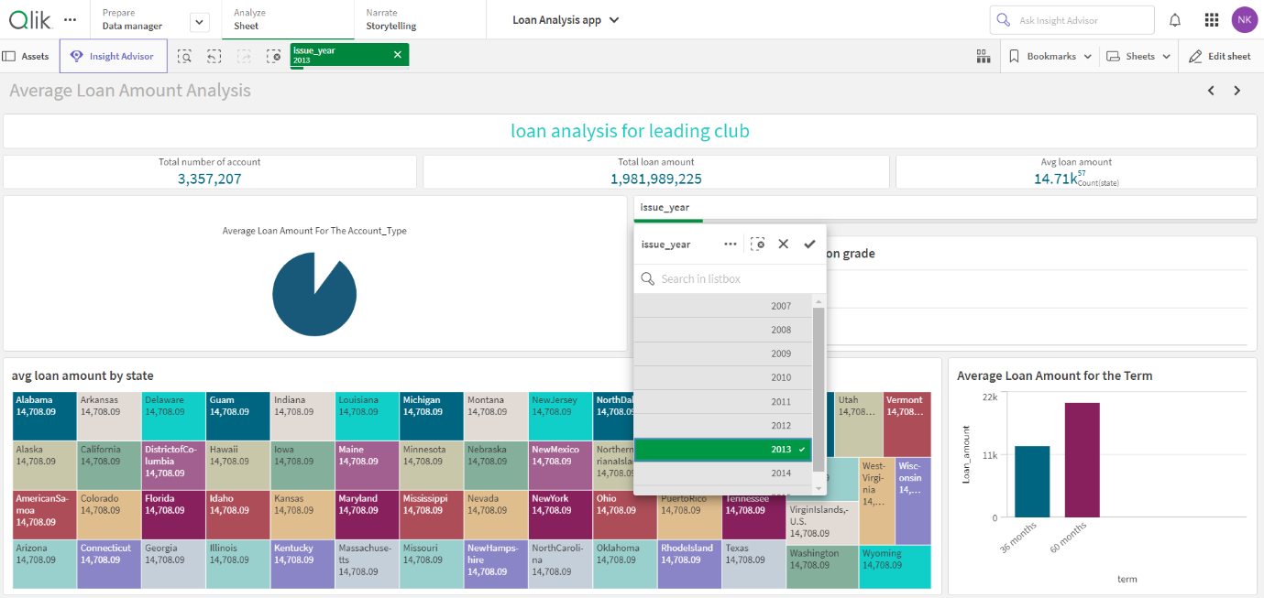

**No Of Visualizations/ Graphs**

1. **Total Number of Accounts**
2. **Total Loan Amount**
3. **Average Loan Amount**
4. **Average Loan Amount for Account type**
5. **Average Loan Interest rate based on Grade**
6. **State wise Average Loan Amount**
7. **Tenure wise Average Loan Amount**
8. **The number of Accounts (Individual/Joint)**
9. **The number of members – Grade wise**
10. **The number of members – Verification Status**