**Summary – scenario -1**

**Task -**

Convert input pic that include several items(products) and give output of multiple 3d meshes and textures corresponding to the pictures items via PyTorch-3D.

**Result -**

Concept of Conversion image(product) into 3d-meshe is taken from [PyTorch-3D](https://pytorch3d.org/).

For this model files are extracted from [Nikhila Ravi](https://github.com/nikhilaravi) GitHub Profile.

According to your requirements we are using pyTorch-3D to convert an image into meshes and this process of converting 2D or 3D models by any computer program is a render process.

**Table of Content (Execution) -**

**IMPORT**

1. Import Library and Dependencies required for Pytorch 3D:

Before Going to work with PyTorch 3D Download this resources or library to run

this code.

when working with PyTorch3D it will show error so we can download via two ways:

* 1. Via Released wheel
* 2. Via PyTorch3D Source

1. Import functions for loading Meshes
2. Data Structures and functions for rendering

**File Format**

For Conversion of image into 3d Meshes and texture we have to create file into few formats :

1. create a .obj file of image
2. create a mtl file of image
3. create a texture image in .png format.

**Setup Cuda**

when working with PyTorch speed of cpu will decrease So here for execution we use Cuda (CUDA-enabled graphics processing unit for general purpose processing) or if cuda is not working then use cpu.

**Set file Path and load file**

Set Data_Dir path from where we can load the required files in .obj format and load these files into meshes.

**Structure**

With the help of matplotlib showing image structure and texture. Meshes is a unique data structure provided in PyTorch3D for working with batches of meshes of different sizes.

**Initialize Setting**

Now we initialize the setting of camera :

1. first we create a renderer
2. renderer uses a perspective camera, point light
3. apply phong shading
4. Define the settings for rasterization and shading
5. Place a point light in front of the object.
6. Create a phong renderer by composing a rasterizer and a shader
7. **Change light of camera (Behind the image)**

**Camera Setting**

Along with Camera setting we can make few more changes for better understand image:

1. change viewing angle of the camera (Rotate the object)
2. change in position of point light (light properties)
3. change the material reflectance properties of the mesh (Modify material Property)

**Showing Image with help of matplotlib after changes on properties of image**

1. Rotate the object by increasing the elevation and azimuth angles.
2. Move the light location so the light is shining on the cow's face.
3. Change specular color to green and change material shininess.
4. Capture Image from Multiple angles and show them via matplotlib.

**Output**

Showing different types of meshe image with the help of plotly for 3d Visualization.

**Input Image :**

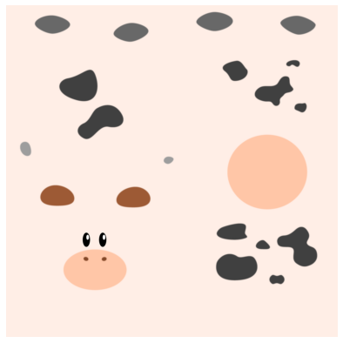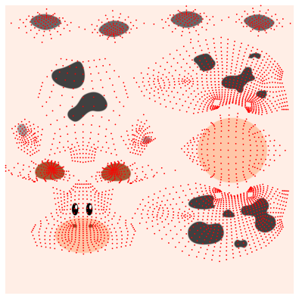

**Texture image**

**Different angle of image**

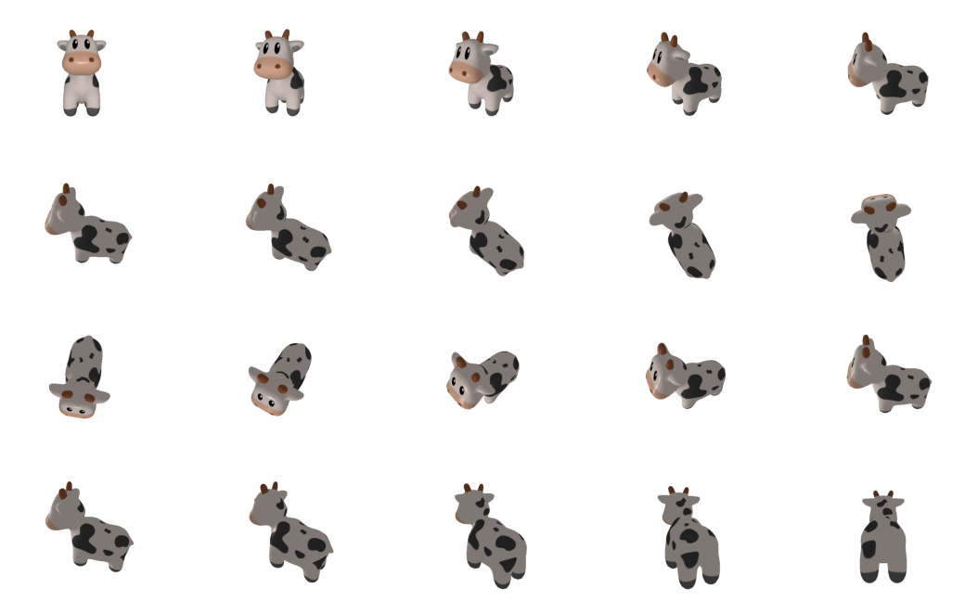

**Output :**

