🛸 PROJECT SUTRA
Subsystem E — Harika's Complete Role & GitHub Guide

📌 This document is written for absolute beginners. No coding experience required. Just follow the steps exactly as shown and you will be fine!

1. What is Project SUTRA?
Project SUTRA (Swarm Unified Tactical Reconnaissance Architecture) is a team project building an autonomous drone swarm that can search for survivors in disaster zones — even in areas with no GPS or internet signal.
The project has 5 subsystems (teams), each responsible for one part of the drone system:

Subsystem | What it Does | Lead
A — GNC | Makes drones fly automatically and avoid collisions | Rohith Kumar
B — Comms | Handles drone-to-drone communication & data compression | Nikhil
C — AI Perception | AI camera: detects survivors, threats using YOLOv8 | Vedanth Sai Ram
D — GCS Dashboard | 3D map on a computer showing all drones live | Siva Kesava
E — Docs & Audit | Writes all documents, verifies the whole system works — YOUR ROLE | Harika ⭐

2. Your Role — Harika (Subsystem E Lead)
You are the Quality Gate Guardian and Documentation Lead of the entire project. Think of yourself as the project's 'Inspector' and 'Reporter'.
You do NOT need to write any drone code. Your job has 3 clear parts:

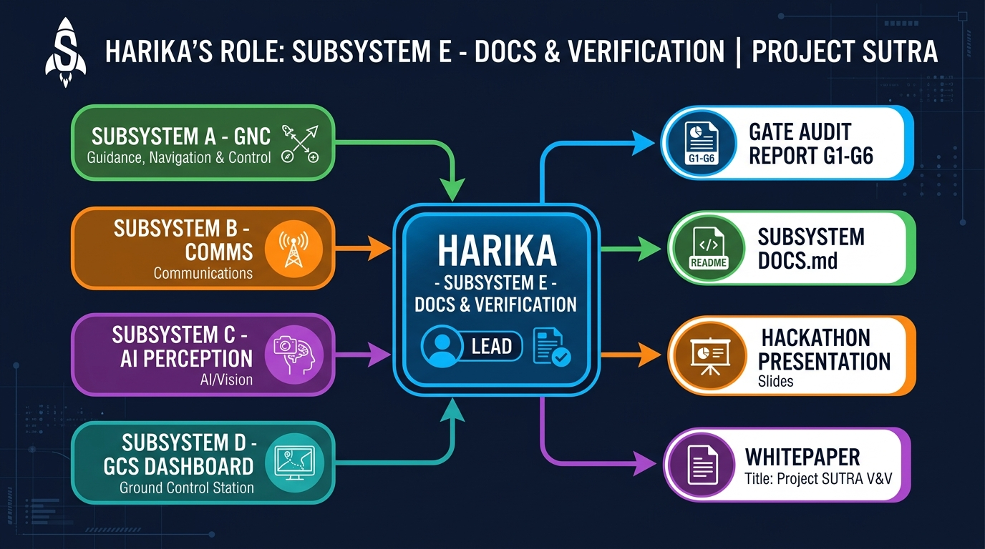
Figure 1 — Harika sits at the centre: all 4 subsystems feed into her for verification

Your 3 Core Jobs

Job 1 — Run the Verification Test Suite (Gate Auditor)
You run a single Python script that automatically checks whether all 5 subsystems are working correctly. The script checks 6 'Gates' (pass/fail tests). ALL 6 must pass before the team can submit.
python3 scripts/SUTRA_48Hr_Hackathon_Master_Suite.py
If any gate fails, you note which one failed and tell the responsible teammate so they can fix it.

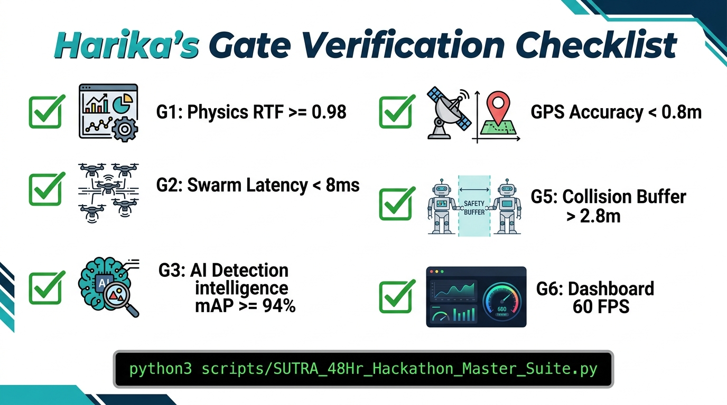
Figure 2 — The 6 Verification Gates you must confirm ALL pass before submission

Gate Reference Table
Gate | What it Checks | Must Show | Which Teammate Fixes If Failed
G1 | Physics simulation speed | RTF ≥ 0.98 | Nikhil (B)
G2 | Drone-to-drone comms latency | < 8 ms, Failover < 150 ms | Nikhil (B)
G3 | AI survivor detection accuracy | mAP@0.5 ≥ 94% | Vedanth (C)
G4 | GPS target location accuracy | Error < 0.8 m | Vedanth (C)
G5 | Drone collision avoidance gap | Buffer > 2.8 m | Rohith (A)
G6 | Ground Control dashboard framerate | 60 FPS locked | Siva Kesava (D)

Job 2 — Update & Audit the Subsystem DOCS.md Files
Each subsystem has a dedicated documentation file (DOCS.md). These files record performance numbers like speed, accuracy, and memory usage. Your job is to:
- Read the DOCS.md file for each subsystem.
- Check that the numbers in the DOCS.md file match what the verification script actually measured.
- If they don't match, update the DOCS.md with the correct numbers from the test output.
The 5 DOCS.md files you audit are:
- A: sutra_ws/src/sutra_gnc/DOCS.md (Rohith's GNC system)
- B: sutra_ws/src/sutra_comms/DOCS.md (Nikhil's comms system)
- C: sutra_ws/src/sutra_perception/DOCS.md (Vedanth's AI)
- D: sutra_ws/src/sutra_gcs/DOCS.md (Siva's dashboard)
- E: sutra_ws/src/sutra_sim/DOCS.md (Simulation world)

💡 TIP: You don't need to understand the technical content deeply. Just compare the numbers. If the script says mAP = 94.8% but the DOCS.md says 90%, update the DOCS.md to say 94.8%.

Job 3 — Write the Project Whitepaper & Presentation Script
You also write and maintain the team's formal documentation stored in the docs/ folder:
- System Architecture Whitepaper — explains how all 5 subsystems work together
- Hackathon Presentation Script — what each teammate will say during the demo
- Flight Logs — a record of every test run with results
- Roadmaps — track which features are done / in progress / pending

3. GitHub Tutorial — Step-by-Step for Beginners
GitHub is where the entire team's code and documents are stored online. Think of it like Google Drive, but for code. You don't need to touch code — you only need to:
- Download the latest files from GitHub to your laptop
- Make your changes (edit DOCS.md files, add reports)
- Upload your changes back to GitHub

3.1 — One-Time Setup

Step 1: Install Git
Git is the program that lets you connect your laptop to GitHub.
- Go to: https://git-scm.com/downloads
- Click 'Download for Windows' (or Mac)
- Install it with all default settings
- Open 'Git Bash' (Windows) or Terminal (Mac/Linux)
git --version
# Should show something like: git version 2.x.x

Step 2: Configure Git with Your Name
This tells Git who you are so your changes show your name. Run these two lines in Git Bash:
git config --global user.name "Harika"
git config --global user.email "your-email@example.com"

Step 3: Clone the Repository (Download the Project)
This downloads the entire project to your laptop. You only do this ONCE.
git clone https://github.com/nikhil49023/SUTRA.git
cd SUTRA
After this, you will see a folder called SUTRA on your laptop with all the project files.

⚠️ IMPORTANT: You only clone once. Every time after that, just open the SUTRA folder and run git pull to get the latest updates.

3.2 — Daily Workflow (Every Time You Work)

Step 4: Open Your Project Folder in Terminal
On Windows: Right-click inside the SUTRA folder → 'Open Git Bash here'
On Mac/Linux: Open Terminal and type:
cd ~/Desktop/SUTRA # (or wherever you saved it)

Step 5: Switch to YOUR Branch
A 'branch' is like your personal copy of the project where you make changes. Your branch is called feature/subsystem-e-docs. Always switch to it before working.
git checkout feature/subsystem-e-docs
You should see: Switched to branch 'feature/subsystem-e-docs'

Step 6: Pull the Latest Changes from the Team
This downloads any updates your teammates made since you last worked. ALWAYS do this before making any changes.
git fetch origin dev
git merge origin/dev --no-edit
If it says 'Already up to date.' — great, you already have the latest version!
📌 RULE #0: This fetch + merge step is MANDATORY at the start of every session. Never skip it!

Step 7: Run the Verification Suite
Now run the master verification script and watch the output:
python3 scripts/SUTRA_48Hr_Hackathon_Master_Suite.py
You will see 6 lines of output. All 6 must end with ✓. If any show an error, note the Gate number and message, and tell the responsible teammate.

Step 8: Make Your Changes
Now open and edit whichever DOCS.md or docs/ file you need to update. You can use any text editor — Notepad, VS Code, or even Notepad++.
For example, to update Rohith's DOCS.md:
# Open this file in your text editor:
sutra_ws/src/sutra_gnc/DOCS.md

Step 9: Save Your Changes to GitHub (Commit & Push)
After editing files, run these 3 commands to upload your work:
# Step 9a: Stage all your changes
git add .
# Step 9b: Write a commit message describing what you did
git commit -m "audit(gates): updated DOCS.md files with G1-G6 verified results"
# Step 9c: Push (upload) to GitHub
git push origin feature/subsystem-e-docs
After this, your changes are live on GitHub for the whole team to see!

3.3 — Quick Reference Card
What You Want to Do | Command to Run
Download project (first time only) | git clone https://github.com/nikhil49023/SUTRA.git
Switch to your branch | git checkout feature/subsystem-e-docs
Get latest team changes | git fetch origin dev && git merge origin/dev --no-edit
Run verification gates | python3 scripts/SUTRA_48Hr_Hackathon_Master_Suite.py
Stage changes | git add .
Save + upload your changes | git commit -m "your message" && git push origin feature/subsystem-e-docs

4. Common Problems & Solutions
❌ I ran git checkout and got an error
✅ Solution: You might be on the wrong directory. Make sure you cd into the SUTRA folder first:
cd ~/Desktop/SUTRA
git checkout feature/subsystem-e-docs

❌ The merge says 'CONFLICT'
✅ Solution: Don't panic. Just message Nikhil on WhatsApp/Teams with a screenshot. He will fix it for you since he has full access.

❌ python3 not found when running the script
✅ Solution: You need to install Python 3. Go to https://python.org → Download → Install. Make sure to check 'Add Python to PATH' during install.

❌ A gate fails (shows AssertionError)
✅ Solution: Note the Gate number (e.g. G3) and the error message. Send it to the responsible teammate (check the Gate table in Section 2). Do NOT try to fix it yourself.

❌ git push says 'rejected'
✅ Solution: Run git pull origin feature/subsystem-e-docs first, then push again.

5. Harika's Daily Checklist
Print this page or save it on your phone. Every time you sit down to work, follow this list in order:

☐ 1 | Open Git Bash inside the SUTRA folder
☐ 2 | Switch to your branch: git checkout feature/subsystem-e-docs
☐ 3 | Pull latest changes: git fetch origin dev && git merge origin/dev
☐ 4 | Run verification: python3 scripts/SUTRA_48Hr_Hackathon_Master_Suite.py
☐ 5 | Check all 6 Gates show ✓ (if any fail, notify the responsible teammate)
☐ 6 | Update any DOCS.md files with numbers from the test output
☐ 7 | Stage, commit, and push: git add . → git commit → git push
☐ 8 | Notify the team on chat: 'Gate audit done — all 6 passed ✅'

🏆 Remember: You are the last line of defence before the hackathon demo. If all 6 gates pass and the docs are accurate, the team is READY TO WIN!

Project SUTRA — Subsystem E Guide | Document maintained by Nikhil (Tech Lead) | For questions: contact Nikhil

