AI – Driven Scheduling System for Academic Timetables Using Genetic Algorithm and Constraint Satisfaction

Sonakshi
Department of Computer Science and Engineering
Chitkara University
Punjab, India
sonakshi862.be22@chitkara.edu.in
Nikhil Singla
Department of Computer Science
Chitkara University
Punjab, India
nikhil1982.be@chitkara.edu.in
Dev Rathi
Department of Computer Science and Engineering
Chitkara University
Punjab, India
dev256.be22@chitkara.edu.in
Shashwat Sharma
Department of Computer Science and Engineering
Chitkara University
Punjab, India
shashwat2292.be22@chitkara.edu.in

ABSTRACT– Timetable scheduling in academic institutions is a very complicated process which requires lectures, lecturers, lecture halls, and time slot allocation with many other constraints. Conventional manual approaches for solving such a problem are very inefficient, time-consuming, and error-prone, particularly when the scale of the organization increases. The approach presented in this paper presents an intelligent scheduling algorithm using Artificial Intelligence (AI) methods, specifically the Genetic Algorithm, along with CSP techniques, in order to generate optimized timetables without conflicts. The system takes dynamically any input information including subjects, lecturers, preferred time slots, and available lecture halls. The backend uses a genetic algorithm to apply several candidate solutions, which are iteratively improved by selection, crossover, and mutation operations. The fitness function evaluates each solution with respect to the satisfaction of constraints by adjusting the conflicts, such as faculty overlaps and room overlaps. CSP methods are used to enforce hard constraints and improve soft constraints such as preferred time allocations. This is accomplished through the application of an advanced architecture of the system, which is based on a friendly interface to achieve effective management of the data as well as instant creation of the timetable. From our experimentation, it is clear that the proposed technique can effectively lower the scheduling conflicts and efficiently generate realistic timetables within a short period. We prove that the integration of growing algorithms and constraint satisfaction methods is useful in real-world problems.
Keywords- Genetic Algorithm, Constraint Satisfaction Problem, Timetable Scheduling, Artificial Intelligence, Optimization

Introduction
As institutions become bigger and more complex, the timetable generation process becomes harder because of the sheer number of variables and constraints that are involved. Administrators have traditionally done the timetable scheduling manually. Though a small organization may schedule their courses manually, it is not an efficient practice when it comes to larger organizations comprising several departments and faculties. It is an arduous task that consumes both time and effort. Besides, such a process is prone to human errors resulting in clashes in lecture timings and wastage of both time and energy. Much research has been conducted on the use of AI for automating the scheduling process.. These systems aim at reducing manual effort, enhancing accuracy, and generating optimized schedules on time. Different artificial intelligence approaches can be used to solve optimization problems, one of which is the Genetic Algorithm that has been found to be very efficient in finding solutions as a result of exploring a broad search space and converging on the best solution. CSPs define a mathematical model used in formulating scheduling problems, which involves satisfying a certain number of constraints. By combining GA with CSP, a hybrid system can be constructed that not only explores the optimal solutions but also satisfies all the constraints. In this paper, we suggest a timetable schedule making system based on AI, which incorporates the benefits of GA and CSP in creating a conflict-free timetable. This system is designed to be highly scalable, flexible, and user-friendly, and hence ideal for use in real academic settings. CSP for conflict-free and efficient timetable creation.

Problem Formulation
The planning process for the timetable may be viewed as a highly intricate problem which comprises the assignment of lectures to time intervals and classrooms in an effective manner. Not only does this involve organizing lectures, but it also involves ensuring that all the regulations are adhered to and that the timetable itself is feasible and convenient for both the teachers and students. To solve this intricate problem effectively, it is subdivided into various constraints and guided by an objective function.

Hard Constraints
The hard constraints are the absolute constraints that are always adhered to irrespective of circumstances. In case any of these constraints is breached, the entire schedule becomes null and void, thus making it impossible for its application.
These constraints guarantee the validity of the schedule.
- A lecturer cannot be assigned to teach two courses at once since they have to be physically present in both classes at once.
- The classroom cannot accommodate multiple lectures at once since one classroom can contain one class alone.
- The lecture is to be accommodated in the available time periods stipulated in the timetable. This guarantees the scheduling of all activities within working hours.

The lecture must be scheduled once, i.e., there are no cases of lectures being omitted or duplicated.

This constitutes the foundation of the schedule.

Soft Constraints
Soft constraints are not as stringent as hard constraints since they are optional but are strongly preferred. Soft constraints emphasize bettering aspects such as quality, comfort, and convenience of the timetable. Although one can do away with these constraints when drawing up timetables, meeting these constraints brings about a timetable that is more efficient and convenient.
- Individual faculties might have their own preferred periods, and meeting these preferences may ensure satisfaction with the timetable.
- The scheduling of lectures must be done in such a way that the lectures are evenly distributed and some days are not overloaded.
- Schedule lectures for individual lecturers in such a way that there will not be back-to-back lectures.

As a result, by satisfying these soft constraints, the schedule will be more optimized and practically applicable.

Objective Function.

The objective function can be viewed as the guideline in finding the optimal timetable. This involves testing possible schedules in order to find the most optimal solution that results from them.

Minimizing any sort of conflict and maximizing resource utilization like time slots and rooms, and at the same time fulfilling all hard and optimizing soft constraints, is the aim.

This simply means coming up with the optimal schedule which should not only be a feasible schedule but also a balanced and practical schedule.

Methodology
In order to come up with the most appropriate timetable using the proposed model, the methodology chosen entails combining the merits of optimization and constraint handling methods. This methodology uses GA as its optimization technique and CSP as the constraint-handling technique in creating the most optimal timetables.

Genetic Algorithm
A genetic algorithm is another form of evolution-based approach where it uses the natural selection process in improving a certain population of individuals. It starts by initializing the possible timetable solutions, evaluating their suitability in meeting certain criteria, selecting those that qualify as the fittest among them, and then proceeding to generate more possible solutions in successive generations. The algorithm has several important processes as follows:
- Initialization of Population: The algorithm starts off by creating an initial generation of possible timetables. Here, a set of feasible timetables will be generated and each member of such generation represents one possible timetable solution.
- Fitness Evaluation: All generated timetables will then be subjected to evaluation depending on their performance as captured through the fitness value.
- Selection: After evaluation, the best timetables will be selected as the parents who will be used to generate the next generation.
- Crossover: This is done by crossing two parent timetables to produce new offspring solutions.
- Mutation: After crossover, mutation takes place whereby small random changes can be made on some individuals in order to enhance diversity.

Termination: The termination criteria are based on certain requirements being fulfilled. These may be a predefined generation limit, attaining a desirable fitness value, or the lack of progress within a set period.

Fitness Function
Fitness functions play an essential role in directing the Genetic Algorithm towards generating more favorable solutions. Some of the elements which are considered during this phase include:

- Number of Conflicts: Solutions with lower numbers of conflicts, for instance, double bookings, have better fitness values.

- Preferences Satisfied: Timetables that take into account the preferences of the faculties in terms of time allocation and low congestion have higher fitness scores.
- Utilization of Resources: Effective allocation of classroom and time resources is encouraged to prevent waste and balance out schedules.

With all these parameters, the fitness function plays a role in evaluating the solutions as well as guiding the process of optimization.

Constraint Satisfaction
The Constraint Satisfaction methods are applied to guarantee that all hard constraints will be obeyed. With this approach, validity and feasibility of the schedule will be ensured. Concerning CSP, it addresses the following issue:
- Ensuring that lecturers will not be scheduled for several courses at the same time
- Scheduling of one lecture in each room within the specified time slot
- Allocation of courses in feasible and valid time periods

Thus, using constraint satisfaction, the integrity of the schedule can be guaranteed.

Hybrid Model
The combination of Genetic Algorithm and CSP constitutes a hybrid approach which exploits the strengths of both methodologies. On the one hand, the role of the Genetic Algorithm is to search through all available combinations of solutions and optimize them. At the same time, the CSP part makes sure that all proposed solutions are legal.

Thus, the result is an efficient schedule planning tool which can easily cope with difficult tasks and produce effective timetables.

System Architecture

The system will use the Client/Server architectural pattern for designing the software. In Client/Server architecture, there is separation between User Interface (Client Application) and Core Processing. Thus, Client/Server Architecture is highly scalable and easy to maintain as well. Various layers in the architecture have their responsibilities.

Frontend Layer (User Interface)
In Client/Server architectural pattern, Front End Layer is where the User Interfaces of the application exist. In this application, the frontend layer contains the administrator or faculty member or staff interface where they would enter various inputs to generate their timetables.

Users will use this interface to do actions like entering lectures data, entering data about faculty members and staff available on the day, room availability, and others. The user interface layer ensures that users get a smooth experience and a responsive interface.

Backend Layer (Application Logic)
The backend layer is in charge of managing the internal logic of the system. The backend layer takes care of the user inputs collected through the frontend and oversees the communication among the various parts of the system.

The backend layer serves as the main controller, validates the data, runs the scheduling algorithms, and guarantees correct operation of all activities. This layer also manages API calls to ensure the accuracy of the output sent to the frontend layer.

Database Layer
The database layer is responsible for storing and maintaining all the necessary data needed for the generation of timetables. Data to be stored include things such as information about lectures, faculty availability, room sizes, and available time slots among others.

Data storage in a database allows for easy access as well as persistence of the data, allowing for future modification if need be.

Algorithm Layer
The algorithm layer is the backbone of our system because it is the main place where the timetabling process happens. The layer uses Genetic Algorithms and Constraint Satisfaction Problems to achieve its goal.

Genetic Algorithms explore and evolve a schedule, and CSP is used to ensure that all the hard constraints are satisfied by the generated schedule.

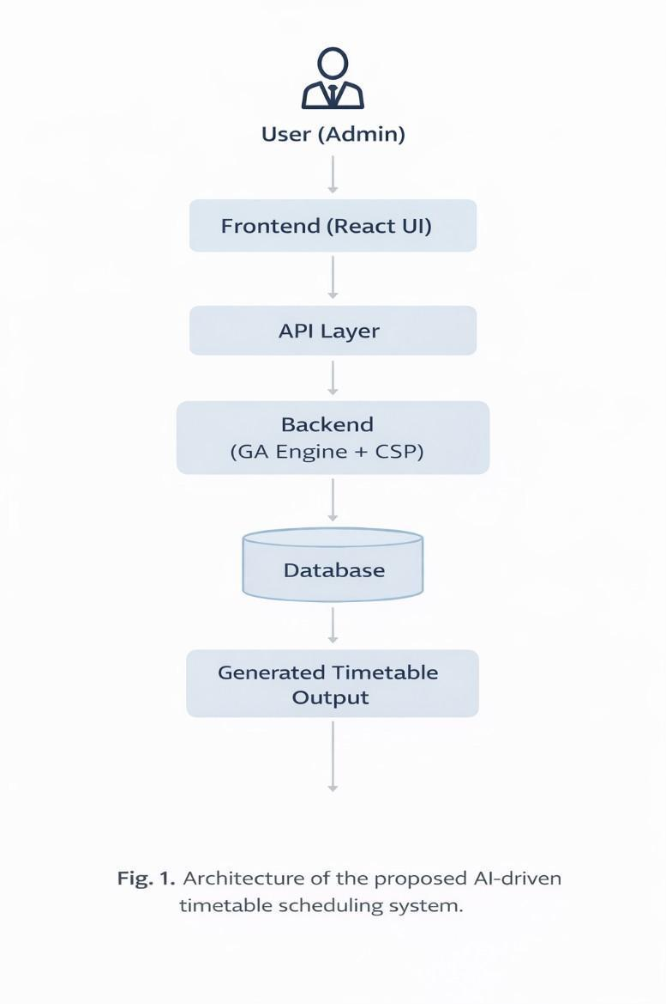

Communication Flow
The communication process between the above mentioned layers is done using APIs. Whenever there is some kind of user input in the front end, it passes to the back end through API calls. Then the back end processes the data and requests the algorithm layer to come up with a timetable and collect the required data from the database.

When the computation process is finished, the back end returns the result to the front end and presents the results to the user in a comprehensible manner.

The use of layers helps achieve a clean division of responsibilities, increased efficiency, and even future scalability of the system.

Implementation
During the implementation process, the system is realized in a way that converts the system design into an actual product using suitable technologies and well-developed modules. Web-based technology is used during the realization of the system.

Technologies Used
A combination of frontend, backend, and database technologies is used to build the system:

- HTML, CSS, and JavaScript: All these technologies are required to construct the frontend of the application. The use of HTML is done to give the basic structure of the web pages, the use of CSS to style the pages and give them appropriate formats, and the use of JavaScript to provide functionality to the web pages. Thus, there is a provision of an interactive and responsive interface through which the user can manage the timetable information.

- Python Flask Framework: The Flask is used as the framework with the help of which the backend will be designed for this project. Flask is used to construct web applications using Python and it offers a simple architecture and easy-to-use route mapping and request handling mechanisms.

- SQLite Database Management System: SQLite is selected as the DBMS that will store all the information relating to lecture details, lecturer information, available classrooms, and timetables of classes.

System Modules
The system application consists of various modules which cater to different functions and purposes in order to create the whole application as a whole.

- Authentication Module: The authentication module caters to the purpose of logging in to the system. In addition, it provides user access only to people who are authorized to do so, including administrators and staff members.

- Lecture Management Module: This module contains the functions of adding, updating, and deleting lectures' information. Information contained in lectures includes names of the courses, the faculty assigned, duration, and time slots required.

- Room Management Module: Room management module contains information regarding available rooms for allocation to the lectures. This includes the number of students accommodated, room location, and room availability.

- Timetable Generation Module: This is the main module where the scheduling of timetable is done. Genetic algorithm and constraint satisfaction technique is used in generating optimized timetables within given constraints.

- PDF Export Module: This module enables the export of the timetable generated by the program into a PDF document format. This will make it easier to share and print the schedules generated by the program.

This design framework makes the application structured, efficient, and scalable in the future in case there is need to add more functions or modules.

Results and Discussion

The suggested timetable scheduling approach was tested on several different data sets, which simulated realistic academic environments. For the tests, it was assumed that there were about 10 to 12 teachers who were responsible for several subjects with specific constraints. It was done to evaluate how the suggested approach copes with various conditions and combinations of constraints.

As a result, it should be stated that the approach provides better results regarding the minimization of conflicts in comparison with standard approaches. Due to the use of genetic algorithms and constraint satisfaction methods, there was no need to worry about conflicts with teachers and class rooms, which means that all produced schedules were error-free.

Besides, the results showed that all resources were used efficiently during the tests. There were no overloaded classes and time slots, as well as unused resources. It means that a very practical timetable was created.

As for the performance of the algorithm, it showed very good results. The processing speed was impressive for an algorithm which processes multiple constraints at the same time.

Furthermore, scalability of the model was proven in this study. With an increasing number of teachers, subject areas, and constraints considered, there were no notable decreases in the efficiency of the model when the algorithm was implemented. This means that further improvements to this approach could be made.

All in all, these findings demonstrate that the presented timetable scheduling system is able to provide feasible solutions. The ability to minimize conflicts and optimally allocate resources while remaining flexible and scalable means that the system can efficiently be applied to any timetable problem.

Advantages
There are a number of significant advantages offered by the proposed system for timetable scheduling. With an effective combination of automation and optimal approaches to schedule generation, the system becomes a useful tool in this field.

- Fully Automated Scheduling: The system completely automates the scheduling process by creating timetables automatically using provided data and restrictions. This allows for significant improvement of efficiency of the entire process.

- Decrease in Manual Errors: The process of manual timetable creation has been observed to be quite error-prone in many cases due to overlapping lectures, inaccurate allocation of rooms, etc. Such errors have been minimized to a great extent by ensuring constraints and generating valid timetables.

- Scalability: Scalability is one of the most important qualities possessed by this system. Irrespective of whether there is an increase in the number of faculties, subjects, or constraints, the system has been successfully able to manage them all without any problems.

- User Friendly Interface: The timetable generator has been programmed in a way that the user can easily enter data into the system and generate timetables. Hence, the interface is extremely user friendly.

Limitations
It has been seen that although the system is highly efficient and effective, there are certain limitations associated with it which need to be known.

- Limited Dataset Size: Small Data Set Size: The system was implemented in a small data set where there were only around 10-12 teachers and a reasonable amount of subjects. Even though the results look promising, the system needs to be checked for functionality in universities with hundreds of faculty members, many departments, and complicated scheduling criteria.

- Basic Interface Design: Although the user interface used by the system works well, it is very simple with no advanced design and interaction facilities. The system lacks all UI/UX elements, like drag-and-drop facility, dynamic interface update, and visual representation of timetable.

- No Predictive Learning Algorithms: The system uses simple logic for scheduling without any predictive learning algorithm that can be used to improve the efficiency of the algorithm and reduce scheduling conflicts.

Future Scope
The designed timetable scheduling system has laid a solid groundwork. However, there are many possible improvements and extensions that could be made in further versions to increase the power, intelligence, and applicability of the application in the real world.

- Supporting Multiple Departments: The current algorithm can be extended to cater to multiple departments at the same time, thus allowing the use of a single tool for scheduling timetables in universities and colleges.

- Deployment in Cloud Services: The timetable scheduling system can be deployed using cloud services for easy access and high availability for multiple users.

- Dynamic Schedule Changes: Further developments may enable real-time changes in the schedules if unexpected events happen during the day, such as the faculty's absence from work or the unavailability of classroom space. In such cases, the system should be able to reschedule automatically without generating a new timetable.

Integration with Existing University/College Systems: The system can also be integrated into other systems used by universities or colleges such as attendance tracking and student information systems.

Conclusion
The purpose of this paper is to present an AI-based timetable scheduler system based on Genetic Algorithms (GA) and Constraint Satisfaction Problem (CSP). The key aim of the system is to create conflict free optimized timetables without relying heavily on manual scheduling practices.

Through the effective integration of GA and CSP techniques, the system manages to efficiently solve the difficult problem of handling hard and soft constraints while simultaneously fulfilling essential needs and taking into consideration preferences and optimization issues. Due to the effective exploration of GA in conjunction with CSP, the system manages to offer accurate results in the form of conflict free and highly feasible timetables.

According to the findings, the new system successfully manages to handle any conflicting issue while achieving optimum use of resources. Besides, the system helps in minimizing the time needed for timetable generation while offering highly reliable results.

Conclusively, the paper has demonstrated the power of Artificial Intelligence algorithms in solving practical scheduling problems. The developed system can be scaled to accommodate a bigger academic institution, thus making it highly suitable for future implementations. With additional improvements in features like machine learning, the system could prove useful in practice.

References

- W3Schools, “HTML, CSS, and JavaScript Tutorials.” [Online]. Available: https://www.w3schools.com
- GeeksforGeeks, “Genetic Algorithm in Machine Learning” and “Constraint Satisfaction Problems.” [Online]. Available: https://www.geeksforgeeks.org
- Flask Documentation, “Flask Web Framework Documentation.” [Online]. Available: https://flask.palletsprojects.com
- Python Software Foundation, “Python Official Documentation.” [Online]. Available: https://docs.python.
- Tutorialspoint, “DBMS and SQLite Tutorials.” [Online]. Available: https://www.tutorialspoint.com
- D. E. Goldberg, Genetic Algorithms in Search, Optimization, and Machine Learning, Addison-Wesley, 1989
- S. Russell and P. Norvig, Artificial Intelligence: A Modern Approach, 4th ed., Pearson, 2020.
- A. E. Eiben and J. E. Smith, Introduction to Evolutionary Computing, Springer, 2003.
[9] SQLite Consortium, “SQLite Documentation.” [Online]. Available: https://sqlite.org
[10] Mozilla Developer Network (MDN), “JavaScript Guide.” [Online]. Available: https://developer.mozilla.org

