**Project SRS**



Construction CRM Web Panel

**Prepared For**

**Version**

**Date**

Mr. Jonathan

V1.0

April 1, 2024

**Executive Summary**

This Software Requirements Specification (SRS) document for the Construction CRM includes the features that will be incorporated into the Website design and development. The document outlines a comprehensive list of functionalities of the project.

**Scope of Work**

**Functional Requirement – Marketing Website**

This section includes all mentioned functional requirements of the proposed document with descriptions of all features and functionalities of the Marketing Website

* **Home Page** – The website’s homepage will be bifurcated into Header, Body & Footer sections respectively as mentioned below
  + Header Section – The responsive website header will be carried out throughout the site for the front end
    - Website Logo – It will display the logo of the website. It should be clickable. By clicking on the logo, the user will be redirected to the home page
    - Website Title – It will display the website title
    - About Us
    - Resources
    - Pricing
    - Integration
    - News
    - Case Study
    - Schedule Session

*By clicking on any of the above, User will be redirected to the respective pages*

* + Body Section – The User will be able to view the main content area of a website including content such as text, images, and multimedia elements
    - Resources
    - Our Success Stories
    - Case Study
    - Pricing Plans
    - Download App
      * App store link
      * Google Play Store link

By clicking on, user will be redirected to the respective pages

* + Footer Section
    - Website Logo – It will display the logo of the website. It should be clickable. By clicking on the logo, the user will be redirected to the home page
    - Website Title – It will display the website title
    - About Us – Here, two lines about company will be displayed
    - Links to social media pages
      * Facebook – Redirected to the Facebook page of the company
      * Twitter – Redirected to the Twitter page of the company
      * YouTube – Redirected to the YouTube page of the company
    - Resources – User will be able to view the following sections in the resources and by clicking on any the User will be navigated to the respective pages
      * Standard Operating procedure
      * Complete SOP Guide
      * Water Mitigation
      * Mold
      * Reconstruction
    - Quick Links
      * About Us
      * Integration
      * News
      * Case Study
      * Pricing

*By clicking on any of the above, User will be redirected to the respective pages*

* + - Contact Us
      * View Email Address
      * View Contact Number
    - Copyrights
    - Privacy Policy
    - Terms & Conditions
    - Safety & Security
* **About Us** – It will display about the company’s story, core values and latest news
* **Resources** – User will be able to view the following information in resources
  + Standard Operating procedure – By clicking here, User will be navigated to this page and he/she will view the description with the following form
    - Fill the Form
      * Enter Full Name* (Text Box)
      * Enter Email Address* (Text Box)
      * Enter Phone Number
      * How did you hear about Us? (Drop-Down)
        + Via Ad
        + Via Call
        + Via Friend
      * What can we help you with (Text Area) – User needs to enter the brief about their concern for raising the query
      * Download Pdf – By clicking here, User will be able to download the pdf of the above form

*Note:* ‘*’ *this asterisk symbol denotes that it is mandatory to enter the details for these fields*

* + Complete SOP Guide – By clicking here, User will be navigated to this page and he/she will view the description with the following form
    - Fill the Form
      * Enter Full Name* (Text Box)
      * Enter Email Address* (Text Box)
      * Enter Phone Number
      * How did you hear about Us? (Drop-Down)
        + Via Ad
        + Via Call
        + Via Friend
      * What can we help you with (Text Area) – User needs to enter the brief about their concern for raising the query
      * Download Pdf – By clicking here, User will be able to download the pdf of the above form

*Note:* ‘*’ *this asterisk symbol denotes that it is mandatory to enter the details for these fields*

* + Water Mitigation – By clicking here, User will be navigated to this page and he/she will view the description with the following form
    - Fill the Form
      * Enter Full Name* (Text Box)
      * Enter Email Address* (Text Box)
      * Enter Phone Number
      * How did you hear about Us? (Drop-Down)
        + Via Ad
        + Via Call
        + Via Friend
      * What can we help you with (Text Area) – User needs to enter the brief about their concern for raising the query
      * Download Pdf – By clicking here, User will be able to download the pdf of the above form

*Note:* ‘*’ *this asterisk symbol denotes that it is mandatory to enter the details for these fields*

* + Mold – By clicking here, User will be navigated to this page and he/she will view the description with the following form
    - Fill the Form
      * Enter Full Name* (Text Box)
      * Enter Email Address* (Text Box)
      * Enter Phone Number
      * How did you hear about Us? (Drop-Down)
        + Via Ad
        + Via Call
        + Via Friend
      * What can we help you with (Text Area) – User needs to enter the brief about their concern for raising the query
      * Download Pdf – By clicking here, User will be able to download the pdf of the above form

*Note:* ‘*’ *this asterisk symbol denotes that it is mandatory to enter the details for these fields*

* + Reconstruction – By clicking here, User will be navigated to this page and he/she will view the description with the following form
    - Fill the Form
      * Enter Full Name* (Text Box)
      * Enter Email Address* (Text Box)
      * Enter Phone Number
      * How did you hear about Us? (Drop-Down)
        + Via Ad
        + Via Call
        + Via Friend
      * What can we help you with (Text Area) – User needs to enter the brief about their concern for raising the query
      * Download Pdf – By clicking here, User will be able to download the pdf of the above form

*Note:* ‘*’ *this asterisk symbol denotes that it is mandatory to enter the details for these fields*

* **Pricing** – Here, User will be able to view the pricing plans for using the platform
  + Plan List (currently only one plan will be displayed, though more plans can be created from admin panel) These details will be collected from Admin panel
    - View Information
      * Plan Name – It will display the name of the Plan
      * Plan Price – It will display the price of the plan
      * Plan Features – It will display the list of features that plan is offering
    - Perform Action
      * Buy – By clicking here, User will be redirected to the registration page where he/she needs to register first to buy the subscription
* **Registration Page** – User will be able to register in to the platform with the following required details

*Note:* ‘*’ *this asterisk symbol denotes that it is mandatory to enter the details for these fields*

* + Enter Email Address* (Text Box)

*Case 1: User should be informed if email address is invalid*

*Case 2: User should be informed if email ID is already registered*

* + Enter Company Name* (Text Box)

*Case: The text box filed must not be left blank otherwise it should display error*

* + Enter Website URL* (Text Box)

*Case 1: The text box filed must not be left blank otherwise it should display error*

*Case 2: The entered website URL must be in a valid format*

* + Enter Fax Number* (Text Box)

*Case 1: The text box filed must not be left blank otherwise it should display error*

*Case 2: The entered fax number must be in a valid format*

* + Enter Phone Number* (Text Box) (Numeric)

*Case 1: The text box filed must not be left blank otherwise it should display error*

*Case 2: The entered phone number must be in a valid format*

* + Enter Administrative Email* (Text Box)

*Case 1: The text box filed must not be left blank otherwise it should display error*

*Case 2: The entered email address must be in a valid format*

* + Enter Administrative Name* (Text Box)

*Case: The text box filed must not be left blank otherwise it should display error*

* + Submit – By clicking here, User will be registered in to the platform

*Case: All* ‘*’*fields should fill out correctly*

* **Stripe Payment Page** – Once User register successfully on the platform then he/she will be navigated to the stripe payment page and User will be able to view the following information

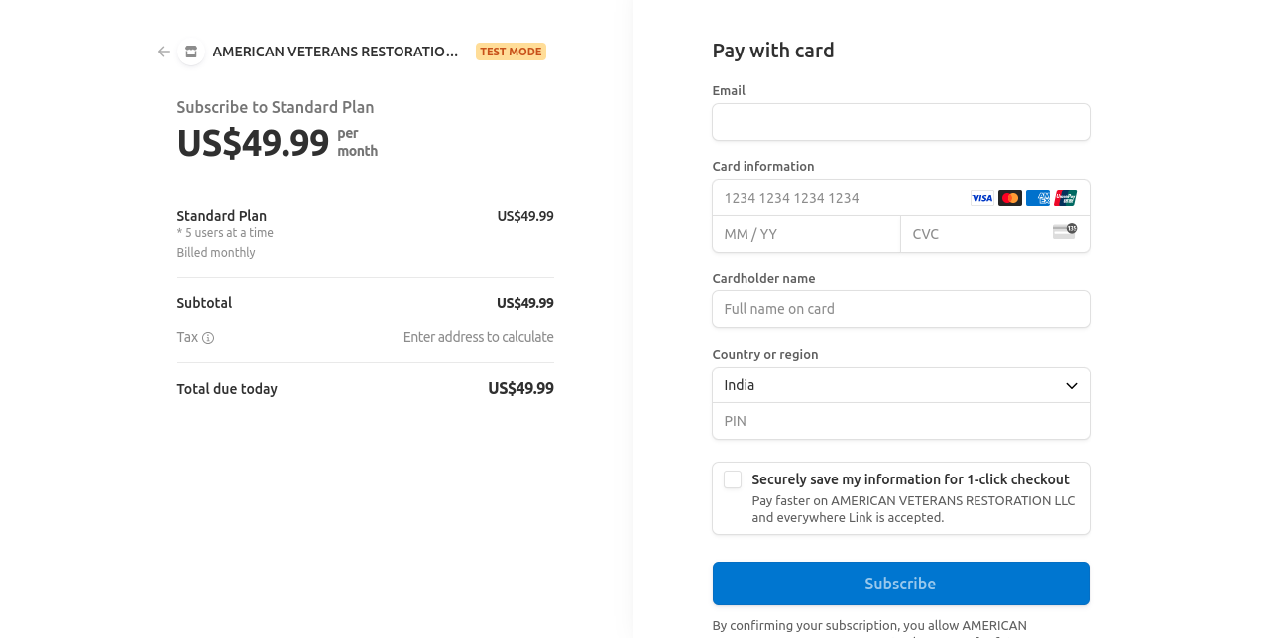

* + View Information
    - Standard Plan Price – It will display standard plan price of standard plan
      * Total Number of Users (It will be displayed by default)
      * Billed Monthly (It will be displayed by default)
    - Subtotal Amount
      * Tax
    - Total Due today – Total Amount will be displayed
  + Perform Action
    - Pay with Card
      * Enter Email Address (Text Box)
      * Card Information
        + Enter Account Number (Text Box)

*Case 1: User should enter account number in a valid format*

*Case 2: Account Number should be in 15 digits or 16 Digits depending of the card*

*Case 3: If the user fails to enter a valid account number, an error message will be displayed indicating that the account number is invalid*

* + - * + Enter MM/YY (Text Box)

*Case: The system should validate that the entered month value is between 1 and 12*

* + - * + Enter CVV (Text Box)

*Case: The system should validate the CVV length based on the selected card type (e.g., 3 digits for Visa/Mastercard, 4 digits for American Express)*

* + - * Cardholder Name (Text Box)
      * Country or Region
        + Select Country (Drop-Down)
        + Enter Pin (Text Box)
        + *Checkbox – User will be able to select the checkbox and the note will be displayed here is ‘’Securely Save my information for 1-click checkout, pay faster on AMERICAN VETERANS RESTORATION LLC and everywhere link is accepted’’*
* **Payment Status** – From here, User will be able to pay for the subscription and can use the platform

**Case1: If the payment is successful**

* + Once the payment has done successfully, the User will be displayed a payment successful screen
    - Transaction ID
    - Order ID
    - Total Amount
    - Subscription Plan Name
  + Further, an email will be sent to the Company email address and admin address with the following details
    - Welcome Message and Next Steps
    - Contact Information
    - Invoice
    - Sign In/Login Credentials
      * Website URL
      * Email Address
      * Password (Auto Generated)
  + Thank you, page– A thank you page will be displayed after successful payment done and there will be an okay button on the thank you page. By clicking on it, User will be redirected to the sign in page. Moreover, two accounts will be generated, one is of Company’s Email Address and Company’s Admin Email Address

**Case 2: If the payment is unsuccessful**

* + If the payment is unsuccessful then the user will stay on stripe payment page only
* **Integration** – This section contains the integration partners list in the form of images  
  and graphics having the name and logo of the specific software they are partnered  
  with
* **News** – Here, User will be able to view the latest news of the company
  + News Listing
    - View Information
      * News Image
      * News Posted Date
      * News Title
      * News Description (two-three lines)
    - Perform Action
      * Learn More – By clicking here, User will be redirected to the news detail page
  + News Detail
    - View Information
      * News Image
      * News Posted Date
      * News Title
      * News Description
    - Perform Action
      * Recent News – By clicking on any from in the recent news the user will be redirected to the detail page
* **Case Study** 
  + Case Study Listing
    - View Information
      * Case Study Image
      * Case Study Title
      * Case Study Description (two-three lines)
    - Perform Action
      * View More – By clicking here, User will be redirected to the news detail page
  + Case Study Detail
    - View Information
      * Case Study Image
      * Case Study Title
      * Case Study Description (two-three lines)
    - Perform Action
      * Recent News – By clicking on any from in the recent news the user will be redirected to the detail page
* **Schedule Session** – The user will be able to schedule the session (Zoom) or a meeting with  
  the experts
  + Fill the Form – User
    - Select Date* (Text Box)
    - Select Time Duration* (Text Box) (Drop-Down)
    - Enter Full Name
    - Enter Email Address
    - How did you hear about us? (Drop-down)
      * Via Ad
      * Via Call
      * Via Friend
    - Enter Phone Number
    - Submit – On clicking this the request will be submitted to the Admin and will be  
      received by the Admin

**Functional Requirement – User (Company Admin) – Web Panel**

This section includes all mentioned functional requirements of the proposed document with descriptions of all features and functionalities of the User end section

***Note****: User (Company Admin) will be able to sign in from the website URL provided in the email address*

***Case 1: When Company Admin Sign In for the first time into the platform, Company Admin will sign in with the temporary sign in credentials that he/she has received on his/her registered email address***

* **Sign In** – The admin can sign in to the platform with the following valid credentials
  + Enter Details
    - Enter Email Address – User needs to enter the provided the email address which he/she has received in the credentials

*Note: If the email is incorrect then a message should display ‘’incorrect email address’’*

* + - Enter Temporary Password – User needs to enter the required password which he/she has received in the credentials

*Case 1: If the user exists in the system and the temporary password matches, then further User will move to submit button*

*Case 2: If the credentials are incorrect, an error message will be displayed and allow the user to retry*

* + - Sign In – By clicking here, User will be successfully Sign in to platform
  + Change Password – To change the password, following are the steps
    - Enter the Current Temporary Password* (Text Box) – Admin will be able to enter the temporary password
    - Enter New Password* (Text Box) – Admin will be able to enter the new password

*Case 1 – The password should stick to the password policy which might include following requirement such as: minimum length, combination of uppercase and lowercase letters, numbers, and special characters*

*Case 2 – If there are any issues while setting the password then the error message will be displayed*

* + - Enter Confirm Password* (Text Box) – To confirm the password, the admin will enter above password here

*Note – This password should match above new password, if not then it should display error that the password is not matching*

* + - Sign In *(Button) – By clicking here, the new password will be created for the sign in*

***Case 2: When Company Admin Sign In for the second time***

* **Company Admin Sign in** – The admin can sign in to the platform with the following valid credentials
  + Enter Email Address* (Text Box) – The admin needs to enter a valid email address

*Case 1: The field must not be left blank*

*Case 2: User should be informed if email address is invalid*

* + Enter Password* (Text Box) (Visible Icon) – The admin needs to enter the password according to the password policy also he/she will also be able to view the entered password by clicking on the visibility icon (eye icon)

*Case 1: The field must not be left blank*

*Case 2: The entered password should stick to the password policy which might include following requirement such as: minimum length, combination of uppercase and lowercase letters, numbers, and special characters*

* + Sign In (Button) –By clicking here, User will be successfully sign in to platform

*Case: Valid email address and password should enter*

**Functional Requirement – Admin side – Backend Web Panel**

This section includes all mentioned functional requirements of the proposed document with descriptions of all features and functionalities of the admin end section

* **Admin Sign in** – The admin can sign in using with following valid credentials

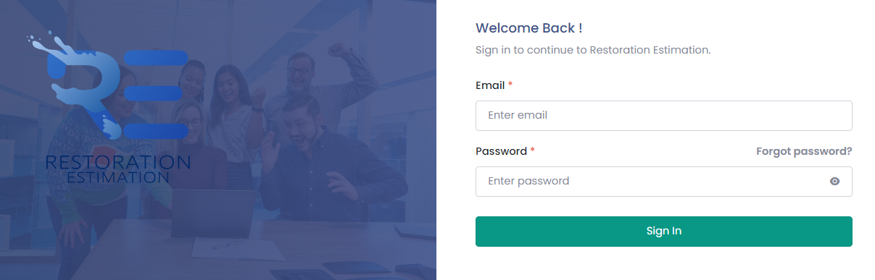

* + Enter Email Address* (Text Box) – The admin needs to enter a valid email address

*Case 1: The field must not be left blank*

*Case 2: User should be informed if email address is invalid*

* + Enter Password* (Text Box) (Visible Icon) – The admin needs to enter the password according to the password policy also he/she will also be able to view the entered password by clicking on the visibility icon (eye icon)

*Case 1: The field must not be left blank*

*Case 2: The entered password should stick to the password policy which might include following requirement such as: minimum length, combination of uppercase and lowercase letters, numbers, and special characters*

* + ForgotPassword– By clicking here, the Admin will be redirected to forgot password page
  + Sign in (Button) – By clicking here, Admin will be successfully login to platform incase forgotten

*Case: Valid email address and password should enter*

* **Forgot Password** –The Admin will be able to reset the password in case of forgotten
  + Enter Email Address – By entering email address, the instructions will be sent to Admin
  + Send Resent Link (Button) – By clicking here, a link will be shared on the above entered email address

*Note: If entered details is invalid the platform will show a pop-up and ask the Admin to re-enter the details*

* **Admin Profile** – The Admin will be able to manage the profile from here
  + Personal Details
    - View Information
      * First Name
      * Last Name
      * Phone Number
      * Email Address
  + Change Password – To change the password, the following are the steps
    - Enter Old Password* (Text Box) – Admin will be able to enter the old password
    - Enter New Password* (Text Box) – Admin will be able to enter new password
    - Enter Confirm Password* (Text Box) – Admin will be able to enter confirm password
    - Change Password (Button) – By clicking here, the password will be change successfully

*Note:* ‘*’ *this asterisk symbol denotes that it is mandatory to enter the details for these fields*

* + Edit Profile – Admin will be able to edit the profile from here
    - First Name* (Text Box) (Editable)
    - Last Name* (Text Box) (Editable)
    - Phone Number* (Text Box) (Editable)
    - Save Changes – By clicking here, changes will be saved

*Note:* ‘*’ *this asterisk symbol denotes that it is mandatory to enter the details for these fields*

* **General Settings** – Admin can manage the following settings of web-panel
  + Date Format – Admin has the option to change or set the format of the date
  + Manage Email Template – Admin can set from pre-defined email template
* **Dashboard** – Admin will be able to view the following statistical information on the dashboard
  + Statistics
    - View Information
      * + Total Number of Subscribers
        + Total Number of Users
        + Total Number of Subscription Plans
        + Total Revenue Generated
    - Perform Action
      * + Option to Apply Filter

By Date Range (DD/MM/YYYY)

* **Side Menu Bar** 
  + Dashboard
  + User Management Module
  + Subscriber/Company Management Module
  + Subscription Management Module
  + Transaction Management Module
  + Reports Management Module

***Note****: By Clicking on any User will be redirected to the respective module*

* **Subscriber/Company Management Module** – Here, Admin will be able to manage the subscriber of the platform
  + Subscriber Listing
    - View Information
      * Subscriber/Company Name
      * Subscriber Phone Number
      * Subscriber Email Address
      * Subscriber Status
        + Active
        + Deactivate
      * Subscriber Joining Date
    - Perform Action
      * Option to View Details – By clicking here, Subscriber will be redirected to the detail page
      * Option to mark Status
        + Active
        + Inactive
      * Option to Apply Filter
        + By Name
        + By Email
        + By Administrator Name
      * Option to Sort
        + By Joining Date
  + Subscriber Detail Page
    - View Information
      * Subscriber/Company Name
      * Subscriber Phone Number
      * Subscriber Email Address
      * Subscriber Joining Date
      * Subscriber Website
      * Fax Number
      * Administrative Email
      * Administrative Name
      * Total Number of Users
      * Subscription Plan Details
        + Plan Name – It will display subscription plan
        + Billing Cycle – It will display billing cycle type
        + Plan Price Per Cycle – It will display plan price per cycle
        + Plan Status – It will display plan status and it will include the following status

Published

Created

Active

Inactive

* + - * + Description – It will display the description of the plan
* **User Management Module** – Admin will be able to manage the User of the platform from here
  + User Listing
    - View Information
      * User Name
      * User Email Address
      * User Phone Number
      * User Status
        + Active
        + Inactive
      * Subscriber Name
    - Perform Action
      * Apply Filter
        + By Subscriber Name
        + By Subscriber Name
      * Option to mark Status
        + Active
        + Inactive
  + User Detail
    - View Information
      * User Name
      * User Email Address
      * User Phone Number
      * Subscriber Name
      * Created Jobs
* **Subscription Plan** **Management Module** – From here, Admin will be able to manage the Subscription of the platform
  + 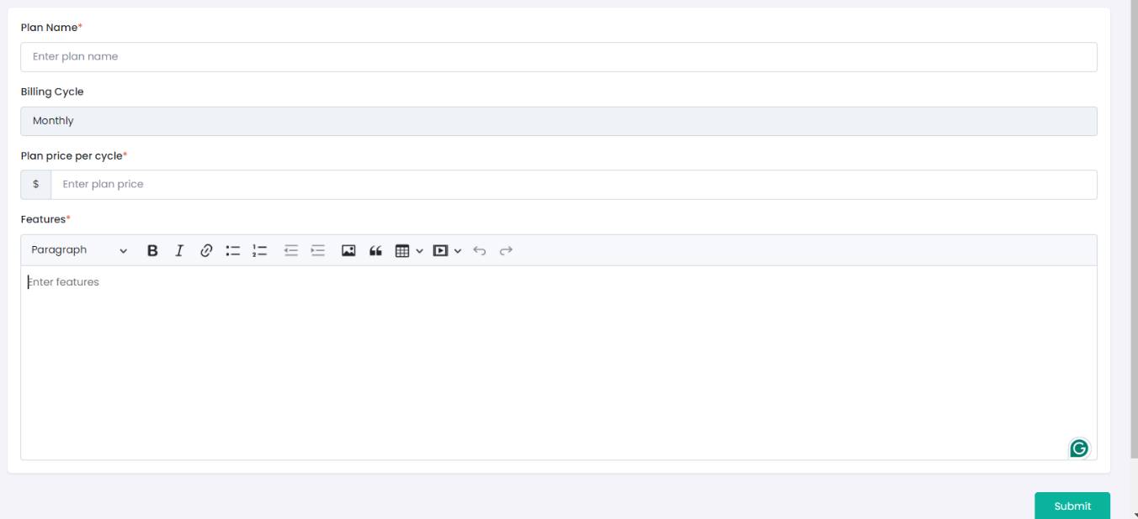Create Plan – Admin will be able to create the subscription plan with the following details
    - Enter Plan Name* (Text Box)
    - Billing Cycle (Drop-down)
      * Monthly

*Note: As of now, monthly billing cycle will be there by default*

* + - * Yearly

*Note: In the next phase development, yearly might be include*

* + - Plan Price Per Cycle*
      * Enter Plan Price (Numeric) (Text Box) – Admin will be able to enter the plan price in dollar
    - Max. Users Allowed* (Stepper Control) – The administrator has the ability to limit the total number of users from a single subscription-based organization who can access the platform.
      * *Note: Admin will be able to add up to 5 user and minimum 1 will be there by default*
    - Features* (Rich Text Editor) – Admin will be able to add features of the subscription plan

*Note:* ‘*’ *this asterisk symbol denotes that it is mandatory to enter the details for these fields*

* + - Submit – By clicking here, subscription plan will be created *it will be saved into the* draft
  + Subscription Plan Management Listing

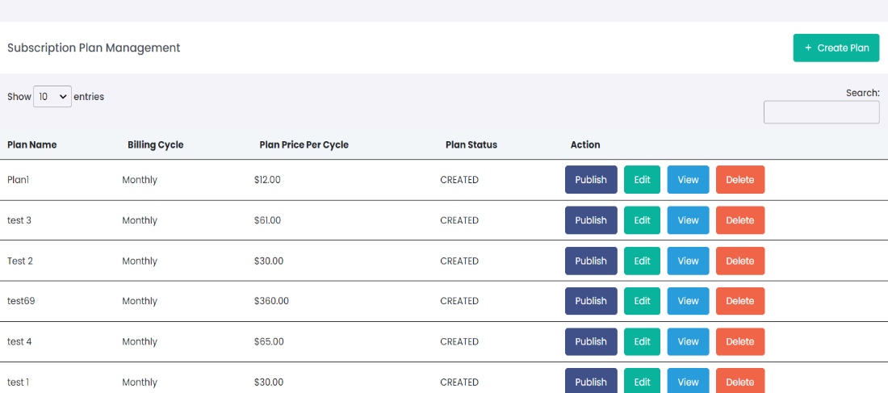

* + - View Information – Admin will be able to view the following information on subscription listing page
      * Plan Name – It will display subscription plan name
      * Billing Cycle – It will display billing cycle type
      * Plan Price Per Cycle – It will display plan price per cycle
      * Plan Status – It will display plan status and it will include the following status
        + Published
        + Created
        + Active
        + Inactive
    - Perform Action – Admin will be able to perform the following action on subscription listing page
      * Option to Search – Admin will be able to search on listing page by the following ways
        + Plan Name – Admin will be able to search by plan name
        + Plan Price Per Cycle – Admin will be able to search by Plan Price Per Cycle
        + Plan Status – Admin will be able to search by plan status
      * Option to Publish – By clicking here on publish button, the following details will be popup
        + Are you sure want to publish this plan to users?

Yes – By clicking here, the plan will be published and it will be displayed to the users

No – By clicking here, the plan will not be published and the user will be redirected to the listing screen

*Note 1: Admin will be able to Active and Deactivate the published plan*

*Note 2: Admin will not be able to edit the published plan*

* + - * Option to Edit – by clicking here, Admin will be able to edit the respective plan

*Note: If Admin edit the plan price, then it will* reflect *in next billing cycle only*

*Note 2: Only active plans will be edited*

* + - * Option to View – by clicking here, Admin will be redirected to the subscription plan details page
      * Option to Inactive – by clicking here, a confirmation window will popup which will include the following details
        + Are you sure you want to delete?

Cancel (Button) – By clicking on cancel button, user will be redirected to the listing page

Yes (Button) – By clicking here, plan will be deleted respectively

*Note 1: Once admin inactive the plan then it will not be displayed to the end user for purchase*

*Note 2: Subscription plan which has at least one subscriber cannot be made In Active*

* + - * Option to Delete – by clicking here, a confirmation window will popup which will include the following details
        + Are you sure you want to delete?

Cancel (Button) – By clicking on cancel button, user will be redirected to the listing page

Yes (Button) – By clicking here, plan will be deleted respectively

*Note: Admin will not be able to delete the plans which is created. Plans which are published can not be deleted*

* + Subscription Plan Management Details – By clicking on view, Admin will be redirected to the subscription detail page

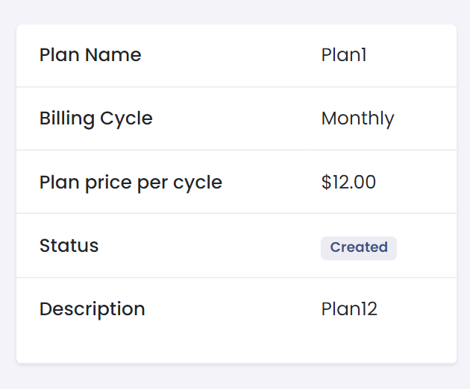

* + - Plan Name – It will display subscription plan name
    - Billing Cycle – It will display the type of billing cycle
    - Plan Price Per Cycle – It will display price plan per cycle
    - Plan Status – It will display the status of the subscription plan
    - Description – It will display the description of the plan
* **Scheduled Session Management Module** – The Admin will be able to manage the schedule session module from here
  + Received User Details
    - Selected Date
    - Selected Time Duration
    - Full Name
    - Email Address
    - Phone Number
    - How did User about Company
      * Via Ad
      * Via Call
      * Via Friend
    - Description about Concern
  + Time Slot Management
    - Add/Edit/Delete
  + Time Duration
* **Transaction Management Module** – Admin will be able to view the transaction on the platform
  + Listing
    - View Information
      * Transaction ID
      * Date and Time of Payment
      * Subscriber Name
      * Amount
      * Mode of Payment
    - Perform Action
      * Search
        + By Subscriber Name
* **Reports Management Module** – Admin will be able to generate the following reports from the backend admin panel:
  + Subscriber – Admin will be able to generate the Subcriber report from one date to another and will be able to download the report in CSV form with the following details
    - Subscriber Name
    - Email Address
    - Phone Number
    - Total Number of Users­
    - Type of Purchase Plan
  + Transaction – Admin will be able to generate the Transaction report from one date to another and will be able to download the report in CSV form with the following details
    - Transaction ID
    - Date and time
    - Name of Subscriber
    - Total Amount paid
  + Revenue Report – Admin will be able to generate the Revenue report from one date to another and will be able to download the report in CSV form with the following details
    - Transaction ID
    - Transaction Date
    - Total Amount
    - Net Earnings

Logout –

* **Logout** – The Admin will be able to logout of the backend panel. By clicking here, a small window will popup which will include the following details
  + Are you sure you want to logout?
    - Cancel (Button) – By clicking here, Admin will be redirected to the back page
    - Logout (Button) – By clicking here, Admin will be logout from the backend admin panel

**Considerations**

* We have considered that an email notification will be sent to the user two days before his/her monthly billing cycle expires
* We have considered that upon confirmation of plan cancellation by the payment gateway, an email will be sent to the user immediately
* We have considered that if User’s subscription plan is not active anymore, he/she will not be able to use certain features of the panel
* We have considered that Subscribers with inactive plans can still log in, but they will not be able to do anything else. If they try, they will see a message encouraging them to renew their plan instead of being allowed access
* We have considered that an email notification will be sent to the user immediately after a successful auto-renewal transaction by the payment gateway
* We have considered that an email notification will be sent to the user immediately after the payment gateway responds with a failed transaction
* We have considered that in case of a planned price change or feature update for a specific subscription plan, an email notification will be sent to all relevant subscribers twodays before the changes take effect