Python Introduction
1. Python Syntax
2. Python Comments
3. Python Variables
4. Python Data Types
5. Python Numbers
6. Python Casting
7. Python Strings
8. Python Boolean
9. Python Lists
10. Python Operators
11. Python Tuple
12. Python Sets
**13. Python Dictionaries
14. Python if else
15. Python while loops
16. Python for loops
17. Python Functions
**18. Python Lambda
19. Python Arrays
**20. Python Classes/Objects
**21. Python Inheritance
22. Python Iterators
23. Python Scope
24. Python Modules
26. Python Maths
27. Python User Input

Python User Input
Whenever you enter as input , input() function convert to into a string.
If you enter an integer,float value still function convert it to string
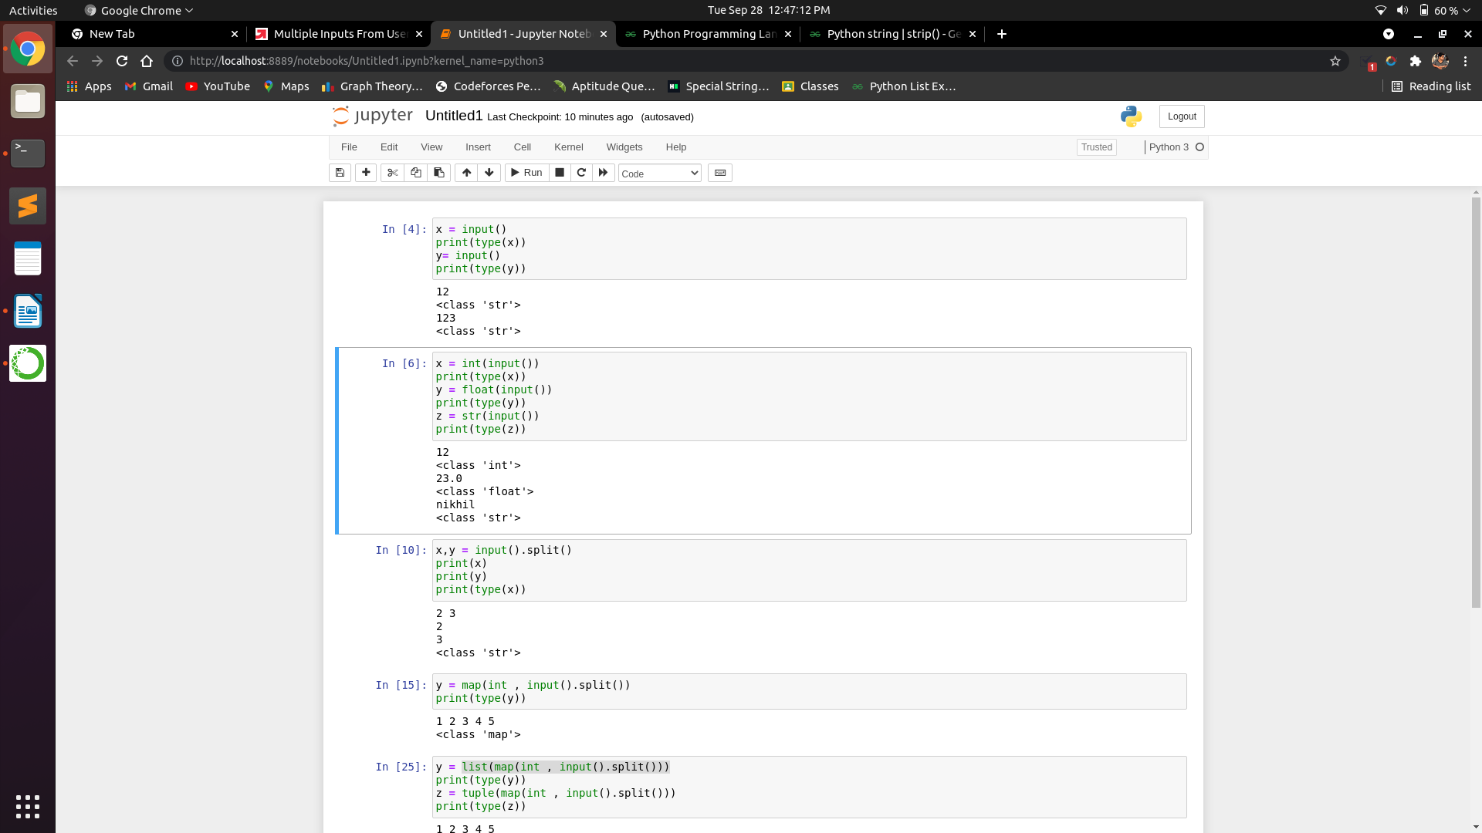

We can get desired data type of our input by typecasting
Typecasting input to integer
Typecasting input to float
Typecasting input to string

Taking Multiple inputs at a time
Split() function: It helps to specify a character that will be used as a saperator to break the input provided by the user
Taking two input at a time
x,y=input().split(“saperator“) // In case of blank space nothing write inside parameter.
[ Note data type of x and y will be string as input() always convert input to string ]
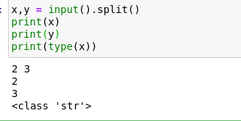

map function
map() function returns a map object ( which is an iterator ) of the results after applying the given function to each item of a given iterable
map(fun , iter)

Taking multiple inputs from user by using map class

Taking multiple inputs from user and then typecasting into another data type
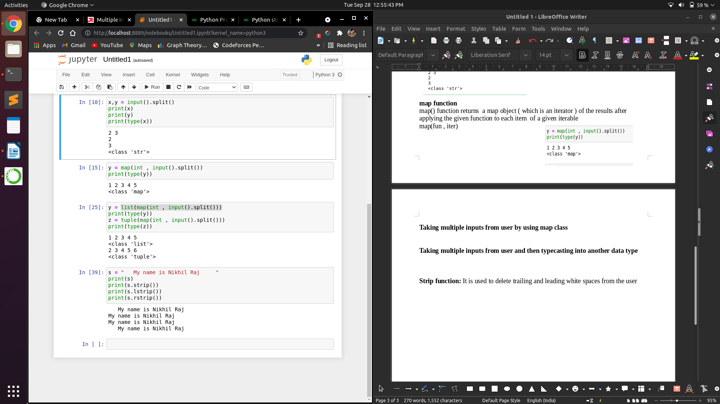

Strip function: It is used to delete trailing and leading white spaces from the user

if statement
if ( ):
[ ]
elif ( ):
[ ]
else :
[ ]

if statement cannot be empty if we have no statement to write put pass over there

Short hand if:: if a>b: print(.....)
Short hand if else:: print(....) if ( ) else print(....)

While loop

For loop
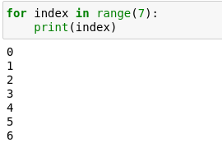
The range() function
The range() function returns a sequence of numbers starting from 0 by default and increments by 1( by default) and ends at specified number
range(7) is value from 0 to 6

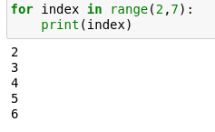
The range function defaults to 0 as a starting value however it is possible to specify the starting parameter : range(2,7) which means value from 2 to 6

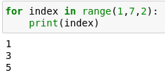
The range() function defaults to increment the sequence by 1 however it is possible to specify the increment value by adding a third parameter. Range(2,7,2)
for loops cannot be empty so write pass if nothing to write

Python Operator
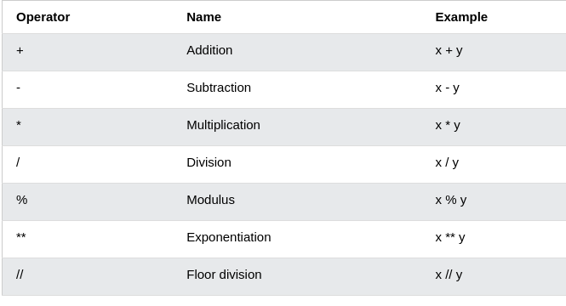

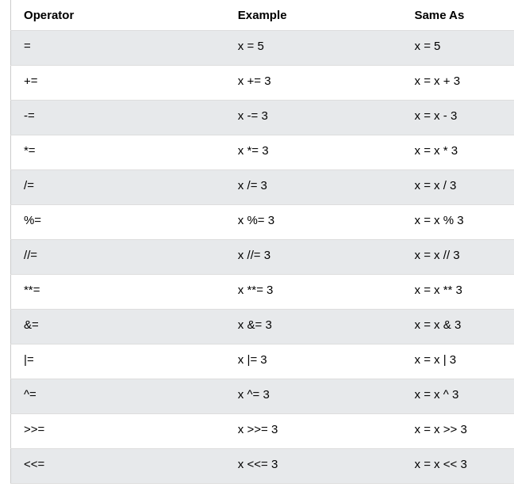
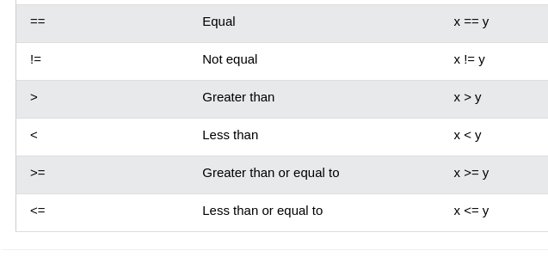

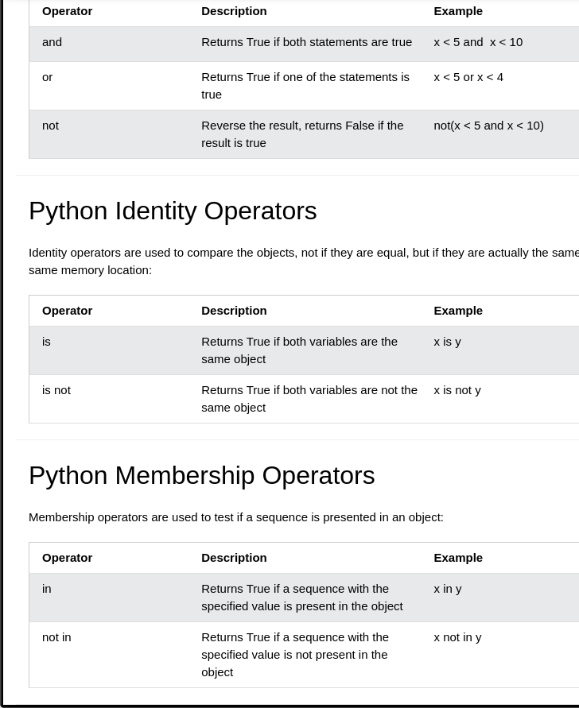

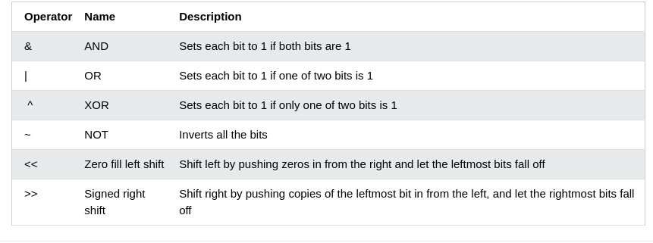

Python Data Types
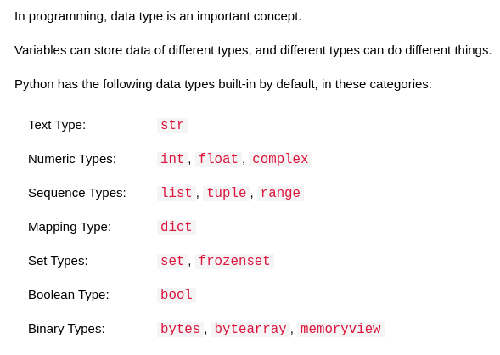

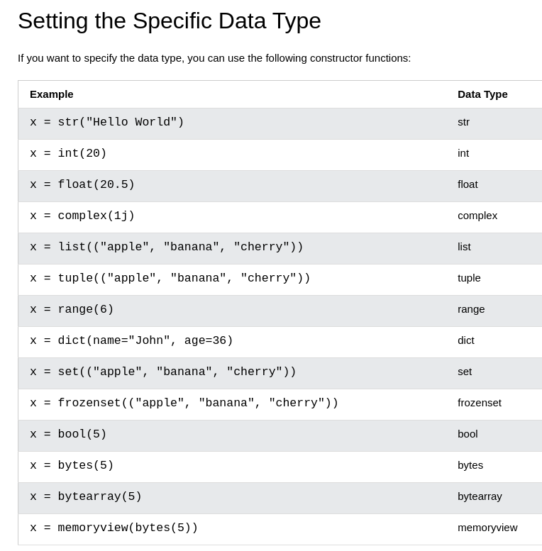

Python Booleans:
Boolean represents one of two values: True or False
Any string is true except empty strings
Any number is True,except 0
Any list ,tuple , set and dictionary are True except empty ones

Python Numbers
1. int 2. float 3. complex
x = 1 // int y = 2.8 // float z = 1j // complex
int: int or integer is a whole number positive or negative without decimals of unlimited length
float: float is a number positive or negtive containing one or more decimals
float can be scientific with an e to indicate the power of 10
complex: complex numbers are written with a “ i “ as an imaginary part

Python Math
The min() and max() functions can be used to find the lowest or highest value in a interable
The abs() function returns the absolute positive value of the specified number
The pow(x,y) function return the value of x^y
Python has also built in module called math which extends the ist of functions
To use it we must import math module::: import math
math.sqrt() returns the square root of a number. math.sqrt(69)
math.ceil() returns the ceil value of number. math.ceil(1.4)
math.floor() returns the floor value of a number math.floor(3.4)
the math.pi constant returns the value of PI (3.1428..)
Sets
Sets are used to store multiple items in a single variable.
A set is a collection which is both unordered and unindexed
Sets are written in curly brackets and do not alow duplicate values
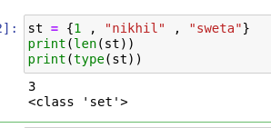
Sets are unchangeable meaning we cannot change the item after the set has been created but we can add item
Set Items can be of any data type

Print length of the set : len(name_of_set))

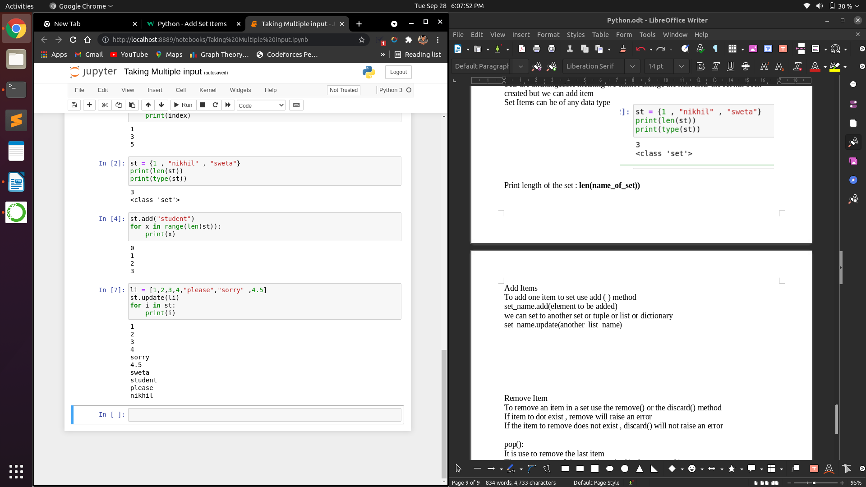
Add Items
To add one item to set use add ( ) method
set_name.add(element to be added)
we can set to another set or tuple or list or dictionary
set_name.update(another_list_name)

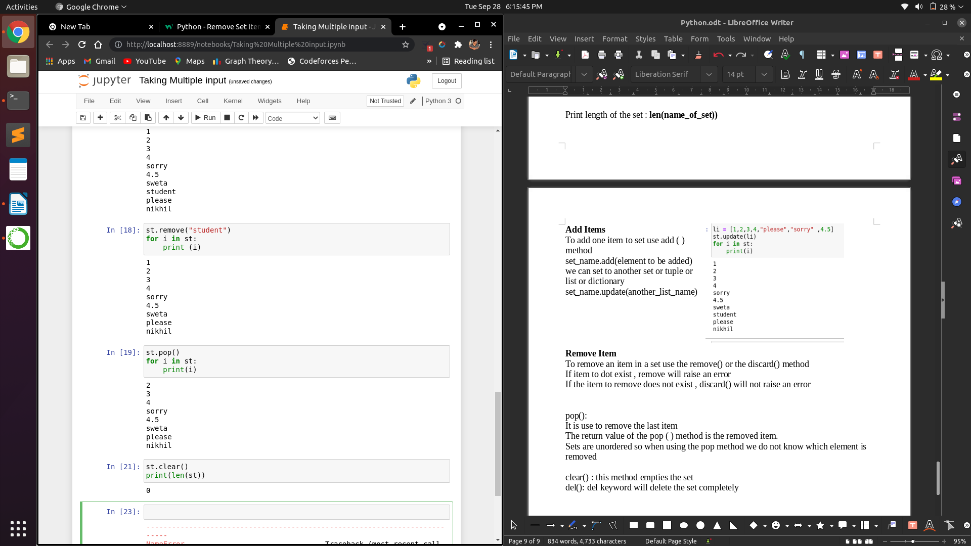
Remove Item
To remove an item in a set use the remove() or the discard() method
If item to dot exist , remove will raise an error
If the item to remove does not exist , discard() will not raise an error

pop():
It is use to remove the last item
The return value of the pop ( ) method is the removed item.
Sets are unordered so when using the pop method we do not know which element is removed

clear() : this method empties the set
del(): del keyword will delete the set completely

union() or update(): It returns a new set containing all items from both sets
Both union() and update() method will exclude any duplicate items
The intersection_update() method will keep only the items that are present in both sets
SYNTAX::set_name1.intersection_update(set_name2)
The intersection() method wil return a new set that contains only items that are present in both sets
new_set = set_name1.intersection(set_name2)

The symmetric_diffrence() method will return a new set that contains only the elements that are not present in both sets
new_set = set_name1.symmetric_diffrence(set_name2)
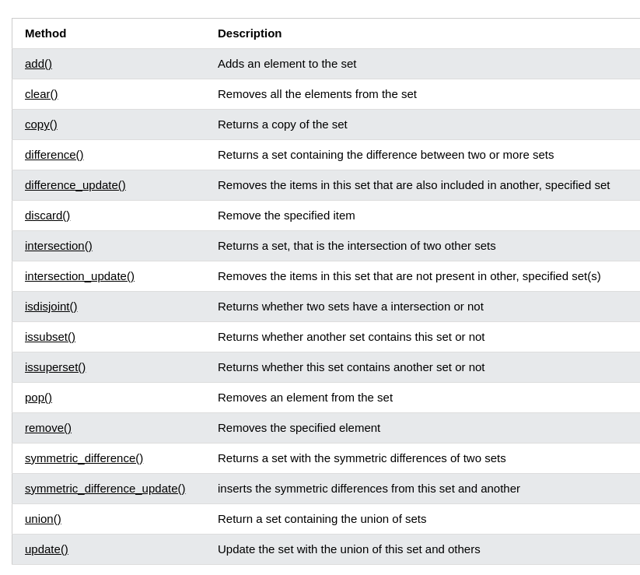

Tuples
Tuples are used to store multiple items in a single variable
A tuple is a collection which is ordered and unchegable
Tuples item are ordered , unchangeable and allow duplicate values
Tuple items are indexed , the first item has [0] index
Ordered
It means they have definite order and order will not change
Unchangeable
We cannot change add or remove items after the tuple has been created
To create a tuple with only one item you have to add a comma after the item otherwise Python will not recognize it as tuple
Tuple items can be of any data type
del : It delete tuple completely

Update tuples
Tuples are uchangeable/immutable but we can convert them to list and back to tuple

Access tuple items
print(tuple_name[x:y] :: print tuple from index x to index y-1
print(tuple_name[x:] :: print tuple from index x to last
print(tuple_name[:y] :: print tuple from index 0 to index y-1
print(tuple_name[-x:-y] :: print tuple from index -x to index -y+1
check if item exist or not using in keyword :: if item_name in tuple_name:

Python-Unpack Tuples

Join tuples
To join two or more tuple we can use + operator
new_tuple = tuple_name1 + tuple_name2
If we want to multiply the content of a tuple a given number of times you can use * operator
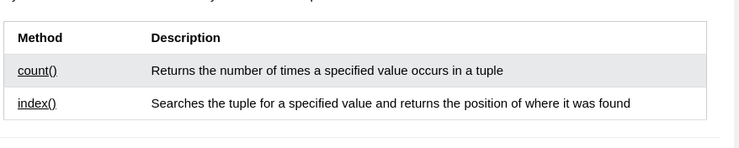
List
List are used to store multiple items in a single variable
List are created using square brackets
List Items
List Items are ordered , changeable and allow duplicate values
List items are indexed and indexing starts with 0
List items can be of any data type

Ordered
Items have definite order and order will not change
If we add items to a list the new items will be placed at the end of the list

Changeable
The list is changeable meaning we can change add or remove items in a list after it has been created

Access List Items
print(list_name[x:y] :: print list from index x to index y-1
print(list_name[x:] :: print list from index x to last
print(list_name[:y] :: print list from index 0 to index y-1
print(list_name[-x:-y] :: print list from index -x to index -y+1
check if item exist or not using in keyword :: if item_name in list_name:

Change List Items
To change the value of a specific item refer to thr index number

Add list items
To add an item to the end of the list use the append() method
list_name.append(item_name)

Insert Items
To insert a list item at a specified index use the insert method
list_name.insert(index_no , item_name)

The extend() method append elements from another list to the current list
current_list.extend(another_list)

Remove():: it removes the specified item :::list_name.remove(item_name)
pop():: It removes the specified index syntax::: list_name.pop(index)
If not specified the pop() element removes the last item:::list_name.pop()
clear() :: The clear method empties the list :::list_name.clear()
del(): It removes at specified index ::: list_name.del(index)
the del keyword can also delete the list completely

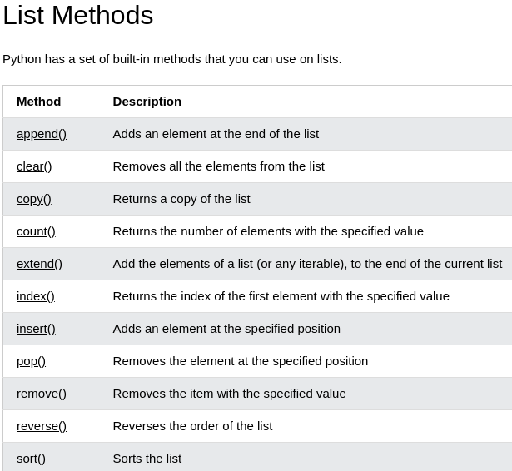

List Comprehension

Function
def function_name():
To call a function use the function name followed by paranthesis function_nam()

Arguements
We can add as many arguements as we want just saperated with comma
Arguements are often shortened to args in Python documents
The term parameter or arguements can be used for same thing
Number of Arguements
By default a function can be called with the correct number of arguements

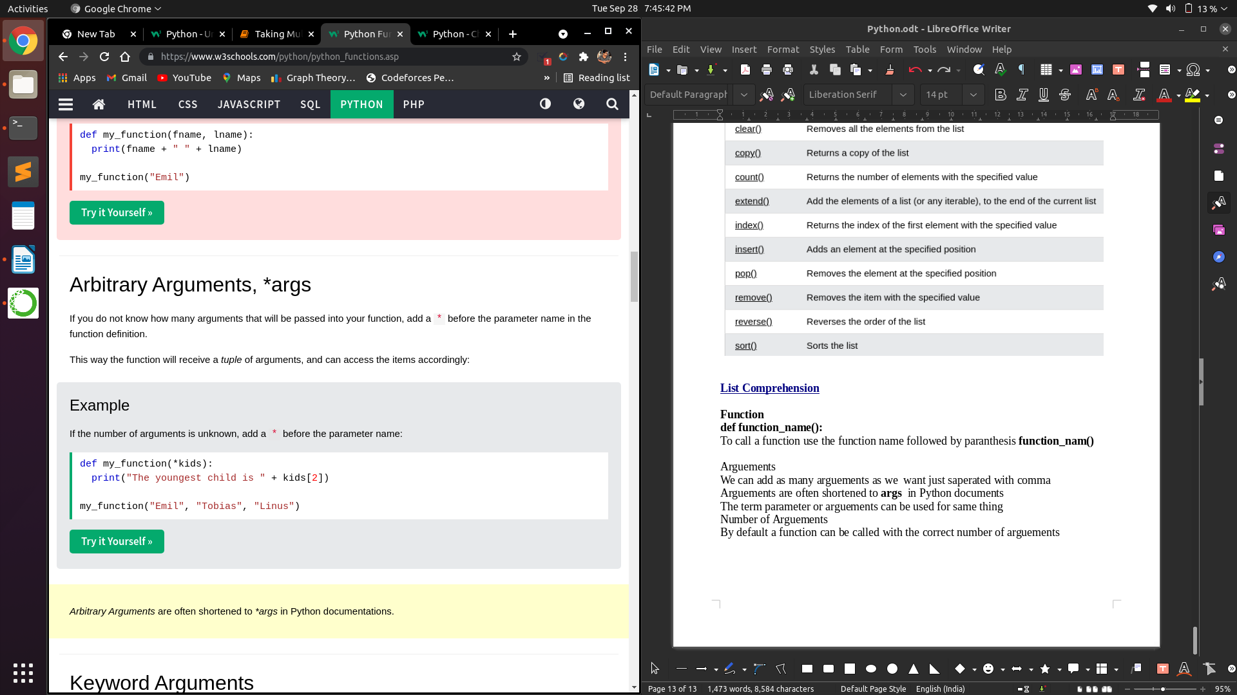
Keyword Arguements
You can also send arguements with the key = value syntax
This way the order of the arguements do not matter
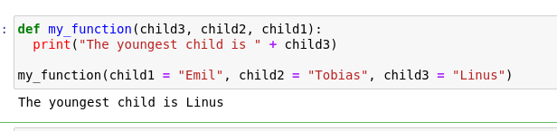
Default parameter value
If we call function without arguement it uses the default value
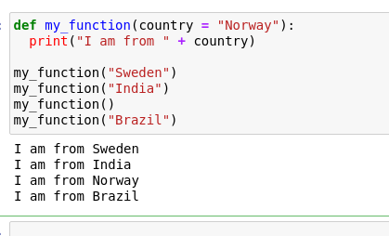

Pass statement
functionn definition cannot be empty but if some reason our function has no content put in the pass statement to avoid getting an error.

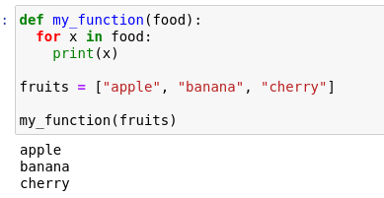
Passing a List as an arguement
We can send any data types of arguement to a function and it will be treated as the same data type inside the function
If we send a list as an arguement it will be a list when it reaches the function

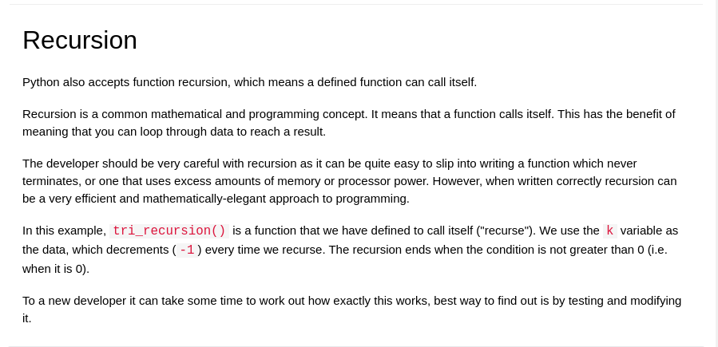
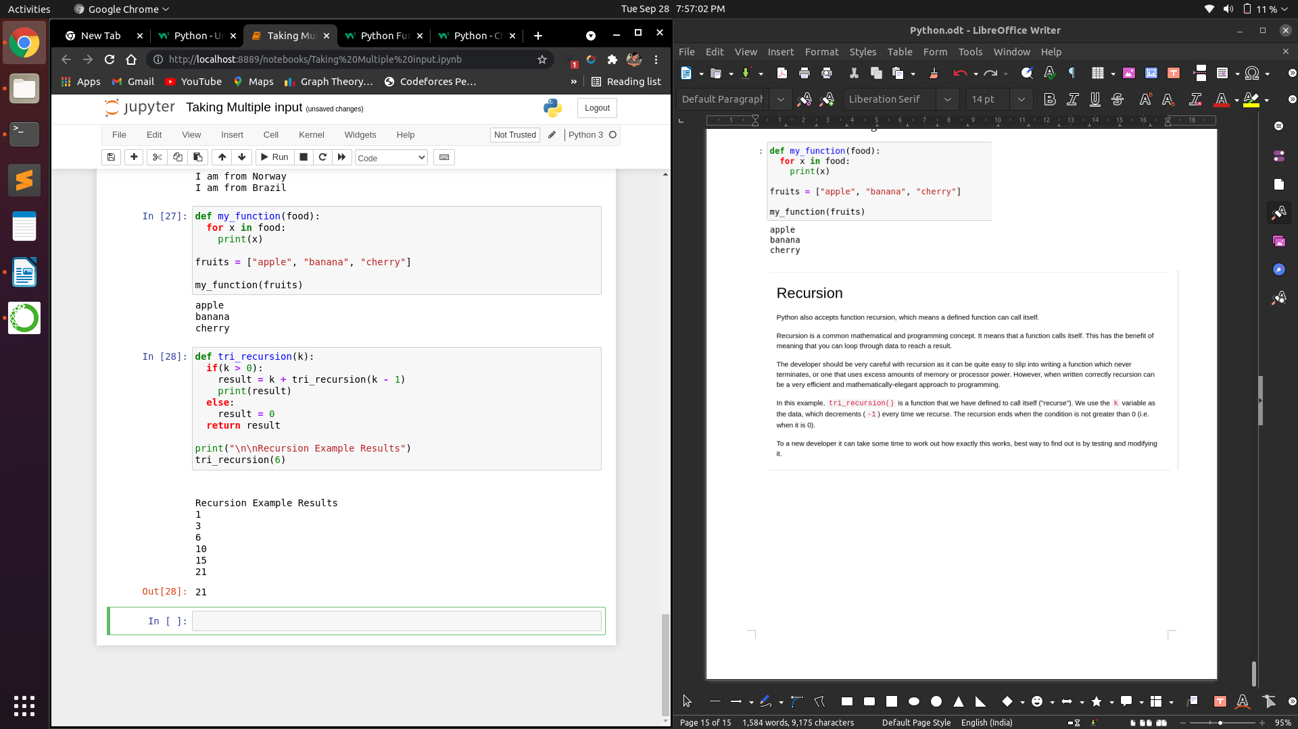

Python Srings
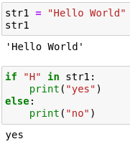
Strings in Python are surrounded by either single quotation or double quotation marks
Strings behave like an array
To check if a certain phrase or chracter is present in a string we use the keyword in
String Slicing
print(string_name[x:y] :: print string from index x to index y-1
print(string_name[x:] :: print string from index x to last
print(string_name[:y] :: print string from index 0 to index y-1
print(string_name[-x:-y] :: print string from index -x to index -y+1

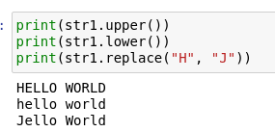
Upper case:: It returns the string in upper case ::: string.name.upper()
Lower case:: It returns the string in lower case ::: string_name.lower()
Replace():: It replaces a string with another string
To concatenate or combine string use + operator
str_name = str1 + str2

String Format
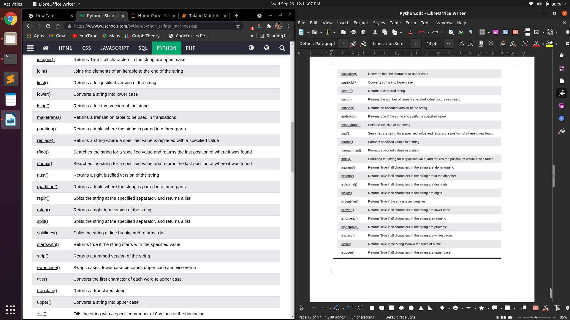

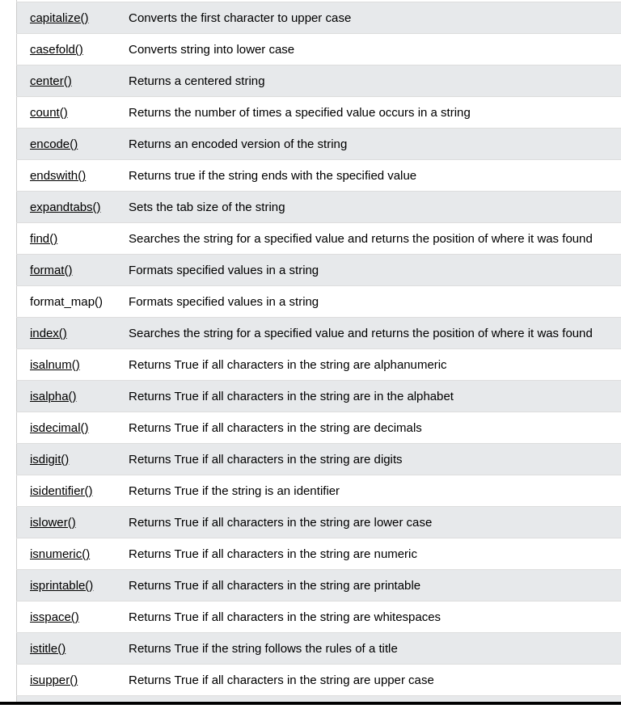

Python Arrays
Python does not built in support for Arrays but Python Lists can be used instead
To work with Arrays in Python we need to import a library like NumPy libreary
Arrays are used to store multiple values in a single variable
Access the Elements of an Array
We can refer to an array element by referring index number
Length of Array
By using len() method we can return the length of the array
Add element
We can add elements by using append() method
Remove Elements
We can remove the elements using pop method array_name.pop(index_no)
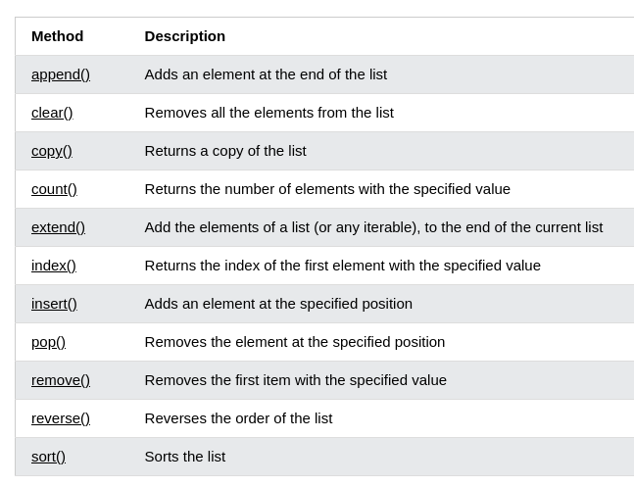
Python Iterator
An iterator is an object that contains a countable number of values
An iterator is an object that can be iterated upon meaning we can tarverse through all the values
In Python an iterator is an object which implements the iterator protocol which consists of the methods __itr__() and __next__()

Iterator vs Iterable
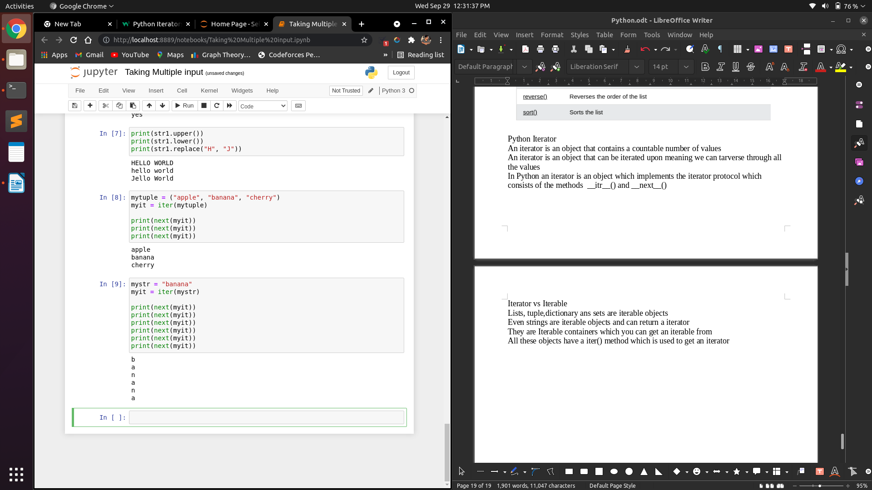
Lists, tuple,dictionary ans sets are iterable objects
They are Iterable containers which you can get an iterable from
All these objects have a iter() method which is used to get an iterator

Even strings are iterable objects and can return a iterator
The for loop actually creates an iterator object and executes the nect() method for each loop
Create and Stop an Iterator

Scope of function
A variable created inside a function belongs to the local scope of that function and can only we used inside that function
Global Scope
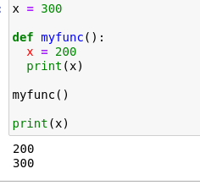
A variable created in the main body of the python code is a global variable and belongs to the global scope
Global variables are available from within any scope global and local
Naming variable
If you operate with the same variable name inside and outside of a function Python will treat them as a saperate variable one available in global scope and one vailable in local scope

Global Keyword
if we need to create a global variable but stuck in local scope we can use global keyword
The global keyword makes the variable global
Also use the global keyword if you want to make a change to a global variable inside a function

