**AWS**_**SimpleQueueService**

1. We have used these services to decouple the applications.

Multiple applications talk to each other than that time we are used to SQS

2. Send, receive, and store messages between Software components

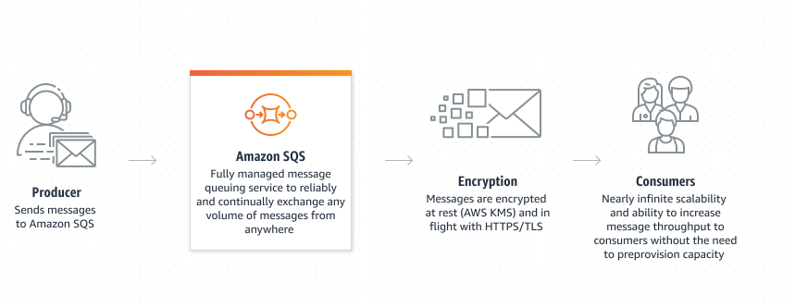

3. It moves data between distributed application components and helps you decouple these components.

4. FIFO QUEUE

FIRST IN FIRST OUT