# Monitoring tools(Grafana, Prometheus, Windows Exporter) guide for Ubuntu & Windows

Prerequisites- Grafana( visualization ), Prometheus Windows Exporter(windows) for Linux(Node Exporter)

There are two ways to install

Using the Ubuntu Operating System & Windows Operating System

Task:1

Install the Windows Exporter(windows)

The Windows Exporter (formerly known as the WMI Exporter) is a tool that collects Windows system metrics and exposes them in a format that Prometheus can scrape. It allows you to monitor various aspects of Windows operating systems, such as CPU usage, memory usage, disk usage, and network performance, among other metrics. This is especially useful for integrating Windows systems into a Prometheus-based monitoring solution.

<https://github.com/prometheus-community/windows_exporter/releases>

download the exe and run

Task:2

Install the Grafana on the ubuntu or windows

Grafana is a powerful open-source platform used for monitoring, visualization, and analysis of time-series data from various data sources. Here are some key uses and features of Grafana:  
Data Visualization:  
Monitoring and Alerting  
Data Source Integration:

Dashboard Sharing and Collaboration:

Centralized Monitoring:

Customizable and Extensible:

Step for the Ubuntu

1. sudo apt update

2. sudo apt install -y software-properties-common

3. sudo add-apt-repository "deb https://packages.grafana.com/oss/deb stable main"

4. sudo wget -q -O - https://packages.grafana.com/gpg.key | sudo apt-key add –

5. sudo apt update

6. sudo apt install -y Grafana

7. sudo systemctl start grafana-server

sudo systemctl enable grafana-server

8. sudo systemctl status grafana-server

Task:3

Install the Prometheus on the ubuntu or windows

Prometheus is an open-source systems monitoring and alerting toolkit originally built at SoundCloud. Since its inception, Prometheus has grown to become the de facto standard for monitoring and alerting within cloud-native environments. Here are its key functions and components:

data_collection

Time-Series Database:

Querying:

Alerting  
Service Discovery:

1. wget https://github.com/prometheus/prometheus/releases/download/v2.46.0/prometheus-2.46.0.linux-amd64.tar.gz

tar -xvzf prometheus-2.46.0.linux-amd64.tar.gz

cd prometheus-2.46.0.linux-amd64

2. Then edit the Prometheus.yml file

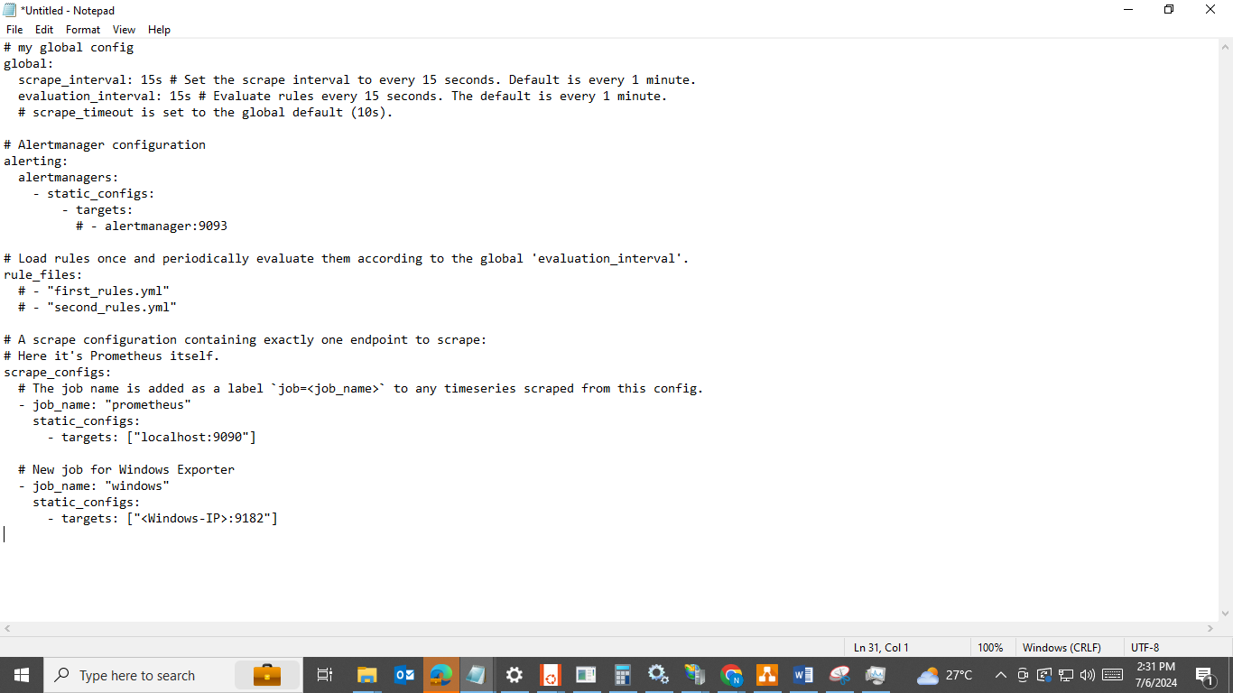

Just add a target server where Windows exporters are running

3. ./prometheus --config.file=prometheus.yml

Task4:

Then Create the Dashboard on the Grafana  
1. New dashboard

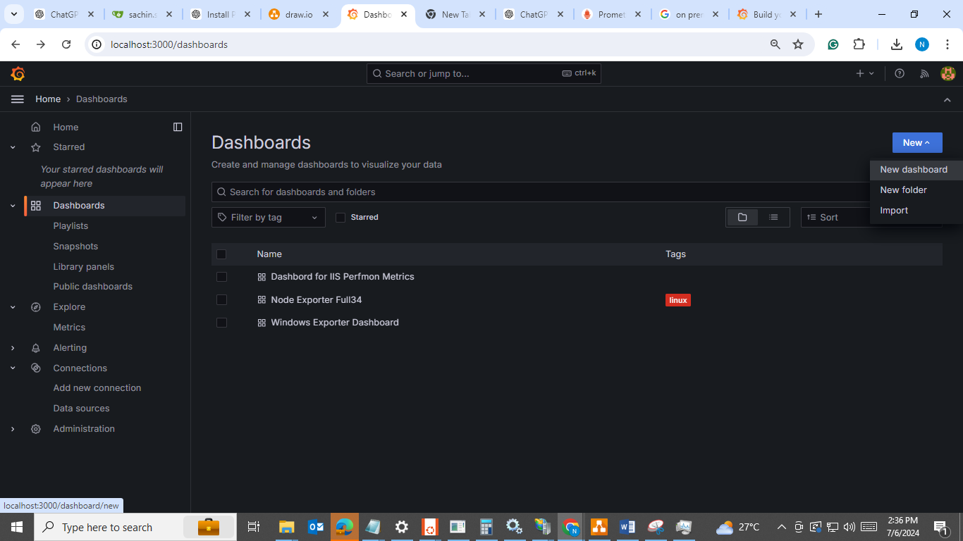

2. Import the dashboard

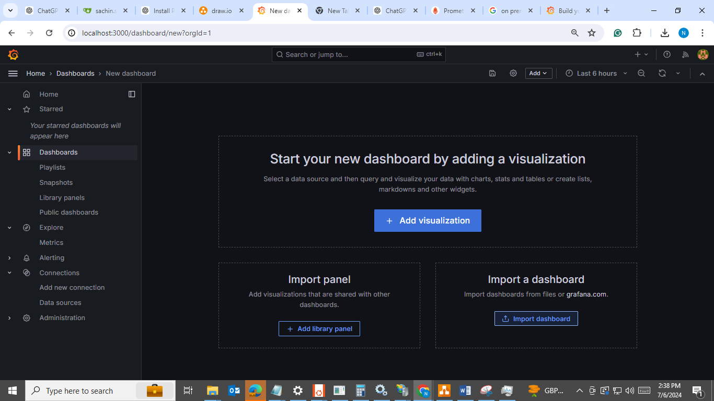

<https://grafana.com/grafana/dashboards/>

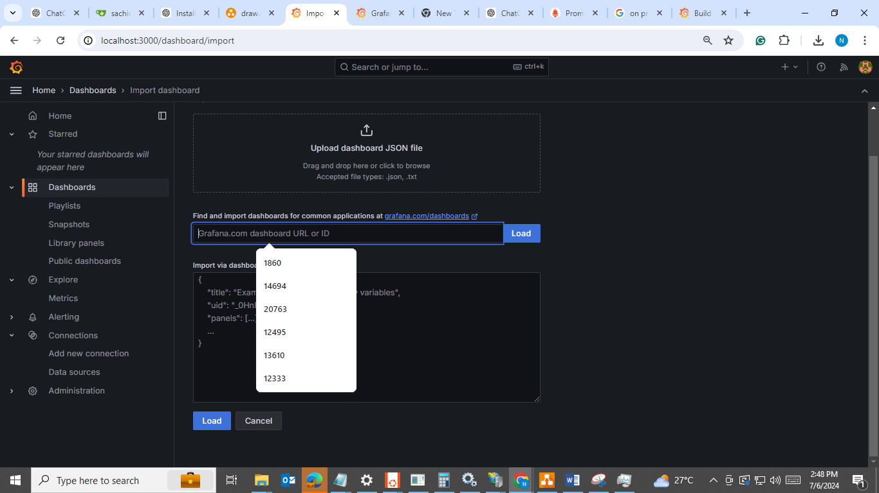

from the above number, you can import the already present dashboard.