

DEPARTMENT OF ELECTRONICS AND COMMUNICATION ENGINEERING

**CERTIFICATE**

Certified that the Mini Project entitled “**Home Automation System using Bluetooth**” is carried out by **Nikhil Dwivedi (1NH17EC729), Syed Touqeer (1NH17EC753), and Nilothpal Raj Bhattacharya (1NH16EC065)** bonafide students of **New Horizon College of Engineering**, **Bengaluru** in partial fulfilment for the award of **Bachelor of Engineering** in **Electronics & Communication** of the **Visvesvaraya Technological University** during the year **2018-19**.

It is certified that all corrections/suggestions indicated for internal assessment has been incorporated in the report deposited to the department library. The Mini Project report has been approved as it satisfies the academic requirements in respect of the Mini Project work prescribed for the said degree.

Signature of HOD Signature of Internal Guide

Dr Sanjeev Sharma Dr Shreesha Kalkoor

Professor and HOD Associate Professor

Dept. of ECE Dept. of ECE

NHCE, Bangalore NHCE, Bangalore

EXTERNAL EXAMINER

Name of Examiner Signature with Date

1.

2.

**ACKNOWLEDGEMENT**

We would like to thank the management, Dr Mohan Maghnani, Chairman of New Horizon Educational Institutes for providing us the necessary infrastructure and creating a good environment.

We would like to express our sincere gratitude to our principal, Dr Manjunatha for giving us this opportunity to undertake this project.

We also wish to express our gratitude to Mr Sanjeev Kumar, HOD of Electronics & Communication Engineering Department, for his kind hearted support.

It gives us immense pleasure to express our deepest sense of gratitude and sincere thanks to our guide Dr Sreesha for his valuable guidance, encouragement and help throughout this project. The useful suggestion for this Mini Project and cooperative behaviour are sincerely acknowledged.

We also wish to express our indebtedness to our parents as well as our family members whose blessings and support always helped us to face the challenges ahead. At the end we would like to express our sincere thanks to all our friends who helped us directly or indirectly during this project work.

Rigorous hard work has been put in this project to ensure that it proves to be the best. I hope that this project will prove to be a breeding ground for the next generation of students and will guide them in every possible way.

**ABSTRACT**

Technology is an endless project. And it has become a part of human’s life. It has changed the entire lifestyle of humans. To develop a project that will be beneficial to the humans is a massive contribution to the society and we can’t be happier than to give something to the society. So this project exhibits the development of an easy, adaptable and protected Home Automation System based on a smartphone and a microcontroller where you can control your home machines through voice commands or text commands. The plan depends on a microcontroller Arduino UNO board, 4 channel Relay Module, HC-05 Bluetooth Module. The home appliances are connected to the I/O ports by means of relay switches. The interaction between the cell phone and the Arduino UNO board is remote and secured and is password protected so that only the user has access to the appliances

**TABLE OF CONTENTS**

1. INTRODUCTION
2. LITERATURE SURVEY
3. BLOCK DIAGRAM
4. CIRCUIT DIAGRAM
5. PROPOSED METHODOLOGY
6. RESULTS OBTAINED
7. FUTURE SCOPE
8. REFERENCES
9. APPENDIX

INTRODUCTION

This 21st century is the age of wireless technology and days are gone when we used to connect everything using cables and wires. The wireless technology is becoming more popular among the humans and they are very easily getting along with this technology. And among these popular wireless technologies available Home Automation is one of the most famous application.

Home Automation with respect of Internet of Things is a way devices and appliances are connected together to provide a seamless control over the aspects of our home. It is using the information technology and control system so as to lessen the human efforts/work. The quick development of innovations impact us to utilize cell phones to remotely control the home apparatuses. An automated gadget has the tendency to do work with determination, flexibility and with least error rate. Home automation framework is a noteworthy issue for analysts and home appliances companies as it rapidly decreases the human efforts, consumes significant time and energy. Early home automation frameworks were utilized in labour sparing machines yet these days its fundamental target is to give offices to elderly and impaired individuals to perform their day by day schedule assignments and control the home apparatuses/appliances remotely. The Allied Business Intelligence (ABI) look into reports that right around 1.5 million programmed home machines were introduced in United States of America (USA) amid 2012 and their expanding rate is 45.2%. In remote based home automation framework diverse sort of advances, for example, General Packet Radio Service (GPRS), Zig Bee, Global System for Mobile (GSM), Z-Wave, Infrared, Bluetooth and wireless fidelity (Wi-Fi) are utilized, every innovation has their very own upsides and downsides. A Bluetooth based remote home automation framework can be execute with a minimal effort and it is anything but difficult to introduce in a current home. An examination work demonstrated that Bluetooth framework are quicker than remote and GSM frameworks. Bluetooth technology has capacity to transmit information sequentially up to 3 Mbps inside a physical scope of 10m to 100m contingent upon the kind of Bluetooth device.

Wireless advancements are ending up becoming more famous around the globe and the buyers’ value this wireless way of life. Presently with the implanted Bluetooth innovation, advanced gadgets frame a system in which the machines and gadgets can communicate or interact with one another. Today, Bluetooth and Wi-Fi are one of the most applied technology in the home automation concept. Working over universally accepted frequency of 2.4GHz, it can connect with the gadgets with bandwidth up to 3MBps within a range of 10 meters to 100 meters.

There are few issues also involved with the design and development of home automation system. The system should be secure and protected so that only the authentic clients can control the devices or appliances connected to the network. The system should be globally accepted with a future scope in minds such that all the devices available globally is compatible with the system and can be connected to it and the devices to be launched in the future should be compatible with the system. The system should be easy to setup and easy to use having user-friendly interface so people with no technical knowledge can setup and operate it. The system should be fast enough almost instant without any lag. The system should provide some diagnostic service so the issues can be traced and solved. And finally the system should be cost effective within the budget of common people.

In this project we are developing a user friendly, cost effective and globally accepted smartphone based Home Automation system where the home appliances are connected to the Arduino UNO using the relay board. The communication between microcontroller and smartphone is wireless using the HC-05 Bluetooth module. We are using a 4-channel relay board so four different home appliances can be connected to the system. Here we have used 2 AC bulbs and a DC motor as a fan. We are using an android application to communicate with the Bluetooth module.

**BLOCK DIAGRAM**

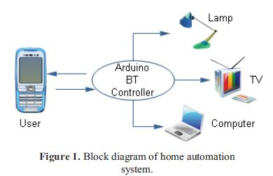

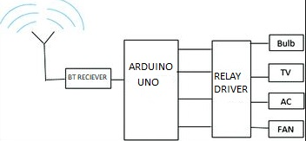

**CIRCUIT DIAGRAM**

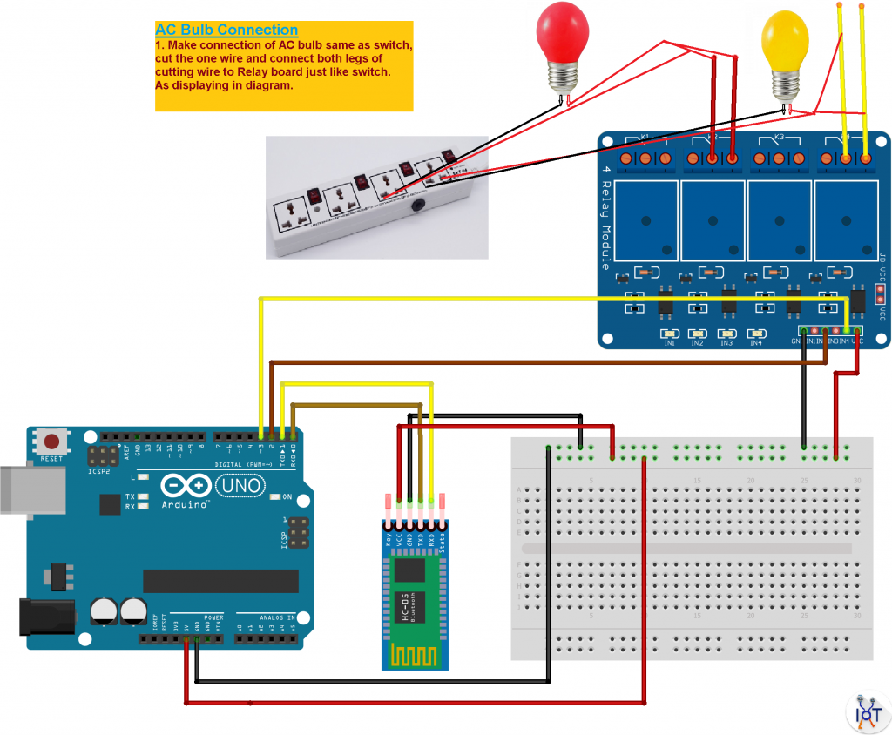

**PROPOSED METHODOLOGY**

1. COMPONENTS REQUIRED
2. ARDUINO UNO
3. 4-CHANNEL RELAY MODULE
4. HC-05 BLUETOOTH MODULE
5. AC BULBS (BLUE & YELLOW)
6. DC MOTOR
7. BREAD BOARD
8. JUMPER WIRES
9. EXTENSION BOARD
10. ARDUINO UNO

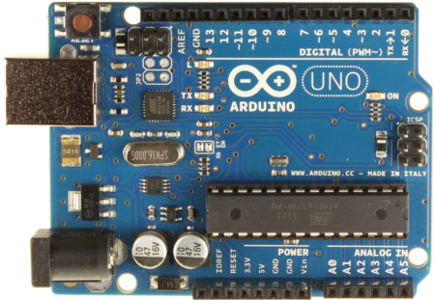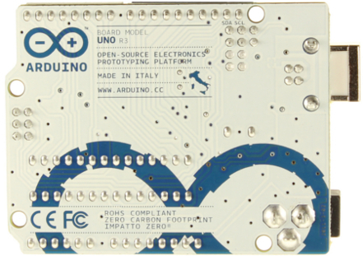

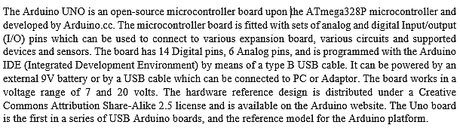



1. 4-CHANNEL RELAY MODULE

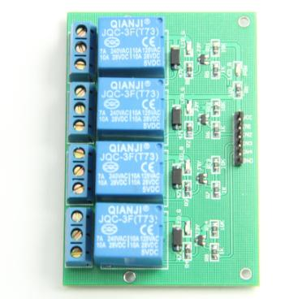

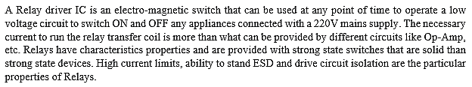



1. HC-05 BLUETOOTH MODULE

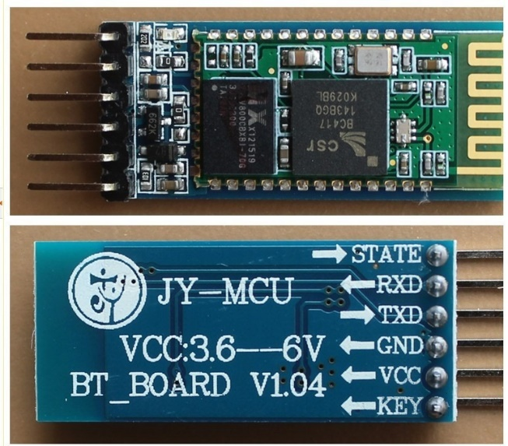

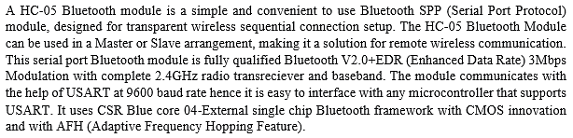



1. IMPLEMENTATION

The Google Android Application and Google Play service is used as a voice to text converter if we want to send voice commands. For sending the text commands IoTBoys android application is used. The Bluetooth module is connected to the smartphone and that particular module is selected as the primary robot in the application for sending the voice or text commands. The commands are then given to the smartphone (application) which transmits the data to the HC-05 module.

The Bluetooth receiver in HC-05 module receives the data transmitted from the smartphone. Subsequently this data is processed through the ATmega328 microcontroller present in the Arduino UNO. The Arduino board have different output ports which are connected to different home appliances through the 4-channel relay board. This relay board acting as switches and switches the home appliances ON/OFF as per the data processed through the Atmega328 microcontroller. For testing purpose we are using 2 25W, 240V AC bulbs connected to AC mains supply and a 5V DC motor connected to a 9V high watt battery. The appliances switches ON/OFF as per the commands given by the user.

Following actions can be done by giving voice/text commands:

* Switch ON kitchen (blue) light.
* Switch ON bathroom (yellow) light.
* Switch ON all the lights at once.
* Switch ON the fan (motor).
* Switch ON all the appliances at once.
* Switch OFF any particular bulb.
* Switch OFF all the bulbs.
* Switch OFF the fan (motor).
* Switch OFF all the appliances.

**RESULT OBTAINED**

Following outputs were observed after giving the respective commands:

1. Initially when all the appliances were off or When “ALL OFF” command is given

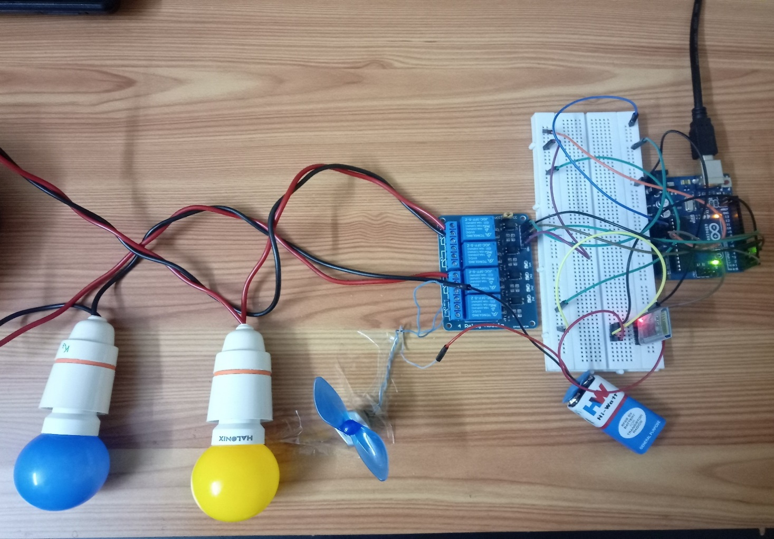

1. When “ALL ON” command is given:

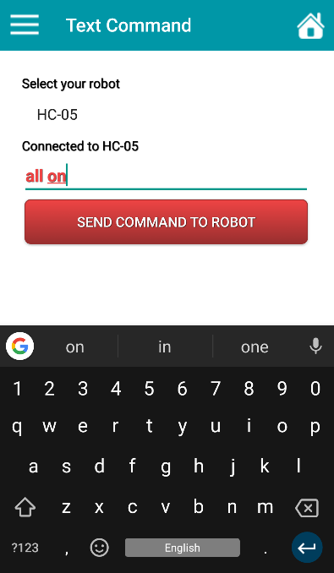 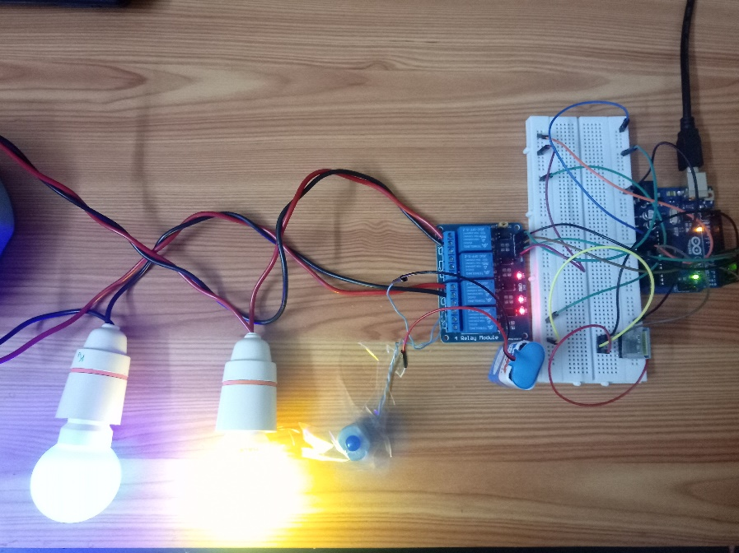

1. When “LIGHTS ON” command is given:

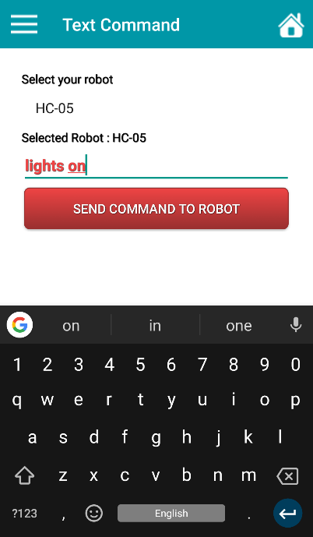 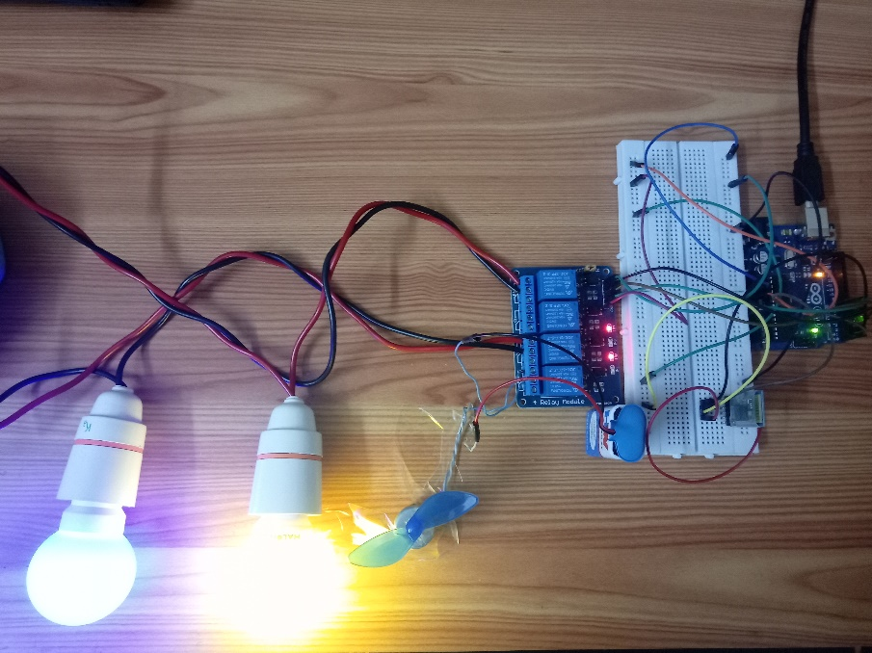

1. When “FAN ON” command is given:

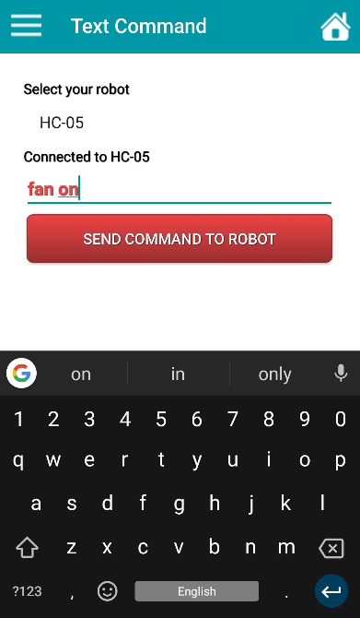 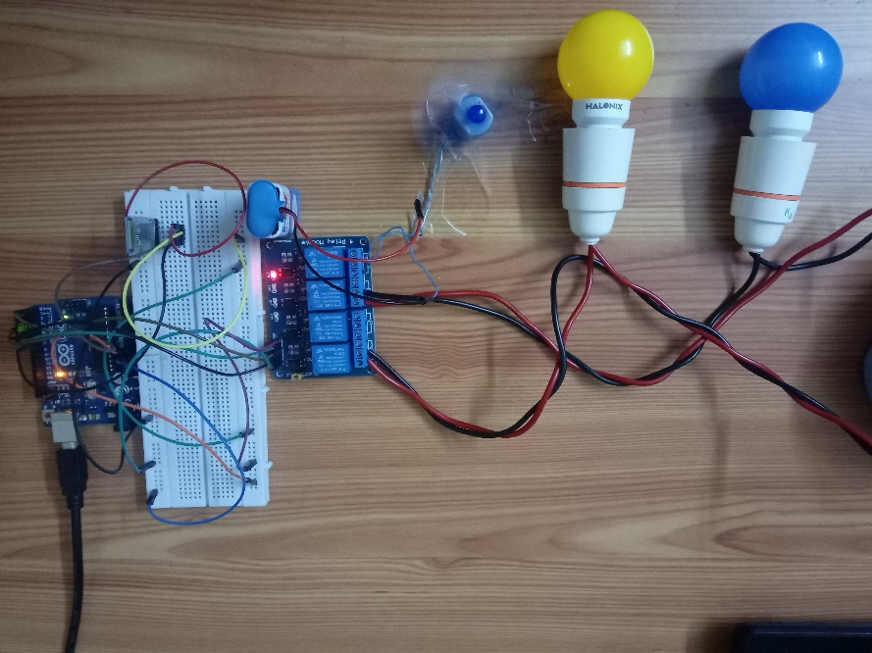

1. When “KITCHEN OFF” command is given:

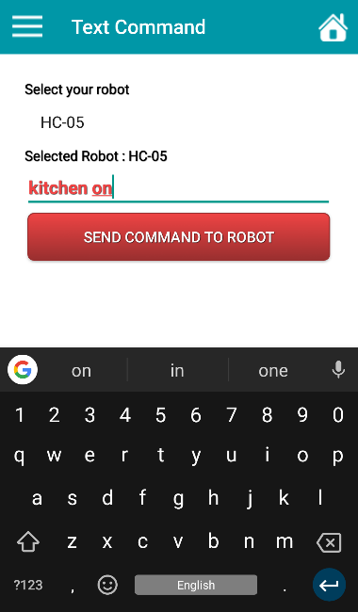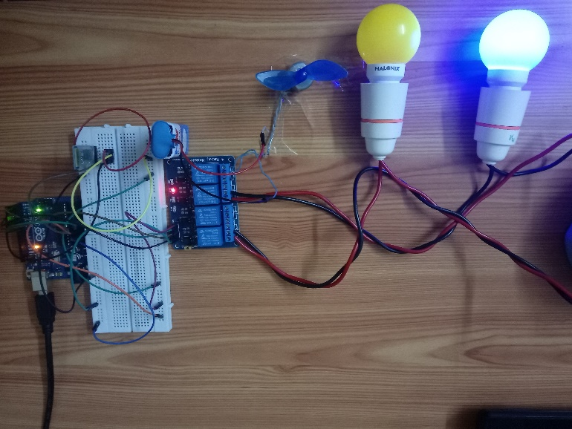

**FUTURE SCOPE**

In recent years the Internet of Things (IOT) have enabled shrewd innovation to end up plainly a vital piece of our day by day lives. Everything from refrigerators, to apparatuses, to home security can be controlled with smart home innovation. Home devices, when remotely observed and controlled through the Internet, are an essential constituent of the Internet of Things.

Automated systems are uniformly evolving these days in terms of ability, efficiency and overall performance. Home Automation systems are one of the most popular and in demand services in the world consumer markets. Some of the products in the market like Google Home, Amazon Alexa, Philips Hue bulbs are very popular among the consumers and are already selling at a very high rate in the market globally. The demand for Home Automation solutions is more in the developed countries like US, Japan, Germany and UK than the emerging countries like India, China etc. But these emerging countries are catching up to the competition.

[Global home automation Market](http://snip.ly/mybskz) is expected to reach USD 79.57 billion by 2022 and USD 116.26 billion by 2026. The availability of home automations systems these days are due to other facts too like high powerful smartphones, availability of high speed internet connection, high range Bluetooth and Wi-Fi, feasible electricity and internet connections and availability of wide range of products compatible with these systems.

Some of the major companies associated with home automation product across the globe are Google, Philips, Amazon, Creston Electronics, Schneider Electric SA, AMX LLC, Crestron Electronics, Siemens AG, iControl Networks Inc., Vantage Controls, ADT Corporation, 2GIG Technologies, Honeywell International Inc., Johnson Controls and Control4 Corporation.

**REFERENCES**

Following sources were used to complete this project

1. Bluetooth based Home Automation System Using cell phone by Rajiv Piyare and M.Tazil, Fiji National University, 2011 IEEE 15th International Symposium on Consumer Electronics
2. Home Automation: Past, Present and Future by Sharda R Karte and Dinesh V Rojatkar, International Research Journal of Engineering and Technology (IRJET)
3. Embedded Web Server for home appliances by Abhishek Vichare and Shilpa Verma, International Journal of Engineering Research and Application
4. [www.arduino.cc](http://www.arduino.cc)
5. [www.iotboys.com/projects](http://www.iotboys.com/projects)/2
6. [www.google.co.in/images](http://www.google.co.in/images)
7. en.wikipedia.org/ArduinoUno
8. [www.electronicshub.com](http://www.electronicshub.com)
9. [www.howtomechatronics.com](http://www.howtomechatronics.com)
10. Google Playstore.

**APPENDIX**

1. String voice;
2. int BLUE = 3;
3. int YELLOW = 5;
4. int FAN = 7;
6. void BlueOn()
7. {digitalWrite (BLUE, LOW);
8. }
9. void BlueOff()
10. {digitalWrite (BLUE, HIGH);
11. }
12. void YellowOn()
13. {digitalWrite (YELLOW, LOW);
14. }
15. void YellowOff()
16. {digitalWrite (YELLOW, HIGH);
17. }
18. void FanOn()
19. {digitalWrite (FAN, LOW);
20. }
21. void FanOff()
22. {digitalWrite (FAN, HIGH);
23. }
24. void allon()
25. {digitalWrite (BLUE, LOW);
26. digitalWrite (YELLOW, LOW);
27. digitalWrite (FAN, LOW);
28. }
29. void alloff()
30. {digitalWrite (BLUE, HIGH);
31. digitalWrite (YELLOW, HIGH);
32. digitalWrite (FAN, HIGH);
33. }
35. void setup()
36. {
37. Serial.begin(9600);
38. pinMode(BLUE, OUTPUT);
39. pinMode(YELLOW, OUTPUT);
40. pinMode(FAN, OUTPUT);
41. digitalWrite (BLUE, HIGH);
42. digitalWrite (YELLOW, HIGH);
43. digitalWrite (FAN, HIGH);
44. }

47. void loop()
48. {
49. while(Serial.available())
50. {
51. delay(10); char c=Serial.read();
52. if(c=='#')
53. {
54. break;
55. }
56. voice += c;
57. }
58. if (voice.length() > 0)
59. {
60. Serial.println(voice);
61. if (voice == "on" || voice== "all on" || voice== "on all")
62. { allon() ;
63. }
64. else if (voice == "off" || voice=="all off" || voice== "off all" || voice== "of all" || voice== "all of")
65. { alloff() ;
66. }
67. else if(voice =="blue" || voice =="blue on" || voice =="turn on kitchen light" || voice =="switch on kitchen light" || voice =="kitchen on" || voice =="kitchen light on")
68. { BlueOn();
69. }
70. else if(voice =="blue off" || voice =="turn off kitchen light" || voice =="switch off kitchen light" || voice =="kitchen off" || voice =="kitchen light off")
71. { BlueOff();
72. }
73. else if(voice =="yellow" || voice =="yellow on" || voice =="turn on bathroom light" || voice =="switch on bathroom light" || voice =="bathroom on" || voice =="bathroom light on")
74. { YellowOn();
75. }
76. else if(voice =="yellow off" || voice =="turn off bathroom light" || voice =="switch off bathroom light" || voice =="bathroom off" || voice =="bathroom light off")
77. { YellowOff();
78. }
79. else if(voice =="lights on" || voice =="turn on all the lights" || voice =="switch on all the lights" || voice =="all lights on")
80. { BlueOn();
81. YellowOn();
82. }
83. else if(voice =="lights off" || voice =="turn off all the lights" || voice =="switch off all the lights" || voice =="all lights off")
84. { BlueOff();
85. YellowOff();
86. }
87. else if(voice =="fan" || voice=="fan on" || voice =="switch on the fan")
88. { FanOn();
89. }

92. else if (voice =="fan off" || voice =="switch off the fan")
93. { FanOff();
94. }
95. voice="";
96. }}