**GROUP 7: Temple management system**

**Scope:** The Temple Management System is designed to efficiently manage various activities related to temple operations. It covers the management of temple details, visitors, priests, donations, events, bookings, ticketing, services, committee members, and finances.

**Functionalities of each table:**

**Temple Management**:

* + Register new temples with unique identifiers, names, and locations.
  + Update temple information.
  + Delete or archive temple details.
* **Visitor Management**:
  + Register visitors with contact details.
  + Link visitors to specific temples.
  + Update visitor details.
  + Maintain a record of all visitors for a particular temple.

* **Priest Management**:
  + Add new priests with associated details.
  + Link priests to specific temples.
  + Update or delete priest details.
* **Donation Management**:
  + Record donations from visitors with the date of donation.
  + Generate reports on donations for specific time frames.
  + Identify top donors.

* **Event Management**:
  + Schedule and manage temple events with descriptions.
  + Set dates for specific rituals.
  + Link events to temples.
  + Update or cancel events.

* **Booking Management**:
  + Manage event bookings for visitors.
  + Link bookings to specific events and temples.
  + Update or cancel bookings.

* **Ticket Management**:
  + Set prices for tickets related to events or temple visits.
  + Update ticket prices.

* **Service Management**:
  + Offer and describe various services available in the temple, like special pujas or guided tours.
  + Update or discontinue services.

* **Committee Member Management**:
  + Register committee members with their roles.

* **Finance Management**:
  + Record costs and revenue related to temple operations.

**ER DIAGRAM:**



**All the elements of ER diagram have been explained above with their functionalities.**

**QUERIES:**

**CREATING TABLES FOR BOOKING , SERVICE , COMITTEEMEMBER , FINANCE.**

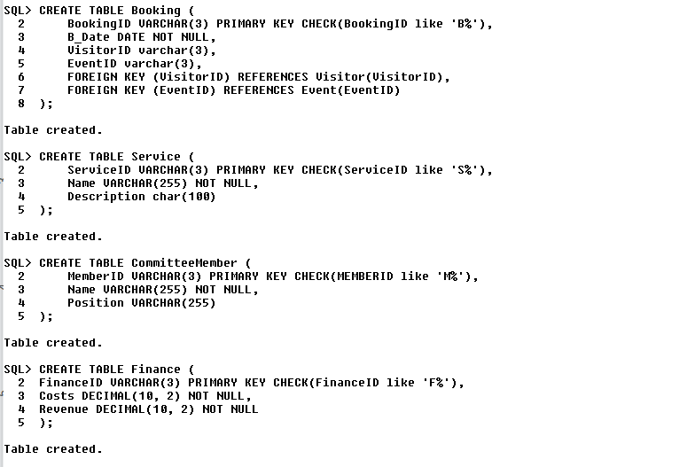

**DML QUERY TO UPDATE DATA:**



**DML QUERY TO DELETE DATA:**



**DCL QUERY TO GRANT PERMISSION TO NEWUSER:**



**USING JOINS TO SHOW ALL DONATIONS FROM THE SAME VISITOR:**

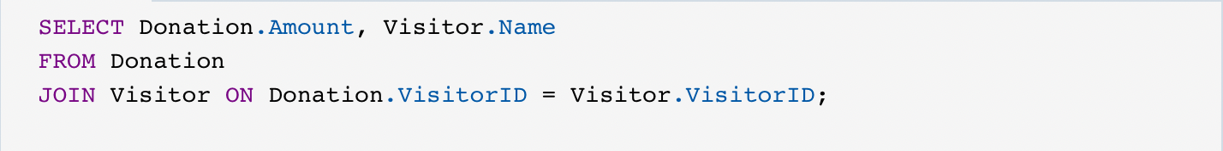

**NESTED QUERY TO FIND WHICH TEMPLE HAS THE MOST DONATIONS:**

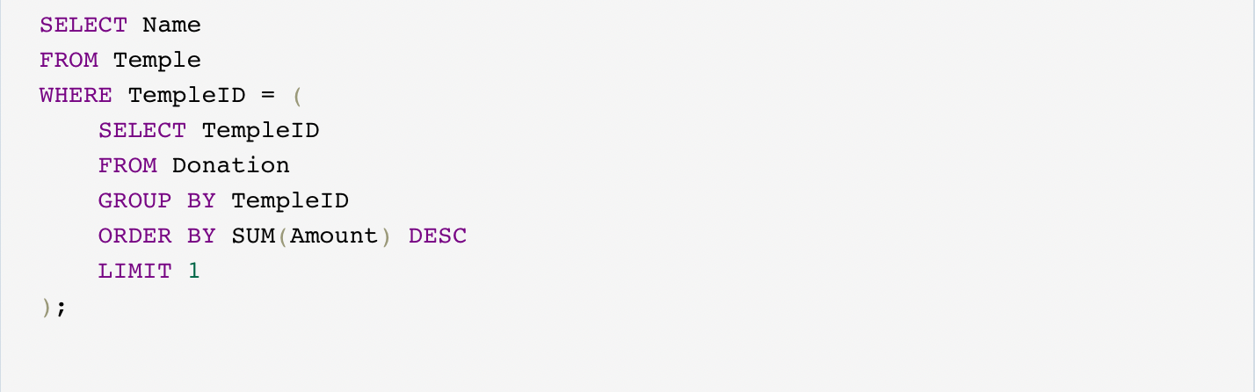

**USING NY ALL TO SEE WHO HAVE DONATED MORE TIMES THAN OTHERS:**

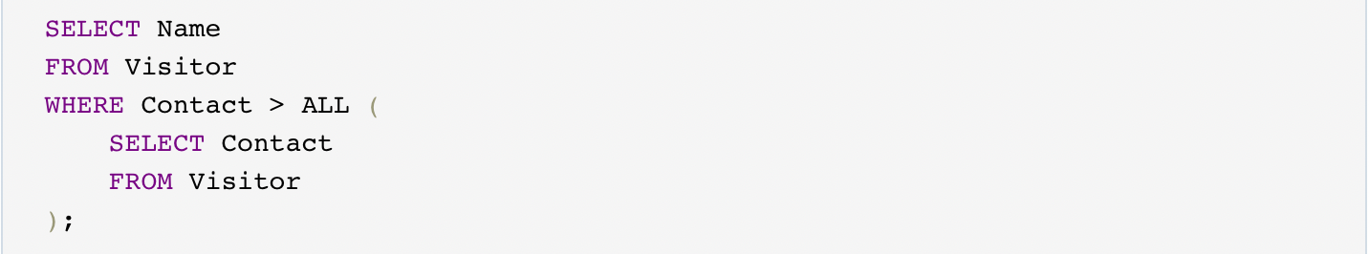

**LIST OF PRIESTS WITHOUT A TEMPLE ASSIGNED TO THEM:**

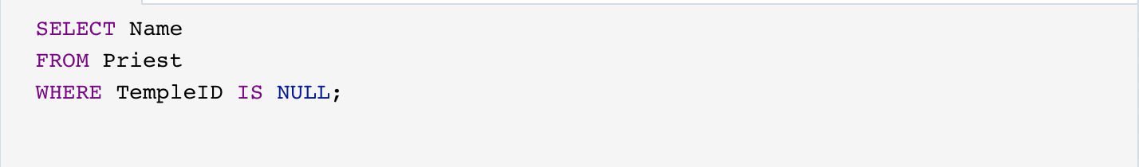

**OUTPUT OF COMITTEEMEMBER TABLE:**

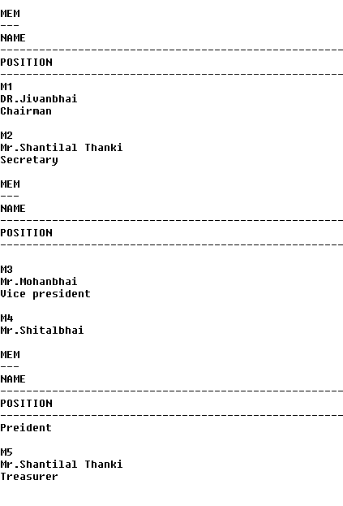

**CREATING FUNCTION:**

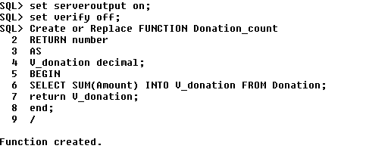

**CALLING THE FUNCTION:**

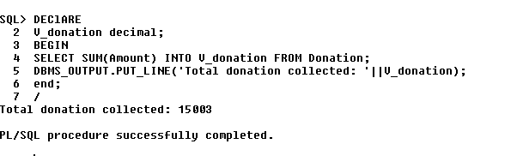

**CREATING AND CALLING THE PROCEDURE:**

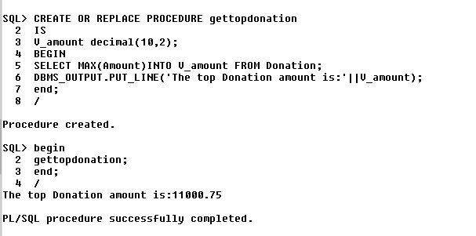

**CREATING TRIGGERS:**

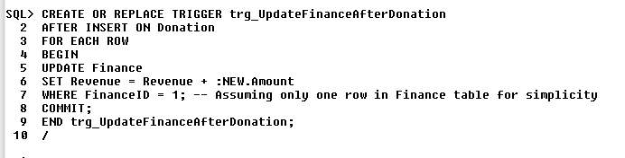

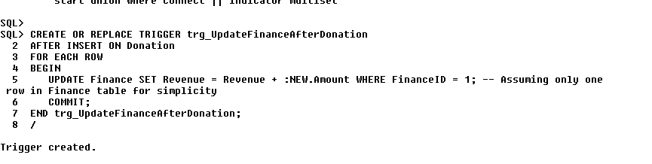

**DOCUMENTATION OF GROUP 7 PROJECT : TEMPLE MANAGEMNET SYSTEM.**