DECIVERSE - DECISION AGENT
Autonomous Social Decision Intelligence through Multi-Agent Simulation
Problem & Solution Brief + System Architecture
Tech Zephyr 4.0 — IIT Bhubaneswar | Agentic AI Hackathon

CORE PROPOSITION
MiroFish Decision Agent is an autonomous decision-making system that uses a simulated society as its environment. It plans actions, executes them through tools, observes emergent social consequences, adapts when constraints fail, incorporates human guidance, handles failures, and verifies the final outcome.

Goal → Observe → Plan → Decide → Act → Evaluate → Verify → Replan → Final Outcome
Github - https://github.com/nikhil8424/DECIVERSE-Decision-Agent
Demo Video - https://drive.google.com/file/d/1ytQy0oEbKx0Sv7dJSeFcwodUEskfbtO1/view?usp=sharing

1. Executive Summary
MiroFish Community was upgraded from a sequential social-simulation pipeline into a closed-loop, tool-using and adaptive decision agent. The system accepts public-policy or organizational decision goals with explicit multi-dimensional constraints, builds context and stakeholder representations, formulates policy scenarios, dynamically ranks candidate actions, executes multi-agent social simulations through OASIS, evaluates emergent behaviour and social impact, verifies outcomes against the user's constraints, and replans when the current strategy fails.
The architecture is deliberately designed around feedback: an action is not treated as successful merely because an LLM generated a plausible response. The simulated environment produces intermediate evidence, the verifier checks that evidence against explicit constraints, and the controller decides what should happen next. The system also supports human checkpoints, technical failover, uncertainty handling, persistent state, and safe stopping.
WHY IT IS AGENTIC
The next action is selected at runtime from multiple candidate actions using a seven-term utility function and the current DecisionState. When simulation results violate constraints, the system diagnoses the deficit, mutates the policy, and feeds the adapted scenario back into planning.

2. Problem Statement
Complex social and public-policy decisions are dynamic, multi-stakeholder problems. A decision can appear beneficial from one perspective while creating polarization, stakeholder opposition, equity concerns, or adoption problems elsewhere.
A conventional one-shot AI workflow generally follows:
TRADITIONAL PATTERN
Prompt → LLM → Recommendation

This is insufficient when the quality of a decision depends on what happens after an intervention is tested. A useful system must be able to act, observe consequences, detect constraint violations, change its strategy, and verify the new outcome.
PROBLEM TO SOLVE
How can an AI system autonomously pursue a complex social decision, interact with an evolving environment, learn from intermediate results, adapt its strategy, and verify whether the final outcome satisfies explicit constraints?

3. Target Users
User Group | Primary Need | How MiroFish Helps
Public-policy teams | Stress-test proposed interventions before deployment | Simulates stakeholder reactions and evaluates policy constraints.
Urban planners | Explore transport and civic policy alternatives | Compares scenarios and adapts policies based on simulated outcomes.
Community organizations | Understand stakeholder response and conflict | Models heterogeneous stakeholder digital twins and emergent behaviour.
Decision-makers | Compare strategies under explicit objectives | Provides ranked actions, quantified impact, verification, and audit trails.
Researchers / developers | Study agentic decision systems | Offers a reproducible closed-loop architecture with simulation and failure handling.

4. Why the Problem Requires an Agentic Solution
The system needs capabilities that are naturally expressed as an autonomous control loop:
- Goal pursuit — understand the decision objective and measurable constraints.
- Observation — inspect context, stakeholders, scenarios, prior decisions, and current state.
- Planning — generate several feasible next actions rather than follow a fixed sequence.
- Decision — rank actions using current state, expected benefit, information gain, cost, risk, and repetition history.
- Action — execute the selected tool against the simulation environment.
- Intermediate-result reasoning — evaluate what actually happened rather than assuming the action succeeded.
- Adaptation — replan and mutate the policy when constraints are violated or the environment changes.
- Human interaction — pause for approval or guidance when value conflicts or uncertainty justify intervention.
- Failure recovery — distinguish domain failures from technical failures and use retries/failover where possible.
- Verification and safe stopping — issue VERIFIED only when quantitative constraints are satisfied; otherwise continue or stop honestly as unresolved.
AGENTIC LOOP
Goal → Decision → Action → Intermediate Result → Adaptation → Final Outcome

5. Proposed Solution

5.1 MiroFish Decision Agent
The proposed system adds an autonomous decision layer around the existing MiroFish/OASIS social-simulation environment. MiroFish/OASIS acts as the environment in which policy actions produce simulated social reactions. The autonomous controller is responsible for deciding what to do next.
Example decision objective:
EXAMPLE GOAL
Find the most socially viable public-transit policy while keeping polarization and conflict below target thresholds and maintaining sufficient adoption.

Example constraints:
- Polarization < 0.35
- Conflict < 0.30
- Adoption > 0.50

5.2 Core Agent Components
Component | Role | Key Responsibility
Autonomous Controller | Agent/controller | Runs the closed loop, manages state, iteration budget, callbacks, and safe stopping.
DecisionState | Memory/state | Persists goals, observations, decisions, action history, failures, disruptions, and verification history.
Action Utility Planner | Planning | Generates candidate actions and ranks them using a seven-factor utility function.
Dynamic Replanner | Adaptation | Diagnoses failed constraints and proposes targeted policy mutations/recovery actions.
Agent Tool Registry | Tools | Routes executable context, scenario, simulation, comparison, and evaluation operations.
MiroFish / OASIS | External environment | Runs the multi-agent social simulation where stakeholder digital twins interact.
EmergentBehaviourAnalyzer | Evaluation | Derives emergent social patterns from simulation activity.
SocialImpactModel | Evaluation | Computes multidimensional social consequence metrics.
Integrated Verifier | Verification | Checks actual social-impact metrics against explicit user constraints.
Human Interaction | Human-in-the-loop | Pauses for human approval/guidance and feeds the response back into planning.
Failure Handler + Failover | Failure handling | Classifies failures, repairs malformed outputs, retries, switches providers, or safely stops.
Uncertainty Quantifier | Robustness | Uses repeated simulation runs to estimate variance and confidence intervals when evidence is uncertain.

5.3 Dynamic Action Planning
The planner generates a pool of feasible actions and scores every candidate against the current state. The selected action is the candidate with the highest utility at that moment.
Utility(a) = 0.25·GoalProgress + 0.30·ConstraintRecovery + 0.15·InformationGain + 0.20·ExpectedImprovement − 0.10·ActionCost − 0.10·FailureRisk − 0.15·RepetitionPenalty
This prevents the controller from being a fixed if/else action tree. The candidate ranking can change as polarization, conflict, adoption, uncertainty, previous failures, and human feedback change the DecisionState.

6. System Architecture
The architecture below represents the major components of the implemented system and their control/data flow. The autonomous controller sits above the existing MiroFish research and simulation stack. Persistent state, planning, verification, human interaction, and failure handling operate around the execution loop.

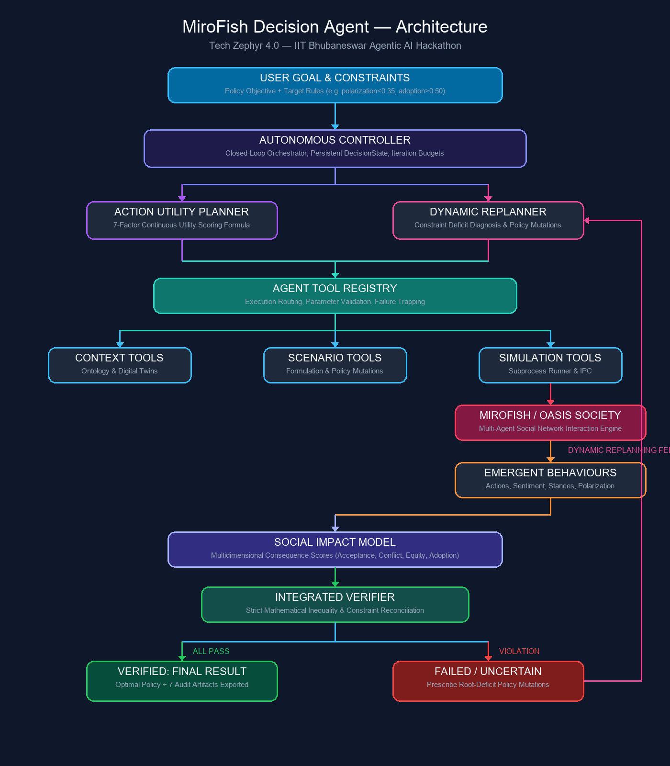
Figure 1. system architecture.

7. Architecture Component Explanation

7.1 Agent / Controller
The Autonomous Decision Controller is the central orchestrator. It receives the goal and constraints, maintains DecisionState, requests planning, routes the selected action to tools, captures results, triggers evaluation and verification, and either finalizes or sends the state back through replanning. It also manages iteration budgets and safe stopping.

7.2 Tools
The Agent Tool Registry exposes executable operations rather than merely describing capabilities. Tool categories include context and stakeholder inspection, scenario creation and mutation, simulation execution, social-impact calculation, scenario comparison, additional simulation for uncertainty, constraint verification, and human interaction.

7.3 External Systems / Environment
MiroFish/OASIS is the principal external execution environment. The simulation contains heterogeneous digital-twin personas that interact over multiple rounds. Simulation processes are isolated as subprocesses and their actions/results are captured for downstream analysis.

7.4 Memory / State
DecisionState is the agent's persistent working memory. It records the current goal, constraints, candidate scenarios, observations, decision history, tool events, failures, disruptions, verification records, human feedback, uncertainty, iteration budget, and final status. Immutable run artifacts provide an auditable record of execution.

7.5 Retrieval / Context Grounding
The research layer grounds the simulation using source documents or prompt descriptions. CommunityContextEngine defines the relevant community boundary, StakeholderDigitalTwin constructs stakeholder personas, and graph-backed context can be used to retrieve entities and relationships. The existing pipeline extracts document text, builds an ontology/graph, and prepares simulation profiles.

7.6 Planning
The Action Utility Planner generates multiple candidate actions and scores them against the current DecisionState. The Dynamic Replanner takes over after constraint failures or changed conditions, diagnoses root deficits, and generates recovery-oriented policy mutations.

7.7 Evaluation / Verification
EmergentBehaviourAnalyzer analyzes simulation activity, SocialImpactModel computes multidimensional social consequences, and the Integrated Verifier reconciles those metrics against the user's mathematical constraints. Verification produces VERIFIED, FAILED, or UNCERTAIN rather than trusting generated prose.

7.8 Human Interaction
At high-stakes checkpoints, the agent can pause and request approval or guidance. A rejection is persisted and influences subsequent planning through history and repetition penalties; textual guidance can become part of the next intervention specification.

7.9 Failure Handling
Failure handling distinguishes domain failures, such as polarization or stakeholder opposition, from technical failures, such as provider timeouts, malformed JSON, or tool exceptions. The system can repair/retry where appropriate, fail over from Ollama to Claude CLI to Codex CLI, and safely terminate when the available recovery path is exhausted.

8. Detailed Autonomous Control Loop
Step | Agent Operation | Purpose
1. Goal & Constraints | Autonomous controller | Ingest the decision objective, context, and explicit constraint thresholds.
2. Observe | Autonomous controller | Inspect community context, knowledge graph, stakeholder digital twins, scenarios, previous actions, and verification history.
3. Generate Candidate Actions | Autonomous controller | Construct multiple feasible next actions such as gathering evidence, modifying a scenario, simulating, comparing options, requesting human input, or handling uncertainty.
4. Rank | Autonomous controller | Compute the seven-term Action Utility score for every feasible candidate.
5. Decide | Autonomous controller | Select the highest-utility candidate for the current state.
6. Act | Autonomous controller | Route the selected action through the Agent Tool Registry and execute it.
7. Observe Result | Autonomous controller | Capture outputs, timing, errors, and intermediate results; update DecisionState.
8. Evaluate | Autonomous controller | Analyze emergent behaviour and calculate multidimensional social impact.
9. Verify | Autonomous controller | Compare actual metrics with constraints and classify the result as VERIFIED, FAILED, or UNCERTAIN.
10. Replan or Finalize | Autonomous controller | If constraints pass, finalize. If they fail, diagnose deficits, mutate the scenario, and return to planning.

9. End-to-End Example: Transit Policy
A policymaker asks the agent to find a socially viable transit policy under strict polarization, conflict, and adoption constraints.
Goal: Optimize a transit policy under explicit social constraints.
Observe: Inspect context, stakeholders, prior state, and available scenarios.
Decision: Generate and rank candidate actions using current utility scores.
Action: Modify or simulate a candidate policy through the tool registry.
Intermediate Result: Simulation reveals actual social outcomes, including adoption, polarization, conflict, equity, and related measures.
Verification: Compare the measured outcomes against the user's constraints.
Adaptation: If a constraint fails, diagnose the deficit and generate a revised policy.
Human Interaction: If needed, pause for policy approval or targeted guidance.
Environment Change: If a disruption changes the social state, re-observe and replan.
Final Outcome: Return a verified policy, an uncertain result requiring more evidence, or an unresolved state if the goal cannot be satisfied within the allowed budget.

10. Failure Handling & Adaptation
Failure Type | Example | System Response
Domain failure | Polarization surge / stakeholder opposition | Verifier detects failed constraint → Replanner diagnoses deficit → policy mutation → new simulation.
Technical failure | LLM/provider timeout | Failure classifier records technical failure → provider failover/retry → continue if a provider is available.
Malformed output | Invalid JSON from a tool/provider | Repair heuristic / validation path attempts recovery; failure is recorded if recovery is not possible.
Human rejection | Human rejects a proposed intervention | Pause → persist rejection and guidance → penalize rejected option → rerank alternatives → resume.
Uncertain evidence | High variance across simulation runs | Request additional stochastic samples and quantify variance/confidence before final verification.
Unresolvable goal | Constraints cannot be satisfied within budget | Stop safely with unresolved diagnostics and preserve the best candidate rather than claiming success.

11. State, Memory & Auditability
The system persists a structured audit bundle so that an autonomous run can be inspected after execution. The artifacts make the agent's actions, tool interactions, failures, verification decisions, and final outcome traceable.
- state.json — complete decision-state snapshot.
- decisions.json — candidate actions, utility scores, and decision history.
- tool_events.json — tool execution history, inputs/outputs, and timing information.
- failures.json — classified domain and technical failures.
- verification.json — constraint checks and verification outcomes.
- final_result.json — final executive result and policy recommendation.
- demo_trace.md — human-readable execution trace.

12. Existing MiroFish Research & Retrieval Stack
The autonomous layer preserves the underlying MiroFish pipeline instead of replacing it. The existing stack supports document ingestion, ontology extraction, graph construction, entity retrieval, stakeholder profile generation, simulation preparation, OASIS execution, and report/verdict generation.
- CommunityContextEngine — grounds the community context and defines decision boundaries.
- StakeholderDigitalTwin — constructs heterogeneous stakeholder personas.
- ScenarioDesigner — formulates and mutates policy scenarios.
- Kùzu-backed graph/context layer — supports structured entities and relationships.
- OASIS simulation — provides the multi-agent social environment.
- EmergentBehaviourAnalyzer — extracts behavioural and social patterns.
- SocialImpactModel — evaluates multidimensional social consequences.
- DecisionComparisonEngine / DecisionIntelligenceEngine — supports scenario trade-offs and decision synthesis.

13. Expected Impact

13.1 Immediate Impact
- Stress-test policy alternatives before real-world deployment.
- Identify potential stakeholder conflict and polarization earlier.
- Compare competing interventions under explicit constraints.
- Provide auditable evidence for why a policy was selected or rejected.

13.2 Longer-Term Potential
- Public transportation and urban policy.
- Community governance and public consultation.
- Organizational strategy and resource allocation.
- Policy experimentation where real-world testing is expensive, risky, or difficult.
EXPECTED SHIFT
From AI that only generates recommendations → to AI that autonomously explores decisions, learns from simulated consequences, adapts, and verifies outcomes.

14. Evidence That the System Is Agentic
Agentic Requirement | Implementation Evidence
Closed loop | Goal → Observe → Plan → Act → Evaluate → Verify → Replan.
Dynamic planning | Multiple candidate actions are generated and ranked using a seven-term utility function.
State-dependent action selection | Current deficits, history, risk, information needs, and expected improvement can change the ranking.
Environment interaction | The agent executes tools against the MiroFish/OASIS social simulation.
Adaptation | Failed constraints trigger diagnosis and policy mutation rather than a fixed next step.
Human interaction | Human rejection/guidance changes the subsequent decision state and planning.
Failure recovery | Technical and domain failures are classified and handled through retry, repair, failover, or safe stop.
Verification | Final success is tied to quantitative SocialImpactModel metrics and explicit constraints.
Safe stopping | The system can terminate as unresolved when a goal cannot be achieved within the iteration budget.
Persistence | Decision state and execution evidence are exported as structured artifacts.

15. Implementation Overview
The autonomous layer is implemented under app/agent/. The broader repository contains the existing CLI, research, pipeline, services, resources, simulation scripts, and artifact-management layers.
Module | Purpose
app/agent/autonomous_controller.py | Central closed-loop orchestrator.
app/agent/state.py | Serializable DecisionState and execution records.
app/agent/planner.py | Candidate generation and seven-term utility scoring.
app/agent/replanner.py | Constraint-deficit diagnosis and policy mutations.
app/agent/verifier.py | Constraint parsing and SocialImpactModel reconciliation.
app/agent/tools.py | Executable agent tool registry.
app/agent/provider_failover.py | Provider fallback and timeout handling.
app/agent/failure_handler.py | Domain/technical failure classification and repair.
app/agent/disruption_engine.py | Controlled domain and technical disruptions.
app/agent/human_interaction.py | Human checkpoint and guidance handling.
app/agent/uncertainty.py | Repeated-run variance and confidence estimation.

16. Runnable Demonstration
The project provides both a deterministic CLI demonstration and an interactive Streamlit application.

CLI DEMO
uv run mirofish autonomous-demo

INTERACTIVE UI
uv run streamlit run app/streamlit_app.py

The existing documentation specifies that the autonomous demo runs the real controller, tools, verifier, and artifact export path. The Streamlit interface exposes the Autonomous Decision Agent dashboard, scenario presets, constraint controls, disruption controls, live trace, human guidance, scenario comparison, and artifact export.

17. Honest Boundaries & Limitations
- Simulation stochasticity: multi-agent social simulations are approximations and cannot perfectly predict real human behaviour.
- Provider setup: CLI failover requires the corresponding provider binaries/configuration to be available.
- Runtime: full OASIS multi-round simulations can take significant time depending on agent count and rounds.
- Interpretation: simulation outputs should support decision exploration, not be treated as guaranteed forecasts of real populations.

18. Conclusion
MiroFish Decision Agent turns social simulation into an autonomous decision-making loop. The system does not merely produce a policy recommendation; it decides what to do next based on the current state, takes actions in a simulated society, observes the consequences, adapts when constraints fail, incorporates human guidance when appropriate, handles failures, and verifies whether the resulting policy satisfies the original objective.
FINAL MESSAGE
MiroFish/OASIS is the environment. The Autonomous Controller is the decision-maker. The Planner chooses actions. The simulation provides consequences. The Verifier determines whether the goal was actually achieved.

