***FUNCTIONS PRACTICAL***

***Function book_count***

*Create table book*

*(*

*Count number(2),*

*Bookname char(20),*

*Author char(10)*

*);*

*Insert into book values(10,’The alchemist’,’paulo coello’);*

*Insert into book values(11,’verity’,’collen hoover’);*

*Insert into book values(5,’one Indian girl’,’chetan bhagat’);*

*Insert into book values(10,’all I ever want’,’nikhil raj’);*

*create or replace function book_count(author_name in char)*

*return number*

*as*

*v_count number(5);*

*begin*

*select Count into v_count from book where Author=author_name;*

*return v_count;*

*end;*

*/*

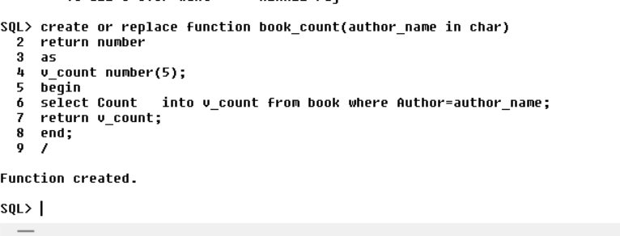

*begin*

*dbms_output.put_line(‘Count of books‘ ||book_count (‘&author_name’));*

*end;*

*/*

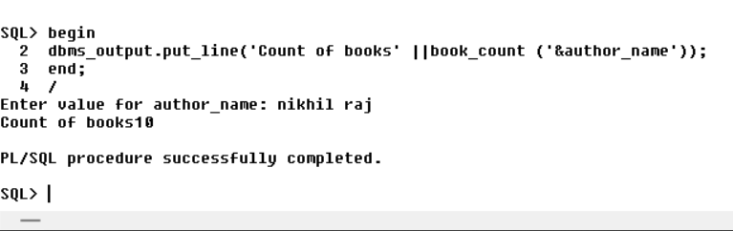

***Find maximum no:***

*create or replace FUNCTION findMax(x IN number, y IN number)*

*RETURN number*

*IS*

*z number;*

*BEGIN*

*IF x > y THEN*

*z:= x;*

*ELSE*

*Z:= y;*

*END IF;*

*RETURN z;*

*END;*

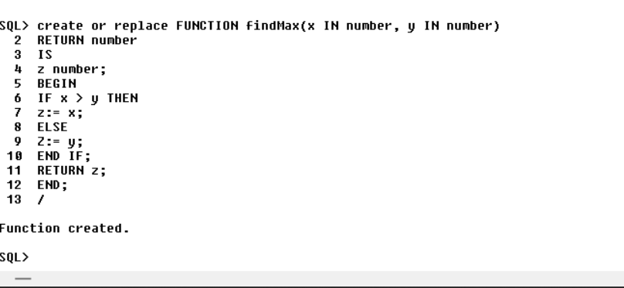

*Declare*

*a number;*

*b number;*

*c number;*

*BEGIN*

*a:= 23;*

*b:= 45;*

*c := findMax(a, b);*

*dbms_output.put_line(‘Maximum of (23,45): ‘|| c);*

*END;*

*/*

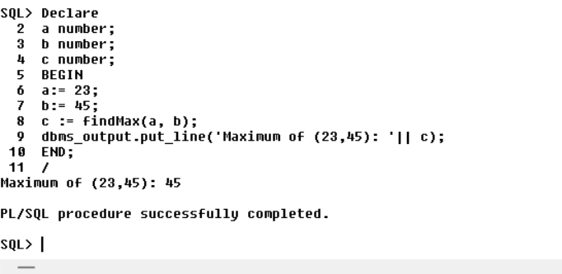

***Create function to get name of employee from emp_id:***

***Table:***

*Create table emp_tbl*

*(*

*empID number(3),*

*first_name char(10),*

*last_name char (10)*

*);*

*Insert into emp_tbl values(100,’nita’,’deshmukh’);*

*Insert into emp_tbl values(101,’gayatri’,’patil’);*

*Insert into emp_tbl values(102,’kartik’,’sharma’);*

*Insert into emp_tbl values(103,’omkar’,’jadhav’);*

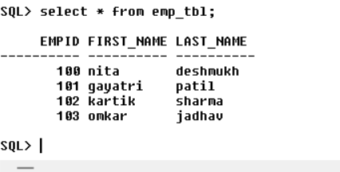

*CREATE OR REPLACE function details(id IN NUMBER)*

*RETURN char*

*AS*

*emp_name char(10);*

*BEGIN*

*SELECT first_name INTO emp_name*

*FROM emp_tbl WHERE empID = id;*

*RETURN emp_name;*

*END;*

*/*

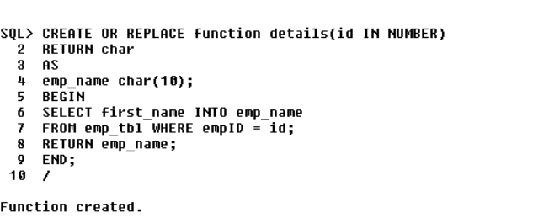

*Begin*

*dbms_output.put_line(‘first name is:’ ||details(‘&id’));*

*end;*

*/*

