**PRACTICAL NO.1**

AIM: to study entity relationship diagram

Q.1

Draw an ER diagram for the following application from the manufacturing industry:

1. Each supplier has a unique name.

2. More than one supplier can be located in the same city.

3. Each part has a unique part number.

4. Each part has a colour.

5. A supplier can supply more than one part.

6. A part can be supplied by more than one supplier.

7. A supplier can supply a fixed quantity of each part.

DIAGRAM:

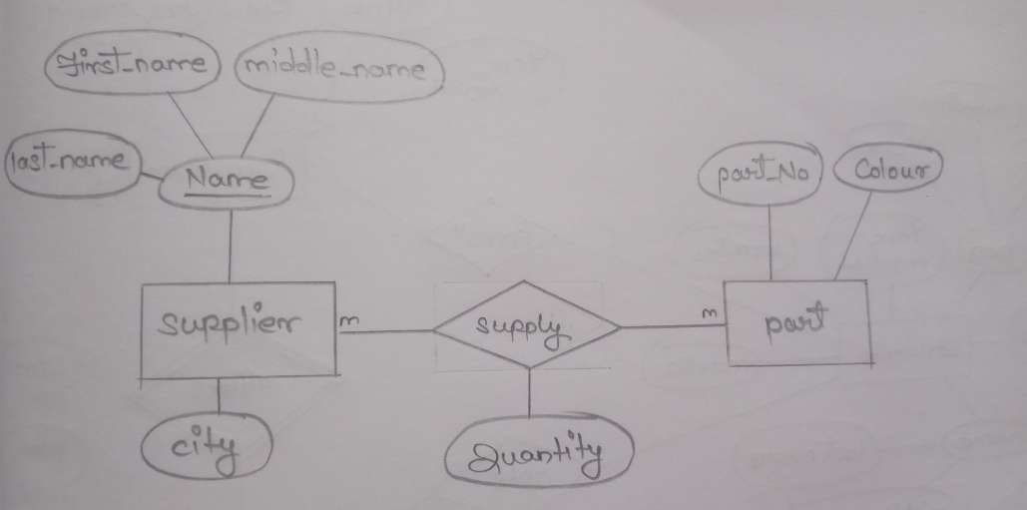

Q.2

Draw an ER diagram for the following application from the Airline industry:

1. The airline has one or more airplanes.
2. An airplane has a model number, a unique registration number, and the capacity to take one or more passengers.
3. An airplane flight has a unique flight number, a departure airport, a destination airport, a departure date and time, and an arrival date and time.
4. Each flight is carried out by a single airplane.
5. A passenger has given names, a surname, and a unique email address.
6. A passenger can book a seat on a flight.

DIAGRAM

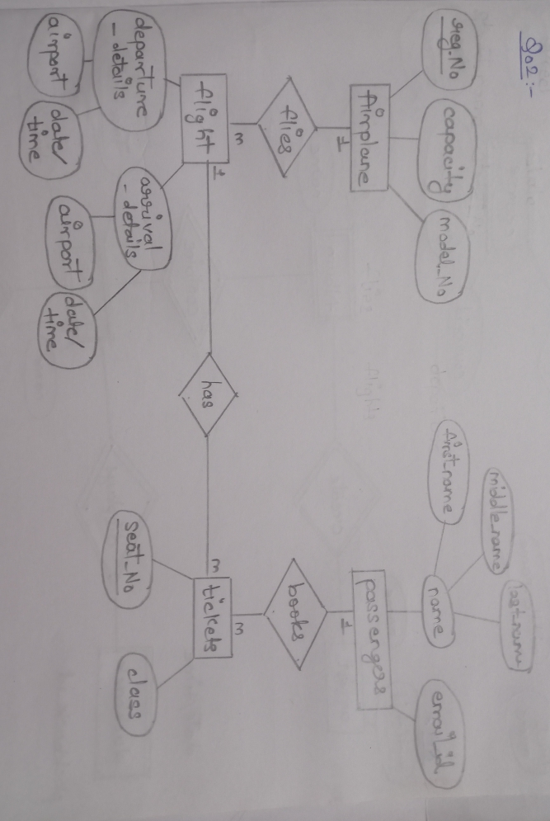

Q.3

Draw an ER diagram for the following application from the Education sector:

1. The university offers one or more programs.
2. A program is made up of one or more courses.
3. A student must enroll in a program.
4. A student takes the courses that are part of her program.
5. A program has a name, a program identifier, the total credit points required to graduate, and the year it commenced.
6. A course has a name, a course identifier, a credit point value, and the year it commenced.
7. Students have one or more given names, a surname, a student identifier, a date of birth, and the year they first enrolled. We can treat all given names as a single object—for example, “John Paul.”
8. When a student takes a course, the year and semester he attempted it are recorded. When he finishes the course, a grade (such as A or B) and a mark (such as 60 percent) are recorded.
9. Each course in a program is sequenced into a year (for example, year 1) and a semester (for example, semester 1)

DIAGRAM:

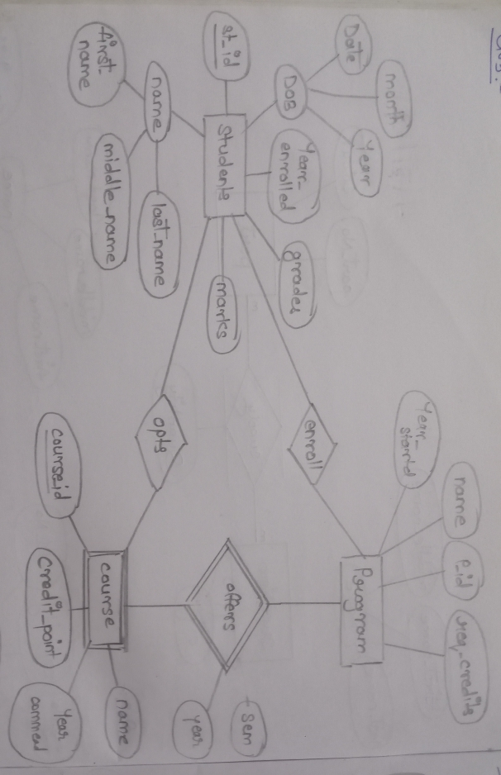

Q.4

Draw an ER diagram for the following application from the Music industry:

1. The collection consists of albums.
2. An album is made by exactly one artist.
3. An artist makes one or more albums.
4. An album contains one or more tracks
5. Artists, albums, and tracks each have a name.
6. Each track is on exactly one album.
7. Each track has a time length, measured in seconds.
8. When a track is played, the date and time the playback began (to the nearest second) should be recorded; this is used for reporting when a track was last played, as well as the number of times music by an artist, from an album, or a track has been played.

DIAGRAM:

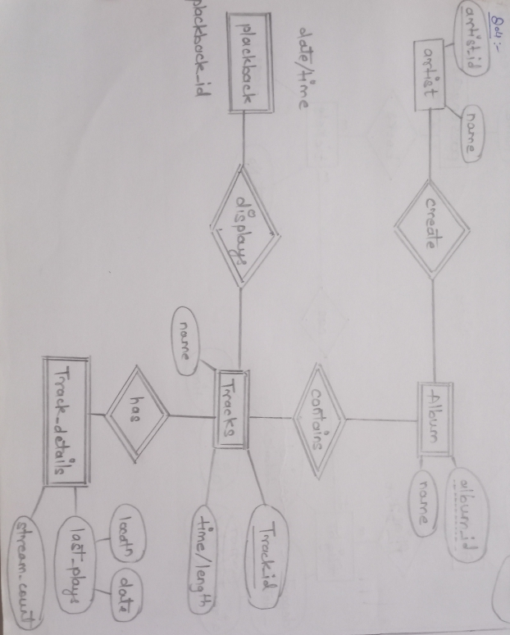

Q.5

Study following case study. Do following things

* Identify and draw entitiwise attributes separately
* Draw ER diagram

In an educational institute, there are several departments and students belong to one of them. Each department has a unique department number, a name, a location, phone number and is headed by a professor.

Professors have a unique employee Id, name, phone number. We like to keep track of the following details regarding students: name, unique roll number, sex, phone number, date of birth, age and one or more email addresses.

﻿Students have a local address consisting of the hostel name and the room number. They also have home address consisting of house number, street, city and PIN. It is assumed that all students reside in the hostels.

A course taught in a semester of the year is called a section. There can be several sections of the same course in a semester; these are identified by the section number. Each section is taught by a different professor and has its own timings and a room to meet.

﻿

Students enroll for several sections in a semester. Each course has a name, number of credits and the department that offers it. A course may have other courses as pre- requisites i.e, courses to be completed before it can be enrolled in.

Professors also undertake research projects. These are sponsored by funding agencies and have a specific start date, end date and amount of money given. More than one professor can be involved in a project. Also a professor may be simultaneously working on several projects. A project has a unique projectId.

DIAGRAM:

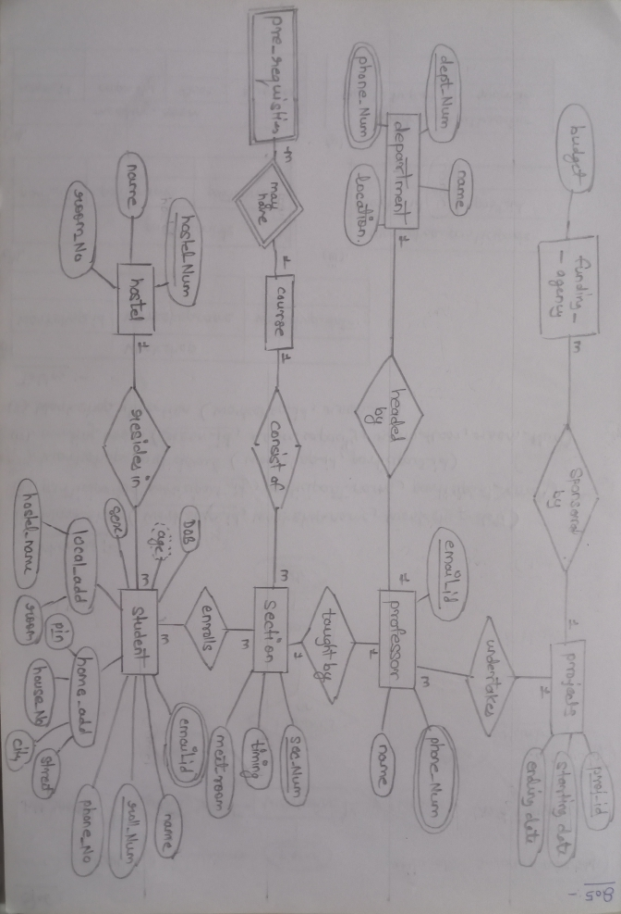

Q.6

Study following ER diagrm.Convert ERD into schema and tables

