**PRACTICAL NO .2**

**AIM:**

**DESCRIPTION:**

1**.** syntax to create table : Create table table_name

(

Column datatype(size),

Column datatype(size)

);

2. syntax to insert values : insert into table_name

Values(value1,value2,….valueN);

3.syntax to see the table : select*from table name;

4.Syntax to see column: select column_name from table_name;

5.Syntax to update table : update table_name Set

column1=value1,…..Where condition;

6.Syntax to delete record in a table : delete from table_name

Where condition;

7.Syntax to alter table add column : alter table table_name

Add column_name datatype;

8.Syntax to delete table along data : drop table table_name;

9.Syntax to rename the table : alter table table_name

Rename tonew_table_name;

Q2. INSERT THE FOLLOWING DATA IN TO THE RESPECTIVE TABLES

1. CLIENT_MASTER1 TABLE

|  |  |  |  |  |  |
| --- | --- | --- | --- | --- | --- |
| clientNo | name | city | pincode | state | BalDue |
| C00001 | ivanbayross | mumbai | 400054 | maharashtra | 15000 |
| C00002 | Manta muzumdar | madras | 780001 | Tamil nadu | 0 |
| C00003 | Chhaya bankar | mumbai | 400057 | maharashta | 5000 |
| C00004 | Ashwini joshi | banglore | 560001 | karnataka | 0 |
| C00005 | Hansel colaco | mumbai | 400060 | maharashtra | 2000 |
| C00006 | Deepak sharma | manglore | 560050 | karnataka | 0 |

create table client_master1

(

clientno varchar(7),

name varchar2(20),

address1 varchar2(30),

address2 varchar2(30),

city varchar2(15),

pincode number(8),

state varchar2(15),

baldue number(10,2)

);

insert into client_master1(clientno,name,city,pincode,state,baldue)

values('c00001','ivan bayross','mumbai',400054,'maharashta',15000);

insert into client_master1(clientno,name,city,pincode,state,baldue)

values('c00002','mamta muzumder','madars',780001,'tamil_nadu',0);

insert into client_master1(clientno,name,city,pincode,state,baldue)

values('c00003','chhaya bankat','mumbai',400057,'maharashta',5000);

insert into client_master1(clientno,name,city,pincode,state,baldue)

values('c00004','ashwini joshi','banglore',560001,'karnataka',0);

insert into client_master1(clientno,name,city,pincode,state,baldue)

values('c00005','hansel colaco','mumbai',400060,'maharashtra',2000);

insert into client_master1(clientno,name,city,pincode,state,baldue)

values('c00006','deepak sharma','manglore',560050,'karnatakaa',0);

select name from client_master1;

Select*from client_master1;

Select name,city,state from client_master1;

OUTPUT:

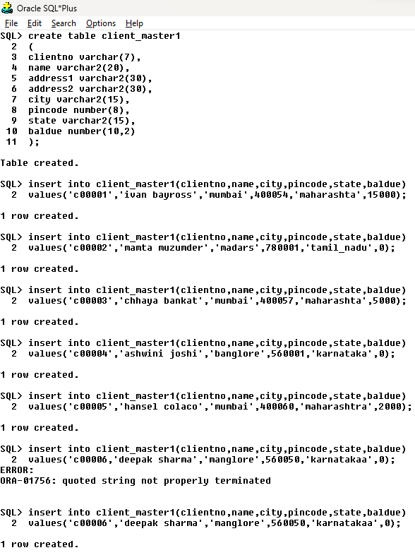

2.PRODUCT_MASTER5 TABLE

|  |  |  |  |  |  |  |  |
| --- | --- | --- | --- | --- | --- | --- | --- |
| **Productno** | description | Profit  percent | Unit  measures | QntOnHand | recorderLvl | Sell  price | Cost  price |
| P00001 | T shirts | 5 | piece | 200 | 50 | 350 | 250 |
| P0345 | shirts | 6 | piece | 150 | 50 | 500 | 350 |
| P06734 | cOtton jeans | 5 | piece | 100 | 20 | 600 | 450 |
| P07865 | jeans | 5 | piece | 100 | 20 | 750 | 500 |
| P07868 | trousers | 2 | piece | 150 | 50 | 850 | 550 |
| P07885 | Pull overs | 2.5 | piece | 80 | 30 | 700 | 450 |
| P07965 | Denimshirt | 4 | piece | 100 | 40 | 350 | 250 |
| P07975 | Lycra tops | 5 | piece | 70 | 30 | 300 | 175 |
| P08865 | skirts | 5 | piece | 75 | 30 | 450 | 300 |

create table product_master5

(

ProductNo varchar2(6),

desrciption char(15),

profitPercent number(3),

UnitMeasure char(6),

QntOnHand number(4),

RecorderLvl number(2),

SellPrice number(3),

costPrice number(30)

);

insert into product_master5

values('p00001','tshirt',5,'piece',200,50,350,250);

insert into product_master5

values('p0345','shirt',6,'piece',150,50,500,350);

insert into product_master5

values('p06734','cotton jeans',5,'piece',100,20,600,450);

insert into product_master5

values('p07865','jeans',5,'piece',100,20,750,500);

insert into product_master5

values('p07868','trousers',2,'piece',150,50,850,550);

insert into product_master5

values('p07885','pullovers',2.5,'piece',80,30,700,450);

insert into product_master5

values('p07965','denim shirt',4,'piece',80,30,700,450);

insert into product_master5

values('p07975','lycra tops',2.5,'piece',70,30,300,150);

insert into product_master5

values('p08865','skirts',5,'piece',75,30,450,300);

OUTPUT :

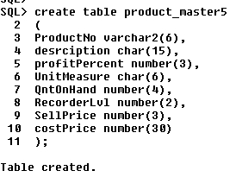

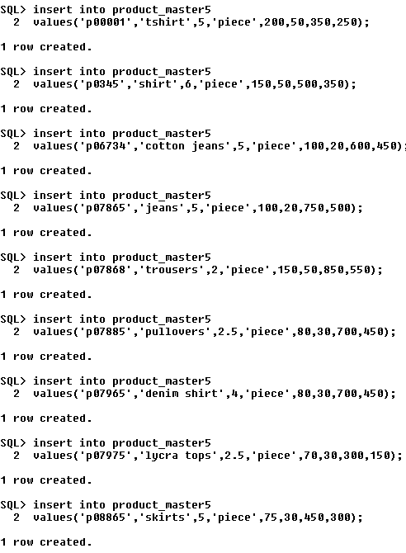

3.SALESMAN_MASTER_1 TABLE

|  |  |  |  |  |  |  |
| --- | --- | --- | --- | --- | --- | --- |
| **salesmanNo** | **name** | **Address1** | **Address2** | **city** | **pincode** | **state** |
| S00001 | aman | A/14 | worli | mumbai | 400002 | maharashta |
| S00002 | omkar | 65 | nariman | mumbai | 400001 | maharashta |
| S00003 | raj | P-7 | bandra | mumbai | 400032 | maharashta |
| S00004 | ashish | A/5 | juhu | mumbai | 400044 | maharashta |

SCHEMA:salesman_master__1

create table salesman_master__1

(

SalesmanNo varchar(6),

Name char(7),

Address1 varchar(5),

Address2 char(8),

City char(7),

PinCode number(6),

Stste char(12)

);

Insert into salesman_master__1

Values('S00001','aman','A/14','worli','mumbai',400002,'maharashtra');

Insert into salesman_master__1

Values('S00002','omkar','65','nariman','mumbai',400001,'maharashta');

Insert into salesman_master__1

Values('S00003','raj','P-7','bandra','mumbai',400032,'maharashta');

Insert into salesman_master__1

Values('S00004','ashish','A/5','juhu','mumbai',400044,'maharashta');

OUTPUT :

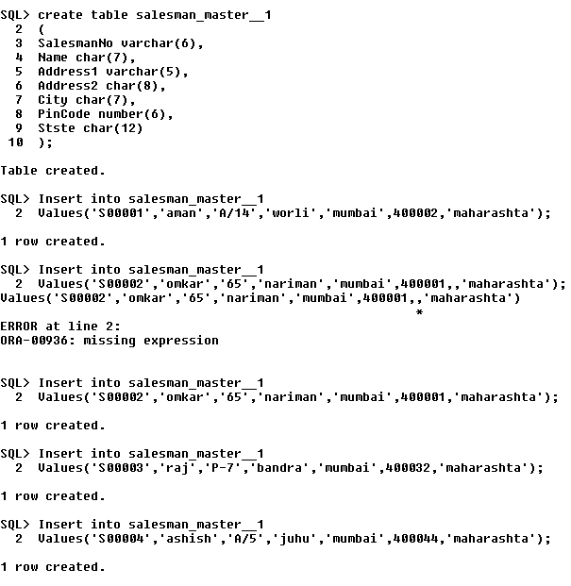

1. SALESMAN_MASTER_3 TABLE

|  |  |  |  |  |
| --- | --- | --- | --- | --- |
| **salesmanNo** | **SalAmt** | **TgtToGet** | **YtdSales** | **remarks** |
| S00001 | 3000 | 100 | 50 | good |
| S00002 | 3000 | 200 | 100 | good |
| S00003 | 3000 | 200 | 100 | good |
| S00004 | 3500 | 200 | 150 | good |

SCHEMA:salesman_master_3

create table salesman_master_3

(

SalesmanNo varchar(6),

SalAmt number(4),

TgtToGet number(4),

YtdSales number(4),

Remarks char(5)

);

Insert into salesman_master_3

Values('S00001',3000,100,50,'good');

Insert into salesman_master_3

Values('S00002',3000,200,100,'good');

Insert into salesman_master_3

Values('S00003',3000,200,100,'good');

Insert into salesman_master_3

Values('S00004',3500,200,150,'good');

OUTPUT :

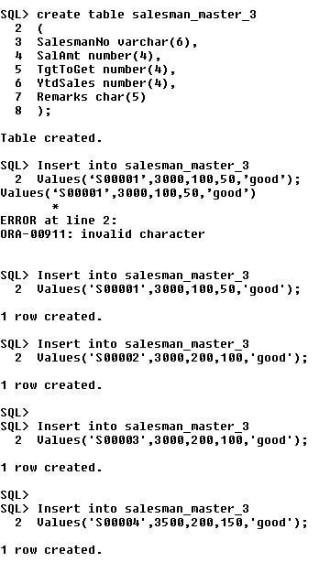

**Q.3** : EXERCISE ON RETRIEVING RECORDS FROM THE TABLE

1. A.Find out name of all clients

select name from client_master1;

OUTPUT:

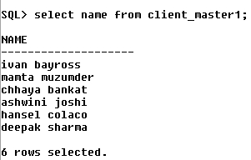

1. Retrieve the entire content of client_master table

Select*from client_master1;

OUTPUT :-

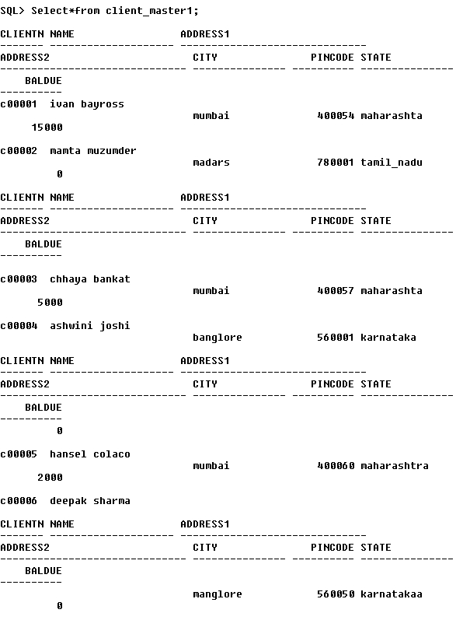

1. Retrieve the list of names,city and state of all clients

Select name,city,state from client_master1;

OUTPUT:

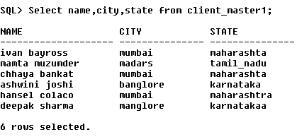

1. List the various products available on ‘product_master4 tablr

Select desrciption from product_master5;

OUTPUT:

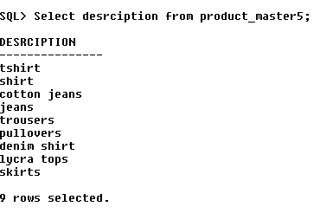

1. List of clients who are located in mumbai

Select name from client_master where city=‘mumbai’;

OUTPUT:

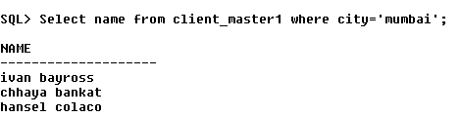

1. .Find names of all salesman who lives in juhu

Select name from salesman_master__1 where address2='juhu';

OUTPUT:

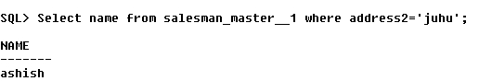

Q4. EXERCISE ON UPDATING RECORDS IN TABLE

1. Change the city of ClientNO ‘C00005’ to ‘Bangalore’.

OUTPUT :-

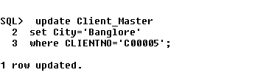

B.Change the BalDue of ClientNo ‘C00001’ to Rs 1000

OUTPUT:-

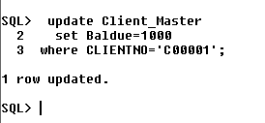

C.Change the cost price of ‘Trousers’ to Rs 950.

OUTPUT :-

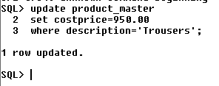

D.Change the city of salesman to Pune.

OUTPUT:-

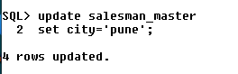

Q5. EXERCISE ON DELETING RECORDS IN TABLE

1. Delete all salesmen from SALESMAN_MASTER whose salaries are equal to Rs 3500.

OUTPUT :-

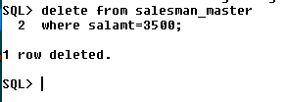

1. Delete all products from PRODUCT_MASTER where the quantity on hand is equal to 100.

OUTPUT :-

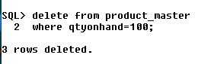

C.delete from client master wherethe columnstate holdsvalue tamil nadu

1. Deete from client_master1 where state=‘tamil_nadu’;

OUTPUT

Q6. EXERCISE ON ALTERING THE TABLE STRUCTURE

1. Add a column called ‘Telephone’ of data type ‘number’ and size = ‘10’ to clientmaster table

OUTPUT :-

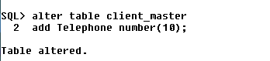

1. Change the size of SellPrice column in PRODUCT_MASTER to 10,2

OUTPUT :-

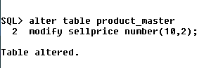

Q7. EXERCISE ON DELECTING THE TABLE STRUCTURE ALONG WITH THE DATA

1. Destroy the table Client_Master along with its data.

OUTPUT :-

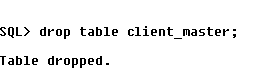

Q8. EXERCISE ON RENAMING THE DATA

1. Change the name of the Salesman_Master table to sman_mast

OUTPUT :-

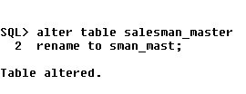

create table deptart

(

dept_id number(3) primary key,

dept_nm char(20) not null,

emp_count number(2) check(emp_count<=15)

);

create table employ

(

emp_no varchar(3) primary key check(emp_no like 'e%'),

dept_no number(3) constraint c1 references deptart(dept_id) ,

sal number(2) check(sal>=5000),

gender char(1) default 'm'

);

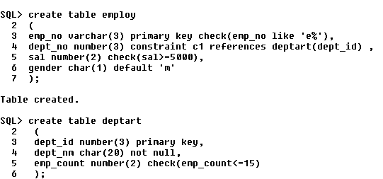

Style2

create table employ2

(

emp_no varchar(3) ,

dept_no number(3) ,

sal number(2) ,

gender char(1) default 'm',

primary key(emp_no),

check(emp_no like 'E%'),

checK (sal>=5000),

foreign key(dept_no) references deptart(dept_id)

);

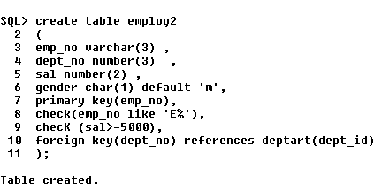

insert into deptart

values(1,'marketing',3);

insert into deptart

values(2,'digitalmarketing',4);

insert into deptart

values(3,'sales',4);

fit the value in other table also

do the voilet of every statement