**PRACTICAL 3-FUNCTIONS**

**1)STRING FUNCTIONS**

1. Write a query to get the details of the clients where the length of the first name greater than or equal to 6.  
**INPUT:**  
SELECT * FROM Client_master11 WHERE LENGTH(F_NAME)>=6;  
**OUTPUT:**  
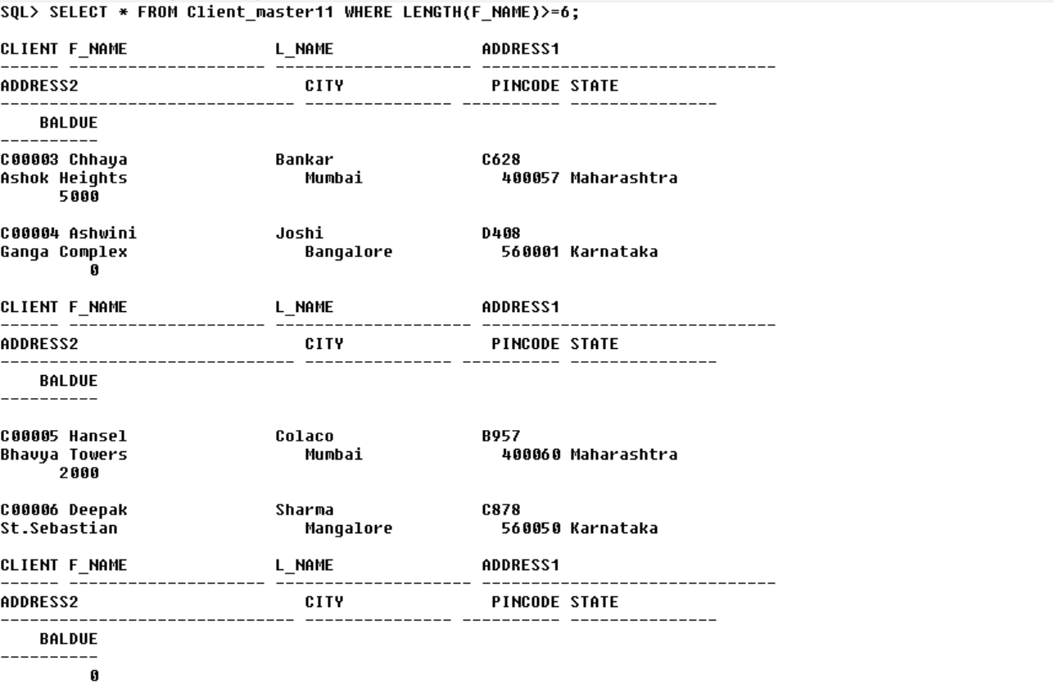

2. Write a query that displays the first name and the length of the first

name for all clients whose name starts with the letters ‘A’, ‘J’ OR ‘M’.

Give each column an appropriate label. Sort the results by the

Client’s first names.  
**INPUT:**  
SELECT F_NAME,LENGTH(F_NAME) AS FIRSTNAME_LENGTH FROM Client_master11 WHERE F_NAME LIKE 'A%' OR F_NAME LIKE 'J%' OR F_NAME LIKE 'M%' ORDER BY F_NAME;  
**OUTPUT:**  


3. Convert Ruia to upper and lower case.  
**INPUT:**  
SELECT UPPER('ruia') AS Uppercase FROM DUAL;

SELECT LOWER('Ruia') AS Lowercase FROM DUAL;  
**OUTPUT:**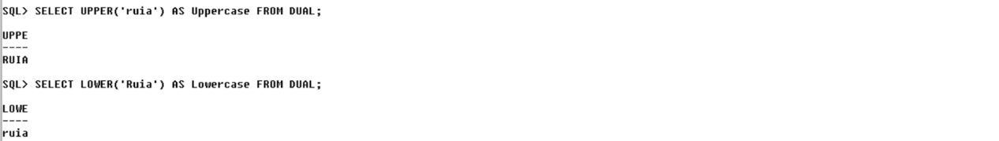  
  
  
4. Display substring from “BSc in computer science” starting from 3 to 5.  
**INPUT:**  
SELECT SUBSTR('Bsc in computer science',3,5) AS SUBSTR FROM DUAL;  
**OUTPUT:**  


5. Write a query to display leading zeros before maximum and minimum

salary.  
**INPUT:**  
SELECT

  TO_CHAR(MAX(BalDue),'FM0000000') AS max_baldue_with_zeros,

  TO_CHAR(MIN(BalDue),'FM0000000') AS min_baldue_with_zeros FROM Client_master1;  
**OUTPUT:**  
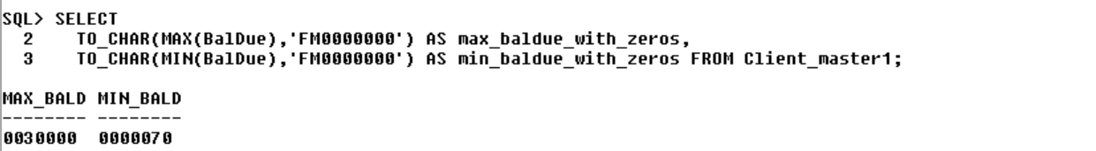

6. Write a query to extract the last 4 character of phone numbers.  
**INPUT:**  
SELECT SUBSTR(PHONE_NO, -4) AS last_four_chars FROM Client_master1;

**OUTPUT:**  
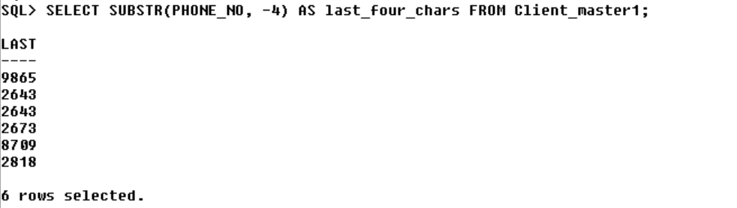

7.Concatenate GOOd and Morning string.  
**INPUT:**  
SELECT CONCAT('GOOD','MORNING') FROM DUAL;  
**OUTPUT:**  
  
  
  
8. Replace “good morning” morning with night’.  
**INPUT:**  
SELECT REPLACE('GOOD MORNING','MORNING','NIGHT') FROM DUAL;

**OUTPUT:**

9. Find position of o from “Welcome Ruia”  
**INPUT:**  
SELECT INSTR('Welcome Ruia', 'o', 1) FROM DUAL;  
**OUTPUT:**  
  
  
10. Find second position of E from Hello Welcome.  
**INPUT:**  
SELECT INSTR('Hello Welcome', 'e') FROM DUAL;  
**OUTPUT:**  


11. Remove characters from “***Ruia***”  
**INPUT:**  
SELECT REPLACE('***Ruia***','***') FROM DUAL;  
**OUTPUT:**  
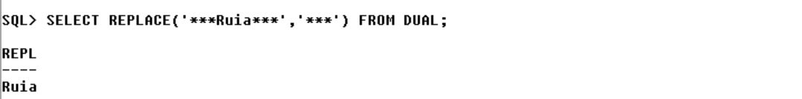

12. Trim out places from  “ my college name is Ruia ”  
**INPUT:**  
SELECT TRIM(' ' FROM  ' MY COLLEGE NAME IS RUIA ') FROM DUAL;

**OUTPUT:**  
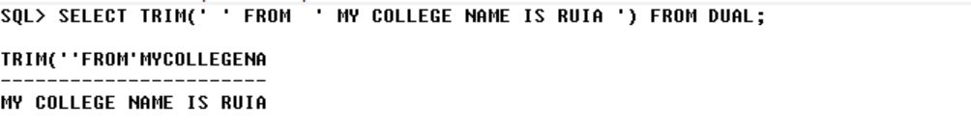

13. Add $ before 300  
**INPUT:**  
SELECT LPAD(300,4,'$') FROM DUAL;  
**OUTPUT:**  


14. Add + before hello to make length 12.  
**INPUT:**  
SELECT LPAD('hello',12,'+') FROM DUAL;  
**OUTPUT:**  


**2)DATE FUNCTIONS**

1.Display today’s date.  
**INPUT:**  
SELECT SYSDATE AS CURRENTDATE FROM DUAL;  
**OUTPUT:**  
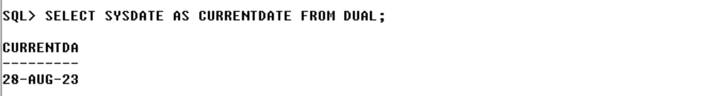

2.Display 5 days back and 10 days afterwards date  
**INPUT:**  
SELECT(SYSDATE - 5) AS five_days_before,

                   (SYSDATE +10) AS ten_days_after

   FROM DUAL;  
**OUTPUT:**  
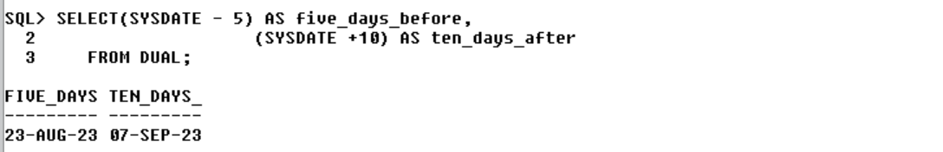

3.Display current date in MM-DD-YYYY HH:MI:SS format.  
**INPUT:**  
SELECT TO_CHAR(SYSDATE, 'MM-DD-YYYY HH:MI:SS') AS FORMATTED FROM DUAL;  
**OUTPUT:**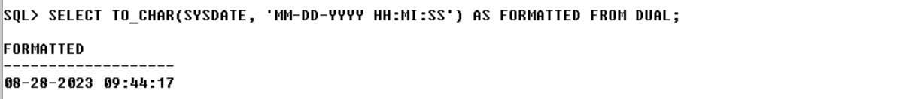

4.Display date after 2 month from independence day.  
**INPUT:**  
SELECT ADD_MONTHS('15-AUG-2023',2) FROM DUAL;

**OUTPUT:**  


5.Display last date of today’s month  
**INPUT:**  
SELECT LAST_DAY (SYSDATE) AS LAST_DATE FROM DUAL;  
**OUTPUT:**  
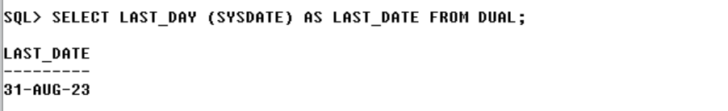

6.List the order number and day on which clients placed their order.  
**INPUT:**SELECT ORDER_NO,TO_CHAR(ORDER_DATE,'DAY') AS DAYS_OF_WEEK FROM sales_order;

**OUTPUT:**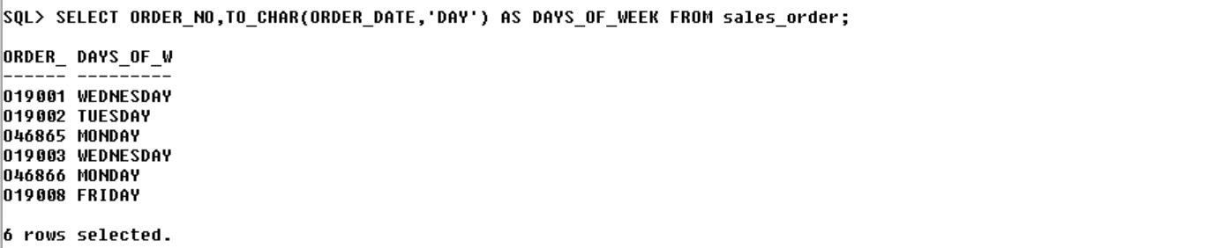

7.List the month (in alphabets) and date when the orders must be   delivered.  
**INPUT:** SELECT TO_CHAR(DELIVERY_DATE,'MONTH') AS DELIVERY_MONTH,

 TO_CHAR(DELIVERY_DATE,'DD') AS DELIVERY_DAY

  FROM sales_order;

**OUTPUT:**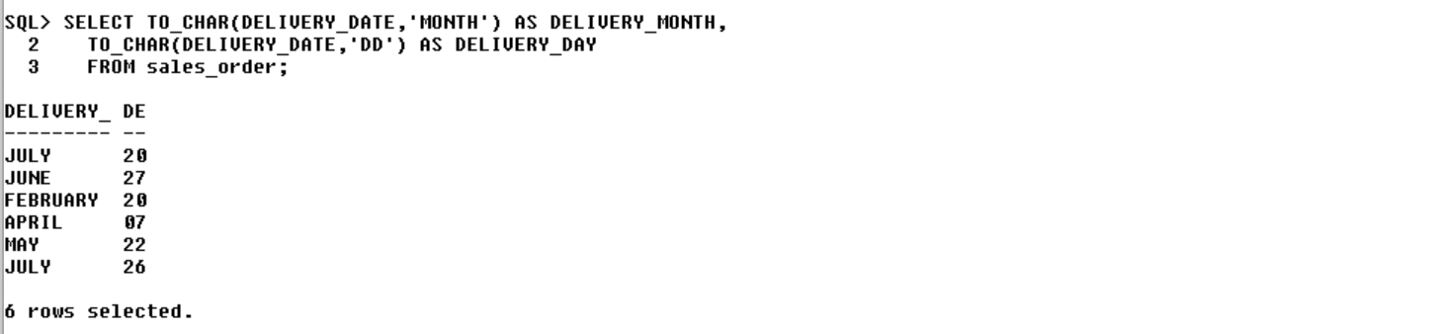

8.List all OrderDate in the format ‘DD-Month-YY’.e.g. 12-February-02.

**INPUT:**SELECT TO_CHAR(ORDER_DATE,'DD-Month-YY') AS ORDER_DATE from sales_order; **OUTPUT:**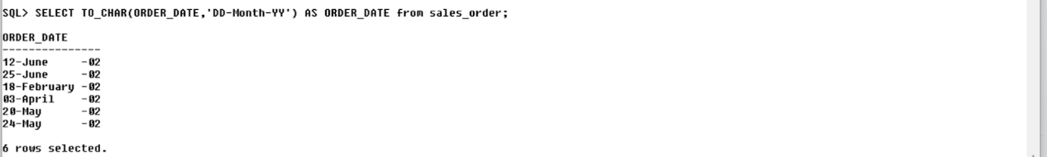

9.List the date, 15 days after today’s date.  
**INPUT:**  
SELECT(SYSDATE +15) AS fifteen_days_after FROM DUAL;  
**OUTPUT:**  
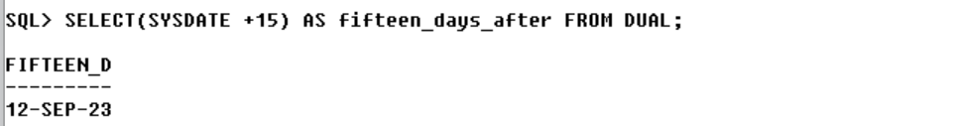

10.List the order number and day on which clients placed their order.  
**INPUT:**SELECT ORDER_NO,TO_CHAR(ORDER_DATE,'DAY') AS DAYS_OF_WEEK FROM sales_order;

**OUTPUT:**

11.List the month (in alphabets) and date when the orders must be

delivered.  
**INPUT:** SELECT TO_CHAR(DELIVERY_DATE,'MONTH') AS DELIVERY_MONTH,  
   TO_CHAR(DELIVERY_DATE,'DD') AS DELIVERY_DAY    
   FROM sales_order;

**OUTPUT:**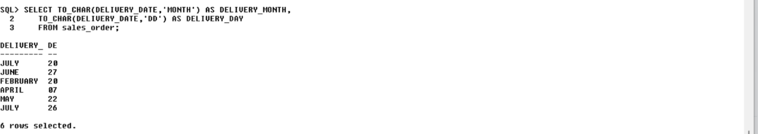

12.List all OrderDate in the format ‘DD-Month-YY’.e.g. 12-February-02.  
**INPUT:**SELECT TO_CHAR(ORDER_DATE,'DD-Month-YY') AS ORDER_DATE from sales_order; **OUTPUT:**

**3)MATH FUNCTIONS**

1.Display count of clients available in client master  
**INPUT:**SELECT COUNT(*) AS NO_OF_CLIENTS FROM Client_master1;  
**OUTPUT:**  


2.Display sum of salary of all male candidate  
**INPUT:**SELECT SUM(Salary) AS TOTAL_SALARY FROM candidate WHERE Gender LIKE 'M';

**OUTPUT:**  
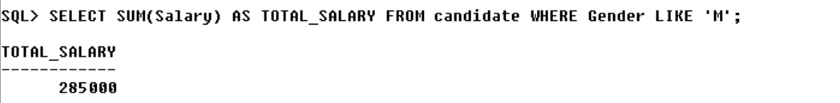

3.Find max salary  
**INPUT:**  
SELECT MAX(Salary) AS MAX_SALARY FROM candidate;  
**OUTPUT:**  


4.Find min salary  
**INPUT:**  
SELECT MIN(Salary) AS MIN_SALARY FROM candidate;  
**OUTPUT:**  


5.Display count of clients available in client master  
**INPUT:**  
SELECT COUNT(*) AS NO_OF_CLIENTS FROM Client_master1;  
**OUTPUT:**

6.Find maximum among 10 to 15  
**INPUT:**SELECT GREATEST(10,11,12,13,14,15) FROM DUAL;

**OUTPUT:**

7.Find min among factors of 28  
**INPUT:**  
SELECT LEAST(1,2,4,7,14,28) FROM DUAL;

**OUTPUT:**  
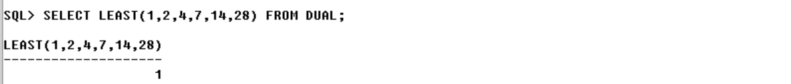

8.Find 23%12  
**INPUT:**  
SELECT MOD(23,12) FROM DUAL;  
**OUTPUT:**  
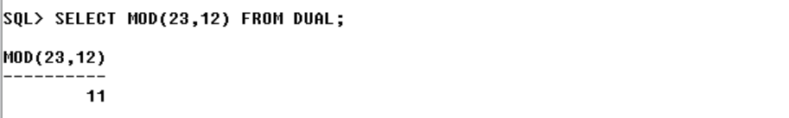

9.Find 5^6  
**INPUT:**  
SELECT POWER(5,6) AS result FROM DUAL;  
**OUTPUT:**  
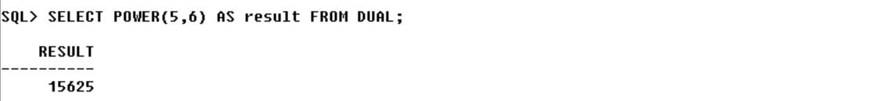

10.Find square root of 25  
**INPUT:**  
SELECT SQRT(25) FROM DUAL;  
**OUTPUT:**  
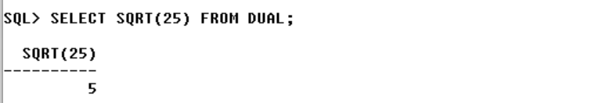

11.Find truncated value of 56.985  
**INPUT:**SELECT TRUNC(56.985) AS TRUNCATED_VALUE FROM DUAL;  
**OUTPUT:**  


12.Find round value of 45.78  
**INPUT:**  
SELECT ROUND(45.78) FROM DUAL;  
**OUTPUT:**  
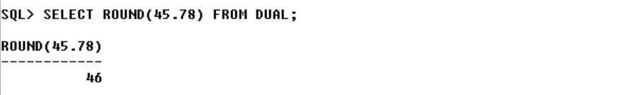

13.Find sin,cos and tan value of 7  
**INPUT:**  
SELECT

SIN(7) AS sine_value,

COS(7) AS cosine_value,

TAN(7) AS tangent_value

FROM DUAL;  
**OUTPUT:**  
