1. Write a PL/SQl block to accept length, breadth and height of a box and prints

its area and volume.

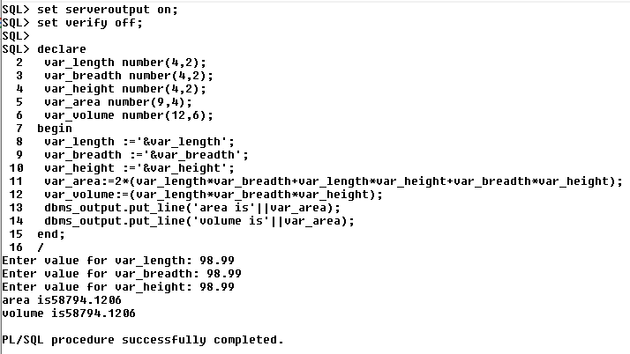

1. Write a PL/SQl block to find the average of three numbers.

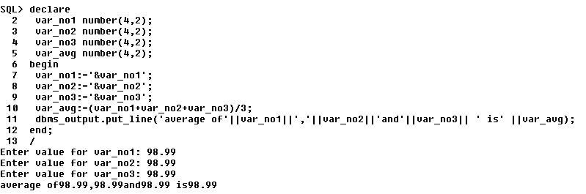

1. Write a PL/SQl block to find the sum, subtraction, product and division of two

Numbers

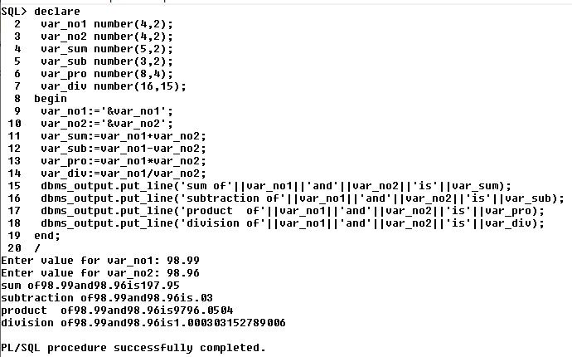

1. Write a PL/SQL Block to accept StudentNo and display the information of

Student

on following relation

Table Name:-Student (StudentNo, StudentName, College_name,

Date_of_admission,Address, City)

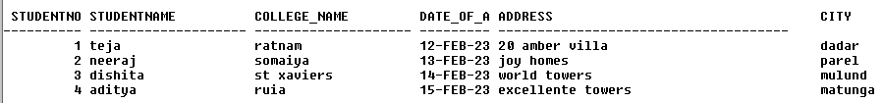

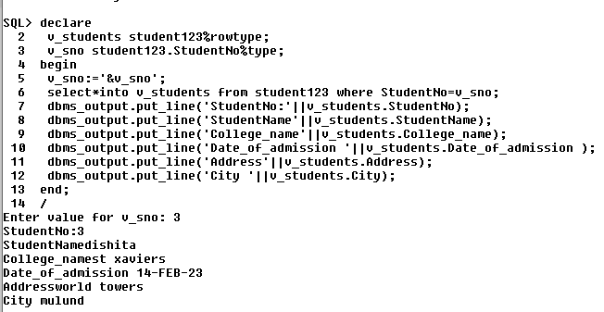

1. Write a PL/SQL Block to display the mobile numbers of those customer which

starts with ‘9819’

on following relation

Table Name:-Customer(CustNo, CustomerName, mobile no ,Address, City)

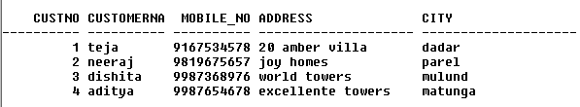

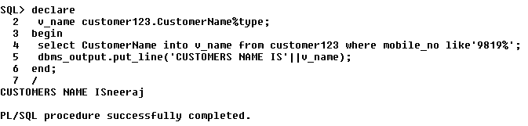

1. Write a PL/SQL Block to display the names of customer who lives in Bangalore

or Delhi

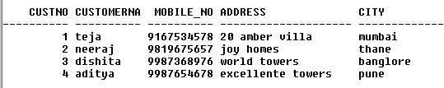

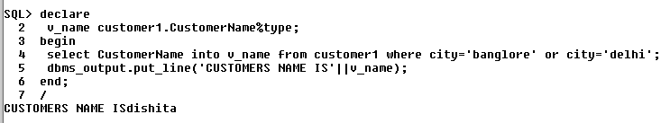

1. Write a PL/SQL Block to cancel admission of student. Accept Student no from

user.

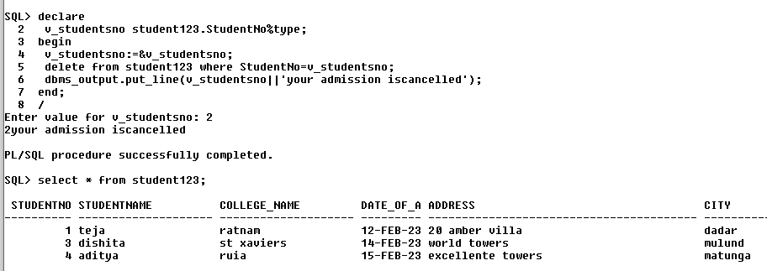

1. Write a PL/SQL Block to change status of whatsapp.Accept name from user.

Whatsapp(name,mobile_no,status)

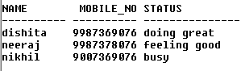

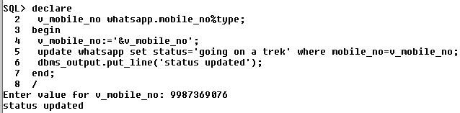

1. Write a PL/SQL Block to display service period of employee.

Emp ( emp_id, name, joining date, retirement date).

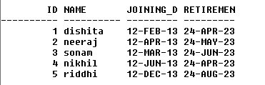

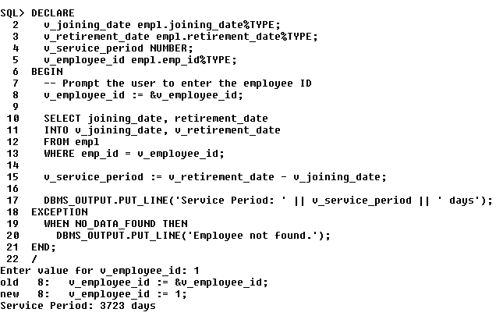

1. write a PL/SQL Block to calculate annual package of employee by accepting

basic sal.

Monthly sal = basic sal - 20%basic_sal + da - income tax

