**PRACTICAL 2**

**PL/SQL BLOCK**

**IF ELSE AND CASE…WHEN**

1.Write a PL/SQl block to accept number from user and according to number display positive negative or 0

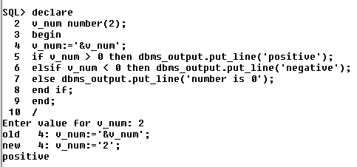

2.Write a PL/SQl block to accept day number from user and according to day number display the day it is

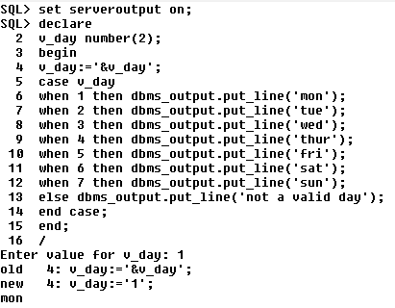

**3.** .Write a PL/SQl block to accept number from user and according to number display even or odd

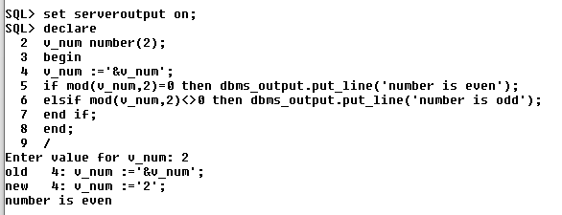

**4.** Write a PL/SQl block to accept number from user and check whether it is divisible by 3 and 7 or not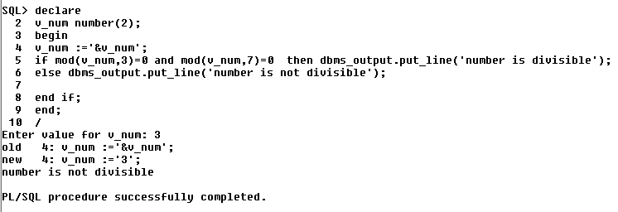

* 1 Create table Employee with fields as EmpId , EmpName , Date Of Joining ,

EmpSalary . Write a PL/SQL block to increase the salary of employee whose

DateOfJoining is before a user specified date by 15% otherwise by 5%.

OUTPUT:

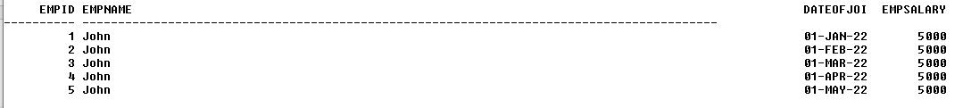

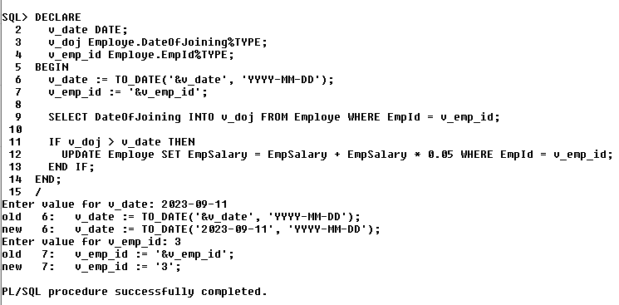

* 2 Write a PL/SQl block to accept date from user and according to day name

display work.

Monday-event logging

Tuesday-helping developers

Wednesday-rebuild indexes

Thursday-reading papers

Friday-testing

Saturday-printing report

OUTPUT:

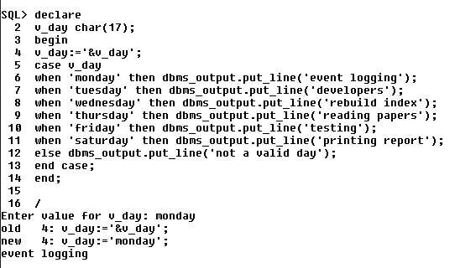

* 3. Create ResearchDB(RES_name, res_id, Res_area, RES_guide). Write a pl/sql

block with case…when statement that prints the area of research when name of

researcher and guide is input by user.

QUERY:

OUTPUT:

* 4 Write a pl/sql block to display details of cyber forensic case as following:

(*) Case name:

(*) Investigator name:

Nature of case:

No of evidence:

No of days to solve:

Based on no of days justify whether it is simple complex or high tech

investigation.

(Fields marks with(*) are mandatory,use of not null)

QUERY:

OUTPUT:

* 5 Create table Project

Project_id primary key starts with ‘P’,

Project name char(20),

Cost should not exceed 10000

Technology char(25)

LOC number(10);

Insert 3 records.Write pl/sql block to distinguish type of project simple average

complex based on LOC

QUERY:

OUTPUT:

* 6 Write PL/SQL block if year of experience is greater than 10 then update the designation to manager else keep it as employee.

QUERY:

OUTPUT:

* 7 Write PL/SQL block to accept the value from the user for the age&gt;18 valid for voting else not.

QUERY:

OUTPUT: