**PLSQL LOOPS**

**1) Write a PL/SQL block to find sum of first 100 natural odd and even numbers.**

1. --using loop exit when

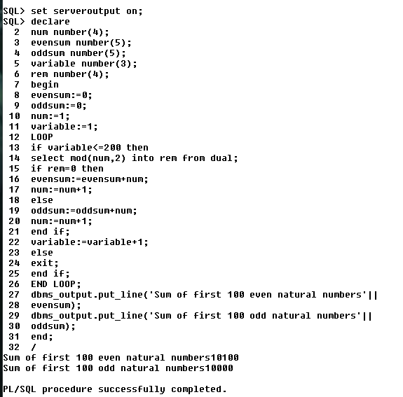

1. Using loop ….exit when

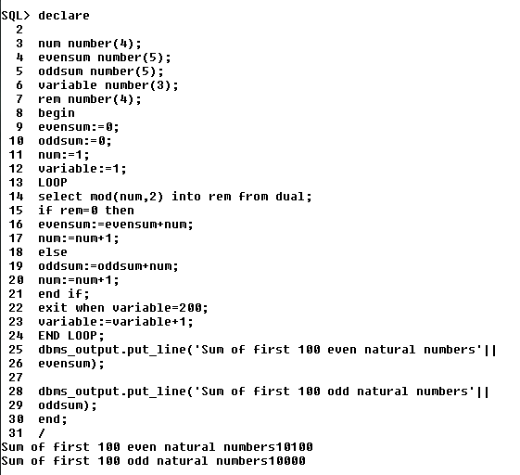

1. Using while loop

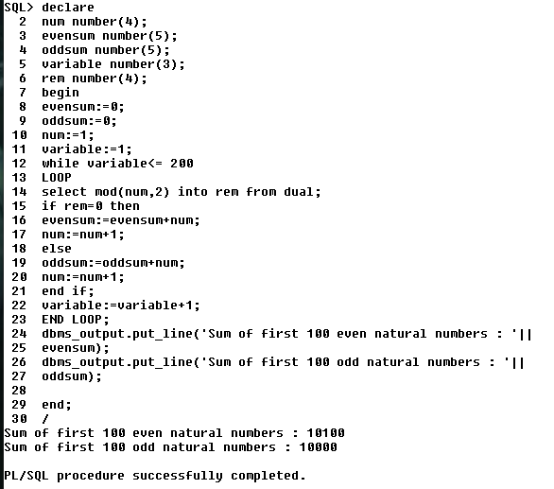

1. Using for loop

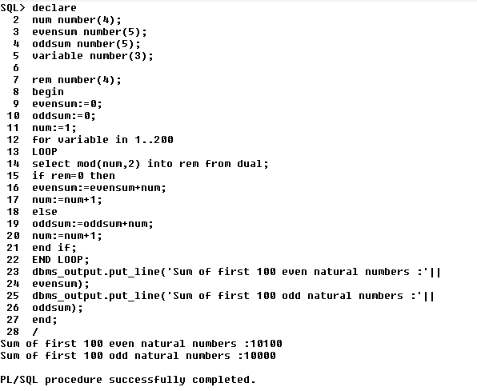

**2) Write PL/SQL block to calculate area of circle with radius 1,2,3,4. Store the**

**radius and corresponding area in table.**

**Using Loop .. exit when**

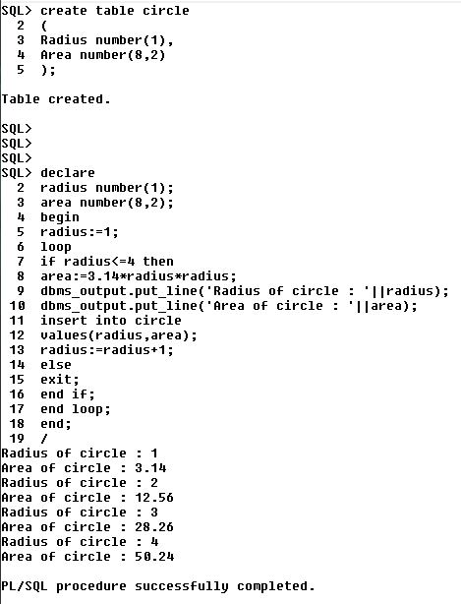**s**

**3. factorial of a number**

