MAT_LSPIV

User Manual

A Matlab LSPIV software.
Alexandre Hauet
IIHR – Hydroscience & Engineering
The University of Iowa
Iowa City, USA
2007

Start the program
Run Matlab, and go to the Mat_LSPIV folder.

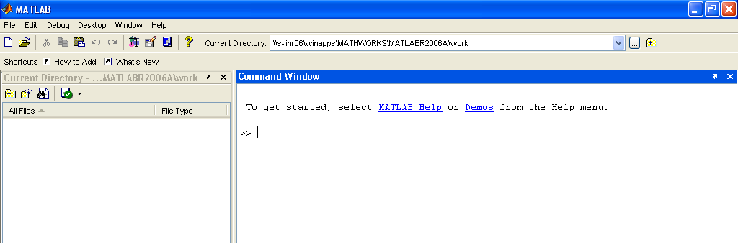
Use this button to access the Mat_LSPIV folder

Launch the program Mat_LSPIV.

Create or resume a project
A pop-up window appears. Browse for the location you want to create a new project file, or to the location of an existing project file. Then, click on Make New Folder to create a new project, or click on the project folder to resume.

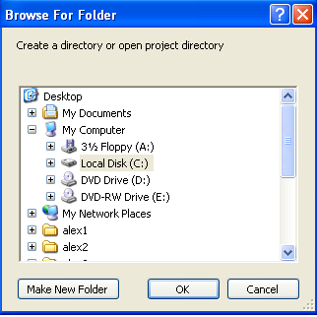

Architecture of the project folder
The project folder contains 4 folders:
- outputs: contains all the intermediaries results
- img_transf: contains the ortorectified images
- displacements: contains the raw velocity fields
- quality_vel: contains the filtered velocity fields

LSPIV procedure
The LSPIV procedure selection window shows the 3 main steps of the LSPIV procedure:
- Orthorectification;
- PIV Analysis;
- Post Processing.

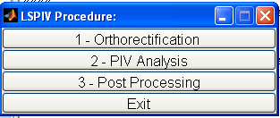

First, click on 1 – Orthorectification.

Orthorectification
Orthorectification means the correction of the effect of perspective of the images. Mat_LSPIV uses an implicit calibration method to transform the raw images onto perspective-free images.

The Orthorectification selection window shows the 3 steps of the orthorectification procedure:
- GRPs Localisation;
- Transformation Parameterization;
- Transform all the images

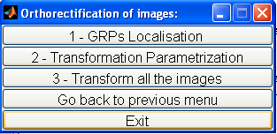

Click on 1 - GRPs Localisation.

GRPs Localisation

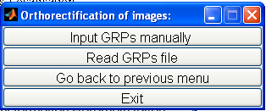

GRP stands for Ground Reference Points, which are points of known coordinates in both the image coordinate system (in pixels) and the space coordinate system (in Cartesian units, such as meter or feet). One can enter the location of the GRPs manually or input a file containing the GRPs locations. The Cartesian units of the computation depend on the units of the GRPs. If you input GRPs in meter, then all the software outputs will be in meter. If you input GRPs in feet, then all the software outputs will be in feet. For clarity, the following of the user manual assumes that the unit is meter.

Input GRPs manually

Inputting the GRPs manually means localizing the points on the images and input the space coordinates. First, browse for an image containing the GRPs.
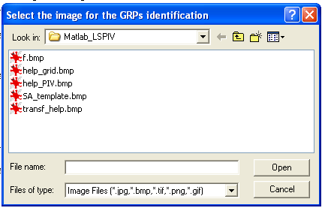

The selected image is displayed on the window Figure 2. Zoom, on Figure 2, in the area of the GRPs you want to localize. When the view is adjusted, press Enter. Then, click on the GRPs to assess its image coordinates. Figure 1 shows all the inputted GRPs. Click right if you enter the last GRP. Input the GRP Cartesian coordinates. Once the last point is inputted, Figure 2 shows the localization of the points on the image coordinate system and on the space coordinate system. If the localizations are good, click on Yes to the question Is the GRP localization OK, else click on No and do this step again.

If the GRPs localization is OK, a file called GRP.dat is created in outputs.dir. The format of this file is:
- 1 line of header (‘GRP’);
- 1 line with the number of GRPs localized (8 in the following example);
- 1 line with the data legend: X,Y,I,j where X,Y stand for the space coordinates and i,j stand for the image coordinate;
- The data.
Example:
GRP
8
X Y i j
0 0 210 1442
0 7 580 576
0 12 679 173
3 0 716 1436
3 7 919 623
3 12 1032 218
1.5 7 758 610
1.5 0 470 1460

Read GRP file
If a GRP file, in the format described above, is available, one can directly download it by using the Read GRP file button. Browse to this file, and click OK.

Computation of the plan-to-plan projection matrix
Once the GRPs are inputted, the software solves an 8-parameters plan-to-plan projection matrix (Equation 1) using least-square method.
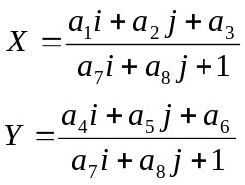 | (1)

The 8 parameters are stored in the file outputs/coeff.dat.

Transformation Parameterization
The aim of this step is to define the size and the resolution of the orthorectified images. A GUI window helps you in the procedure.
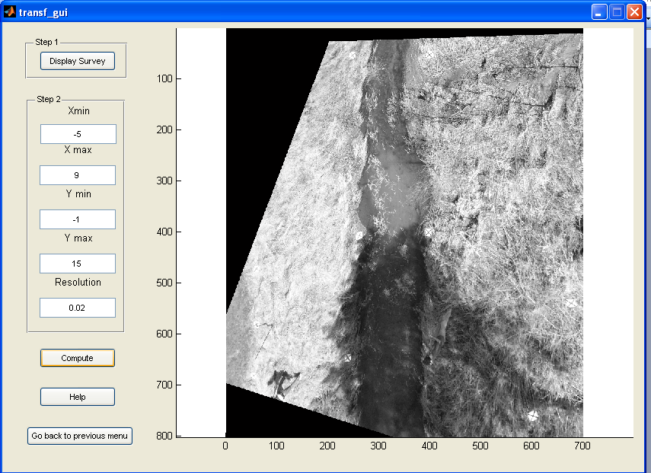

Click on Display Survey to open a window showing the GRPs. This window helps you defining the ortho-image corners position. As the ortho-image has a rectangular shape, you need to input the position, in space coordinates, of 2 opposite corners of the image ([Xmin,Ymin] and [Xmax,Ymax]). The resolution is the space size covered by one pixel. For example, if the Cartesian unit used is meter, a resolution of 0.01 means that a pixel covers a physical size of 1*1 cm². The more the resolution is a small number, the more the ortho-image will be detailed, and the more the computational time will be important. It is no use to put a too good resolution if the study does not require it. A rule of thumb is that the size of the otho-image ([Xmax-Xmin]/Resolution) should be nearly the same than the size of the raw image.
An efficient procedure to get a good ortho-image is:
- Display the survey
- Define roughly the positions Xmin, Ymin, Xmax and Ymax so that all the GRPs are included in the rectangle of opposite corners [Xmin,Ymin] and [Xmax,Ymax].
- Input those values in the GUI window.
- Input a bad resolution (small ortho-image, but fast computational time)
- Click on Compute
- Check on the displayed ortho-image if the corners positions are good. Adjust the positions and Compute until you’re satisfied.
- When satisfied with the corner position, input the final resolution and compute.
The ortho-image parameters are stored in the file outputs/img_ref.dat

Click on Go back to previous menu to access the Orthorectification selection window.

Transform all the images
During that step, all the selected images are orthorectified using the coefficient computed in step 1-GRP localization and the parameters set in step 2- Transformation parameterization.
Select the images to process and click Open. The program transforms all the selected images, and the ortho-imaes are stored in img_transf/

This step is the last of the Orthorectification procedure. The PIV Analysis is the next step.

PIV Analysis

PIV parameterization
PIV algorithm calculates the correlation between the interrogation area (IA) centered on a point a_{ij} n the first image and the IA centered at point b_{ij} in the second image taken with a time interval of δt seconds. The IA size defines the spatial resolution of the measurement. It must be small enough to preserve the scale of interest in the flow since any flow scales smaller than the size of the IA are lost through processing. However, it has to be large enough to include recognizable tracer patterns within it, i.e. to encompass one ore more “typical patterns” that are used to trace the flow free surface. The correlation coefficient R(a_{ij},b_{ij}) is a similarity index for the grey-scale intensity of a group of pixels contained in the two compared IAs, expressed as:
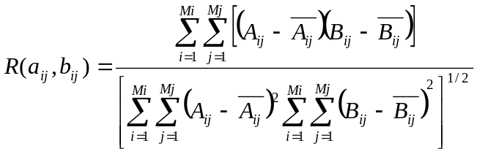
Figure 1
where Mi and Mj are the sizes of the interrogation areas (in pixels), and Aij and Bij are the distributions of the grey-level intensities in the two interrogation areas. Correlation coefficients are only computed for points within a searching area (SA). The SA size has to be selected so that the displacement of tracer patterns from the first image is contained within the SA of the second image. Consequently, the SA size is commensurate with the expected range of velocities of the river. For rivers with small cross-stream velocities, the SA should be asymmetric, elongated in the direction of the flow. The PIV approach assumes that the most probable displacement of the fluid from point aij during interval time between 2 images of a pair, δt, is the one corresponding to the maximum correlation coefficient. Sub-pixel displacement accuracy can be reached using a parabolic fit. Velocity vectors are derived from these displacements by dividing them by δt.
The figure PIV_param_gui helps in the PIV parameterization. Display 2 corrected images by clicking on Display 2 images and asses the size of the IA and of the SA regarding the flow and tracers properties. The IA shape is a square. Its size must be an even number. The SA is defined by 4 lengths: Sim, Sip, Sjm, Sjp, where i and j are the 2 axis of the image and m and p stands for minus and plus. Sim is so the length of the SA from the center of the IA following the i axis in the negative direction.
The Min Correlation edit zone allows inputting a threshold for the minimum value of the correlation coefficient that is used. If the maximum R is lower to that threshold, the vector is considered as spurious.
Clicking on create IA and SA display a corrected images and an IA (in red) and a SA (in blue) localized in the center of the image. Check if the sizes of the IA and SA are OK.

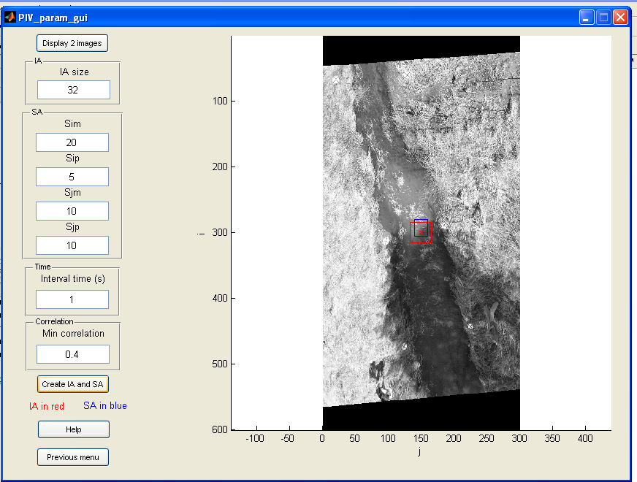

The parameters of the LSPIV analysis are stored in outputs/PIV_param.dat.

Computational grid
The computational grid defines the points in the image coordinate system where the IAs and the SAs are centered. The grid is defined by its 4 corners and the number of steps. Input the 4 corners localization by clicking on Input corners, and then by clicking on the image. The corners should be inputted clockwise or counterclockwise. Then input the number of steps between the points 1 and 2 and the points 3 and 4, and the number of steps between the points 2 and 3 and the points 4 and 1. The grid is displayed when the button Compute grid is pushed.

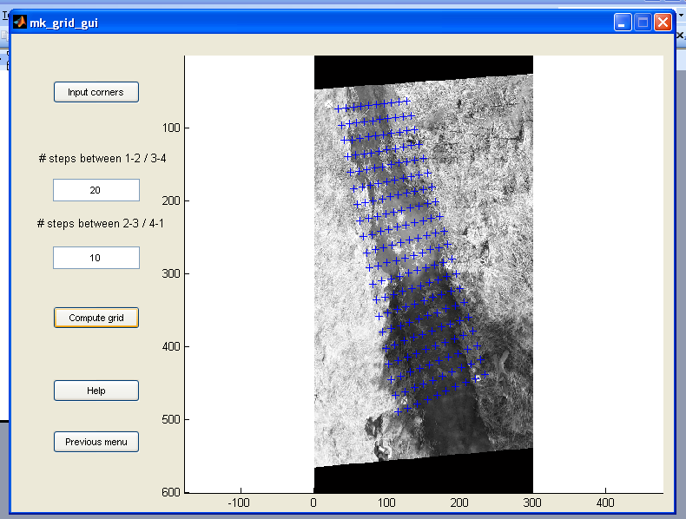

The coordinates of the nodes of the grid are stored in the file outputs/grid.dat.

PIV processing of all the images
Select if the images were recorded as a sequence or as pairs. The following figure illustrates the difference:
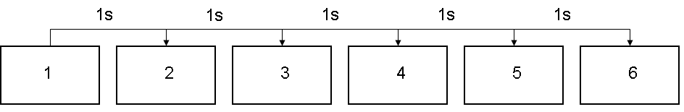
Sequence: 5 velocity fields computed
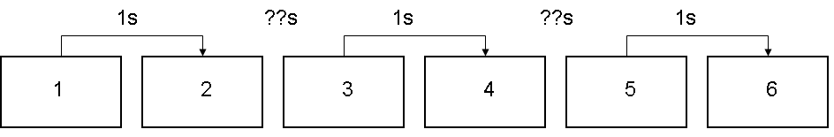
Pairs: 3 velocity fields computed

The software analyses each pair of images with a PIV algorithm. The computed velocity fields are stored in displacements/. A velocity field contains 5 columns: X, Y, U, V, R², i.e. the starting space coordinates of the velocities (X,Y), the components of the velocities in the X and Y directions (U,V) and the correlation coefficient associated to the velocities (R²). A line where U, V and R are 0 does not mean that the velocity at that point is 0, but means that no velocities were computed for that point.

Post-processing

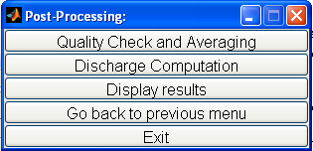

Quality Check and Averaging
During that step, one can input a filter on the velocity magnitude. A threshold on the minimum and the maximum of the velocity intensity can be inputted using the GUI, and the averaged-filtered velocity field is displayed. Using the GUI, one can adjust the filtering parameters until the result is satisfactory. The averaged velocity field is stored in the file outputs/average_vel.dat. The file contains 6 columns: X, Y, U, V, SDU, SDV, where SDU stands for the standard deviation of U and SDV the standard deviation of V.

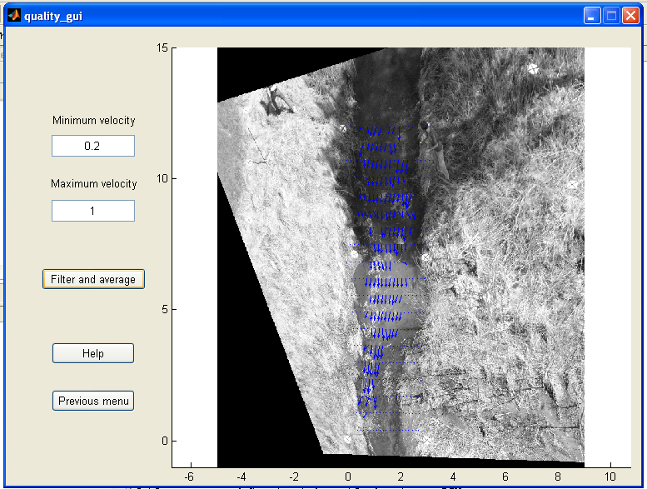

Velocity derives quantities
This step allows to display velocity derived quantities such as the averaged velocity field, the contour map of the intensity of the velocities, the streamlines or the vorticity field or velocities along a cross-section.
The vorticity is computed as dv/dx-du/dy and saved in outputs.dir/vorticity.out.
For the extraction of velocities along a cross-section, input manually with the mouse the beginning and ending points of a cross-section. Velocities are interpolated for 11 points distributed along the segment and saved in outputs.dir/cross_vel.out.

The last button of the tool bar 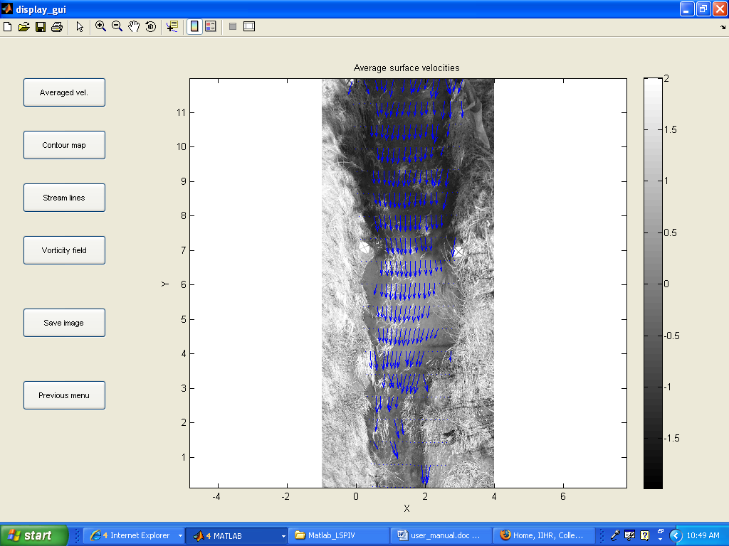 allows making some editorial changes. Clicking on it opens the plot browser and the property editor, where color, colormap, markers, lines, etc… can be changed.
The button Save plot allows saving the current figure onto jpeg format.

Model to prototype: Froude scaling
This tool should be used when dealing with laboratory models. Input the ratio α between the full and the model scales. The X and Y coordinates are scaled using X*α and Y*α. The averaged velocity field is scaled using the Froude scaling: u*√ α and v*√ α. This scaled velocity field is saved as outputs.dir/Froude_scaling.out.

Discharge Computation
If a cross-section bathymetry is available, a discharge can be computed. Input the bathymetry file. It must be a 3 columns file containing:
- X
- Y
- h, the water depth at the position X,Y

Example:
-1 10.4 0
-0.5 10.4 0
0 10.4 0
0.188 10.4 0
0.5 10.4 0.12
0.8 10.4 0.23
1 10.4 0.2
1.2 10.4 0.16
1.5 10.4 0.24
1.75 10.4 0.23
2 10.4 0.32
2.25 10.4 0.35
2.5 10.4 0.36
2.65 10.4 0
3 10.4 0
3.5 10.4 0
4 10.4 0
Then input the ratio k between depth-averaged velocity and surface velocity. This ratio is usually considered close to 0.85. A discharge is then computed using the Velocity Area Method: for each point of known bathymetry, the program averages the 4 closest velocity estimates and projects it on the streamline direction. This averaged velocity is multiplied by k, by the water depth and by the distance related to the considered bathymetry measurement. The so computed discharge is stored in the file outputs/discharge.dat. The 3D view of the cross-section bathymetry and the surface velocities is displayed.

