THAKUR NIHAR SINGH  B.Com Student | Finance and Data Analytics | Power BI | Excel | SQL | Python  Hyderabad, Telangana | +91 89774 57003 | thakurnihar11@gmail.com  niharprojects.com | LinkedIn | GitHub | 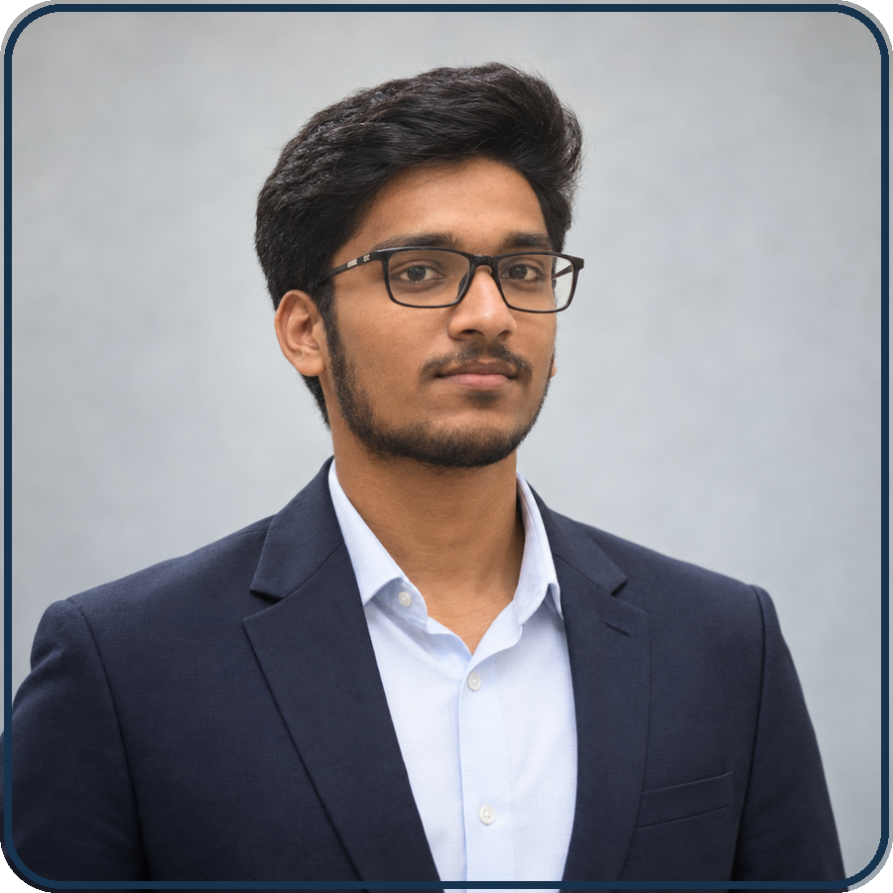
CGPA 8.51 | PEAK SGPA 9.04 | 10 LIVE FINANCE AND DATA STUDIOS

| PROFESSIONAL SUMMARY
Third-year B.Com student combining commerce fundamentals with hands-on data and web skills. Built and deployed 10 interactive finance and analytics tools covering taxation, accounting, statistics, SQL, cash flow, ratios, and lending. Brings an 8.51 CGPA, clear communication, and a practical approach to turning business concepts into useful digital products. Seeking entry-level analyst, finance operations, business intelligence, or technology roles.

| EDUCATION
Bachelor of Commerce (CBCS) 2024 - 2027
Indian Institute of Management and Commerce | Osmania University | CGPA 8.51 | Peak SGPA 9.04
- Outstanding grades in Fundamentals of IT, FIT Practical, and Principles of Insurance; A+ in Business Statistics I and II, RDBMS, Financial Accounting I and II, Communication Skills, and Web Technologies Practical.
Intermediate - CEC 2022 - 2024
Telangana State Board of Intermediate Education | 884/1000 | 88.4% | A Grade
Secondary School Certificate 2022
Gowtham Model School, Hastinapuram | CGPA 8.8/10

| TECHNICAL AND BUSINESS SKILLS
Data: Power BI, Microsoft Excel, SQL, RDBMS, Business Statistics, Data Visualization, Dashboard Design
Programming and Web: Python, C, C++, HTML, CSS, JavaScript, React, TypeScript, Git, GitHub
Commerce: Financial and Advanced Accounting, Income Tax, Business Laws, Insurance, Ratio Analysis, CVP and Break-even, Cash Flow Analysis

| SELECTED PROJECTS
niharprojects.com - Portfolio and 10 Interactive Studios | React | TypeScript | Vite | GitHub Pages
Designed and deployed a responsive personal portfolio with a custom domain, HTTPS, SEO metadata, structured profile data, and ten live finance and analytics tools.
Insight Board and Statforge | Power BI Concepts | Excel | Statistics
Built a four-semester academic dashboard with KPI cards, SGPA trends, grade heatmaps, and credit views, plus a statistics workbench for mean, median, standard deviation, coefficient of variation, quartiles, and instant charts.
Tax Atelier, Ratio Radar, and Margin Map | Taxation | Financial Ratios | CVP
Created interactive tools for new-regime tax slabs, liquidity, solvency and profitability ratios, contribution margin, break-even units, and margin of safety analysis.
Cashflow Compass, EMI Lab, and Premium Pulse | Cash Flow | Lending | Insurance
Built decision tools for monthly surplus and runway, reducing-balance EMI and amortization, and educational life and general insurance premium illustrations.
Ledger Theatre and Query Forge | Accounting | SQL | RDBMS | React
Developed a double-entry journal and T-account learning lab, plus a commerce database workspace demonstrating SELECT, JOIN, GROUP BY, filters, and aggregates across customer, invoice, and product data.

| STRENGTHS AND LANGUAGES
Strengths: Analytical thinking, problem-solving, attention to detail, communication, teamwork, adaptability, and time management
Languages: English (Professional), Hindi (Fluent), Telugu (Fluent)

