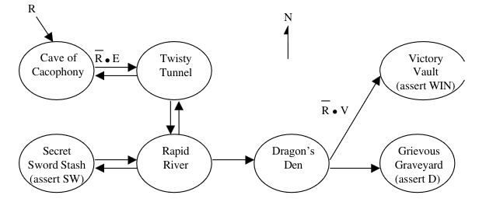

**Figure 1. Completed State Transition Diagram for Room FSM**

| **Current state** | **Inputs** | | | | | | **Next state** | | **Output** |
| --- | --- | --- | --- | --- | --- | --- | --- | --- | --- |
| **R** | **N** | **S** | **E** | **W** | **V** |
| Cave of Cacophony | 0 | X | X | 1 | X | X | Twisty tunnel | |  |
| Twisty Tunnel | 0 | X | 1 | X | X | X | Rapid River | |  |
| 0 | X | 0 | X | 1 | X | Cave of Cacophony | |  |
| Rapid River | 0 | 0 | 0 | 0 | 1 | 0 | Secret Sword Stash | |  |
| 0 | 1 | 0 | 0 | 0 | 0 | Twisty Tunnel | |  |
| 0 | 0 | 0 | 1 | 0 | 0 | Dragon’s Den | |  |
| Secret Sword Stash | 0 | X | X | 1 | X | X | Rapid River | | SW |
| Dragon’s Den | 0 | X | X | X | X | 0 | Grievous Graveyard | | D |
| 0 | X | X | X | X | 1 | Victory Vault | | WIN |

**Table 1.1 Room FSM state table**

| Current state | Inputs | | Next state | | Output |
| --- | --- | --- | --- | --- | --- |
| R | SW |
| No Sword | 0 | 0 | No Sword | |  |
| No Sword | 0 | 1 | Has Sword | |  |
| Has Sword | 1 | 1 | Has Sword | | V |

**Table 1.2 Sword FSM** **state table**

| **Current state** | **Encoding** |
| --- | --- |
|
| Cave of Cacophony | 0000001 |
| Twisty Tunnel | 0000010 |
| Rapid River | 0000100 |
| Secret Sword Stash | 0001000 |
| Dragon’s Den | 0010000 |
| Grievous Graveyard | 0100000 |
| Victory Vault | 1000000 |

**Table 2.1 Encoding Room FSM**

| **Current state** | **Encoding** |
| --- | --- |
|
| No sword | 01 |
| Has sword | 10 |

**Table 2.2 Encoding Sword FSM**

| **Current state** | | **Inputs** | | | | | | **Next state** | | | **Output** |
| --- | --- | --- | --- | --- | --- | --- | --- | --- | --- | --- | --- |
| **R** | **N** | **S** | **E** | **W** | **V** |
| S0 | 0000001 | 0 | X | X | 1 | X | X | 0000010 | | S1 |  |
| S1 | 0000010 | 0 | X | 1 | X | X | X | 0000100 | | S2 |  |
| 0 | X | 0 | X | 1 | X | 0000001 | | S0 |  |
| S2 | 0000100 | 0 | 0 | 0 | 0 | 1 | 0 | 0001000 | | S3 |  |
| 0 | 1 | 0 | 0 | 0 | 0 | 0000010 | | S1 |  |
| 0 | 0 | 0 | 1 | 0 | 0 | 0010000 | | S4 |  |
| S3 | 0001000 | 0 | X | X | 1 | X | X | 0000100 | | S2 | SW |
| S4 | 0010000 | 0 | X | X | X | X | 0 | 0100000 | | S5 | D |
| 0 | X | X | X | X | 1 | 1000000 | | S6 | WIN |

**Table 3.1/ 3.3**

| **Current state** | | **Inputs** | | **Next state** | | | **Output** |
| --- | --- | --- | --- | --- | --- | --- | --- |
| **R** | **SW** |
| S7 | 01 | 0 | 0 | 01 | | S7 |  |
| S7 | 01 | 0 | 1 | 10 | | S7 |  |
| S8 | 10 | 1 | 1 | 10 | | S8 | V |

**Table 3.2/ 3.4**

**Room FSM Equations**

S0 = R’ W S1 + R

S1 = R’ E S0 + R’ N S2

S2 = R ’S S1 + R’ E S S3

S3 = R’ W S2

S4 = R’ E S2

S5 = R’ V S4

S6 = R’ V’ S4

**Sword FSM Equations**

V = R’ SW (R+V’)

**Sword FSM**

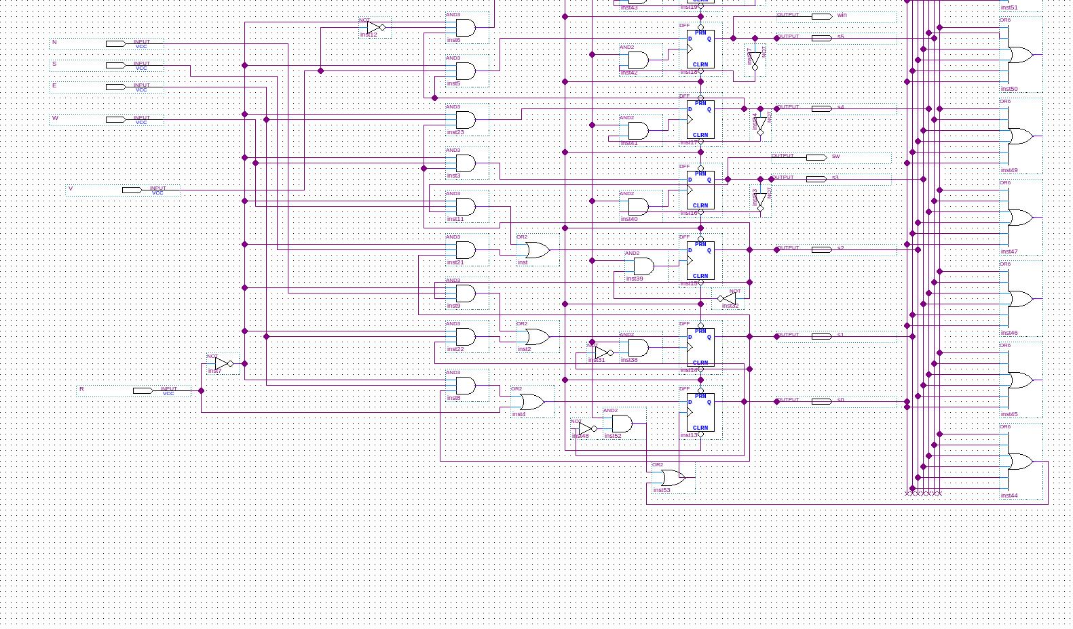

**Game FSM**

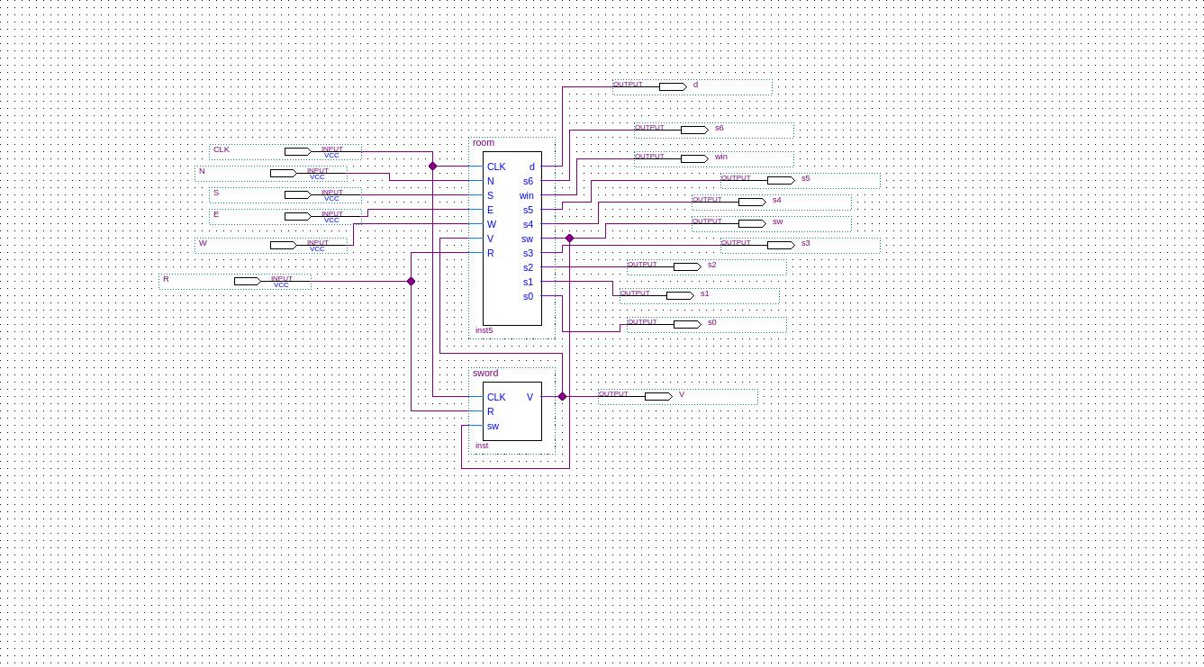

**Room FSM**



**Win**

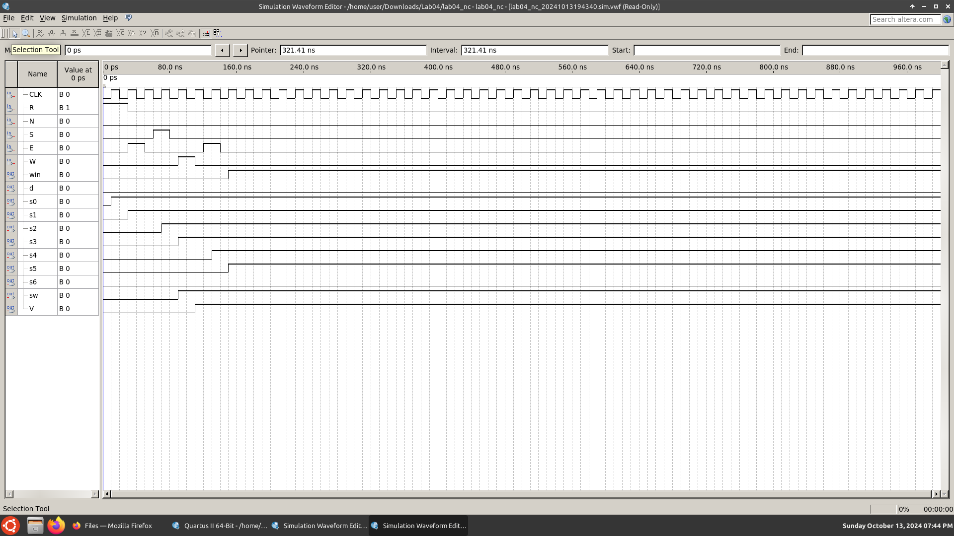

**Loss**

