HA1
Operating System Functionalities
- Explain the purpose of system calls and classify different types of system calls based on their functionality (e.g., process control, file manipulation).¹
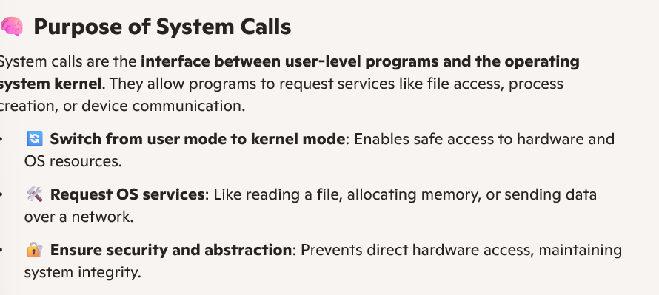
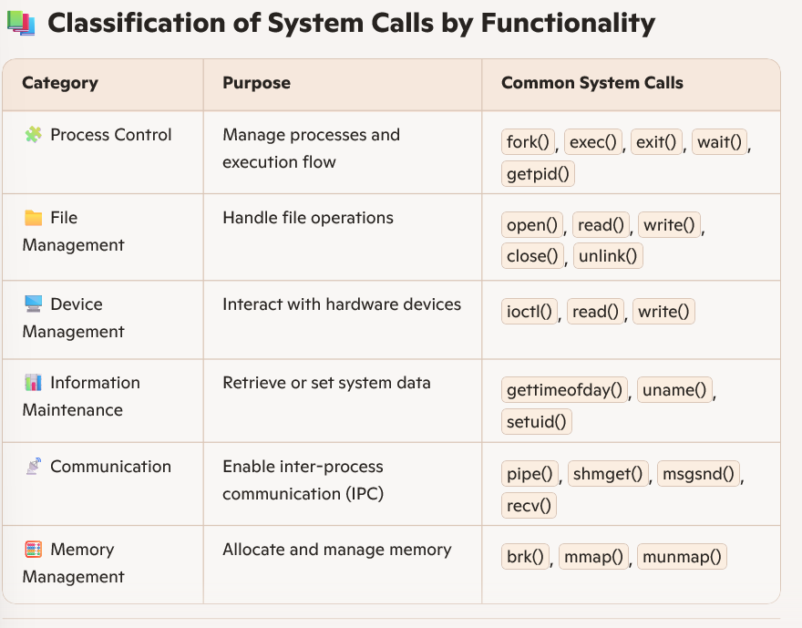
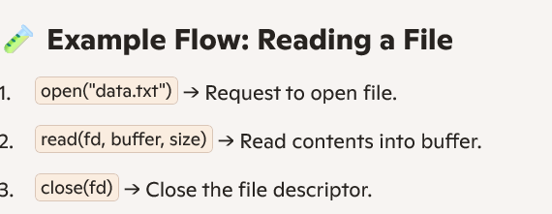
- Explain the main differences between a kernel and a shell in an operating system.² Illustrate how they interact with hardware and user applications.
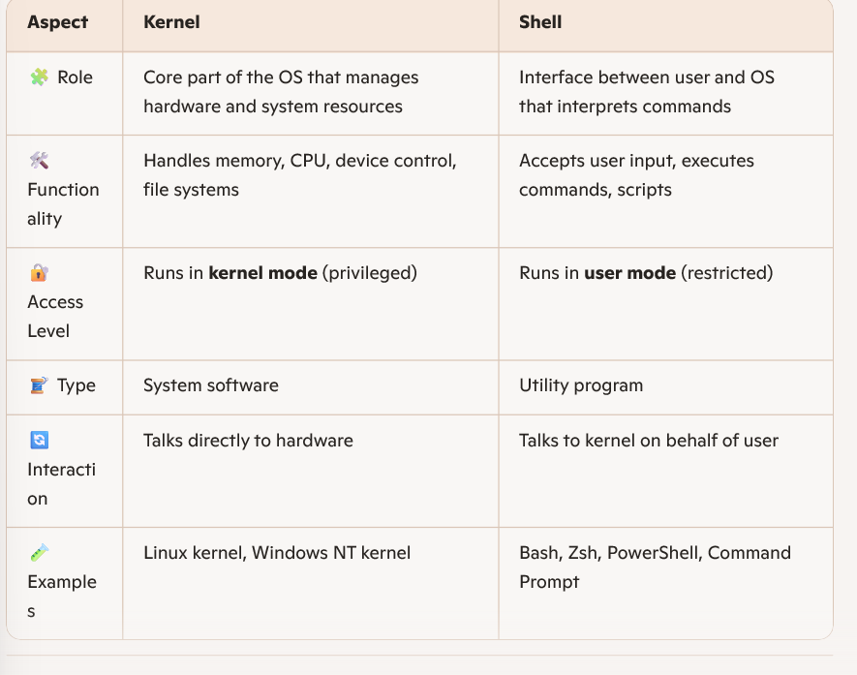
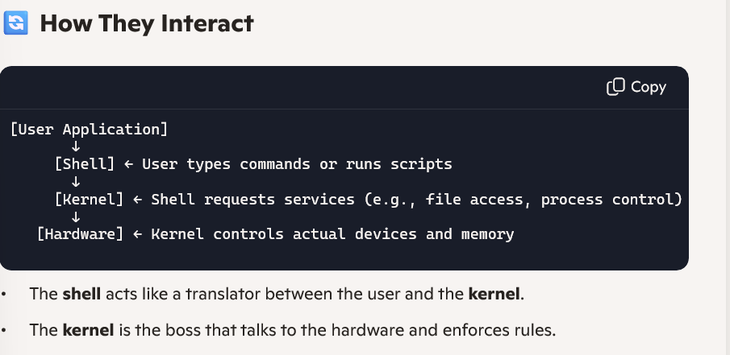
Types of Operating Systems
- Explain how multi-user operating systems relate to the concept of time-sharing, using relevant examples.³
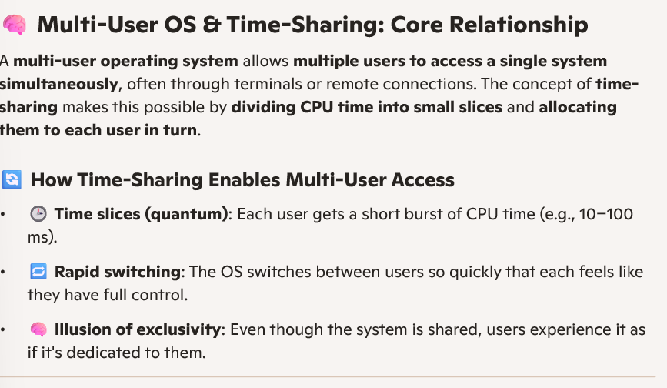
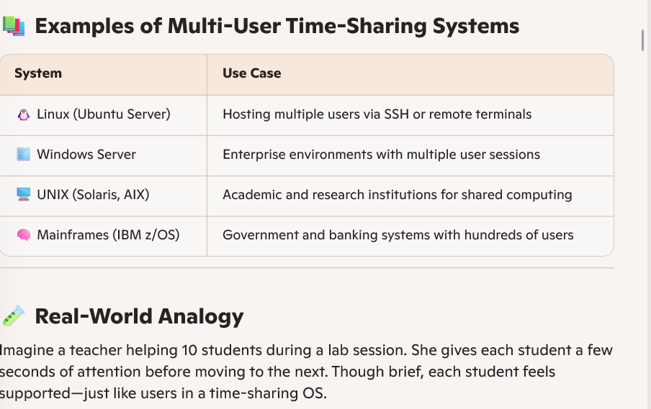
- Compare and contrast batch processing systems and interactive systems with examples. Rephrase how each system handles user jobs and resource allocation.
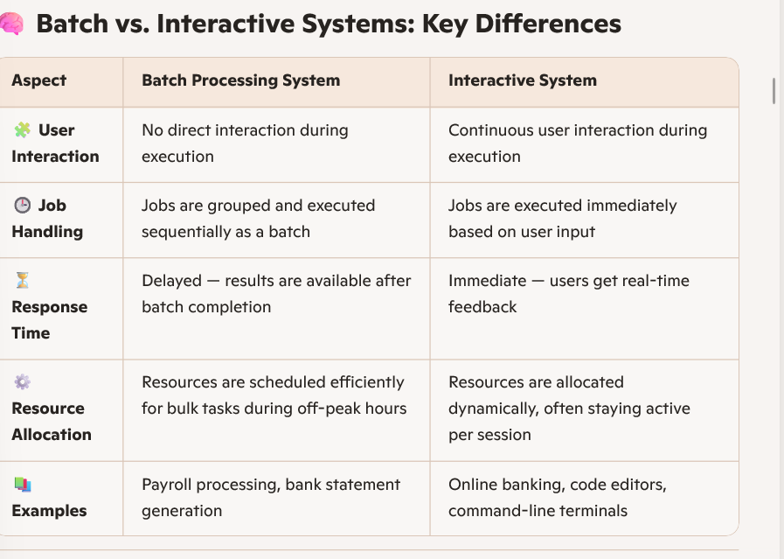
🔄 Rephrased Handling of Jobs & Resources
🧮 Batch Systems
- Jobs are collected over time, queued, and then executed without user intervention.
- The system allocates resources in bulk, often during idle hours, to maximize throughput.
- Users submit jobs and wait for results — no mid-process interaction.
🧑‍💻 Interactive Systems
- Users initiate tasks directly, and the system responds instantly.
- Resources are allocated per session, often staying active even when idle.
- Ideal for tasks requiring real-time decision-making or feedback.
Analogy for Clarity
- Batch: Like dropping off laundry at a service — you leave it, they process it in bulk, and you collect it later.
- Interactive: Like using a washing machine at home — you control each step and get instant results.

Processes
- List the key components maintained in the Process Control Block (PCB) and explain their significance in process management.⁴
Key Fields in a Process Control Block (PCB)
A Process Control Block (PCB) stores essential information about a process. Key fields include:
- Process ID (PID): Unique identifier for the process.
- Process State: Current status (Ready, Running, Waiting, etc.).
- Program Counter: Address of the next instruction to execute.
- CPU Registers: Contents of all registers for context switching.
- Memory Management Info: Base/limit registers, page tables.
- Accounting Info: CPU usage, execution time, job priority.
- I/O Status Info: List of I/O devices allocated and files opened.
These fields help the OS manage, schedule, and switch between processes efficiently.
6. Structure of a PCB & Role in Context Switching
PCB Structure:
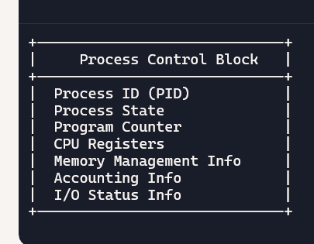
Context Switching Role:
- When switching from one process to another, the OS:
  - Saves the current process’s state in its PCB.
  - Loads the next process’s state from its PCB.
- This ensures smooth multitasking and process isolation.
7. Process State Transition Diagram & System Calls
States:
New → Ready → Running → Waiting → Ready → Terminated
Transitions & Triggers:
admit()
scheduler()
wait()
I/O completion
preemption
exit()
8. Function of the init Process in Unix
- PID 1: The first process started by the kernel.
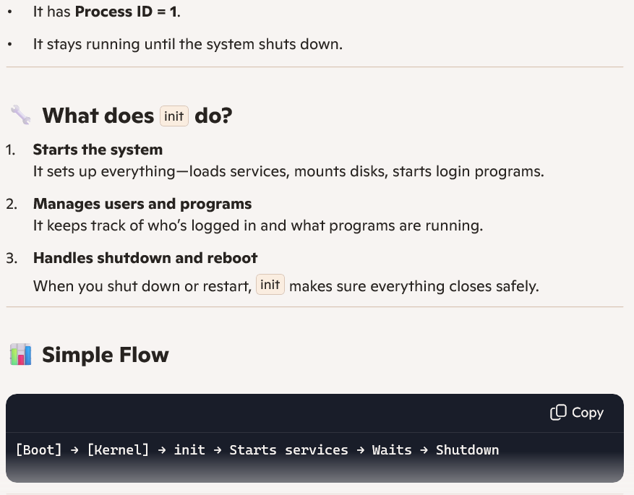
9. Context Switching Mechanism in Multitasking
Context Switching:
- The OS saves the current process’s state (PCB).
- Loads the next process’s state from its PCB.
- Updates CPU registers, program counter, and memory mappings.
Role in Multitasking:
- Enables multiple processes to share the CPU.
- Maintains isolation and fairness.
- Supports responsiveness in interactive systems.
10. Process Scheduling & Code Example
Influence of Process States:
- Only processes in the Ready state are eligible for scheduling.
- The scheduler selects based on priority, time slice, or fairness.
Basic Code Example (Round Robin Simulation):
processes = ['P1', 'P2', 'P3'] time_slice = 2 for p in processes: print(f"Running {p} for {time_slice} units")
This simulates equal CPU time allocation to each process in the ready queue.
Let me know if you'd like these turned into flashcards or diagrams for faster revision!

- Construct the structure of a Process Control Block (PCB) and explain how each component is used by the operating system during context switching.
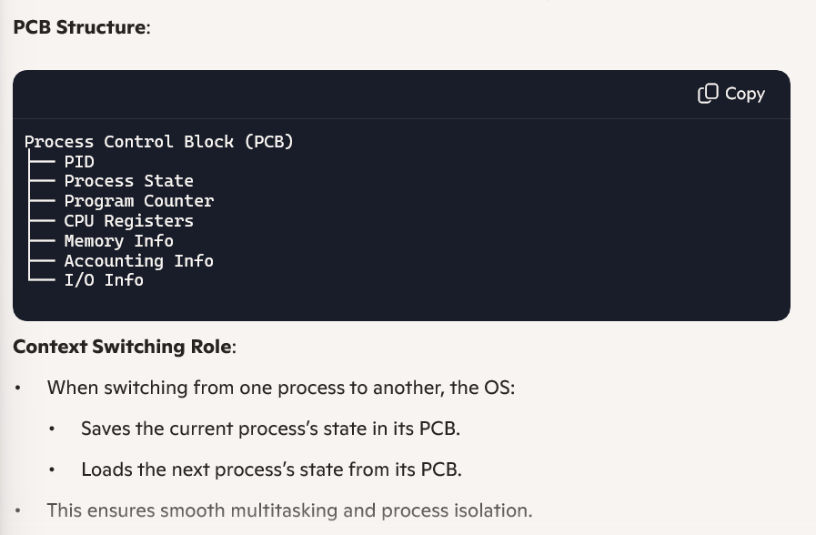
- Construct a process state transition diagram and identify the system calls that trigger transitions between states like ready, running, and terminated.
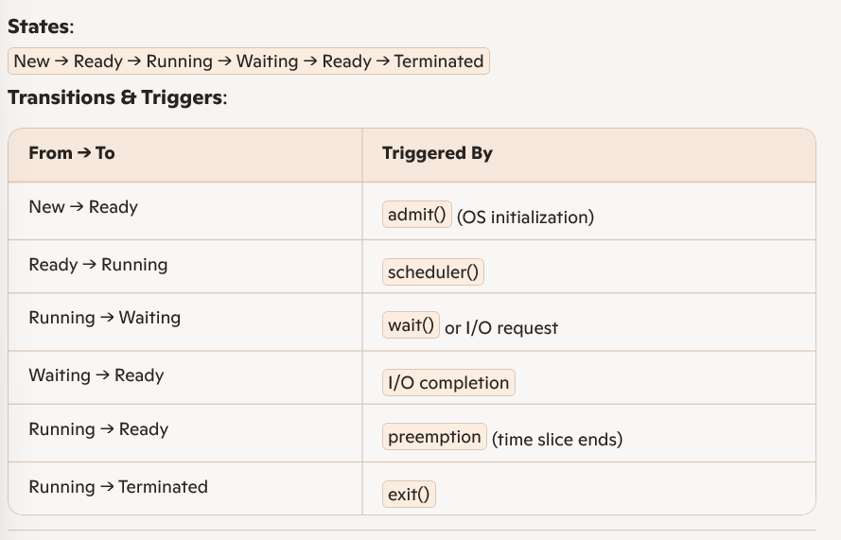
- Describe the function of the init process in Unix-based systems and interpret its role in managing orphaned processes.⁵
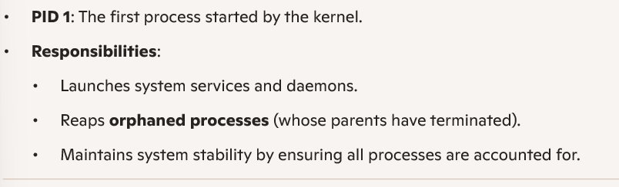
- Describe how the context switching mechanism works and illustrate its role in multitasking environments.⁶
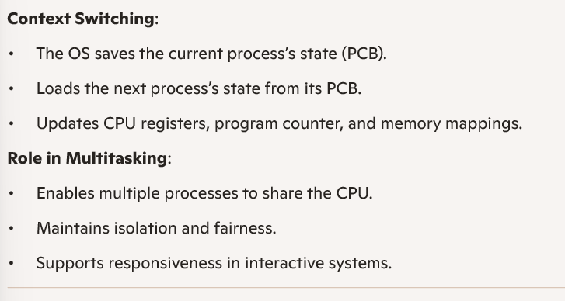
- Identify how process scheduling is influenced by process states and apply basic scheduling concepts using a small code example.
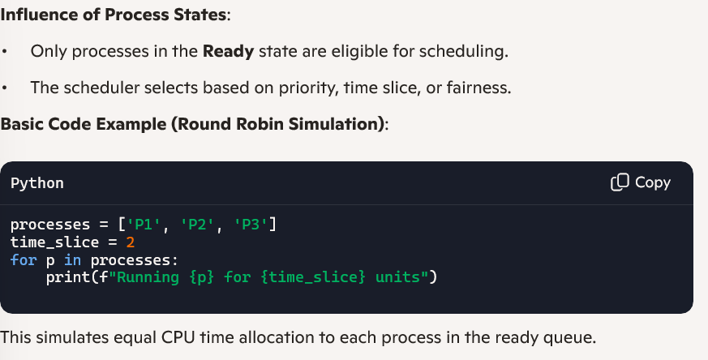
Process API Code
- Apply the concept of process control by writing a program using fork(), exec(), and wait() system calls to create and manage a child process.
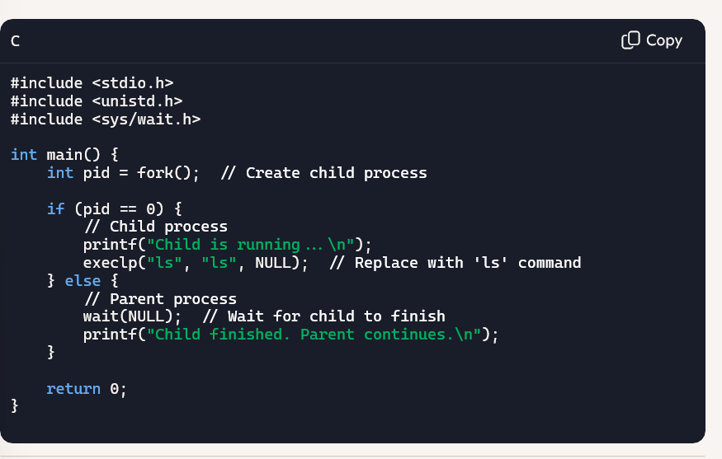
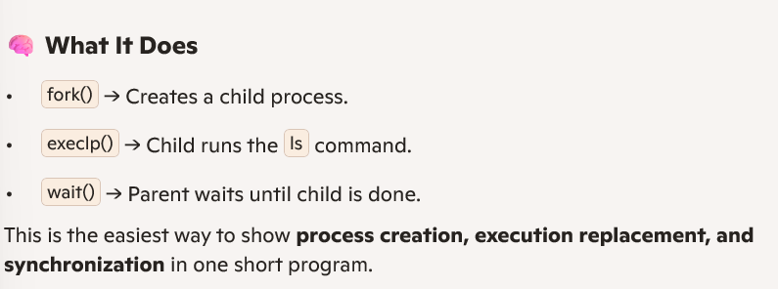
- Utilize the wait() and exit() system calls to demonstrate parent-child synchronization during process termination.
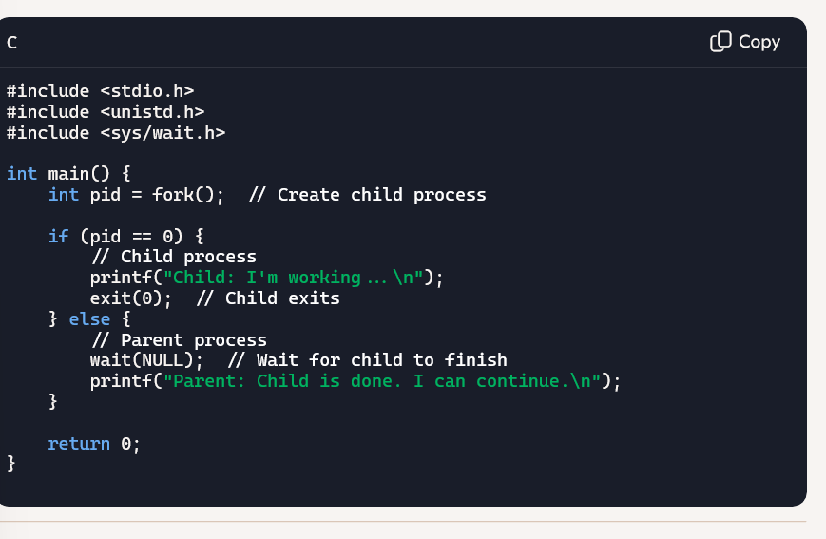
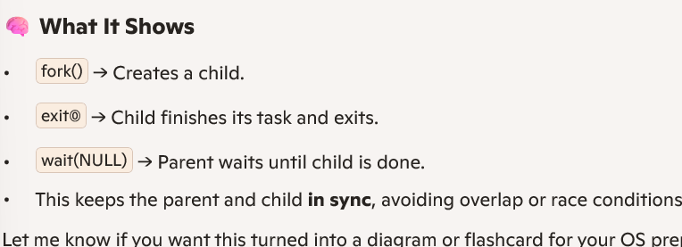
- Develop a program to create both a zombie process and an orphan process and illustrate how the operating system responds to each scenario during process termination.
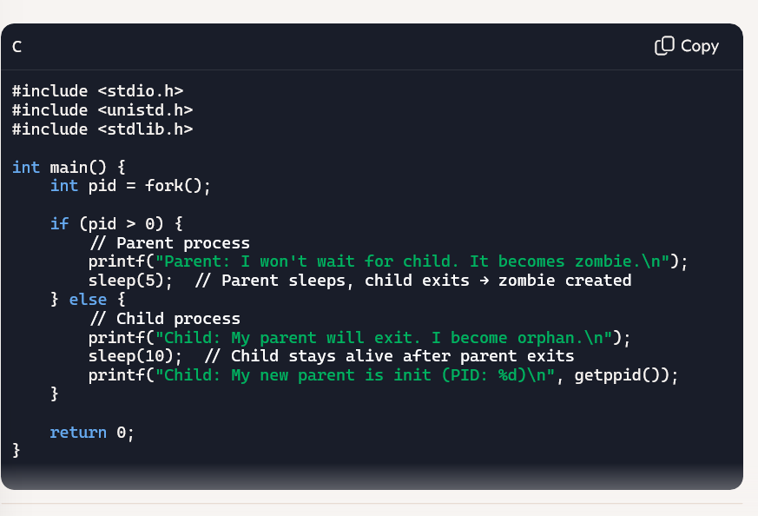
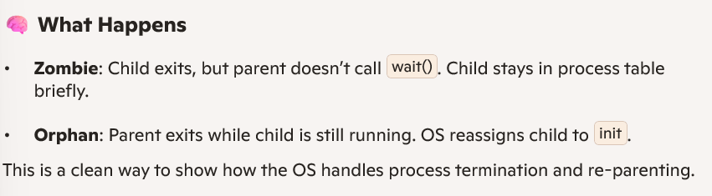
- Make use of process IDs and the getpid() and getppid() system calls to develop a program that prints the parent and child process IDs.
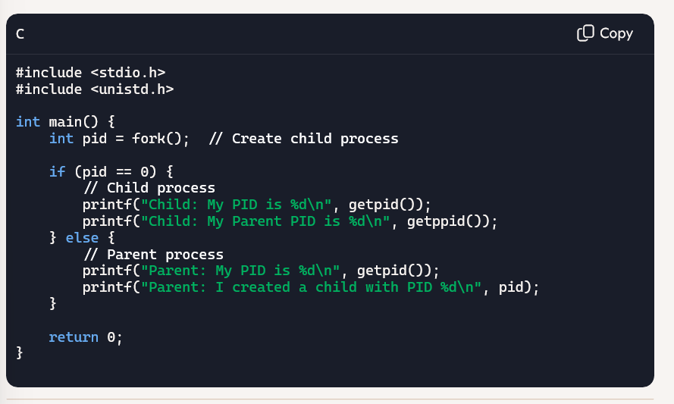
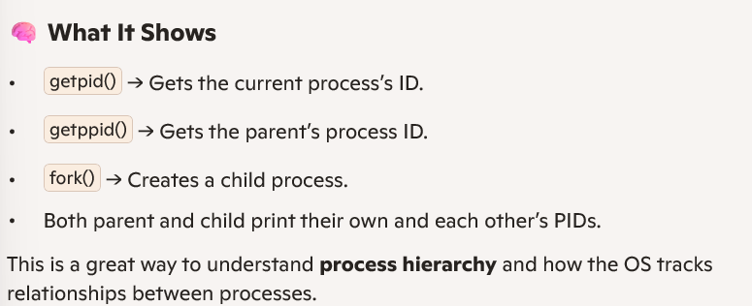
- Construct a scenario where a parent process creates multiple child processes and organize their termination using the wait() system call.
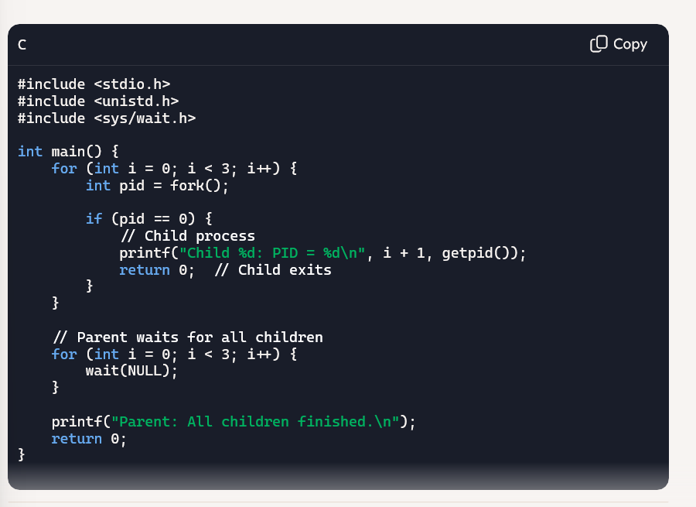
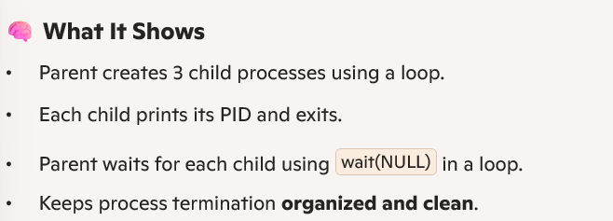
- Make use of the kill() system call to develop a basic program that sends termination signals to a child process and handles them appropriately.
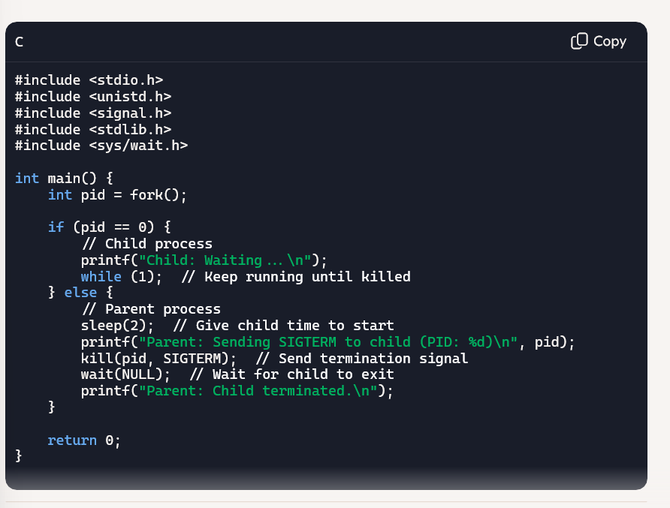
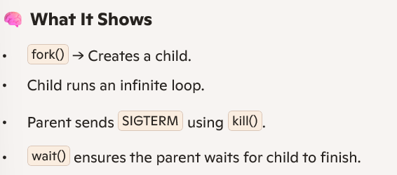
Direct Execution
- Apply the concept of Limited Direct Execution by describing how the operating system uses timer interrupts to regain control from user programs during context switches.
What Is Limited Direct Execution?
Limited Direct Execution (LDE) is a CPU virtualization technique where:
- The OS lets user programs run directly on the CPU for performance.
- But it limits their control to ensure security and fairness.
- The OS uses hardware support (like timer interrupts) to stay in charge.
⏱️ Role of Timer Interrupts in Context Switching
When a user program runs, the OS sets a timer for a fixed time slice (e.g., 50 ms). Here's how the OS regains control:
- User program runs in user mode.
- Timer expires → hardware triggers a timer interrupt.
- Interrupt handler runs in kernel mode.
- OS saves the current process state (into its PCB).
- OS selects another process to run (based on scheduling).
- OS loads the new process state and resumes execution.
This is how the OS forces a context switch, even if the user program doesn’t voluntarily yield.
🔐 Why It Matters
- Prevents any one process from hogging the CPU.
- Ensures fair multitasking.
- Maintains security by switching to kernel mode during interrupts.
🧪 Analogy
Imagine giving each student 1 minute to speak in a group discussion. A timer rings, and the teacher switches to the next student — even if the first one isn’t done. That’s how the OS uses timer interrupts to keep things fair.

- Utilize the principles of Direct Execution to explain how system performance can be improved or degraded based on how context switching is handled.
Direct Execution means the OS lets user programs run directly on the CPU (in user mode) to maximize speed and efficiency. But the OS still controls key events like I/O, memory access, and scheduling — especially through context switching.
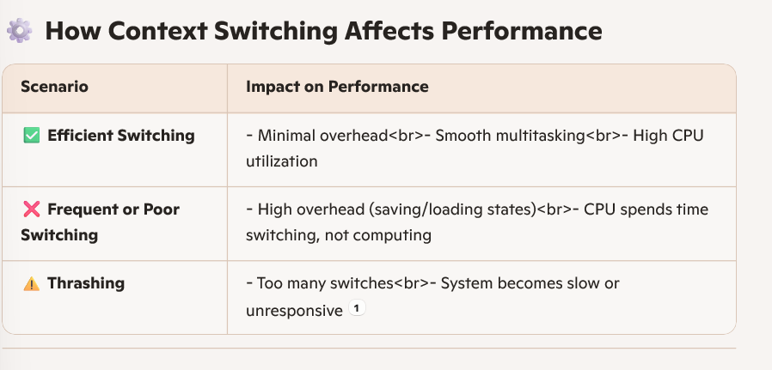
Why It Matters in Direct Execution
- Since user programs run directly on the CPU, the OS must interrupt them safely (e.g., via timer interrupts) to switch tasks.
- If switching is well-managed, performance improves — tasks share CPU fairly and efficiently.
- If switching is too frequent or poorly timed, performance drops — the CPU wastes cycles on overhead instead of useful work.
🧪 Analogy
Imagine a teacher switching between students every few seconds. If done smoothly, everyone gets help. But if the teacher keeps switching too fast, no one gets real support — just interruptions.

- Develop a scenario where Direct Execution leads to a failure in control, and show how the operating system corrects it using privileged mode and interrupts.
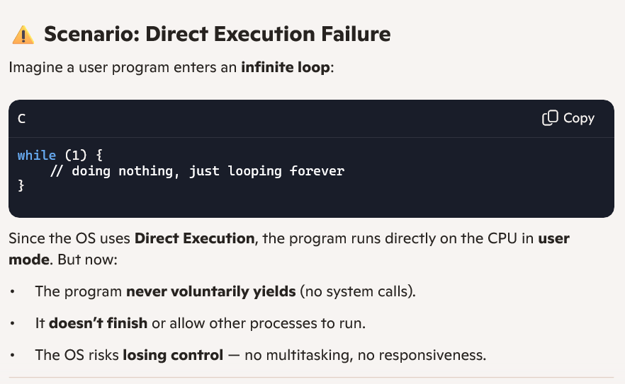
🛡️ How the OS Corrects This
To prevent this, the OS uses hardware support:
✅ 1. Timer Interrupt
- Before giving CPU to the user program, the OS sets a timer.
- When the time slice ends, the timer triggers an interrupt.
- This forces the CPU to switch to kernel mode.
✅ 2. Privileged Mode
- The interrupt handler runs in privileged (kernel) mode.
- The OS saves the current process state (PCB).
- It then selects another process to run — context switch.
✅ 3. Control Regained
- The OS resumes control of the CPU.
- The looping program is paused.
Other processes get a chance to run — system stays responsive.Analogy
Think of a student hogging the mic in a group discussion. The teacher sets a timer. When it rings, the teacher steps in (privileged mode), pauses the student, and lets someone else speak. That’s how the OS keeps things fair.

CPU Scheduling
- Explain how the scheduler selects the next process to execute and outline the factors that affect scheduling decisions.
The CPU scheduler picks one process from the ready queue to run next. It uses a scheduling algorithm to decide which process gets the CPU based on system goals like fairness, efficiency, and responsiveness.

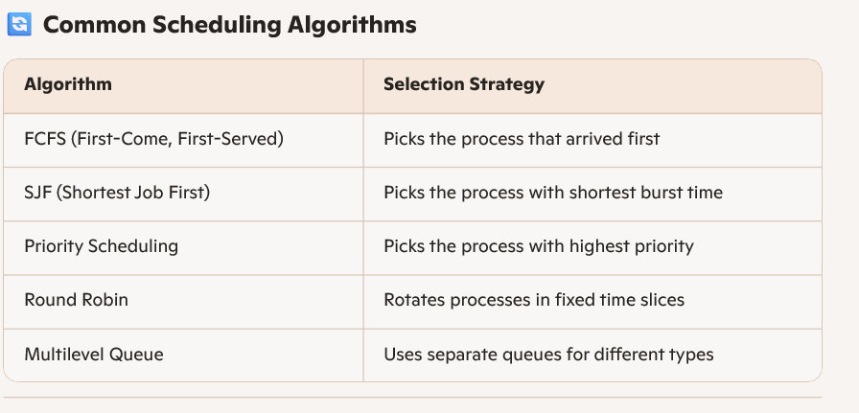
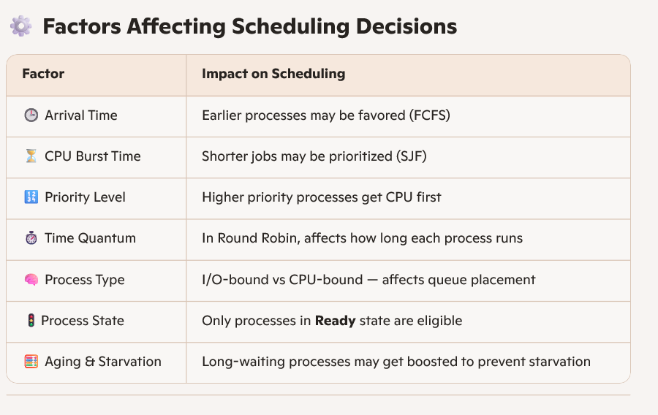
Think of a teacher deciding which student gets help next:
- First-come gets help first (FCFS).
- Quick questions get answered first (SJF).
- Urgent doubts get priority (Priority).
- Everyone gets a turn (Round Robin).
Let me know if you'd like this turned into a diagram or flashcard for your OS notes. I can also help you write a short summary for LinkedIn or your study group!

- Compare preemptive and non-preemptive scheduling policies and explain where each would be more suitable.
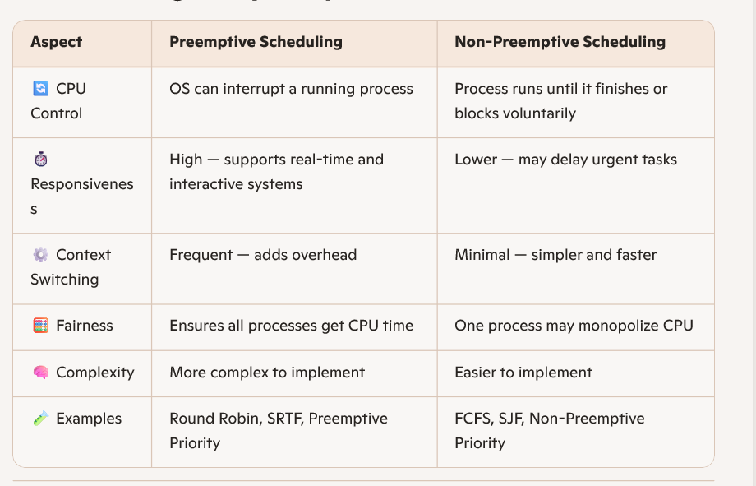
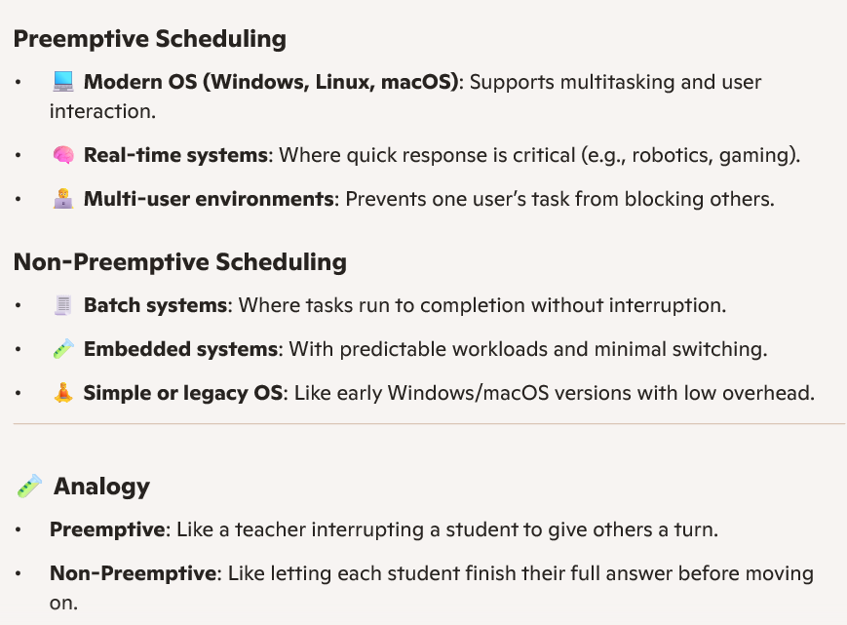

- Apply FCFS, SJF, and SRTF scheduling algorithms to the processes P1–P4 with arrival times 0, 1, 2, 3 ms and burst times 7, 5, 1, 2 ms. Construct Gantt charts and calculate AWT and ATAT for each algorithm.
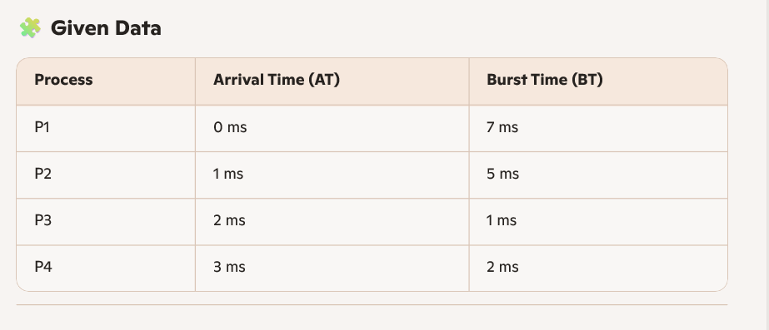
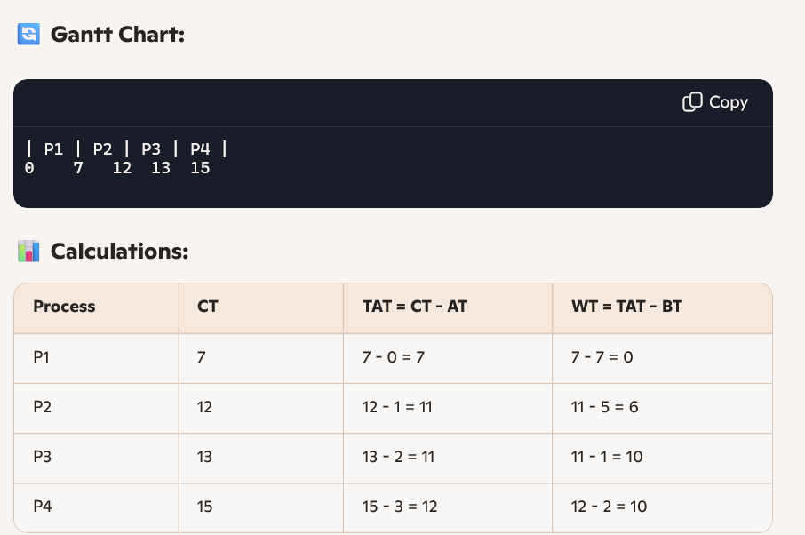
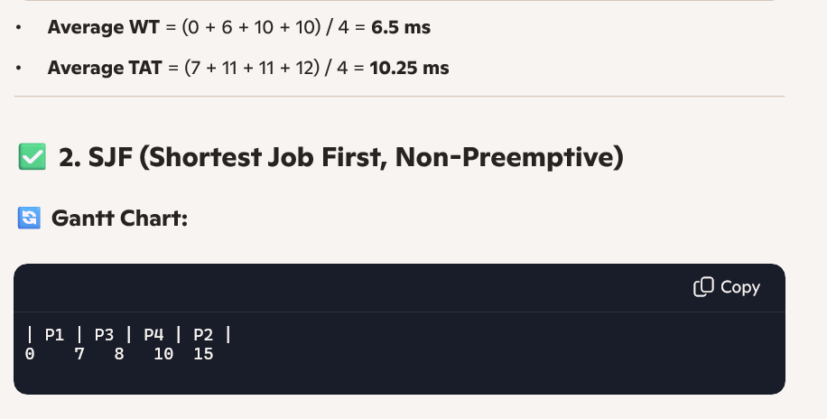
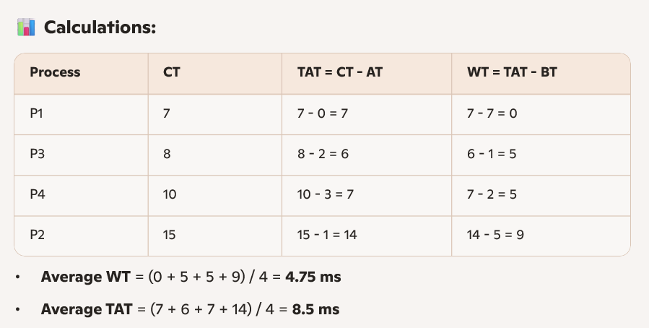
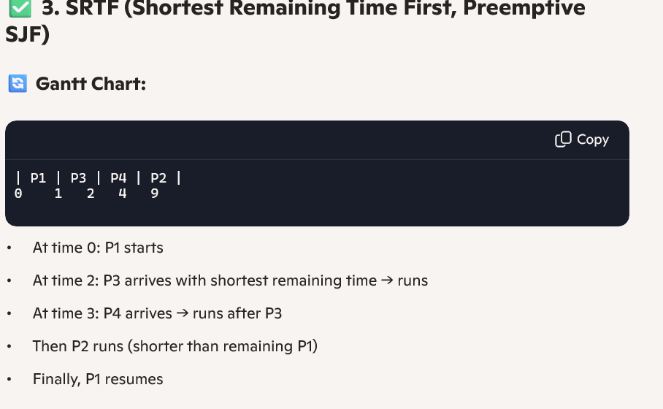
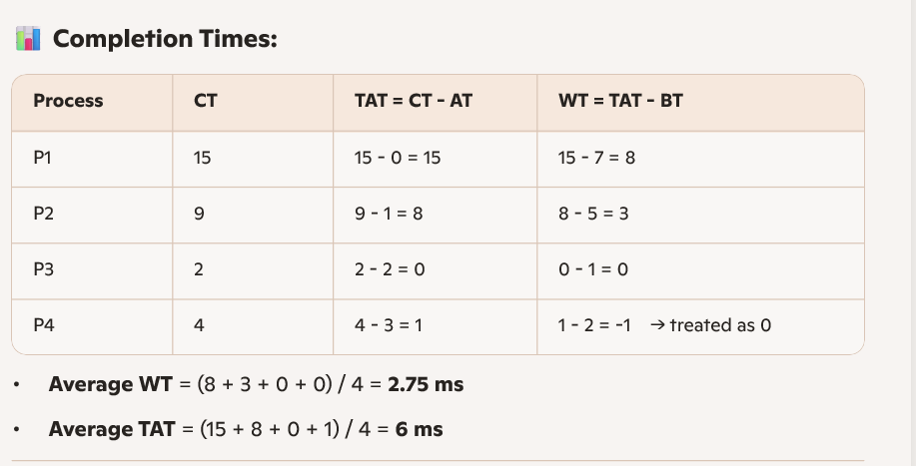
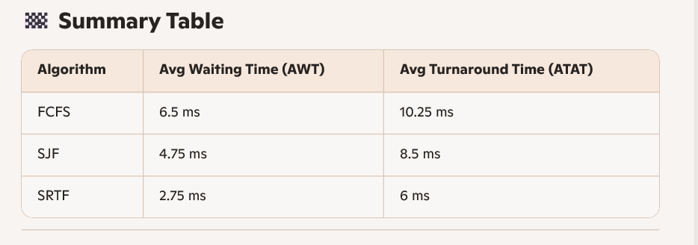
- Analyze the scheduling of four processes using the Priority Scheduling algorithm: Burst times = 6, 8, 7, 3 ms; Priorities = 4, 1, 3, 2. Arrival = 0. Create Gantt chart and calculate AWT and ATAT.
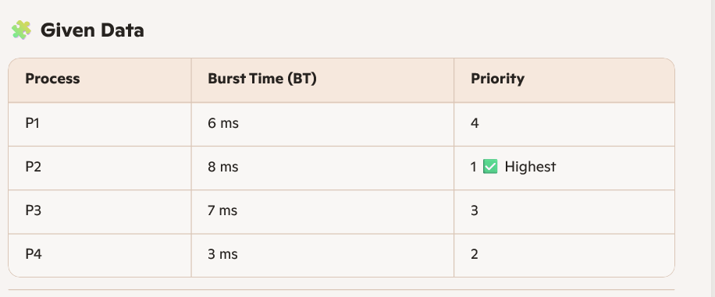
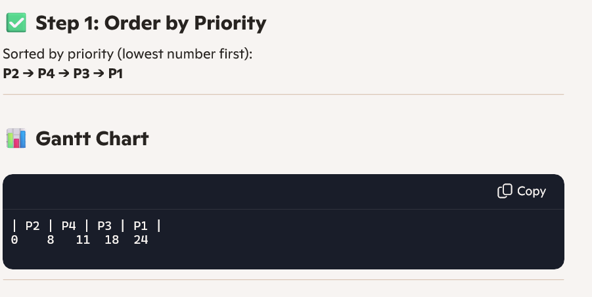
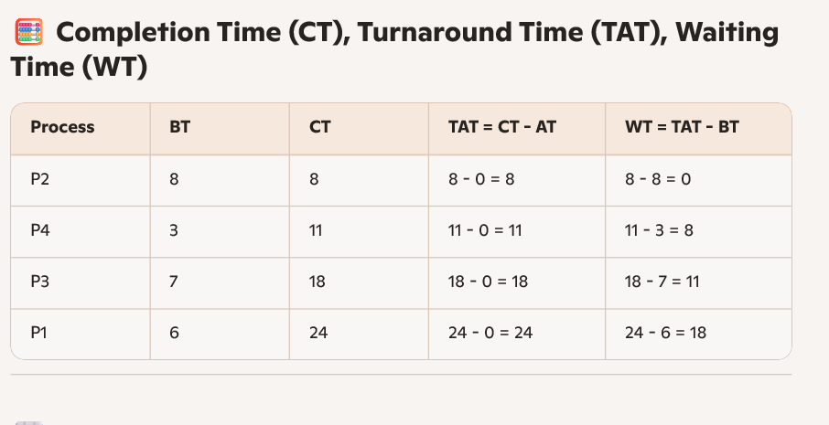
📈 Averages
- Average Waiting Time (AWT) = (0 + 8 + 11 + 18) / 4 = 9.25 ms
- Average Turnaround Time (ATAT) = (8 + 11 + 18 + 24) / 4 = 15.25 ms

- Assume you have the following jobs to execute with one processor... (repeated multiple versions of same STCF, RR, arrival/burst questions) – grouped for reuse:
  - STCF, RR (quantum = 2 ms) → P1, P2, P3, P4; Arrival: 0,1,2,3; Burst: 5,4,2,1.
  - Shortest Time-to-Completion First (STCF) vs Round Robin (2 ms).
  - Gantt chart generation and computation of Waiting/ Turnaround/ Completion Time.
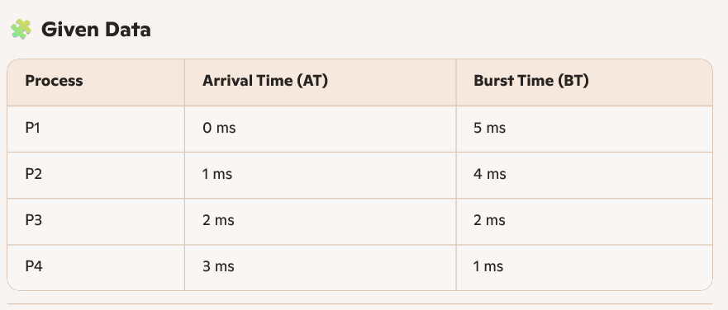
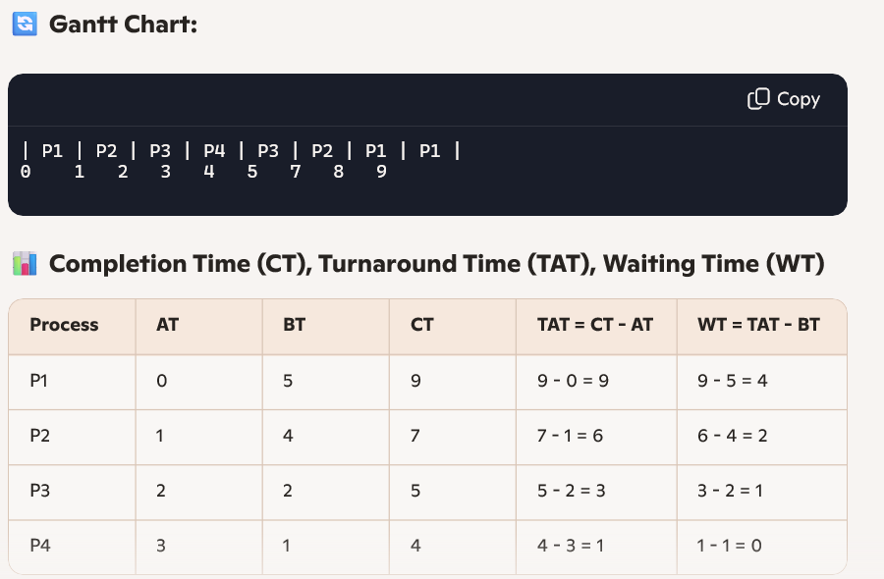
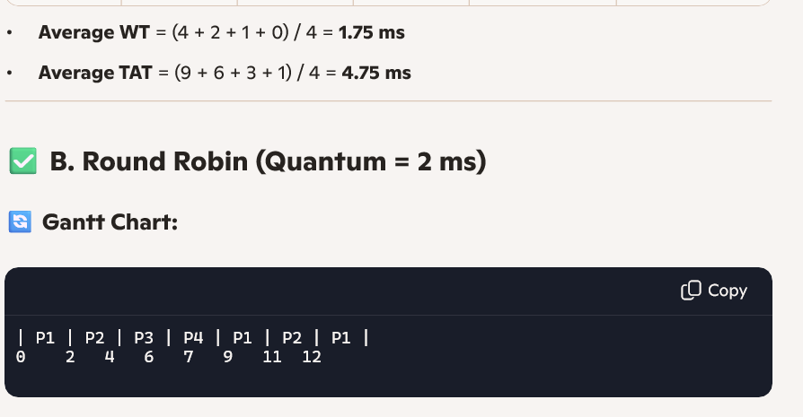
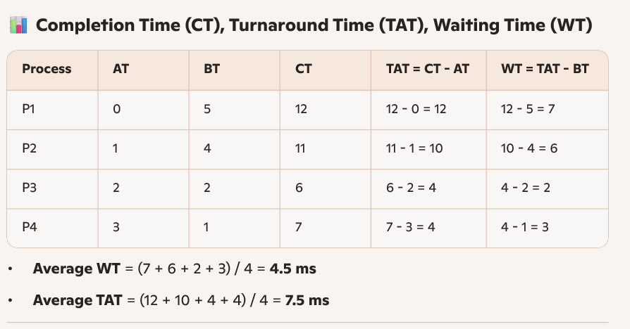
Multi-level Feedback
- Analyze the Multi-level Feedback Queue (MLFQ) scheduling algorithm, detailing its core principles and functionality.⁷
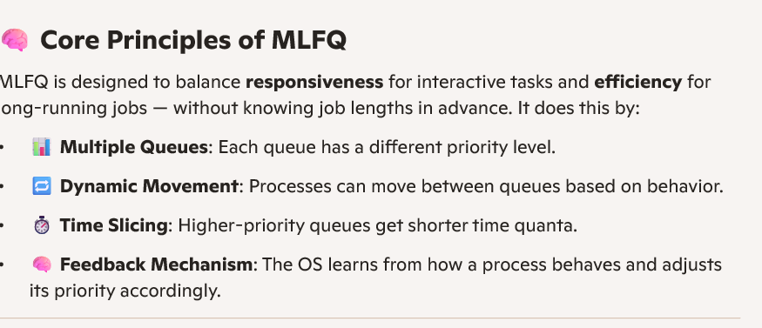
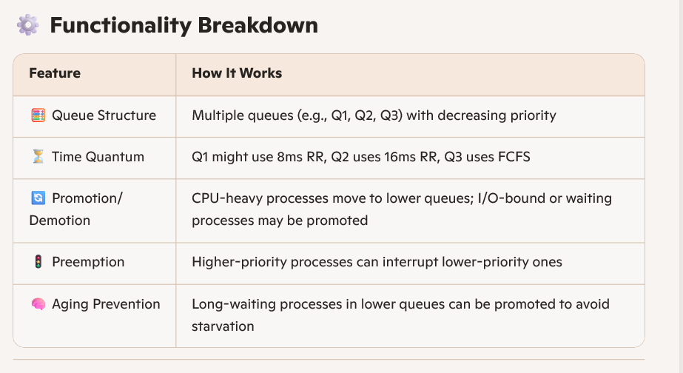
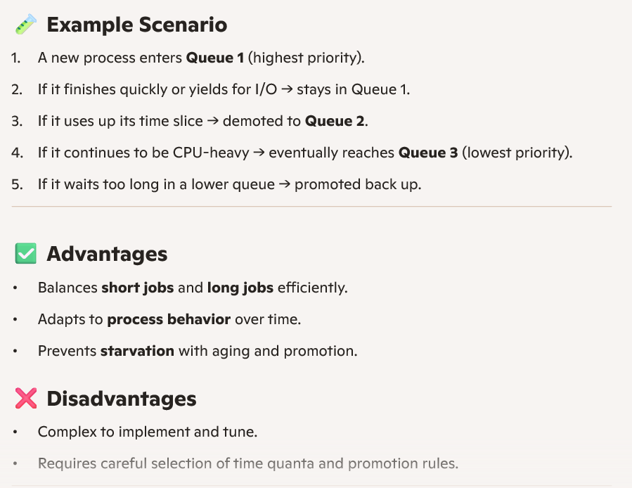
Lottery Scheduling Code
- Apply the concept of lottery scheduling to a scenario where two processes are assigned tickets in a 75% to 25% ratio. Explain how CPU time is likely to be distributed between the two processes based on the ticket allocation.
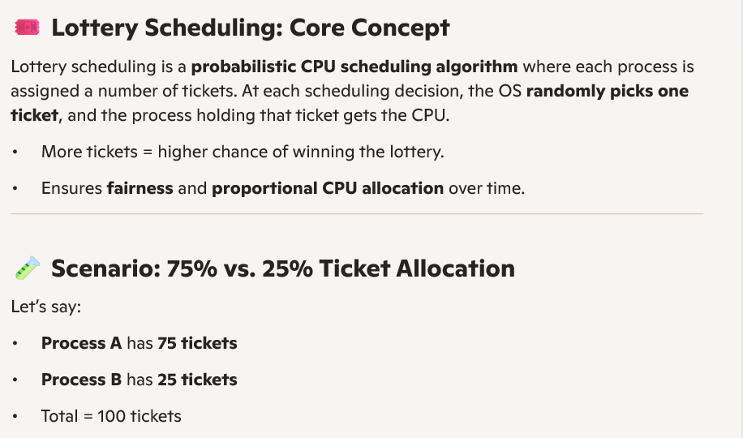
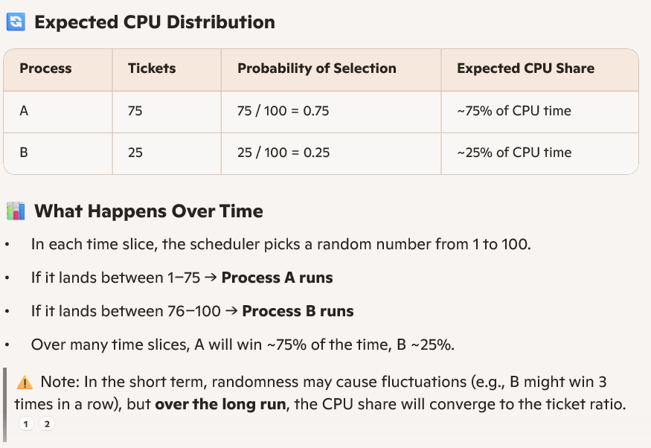
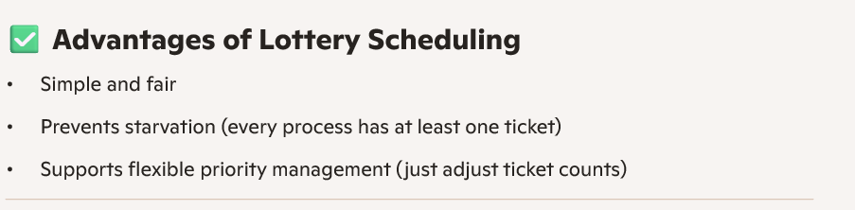
Multiprocessor Scheduling
- Illustrate the concepts of Single-Queue and Multi-Queue Multiprocessor Scheduling. Explain how each approach handles issues such as cache affinity and load imbalance.
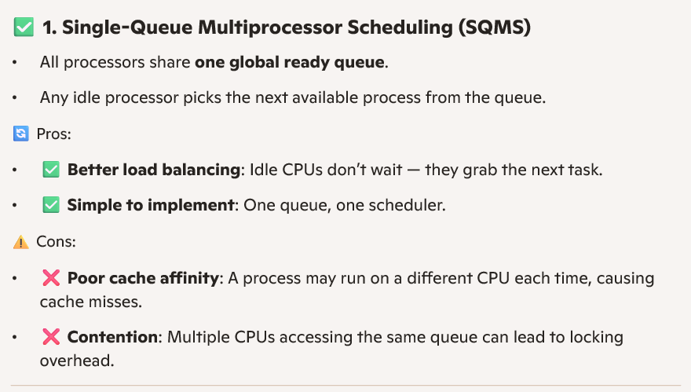
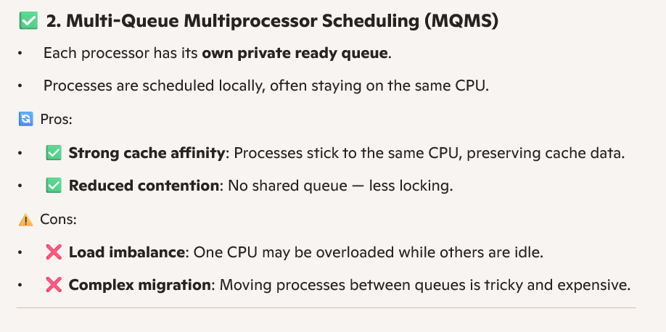
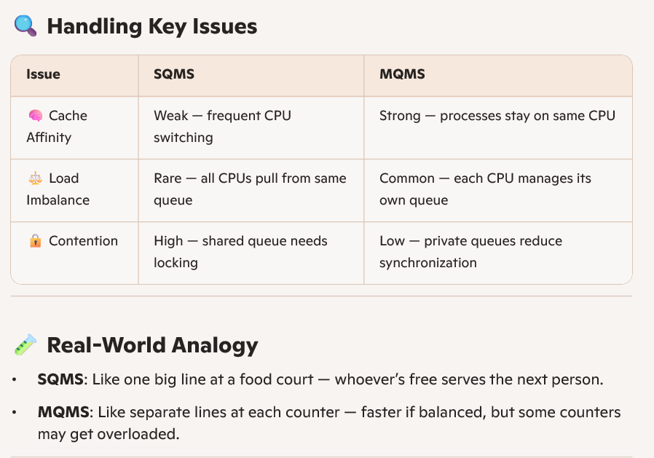
For Reference Topics covered are:
Operating System Functionalities: Covered (System calls, Kernel/Shell).
Types of Operating Systems: Covered (Multi-user/Time-sharing, Batch/Interactive).
Processes: Covered (PCB, Process States, Init Process, Context Switching).
Process API code: Covered (fork(), exec(), wait(), getpid(), getppid(), zombie/orphan, kill()).
Direct Execution: Covered (Timer interrupts, Performance, Failure in control).
CPU Scheduling: Covered (Scheduler selection, Preemptive/Non-preemptive, FCFS, SJF, SRTF, Priority Scheduling, STCF, RR).
Multi-level Feedback: Covered (MLFQ algorithm).
Lottery Scheduling code: Covered (Lottery scheduling scenario).
Multiprocessor Scheduling: Covered (Single-Queue and Multi-Queue).

