Liver Disease Detection Extension

As extension you ask us to implement following modules

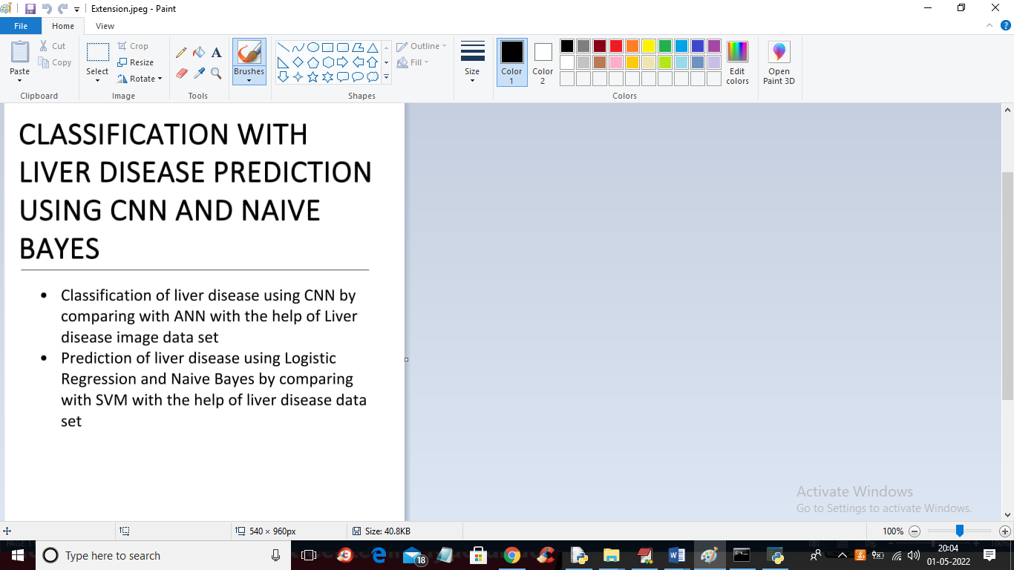

According to above image as extension you asked us to SVM, Logistic regression with liver dataset and CNN and ANN with liver images dataset and we already did that part and now I am adding two new modules as extension where one module take test data as input and then used logistic regression to predict weather that test data contains liver disease or not and for testing purpose we are using below test data

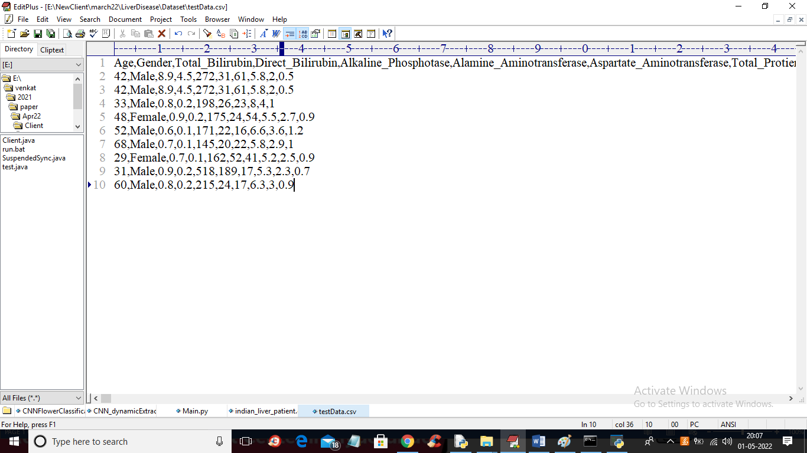

In above screen we have test data without class label 1 (normal) and 2 (liver disease) and when we upload above data then Logistic regression will predict weather its normal or not

Similarly in second module we will upload test image and then ANN will predict weather image is normal or not.

SCREEN SHOTS

To run project double click on ‘run.bat’ file to get below screen

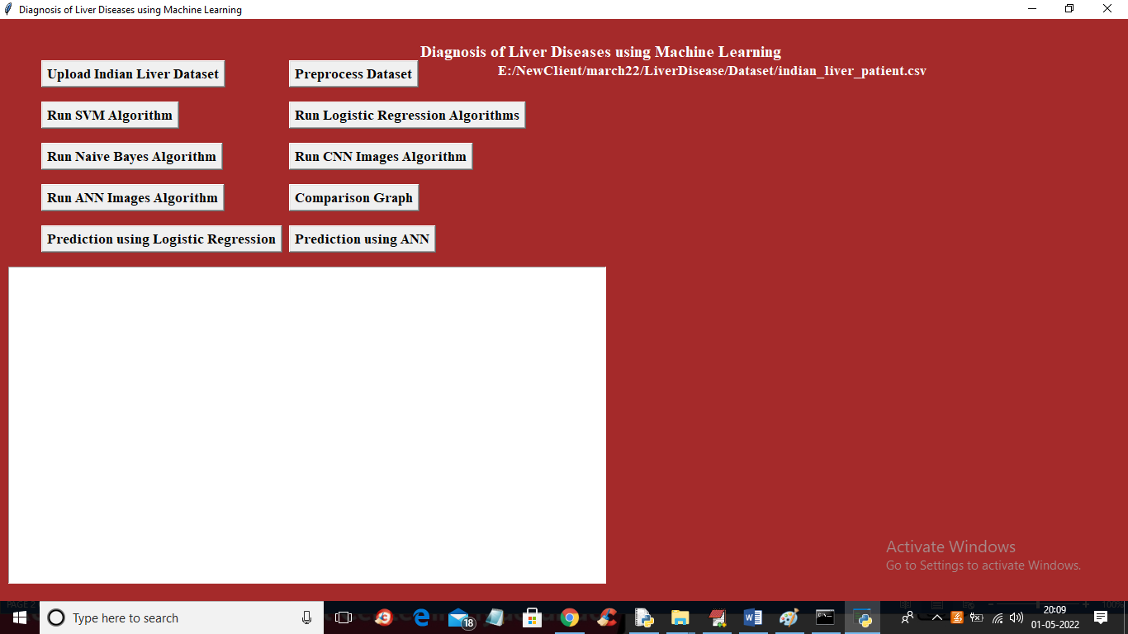

In above screen run all buttons as per old screen shots and in last two button we can used for prediction and now click on ‘Prediction using Logistic Regression’ button to upload test data and get below output

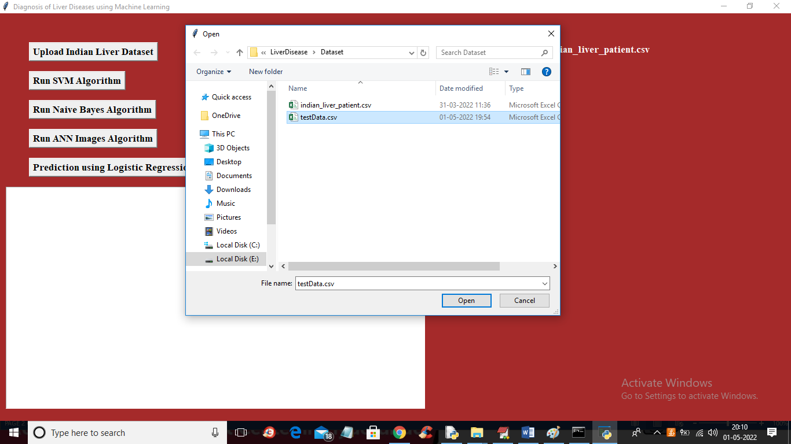

In above screen selecting and uploading ‘testData.csv’ file and then click on ‘Open’ button to get below output

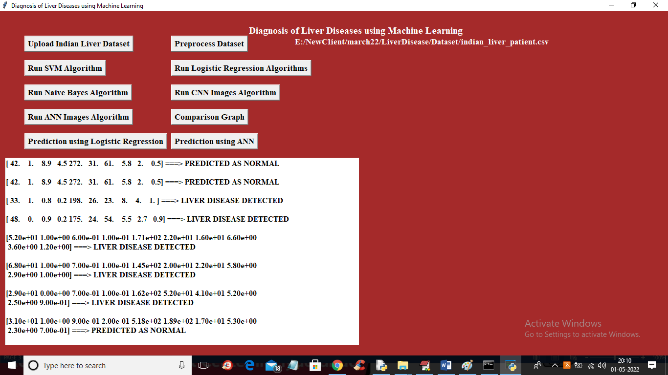

In above screen in square bracket we can see liver disease test data and after arrow symbol we can see predicted values as NORMAL or LIVER DISEASE DETECTED. Similarly click on ‘Prediction using ANN’ button to upload liver scan image and then ANN will predict weather image is normal or not

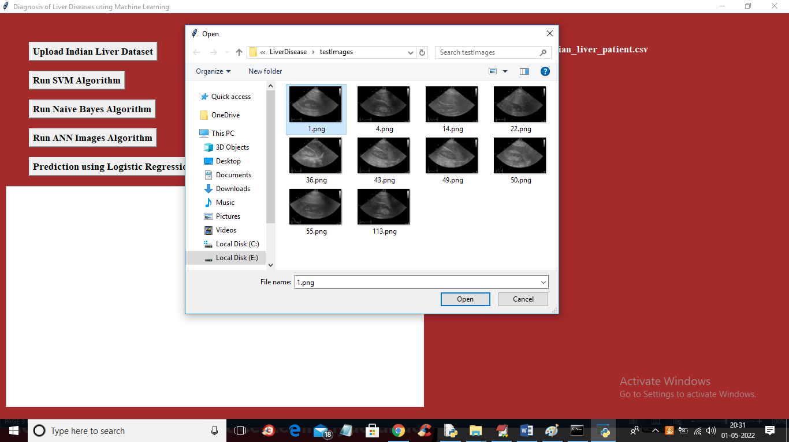

In above screen selecting and uploading ‘1.png’ file and then click on ‘Open’ button to get below output

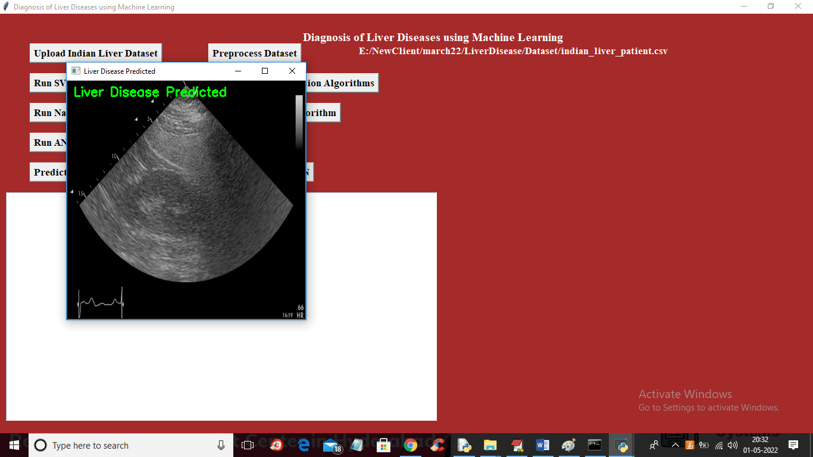

In above screen ANN predict liver disease in the image and similarly you can upload other image and test

