Project Report on “LED Matrix Display”

ENROLLMENT - 20103282, 20103290, 20103296

NAME OF STUDENTS – ARYAN DHAOR, NIKHIL AGRAWAL, YASH KAPOOR

NAME OF THE SUPERVISOR – DR. KAVITA PANDEY



CN-IOT PROJECT 2023

DEPARTMENT OF COMPUTER SCIENCE AND ENGINEERING JAYPEE INSTITUTE OF INFORMATION TECHNOLOGY

NOIDA, UTTAR PRADESH

**CERTIFICATE**

This is to certify that Aryan Dhaor (Roll No. 20103282), Nikhil Agrawal (Roll No. 20103290), Yash Kapoor (Roll No. 20103296) have successfully completed the project titled “ LED Matrix Display ” at Jaypee Institute of Information Technology under my supervision and guidance in the fulfilment of requirements of Sixth Semester, Bachelor of Technology (Computer Science & Engineering) of JIIT, Noida.

Dr. Kavita Pandey

# ACKNOWLEDGEMENT

We deem it a pleasure to acknowledge our sense of gratitude to our project guide Dr. Kavita Pandey, Dr. Potukuchi Raghu Vamsi and Dr. Deepika Varshney under whom we have carried out the project work. Her incisive and objective guidanceand timely advice encouraged us with constant flow of energy to continue the work.

We wish to reciprocate in full measure the kindness shown by Prof. Vikas Saxena (Professor & Head ( CSE & IT)) who inspired us with his valuable suggestions in successfully completing the project work.

Finally, we must say that no height is ever achieved without some sacrifices made at some end and it is here where we owe our special debt to our parents and our friends for showing their generous love and care throughout the entire period of time.

Date: 27.4.2023

Place: JIIT,Noida

# CONTENTS

1. Certificate
2. Acknowledgement
3. Abstract
4. Contents
   1. **INTRODUCTION**
   2. **MOTVATON**
   3. **METHODOLOGY**
   4. **TECHNOLOGIES USED**
   5. **CODE**
   6. **PICTURES**
   7. **CONCLUSION**
   8. **REFERENCES**

**INTRODUCTION**

In this project, we will learn about LED Matrix Displays and two different projects on Arduino 8×8 LED Matrix Interface. The project will be a simple interface between Arduino and 8X8 LED Matrix to display information (even scrolling information and images can be displayed). An LED matrix is a two dimensional array of LEDs that can be used to display symbols, characters or even images.

Based on the orientation of the LEDs in the matrix, there can be two types of LED matrices. They are Common Row Anode and Common Row Cathode. The aim of the project is to interface an Arduino Uno board with an 8 x 8 LED matrix to display information. Even though a single 8 x 8 LED matrix with corresponding MAX 7219 IC is used in this project, multiple LED matrices can be connected in series for long scrolling display.

**MOTIVATION**

It is needed to show the texts or images in public places for better visual understanding and better communication. For example in today’s world it is used in traffic lights, malls and shopping complexes, public transportation like buses & metro and in widely many more areas.

## METHODOLOGY

To make a project where we will be using different hardware components for displaying images and text on the matrix LED’s. We will be using LED matrix, Arduino UNO, Breadboard, some IC’s and wires. It will be a IOT project where we will be connecting all hardware components and then with the help of some simple program of Arduino UNO, we will be displaying graphics on the matrix

LED’s. 3 of the 14 available digital input / output pins are used to control the display driver IC MAX 7219. The 3 pins on the MAX7219 IC are clock, data in and load (or cs in case of MAX 7221 IC). A maximum clock frequency of 10MHz can be applied. DIN (Data in) accepts the serial data from the microcontroller or Arduino board. It is 16 bit long where the first 8 bits (D0 – D7) are for driving the columns (SEG A-G and DP of the MAX 7219 IC) of the LED matrix and the next 8 bits (D8 – D15) are for driving the (DIG 0-7 of the MAX 7219 IC) rows of the LED matrix. The load pin (or CS or chip select pin in case of Max 7221 IC) latches the serial input data on its rising edge.

Another important pin on MAX 7219 is the ISET, which sets the peak current to the segment to drive all the LEDs. It is connected via a resistor (R1), which is called RSET. The capacitors filters

out any noise in the supply. When the serial data in is sent using the Arduino (through the program), the serial data is converted into segments and digits to drive columns and rows of the LED matrix. According to the data sent, the corresponding LEDs on the matrix light up and display the message. The program written here is for scrolling text display. It might be difficult to view long scrolling data on a single 8 x 8 LED matrix. Hence, multiple LED matrices can be chained to form a long matrix. The no. of MAX 7219 ICs are equal to the no. of 8 x 8 LED matrices. In order to extend the display to multiple LED matrices, the Data OUT (DOUT) pin of the first MAX 7219 must be connected to the Data IN (DIN) pin of the second MAX 7219 IC. This process must be continued for multiple LED matrices.

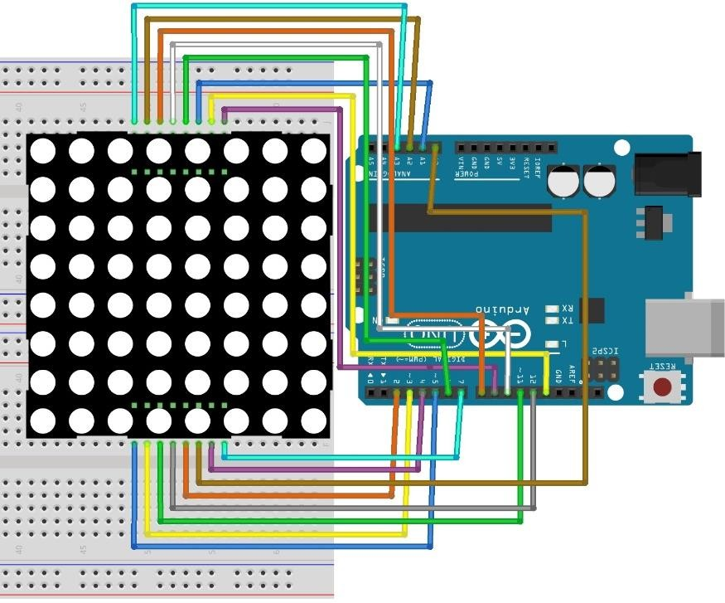

## TECHNOLOGIES USED

1. Arduino Uno board - The project is based on the Arduino Uno microcontroller board. Out of the 14 available digital input / output pins on the Arduino Uno, we need only three pins to implement this project.
2. LED Matrix – 8 x 8 LED dot matrix - An 8 x 8 LED matrix display is used in this project to display the information. LED matrices are available in different styles like single color, dual color, multi-color or RGB LED matrix.
3. IC1 – MAX 7219 - MAX 7219 is a common cathode display driver with serial input and parallel output. It is used to interface microprocessors and microcontrollers with 64 individual LEDs (8 x 8 LED matrix for example has 64 LEDs), seven segment LED displays up to 8 digits or bar graph

displays.

4. R1 – 10 KΩ

5. C1 – 0.1 μF

6. C2 – 10 μF

1. Arduino IDE

## CODE

#define ROW_1 2

#define ROW_2 3

#define ROW_3 4

#define ROW_4 5

#define ROW_5 6

#define ROW_6 7

#define ROW_7 8

#define ROW_8 9

#define COL_1 10

#define COL_2 11

#define COL_3 12

#define COL_4 13 #define COL_5 A0 #define COL_6 A1 #define COL_7 A2 #define COL_8 A3

const byte rows[] = {

ROW_1, ROW_2, ROW_3, ROW_4, ROW_5, ROW_6, ROW_7, ROW_8

};

const byte col[] = {

COL_1,COL_2, COL_3, COL_4, COL_5, COL_6, COL_7, COL_8

};

byte ALL[] = {B11111111,B11111111,B11111111,B11111111,B11111111,B11111111,B11111111,B11111111}; byte EX[] = {B00000000,B00010000,B00010000,B00010000,B00010000,B00000000,B00010000,B00000000}; byte A[] = { B00000000,B00111100,B01100110,B01100110,B01111110,B01100110,B01100110,B01100110}; byte B[] = {B01111000,B01001000,B01001000,B01110000,B01001000,B01000100,B01000100,B01111100}; byte C[] = {B00000000,B00011110,B00100000,B01000000,B01000000,B01000000,B00100000,B00011110}; byte D[] = {B00000000,B00111000,B00100100,B00100010,B00100010,B00100100,B00111000,B00000000}; byte E[] = {B00000000,B00111100,B00100000,B00111000,B00100000,B00100000,B00111100,B00000000}; byte F[] = {B00000000,B00111100,B00100000,B00111000,B00100000,B00100000,B00100000,B00000000}; byte G[] = {B00000000,B00111110,B00100000,B00100000,B00101110,B00100010,B00111110,B00000000}; byte H[] = {B00000000,B00100100,B00100100,B00111100,B00100100,B00100100,B00100100,B00000000}; byte I[] = {B00000000,B00111000,B00010000,B00010000,B00010000,B00010000,B00111000,B00000000}; byte J[] = {B00000000,B00011100,B00001000,B00001000,B00001000,B00101000,B00111000,B00000000};

byte K[] = {B00000000,B00100100,B00101000,B00110000,B00101000,B00100100,B00100100,B00000000}; byte L[] = {B00000000,B00100000,B00100000,B00100000,B00100000,B00100000,B00111100,B00000000}; byte M[] = {B00000000,B00000000,B01000100,B10101010,B10010010,B10000010,B10000010,B00000000}; byte N[] = {B00000000,B00100010,B00110010,B00101010,B00100110,B00100010,B00000000,B00000000}; byte O[] = {B00000000,B00111100,B01000010,B01000010,B01000010,B01000010,B00111100,B00000000}; byte P[] = {B00000000,B00111000,B00100100,B00100100,B00111000,B00100000,B00100000,B00000000}; byte Q[] = {B00000000,B00111100,B01000010,B01000010,B01000010,B01000110,B00111110,B00000001}; byte R[] = {B00000000,B00111000,B00100100,B00100100,B00111000,B00100100,B00100100,B00000000}; byte S[] = {B00000000,B00111100,B00100000,B00111100,B00000100,B00000100,B00111100,B00000000}; byte T[] = {B00000000,B01111100,B00010000,B00010000,B00010000,B00010000,B00010000,B00000000}; byte U[] = {B00000000,B01000010,B01000010,B01000010,B01000010,B00100100,B00011000,B00000000}; byte V[] = {B00000000,B00100010,B00100010,B00100010,B00010100,B00010100,B00001000,B00000000}; byte W[] = {B00000000,B10000010,B10010010,B01010100,B01010100,B00101000,B00000000,B00000000}; byte X[] = {B00000000,B01000010,B00100100,B00011000,B00011000,B00100100,B01000010,B00000000}; byte Y[] = {B00000000,B01000100,B00101000,B00010000,B00010000,B00010000,B00010000,B00000000}; byte Z[] = {B00000000,B00111100,B00000100,B00001000,B00010000,B00100000,B00111100,B00000000};

float timeCount = 0;

void setup()

{

Serial.begin(9600);

for (byte i = 2; i <= 13; i++) pinMode(i, OUTPUT);

pinMode(A0, OUTPUT); pinMode(A1, OUTPUT); pinMode(A2, OUTPUT); pinMode(A3, OUTPUT);

}

void loop() { delay(5); timeCount += 1;

if(timeCount < 100)

{

drawScreen(A);

}

else if (timeCount < 200)

{

drawScreen(N);

}

else if (timeCount < 300)

{

drawScreen(Y);

}

else if (timeCount < 400)

{

drawScreen(B);

}

else if (timeCount < 500)

{

drawScreen(I);

}

else if (timeCount < 600)

{

drawScreen(O);

}

else { timeCount = 0;

}

}

void drawScreen(byte buffer2[])

{

for (byte i = 0; i < 8; i++)

{

digitalWrite(rows[i], HIGH); for (byte a = 0; a < 8; a++)

{

digitalWrite(col[a], (buffer2[i] >> a) & 0x01); delayMicroseconds(100);

digitalWrite(col[a], 1);

}

digitalWrite(rows[i], LOW);

}

}

## PICTURES

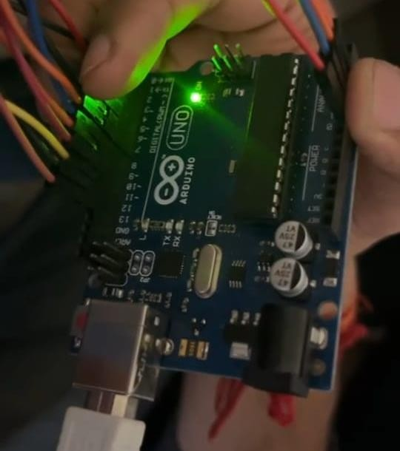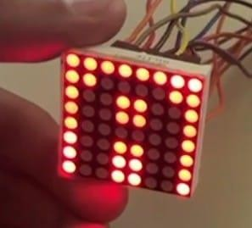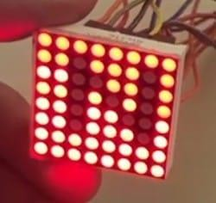

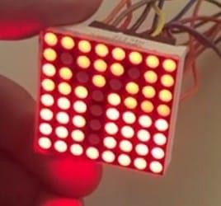 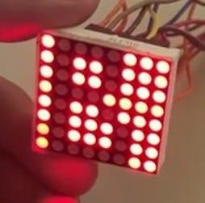 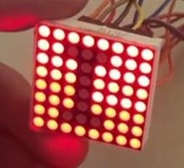 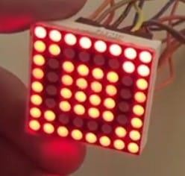

## CONCLUSION

It is a hardware based project which consist of Arduino and LED matrix which shows anything using Arduino code written on Arduino IDE.

## REFERENCES

* + <https://www.javatpoint.com/arduino-uno>
  + <https://en.wikipedia.org/wiki/Dot-matrix_display>
  + <https://www.maximintegrated.com/en/products/power/display-MAX7219.html>
  + <https://www.tinkercad.com/>