**PROJECT REPORT ON**

**“LAND REGISTRATION USING BLOCKCHAIN”**

**Enrollment - 20103282, 20103290, 20103296**

**Name of Students– Aryan Dhaor, Nikhil Agrawal, Yash Kapoor**

Jaypee Institute of Information Technology Logo


**December - 2022**

**Submitted in partial fulfillment of the Degree of**

**Bachelor of Technology**

**In**

**Computer Science Engineering**

**DEPARTMENT OF COMPUTER SCIENCE ENGINEERING & INFORMATION TECHNOLOGY**

**JAYPEE INSTITUTE OF INFORMATION TECHNOLOGY NOIDA,**

# **(I)**

# **TABLE OF Contents**

1. Contents ……………………………………………………………………………… 2
2. Declaration …………………………………………………………………………... 4
3. Certificate ……………………………………………………………………………. 5
4. Acknowledgement …………………………………………………………………… 6
5. Abstract ……………………………………………………………………………… 7
6. Keywords ……………………………………………………………………………. 8
7. List of Figures ……………………………………………………………………….. 9
8. List of Tables ……………………………………………………………………….. 10
9. **Introduction ………………………………………………………….. 11**

1.1 General Introduction ………………………………………………. 11

1.2 Specific Introduction ……………………………………………… 11

1.3 Problem Statement

1.4 Existing System ………………………………………………….... 12

1.5 Proposed System ………………………………………………….. 12

1.6 Need for Change ………………………………………………….. 13

1.7 Contribution of the Project ………………………………………... 14

1. **Related Work ………………………………………………………… 15**
   1. Discussion on Available Applications …………………………….. 15
   2. Merits and Limitations of Existing System ……………………….. 17
2. **Methodology of Work ……………………………………………….. 19**
   1. **Requirement Analysis …………………………………………… 19**
      1. Functional Requirements ………………………………….... 19
      2. Non-Functional Requirements ……………………………… 20
      3. Description Module …………………………………………. 20
   2. Design ……………………………………………………………... 21
   3. Languages and Libraries Used
   4. Coding
   5. Testing
3. **System Implementation**
   1. Deployment
   2. Working System
4. **Conclusion and Future Work**
5. **References**

## (II)

**DECLARATION**

We hereby declare that this submission is our own work and that, to the best of our knowledge and belief, it contains no material previously published or written by another person nor material which has been accepted for the award of any other degree or diploma of the university or other institute of higher learning, except where due acknowledgment has been made in the text.

Place: Signature:

Date: 03 December 2022 Name: Aryan Dhaor

Nikhil Agrawal

Yash Kapoor

Enrollment No: 20103282 (B10)

20103290 (B10)

20103296 (B10)

## (III)

## CERTIFICATE

This is to certify that the work titled “**Land Registration using Blockchain**” submitted by “**Aryan Dhaor, Nikhil Agrawal, Yash Kapoor**” in partial fulfillment for the award of degree of B.Tech. of Jaypee Institute of Information Technology, Noida has been carried out under my supervision. This work has not been submitted partially or wholly to any other University or Institute for the award of this or any other degree or diploma.

Signature of Supervisor ……………………...

Name of Supervisor Dr. P. Raghu Vamsi

Designation Assistant Professor (SENIOR GRADE)

Date 03 December 2022

# **(IV)**

# **ACKNOWLEDGEMENT**

We deem it a pleasure to acknowledge our sense of gratitude to our project guide Dr. P. Raghu Vamsi under whom we have carried out the project work. His incisive and objective guidance and timely advice encouraged us with constant flow of energy to continue the work.

We wish to reciprocate in full measure the kindness shown by Prof. Vikas Saxena (Professor & Head (CSE & IT) who inspired us with his valuable suggestions in successfully completing the project work.

Finally, we must say that no height is ever achieved without some sacrifices made at some end and it is here where we owe our special debt to our parents and our friends for showing their generous love and care throughout the entire period of time.

Signature of Supervisor ……………………...

Name of Supervisor Dr. P. Raghu Vamsi

Designation Assistant Professor (SENIOR GRADE)

Date 03 December 2022

# **(V)**

# **ABSTRACT**

## India has been facing challenges in land acquisition. The prime reason beneath is the rehabilitation of the people impacted with the development of industrial projects and also poor implementation of laws protecting land owners from external threats. This results in illegal land acquisitions and people losing their generational asset. Poor implementation of laws and non-transparency in the system causes various hindrances both for the community and governments.

## Land conflicts are a major cause of civil unrest in India. It poses a grave challenge to the authority of the State, on one hand and the democratic rights of citizens, on the other. It is important to provide the public with an entrusted system of land registration that does not allow tampering by external forces along with adequately addressing the issues raised by those impacted by the acquisition of land.

Blockchain land registration system allows user to sell and purchase the land from a web application. It is a simple process and is time and money efficient. The ledger of the land will be public and the buyer can see it by paying some amount of fees. No middlemen will be there and all the data will be verified by the land officer. The seller can sell the land easily without any interference. All the data will be decentralized so that there will be no loss of data. The platform will allow you to upload the title documentation to the blockchain network where signers can sign the document and other users can verify it when needed.

# **(VI)**

# **KEYWORDS**

## Land Administration: Land administration is the way in which the rules of land tenure are applied and made operational. Land administration, whether formal or informal, comprises an extensive range of systems and processes to administer.[1] The processes of land administration include the transfer of rights in land from one party to another through sale, lease, loan, gift and inheritance; the regulating of land and property development; the use and conservation of the land; the gathering of revenues from the land through sales, leasing, and taxation; and the resolving of conflicts concerning the ownership and the use of land.

1. Blockchain Technology: Blockchain is a shared, immutable ledger that facilitates the process of recording transactions and tracking assets in a business network. An asset can be tangible (a house, car, cash, land) or intangible (intellectual property, patents, copyrights, branding). Virtually anything of value can be tracked and traded on a blockchain network, reducing risk and cutting costs for all involved.
2. Security: Blockchain technology produces a structure of data with inherent security qualities. It's based on principles of cryptography, decentralization and consensus, which ensure trust in transactions. In most blockchains or distributed ledger technologies (DLT), the data is structured into blocks and each block contains a transaction or bundle of transactions. Each new block connects to all the blocks before it in a cryptographic chain in such a way that it's nearly impossible to tamper with. All transactions within the blocks are validated and agreed upon by a consensus mechanism, ensuring that each transaction is true and correct.
3. Proof of Work: Proof of work (PoW) describes a system that requires a not-insignificant but feasible amount of effort in order to deter frivolous or malicious uses of computing power, such as sending spam emails or launching denial of service attacks. The concept was subsequently adapted to securing digital money by Hal Finney in 2004 through the idea of "reusable proof of work" using the SHA-256 hashing algorithm.
4. Registry: When a property is transferred from one person to another, this transaction must be formalised through registration at sub-registrar’s office after payment of certain dues like stamp duty. This process is known as registry of property.
5. Smart Contracts: Smart contracts are simply programs stored on a blockchain that run when predetermined conditions are met. They typically are used to automate the execution of an agreement so that all participants can be immediately certain of the outcome, without any intermediary’s involvement or time loss. They can also automate a workflow, triggering the next action when conditions are met.
6. Authentication: Blockchain authentication refers to the system developed for increasing the security of the users and verifying user identity and allows users to connect to the resources found on technologies of digital currency, transactions, cryptocurrencies, etc.
7. Distributed Ledger: A distributed ledger is a database that is consensually shared and synchronized across multiple sites, institutions, or geographies, accessible by multiple people. It allows transactions to have public "witnesses." The participant at each node of the network can access the recordings shared across that network and can own an identical copy of it. Any changes or additions made to the ledger are reflected and copied to all participants in a matter of seconds or minutes.

# **(VIi)**

# **LIST OF FIGURES**

|  |  |  |
| --- | --- | --- |
| Figure No. | Details | Page No. |
| I | Use Case Diagram | 22 |
| II | Class Diagram | 23 |
| III | Add User Contract | 24 |
| IV | Add Registrar Contract | 24 |
| V | Registration Contract | 25 |
| VI | Request to Land Owner Contract | 25 |
| VII | Process Request Contract | 25 |
| VIII | Govt. Status Contract | 26 |
| IX | Buy Property Contract | 26 |
| X | Index Page HTML | 27 |
| XI | Home Page HTML | 27 |
| XII | User Details HTML | 28 |
| XIII | Remix IDE Contract | 30 |
| XIV | Index Webpage | 31 |
| XV | Home Webpage | 32 |
| XVI | User Details Webpage | 32 |

# **(VIII)**

# **LIST OF TABLES**

|  |  |  |
| --- | --- | --- |
| Table No. | Details | Page No. |
| I | Registrar Module Test Cases | 28 |
| II | Exceptional Test Cases | 28 |

# **CHAPTER I**

# Introduction

General Introduction

What is Blockchain?

Blockchain is a shared ledger which is immutable and facilitates the process of recording transactions and tracking assets in a business network. An asset can be both tangible (a house, car, cash, land) or intangible (intellectual property, patents, copyrights, branding). On a blockchain network anything valuable can be tracked or traded virtually, reducing risk and cutting costs for all involved.

Importance of Blockchain

Today we live in the world which runs on information. It becomes more accurate and better as faster it receives. Blockchain is safe place for delivering the information because it provides immediate, shared and completely transparent information stored on an immutable ledger which can only be accessed by permissioned network members.

Use of Blockchain in Land Registration System

In this report, we will see the feasibility of blockchain technology in the documentation of land registration to enable the empowerment of different land users who participate in informal land markets. There is little discussion or evidence of the application of blockchain in addressing individual to individual relationships to land while the blockchain land administration projects focus on the state to individual relationship to land through the preservation of transferring of rights/ownership. The question arises as to how this emerging technology can be applied to verbal land agreements/handshake deals to protect livelihoods, while maintaining transparency, openness, confidentiality, and protection of both land users and land owners.

Specific Introduction

Land Registration using Blockchain is a project in which the user can buy or sell his/her land in a digitized way without any fraud, corruption, tampering and also time saving. Here the user registers and take the role as a buyer or seller. After that the seller registers his/her land along with the land value and proofs by paying some fees to government which can only be verified by registrar of that area who is appointed by government. The buyer can see various lands by paying some processing fees and then can apply for the purchase. With the whole idea of inspection and analysis regarding the traditional way and considering that Blockchain has an increased transparency and integrity maintenance along with the transportability factor, we put forward a blockchain based land registration system which provides a transparent, secured and decentralised method for execution of transactions between the users by employing the concept of distributed ledger.

Problem Statement

The current system of land registration is a centrally managed database and provides the list of services that allow to connect via web interface. Despite the modernization by the government and doing e-Governance there are lot of flaws like corruption, transparency and many more. So, it is questionable to government as they manage all this and there is need to increase the security and transparency of all this. All this can be achieved by the block chain. Propose a blockchain based web application which allows the user to buy and sell land with the proper use of time and money. This application should be secured, efficient and transparent.

Existing System

Currently, in India when person wants to buy a land, he/she has to contact to a broker who shows various lands in a area where buyer wants to purchase the land. When buyer likes any land and he/she wants to buy than the broker establishes the connection between buyer and seller. There are many issues with it such as commission, frauds, time consuming and many more. India is classified as deed registration country. Under the Registration Act 1908 land registration is compulsory in the case of most of the transactions, but many transactions like compromise verdict, grants by government, instrument of partition etc. are exempted from compulsory registration. Therefore, all the transactions, creating rights in land, are recorded in the registry department. Further, there is no record of land transfer by inheritance in the registry department. Therefore, though India is defined as action registration country, it actually has two sub-systems of maintaining records of ownership. Unfortunately, both sub-systems are working independently without utilizing the synergy between each other. The main problems in the present land registration system in India are poorly updated land records, especially in urban areas, heavy litigation, difficulty in assessing the hindrance on land at the time of purchase and an unproductive delivery system.

Proposed System

Our system (unlike the traditional system), provides security, transparency, openness and confidentiality of both land users and land owners. The account of user contains all the necessary information which is needed to verify the integrity of the buyer or the seller. Also, the necessary land information is provided to interested buyers. This information is verified as the seller when registers his/her land on our website, has to upload official land document which are verified by government authority. All of the legal processes are done by the approval of the government as the government authority audits the user's land details and has the right to approve or decline their application. When a buyer is interested in purchasing a land, the land owner will receive the request and they are allowed to accept/decline by verifying the requester’s details. The requester also has to pay a small fee for the request sent to the government regarding the purchasing of land.

If both, the land owner and the government authority accept the respective requests, buyer can now make transaction and the ownership of previous land will be removed and the amount get transferred to the land owner. If rejected, then land will again be available to the users. There is no intermediary in the transaction process.

Once the ownership is updated, a certificate is automatically generated containing the new owner’s details and the land details. This certificated is verified by the government authority and then deployed in the Blockchain as a legitimate proof of ownership.

Need for Change

Development of new technologies and Digitalization is the strongest force of change in the society. In the traditional system, if a user loses its original physical documents which acts as concrete proof of the ownership or if documents get damaged or altered then it is very difficult to navigate all the details in regards with the assets. Today at this time it takes a huge amount of time for verification of owner, land papers manually which in turn slows down the authentic transactions. Another alarming concern is that of fraudulent activities including hampering, bribery, forgery or alteration carried out by broker agents in the process which results in lack of security. There are chances of losing or tampering of the agreements as anyone with certain powers can access or alter the papers easily which in turn threatens this concrete proof of land. Thus, this type of system as compared to our proposed system in which we make use of a smart contract to deal with the assets and transactions among the participants, is very much time consuming, less secure and unsynchronized where activities including corruption and fraudulence might be associated during the execution of the required process.

Contribution of the Project

This project helps in developing a safe and secure land registration method using blockchain where every action is done under supervision of government. This project aims on rectifying the limitations of traditional land registration system by making a secured smart contract. It shows that with the help of fourth internet revolution we can change the existing land registration system. It also contributes in making a secure website where land registration can be done under guidance of Government (DM) and Registrar.

# **CHAPTER II**

RELATED WORK

Discussion on Available Applications

* 1. <https://www.mdpi.com/2073-445X/9/12/491/htm>

This paper aimed to identify the essential elements and relations between the blockchain technology and transparency of land administration in the existing literature, and to assess the potential of blockchain to improve the transparency of land administration processes—based on the context from Ghana. These aims were achieved through a comprehensive review of all the land administration processes in Ghana, the inherent transparency issues in them, and the possibility of blockchain to support and enhance transparency in these processes simultaneously. The paper argued and demonstrated that the completeness of land administration transparency is when transparency is achieved across all land administration processes, and stakeholders simultaneously. A single permissionless public blockchain can help achieve this. However, there is the need for the different land divisions to establish standardization in the land administration processes prior to the blockchain’s application in such a compressive approach. This is because, where there is no such standardization, there is a high possibility of inconsistencies and irregularities in the processes across the different divisions which can affect the efficient working of the blockchain system across all the divisions.

This study is relevant for all land stakeholders, as it provides a better understanding, and an interpretive approach to the social and political realities of land administration in Ghana. It has also extended the discourse on the topic and offers a quick and easy reference guide for scholars, practitioners, and policy makers as hitherto, land administration processes and transparency issues in Ghana have been discussed individually, in piecemeal and scattered across different works, which hindered a better appreciation of the topic due to the polarization and different epistemological views.

* 1. <https://ieeexplore.ieee.org/abstract/document/9642505>

Due to the immutability and high security features offered by blockchain technology, it is extremely beneficial in the Land Registration sector. It also eliminates intermediaries involved in the land registry operation. The irreversible nature of blockchain is attracting governments worldwide to adopt this technology throughout the land registration system. Every year, an enormous number of fraud and bribery cases arise in the land registry process in Bangladesh, which also takes a very long period to solve. The adoption of Blockchain technology for land registry would significantly reduce fraudulent transactions. Besides, it is also capable of increasing transparency over ownership and valuation as well. In this paper, we proposed a secure, smooth and easy-to-use platform to facilitate land registration of Bangladesh. We are confident that our proposed system is going to revolutionize the traditional land registration process of Bangladesh by eradicating numerous flaws at the same time.

* 1. <https://link.springer.com/article/10.1007/s11277-021-08833-1>

The Block Chaining land registry solves the hassle of untitled land; maintains a record of a particular land. It's far going to revolutionize the modern-day system to eradicate numerous flaws at the same time. Block chaining is mainly based on the system that provides property owners with a land title guaranteed by the government to use time and money properly. While storing reports of land digitally by indulging this concept, the office work registration can be decreased. The block chaining-base26d land registry method assumes that a land or assets identity is available in a trusted way in a community. We have proposed an architecture wherein the chain could be used to secure land record data. In this model, we have considered the registration document, the dealer (seller), customer (buyer), financial institution, i.e., Bank record, and the whole system in a tangible way inside the network system for the authentication. And subsequently, the device continues the correct record of land save from fraud and duplication.

* 1. <https://www.sciencedirect.com/science/article/abs/pii/S0268401219303329>

This paper explores the usage of Blockchain Technology for Land Records Management in India. It highlights issues, such as minimal transparency, accountability, incoherent data sets with different Government Departments pertaining to the same piece of land and delays in the current Land Records management process and how to overcome these problems using Blockchain Technology. The paper describes the current process of land records maintenance and land registration in the country, and discusses various challenges encountered during the implementation of Blockchain Technology like public key infrastructure and Internet, privacy rules and security issues. Finally, the paper illustrates a system design using Blockchain Technology for the implementation of Land Titling system in the country, so that land titles are tamper-proof, and provides authentic and conclusive rights on ownership.

* 1. <http://xajzkjdx.cn/gallery/355-april2020.pdf>

Land registry in India as well as in many parts of the world is very slow and cumbersome process. There are also many intermediaries involved in the process of land registration. Developing a system that not only accelerate the process of land registration, but also make it easier for Buyers, Sellers and Government registrars to transfer the land ownership from seller to a new buyer, is only possible by creating a distributed system that store all the transactions made during the process of land buying. In this paper we’ll try to explore the possibilities and problems solved by using a blockchain based system for land ownership transfer. The system that we are trying to implement is based on Ethereum Blockchain that will store all the transactions made during the process of land ownership transfer. Using the concept of smart contracts of blockchain technology we can triggers various events like access of land documents to a land inspector and fund transfer event from buyer to seller after successful verification of the land ownership transfer. This system will solve the problems faced by all the three parties during the land registration and will also remove the intermediaries like property dealers. This system makes the process of land registration resilient and decrease the cases of fraud in the process. Using the system, validation of the lands is also possible as immutable transactions are being stored in the public ledger.

Merits and Limitations of Existing System

Merits of Existing System

In the traditional land registration system of India, if anyone wants to buy or sell the land, he/she has to contact a middlemen or broker. The broker establishes the link between the buyer and seller. All the documents with regards to an agreement as a proof of property will be created and assembled by the broker on behalf of buyer and seller. Broker will assure that all the land/property will be registered by an authorized government office where all the things are noted in the ledger and then the whole transaction takes place between them and the broker takes the money form of commission from them

Limitations of Existing System

MIDDLEMEN

When anyone wants to purchase the land, they are sometimes get harassed by these brokers. It is necessary to buy the land with the help of legal practitioners who have knowledge and can give right advice.

CENTRALIZATION

The land registry system involves a massive amount of registration documents to be stored on central databases that facilitate the transaction for the trading of land title.

TIME CONSUMING

The process to get the possession of land is very time consuming as all the data are paper based

SCAMS AND FAILURES

In the current system it is very difficult to detect frauds and scams as they are all paper work. Currently all data is centralized, so it is single point of failure and the possibility of data change is more.

NON-TRANSPARENT

Most of the procedure in the system is not transparent as they are poorly secured and the property can be sold multiple times. As the thousands of records are preserved it is difficult to find the actual owner of property.

# **CHAPTER III**

# METHODOLOGY OF WORK

REQUIREMENTS ANALYSIS

FUNCTIONAL REQUIREMENTS

**The Government Module**

* The District Magistrate and the registrar should be able to login to their respective accounts.
* The registrar should be able to view all of the user accounts and user details.
* The registrar should also be able to view, deny and accept the user’s requests regarding the approval of buying and selling land.
* The registrar should be able to verify the user details and check whether the registration fees has been paid by the user.
* The District Magistrate should be able to kill the smart contracts at will.
* The District Magistrate will appoint the registrar for a particular region for a specific amount of time.

**The User Module**

* The user should be able to register after filling in the required details.
* The user should be able to login to his/her after registration is complete.
* The option of whether to ‘BUY’ or ‘SELL’ should be displayed to the user after registering.
* The user should be able to upload all the legal documents required for verification of the buyer or seller.
* The user should be provided with the payment facility for the payment of registration fees to the registrar and the land price to the seller.
* The seller should be able to send request for the registrar’s approval of the land’s authenticity after all the necessary documentation is completed.
* A direct way of communication is to be provided between the buyer and seller.

NON-FUNCTIONAL REQUIREMENTS

The application should have the non-functional requirements:

* Make a friendly user interface.
* Display appropriate success and error messages on the user interface itself.
* Validate all the input fields sof all the forms.
* Blocks should be created successfully and securely.
* Payment should be done at right address.
* Payment should be done securely.
* All the process should be done quickly.
* Many users can easily access the lands.
* There should not be inconsistency while buying the land.
* All the details which are necessary should only be shown to user.
* Only government should easily log-in and access the government credentials.

DESCRIPTION MODULES

* Buyer should be able to login to the application
* Registrar should be able to view all buyers and sellers and assigned land and status
* Registrar should be able to remove the land assigned to the buyer and assign it to a different buyer at any time
* Buyer should be able to request status of land
* User should be able to download the record of the land
* Seller should be able to login to the application
* User should be able to update the land details
* Registrar should be able to download land records
* DM will intitalise the smart contract

DESIGN

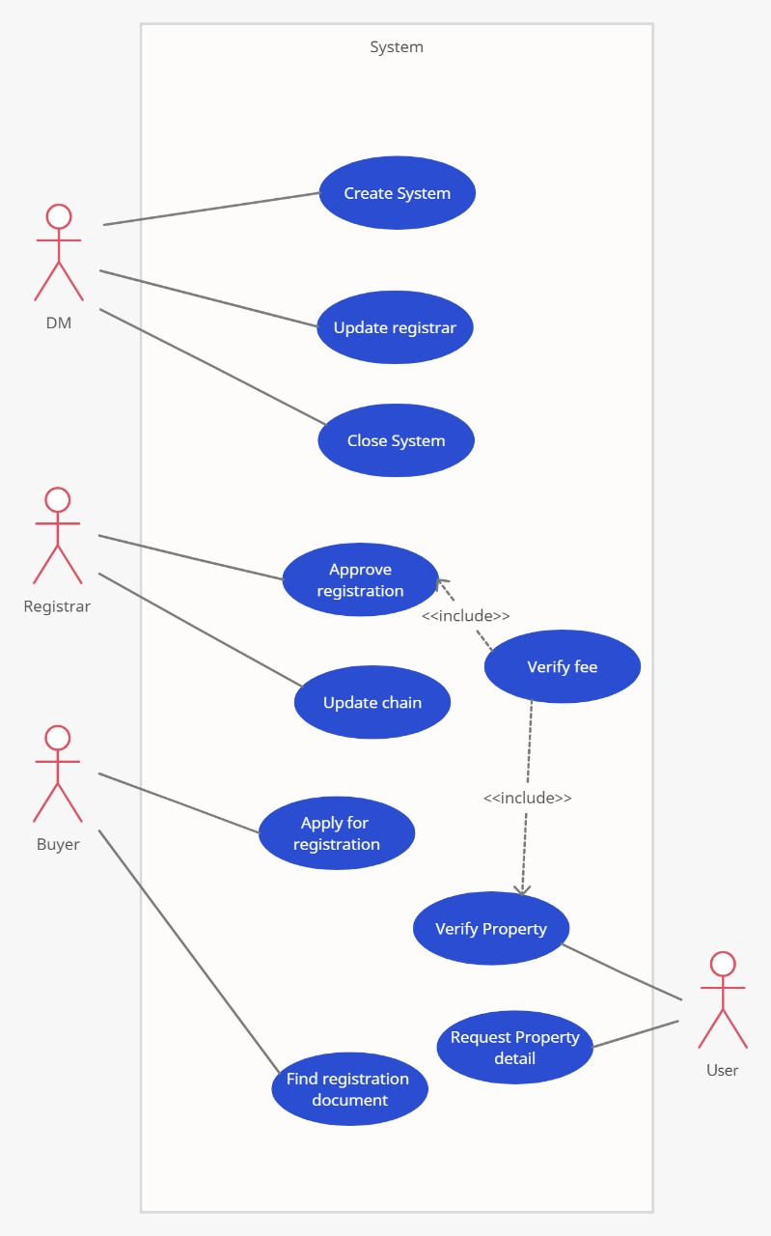

(I)

**Use Case Diagram**

**DM**

* Creates System
* Update Registrar
* Kills the System

**Registrar**

* Approves Registration of user
* Deploys the certificate of ownership in blockchain
* Verifies the registration fee paid by user
* Verifies the legal documents of the land that the user wishes to upload on the website to sell.

**Buyer**

* Applies for registration
* Checks the legal land documents and seller’s details before buying

**User**

* Requests property details
* Verifies property.

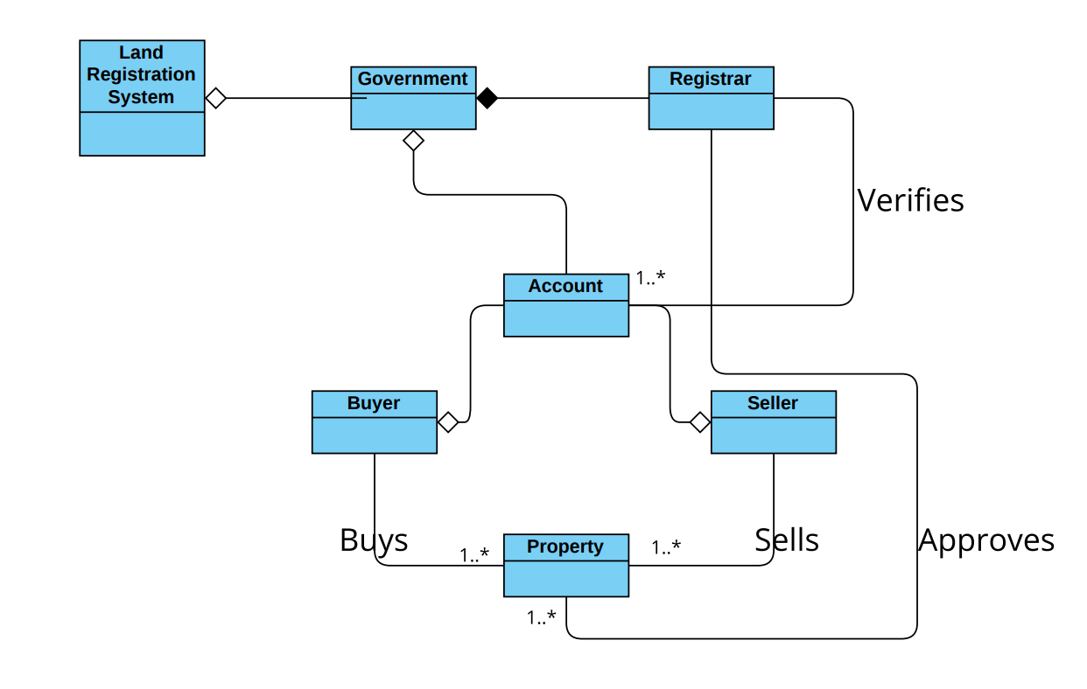

**(II)**

**Class Diagram**

Land Registration is run by a government.

Government appoints many registrars in different cities.

Registrar of that city verifies and approves both account and property.

Buyer purchases a land and seller sells a land.

After completion of everything buyer transfer funds to government and then it is transferred to buyer.

**Sequence Diagram**

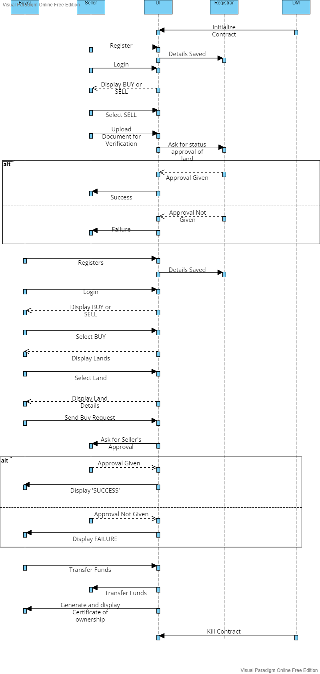

LANGUAGES AND LIBRARIES USED

1. Web2
   * HTML
   * CSS
   * Javascript
   * Web
   * Cdnjs – Font awesome libraries
2. Web3
   * Solidity

CODING

1. Add User

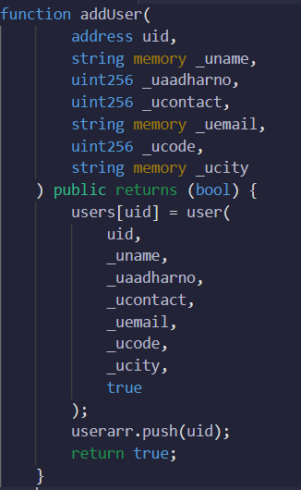’

(III)

This public module takes input from user and helps to add the user to database and returns the entered details.

1. Add Registrar



(IV)

This private module takes the address and city of registrar and add the registrar to that particular city. It can be done only by government.

1. Registration

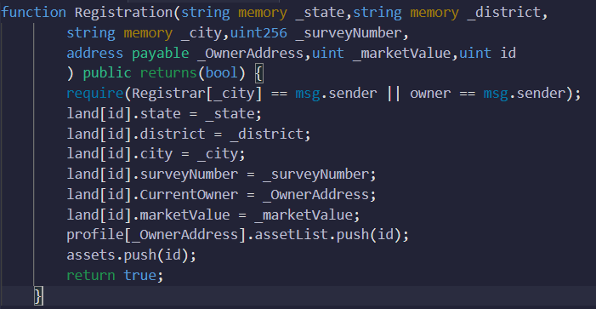

(V)

This private module will take the details of land and user and then checks if the registrar of that city and owner approves it than it will register the land in the name of user.

1. Request to Land Owner

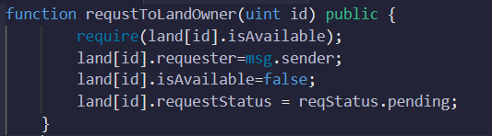

(VI)

This module will take id as input and if the land is available than it will request the owner for the land.

1. Process Request

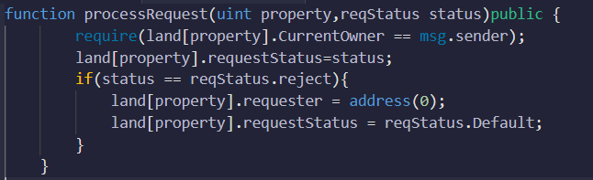

(VII)

This will take the property as input and if the request will be rejected than it will remove the request from the buyer and make the land available.

1. Govt Status

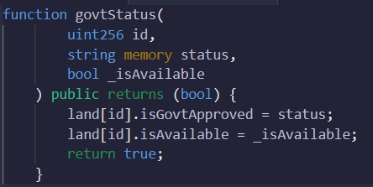

(VIII)

This will take the land id, status of that land and status if it is available or not and will return true if accepted else will not.

1. Buy Property

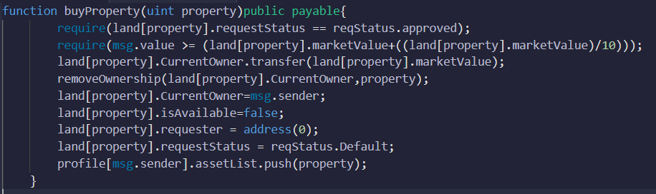

(IX)

This is a payable module which takes the input as property and if all the things done well than it will transact the money and the land will be registered to user.

1. Index Page

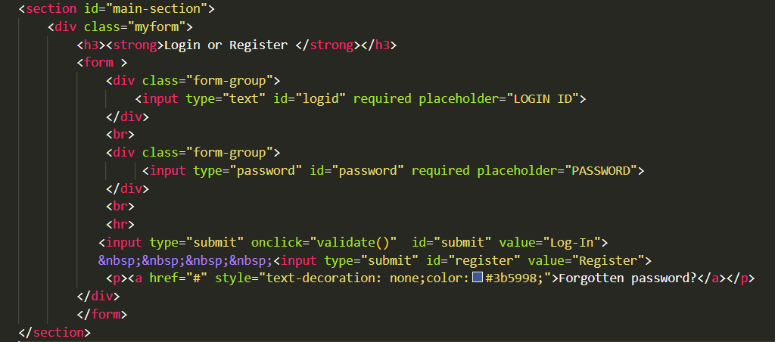

(X)

This html page will take user id and password as input and will help the user to register or login. If the user wants to login than the user id and password will be validated and then the user will get log in.

1. Home Page

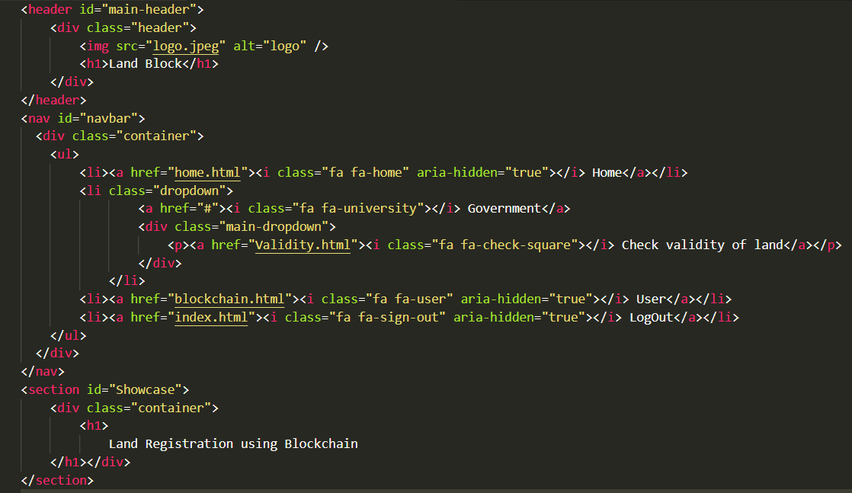

(XI)

This will be the homepage of our webpage after login, where user can see the description and can choose different options from the navigation bar like Home, Government login, User details and Logout.

1. User Details

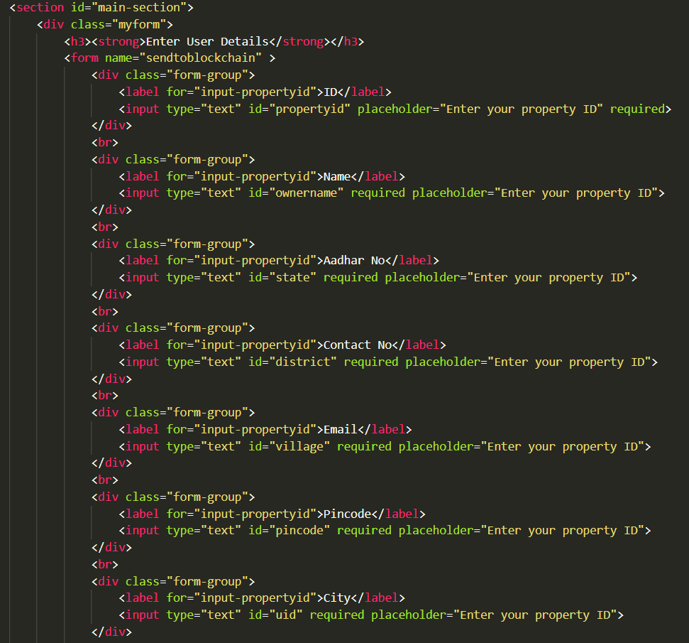

(XII)

This webpage will be opened from home page and fill display the form where the user will submit all the details required for the identity.

TESTING

|  |  |  |  |
| --- | --- | --- | --- |
| Test Case ID | Input | Output | Status |
| 1 | Invalid username and password | Throws an error | Pass |
| 2 | Invalid username format | Throws an error | Pass |
| 3 | Invalid inputs entered in land registration details | Throws an error | Pass |
| 4 | Invalid dates entered in updating land details | Throws an error | Pass |
| 5 | Incorrect details | Directed to homepage | Pass |
| 6 | Whole Application in single page applications | No error | Pass |
| 7 | Unable to save data to backend | Throws an error | Pass |

# Registrar Module Test Cases

# (I)

|  |  |  |
| --- | --- | --- |
| S.NO | TEST CASE | sOLUTION |
| 1 | INVALID EMAIL ID AND PASSWORD ENTERED BY USER | SHOW APPROPRIATE SUCCESS AND ERROR MESSAGES |
| 2 | SERVER NOT WORKING | SHOW APPROPRIATE EROOR MESSAGE |
| 3 | Testing all components | If any components throw an error |
| 4 | Any unknown url hit by user | SHOw status 404 on the browser |

# Exceptional Test Cases

# (II)

# **CHAPTER IV**

# SYSTEM IMPLEMENTATION

DEPLOYMENT

All the contracts are deployed on remix ide which provides all the necessary environment for a contract to be deployed. When a contract is deployed on remix it makes a function buttons which will be used in the project. The function buttons are add user project which adds user to the database, add registrar button which will be exclusively used by government to add registrar to a city, registration and buy property button which will take all the necessary inputs and will register land to the user and helps to do the transaction and many more. These will be connected to the project and will be deployed on the test networks and will be deployed using truffle.

The frontend part starts with taking the user id and password as input and helps in login or register. Than after loggging in i twill show various options in navigation bar for both user and government. The user can than fill the details for buying or selling and government can login and approve and verify for the land and the transaction. All the frontend is currently done using HTML, CSS, JS and deployed on local network.

WORKING SYSTEM

1. Contracts

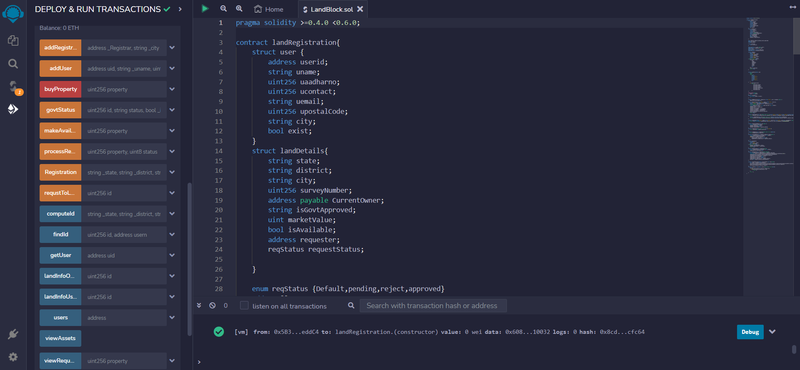

(XIII)

Contracts are the integral part of the Decentralized Web App. We have made a contract for the land registration which contains various structures and functions which are explained in the code section. It is a software stored on the blockchain network which executes on agreement. The functions written in this contract helps to store the data in the blockchain just like standard database and also helps to access the data. These are just like functions in any coding language but are stored in any blockchain network. These functions helps to add users, approve land, get registration, get assets details, get land details, get user details, helps to transfer fund and many more. The above contract is written in remix ide, from Remix IDE we were able to write, compile, test, and deploy your Solidity smart contracts pushing a button. In left side there are buttons for variables and functions. Orange buttons represents private functions/variables which are not visible to public. Red buttons are payable functions/variables which are used to transfer funds. Blue buttons are public functions/variables which are visible to public. Next this contract will be deployed and will be linked to project.

1. Index Page

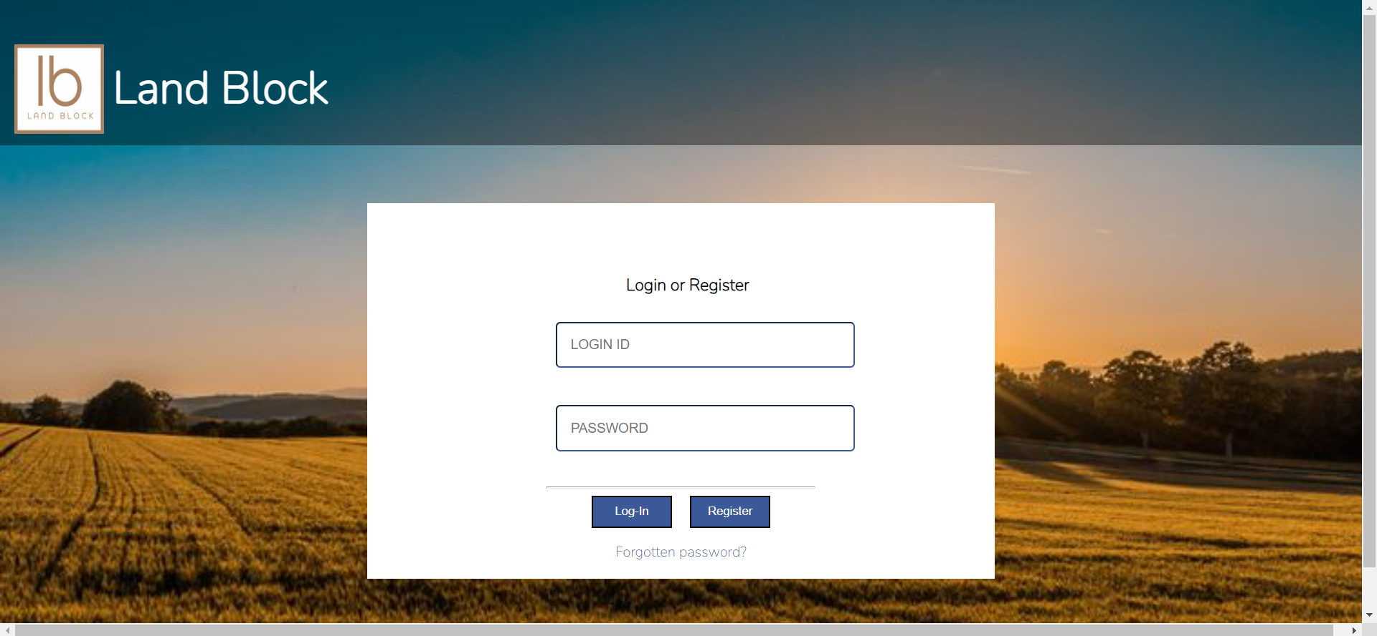

(XIV)

This is the index page of the project. Here the user will enter the login id and password for login or register. If the user will login than the credentials will be checked and if right than user will be logged in else they will get error. If the user will register than there credentials will be stored in database in future.

1. Home Page

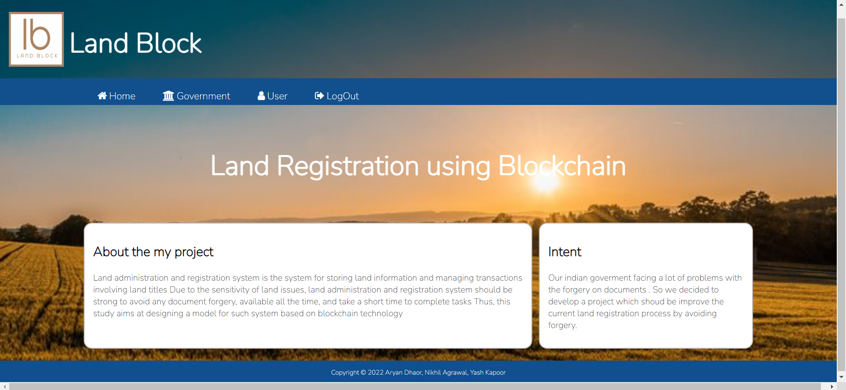

(XV)

After logging in the user will be landed to home page which has navigation bar and description of this project. In navigation bar there are currently 4 options which are Home which get user to home page, Government which will include the login and validity of land for government, User which include the form for user details to be registered and at last Logout which will return user to index page.

1. User Details Page

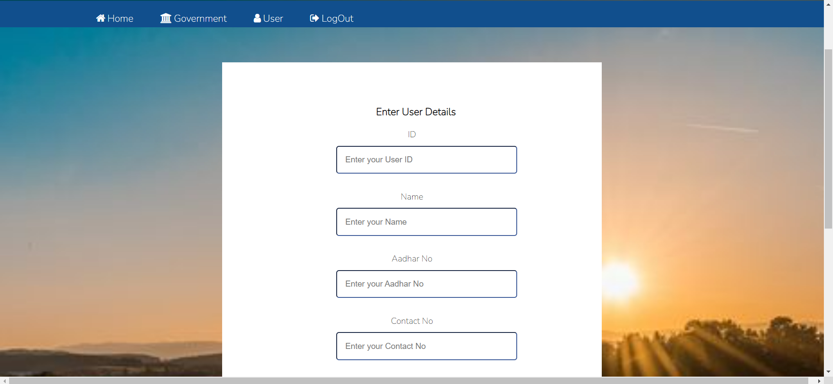

(XVI)

This page opens when the user clicks on the user on home page. After opening the user can enter details for storing required information in database. In future there will be option for buy/sell.

DEPLOYED LINK

# **CHAPTER V**

# CONCLUSION AND FUTUTRE WORK

This project aims on rectifying the limitations of traditional land registration system by making secured smart contracts. It shows that with the help of fourth internet revolution we can change the existing land registration system. This project helped in developing a safe and secure land registration method using blockchain where every action is done under supervision of government. This project aims on rectifying the limitations of traditional land registration system by making a secured smart contract. This project proposed system in which we make use of a smart contract to deal with the assets and transactions among the participants, is very much time consuming, less secure and unsynchronized where activities including corruption and fraudulence might be associated during the execution of the required process.

# **CHAPTER VI**

# REFERENCES