**SIMPLE CHOCOLATE CAKE**

Ingredients

* Warm Milk (1½ cups)
* White Flour (1½ cups)
* Butter (¾ cup)
* Powdered Sugar (1 tablespoon)
* Baking Powder (1 tablespoon)
* Baking Soda (1½ tablespoon)
* Cocoa powder (¼ cup)
* Pinch of Salt

The procedure

1. 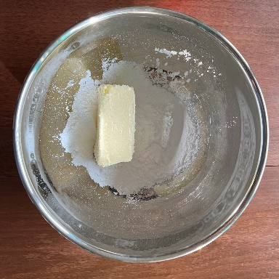Firstly, put butter and powdered sugar in a big enough bowl and beat it till the mixture turns smooth and fluffy.

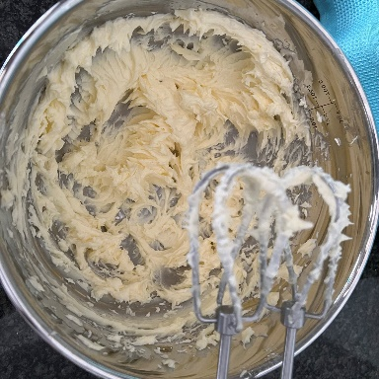

1. Then add the buttermilk and combine it well.

1. 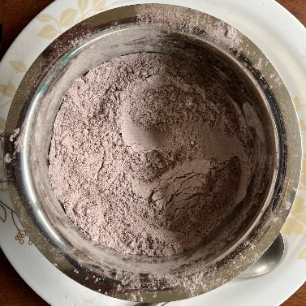Now sieve white flour, cocoa powder, baking powder, baking soda and a pinch of salt.
2. 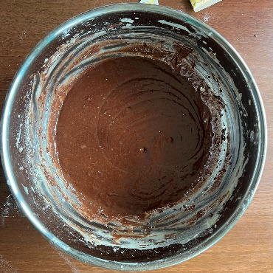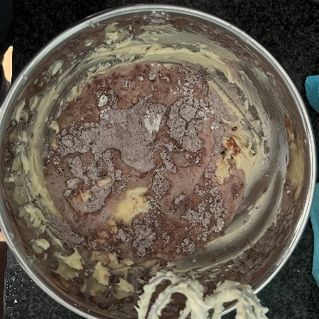Then mix it all together (step 3 and milk) till a smooth consistent batter is formed.
3. 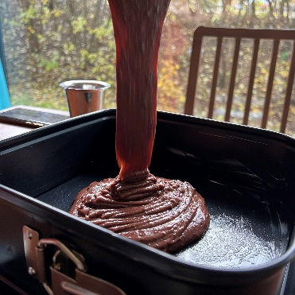Pour the batter into a mould.
4. 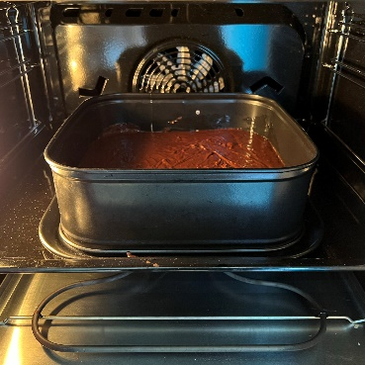Finnaly heat the cake at 220 degrees in the oven.

Thank You