T13Hide Meeting Minutes

|  |  |  |
| --- | --- | --- |
| **Location:** Online Meeting | **Date:** 2022-01-13 | 8:30-10:30 am |

|  |  |
| --- | --- |
| **Present** | Russell Robertson, Nikhil Arora, Samuel Reed, Melissa Fruci, Elijah Cook, Jason Adams |
| **Regrets** |  |
| **Absent** |  |

# Agenda

Team charter

Draft questions for client meeting Friday

Discuss anyone’s initial ideas on projects, knowns and unknowns on where we can get started

## Report on Open Action Items

* No open action items to report on as it is the first meeting.

## Current Business

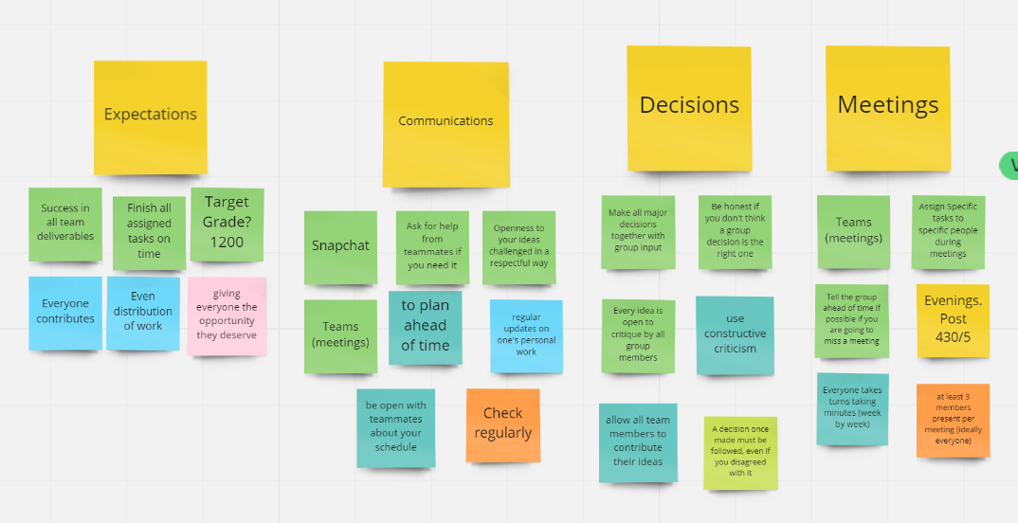

Team charter complete, focus on open communication, teamwork, and inclusion.

Snapchat group chat was previously made, do not need additional contact info.

Drafted and edited 12 good open-ended questions for the client meeting. Can access question list in team files as “Client Meeting Questions.”

Focused on clarifying details of example habitats and if this client desires these same qualities, how wildlife will react and interact with different materials we may use.

## Next Scheduled Meeting

* Friday 4:30 online, Jason is the chair, Samuel is the lead speaker for client meeting

# Action Items

|  |  |  |  |  |
| --- | --- | --- | --- | --- |
| **Action Item** | **Responsible** | **Assigned** | **Due** | **Status (date complete)** |
| Brainstorm Research Questions for individual research (Not Client) | Everyone | Jan 13, 2022 | Jan 20, 2022 | Incomplete |
| Prepare Team Charter as Word Doc instead of Stickies | Elijah | Jan 13, 2022 | Jan 17, 2022 | Incomplete |
|  |  |  |  |  |

*Note: Entries should stay in the table until completed. Copy incomplete action items from the previous Minutes.*