EasyAI User Manual

Overview
EasyAI is a Windows desktop application that gives you a simple, plain-language front end for ComfyUI — the node-based engine that powers many local Stable-Diffusion-style AI tools. Instead of building node graphs, you pick a “style” (a pre-built workflow), type a description of what you want, choose a shape, and press Create. EasyAI handles talking to ComfyUI, shows you a live preview while your image or video is being generated, and saves the finished result for you.
EasyAI is built for people who want to use AI image, video, and prompt-writing tools without learning ComfyUI’s node editor — hobbyists, artists, and anyone who has a ComfyUI installation (or is willing to install one) and wants a friendlier way to drive it. It has three main tabs — Image, Video, and Prompt Helper — each built around the same “pick a style, describe it, choose a shape, press Create” idea.
EasyAI does not include ComfyUI itself. You either point EasyAI at a ComfyUI installation you already have, or use the separate EasyAI Setup tool (covered near the end of this manual) to download and install one.

Installation & Requirements
Operating system: EasyAI is built and tested for Windows. (Some non-Windows code paths exist in the app, but the documented, supported way to install and launch EasyAI is on Windows.)
Python: version 3.10 or newer. The launcher checks this on startup and will show an on-screen message and refuse to continue if your Python is too old.
Python packages (installed automatically the first time you run EasyAI — see below): PySide6, requests, websocket-client, Pillow.
A working ComfyUI installation. EasyAI is a front end for ComfyUI, not a replacement for it — it needs a ComfyUI folder to point at. If you don’t already have one, run the separate EasyAI Setup program described in EasyAI Setup (companion installer) to download and install one.
Graphics hardware: image and video generation is GPU-intensive, and EasyAI shows VRAM warnings as you increase detail/length, but the project does not state an official minimum GPU, VRAM amount, or whether CPU-only use is supported.

Installing EasyAI
- Install Python 3.10 or newer. When the Python installer asks, tick “Add python.exe to PATH.”
- Get a copy of the EasyAI folder (from wherever you obtained it) onto your computer.
- Start EasyAI by double-clicking the EasyAI shortcut, or by running python EasyAI.py from a command prompt in the EasyAI folder.
- The first time you launch it, EasyAI notices that its required packages aren’t installed yet and installs them for you automatically. A console window appears briefly for this one-time step; after that, EasyAI always opens without a console window in the background.

First-Run Setup
The very first time you open EasyAI (before you have ever used it), the app does two things automatically, in order:
- Shows a one-time welcome message telling you it has guessed where your ComfyUI installation lives.
- Opens the Settings window automatically so you can check — and if needed, correct — that guess before you try to create anything.
You only see this automatic flow once. After that, you can always reach Settings yourself from File → Settings….
See First-run Welcome and Settings below for what each of these screens looks like and what to do on them.

Feature Walkthrough

First-run Welcome
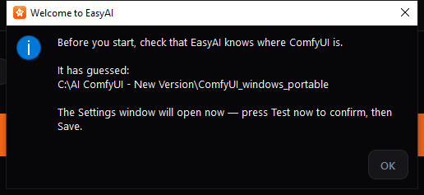
This message box appears only once, the very first time you open EasyAI. It tells you that EasyAI has made a guess at where ComfyUI is installed on your computer, and that the Settings window is about to open so you can confirm or correct that guess.
What to do:
- Read the guessed folder path shown in the message.
- Click OK.
- The Settings window opens next — go to Settings below and use Test now to check whether the guessed folder is actually correct before you close it.
You don’t need to change anything on this screen itself; it’s just a heads-up before Settings opens.

Settings
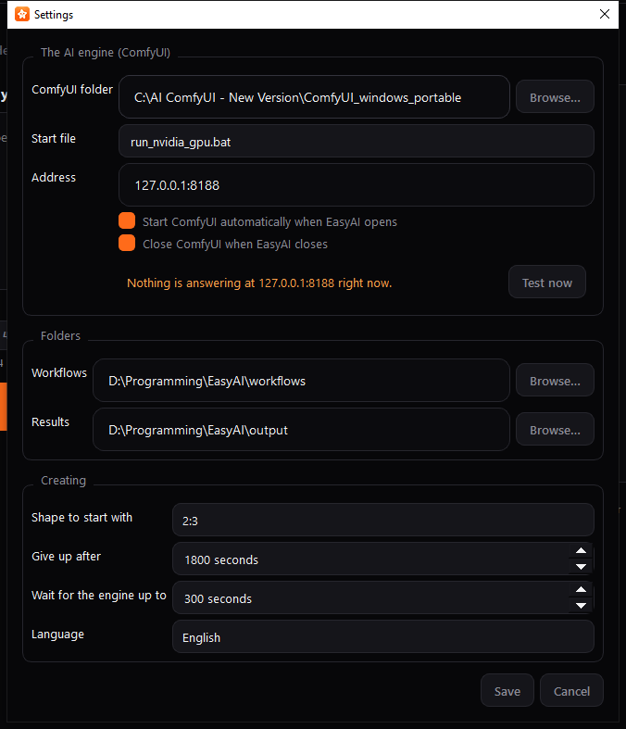
Settings is where you tell EasyAI where ComfyUI lives, how it should be started, where your workflows and results are stored, and a few generation defaults. You can open it any time from File → Settings… (or the keyboard shortcut Ctrl+,).
What to do:
- ComfyUI folder — Click Browse… and select the folder your ComfyUI installation lives in, if the pre-filled path isn’t correct.
- Start file — Choose which .bat file inside that folder should be used to start ComfyUI (EasyAI lists every .bat file it finds in the folder). If you have an NVIDIA GPU, a launcher with “nvidia” in its name is usually the right pick, and EasyAI tries to put likely choices at the top of the list.
- Address — Leave this as 127.0.0.1:8188 unless you know your ComfyUI server runs somewhere else.
- Tick or clear “Start ComfyUI automatically when EasyAI opens” and “Close ComfyUI when EasyAI closes” depending on how you want ComfyUI’s lifecycle managed. The second option only ever closes a ComfyUI process that EasyAI itself started — it will never close a copy of ComfyUI you started yourself.
- Click Test now to check the connection. The status line below turns green and says “ComfyUI is answering at …” if everything is set up correctly; otherwise it shows a warning explaining what’s wrong.
- Under Folders, confirm or change the Workflows folder (where your exported workflow files live) and the Results folder (where finished images/videos are saved).
- Under Creating, set your preferred starting shape, and how long EasyAI should wait before giving up on a stuck generation or a slow-starting engine.
- Choose your Language from the dropdown if you want the app in a language other than the default.
- Click Save to apply your changes (this happens immediately, with no restart needed), or Cancel to discard them.
If you change the ComfyUI folder, start file, server address, or workflows folder, EasyAI automatically re-checks the connection and reloads your workflow lists for you when you close this window.

Startup Splash
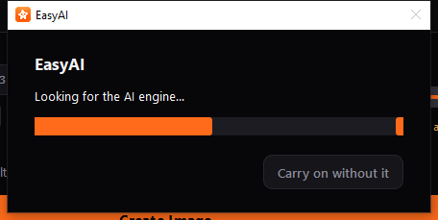
This small progress window appears while EasyAI is looking for, or starting, the ComfyUI engine — so you’re never staring at a window that looks frozen. You’ll typically only see it right after launching EasyAI, and only if ComfyUI isn’t already running.
What to do:
- Just wait. EasyAI is either checking whether ComfyUI is already running, or launching it for you using the start file you chose in Settings.
- If you don’t want to wait, click Carry on without it. The main EasyAI window opens right away, but you won’t be able to generate anything until the engine connects.
- If ComfyUI fails to start in time, EasyAI shows a message explaining that the app is still usable for browsing your workflows, but not for creating anything, until the engine is available.

Main Window
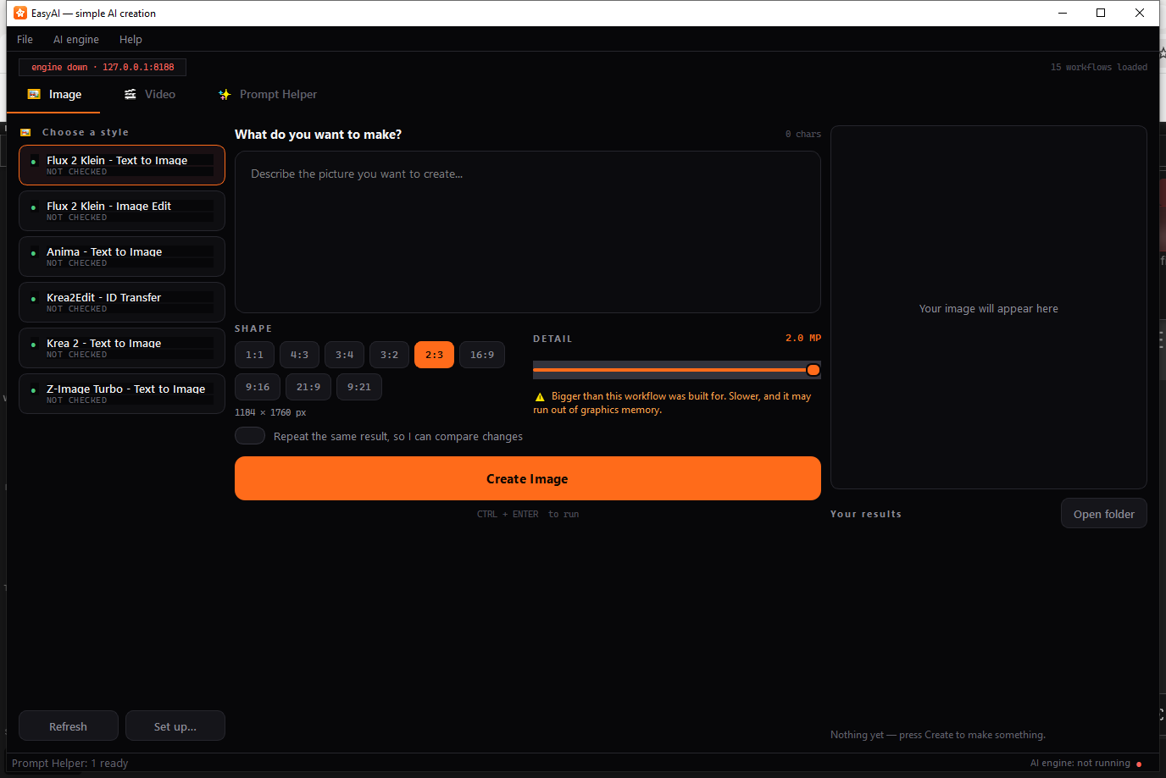
This is the main EasyAI window you’ll spend most of your time in. Across the top is a menu bar and an engine status strip; below that are the three generation tabs; at the bottom is a status bar.
What you see:
- Menu bar — File (open your workflows/results folders, Settings, Quit), AI engine (check connection, start the engine, reload workflows), and Help (quick reference and About).
- Engine status strip — a pill showing whether the engine is live (green, with the address it’s answering on) or down (red), plus a count of loaded workflows.
- Tab bar — switch between Image, Video, and Prompt Helper.
- Status bar (bottom) — shows VRAM usage while the engine is running and reporting a graphics device, a coloured dot with “AI engine: running / not running,” and brief status messages.
Useful keyboard shortcuts:
Shortcut | Action
Ctrl+Enter / Ctrl+Return | Run Create on whichever tab you’re viewing
Ctrl+, | Open Settings
F5 | Check that the engine is running
Ctrl+R | Reload the workflow lists
A workflow list showing every entry as “NOT CHECKED” and an engine status of “not running” simply means EasyAI hasn’t yet connected to a live ComfyUI server — as soon as ComfyUI is running and reachable, EasyAI automatically re-checks each workflow and updates its status.
EasyAI remembers your window size and position between sessions. When you close the window, any generation job in progress is cancelled, and — if you left “Close ComfyUI when EasyAI closes” turned on in Settings — any ComfyUI process EasyAI itself started is shut down for you.

Image tab
The Image tab is where you generate still images. It’s arranged in three columns: your list of styles on the left, your prompt and options in the middle, and a preview plus your results on the right.
What to do:
- Choose a style — In the left-hand list, click the workflow you want to use. Each entry shows a status dot and a short label:
  - READY (green) — ready to use.
  - CHECK SET UP / NOT CHECKED (amber) — EasyAI guessed how this workflow works, or hasn’t checked it against a live engine yet.
  - MISSING ADD-ON / MISSING MODEL (red) — something this workflow needs isn’t installed in your connected ComfyUI.
  - NEEDS RE-EXPORT (red) — see Troubleshooting.
  - If the list is empty, EasyAI tells you which folder to save exported workflow files into, then press Refresh.
- Describe what you want — Type your description into the prompt box. A character counter above the box tracks your typing.
- Attach files, if the style needs them — Some styles show one or more file boxes for pictures, sound, or video. Click a box (or drag a file onto it) to attach a file; click Remove to clear it. Boxes marked “(optional)” can be left empty.
- Pick a Shape — Click one of the ratio buttons (e.g. 1:1, 16:9) to set the output’s proportions. The exact pixel size appears underneath.
- Adjust Detail, if shown — Drag the slider to trade off quality against speed and memory use. A hint line under the slider tells you what the current value means; an amber warning appears if you go high enough that it may run out of graphics memory.
- Turn on “Repeat the same result” if you want to keep the same random seed across runs (useful for comparing small changes to your prompt).
- Click Create Image (or press Ctrl+Enter). A progress bar appears while EasyAI generates your image, and a live preview shows ComfyUI’s in-progress frames.
- When it’s done, your image appears in the preview pane and is added to Your results below it. Double-click a result to open it, or click Open folder to see all your saved images in Windows Explorer.
If you press Create while the engine isn’t running, or while a required file is missing, EasyAI shows a message telling you what to fix instead of sending a broken job to ComfyUI.

Video tab
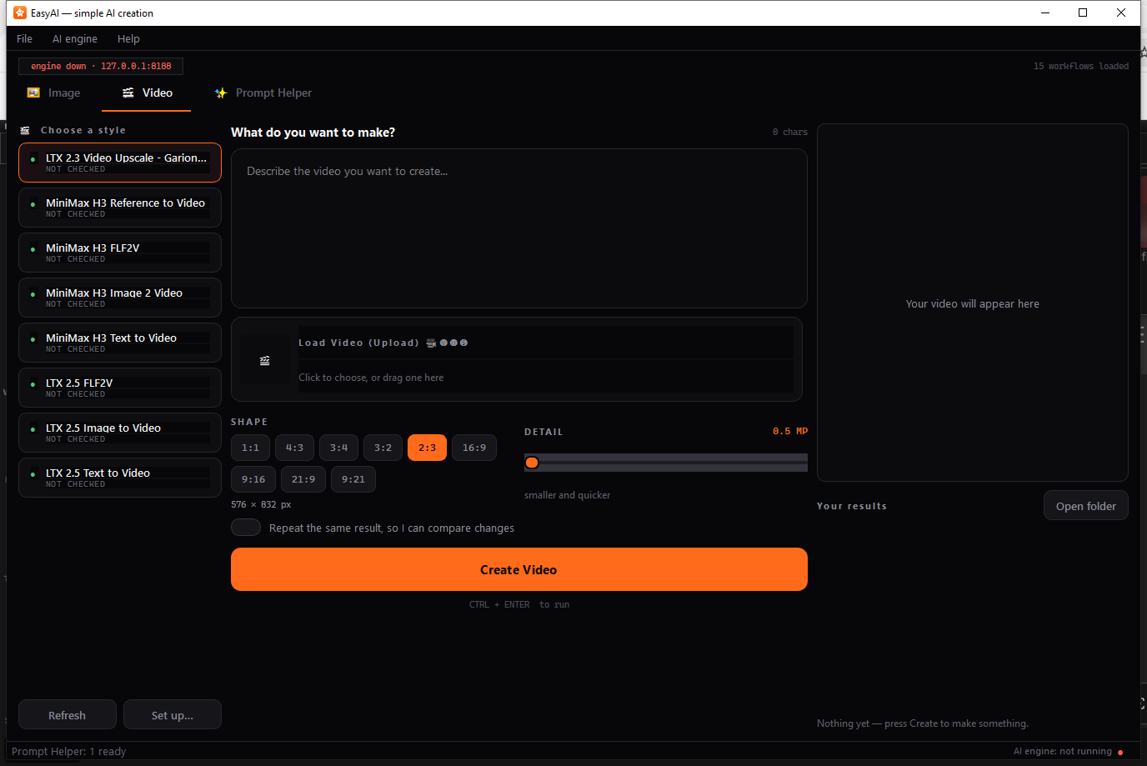
The Video tab works the same way as the Image tab, with a few video-specific differences.
What’s different from Image:
- Some video styles need a starting picture or clip — attach it in the file box provided (for example, “Load Video (Upload)”).
- A Length control (in seconds) sets how long the finished video will be; the equivalent frame count is shown underneath. Longer videos use noticeably more graphics memory — an amber caution appears once you pass a set threshold.
- The Create Video button carries a tooltip reminding you that video generation takes much longer than a still image.
- While a job is running, the Create button is replaced with a Stop button, which cancels the current job.
Otherwise, choosing a style, writing a prompt, picking a shape/detail level, and viewing your results work exactly as described in Image tab above.

Prompt Helper tab
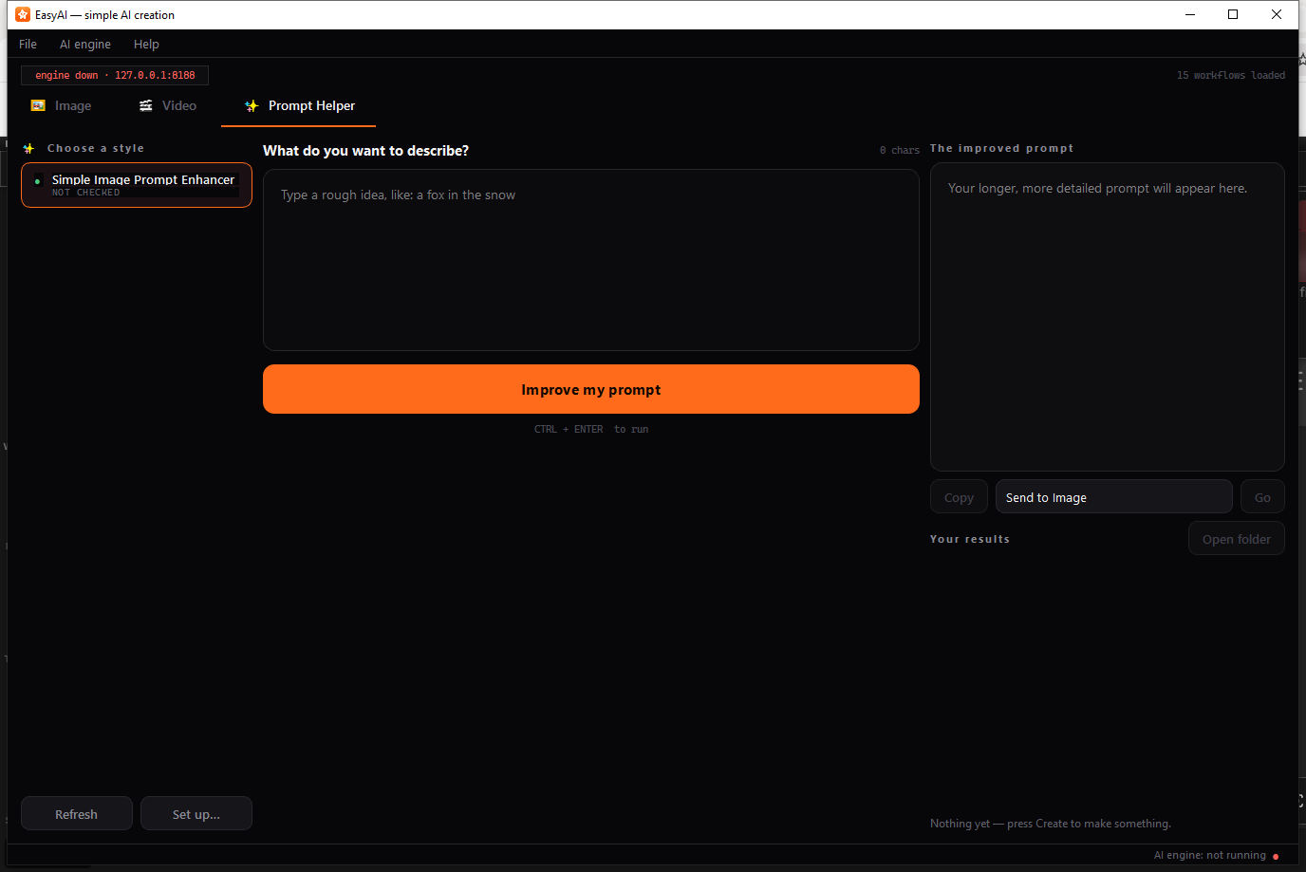
The Prompt Helper tab doesn’t generate a picture or video — it takes a short, rough idea and expands it into a longer, more detailed prompt you can reuse on the Image or Video tab.
What to do:
- Choose a style from the list on the left (there is usually just one: a prompt-enhancer style).
- Type a short idea into the box — for example, “a fox in the snow.”
- Click Improve my prompt (or press Ctrl+Enter).
- The expanded result appears on the right, under The improved prompt.
- From here you can:
  - Click Copy to copy the text to your clipboard.
  - Choose Send to Image or Send to Video from the dropdown, then click Go, to drop the improved prompt straight into that tab’s prompt box and switch to it.
  - Click any entry in your history list to reload a prompt you improved earlier in a previous session.
If a workflow finishes without producing any readable text, see Troubleshooting below.

Set up… (Manifest Editor)
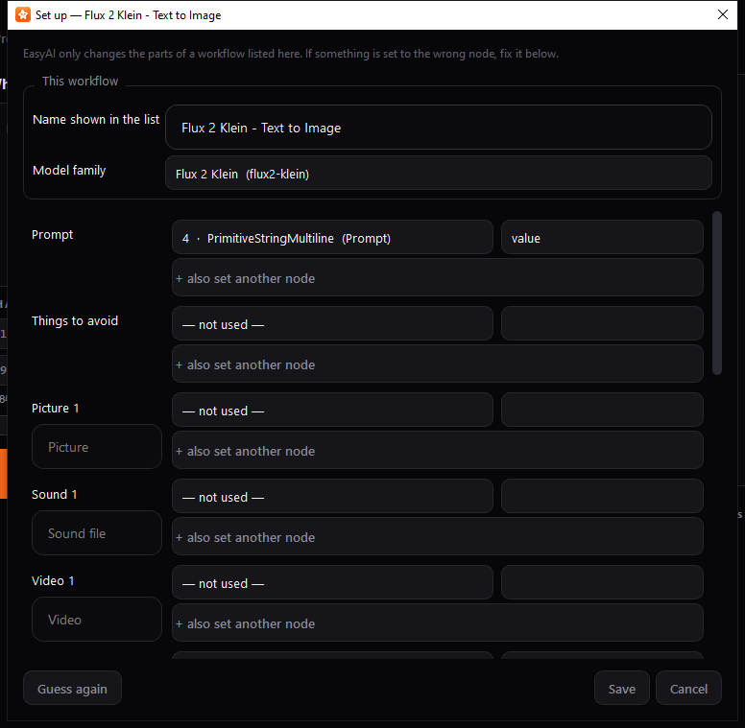
The Manifest Editor lets you correct EasyAI’s automatic guesses about which parts of a workflow correspond to the prompt box, shape, seed, and so on — without having to edit any files by hand.
When you’ll see this: click Set up… below a style list, right-click a style and choose Set up…, or follow the prompt when a style is flagged CHECK SET UP.
What to do:
- If EasyAI had to guess some of these settings, an amber note near the top names which ones — worth double-checking those first.
- Give the workflow a friendly Name shown in the list, if you’d like one other than the file name.
- Set Model family if you know which engine the workflow was built for, or leave it on “Work it out automatically.”
- For each row (Prompt, Things to avoid, Width, Seed, and so on), use the dropdowns to pick which node — and which input on that node — EasyAI should control. Use “+ also set another node” if a single value (like width) needs to be written to more than one place in the workflow.
- Click Save to apply your changes, Cancel to discard them, or Guess again to have EasyAI re-run its automatic detection and start over (this doesn’t save until you click Save).
Your corrections are saved next to the workflow file and are not overwritten if you re-export the same workflow from ComfyUI later — so you only need to fix a given workflow’s setup once.

Rename dialog
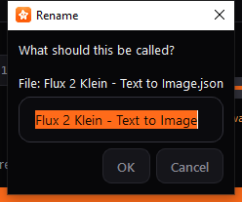
Use this to give a workflow a friendlier name in the style list than its raw file name.
How to reach it: select a workflow and press F2, double-click it, or right-click it and choose Rename….
What to do:
- Type the new name you want shown in the style list.
- Click OK to save it, or Cancel to leave it unchanged.
The custom name is stored separately from the file itself, so re-exporting the same workflow later from ComfyUI won’t lose your renamed label. Clearing the name back to blank makes EasyAI fall back to showing the file name.

Help menu
EasyAI’s Help menu has two entries, both simple reference dialogs.

How do I add a workflow?
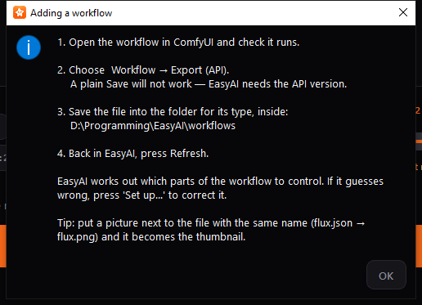
A quick, in-app reminder of the steps for adding a new style to EasyAI:
- Open the workflow in ComfyUI and make sure it runs.
- Choose Workflow → Export (API) in ComfyUI — a plain Save will not work; EasyAI needs the API version of the file.
- Save the exported file into the matching folder inside your workflows folder (the exact path is shown live in this dialog).
- Back in EasyAI, click Refresh.
EasyAI then works out which parts of the workflow it can control automatically. If it guesses something wrong, use Set up… to correct it (see Set up… (Manifest Editor) above). As a tip, placing a picture next to the exported file with a matching name (for example, flux.json and flux.png) makes EasyAI use that picture as the style’s thumbnail.

About EasyAI
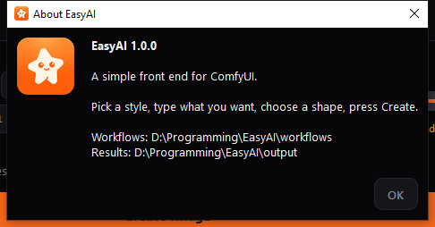
Shows the installed EasyAI version, a one-line description, and the current location of your workflows and results folders — handy if you’ve forgotten where you pointed them in Settings.

EasyAI Setup (companion installer)
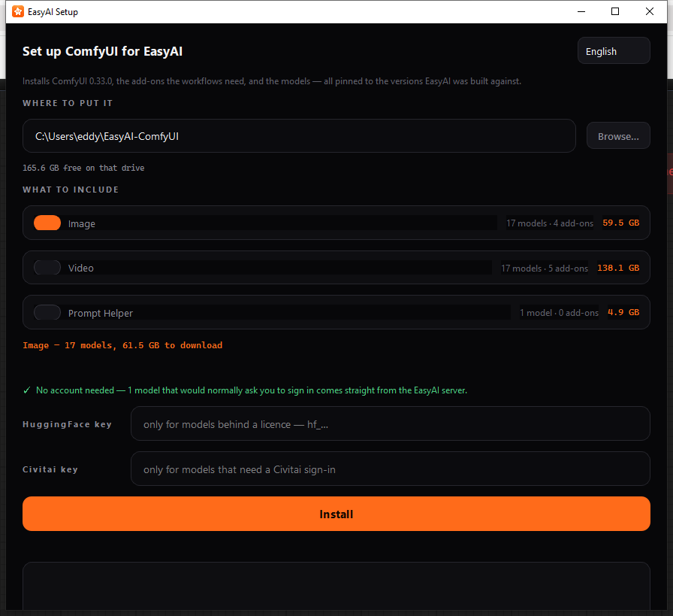
Note on scope: EasyAI Setup is a separate program from EasyAI itself — it has its own shortcut/launcher and never reads or changes EasyAI’s own settings. It’s included here as a companion tool because, in practice, a first-time user with no ComfyUI installation would likely need to run it before opening EasyAI at all. If you already have a working ComfyUI installation, you can skip this section and just point EasyAI at it from Settings.
EasyAI Setup downloads and installs a specific, known-good version of ComfyUI, along with the add-ons and models that EasyAI’s built-in workflows expect, into a folder you choose.
What to do:
- If needed, change the app’s language using the dropdown in the top-right corner.
- Under WHERE TO PUT IT, confirm or change the install location using Browse…. The free disk space on that drive is shown underneath.
- Under WHAT TO INCLUDE, turn on the toggle for each group of features you want (for example, Image, Video, Prompt Helper). Each group shows how many models and add-ons it includes and its download size; a running total is kept as you toggle groups on and off. Watch for amber warnings about insufficient disk space or models that need special handling, and green notes where no account is required.
- If a model needs a Hugging Face or Civitai account, enter your access key in the matching field. These keys are used only for that install run and are never saved to disk.
- Click Install. A confirmation dialog shows the exact download size and destination before anything downloads.
- Watch the progress bar, current file/speed readout, and the log for status. Click Stop if you need to pause — downloads resume where they left off the next time you click Install.
Once installation finishes, open EasyAI, go to Settings, and point the ComfyUI folder at the location you installed to here.

Settings Reference
These settings are stored automatically as you use the app. Most are set from the Settings window; a few are remembered in the background as you use the Image/Video/Prompt Helper tabs and aren’t edited directly.
Setting | What it does | Default
ComfyUI folder | Folder where your ComfyUI installation lives. | C:\AI ComfyUI - New Version\ComfyUI_windows_portable
Start file | Which .bat file inside that folder EasyAI runs to start ComfyUI. | run_nvidia_gpu.bat
Address | The host:port EasyAI talks to ComfyUI on. | 127.0.0.1:8188
Start ComfyUI automatically when EasyAI opens | Whether EasyAI launches ComfyUI itself if nothing answers at startup. | On
Close ComfyUI when EasyAI closes | Whether EasyAI shuts down a ComfyUI process it started, when you quit EasyAI. Never affects a copy of ComfyUI you started yourself. | On
Give up after (job timeout) | How long EasyAI waits for a single generation before giving up on it. | 1800 seconds (30 minutes)
Wait for the engine up to (launch timeout) | How long EasyAI waits for ComfyUI to finish starting before giving up. | 300 seconds (5 minutes)
Workflows folder | Folder holding your exported workflow files, organized by type. | <EasyAI folder>/workflows
Results folder | Folder your generated images/videos are saved into. | <EasyAI folder>/output
Shape to start with | The shape chip pre-selected when you pick a new style. | 2:3
Repeat the same result (seed lock) | Whether “repeat the same result” starts turned on. Remembered separately per tab so locking one tab doesn’t reuse another tab’s seed. | Off
How many (batch count) | Default number of images/videos requested per run, when a style supports it. | 1
Let the AI improve my wording first | Default state of the prompt-enhancer switch, when a style has one. | On
Detail (Image) | Remembered detail/megapixel level for the Image tab. | 1.0 MP
Detail (Video) | Remembered detail/megapixel level for the Video tab. | 0.5 MP
Detail warning threshold (Image) | Detail level above which the Image tab shows a memory-cost warning. | 1.5 MP
Detail warning threshold (Video) | Detail level above which the Video tab shows a memory-cost warning (lower than Image, since video pays the cost per frame). | 1.0 MP
Length (default) | Starting value of the Length control on the Video tab. | 5 seconds
Length (minimum / maximum) | Allowed range for the Length control. | 2 / 15 seconds
Length warning threshold | Video length above which EasyAI shows a memory-exhaustion caution. | 8 seconds
Language | The app’s current display language. | English (en)
Window size and position | Remembered automatically so EasyAI reopens the way you left it. | (none until first saved)
First-run flag | Internal marker for whether the first-run welcome/Settings flow has already been shown. | Off (until first launch completes)

Troubleshooting
The workflow list shows everything as “NOT CHECKED.” This is normal until EasyAI has connected to a running ComfyUI server — EasyAI can’t confirm a style’s requirements are met until it can actually ask ComfyUI what’s installed. Start ComfyUI (or let EasyAI start it for you) and the statuses will update once the engine connects. Use F5 or AI engine → Check it is running to force a re-check.
A style is greyed out and says “MISSING ADD-ON” or “MISSING MODEL.” The connected ComfyUI installation is missing a custom node or model file this workflow needs. The status text names the missing add-on or model file — install it into your ComfyUI installation (or use EasyAI Setup if you’re setting up from scratch), then press Refresh.
A workflow says “NEEDS RE-EXPORT.” {#a-workflow-says-needs-re-export} ComfyUI’s plain Save does not produce a file EasyAI can use. Open the workflow in ComfyUI and use Workflow → Export (API) instead, then replace the file in your workflows folder and press Refresh. EasyAI deliberately does not trust a workflow’s “last run” data embedded from a plain save, because in practice that embedded copy is very often out of date.
“EasyAI cannot reach ComfyUI” when you press Create. The engine isn’t running or isn’t reachable at the address in Settings. Check the engine status pill at the top of the main window; open Settings and click Test now, or use AI engine → Start it now.
“ComfyUI closed straight away.” The .bat file EasyAI tried to launch exited immediately — usually a sign of a broken or incomplete ComfyUI install. Try running that same .bat file directly (outside EasyAI) to see the actual error ComfyUI reports.
“The AI engine did not start within N seconds.” ComfyUI took longer to start than the “Wait for the engine up to” setting allows. Try running the .bat file by hand to see what’s happening, or increase the wait time in Settings.
“Almost there” dialog when you press Create. A required file input (a picture, sound, or video slot) is still empty. Fill in the listed slot(s) and try again.
Prompt Helper says “The workflow finished but produced no text.” {#prompt-helper-produced-no-text} The underlying workflow doesn’t have a node set up to show its output text. This typically needs fixing in the workflow itself (via ComfyUI), or by checking the workflow’s setup with Set up….
“The AI engine finished but produced no files.” Either the workflow has no node configured to save its output, or the job was stopped before it finished. Check the workflow’s setup, or try running it again without stopping it.
The finished image/video’s size doesn’t exactly match the Shape you picked. Some engines round the final width and height to a multiple of a fixed grid size after computing your requested shape, so the saved file can be a few pixels off from the label on the shape chip. This is expected behavior for those engines, not an error.
Detail slider won’t go as low as you expect. Some workflows are built with a lower minimum than EasyAI’s normal range; EasyAI keeps that workflow’s own lower floor instead of rounding it up, so it doesn’t change a result the workflow’s author tuned or risk running the workflow the way it wasn’t designed for.
A file slot that looks optional in ComfyUI is still required in EasyAI. EasyAI only marks a file slot as safely skippable when it can confirm, from a live ComfyUI connection, that every input relying on it is optional. Without a live connection to check, EasyAI plays it safe and still asks for the file.
My first-run guess at the ComfyUI folder was wrong. This is exactly what the first-run welcome message and Test now button in Settings are for — open Settings, browse to the correct folder, and click Test now to confirm before saving.

