Context Profile Load

1) Create a context-group
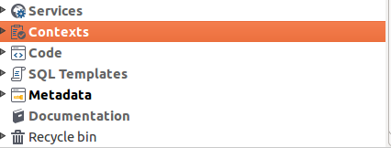

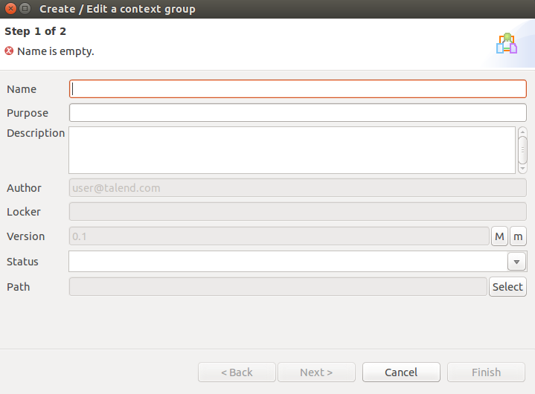

2) Create different profiles.

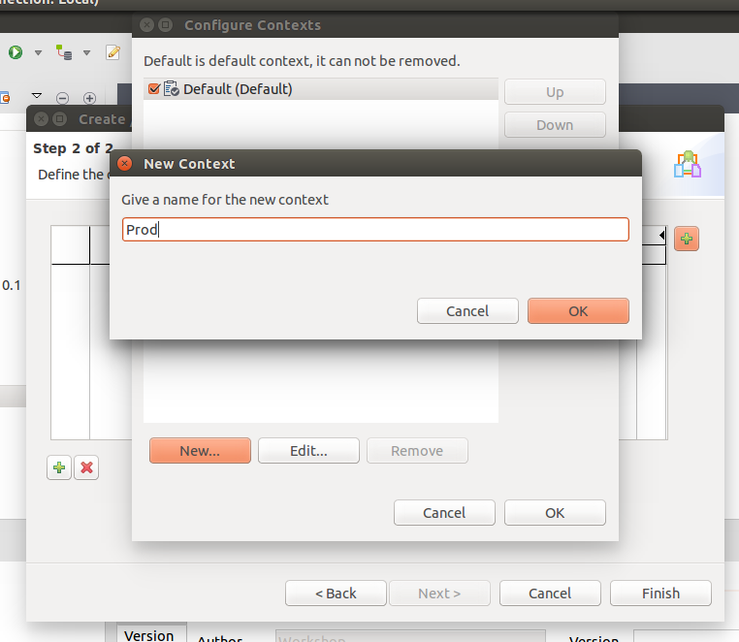

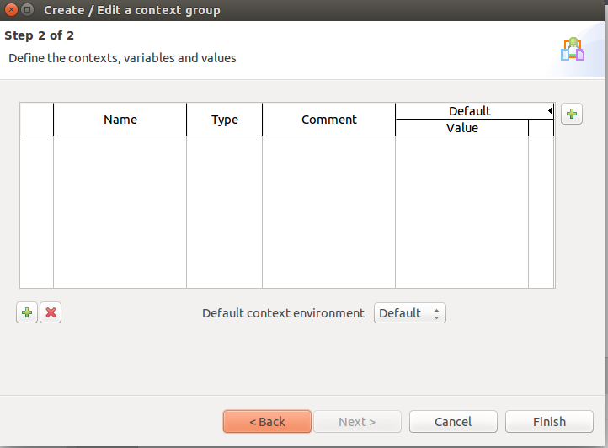

3) Place a file with the same name as of the job.cfg but without version number under path “$TALEND_RUNTIME/container/etc/$JOB_NAME”
For e.g.:- if the job name is Test-0.1.jar then the file name should be Test.cfg
4) Put in one property saying context=profile_name
For e.g.:- if the profiles are prod, qa, stagnig, etc and if you want to select staging the
context=staging

