Devops MSE 1
Nikhil Dubey
2400290120163
Github- https://github.com/nikhilatkiet/github-skills-challenge/
Pull Request- https://github.com/nikhilatkiet/github-skills-challenge/pull/3
Github Actions Workflow-
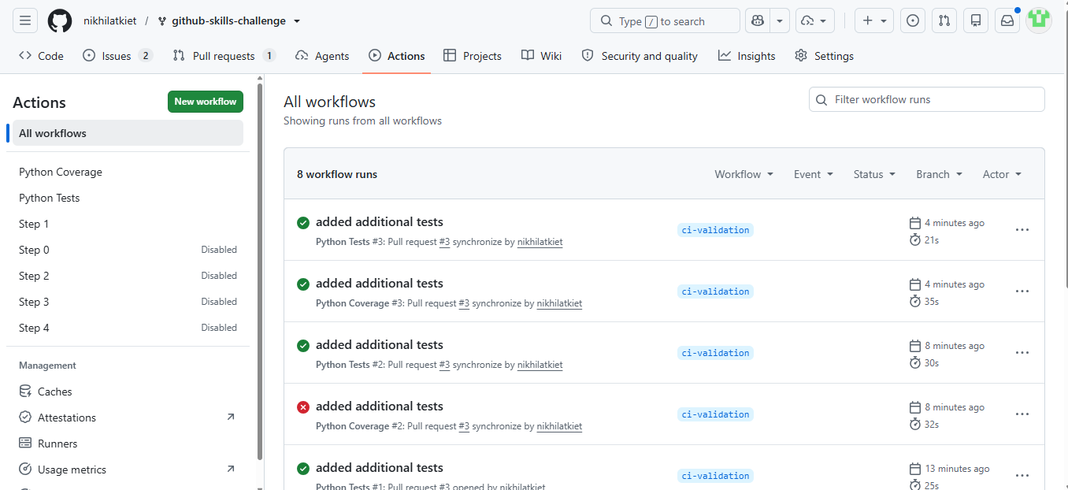
Successful Test workflow-
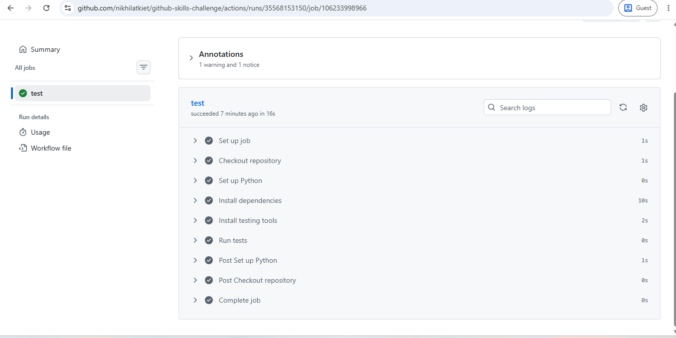

Successful Coverage workflow-
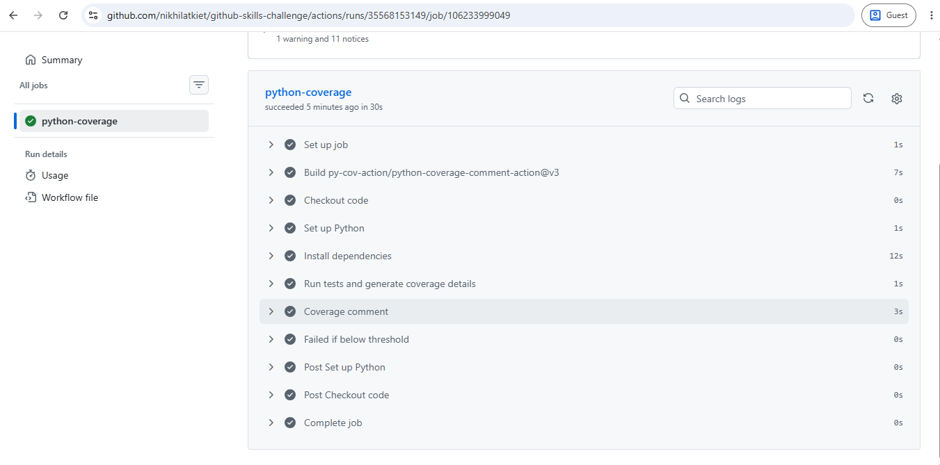

Final Repo-
