ISSUE 1

Issue overview:
All HTML canonical indexable pages that received 0 impressions based on Google Search Console data for the last 30 days.

The importance of the issue
The canonical page that open for indexing can receives no impressions, for different reasons:
- there is no search demand for this content;
- Google doesn't understand for what queries this page is created for;
- Google haven't crawled the page yet;
- Googlebot crawled this page and decided not index it because of low value of the page.
Regardless of the reason, pages without impressions are the waste of time and money. If you created them to acquire organic search traffic, you should detect the problem and fix it.

How to fix this issue
Problem 1. There is no search demand for this content
- Redirect the page to the similar one that has impressions or;
- Make keyword research and rewrite the content for queries that people look for in Google.
Problem 2. Google doesn't understand for what queries this page is created for
- Redirect the page to the similar one that has impressions or;
- Make keyword research and try to narrow your content for a specific problem / product / service people look for in Google.
Problem 3. Google haven't crawled the page yet
- Visit Google Search Console and use URL Inspection tool to check the crawling status this page. If it is not crawled yet request indexing.
Problem 4. Googlebot crawled this page and decided not index it because of low value of the page
- Add more value to the content. Usually it means to add more content and internal and external backlinks.

ISSUE 2
Orphan URLs - only found via sitemap
Issue overview:
These are URLs not discoverable through internal linking and have a status code other than 404. They're detectable only via the sitemap, and 'float' within a domain's set of URLs, evading web crawlers and standard Google bot indexing.

Why it is important
Google recommends to add internal links to all website pages you would like to index.
...Although you may believe that users prefer a search box on your site rather than category navigation, it's uncommon for search engine crawlers to type into search boxes or navigate via pulldown menus. So make sure your important pages are clickable from the homepage and for easy for Googlebot to find throughout your site. It's best to create a link architecture that's intuitive for users and crawlable for search engines...
... Sitemap submission is also helpful for major search engines, though it shouldn't be a substitute for crawlable link architecture...
Yes, Google can find your pages via sitemap, but internal links have a big impact on page rankings in Google SERP. More internal links means better positions in SERP. So, by adding pages to the sitemap and not linking to them from other pages on the site, you are contradicting yourself.

How to find the issue?
The simplest way is to check your internal incoming links (links from other pages of your website.) If the page has none internal incoming links the issue is valid.
To check it, click on the page URL and open Page details.
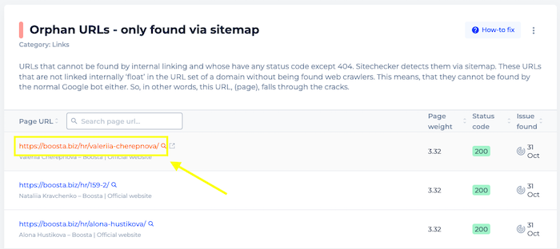
Then choose the section "Internal backlinks".
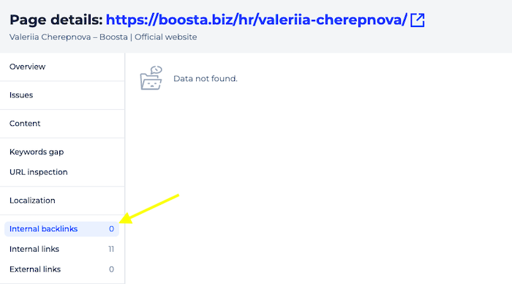
Zero links means that issue is valid.

How to fix the issue
- Add internal links to pages you would like to index and get better rankings for them.
- Delete unvaluable pages and delete links to them from sitemap.

ISSUE 3
Canonicalized URL in XML sitemaps
Issue overview:
Pages that are included in the XML sitemap but have a canonical element pointing to another URL.
Why is this issue important?
Your XML sitemap should only contain URLs that you want search engines to index. If a URL is canonicalized, it signals to search engines that you do not want this URL to be indexed. Instead, you want the canonical URL to consolidate indexing signals.
Including a canonicalized URL in a sitemap can provide conflicting information to search engines. This confusion may impact their understanding of what the canonical URL is and may result in unintended URLs being indexed.
How to fix the issue?
To resolve this issue, you need to do one of the following:
- If the URL should be canonicalized, then remove it from all XML sitemaps. Once it is removed, resubmit the sitemaps to Google Search Console.
- If the URL should not be canonicalized, then remove the canonical tag from the URL.
ISSUE 4

Page has identical headings
Issue overview:
URL has headings duplicates. Example: h1 = h3, h2 = h3, h1 = h2, as well as h2 = h2, h3 = h3. Google recommends to avoid having duplicate or near-duplicate versions of your content across your site. Update headings to make them unique or delete the duplicates.

Why it is important
Google's SEO Starter Guide contains a recommendation to avoid having duplicate or near-duplicate versions of your content across your site.
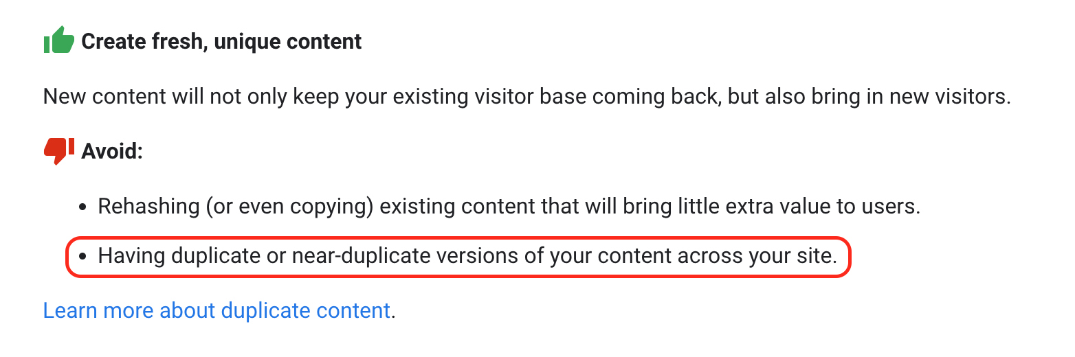
While most duplicate content problems are related to the same content on different pages, having duplicate content within the same page is also a problem because it doesn't add value to the user. Remember how the table of content of any book looks like. Have you ever seen the same headlines there? No. Apply the same logic to headings on your page.

How to check the issue
Click on the URL of the affected page to open "Page Details."
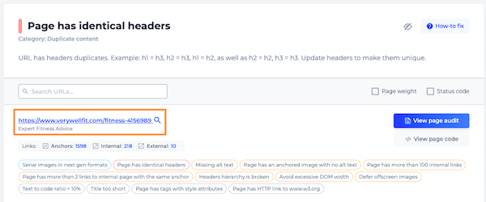
Chose the "Content" tab and check the list of the page headers to spot identical ones.
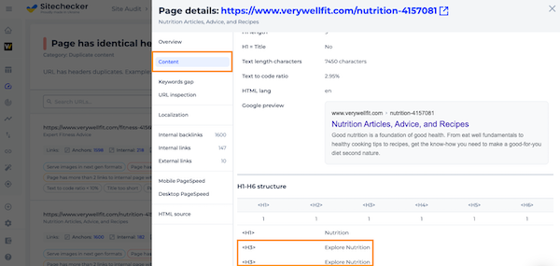

How to fix the issue
It depends on the type of problem that causes this issue.
- If the headings are duplicated in the content due to human error, you need to remove these tags or rewrite them so that they are all unique.
- If the headings are duplicated due to some plugin or code, then you need to make changes to this plugin or code to remove the changes on all affected pages.

ISSUE 5

404 page
Issue overview:
Non-existent pages on the website don't respond 404 HTTP status code. It tells search engines that there’s a real page at that URL. As a result, that URL may be crawled and its content indexed.

How to fix the issue
We recommend that you always return a 404 (Not found) response code in response to a request for a non-existing page. Read more details about creating 404 pages in our guide and Google article.

ISSUE 6

WWW and non-WWW
Issue overview:
The home page has no server-side 301 redirect from WWW to non-WWW website version or vice verca. This issue may lead to appearing duplicate content in Google index. Choose a preferred domain and set up redirect from non-preferred domain version to preferred domain version.

How to fix the issue
Links may point to your site using both the www and non-www versions of the URL (for instance, http://www.site.com and http://site.com). The preferred domain is the version that you want to use for your site in the search results.
We recommend that you use a server-side 301 redirect. Also, you can use rel="canonical" HTTP headers to indicate the canonical URL for HTML documents and other files.
Explore more about choosing between WWW and non-WWW versions.

ISSUE 7

Mobile PageSpeed
Issue overview:
The home page loading speed on mobile devices is slow. Click "View PageSpeed Insights" to find out which scripts, styles and images you should optimize to speed up the website.

Why it is important
Google Search Documentation says that a good user experience is a ranking factor. And when it comes to user experience, speed matters. A consumer study shows that the stress response to delays in mobile speed are similar to that of watching a horror movie or solving a mathematical problem, and greater than waiting in a checkout line at a retail store.
As a site begins to load, there's a period of time where users wait for content to appear. Until this happens, there's no user experience to speak of. This lack of an experience is fleeting on fast connections. On slower connections, however, users are forced to wait. Users may experience more problems as page resources slowly trickle in.
Get know more about why speed matters here.

How PageSpeed Insights report works
Google PageSpeed Insights (PSI) reports on the performance of a page on both mobile and desktop devices and provides suggestions on how that page may be improved.
PSI uses Lighthouse to analyze the given URL, generating a performance score that estimates the page's performance on different metrics, including First Contentful Paint, Largest Contentful Paint, Speed Index, Cumulative Layout Shift, Time to Interactive, and Total Blocking Time.
Lighthouse separates its audits into three sections:
- Opportunities provide suggestions on how to improve the page’s performance metrics. Each suggestion in this section estimates how much faster the page will load if the improvement is implemented.
- Diagnostics provide additional information about how a page adheres to best practices for web development. Passed Audits indicate the audits that have been passed by the page.
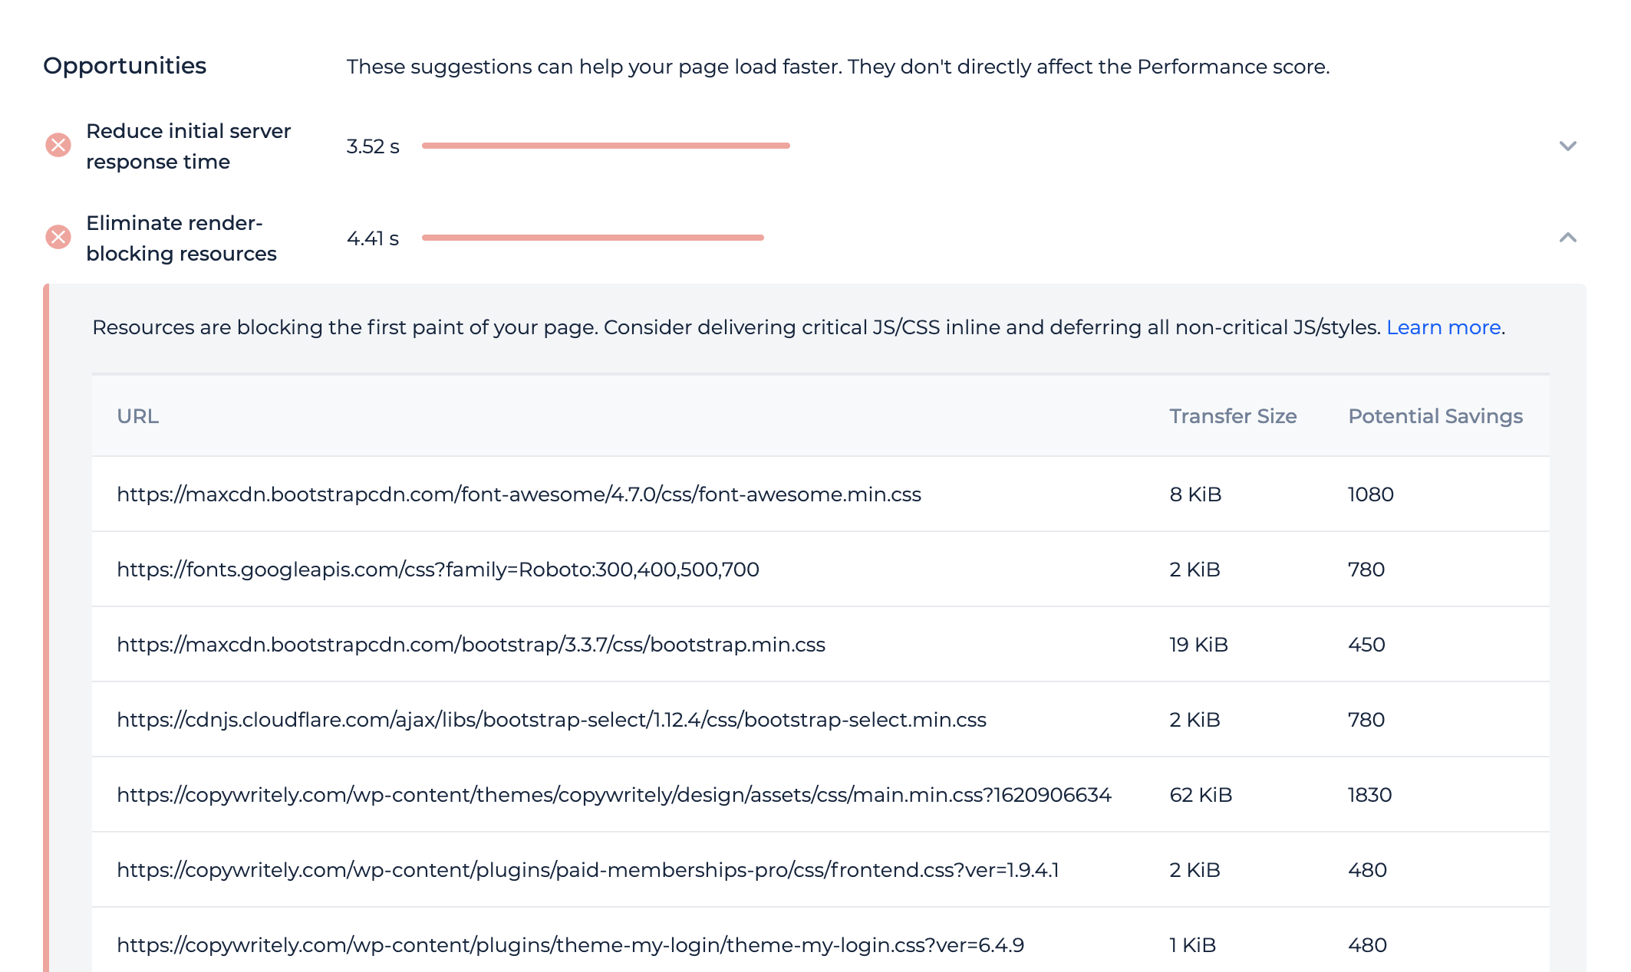

How to fix the issue
It's good to speed up all pages on the website, but it takes time, so you can start from the home page. PageSpeed Insights report contains the list of resources (images, CSS and JS files) that should be optimized to increase the page speed. Send the link to Page Audit of the home page to developers and explain that they should optimize these files.
Sometimes you can improve your page loading time yourself if you are running a website on content management system that has ability to install plugins to optimize page loading speed. For example, if you are using WordPress, you can install W3 Total Cache, WP Rocket, WP Super Cache or other similar plugin to improve page speed without help of developers.
ISSUE 7

Add dimensions to images
Issue overview:
Page contain images that do not have width and height size attributes. Always include width and height size attributes on your images and video elements. This approach ensures that the browser can allocate the correct amount of space in the document while the image is loading.

Why it is important
Cumulative Layout Shift (CLS) is one of the Core Web Vitals metrics that feed into Google's understanding of 'page experience.' CLS is about how much it feels that the page layout moves around as it is loading.
If you don't specify width and height on images, when loading the page, the browser does not know how much space to allocate for the images. This results in an image 'jump', as the layout shifts around the images.

How to fix the issue
Simply adding 'width' and 'height' attributes to <img> tags will avoid layout shifts, but a fully responsive solution is a little more complicated.
When working with responsive images, use 'srcset' to define the set of images you want the browser to select from, and what size each image is. The browser will calculate the aspect ratio and therefore understand what space to allocate in the layout (ensure that the images themselves use the same aspect ratio).
Guides:
Optimize Cumulative Layout Shift - Images without dimensions (Lighthouse documentation)
Setting Height And Width On Images Is Important Again
ISSUE 8

Defer offscreen images
Issue overview:
The page contains images that are fully loaded by the browser even though they are not visible in the user's viewport. This negatively affects page loading speed. Consider lazy-loading these images after all critical resources have finished loading to improve page speed metrics.

Why it is important
When a browser loads a page, it will load in all page resources (that are not deferred), including images that are only visible to the user once they scroll down the page. This means that the browser spends time during the initial render downloading images that are not necessary to download right away, which increases the Time to Interactive (the amount of time it takes for the page to become fully interactive).

How to fix the issue
You can resolve this issue by lazy-loading images which appear below-the-fold, which ensures that the browser only loads in the images that are actually needed for display in the viewport. In order to lower Time to Interactive, implement lazy-loading for these images after all critical resources have finished loading.
There are multiple different ways to implement lazy-loading, so you should work with your developer to understand the most appropriate one for the website you are dealing with.
Guides that will help you to implement lazy-loading:
Defer offscreen images (Lighthouse documentation)
The Complete Guide to Lazy Loading Images

ISSUE 9

JavaScript file size is over 25 KB
Issue overview:
URLs contain JavaScript files of size over 25 KB.
URLs contain JavaScript files of size over 25 KB. The figure of 25KB is relatively arbitrary - there is no hard and fast rule as to what constitutes an JavaScript file that is 'too large'.

Why it’s important
A lower JavaScript file size/payload reduces the time spent parsing scripts, resulting in faster page loads and improved page experience.

How to fix
Reduce JS file sizes by removing comments, white spaces, and redundant code, and in some cases, use shorter variable and function names.
Minifying your JavaScript is less impactful on the overall page experience when compared to other optimizations like code-splitting, eliminating dead code, and caching your JavaScript code.
Hence, minification is a lower priority optimization that should be regarded as a fine-tuning step to refine your page experience rather than single-handedly boost your page performance.

ISSUE 10

H1 duplicates
Issue overview:
Identical h1 tags are present on several pages. To see which pages contain duplicates, click on the button "View pages".

Why It's Important
The hierarchy of headings in an HTML document is as follows: h6 is the lowest level heading, h1 - the highest priority one, while all other headings have intermediary importance - the lower the number, the higher the importance. Thus, h2 headings could be viewed as the main sections of the article, lower level headings - as hierarchically organized subsections, while the h1 tag - as the title of the article. Headings are styled accordingly so that users visually determine their relative importance - the h1 tag is typically formatted using the biggest font size.
Duplicate h1 headings don’t come with penalties. But identical headings on pages with different content imply that the headings don’t uniquely describe the specific content on each page. You can read more about how Google recognizes duplicate content here.

How to check the issue?
Access the source code of the page by following this link https://codebeautify.org/source-code-viewer or by right-clicking a neutral region of the web page in the Chrome browser and picking “View page source” - most other browsers also offer this functionality.
Locate h1 tags by searching for text flanked by <h1>.

How to Fix the Issue?
Edit or rewrite h1 tags so that they specifically match the content of the pages they belong to.

ISSUE 11

Has only one followed internal linking URL
Issue overview:
The URL has only one followed incoming link from one other URL on the website. The amount of internal backlinks and their anchors have impact on page rankings. More internal backlinks means higher rankings, so it is better to add more links from other internal pages to pages listed in this filter.

Why it is important
Internal linking is the main way you help users and search engine crawlers discover pages on your website. From an SEO perspective, internal links are the most effective method of indicating to search engines the relative importance of pages on your website.
URLs with only a single followed incoming link only inherit a small amount of link equity, which can make ranking very difficult.

What does the issue check
This issue will trigger for any internal URL which has incoming internal followed links from only one URL. Note that it may have multiple links from that same one URL, and may also have nofollow links from other internal URLs.

How to fix the issue
- For pages that you intrested to index and rank higher add more internal backlinks from relevant pages.
- For pages that have no value and you would like to delete or deindex them, delete internal backlink to them from one page that contains it.

ISSUE 12

X Frame Options
Issue overview:
Site has no X-Frame-Options HTTP response header, so defence against click-jacking attacks is not implemented. This header can be used to indicate whether or not a browser should be allowed to render a page in a <frame>, <iframe>, <embed> or <object>. Sites can use this to avoid click-jacking attacks, by ensuring that their content is not embedded into other sites.

How to fix the issue
Add the following HTTP header:
X-Frame-Options: DENY
or
X-Frame-Options: SAMEORIGIN
If you specify DENY, not only will the browser attempt to load the page in a frame fail when loaded from other sites, attempts to do so will fail when loaded from the same site. On the other hand, if you specify SAMEORIGIN, you can still use the page in a frame as long as the site including it in a frame is the same as the one serving the page.
DENY
The page cannot be displayed in a frame, regardless of the site attempting to do so.
SAMEORIGIN
The page can only be displayed in a frame on the same origin as the page itself. The spec leaves it up to browser vendors to decide whether this option applies to the top level, the parent, or the whole chain, although it is argued that the option is not very useful unless all ancestors are also in the same origin.
Get more info about implementing X-Frame-Options in MDN Web Docs
ISSUE 13

X Content Type Options
Issue overview:
Site has no X-Content-Type-Options: nosniff response header. This header is a marker used by the server to indicate that the MIME (Multipurpose Internet Mail Extensions) types advertised in the Content-Type headers should be followed and not be changed. The header allows you to avoid MIME type sniffing by saying that the MIME types are deliberately configured.

How to fix the issue
Add the following HTTP header to the pages:
X-Content-Type-Options: nosniff
Nosniff directive blocks a request if the request destination is of type style and the MIME type is not text/css, or of type script and the MIME type is not a JavaScript MIME type.
Get more info about MIME type snuffing and X-Content-Type-Options in MDN Web Docs.
ISSUE 14

Cookies Security
Issue overview:
Site has Set-Cookie HTTP response header, but has no HttpOnly additional flag in its header.

How to fix the issue
In order to improve the security of your site (and your users), you should enable the HttpOnly flag on all of your cookies. It helps prevent XSS (cross-site scripting attacks) from gaining access to the session cookies via JavaScript. This is how your cookies should look:
Set-Cookie: COOKIE=VAL; path=/; domain=.domain.com; secure; HttpOnly
Read more about implementing HttpOnly in OWASP guide.
ISSUE 15

Desktop PageSpeed
Issue overview:
The home page loading speed on desktop devices is slow. Click "View PageSpeed Insights" to find out which scripts, styles and images you should optimize to speed up the website.

Why it is important
Google Search Documentation says that a good user experience is a ranking factor. And when it comes to user experience, speed matters. A consumer study shows that the stress response to delays in mobile speed are similar to that of watching a horror movie or solving a mathematical problem, and greater than waiting in a checkout line at a retail store.
As a site begins to load, there's a period of time where users wait for content to appear. Until this happens, there's no user experience to speak of. This lack of an experience is fleeting on fast connections. On slower connections, however, users are forced to wait. Users may experience more problems as page resources slowly trickle in.
Get know more about why speed matters here.

How PageSpeed Insights report works
Google PageSpeed Insights (PSI) reports on the performance of a page on both mobile and desktop devices and provides suggestions on how that page may be improved.
PSI uses Lighthouse to analyze the given URL, generating a performance score that estimates the page's performance on different metrics, including First Contentful Paint, Largest Contentful Paint, Speed Index, Cumulative Layout Shift, Time to Interactive, and Total Blocking Time.
Lighthouse separates its audits into three sections:
- Opportunities provide suggestions on how to improve the page’s performance metrics. Each suggestion in this section estimates how much faster the page will load if the improvement is implemented.
- Diagnostics provide additional information about how a page adheres to best practices for web development. Passed Audits indicate the audits that have been passed by the page.


How to fix the issue
It's good to speed up all pages on the website, but it takes time, so you can start from the home page. PageSpeed Insights report contains the list of resources (images, CSS and JS files) that should be optimized to increase the page speed. Send the link to Page Audit of the home page to developers and explain that they should optimize these files.
Sometimes you can improve your page loading time yourself if you are running a website on content management system that has ability to install plugins to optimize page loading speed. For example, if you are using WordPress, you can install W3 Total Cache, WP Rocket, WP Super Cache or other similar plugin to improve page speed without help of developers.
ISSUE 16

Serve images in next gen formats
Issue overview:
Pages that have at least one image of older formats: JPG, JPEG, PNG or BMP. Encode your images in AVIF or WebP formats rather than older formats to improve page loading speed.

Why it is important
AVIF and WebP are image formats that have superior compression and quality characteristics compared to their older JPEG and PNG counterparts.
AVIF is supported in Chrome, Firefox, and Opera and offers smaller file sizes compared to other formats with the same quality settings. See Serving AVIF Images Codelab for more on AVIF.
WebP is supported in the latest versions of Chrome, Firefox, Safari, Edge, and Opera and provides better lossy and lossless compression for images on the web. See A New Image Format For The Web for more on WebP.
- YouTube found that switching to WebP thumbnails resulted in 10% faster page loads.
- Facebook experienced a 25-35% filesize savings for JPEGs and an 80% filesize savings for PNGs when they switched to using WebP.

How to fix the issue
Convert all images to WebP format. This web.dev guide can help you in it.
ISSUE 17

Page has outbound internal links with one word anchor
Issue overview:
Page has one or more outgoing links to internal pages with one word anchor text. Using more descriptive anchor text you can help Google to understand the context of the pages you link to and start ranking by more keywords.

Why it is important
Google recommends to write short but descriptive link text that helps provide context. Internal links and their anchor text has an impact on page rankings in search engine results page. It's better to use descriptive anchors in internal links when you link to the specific page.
For example Sitechecker home page has internal link to the page https://sitechecker.pro/website-crawler/.
Bad implementation of anchor text for such internal link is any of:
- crawler
- tool
- audit
Good implementation of anchor text for such internal link is any of
- website crawler
- online website crawler
- website crawler tool

How to fix the issue
Rewrite non-descriptive anchor text on internal links. Paste keywords that your audience uses to find the target page.
ISSUE 18

Page has no strong importance elements
Issue overview:
Pages that have no <strong> elements in the code. The <strong> HTML element indicates that its contents have strong importance, seriousness, or urgency. Browsers typically render the contents in bold type. Using this element you can manage user attention better and improve user engagement on the page.

Why it is important
The <strong> element is for content that is of "strong importance," including things of great seriousness or urgency (such as warnings). This could be a sentence that is of great importance to the whole page, or you could merely try to point out that some words are of greater importance compared to nearby content. Missing <strong> element isn't a critical issue, but using it you can improve the use experience.
Here is an example of using <strong> element. You can use it as for marking a word, phrase such for a marking a whole sentence or paragraph.
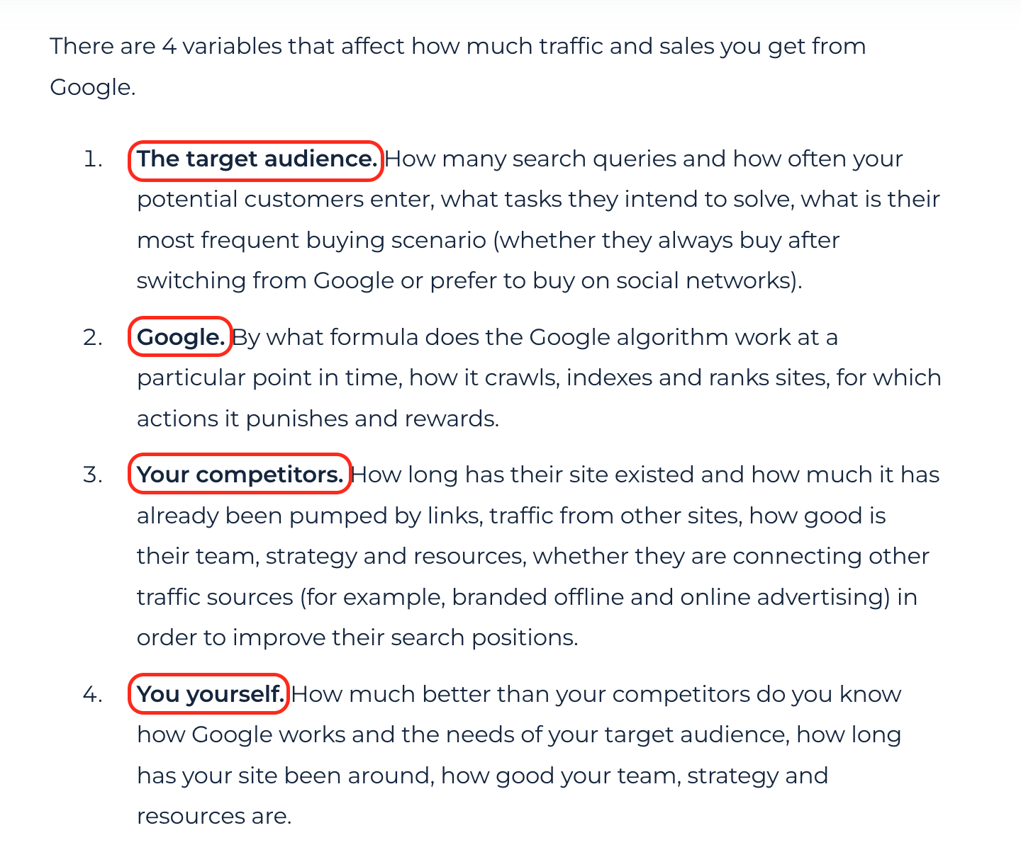

How to fix the issue
Review the page content and add <strong> elements to the most important words, phrases and sentences.
ISSUE 19

Page has no list markdown
Issue overview:
Page that have no <ol> or <ul> list markdown. The <ol> and <ul> elements both represent a list of items. The difference is with the <ol> element, the order is meaningful. To determine which one to use, try changing the order of the list items; if the meaning is changed, the <ol> element should be used, otherwise you can use <ul>. Using these elements in HTML you can manage user attention better and improve user engagement on the page.

Why it is important
Using list markdown helps to structure the text on the page and improve the user experience. This is especially important if the page type is article and it has many words and paragraphs.

How to fix the issue
Review the page content and add <ol> or <ul> elements to the lists in the text.
ISSUE 20

H1 = Alt
Issue overview:
The page has identical values in <h1> tag and alt attributes.
What is an alt tag?
ALT tags or ALT attributes are "alternative text" for an image. ALT tags are used to describe the image or what the image is representing. One of the main purposes of ALT tags is for the benefit of visually impaired users who use screen readers when browsing. ALT tags are also used for those who surf the web with images turned off or users that have text only browsers. As with many website specifics, ALT tags also play a role in SEO. ALT tags help search engines associate images with a webpage's content so they can properly index it within their search results. ALT tags also help search engines determine the best results to provide when a user searches for images.
What is H1?
The <h1> to <h6> HTML elements represent six levels of section headings. <h1> is the highest section level and <h6> is the lowest. The H1 tag is most commonly used to indicate the main topic on a web page.
What's wrong with having identical H1 and Alt tags on the page?
In a nutshell, it's not an error to have identical H1 and Alt tags. Anyway, it might be a lost opportunity or a sign of keywords overspamming on the page. Since, H1 and Alt tags serve for absolutely different purposes (Alt tags describe images, H1 describe page topic) and probability that the page topic equals some image on the page is pretty low.
How to resolve this issue?
Consider updating <h1> tag value or alt attribute value to make them unique. It may help to cover more keywords in page content and rank for more low-volume queries in Google as a result.
Further reading:
Guide on writing Alt tags
ISSUE 21

Page has less than 10 internal backlinks
Issue overview:
The optimum number of internal backlinks that point back to the page for most websites should be around 20.
This issue is being tested in the beta mode. If you need help with fixing this particular issue, please drop us a line at support@sitechecker.pro
What is an internal backlink?
An internal link is created when a link is added from one page on a website to another page on the same website.
How many incoming internal links should my page have?
"For most websites, and for most pages on those websites, the optimum number of links that point back to your content should be around 20. As with everything else related to SEO, this number will get slightly smaller or larger depending on the size of your site".
Source: https://www.directom.com/internal-links-affect-seo/
How to fix the issue?
Consider adding more internal backlinks to the page. Usually, it applies to the pages you want to get ranked for.
How to find the issue with Sitechecker?
Click on the links tab
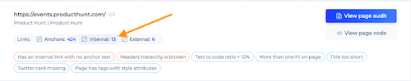
Then choose the internal backlinks filter.
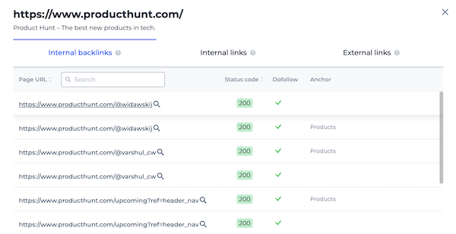
ISSUE 22

Page has internal backlinks with the same anchor
Issue overview:
Page has internal backlinks from different pages with the same anchor. Try to diversify your anchor list from internal backlinks to the specific page.

Why it is important
Internal backlinks and their anchor text has an impact on page rankings in search engine results page. It's better to use different anchors but with the same intent in internal backlinks to the page. For example Sitechecker has a page https://sitechecker.pro/wordpress-plugin-checker/ and internal backlinks to this page.
Bad implementation of anchors in internal backlinks for this page
- wordpress plugin checker
- wordpress plugin checker
- wordpress plugin checker
Good implementation of anchors in internal backlinks for this page
- wordpress plugin checker
- wordpress plugin detector
- wp plugin checker

How to fix the issue
Try to diversify your anchor list from internal backlinks to the specific page.
ISSUE 23

H1 has other tags inside
Issue overview:
There are some other tags within an <h1> tag. Example: <h1><a href=>test</a></h1>. Remove redundant tags from H1 tag to fix the issue.
How to find the issue?
Click on the View page code and search for the "<h1>". Find the redundant tags.
How to fix the issue?
Consider removing redundant tags inside the h1 tag.
ISSUE 24

Page has at least 1 click
Issue overview:
All HTML indexable pages that received at least 1 click based on Google Search Console data for the last 30 days.
Pages that already received clicks from Google usually are the most important to work with. Fixing issues, improving content and building backlinks to them you can increase organic traffic to them fast.
ISSUE 25

Page might have an outdated title
Issue overview:
Pages where title tag contains any other year but not this year. For example, <title>Top SEO Companies of 2020</title>.

How to fix the issue
Usually the year is used in title in two cases.
1. The page describes some things of the past
For example, The Great Recession of 2008: A Timeline and Its Effects. In this case you shouldn't change your title tag.
2. If the page is created to display the list of products, services, companies, etc. of the actual year
For example, 15 Best Notebooks 2021. In this case you usually need to change your title and update content to keep your page relevant for Google and target audience.
ISSUE 26

Page has tags with style attributes
Issue overview:
Pages that contain tags with style attributes, for example <p style="color:green">This is a paragraph.</p>.

Why it is important
Stephen Ostermiller left a great explanation on StackExchange about why using style attributes in tags is a bad practice.
Having inline CSS means that it can't be cached between page loads. That means that the first page view may be able to render faster, but subsequent page views are going to be slower.
There are good development practice reasons to keep you styles out of style attributes:
- Code in style attributes effects only one tag. If that same style is to be applied to multiple tags, the CSS code must be duplicated. That would violate the good development practice of "don't repeat yourself" (DRY).
- Keeping all CSS in .css files means that it is easy to find. Somebody looking at your code base for the first time is going to start looking for styles there and wouldn't want to have to open PHP and HTML files to find CSS.
- Keeping all CSS in .css files helps separate code that different developers are likely to work on. This "separation of concerns" means that the front end designer and the back end coder are less likely to step on each other's toes, and less likely make code changes that conflict with each other.

How to fix the issue
Delete style attributes in tags and set up all styles via .css files.
ISSUE 27

H1 too long
Issue overview:
The h1 tag exceeds 70 characters in length.

Why It's Important
Of all the headings in an HTML document, the h1 tag is the one with the highest priority, while h6 has the lowest possible priority level. Lower level headings and the text that they refer to are part of higher-level headings, hence, the totality of headings in a document forms a hierarchical structure similar to the outline of a document. While h2-h6 headings ale the elements of this outline, the h1 plays the role of the headline of the page or article. Headings are formatted using visual styles that convey their relative importance - h1 typically has the greatest font size.
An overly long h1 tag may lower the power of the text embedded in this tag.
Search Engine Optimization (SEO) Starter Guide made by Google recommends avoiding: excessive use of heading tags on a page and very long headings.

How to Check the Issue?
Head to https://codebeautify.org/source-code-viewer in order to open the source code of the page. Alternatively, use the functionality of your browser. In Chrome, it is enough to right-click the page and pick “View page source” from the context menu.
In the source code, locate text sequences flanked by <h1> which designate h1 tags.

How to Fix the Issue?
Edit h1 tags so that they have 20-70 characters in length, as recommended.
ISSUE 28

URL contains no Google Tag Manager code
Issue overview:
Pages that don't contain Google Tag Manager container code.
ISSUE 29

Page has more than 2 links to internal page with the same anchor
Issue overview:
Pages that contain more than 2 outgoing links to the same internal page with the same anchor. Usually it means that page has redundant links implemented manually by mistake or automatically by plugin.

Why it is important
Usually it is enough one internal link on the page for Googlebot to find and crawl a new page of your website. If the page has 3 and more internal links to the same target with the same anchor this is a trigger for research.

How to fix the issue
Check the internal links with the same anchor on the page. If some of the links are inserted manually by mistake or automatically by plugin, just delete them. But if you think that many similar links have a value for your website visitors don't change anything and ignore the issue.
ISSUE 30

Issue overview:
Consider changing HTTP link to HTTPS.
ISSUE 31

More than one h1 on page
Issue overview:
You have more than one H1 tag on the page. While a page can have multiple h2, h3, h4, or other heading tags, it's important to only have one h1.

The Importance of the issue
The headings used to organize content in the body of an HTML document have different hierarchical levels, starting with the least important (h6) and ending with the most important (h1). Each of these headings corresponds to a specific section of the document and is typically formatted in a style that allows distinguishing visually between headings of different levels. The h1 heading (h1 tag) is typically formatted with the largest font size.
Headings can be viewed as elements of a document’s outline. In this case, the h1 tag corresponds to the article’s title, h2 headings represent top-level chapters or content sections, and headings of lower levels are sub-chapters or sub-sections.
Having just one h1 heading per article is important because it makes it easier both for humans and search engines to identify the hierarchy of the content but also because the importance of the keywords wouldn’t be diminished due to excessive content in h1 tags.
Matt Cutts, the former head of the webspam team at Google, explains in details about using multiple H1 heading tags - video

How to check the issue?
Look into the source code of your HTML document with this simple tool at https://codebeautify.org/source-code-viewer. Alternatively, use the in-built browser tools with similar functionality - in Google Chrome, one can do this by right-clicking on a blank region or text and choosing “View page source.” In the source code, look for text flanked by <h1> - the latter designates h1 headings.

How to fix the issue?
Make sure you leave only one h1 tag - the simplest way to do this might be to convert h1’s into h2’s.
ISSUE 32

Title too long
Issue overview:
The title on certain pages is longer than 65 characters.

Why It's Important
Having a longer title isn’t catastrophic since it is not associated with page ranking penalties. What search engines do with titles longer than 65 characters is to simply ignore any text above this limit, while also truncating it to around 70 characters on the SERP snippet. The exact length at which different search engines truncate varies - for instance, Google will do this at approximately 70 characters (earlier than other search engines). Hence, when writing titles, it is good to adopt this figure as the upper limit, to ensure that titles are displayed in full across various search engines.
Obviously, including important keywords after the 70 character limit must be avoided since they will be simply ignored. In fact, it is advisable to respect this limit in all scenarios, since this will ensure that no truncation happens and users see your titles exactly as you write them.
According to RanRanger research, search snippets can now be anywhere from 160 characters to 230 characters on average. Google officially confirmed that search result snippets were now longer than what once had been the maximum length of 160 characters.

How to Check the Issue?
Access to the source code is needed to locate and fix the issue. You could view the source code with this online tool https://codebeautify.org/source-code-viewer or by using your browser. For instance, right-click on a neutral region in the Chrome browser and select to view the page source from the context menu.
Once done, search for <title> in the head of the HTML document.

How to Fix the Issue?
Shorten titles to under 65 symbols, at least on the most important pages or on pages where important keywords appear past the 70 character limit.
When writing good titles, several rules should be followed:
- The length should be within 40-70 characters.
- The most important keywords should appear as early as possible (leftmost location).
- By contrast, brand names or the name of the site should be mentioned at the very end, so that, if the title gets truncated, it would have a minimal impact.
- Instead of just listing keywords, naturally sounding and easily readable titles should be written.
- Each title should be unique.
- For large sites, it is common practice to employ automatic template-based title generation aided by specialized software. In this case, it is important to closely watch the output of such software and to ensure that the tiles make sense, are relevant, and readable.
ISSUE 33

Issue overview:
URLs where the content to code ratio is less than 10%.

The importance of the issue
John Mueller, a Google employee, on the ratio of the code and content of a page:
As far as I know, we don’t use the text to HTML ratio for anything. So this is something that some SEO tools came up with at some point. But from our point of view we don’t use that at all.
I wouldn’t focus on a metric like that unless there is something of value you can pull out of that for the users. Maybe what you could be looking at there is seeing that these pages are bloated HTML and when you serve them to users, especially on mobile, it slows everything down. Thats one aspect that could be playing a role there, which is more between you and your users.
But at least from a search or SEO point of view, we don’t look at the text to HTML ratio at all.
https://youtu.be/4QL1uuo_NNA?t=1921
Despite this being an indirect Google ranking factor, it is not recommended to “pump” a HTML code relative to the useful content at a page, as it might have an indirect negative influence over your website. Redundant HTML code might slow down the page loading as well as its analysis by search robots.

How to check the issue
Use the data obtained from the free text-to-code-ratio checker or any other online service for Code Ratio check.

How to fix this issue
- Check the HTML code validity here https://validator.w3.org/
- Delete the useless code
- Delete large “empty” spaces from the code
- Delete large comments from the code
- Delete any hidden text that is not visible to users
ISSUE 34

Canonical ≠ URL
Issue overview:
Page has a canonical element pointing at another internal URL.

The importance of the issue
rel=canonical is applied to combine pages with identical contents and set the main version of the page for the search engine https://support.google.com/webmasters/answer/139066?hl=en. A href attribute for <link rel="canonical" href="https://site.com/"> has to contain only an URL of the page we want to set as the main one for several pages with repeating content.

How to check the issue
Using any browser is enough to check the issue. Open the source code of the flawed page To do this, click the right mouse button at any spot of the page and choose “browse the code” option, or apply an online tool https://codebeautify.org/source-code-viewer
Find the link tag with the rel = ”canonical” attribute.
Example:
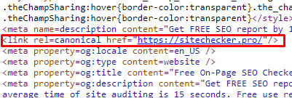
A href attribute value should contain a hyperlink.

How to fix this issue
If the canonical generation takes place automatically, it is necessary to review the algorithm. The issue is mostly caused by manual settings. In this case, you need to set a correct value of a href attribute for rel=canonical in a specific page configuration.
ISSUE 35

Issue overview:
The Description for a specific URL is longer than 160 characters.

The importance of the issue
Search engines mostly use description to generate a snippet. The snippet quality influences the click-through rate, consequently influencing the website traffic and, indirectly, its ranking.
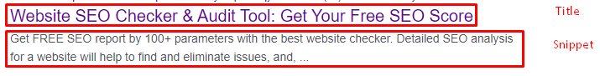
If the meta description is too long, it can be treated as spam and ignored. In its turn, this will cause loss of opportunities for snippet optimization.

How to check the issue
Using any browser is enough to check the issue. Open the source code of the flawed page. To do this, click the right mouse button at any spot of the page and choose “browse the code” option, or apply an online tool https://codebeautify.org/source-code-viewer
Find <meta name=description content=""/> and check the meta description length. It is not recommended to use more than 160 symbols for description . To count symbols, you can copy the meta description to any online service for symbol counting, such as https://copywritely.com/word-counter/

How to fix this issue
If you generate meta descriptions, change the generation algorithm and template to make sure your meta description doesn’t exceed 160 symbols.
If you generate meta descriptions manually, change them for all affected pages.
ISSUE 36

H1 = Title
Issue overview:
The h1 tag and the meta title are identical.

Why it is important
The h1 tag is the HTML heading with the highest level of importance. By contrast, h2 headings have lower importance and designate the main sections of the article. Each h2 heading might contain multiple h3 subheadings and the latter might contain lower-level headings like h4, h5, and h6 (which is the lowest level possible). Putting together all h6-h2 headings by respecting their hierarchy, one would obtain an outline of the document, while the h1 tag would be equivalent to the headline or title of the article. The h1 tag would also be typically formatted with the largest font size on the page, given that headings are normally styled according to their importance.
Although they have a fairly similar goal, the h1 tag and the meta title are displayed differently. Despite the fact that there is no penalty for them being identical, the h1 presents a valuable opportunity to include additional keywords that didn’t fit into the meta title. You can read more about how Google recognizes duplicate content here.

How to checker the issue
Check the source code. Access the page with your Chrome browser, right-click it, and pick “View page source” (this method differs in other browsers). This simple online tool https://codebeautify.org/source-code-viewer will also help you access the source code.
To locate the h1 tag and meta title, look for “<h1>” and “<title>”, respectively and compare these two.

How to fix the issue
Consider rewriting the h1 tag by including overlooked keywords and making it highly relevant for the page.
ISSUE 37

Meta noindex pages
Issue overview:
A specific URL contains <meta name="robots" content="noindex" /> .

The importance of the issue
The presence of the <meta name="robots" content="noindex" /> directive prevents the appearance of the specific URL in search results. The presence of the directive at a page used for attracting users from search engines might harm your website, as the page does not take part in search results, so it does not generate the search traffic. This directive should be used only for the pages which should not appear among the search results.

How to check the issue
Using any browser is enough to check the issue. Open the source code of the flawed page. To do this, click the right mouse button at any spot of the page and choose “browse the code” option, or apply an online tool https://codebeautify.org/source-code-viewer
Find a tag <meta name="robots" content="noindex" />. The presence of such code segment points to an issue at this page.

How to fix this issue
Before fixing this, make sure that indexation has not been prohibited purposefully, which is a common SEO practice.
Delete the construction <meta name="robots" content="noindex" />. In popular CMS, the settings can be adjusted in a plugin:
at a specific page, for example, in Yoast plugin for Wordpress https://yoast.com/wordpress-noindex-post/.
for all CMS Wordpress pages of the same type: https://yoast.com/wordpress/plugins/seo/yoast-seo-robots-meta-configuration/
in case all CMS Wordpress pages contain this directive, follow the guideline:
- enter the /wp-admin of your website and go to Settings -> Reading.
- find the Search Engine Visibility option.
- clear a checkbox Discourage search engines from indexing this site
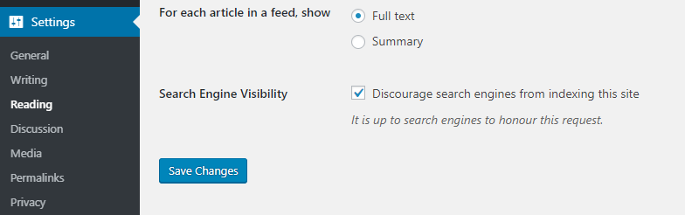
- save the changes.
ISSUE 38

Meta nofollow pages
Issue overview:
A specific URL contains <meta name="robots" content="nofollow" />.

The importance of the issue
The presence of a <meta name="robots" content="nofollow" /> directive notifies the search engine that it should follow the links at this page. The presence of the directive at a page that is used for attracting users to the website can harm your website. It means you recommend a bot to avoid following internal links, thus decreasing their value and weight distribution among the links inside the website. Despite the presence of the recommendation, a search engine mostly follows such links.
The Google support contains the following information:
Use the nofollow value when other values don't apply, and you'd rather Google not associate your site with, or crawl the linked page from, your site. (For links within your own site, use robots.txt, as described below.)

How to check the issue
Using any browser is enough to check the issue. Open the source code of the flawed page. To do this, click the right mouse button at any spot of the page and choose “browse the code” option, or apply an online tool https://codebeautify.org/source-code-viewer
Find a tag <meta name="robots" content="nofollow" />. The presence of such code segment points to an issue at this page.

How to fix this issue
Delete the construction <meta name="robots" content="nofollow" />. In popular CMS, the settings can be adjusted in a plugin of a specific page, such as the Wordpress Yoast plugin.
If such an issue is present at most pages of the website, you should edit the template that has the affected link.

