**System Programming**

` ASSIGNMENT 2

**Name –** Nikhil Badyal

**Roll –** 001810501069

**Class –** BCSE 3rd year

**Group –** A2

1. **Write and test a MASM program to add and subtract two 16 bit numbers.**

**Code:**

.model small

.stack 300h

.data

msg1 db 0AH,0DH,'ENTER 1ST NUMBER: $'

msg2 db 0AH,0DH,'ENTER 2ND NUMBER: $'

msg3 db 0AH,0DH,'THE RESULT AFTER ADDITION IS: $'

msg4 db 0AH,0DH,'THE RESULT AFTER SUBTRACTION IS: $'

space db ' $'

endl db 0AH,0DH,'$'

val1 dw ?

val2 dw ?

.code

print macro msg ; macro to print a string

push ax

push dx

mov ah, 09h

lea dx, msg

int 21h

pop dx

pop ax

endm

main proc

mov ax,@data

mov ds,ax

print msg1 ;printing first msg

call readhex ; reading first hex number

mov val1, ax

print msg2

call readhex ; reading second hex number

mov val2, ax

print msg3

mov ax, val1

mov bx, val2

add ax,bx ; adding first number with second number

call writehex ; printing the result

print msg4

mov ax, val1

mov bx, val2

sub ax,bx ; subtract second number from first number

call writehex ; printing the result

mov ah, 4ch ;exit

int 21h

main endp

readhex proc near

; this will input a 16 bit hexadecimal number

; output : AX

push bx

push cx

push dx

xor bx,bx ;initially bx value is equal to 0

mov cl,4

mov ah,1 ;for taking input

int 21h

input1:

cmp al,0dh ;compare whether the pressed key is 'enter' or not

je line1 ;if it is equal to 'enter' then stop taking first value

cmp al,39h ;find whether it is letter or digit.39h is the ascii value of 9

jg letter1

and al,0fh ;if digit then convert it's ascii value to real value

jmp shift1

letter1: ;if it is letter then subtract 37h from it to find it's real value

sub al,37h

shift1:

shl bx, cl

or bl,al ;making 'or' will add the current value with previous value

int 21h

jmp input1

line1:

mov ax, bx

pop dx

pop cx

pop bx

ret

readhex endp

writehex proc near

; this procedure is to display number in hexadecimal

; Input : AX

push bx

push cx

push dx

mov dx, 0000h

jnc notcarry

inc dx

notcarry:

mov si, ax

mov bx, dx ; Result in reg bx

mov dh, 2

l1: mov ch, 04h ; Count of digits to be displayed

mov cl, 04h ; Count to roll by 4 bits

l2: rol bx, cl ; roll bl so that msb comes to lsb

mov dl, bl ; load dl wth data to be displayed

and dl, 0fH ; get only lsb

cmp dl, 09 ; check if digit is 0-9 or letter A-F

jbe l4

add dl, 07 ; if letter add 37H eg. A+37=41 else only add 30H

l4: add dl, 30H ;eg9+30=39 ascii of 9

mov ah, 02 ; Function 2 under INT 21H (Display character)

int 21H

dec ch ; Decrement Count

jnz l2

dec dh

cmp dh, 0

mov bx, si

jnz l1

pop dx

pop cx

pop bx

ret

writehex endp

end main

**Output:**

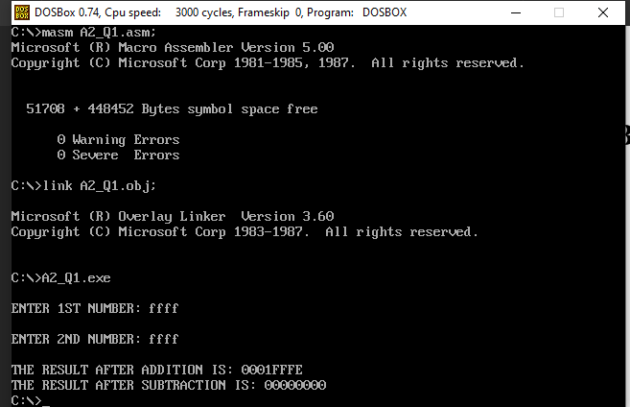

1. **Write and test a MASM program to convert Binary digit to Decimal and vice versa.**

**Code:**

.model small

.stack 300h

.data

msg1 db 0AH,0DH,'Enter binary number: $'

msg2 db 0AH,0DH,'Decimal: $'

msg3 db 0AH,0DH,'Enter Decimal number: $'

msg4 db 0AH,0DH,'Binary: $'

space db ' $'

endl db 0AH,0DH,'$'

binno db 17 ;MAX NO. OF CHARRRACTERS ALLOWED

db ? ;NO. OF CHARACTERS ENTERED BY USER

db 17 dup(0) ;INITIALIZING

str1 db 20 dup('$')

str2 db 20 dup('$')

val1 dw ?

val2 dw ?

.code

print macro msg ; macro to print a string

push ax

push dx

mov ah, 09h

lea dx, msg

int 21h

pop dx

pop ax

endm

read macro memloc ; macro to read a binary number

push ax

push cx

push dx

mov ah, 0ah

lea dx, memloc

int 21h

lea si, memloc + 1 ;NUMBER OF CHARACTERS ENTERED.

mov cl, [si] ;MOVE LENGTH TO CL.

mov ch, 0 ;CLEAR CH TO USE CX.

inc cx ;TO REACH CHR(13).

add si, cx ;NOW SI POINTS TO CHR(13).

mov al, '$'

mov [si], al ;REPLACE CHR(13) BY '$'.

pop dx

pop cx

pop ax

endm

main proc

mov ax,@data

mov ds,ax

start:

print msg1

read binno ; bin no is stOred in binno

print msg2

mov ax,0000h

mov bx,0000h

lea si, binno + 1

mov cl, [si] ;NUMBER OF CHARACTERS ENTERED BY USER

mov ch, 00h

inc si ;NOW SI POINTS TO THE FIRST CHARACTER OF BINNO

mov ax,00h

loop1:

mov bl, [si]

sub bl, '0'

mov bh, 00h

mov dx,02h

mul dx ; ax = ax * dx

add ax, bx

;call writenum

;call endl

inc si

loop loop1

call writenum ;printing the decimal value of given binary number

print endl

print msg3

call readnum ;reading a decimal number

lea si, str1

mov bh, 00

mov bl,2

l1:

div bl

add ah,'0'

mov byte ptr[si],ah

mov ah, 00

inc si

inc bh

cmp al,00

jne l1

mov cl,bh

lea si, str1

lea di, str2

mov ch, 00

add si, cx

dec si

l2:

mov ah,byte ptr[si]

mov byte ptr[di],ah

dec si

inc di

loop l2

print msg4

print str2 ;printing the binary value of given decimal number

exit:

mov ah, 4ch

int 21h

main endp

readnum proc near

; this procedure will take a number as input from user and store in AX

; input : none

; output : AX

push bx

push cx

mov cx,0ah

mov bx,00h

loopnum:

mov ah,01h

int 21h

cmp al,'0'

jb skip

cmp al,'9'

ja skip

sub al,'0'

push ax

mov ax,bx

mul cx

mov bx,ax

pop ax

mov ah,00h

add bx,ax

jmp loopnum

skip:

mov ax,bx

pop cx

pop bx

ret

readnum endp

writenum proc near

; this procedure will display a decimal number

; input : AX

; output : none

push ax

push bx

push cx

push dx

xor cx, cx

mov bx, 0ah

@output:

xor dx, dx

div bx ; divide AX by BX and remainder will store to the dx

push dx ; push remainder onto the STACK

inc cx

or ax, ax

jne @output

mov ah, 02h ; set output function

@display:

pop dx ; pop a value(remainder) from STACK to DX

or dl, 30h ; convert decimal to ascii code

int 21h

loop @display

pop dx

pop cx

pop bx

pop ax

ret

writenum endp

end main

**Output:**

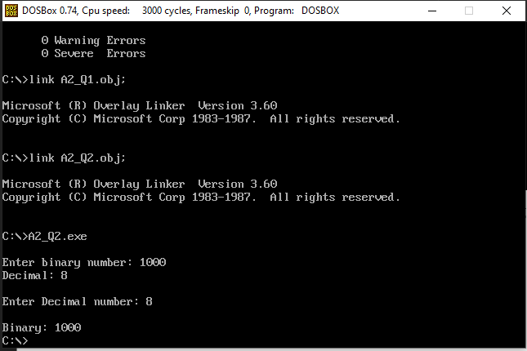

1. **Write and test a program to print pairs of even numbers where the summation of the numbers in each pair is 100.**

**Code:**

.model small

.stack 300h

.data

char1 db '($'

char2 db ')$'

space db ' $'

val1 dw ?

.code

print macro msg ; macro to print a string

push ax

push dx

mov ah, 09h

lea dx, msg

int 21h

pop dx

pop ax

endm

main proc

mov ax,@data

mov ds,ax

mov bx, 100 ; storing the decimal value 100

mov ax, 100

loop1:

print char1 ; print opening bracket

call writenum ; print first number of pair

print space

mov val1, ax

mov ax, bx

mov cx, val1

sub ax, cx ; subtract first number with 100 to get second number of pair

call writenum ; print second number of pair

print char2 ; print closing bracket

print space ; print space

mov ax, val1

sub ax,2 ; subtract first value by 2

jnz loop1 ; loop until first value becomes 0

print char1

call writenum

print space

mov ax, 64h

call writenum

print char2

mov ah, 4ch

int 21h

main endp

writenum proc near

; this procedure will display a decimal number

; input : AX

; output : none

push ax

push bx

push cx

push dx

xor cx, cx

mov bx, 0ah

@output:

xor dx, dx

div bx ; divide AX by BX

push dx ; push remainder onto the STACK

inc cx

or ax, ax

jne @output

mov ah, 02h ; set output function

@display:

pop dx ; pop a value(remainder) from STACK to DX

or dl, 30h ; convert decimal to ascii code

int 21h

loop @display

pop dx

pop cx

pop bx

pop ax

ret

writenum endp

end main

**Output:**

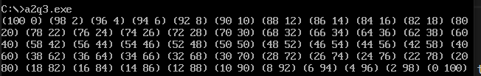

1. **Write and test a MASM program to multiply two 32 bit numbers.**

**Code:**

.model small

.stack 300h

.data

msg1 db 0AH,0DH,'ENTER 1ST HEX NUMBER: $'

msg2 db 0AH,0DH,'ENTER 2ND HEX NUMBER: $'

msg3 db 0AH,0DH,'THE RESULT AFTER MULTIPLYING IS: $'

val1 dw ?

val2 dw ?

.code

print macro msg ; macro to print a string

push ax

push dx

mov ah, 09h

lea dx, msg

int 21h

pop dx

pop ax

endm

main proc

mov ax,@data

mov ds,ax

print msg1

call readhex ; read first hex number

mov val1, ax

print msg2

call readhex ; read second hex number

print msg3

mul val1 ; multiply first number with second number

call writehex ; printing the result

mov ah, 4ch

int 21h

main endp

readhex proc near

; this will input a 16 bit hexadecimal number

; output : AX

push bx

push cx

push dx

xor bx,bx ;initially bx value is equal to 0

mov cl,4

mov ah,1 ;for taking input

int 21h

input1:

cmp al,0dh ;compare whether the pressed key is 'enter' or not

je line1 ;if it is equal to 'enter' then stop taking first value

cmp al,39h ;compare whether it is letter or digit.39h is the ascii 9

jg letter1

and al,0fh ;if it is digit then convert it's ascii value to real value

jmp shift1

letter1: ;if it is letter then subtract 37h from it to find it's real value

sub al,37h

shift1:

shl bx, cl

or bl,al ;making 'or' will add the current value with previous value

int 21h

jmp input1

line1:

mov ax, bx

pop dx

pop cx

pop bx

ret

readhex endp

writehex proc near

; this procedure is to display number in hexadecimal

; Input : AX

push bx

push cx

push dx

mov si, ax

mov bx, dx ; Result in reg bx

mov dh, 2

l1: mov ch, 04h ; Count of digits to be displayed

mov cl, 04h ; Count to roll by 4 bits

l2: rol bx, cl ; roll bl so that msb comes to lsb

mov dl, bl ; load dl wth data to be displayed

and dl, 0fH ; get only lsb

cmp dl, 09 ; check if digit is 0-9 or letter A-F

jbe l4

add dl, 07 ; if letter add 37H else only add 30H

l4: add dl, 30H

mov ah, 02 ; Function 2 under INT 21H (Display character)

int 21H

dec ch ; Decrement Count

jnz l2

dec dh

cmp dh, 0

mov bx, si

jnz l1

pop dx

pop cx

pop bx

ret

writehex endp

end main

**Output:**

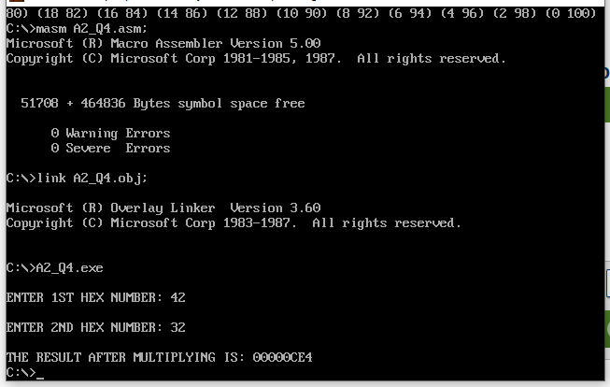

1. **Write and test a MASM program to divide a 16 bit number by an 8 bit number.**

**Code:**

.model small

.stack 300h

.data

msg1 db 0AH,0DH,'ENTER 1ST NUMBER: $'

msg2 db 0AH,0DH,'ENTER 2ND NUMBER: $'

msg3 db 0AH,0DH,'THE RESULT AFTER DIVIDING IS: $'

val1 dw ?

val2 dw ?

.code

print macro msg

push ax

push dx

mov ah, 09h

lea dx, msg

int 21h

pop dx

pop ax

endm

main proc

mov ax,@data

mov ds,ax

print msg1

call readnum ;read first number

mov val1, ax

print msg2

call readnum ; read second number

mov val2, ax

print msg3

mov ax, val1

mov bx, val2

div bx ; dividing first number by second number

call writenum ; printing the result

mov ah, 4ch

int 21h

main endp

readnum proc near

; this procedure will take a number as input from user and store in AX

; input : none

; output : AX

push bx

push cx

mov cx,0ah

mov bx,00h

loopnum:

mov ah,01h

int 21h

cmp al,'0'

jb skip

cmp al,'9'

ja skip

sub al,'0'

push ax

mov ax,bx

mul cx

mov bx,ax

pop ax

mov ah,00h

add bx,ax

jmp loopnum

skip:

mov ax,bx

pop cx

pop bx

ret

readnum endp

writenum proc near

; this procedure will display a decimal number

; input : AX

; output : none

push ax

push bx

push cx

push dx

xor cx, cx

mov bx, 0ah

@output:

xor dx, dx

div bx ; divide AX by BX

push dx ; push remainder onto the STACK

inc cx

or ax, ax

jne @output

mov ah, 02h ; set output function

@display:

pop dx ; pop a value(remainder) from STACK to DX

or dl, 30h ; convert decimal to ascii code

int 21h

loop @display

pop dx

pop cx

pop bx

pop ax

ret

writenum endp

end main

**Output:**

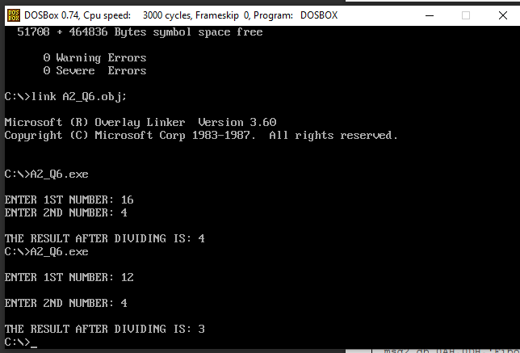

1. **Write and test a MASM program to Print Fibonacci series up to 10 terms.**

**Code:**

.model small

.stack 300h

.data

msg1 db 0AH,0DH,'Enter number of steps: $'

msg2 db 0AH,0DH,'Fibonacci sequence: $'

space db ' $'

endl db 0AH,0DH,'$'

val db ?

.code

print macro msg ; macro to print a string

push ax

push dx

mov ah, 09h

lea dx, msg

int 21h

pop dx

pop ax

endm

main proc

mov ax,@data

mov ds,ax

print msg1

call readnum ; read the number of terms to be printed

mov val, al

mov bx, 00h

mov dx, 01h

mov cl, val

mov ch, 00h

mov ax, 00h

print msg2

print endl

loop1:

mov ax, bx

call writenum ; printing each term

print space

add ax, dx

mov dx, bx

mov bx, ax

loop loop1 ; loop n times ( n is stored in cl )

exit:

mov ah, 4ch

int 21h

main endp

readnum proc near

; this procedure will take a number as input from user and store in AX

; input : none

; output : AX

push bx

push cx

mov cx,0ah

mov bx,00h

loopnum:

mov ah,01h

int 21h

cmp al,'0'

jb skip

cmp al,'9'

ja skip

sub al,'0'

push ax

mov ax,bx

mul cx

mov bx,ax

pop ax

mov ah,00h

add bx,ax

jmp loopnum

skip:

mov ax,bx

pop cx

pop bx

ret

readnum endp

writenum proc near

; this procedure will display a decimal number

; input : AX

; output : none

push ax

push bx

push cx

push dx

xor cx, cx

mov bx, 0ah

@output:

xor dx, dx

div bx ; divide AX by BX

push dx ; push remainder onto the STACK

inc cx

or ax, ax

jne @output

mov ah, 02h ; set output function

@display:

pop dx ; pop a value(remainder) from STACK to DX

or dl, 30h ; convert decimal to ascii code

int 21h

loop @display

pop dx

pop cx

pop bx

pop ax

ret

writenum endp

end main

**Output:**

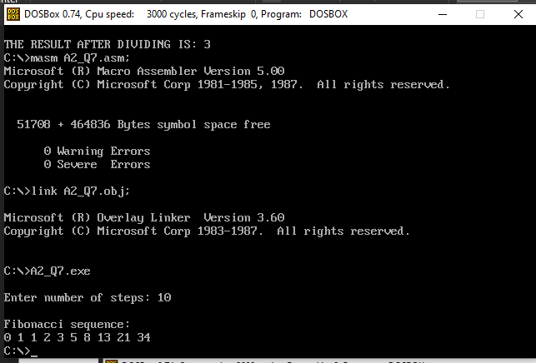

1. **Write and test a MASM program for substring deletion from a given string.**

**Code:**

.MODEL SMALL

.STACK 100H

.DATA

MESS1 DB 10,13, "Enter your string : $"

MESS2 DB 10,13, "Enter your substring that you want to be delete : $"

MESS3 DB 10,13, "The string after deletion is : $"

MESS4 DB 10,13, "Substring is not contained in string.$"

STRING DB 50 DUP(?)

SUBSTRING DB 50 DUP(?)

NUM DW ?

LEN1 DB ?

LEN2 DB ?

STARTINDEX DW ?

ENDINDEX DW ?

.CODE

MOV AX, @DATA

MOV DS, AX

LEA DX, MESS1

MOV AH, 09H

INT 21H

MOV SI, 0

MOV CX, 0

MOV AH, 01H

IN1: INT 21H

CMP AL, 0DH

JE OUT1

MOV STRING[SI], AL

INC SI

INC CX

JMP IN1

OUT1:

MOV LEN1, CL

LEA DX, MESS2

MOV AH, 09H

INT 21H

MOV SI, 0

MOV CX, 0

MOV AH, 01H

IN2: INT 21H

CMP AL, 0DH

JE OUT2

MOV SUBSTRING[SI], AL

INC SI

INC CX

JMP IN2

OUT2:

MOV LEN2, CL

MOV DH, 0

MOV DL, LEN1

SUB DL, LEN2

ADD DL, 1

MOV CH, 0

MOV CL, LEN2

MOV SI, 0

EQUL: MOV STARTINDEX, SI

MOV AL, STRING[SI]

MOV BL, SUBSTRING[0]

CMP AL, BL

JNE NEXXTT

MOV DI, 0

EQULN:

MOV AL, STRING[SI]

MOV BL, SUBSTRING[DI]

CMP AL, BL

JNE NEXT

ADD SI, 1

ADD DI, 1

LOOP EQULN

NEXT: CMP CX, 0

JBE FIND

;MOV NUM, SI

;CALL OUTPUT

MOV SI, STARTINDEX

NEXXTT: INC SI

MOV CH, 0

MOV CL, LEN2

DEC DX

JNE EQUL

JMP NOTFIND

FIND: MOV CL, LEN1

MOV BH, LEN2

CMP CL, BH

JB NOTFIND

LEA DX, MESS3

MOV AH, 09H

INT 21H

SUB SI, 1

MOV ENDINDEX, SI ;ENDINDEX WILL BE SI+LENGTH OF SUBSTRING

MOV CH, 0

MOV CL, LEN1

MOV DI, 0

MOV AH, 02H

PRINT: CMP DI, STARTINDEX

JB PRINTC

CMP DI, ENDINDEX

JA PRINTC

JMP NEXTT

PRINTC:MOV DL, STRING[DI]

INT 21H

NEXTT: ADD DI, 1

LOOP PRINT

JMP EXITT

NOTFIND: LEA DX, MESS4

MOV AH, 09H

INT 21H

EXITT: MOV AH, 4CH

INT 21H

END

**Output:**

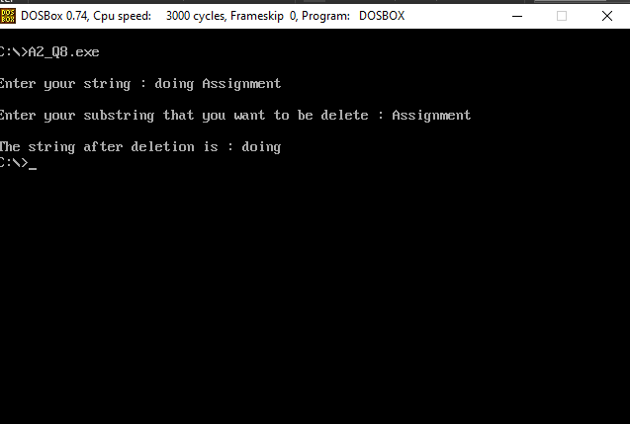

1. **Write and test a MASM program to identify the GCD and LCM of three numbers.**

**Code:**

.model small

.stack 300h

.data

msg1 db 0AH,0DH,'Enter 3 numbers: $'

msg2 db 0AH,0DH,'GCD: $'

msg3 db 0AH,0DH,'LCM: $'

space db ' $'

endl db 0AH,0DH,'$'

val1 dw ?

val2 dw ?

val3 dw ?

num1 dw ?

num2 dw ?

num3 dw ?

.code

print macro msg

push ax

push dx

mov ah, 09h

lea dx, msg

int 21h

pop dx

pop ax

endm

main proc

mov ax,@data

mov ds,ax

start:

print msg1

call readnum

mov val1, ax

call readnum

mov val2, ax

call readnum

mov val3, ax

mov dx, 0000h

mov bx, val1

mov cx, val2

loopgcd:

mov ax, bx

mov dx, 0000h

div cx

cmp dx,0000h

jz ans

mov bx,cx

mov cx,dx

;mov ax,bx

;call writenum

;mov ax,cx

;call writenum

cmp cx, 0001h

jnz loopgcd

ans:

mov num1, cx

mov dx, 0000h

mov bx, val3

loopgcd1:

mov ax, bx

mov dx, 0000h

div cx

cmp dx, 0000h

jz ans1

mov bx, cx

mov cx, dx

cmp cx, 0001h

jnz loopgcd1

ans1:

print msg2

mov ax, cx

call writenum

mov ax, val1

mov bx, val2

mul bx

mov bx, num1

div bx

mov bx, val3

mul bx

div cx

print msg3

call writenum

exit:

mov ah, 4ch

int 21h

main endp

readnum proc near

; this procedure will take a number as input from user and store in AX

; input : none

; output : AX

push bx

push cx

mov cx,0ah

mov bx,00h

loopnum:

mov ah,01h

int 21h

cmp al,'0'

jb skip

cmp al,'9'

ja skip

sub al,'0'

push ax

mov ax,bx

mul cx

mov bx,ax

pop ax

mov ah,00h

add bx,ax

jmp loopnum

skip:

mov ax,bx

pop cx

pop bx

ret

readnum endp

writenum proc near

; this procedure will display a decimal number

; input : AX

; output : none

push ax

push bx

push cx

push dx

xor cx, cx

mov bx, 0ah

@output:

xor dx, dx

div bx ; divide AX by BX

push dx ; push remainder onto the STACK

inc cx

or ax, ax

jne @output

mov ah, 02h ; set output function

@display:

pop dx ; pop a value(remainder) from STACK to DX

or dl, 30h ; convert decimal to ascii code

int 21h

loop @display

pop dx

pop cx

pop bx

pop ax

ret

writenum endp

end main

**Output:**

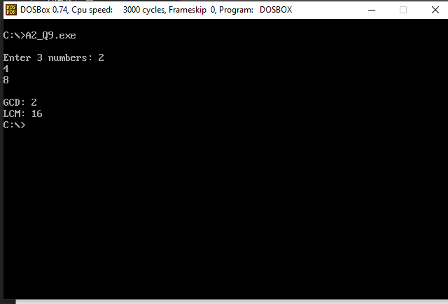

1. **Write and test a MASM program to Implement Linear search and Binary Search.**

**Code:**

.MODEL SMALL

.STACK 300H

.DATA

ARRAY1 DB 11,22,33,44,55

MSG4 DB 0AH,0DH,'Enter size of the array: $'

MSG1 DB 0AH,0DH,'Enter number to be searched: $'

MSG2 DB 0AH,0DH,'FOUND AT POSITION $ '

MSG3 DB 0AH,0DH,'NOT FOUND$'

ENDL DB 0AH,0DH,'$'

SE DB 33H

COUNT DB 00H

.CODE

PRINT MACRO MSG ; macro to print a string

push ax

push dx

mov AH, 09H

lea DX, MSG

int 21H

;int 3

pop dx

pop ax

ENDM

MAIN PROC

MOV AX,@DATA

MOV DS,AX

START:

PRINT MSG4

call readnum ; read size of array

mov COUNT, al

mov cl, COUNT

mov bx, 00h

rdnxt:

PRINT ENDL

call readnum ; read the array elements

mov ARRAY1[BX],AL

inc BX

loop rdnxt

mov cl, COUNT

PRINT MSG1

call readnum ; read the value to be searched

mov se,al

mov al,se

mov ah,00h

LEA SI, ARRAY1

mov bh, 00h

UP:

MOV BL,[SI]

CMP AL, BL

JZ FO

INC SI

inc bh

loop UP

PRINT MSG3 ; print message

JMP END1

FO:

PRINT MSG2 ; print message

mov al, bh

call writenum ; print the position of the found element

END1:

mov ah, 4ch

int 21h

MAIN ENDP

readnum proc near

; this procedure is to read a decimal number

; input : none

; output : AX

push bx

push cx

mov cx,0ah

mov bx,00h

loopnum:

mov ah,01h

int 21h

cmp al,'0'

jb skip

cmp al,'9'

ja skip

sub al,'0'

push ax

mov ax,bx

mul cx

mov bx,ax

pop ax

mov ah,00h

add bx,ax

jmp loopnum

skip:

mov ax,bx

pop cx

pop bx

ret

readnum endp

writenum PROC near

; this procedure will display a decimal number

; input : AX

; output : none

push bx ; push BX onto the STACK

push cx ; push CX onto the STACK

push dx ; push DX onto the STACK

XOR CX, CX ; clear CX

MOV BX, 10 ; set BX=10

@OUTPUT: ; loop label

XOR DX, DX ; clear DX

DIV BX ; divide AX by BX

PUSH DX ; push DX onto the STACK

INC CX ; increment CX

OR AX, AX ; take OR of Ax with AX

JNE @OUTPUT ; jump to label @OUTPUT if ZF=0

MOV AH, 2 ; set output function

@DISPLAY: ; loop label

POP DX ; pop a value from STACK to DX

OR DL, 30H ; convert decimal to ascii code

INT 21H ; print a character

LOOP @DISPLAY ; jump to label @DISPLAY if CX!=0

POP DX ; pop a value from STACK into DX

POP CX ; pop a value from STACK into CX

POP BX ; pop a value from STACK into BX

RET ; return control to the calling procedure

writenum ENDP

END MAIN

MODEL SMALL

.STACK 300H

.DATA

ARRAY1 DB 11,22,33,44,55

MSG1 DB 0AH,0DH,'Enter size of the array: $'

MSG2 DB 0AH,0DH,'Enter a number to be searched: $'

MSG3 DB 0AH,0DH,'Current array: $'

MSG4 DB 0AH,0DH,'Element found.$ '

MSG5 DB 0AH,0DH,'Element not found.$'

space db ' $'

ENDL DB 0AH,0DH,'$'

key dw ?

mididx dw ?

left dw ?

right dw ?

SE DB 33H

COUNT DB 00H

.CODE

PRINT MACRO MSG

push ax

push dx

mov AH, 09H

lea DX, MSG

int 21H

pop dx

pop ax

ENDM

MAIN PROC

MOV AX,@DATA

MOV DS,AX

START:

PRINT MSG1

call readnum

mov COUNT, al

mov cl, COUNT

mov bx, 00h

rdnxt:

PRINT ENDL

call readnum

mov ARRAY1[BX],AL

inc BX

loop rdnxt

print msg2

call readnum

mov key, ax ;key to be searched

mov dx, bx ;last index

mov bx, 0 ;first index

LEA SI, ARRAY1

call binsearch ;calling proc to perform binary search

mov ah, 4ch

int 21h

MAIN ENDP

binsearch proc

;input -

;bx - left index

;dx - right index

push ax

push bx

push cx

push dx

push si

mov cx,key

dec dx

@startsearch:

mov left, bx

mov right, dx

inc dx

mov ah,01h

int 21h

@l1:

xor ah,ah

mov al,array1[bx]

call writenum

print space

inc bx

cmp bx,dx

jne @l1

print endl

mov bx,left

mov dx,right

cmp bx, dx

jg @notfound

mov ax, bx

add ax,dx ;ax = bx+dx

shr ax,1 ; ax = (l+r)/2

mov left, bx ; left = bx

mov mididx,ax ;mididx = ax

mov bx, ax ; bx = ax

cmp cl, array1[bx] ;compare key with midval

je @found

jg @bigpivot

jmp @smallpivot

@bigpivot:

mov ax, mididx

mov bx, left

inc ax

mov bx, ax ;left index = mididx + 1

jmp @startsearch

@smallpivot:

mov ax, mididx

mov bx, left

dec ax

mov dx, ax ; right index = mididx - 1

jmp @startsearch

@notfound:

print msg5

jmp @endsearch

@found:

print msg4

@endsearch:

pop si

pop dx

pop cx

pop bx

pop ax

ret

binsearch endp

readnum proc near

push bx

push cx

mov cx,0ah

mov bx,00h

loopnum:

mov ah,01h

int 21h

cmp al,'0'

jb skip

cmp al,'9'

ja skip

sub al,'0'

push ax

mov ax,bx

mul cx

mov bx,ax

pop ax

mov ah,00h

add bx,ax

jmp loopnum

skip:

mov ax,bx

pop cx

pop bx

ret

readnum endp

writenum PROC near

; this procedure will display a decimal number

; input : AX

; output : none

push bx ; push BX onto the STACK

push cx ; push CX onto the STACK

push dx ; push DX onto the STACK

XOR CX, CX ; clear CX

MOV BX, 10 ; set BX=10

@OUTPUT: ; loop label

XOR DX, DX ; clear DX

DIV BX ; divide AX by BX

PUSH DX ; push DX onto the STACK

INC CX ; increment CX

OR AX, AX ; take OR of Ax with AX

JNE @OUTPUT ; jump to label @OUTPUT if ZF=0

MOV AH, 2 ; set output function

@DISPLAY: ; loop label

POP DX ; pop a value from STACK to DX

OR DL, 30H ; convert decimal to ascii code

INT 21H ; print a character

LOOP @DISPLAY ; jump to label @DISPLAY if CX!=0

POP DX ; pop a value from STACK into DX

POP CX ; pop a value from STACK into CX

POP BX ; pop a value from STACK into BX

RET ; return control to the calling procedure

writenum ENDP

END MAIN

**Output:**

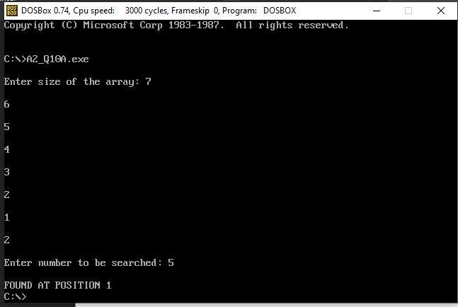

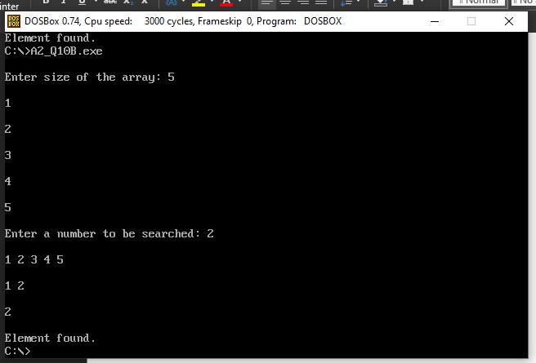

1. **Write and test a MASM program to print prime numbers between 1 to 100.**

**Code:**

.model small

.stack 100h

.data

x db 0ah, 0dh, '$'

.code

main proc

mov ax, @data

mov ds, ax

mov cl, 2

mov ch, 00h

l1: mov bl, 1

mov bh, 0

l2: mov ax, cx

div bl

cmp ah, 0

jne l3

inc bh

l3: inc bl

cmp bl, cl

jne l2

cmp bh, 1

jg l4

mov ax, cx

call displayNumber

l4: inc cl

cmp cl, 100

jne l1

mov ah, 4ch

int 21h

main endp

displayNumber proc

mov bl, 10

mov bh, 00h

l5: mov ah, 00h

div bl

push ax

inc bh

cmp al, 0

jne l5

l6: pop dx

mov dl, dh

mov dh, 0

add dl, 48

mov ah, 02h

int 21h

dec bh

cmp bh, 0

jne l6

lea dx, x

mov ah, 09h

int 21h

ret

displayNumber endp

end

**Output:**

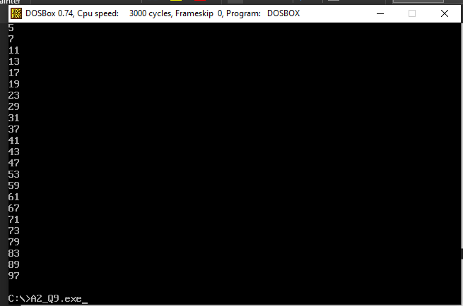

1. **Write and test a MASM program perform selection and insertion sort.**

**Code:**

.model tiny

.stack 100

.data

linefeed db 13, 10, "$"

prompt1 db "Enter Len: $"

prompt2 db "Enter Num: $"

msg1 db "Array is: $"

msg2 db "Selection Sort:$"

msg3 db "Insertion Sort:$"

len db ?

nums db 10 DUP(?), "$"

dec_out db 2 DUP(?), "$"

.code ; code segment

call main

mov ax, 4c00h ; terminate properly

int 21h

main proc

mov ax, @data

mov ds, ax

call get_arr_inp

call ins_linefeed

call selection_sort

mov dx, offset msg2

call show_msg

call ins_linefeed

call disp_arr_output

call ins_linefeed

call ins_linefeed

call get_arr_inp

call ins_linefeed

call insertion_sort

mov dx, offset msg3

call show_msg

call ins_linefeed

call disp_arr_output

call ins_linefeed

ret

main endp

; insertion sort

insertion_sort proc

push ax

push bx

push cx

push dx

mov cl, 1

mov bx, offset nums

ins_outer:

mov ch, 0

mov di, cx

mov dl, nums[di]

mov si, di

dec si

ins_inner:

cmp si, 0

jl ins_outer_update

cmp nums[si], dl

jbe ins_outer_update

mov ch, nums[si]

mov nums[di], ch

dec di

dec si

jmp ins_inner

ins_outer_update:

mov nums[si+1], dl

inc cl

cmp cl, len

jl ins_outer

pop dx

pop cx

pop bx

pop ax

ret

insertion_sort endp

; selection sort

selection_sort proc

push ax

push bx

push cx

push dx

mov cl, len

mov bx, offset nums

sel_outer:

; call disp_arr_output

; call ins_linefeed

mov ch, 0

inc ch

mov dh, cl

mov dl, [bx]

sel_inner:

push cx

xchg cl, ch

mov ch, 0

add bx, cx

mov al, [bx]

cmp dl, al

jbe sel_inner_upd

mov dl, al

mov dh, cl

sel_inner_upd:

sub bx, cx

pop cx

inc ch

cmp ch, cl

jl sel_inner

sel_done_inner:

mov ah, [bx]

push bx

add bl, dh

adc bh, 0

mov [bx], ah

pop bx

mov [bx], dl

inc bx

dec cl

cmp cl, 1

jg sel_outer

pop dx

pop cx

pop bx

pop ax

ret

selection_sort endp

; get array as input

get_arr_inp proc

push ax

push bx

push cx

push dx

mov dx, offset prompt1

call show_msg

call get_dec_val

mov len, al

call ins_linefeed

mov cx, 0

get_arr_elems_loop:

mov bx, offset nums

add bx, cx

mov dx, offset prompt2

call show_msg

call get_dec_val

mov [bx], al

inc cl

cmp cl, len

jl get_arr_elems_loop

done_get_arr_elems:

pop dx

pop cx

pop bx

pop ax

ret

get_arr_inp endp

disp_arr_output proc

push ax

push bx

push cx

push dx

mov cl, 0

mov bx, offset nums

disp_arr_output_loop:

mov al, [bx]

mov ah, 0

call disp_dec_val

mov al, 32

call show_char

inc bx

inc cl

cmp cl, len

jl disp_arr_output_loop

pop dx

pop cx

pop bx

pop ax

ret

disp_arr_output endp

; get decimal value, store in ax

get_dec_val proc

push bx

push cx

push dx

mov dx, 0

get_characters:

call get_char

cmp al, 13 ; cmp w/ [enter]

je done

sub al, 48

mov bx, dx

mov cl, 3

shl bx, cl

shl dx, 1

add dx, bx

add dl, al

jnc get_characters

add dh, 1

jmp get_characters

done:

mov ax, dx

pop dx

pop cx

pop bx

ret

get_dec_val endp

; display ax value in decimal

disp_dec_val proc

push ax

push bx

push cx

push dx

mov cl, 2

disp_dec_val_loop:

dec cl

cmp cl, 0

jl disp_dec_val_loop_done

mov bx, offset dec_out

push cx

mov ch, 0

add bx, cx

pop cx

mov ch, 10

div ch

push ax

add ah, 48

mov [bx], ah

pop ax

mov ah, 0

jmp disp_dec_val_loop

disp_dec_val_loop_done:

mov dx, offset dec_out

call show_msg

pop dx

pop cx

pop bx

pop ax

ret

disp_dec_val endp

; show character, ascii value in al

show_char proc

push ax

push dx

mov dl, al

mov ah, 2

int 21h

pop dx

pop ax

ret

show_char endp

; show message, location in dx

show_msg proc

push ax

mov ah, 9

int 21h

pop ax

ret

show_msg endp

; get a single character, modify ah, store in al

get_char proc

mov ah, 1

int 21h

ret

get_char endp

; insert new-line

ins_linefeed proc

push ax

push dx

lea dx,linefeed

mov ah,9

int 21h

pop dx

pop ax

ret

ins_linefeed endp

end

**Output:**

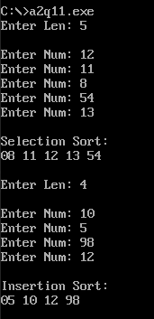

1. **Write and test a MASM program to rename a file.**

**Code:**

.model small

.stack 64

.data

msg1 db 0AH,0DH,'Enter old filename: $'

msg2 db 0AH,0DH,'Enter new filename: $'

;old1 db 'ABC.TXT',0

old db 80 dup('$')

;new1 db 'DEF.TXT',0

new db 80 dup('$')

sucmsg db 'has been renamed to $'

failmsg db 'not found. ERROR!!!$'

.code

print macro msg

push ax

push dx

mov ah, 09h

lea dx, msg

int 21h

pop dx

pop ax

endm

main proc

mov ax,@data

mov ds,ax

mov es,ax

print msg1

lea SI, old

call readstring

print msg2

lea SI, new

call readstring

mov ax,@data

mov ds,ax

mov es,ax

lea dx,old ;ds:dx points to the ASCIIZ string old,0

lea di,new ;es:di points to the ASCIIZ string new,0

mov ah,56h ;DOS function 56h is used for renaming

int 21h

jc error ;if there is an error carry flag is set

print old

print sucmsg

print new

jmp exit

error:

print old

print failmsg

exit:

mov ah,4ch

int 21h

main endp

readstring proc near

read:

mov ah, 01h

int 21h

cmp al, 13

je done

mov [SI],al

inc SI

jmp read

done:

mov al, 0

mov [SI],al

ret

readstring endp

end main

**Output:**

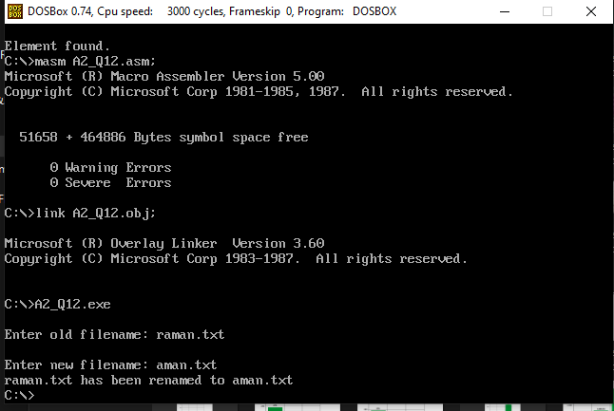

1. **Write and test a MASM program to print the system time and date.**

**Code:**

;Used INTERRUPTS

;AH=2AH //Gets the system date

;AH=02h // Displays the ascii value in DOS Prompt

;For 2AH

; Day is in DL

; Month is in DH

; Year is in CX

;Declaration Part

.MODEL SMALL

.DATA

msg1 db 0AH,0DH,'Current Date : $'

msg2 db 0AH,0DH,'Current Time : $'

endl db 0AH,0DH,'$'

.CODE

print macro msg

push ax

push dx

mov ah, 09h

lea dx, msg

int 21h

pop dx

pop ax

endm

main proc

START: MOV AX,@DATA

MOV DS,AX

print msg1

;Day Part

DAY:

MOV AH,2AH ; To get System Date

INT 21H

MOV AL,DL ; Day is in DL

AAM

MOV BX,AX

CALL DISP

MOV DL,'/'

MOV AH,02H ; To Print / in DOS

INT 21H

;Month Part

MONTH:

MOV AH,2AH ; To get System Date

INT 21H

MOV AL,DH ; Month is in DH

AAM

MOV BX,AX

CALL DISP

MOV DL,'/' ; To Print / in DOS

MOV AH,02H

INT 21H

;Year Part

YEAR:

MOV AH,2AH ; To get System Date

INT 21H

ADD CX,0F830H ; To negate the effects of 16bit value,

MOV AX,CX ; since AAM is applicable only for AL (YYYY -> YY)

AAM

MOV BX,AX

CALL DISP

print msg2

;Hour Part

HOUR:

MOV AH,2CH ; To get System Time

INT 21H

MOV AL,CH ; Hour is in CH

AAM

MOV BX,AX

CALL DISP

MOV DL,':'

MOV AH,02H ; To Print : in DOS

INT 21H

;Minutes Part

MINUTES:

MOV AH,2CH ; To get System Time

INT 21H

MOV AL,CL ; Minutes is in CL

AAM

MOV BX,AX

CALL DISP

MOV DL,':' ; To Print : in DOS

MOV AH,02H

INT 21H

;Seconds Part

Seconds:

MOV AH,2CH ; To get System Time

INT 21H

MOV AL,DH ; Seconds is in DH

AAM

MOV BX,AX

CALL DISP

;To terminate the Program

MOV AH,4CH ; To Terminate the Program

INT 21H

main endp

;Display Part

DISP PROC

MOV DL,BH ; Since the values are in BX, BH Part

ADD DL,30H ; ASCII Adjustment

MOV AH,02H ; To Print in DOS

INT 21H

MOV DL,BL ; BL Part

ADD DL,30H ; ASCII Adjustment

MOV AH,02H ; To Print in DOS

INT 21H

RET

DISP ENDP ; End Disp Procedure

end main ; End of MAIN

**Output:**

