**System Programming Lab Report**

Class – BCSE

Year – 3rd year 1st semester

Roll No. - 001810501069

1. **Write and test a MASM program to Display your name and program title on the**

**output screen.**

.model small

.stack 100h

.data

name1 db 0AH,0DH,'NAME: Nikhil Badyal$'

|  |  |  |
| --- | --- | --- |
| title1 db | 0AH,0DH,'PROGRAM TITLE: A1Q1.ASM$' | |
| .code |  |  |
| print macro msg | | ;macro to print a string |
| push ax | |  |
| push dx | |  |
| mov | ah, 09h |  |
| lea | dx, msg |  |
| int | 21h |  |
| pop | dx |  |
| pop | ax |  |
| endm |  |  |
| main proc |  |  |
| mov | ax,@data |  |
| mov | ds,ax |  |
| print name1 | | ;invoking print macro to display name |
| print title1 | | ;invoking print macro to display title |
| mov | ah, 4ch | ;terminate the program |
| int | 21h |  |

main endp

end main

**OUTPUT :**

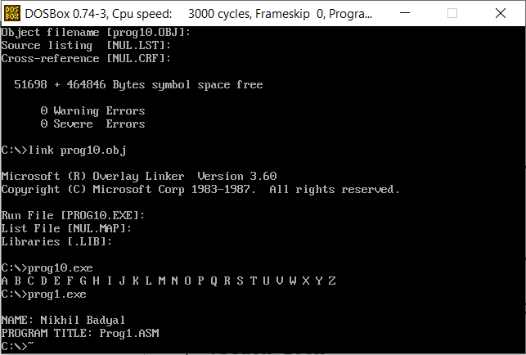



1. **Write and test a MASM program to convert a letter from uppercase to lowercase.**

.model small

.stack 100h

.data

msg1 db 0DH,0AH,'Enter a character: $'

msg2 db 0DH,0AH,'Lower case character: $'

.code

print macro msg ;macro to print a string

push ax

push dx

mov ah, 09h

lea dx, msg

int 21h

pop dx

pop ax

endm

main proc

mov ax,@data

print msg1

mov ah,01h ; read character

int 21h

cmp al,'A'

jl exit

cmp al,'Z'

jg exit

add al,32 ; convert uppercase to lowercase by adding 32 to its ascii

exit:

print msg2

mov dl,al ; display character

mov ah,02h

int 21h

mov ah, 4ch

int 21h

main endp

end main

**OUTPUT :**

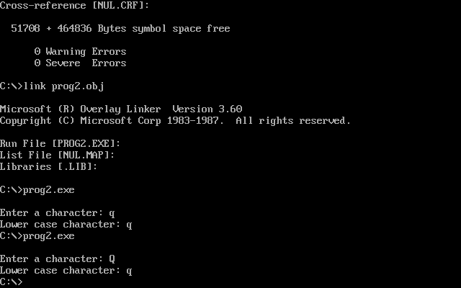

1. **Write and test a MASM program to add two Hexadecimal Numbers.**

.model small

.stack 100h

.data

msg1 db 0AH,0DH,'Enter first 16 bit hex number: $'

msg2 db 0AH,0Dh,'Enter second 16 bit hex number: $'

msg3 db 0AH,0DH,'Result after adding: $'

|  |  |  |  |
| --- | --- | --- | --- |
| .code |  |  |  |
| print macro msg | | | ;macro to print a string |
| push ax | |  |  |
| push dx | |  |  |
| mov | ah, | 09h |  |
| lea | dx, | msg |  |
| int | 21h |  |  |
| pop | dx |  |  |
| pop | ax |  |  |
| endm |  |  |  |
| main proc |  |  |  |
| mov | ax, | @data | ; initialize data section |
| mov | ds, | ax |  |
| print msg1 | | |  |
| call readhex | | | ; Read first number |
| mov | cx, | ax |  |
| print msg2 | | |  |
| call readhex | | | ; Read second number |
| print msg3 | | |  |
| add | ax,cx | | ; add two numbers |

mov ah, 4cH ; terminate Program

int 21H

main endp

readhex proc near

* this will input a 16 bit hexadecimal number
* output : AX

push bx

push cx

push dx

xor bx,bx ;initially bx value is equal to 0

mov cl,4

mov ah,1 ;for taking input

int 21h

input1:

cmp al,0dh ;compare whether the pressed key is 'enter' or not

je line1 ;if it is equal to 'enter' then stop taking first value

cmp al,39h ;compare the input whether it is letter or digit.39h is the ascii

value of 9

jg letter1

and al,0fh ;if it is digit then convert it's ascii value to real value by masking

jmp shift1

letter1: ;if it is letter then subtract 37h from it to find it's real value

sub al,37h

shift1:

shl bx, cl

or bl,al ;making 'or' will add the current value with previous value

int 21h

jmp input1

line1:

mov ax, bx

pop dx

pop cx

pop bx

ret

readhex endp

writehex proc near

* this procedure is to display number in hexadecimal
* Input : AX

push bx

push cx

push dx

|  |  |  |
| --- | --- | --- |
| mov dx, 0000h | |  |
| jnc notcarry | |  |
| inc dx |  |  |
| notcarry: | |  |
| mov si, ax | |  |
| mov bx, dx | | ; Result in reg bx |
| mov dh, 2 | |  |
| l1: | mov ch, 04h | ; Count of digits to be displayed |
| mov cl, 04h | | ; Count to roll by 4 bits |
| l2: | rol bx, cl | ; roll bl so that msb comes to lsb |
| mov dl, bl | | ; load dl wth data to be displayed |
| and dl, 0fH | | ; get only lsb |
| cmp dl, 09 | | ; check if digit is 0-9 or letter A-F |
| jbe l4 |  |  |
| add dl, 07 | | ; if letter add 37H else only add 30H |
| l4: | add dl, 30H |  |

mov ah, 02 ; Function 2 under INT 21H (Display character)

int 21H

dec ch ; Decrement Count

jnz l2

dec dh

cmp dh, 0

mov bx, si

jnz l1

pop dx

pop cx

pop bx

ret

writehex endp

end main

**OUTPUT :**

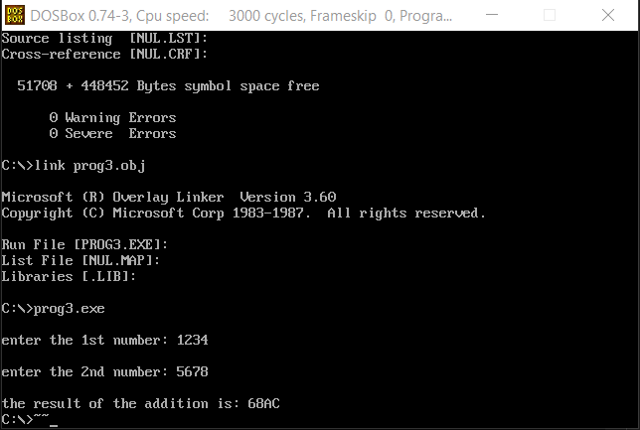

1. **Write and test a MASM program to find the second max and second min from an**

**array.**

.MODEL SMALL

.STACK 300H

.DATA

ARRAY1 DB 11,22,33,44,55

MSG1 DB 0AH,0DH,'Enter size of the array: $'

MSG2 DB 0AH,0DH,'Second Minimum value in array: $'

MSG3 DB 0AH,0DH,'Second Maximum value in array: $ '

ENDL DB 0AH,0DH,'$'

min dw 99

min2 dw 99

max dw 0

max2 dw 0

SE DB 33H

COUNT DB 00H

.CODE

PRINT MACRO MSG ; macro to print a string

push ax

push dx

mov AH, 09H

lea DX, MSG

int 21H

pop dx

pop ax

ENDM

MAIN PROC

MOV AX,@DATA

MOV DS,AX

START:

call readnum ; read the size of array

mov COUNT, al

mov cl, COUNT

mov bx, 00h

rdnxt:

PRINT ENDL

call readnum ; read an element

mov ARRAY1[BX],AL ; and storing it in array

inc BX

loop rdnxt

LEA SI, ARRAY1

call findminmax ; calling procedure to find min2 and max2

print msg2

mov ax, min2 ; second minimum is stored in min2

call writenum ; print the result

print msg3

mov ax, max2 ; second maximum is stored in max2

call writenum ; print the result

mov ah, 4ch

int 21h

MAIN ENDP

findminmax PROC

* this procedure will print the elements of a given array
* input : SI=offset address of the array
* : BX=size of the array
* output : none

PUSH AX ; push AX onto the STACK

PUSH CX ; push CX onto the STACK

PUSH DX ; push DX onto the STACK

push SI

MOV CX, BX ; set CX=BX

@PRINT_ARRAY: ; loop label

XOR AH, AH ; clear AH

MOV AL, [SI] ; set AL=[SI]

cmp min, ax

jl notminupdate ; if min >= ax

mov bx, min

mov min2, bx ; copy min to min2

mov min, ax ; copy ax to min

jmp update1

notminupdate:

cmp min2, ax

jl update1 ; if min2 >= ax

cmp ax,min

je update1 ; and if min2!= ax

mov min2, ax ; copy ax to min2

update1:

cmp max, ax

jg notmaxupdate ; if max <= ax

mov bx, max

mov max2, bx ; copy max to max2

mov max, ax ; copy ax to max

jmp update2

notmaxupdate:

cmp max2, ax

|  |  |  |  |  |
| --- | --- | --- | --- | --- |
| jg | update2 | ; if max2 | | <= ax |
| cmp ax, max | |  |  |  |
| je | update2 | ; and | if max2 != ax | |
| mov max2, ax | | ; copy ax | | to max2 |
| update2: | |  |  |  |
| MOV | AH, 2 | ; | set | output function |
| MOV | DL, 20H | ; | set | DL=20H |
| INT | 21H | ; | print a character | |
| INC | SI | ; | set | SI=SI+1 |
| LOOP @PRINT_ARRAY | | ; | jump to label @PRINT_ARRAY while CX!=0 | |
| pop SI |  |  |  |  |
| POP DX |  | ; | pop | a value from STACK into DX |
| POP CX |  | ; | pop | a value from STACK into CX |
| POP AX |  | ; | pop | a value from STACK into AX |
| RET |  | ; | return control to the calling procedure | |

findminmax ENDP

readnum proc near

* this procedure is to read a decimal number
* output : AX

push bx

push cx

mov cx,0ah

mov bx,00h

loopnum:

mov ah,01h

int 21h

cmp al,'0'

jb skip

cmp al,'9'

ja skip

sub al,'0'

push ax

mov ax,bx

mul cx

mov bx,ax

pop ax

mov ah,00h

add bx,ax

jmp loopnum

skip:

mov ax,bx

pop cx

pop bx

ret

readnum endp

writenum PROC near

* this procedure will display a decimal number
* input : AX
* output : none

|  |  |  |  |  |
| --- | --- | --- | --- | --- |
| push bx | | ; push BX onto the STACK | | |
| push cx | | ; push CX | | onto the STACK |
| push dx | | ; push DX | | onto the STACK |
| XOR | CX, CX | ; | clear CX | |
| MOV | BX, 10 | ; | set BX=10 | |

@OUTPUT: ; loop label

XOR DX, DX ; clear DX

DIV BX ; divide AX by BX

PUSH DX ; push DX onto the STACK

INC CX ; increment CX

OR AX, AX ; take OR of Ax with AX

JNE @OUTPUT ; jump to label @OUTPUT if ZF=0

MOV AH, 2 ; set output function

@DISPLAY: ; loop label

POP DX ; pop a value from STACK to DX

OR DL, 30H ; convert decimal to ascii code

INT 21H ; print a character

LOOP @DISPLAY ; jump to label @DISPLAY if CX!=0

POP DX ; pop a value from STACK into DX

POP CX ; pop a value from STACK into CX

POP BX ; pop a value from STACK into BX

RET ; return control to the calling procedure

writenum ENDP

END MAIN

**OUTPUT :**

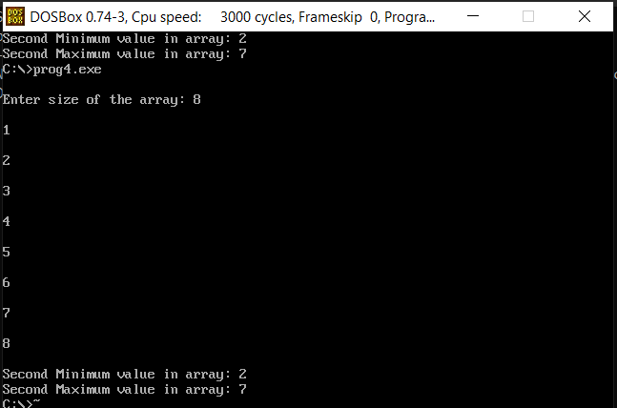

1. **Write and test a MASM program to display a terminating message.**

.model small

.stack 100h

.data

msg1 db 0AH,0DH,'ENTER A CHARACTER (PRESS ENTER KEY TO EXIT): $' msg2 db 0AH,0DH,'PROGRAM TERMINATED.$'

|  |  |  |  |
| --- | --- | --- | --- |
| .code |  |  |  |
| print macro msg | | | ; macro to print a string |
| push ax | |  |  |
| push dx | |  |  |
| mov | ah, | 09h |  |
| lea | dx, | msg |  |
| int | 21h |  |  |
| pop | dx |  |  |
| pop | ax |  |  |
| endm |  |  |  |
| main proc |  |  |  |
| mov | ax, | @data |  |
| mov | ds, | ax |  |
| l1: |  |  |  |
| print msg1 | | |  |
| mov | ah, | 01h | ; read a character |
| int | 21h |  |  |

|  |  |  |  |  |
| --- | --- | --- | --- | --- |
| cmp al,13 | | ; compare with ASCII value | | of enter key |
| jne l1 | | ; | continue until enter key | is not pressed |
| print msg2 | | ; | print terminating message | |
| mov | ah,4CH |  |  |  |
| int | 21h |  |  |  |

main endp

end main

**OUTPUT :**

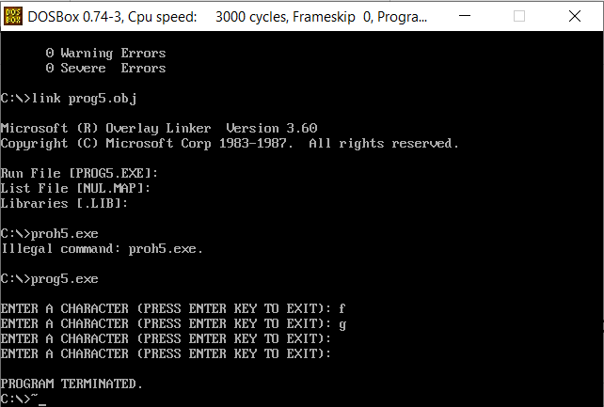

1. **Write and test a MASM program to Take a character from keyboard and print it.**

.model small

.stack 100h

.data

msg1 db 0DH,0AH,'ENTER A CHARACTER: $'

msg2 db 0DH,0AH,'OUTPUT CHARACTER: $'

|  |  |  |  |
| --- | --- | --- | --- |
| .code |  |  |  |
| print macro msg | | | ; macro to print a string |
| push ax | |  |  |
| push dx | |  |  |
| mov | ah, | 09h |  |
| lea | dx, | msg |  |
| int | 21h |  |  |
| pop | dx |  |  |
| pop | ax |  |  |
| endm |  |  |  |
| main proc |  |  |  |
| mov | ax, | @data |  |
| mov | ds, | ax |  |
| print msg1 | | |  |
| mov | ah,01h | | ;read character |
| int | 21h |  |  |
| print msg2 | | |  |
| mov | dl, | al | ;display character |
| mov | ah, | 02h |  |
| int | 21h |  |  |
| mov | ah,4ch | |  |
| int | 21h |  |  |
| main endp |  |  |  |

end main

**OUTPUT :**

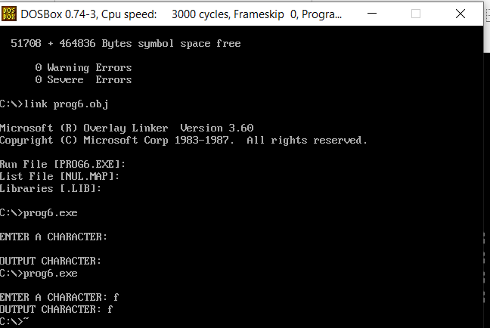

1. **Write and test a MASM program to validate second numbers is less than the first.**

.model small

.stack 300h

.data

msg1 db 0AH,0DH,'Enter first decimal number: $'

msg2 db 0AH,0DH,'Enter second decimal number: $'

msg3 db 0AH,0DH,'Second number is less than first number$' msg4 db 0AH,0DH,'Second number is not less than first number$' .code

|  |  |  |
| --- | --- | --- |
| print macro msg | | ; macro to print a string |
| push ax | |  |
| push dx | |  |
| mov | ah, 09h |  |
| lea | dx, msg |  |
| int | 21h |  |
| pop | dx |  |
| pop | ax |  |
| endm |  |  |
| main proc |  |  |
| mov | ax,@data |  |
| mov | ds,ax |  |
| print msg1 | |  |
| call readdecimal | | ; read first number, value is stored in ax |
| mov | cx, ax | ; copy first number to cx register |
| print msg2 | |  |
| call readdecimal | |  |
| cmp | ax,cx | ; compare second with first number |
| jl less | |  |
| print msg4 | | ; print message if second number is < first |
| jmp | exit |  |
| less: | | ; print message if second number is >= first |
| print msg3 | |  |
| exit: | |  |
| mov | ah, 4ch |  |
| int | 21h |  |
| main endp |  |  |

readdecimal proc near

* this procedure will take a number as input from user and store in AX
* input : none
* output : AX

push bx

push cx

mov cx,0ah

mov bx,00h

loopnum:

mov ah,01h

int 21h

cmp al,'0'

jb skip

cmp al,'9'

ja skip

sub al,'0'

push ax

mov ax,bx

mul cx

mov bx,ax

pop ax

mov ah,00h

add bx,ax

jmp loopnum

skip:

mov ax,bx

pop cx

pop bx

ret

readdecimal endp

end main

**OUTPUT :**

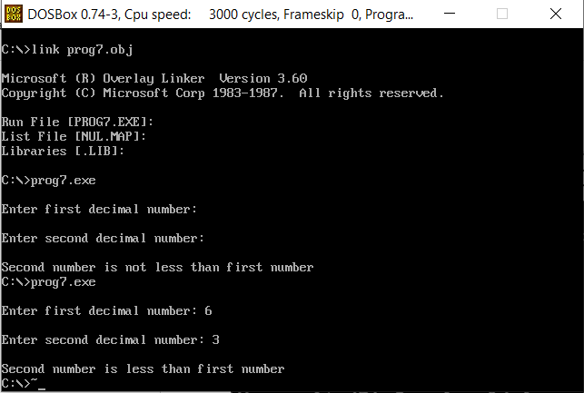

1. **Write and test a MASM program to find maximum and minimum from an array.**

.MODEL SMALL

.STACK 300H

.DATA

ARRAY1 DB 11,22,33,44,55

MSG1 DB 0AH,0DH,'Enter size of the array: $'

MSG2 DB 0AH,0DH,'Minimum value in array: $'

MSG3 DB 0AH,0DH,'Maximum value in array: $ '

ENDL DB 0AH,0DH,'$'

min dw 99

max dw 0

SE DB 33H

COUNT DB 00H

.CODE

PRINT MACRO MSG ; macro to print a string

push ax

push dx

mov AH, 09H

lea DX, MSG

int 21H

pop dx

pop ax

ENDM

MAIN PROC

MOV AX,@DATA

MOV DS,AX

START:

PRINT MSG1

call readnum ; read the size of array

mov COUNT, al

mov cl, COUNT

mov bx, 00h

rdnxt:

PRINT ENDL

call readnum ; read each array element

mov ARRAY1[BX],AL ; storing it in array

inc BX

loop rdnxt

LEA SI, ARRAY1

call findminmax ; calling procedure to find min and max

print msg2

mov ax, min ; minimum value is stored in min

call writenum ; print the result

print msg3

mov ax, max ; maximum value is stored in max

call writenum ; print the result

mov ah, 4ch

int 21h

MAIN ENDP

findminmax PROC

* this procedure will print the elements of a given array
* input : SI=offset address of the array
* : BX=size of the array
* output : none

|  |  |  |
| --- | --- | --- |
| PUSH AX | | ; push AX onto the STACK |
| PUSH CX | | ; push CX onto the STACK |
| PUSH DX | | ; push DX onto the STACK |
| push SI | |  |
| MOV CX, BX | | ; set CX=BX |
| @PRINT_ARRAY: | | ; loop label |
| XOR | AH, AH | ; clear AH |
| MOV | AL, [SI] | ; set AL=[SI] |
| cmp min, ax | |  |
| jl | notminupdate | ; if min >= ax |
| mov min, ax | | ; copy ax to min |
| notminupdate: | |  |
| cmp max, ax | |  |
| jg | notmaxupdate | ; if max <= ax |
| mov max, ax | | ; copy ax to max |
| notmaxupdate: | |  |
| MOV | AH, 2 | ; set output function |
| MOV | DL, 20H | ; set DL=20H |
| INT | 21H | ; print a character |
| INC | SI | ; set SI=SI+1 |
| LOOP @PRINT_ARRAY | | ; jump to label @PRINT_ARRAY while CX!=0 |

pop SI

POP DX

POP CX

POP AX

; pop a value from STACK into DX

; pop a value from STACK into CX

; pop a value from STACK into AX

RET

findminmax ENDP

; return control to the calling procedure

readnum proc near

push bx

push cx

mov cx,0ah

mov bx,00h

loopnum:

mov ah,01h

int 21h

cmp al,'0'

jb skip

cmp al,'9'

ja skip

sub al,'0'

push ax

mov ax,bx

mul cx

mov bx,ax

pop ax

mov ah,00h

add bx,ax

jmp loopnum

skip:

mov ax,bx

pop cx

pop bx

ret

readnum endp

writenum PROC near

* this procedure will display a decimal number
* input : AX
* output : none

|  |  |  |  |
| --- | --- | --- | --- |
| push bx | ; push BX | onto the STACK |  |
| push cx | ; push CX | onto the STACK |  |
| push dx | ; push DX | onto the STACK |  |
| XOR CX, CX | ; clear CX |  |  |
| MOV BX, 10 | ; set BX=10 | |  |
| @OUTPUT: | ; loop label | |  |
| XOR DX, DX | ; clear DX |  |  |
| DIV BX | ; divide AX by BX | |  |
| PUSH DX | ; push DX | onto the STACK |  |
| INC CX | ; increment CX | |  |
| OR AX, AX | ; take OR | of Ax with AX |  |
| JNE @OUTPUT | ; jump to | label @OUTPUT if ZF=0 |  |
| MOV AH, 2 | ; set output function | |  |
| @DISPLAY: | ; loop label | |  |
| POP DX | ; pop a value from STACK to DX | |  |
| OR DL, 30H | ; convert | decimal to ascii code |  |
| INT 21H | ; print a | character |  |
| LOOP @DISPLAY | ; jump to | label @DISPLAY if CX!=0 |  |

POP DX

POP CX

POP BX

; pop a value from STACK into DX

; pop a value from STACK into CX

; pop a value from STACK into BX

RET

writenum ENDP

; return control to the calling procedure

END MAIN

**OUTPUT :**

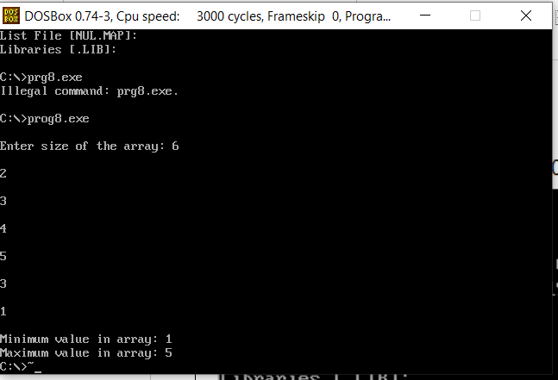



1. **Write and test a MASM program to loop until the user decides to quit.**

.model small

.stack 100h

.data

msg1 db 0AH,0DH,'ENTER A CHARACTER (PRESS ENTER KEY TO EXIT): $' msg2 db 0AH,0DH,'PROGRAM TERMINATED.$'

|  |  |  |  |
| --- | --- | --- | --- |
| .code |  |  |  |
| print macro msg | | | ; macro to print a string |
| push ax | |  |  |
| push dx | |  |  |
| mov | ah, | 09h |  |
| lea | dx, | msg |  |
| int | 21h |  |  |
| pop | dx |  |  |
| pop | ax |  |  |
| endm |  |  |  |
| main proc |  |  |  |
| mov | ax, | @data |  |
| mov | ds, | ax |  |
| l1: |  |  |  |
| print msg1 | | |  |
| mov | ah, | 01h ; read a character | |
| int | 21h |  |  |
| cmp | al,13 | | ; compare with ASCII value of enter key |
| jne | l1 |  | ; continue until enter key is not pressed |
| print msg2 | | | ; print terminating message |
| mov | ah,4CH | |  |
| int | 21h |  |  |
| main endp |  |  |  |

end main

**OUTPUT :**

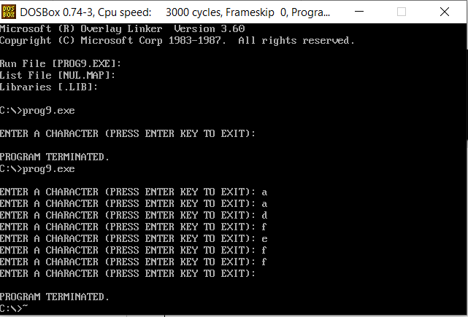

1. **Write and test a MASM program to print all the characters from A-Z.**

|  |  |  |
| --- | --- | --- |
| .model small | |  |
| .stack 100h | |  |
| .data |  |  |
| .code |  |  |
| printchar | macro char | ; macro to display a character |
| push ax | |  |
| push dx | |  |
| mov | dl,char |  |
| mov | ah,02h |  |
| int | 21h |  |
| pop | dx |  |
| pop | ax |  |
| endm |  |  |
| main proc |  |  |
| mov | ax,@data |  |
| mov | ds,ax |  |
| mov | cl,64 | ;cl = 64 (ascii value of character just before ‘A’) |
| l1: |  |  |
| inc | cl |  |
| printchar cl | | ;print alphabet |
| printchar 20h | | ;print space (ASCII - 20H) |
| cmp | cl,'Z' |  |
| jne | l1 | ;loop until Z occurs |
| mov | ah, 4CH |  |
| int | 21h |  |

main endp

end main

**OUTPUT :**

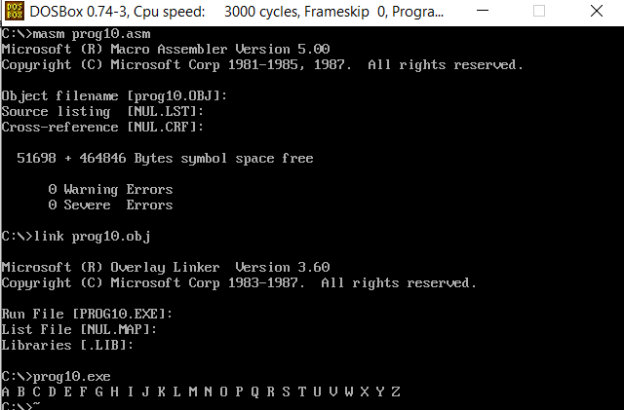



**ASSIGNMENT - 2**

1. **Write and test a program to add and subtract two 16 bit numbers.**

.model small

.stack 300h

.data

msg1 db 0AH,0DH,'ENTER 1ST NUMBER: $'

msg2 db 0AH,0DH,'ENTER 2ND NUMBER: $'

msg3 db 0AH,0DH,'THE RESULT AFTER ADDITION IS: $' msg4 db 0AH,0DH,'THE RESULT AFTER SUBTRACTION IS: $' space db ' $'

endl db 0AH,0DH,'$'

val1 dw ?

Roll numbers – 73 – 77 GROUP – C Page 15 of 45

|  |  |  |
| --- | --- | --- |
| val2 dw ? |  |  |
| .code |  |  |
| print macro msg | | ; macro to print a string |
| push ax | |  |
| push dx | |  |
| mov | ah, 09h |  |
| lea | dx, msg |  |
| int | 21h |  |
| pop | dx |  |
| pop | ax |  |
| endm |  |  |
| main proc |  |  |
| mov | ax,@data |  |
| mov | ds,ax |  |
| print msg1 | |  |
| call readhex | | ; reading first hex number |
| mov | val1, ax |  |
| print msg2 | |  |
| call readhex | | ; reading second hex number |
| mov | val2, ax |  |
| print msg3 | |  |
| mov ax, val1 | |  |
| mov bx, val2 | |  |
| add ax,bx | | ; adding first number with second number |
| call writehex | | ; printing the result |
| print msg4 | |  |
| mov ax, val1 | |  |
| mov bx, val2 | |  |
| sub ax,bx | | ; subtract second number from first number |
| call writehex | | ; printing the result |
| mov | ah, 4ch |  |
| int | 21h |  |

main endp

readhex proc near

* this will input a 16 bit hexadecimal number
* output : AX

push bx

push cx

push dx

xor bx,bx ;initially bx value is equal to 0 mov cl,4

mov ah,1 ;for taking input

int 21h

input1:

cmp al,0dh ;compare whether the pressed key is 'enter' or not

je line1 ;if it is equal to 'enter' then stop taking first value

cmp al,39h ;compare the input whether it is letter or digit.39h is the ascii

value of 9

jg letter1

and al,0fh ;if it is digit then convert it's ascii value to real value by

masking

jmp shift1

letter1: ;if it is letter then subtract 37h from it to find it's real value

sub al,37h

shift1:

Roll numbers – 73 – 77 GROUP – C Page 16 of 45

shl bx, cl

or bl,al ;making 'or' will add the current value with previous value

int 21h

jmp input1

line1:

mov ax, bx

pop dx

pop cx

pop bx

ret

readhex endp

writehex proc near

* this procedure is to display number in hexadecimal
* Input : AX

push bx

push cx

push dx

mov dx, 0000h

jnc notcarry

inc dx

notcarry:

mov si, ax

mov bx, dx ; Result in reg bx

mov dh, 2

l1: mov ch, 04h ; Count of digits to be displayed

mov cl, 04h ; Count to roll by 4 bits

l2: rol bx, cl ; roll bl so that msb comes to lsb

mov dl, bl ; load dl wth data to be displayed

and dl, 0fH ; get only lsb

cmp dl, 09 ; check if digit is 0-9 or letter A-F

jbe l4

add dl, 07 ; if letter add 37H else only add 30H

l4: add dl, 30H

mov ah, 02 ; Function 2 under INT 21H (Display character)

int 21H

dec ch ; Decrement Count

jnz l2

dec dh

cmp dh, 0

mov bx, si

jnz l1

pop dx

pop cx

pop bx

ret

writehex endp

end main

**OUTPUT :**

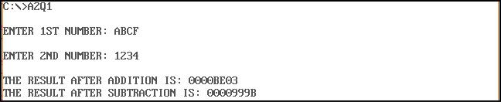

1. **Write and test a program to Convert a Binary digit to Decimal and vice versa.**

Roll numbers – 73 – 77 GROUP – C Page 17 of 45

.model small

.stack 300h

.data

msg1 db 0AH,0DH,'Enter binary number: $'

msg2 db 0AH,0DH,'Decimal: $'

msg3 db 0AH,0DH,'Enter Decimal number: $'

msg4 db 0AH,0DH,'Binary: $'

space db ' $'

endl db 0AH,0DH,'$'

binno db 17

db ?

db 17 dup(0)

str1 db 20 dup('$')

str2 db 20 dup('$')

|  |  |  |  |
| --- | --- | --- | --- |
| .code |  |  |  |
| val1 dw ? |  |  |  |
| val2 dw ? |  |  |  |
| .code |  |  |  |
| print macro msg | | | ; macro to print a string |
| push ax | |  |  |
| push dx | |  |  |
| mov | ah, | 09h |  |
| lea | dx, | msg |  |
| int | 21h |  |  |
| pop | dx |  |  |
| pop | ax |  |  |
| endm |  |  |  |
| read macro memloc | | | ; macro to read a binary number |
| push ax | |  |  |
| push cx | |  |  |
| push dx | |  |  |
| mov | ah, | 0ah |  |
| lea | dx, | memloc |  |
| int | 21h |  |  |
| lea | si, | memloc + 1 ;NUMBER OF CHARACTERS ENTERED. | |
| mov | cl, | [si] ;MOVE LENGTH TO CL. | |
| mov | ch, | 0 | ;CLEAR CH TO USE CX. |
| inc | cx ;TO REACH CHR(13). | | |
| add | si, | cx ;NOW SI POINTS TO CHR(13). | |
| mov | al, | '$' |  |
| mov | [si], al ;REPLACE CHR(13) BY '$'. | | |
| pop | dx |  |  |
| pop | cx |  |  |
| pop | ax |  |  |
| endm |  |  |  |
| main proc |  |  |  |
| mov | ax,@data | |  |
| mov | ds,ax | |  |
| start: | |  |  |
| print msg1 | | |  |
| read binno | | | ; bin no is stOred in binno |
| print | | msg2 |  |
| mov | ax,0000h | |  |
| mov | bx,0000h | |  |

Roll numbers – 73 – 77 GROUP – C Page 18 of 45

lea si, binno + 1

mov cl, [si]

mov ch, 00h

inc si

;add si, cx

mov ax,cx

;call writenum

;print endl

mov ax,00h

loop1:

mov bl, [si]

sub bl, '0'

mov bh, 00h

mov dx,02h

mul dx

add ax, bx

;call writenum

;print endl

inc si

loop loop1

call writenum ; printing the decimal value of given binary number

print endl

print msg3

call readnum ; reading a decimal number

lea si, str1

mov bh, 00

mov bl,2

l1:

div bl

add ah,'0'

mov byte ptr[si],ah

mov ah, 00

inc si

inc bh

cmp al,00

jne l1

mov cl,bh

lea si, str1

lea di, str2

mov ch, 00

add si, cx

dec si

l2:

mov ah,byte ptr[si]

mov byte ptr[di],ah

dec si

inc di

loop l2

|  |  |  |  |
| --- | --- | --- | --- |
| print | | msg4 |  |
| print | | str2 | printing the binary value of given decimal number |
| exit: | |  |  |
| mov | ah, | 4ch |  |
| int | 21h |  |  |

Roll numbers – 73 – 77 GROUP – C Page 19 of 45

main endp

readnum proc near

* this procedure will take a number as input from user and store in AX
* input : none
* output : AX

push bx

push cx

mov cx,0ah

mov bx,00h

loopnum:

mov ah,01h

int 21h

cmp al,'0'

jb skip

cmp al,'9'

ja skip

sub al,'0'

push ax

mov ax,bx

mul cx

mov bx,ax

pop ax

mov ah,00h

add bx,ax

jmp loopnum

skip:

mov ax,bx

pop cx

pop bx

ret

readnum endp

writenum proc near

* this procedure will display a decimal number
* input : AX
* output : none

push ax

push bx

push cx

push dx

xor cx, cx

mov bx, 0ah

@output:

xor dx, dx

div bx ; divide AX by BX

push dx ; push remainder onto the STACK

inc cx

or ax, ax

jne @output

mov ah, 02h ; set output function

@display:

pop dx ; pop a value(remainder) from STACK to DX

or dl, 30h ; convert decimal to ascii code

int 21h

loop @display

Roll numbers – 73 – 77 GROUP – C Page 20 of 45

pop dx

pop cx

pop bx

pop ax

ret

writenum endp

end main

**OUTPUT :**

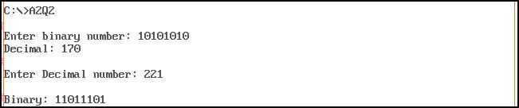

1. **Write and test a program to print pairs of even numbers where the summation of**

**the numbers in each pair is 100.**

.model small

.stack 300h

.data

char1 db '($'

char2 db ')$'

space db ' $'

val1 dw ?

|  |  |  |
| --- | --- | --- |
| .code |  |  |
| print macro msg | | ; macro to print a string |
| push ax | |  |
| push dx | |  |
| mov | ah, 09h |  |
| lea | dx, msg |  |
| int | 21h |  |
| pop | dx |  |
| pop | ax |  |
| endm |  |  |
| main proc |  |  |
| mov | ax,@data |  |
| mov | ds,ax |  |
| mov | bx, 100 | ; storing the decimal value 100 |
| mov | ax, 100 |  |

loop1:

print char1

call writenum

print space

mov val1, ax

; print opening bracket

; print first number of pair

mov ax, bx

mov cx, val1

sub ax, cx ; subtract first number with 100 to get second number of pair

call writenum ; print second number of pair print char2 ; print closing bracket print space ; print space

mov ax, val1

Roll numbers – 73 – 77

GROUP – C

Page 21 of 45

sub ax,2 ; subtract first value by 2

jnz loop1 ; loop until first value becomes 0

print char1

call writenum

print space

mov ax, 64h

call writenum

print char2

mov ah, 4ch

int 21h

main endp

readnum proc near

* this procedure will take a number as input from user and store in AX
* input : none
* output : AX

push bx

push cx

mov cx,0ah

mov bx,00h

loopnum:

mov ah,01h

int 21h

cmp al,'0'

jb skip

cmp al,'9'

ja skip

sub al,'0'

push ax

mov ax,bx

mul cx

mov bx,ax

pop ax

mov ah,00h

add bx,ax

jmp loopnum

skip:

mov ax,bx

pop cx

pop bx

ret

readnum endp

writenum proc near

* this procedure will display a decimal number
* input : AX
* output : none

push ax

push bx

push cx

push dx

xor cx, cx

mov bx, 0ah

@output:

xor dx, dx

div bx ; divide AX by BX

push dx ; push remainder onto the STACK

inc cx

or ax, ax

Roll numbers – 73 – 77 GROUP – C Page 22 of 45

jne @output

mov ah, 02h ; set output function

@display:

pop dx ; pop a value(remainder) from STACK to DX

or dl, 30h ; convert decimal to ascii code

int 21h

loop @display

pop dx

pop cx

pop bx

pop ax

ret

writenum endp

end main

**OUTPUT :**

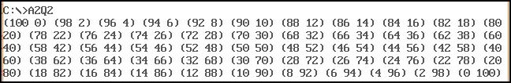

1. **Write and test a program to multiply two 8 bit numbers.**

.model small

.stack 300h

.data

msg1 db 0AH,0DH,'ENTER 1ST HEX NUMBER: $'

msg2 db 0AH,0DH,'ENTER 2ND HEX NUMBER: $'

msg3 db 0AH,0DH,'THE RESULT AFTER MULTIPLYING IS: $'

val1 dw ?

val2 dw ?

|  |  |  |
| --- | --- | --- |
| .code |  |  |
| print macro msg | | ; macro to print a string |
| push ax | |  |
| push dx | |  |
| mov | ah, 09h |  |
| lea | dx, msg |  |
| int | 21h |  |
| pop | dx |  |
| pop | ax |  |
| endm |  |  |
| main proc |  |  |
| mov | ax,@data |  |
| mov | ds,ax |  |
| print msg1 | |  |
| call readhex | | ; read first hex number |
| mov | val1, ax |  |
| print msg2 | |  |
| call readhex | | ; read second hex number |
| print msg3 | |  |
| mul | val1 | ; multiply first number with second number |
| call writehex | | ; printing the result |
| mov | ah, 4ch |  |

Roll numbers – 73 – 77 GROUP – C Page 23 of 45

int 21h

main endp

readhex proc near

* this will input a 16 bit hexadecimal number
* output : AX

push bx

push cx

push dx

xor bx,bx ;initially bx value is equal to 0 mov cl,4

mov ah,1 ;for taking input

int 21h

input1:

|  |  |  |
| --- | --- | --- |
| cmp al,0dh | | ;compare whether the pressed key is 'enter' or not |
| je | line1 | ;if it is equal to 'enter' then stop taking first value |
| cmp al,39h | | ;compare the input whether it is letter or digit.39h is the ascii |
| value of 9 |  |  |
| jg | letter1 |  |
| and al,0fh | | ;if it is digit then convert it's ascii value to real value by |
| masking |  |  |

jmp shift1

letter1: ;if it is letter then subtract 37h from it to find it's real value

sub al,37h

shift1:

shl bx, cl

or bl,al ;making 'or' will add the current value with previous value

int 21h

jmp input1

line1:

mov ax, bx

pop dx

pop cx

pop bx

ret

readhex endp

writehex proc near

* this procedure is to display number in hexadecimal
* Input : AX

push bx

push cx

push dx

|  |  |  |
| --- | --- | --- |
|  | mov si, ax |  |
|  | mov bx, dx | ; Result in reg bx |
|  | mov dh, 2 |  |
| l1: | mov ch, 04h | ; Count of digits to be displayed |
|  | mov cl, 04h | ; Count to roll by 4 bits |
| l2: | rol bx, cl | ; roll bl so that msb comes to lsb |
|  | mov dl, bl | ; load dl wth data to be displayed |
|  | and dl, 0fH | ; get only lsb |
|  | cmp dl, 09 | ; check if digit is 0-9 or letter A-F |
|  | jbe l4 |  |
|  | add dl, 07 | ; if letter add 37H else only add 30H |
| l4: | add dl, 30H |  |
|  | mov ah, 02 | ; Function 2 under INT 21H (Display character) |
|  | int 21H |  |
|  | dec ch | ; Decrement Count |
|  | jnz l2 |  |
|  | dec dh |  |

Roll numbers – 73 – 77 GROUP – C Page 24 of 45

cmp dh, 0

mov bx, si

jnz l1

pop dx

pop cx

pop bx

ret

writehex endp

end main

**OUTPUT :**

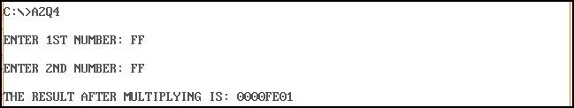

1. **Write and test a program to Convert Binary digit to Hex digit and vice versa.**

.MODEL SMALL

.STACK 1000h

.DATA

HEX_Map DB '0','1','2','3','4','5','6','7','8','9','A','B','C','D','E','F'

HEX_Out DB "00", 13, 10, '$' ; string with line feed and '$'-terminator

msg1 db 0AH,0DH,'Enter binary number: $'

msg2 db 0AH,0DH,'Hexadecimal: $'

msg3 db 0AH,0DH,'Enter hexadecimal number: $'

msg4 db 0AH,0DH,'Binary: $'

space db ' $'

endl db 0AH,0DH,'$'

binno db 17

db ?

db 17 dup(0)

str1 db 20 dup('$')

str2 db 20 dup('$')

.code

val1 dw ?

val2 dw ?

.CODE

print macro msg

push ax

push dx

mov ah, 09h

lea dx, msg

int 21h

pop dx

pop ax

endm

read macro memloc

push ax

push cx

push dx

mov ah, 0ah

lea dx, memloc

int 21h

lea si, memloc + 1 ;NUMBER OF CHARACTERS ENTERED.

Roll numbers – 73 – 77 GROUP – C Page 25 of 45

|  |  |  |  |  |
| --- | --- | --- | --- | --- |
| mov | cl, | [si] ;MOVE LENGTH TO CL. | | |
| mov | ch, | 0 | ;CLEAR CH TO USE CX. | |
| inc | cx ;TO REACH CHR(13). | | |  |
| add | si, | cx ;NOW SI POINTS TO CHR(13). | | |
| mov | al, | '$' |  |  |
| mov | [si], al ;REPLACE CHR(13) BY '$'. | | | |
| pop | dx |  |  |  |
| pop | cx |  |  |  |
| pop | ax |  |  |  |
| endm |  |  |  |  |
| main PROC |  |  |  |  |
| mov | ax, | @DATA |  | ; Initialize DS |
| mov | ds, | ax |  |  |
| print msg1 | | |  |  |
| read binno | | | ; bin no stored in binno | |
| print | | msg2 |  |  |
| mov | ax,0000h | |  |  |
| mov | bx,0000h | |  |  |
| lea | si, | binno + 1 | |  |
| mov | cl, | [si] |  |  |
| mov | ch, | 00h |  |  |
| inc | si |  |  |  |
| ;add si, cx | | |  |  |
| mov | ax,cx | |  |  |
| ;call writenum | | |  |  |
| ;print endl | | |  |  |
| mov | ax,00h | |  |  |
| loop1: | |  |  |  |
|  | mov bl, [si] | | |  |
|  | sub bl, '0' | | |  |
|  | mov bh, 00h | | |  |
|  | mov dx,02h | | |  |
|  | mul dx | |  |  |
|  | add ax, bx | | |  |
|  | ;call writenum | | |  |
|  | ;print endl | | |  |
|  | inc si | |  |  |
| loop loop1 | | |  |  |
| ; Example No. 1 with output | | | |  |
| mov | di, | OFFSET HEX_Out | | ; First argument: pointer |
| ;mov ax, 10101100b | | | | ; Second argument: Integer |
| call IntegerToHexFromMap | | | | ; Call with arguments |
| mov | ah, | 09h |  | ; Int 21h / 09h: Write string to STDOUT |
| mov | dx, | OFFSET HEX_Out | | ; Pointer to '$'-terminated string |
| int | 21h |  |  | ; Call MS-DOS |
| mov | ax, | 4C00h |  | ; Int 21h / 4Ch: Terminate program (Exit code = 00h) |
| int | 21h |  |  | ; Call MS-DOS |
| main ENDP |  |  |  |  |
| IntegerToHexFromMap PROC | | | |  |
| mov | si, | OFFSET Hex_Map | | ; Pointer to hex-character table |
| mov | bx, | ax |  | ; BX = argument AX |
| and | bx, | 00FFh |  | ; Clear BH (just to be on the safe side) |
| shr | bx, | 1 |  | ; Isolate high nibble (i.e. 4 bits) |
| SHR | BX,1 | |  |  |

Roll numbers – 73 – 77 GROUP – C Page 26 of 45

|  |  |  |
| --- | --- | --- |
| SHR BX,1 |  |  |
| SHR BX,1 |  |  |
| mov dl, [si+bx] | ; | Read hex-character from the table |
| mov [di+0], dl | ; Store character at the first place in the output string | |
| mov bx, ax | ; | BX = argument AX (just to be on the safe side) |
| and bx, 00FFh | ; | Clear BH (just to be on the safe side) |
| and bl, 0Fh | ; | Isolate low nibble (i.e. 4 bits) |
| mov dl, [si+bx] | ; | Read hex-character from the table |
| mov [di+1], dl | ; Store character | at the second place in the output string |
| ret |  |  |

IntegerToHexFromMap ENDP

readnum proc near

* this procedure will take a number as input from user and store in AX
* input : none
* output : AX

push bx

push cx

mov cx,0ah

mov bx,00h

loopnum:

mov ah,01h

int 21h

cmp al,'0'

jb skip

cmp al,'9'

ja skip

sub al,'0'

push ax

mov ax,bx

mul cx

mov bx,ax

pop ax

mov ah,00h

add bx,ax

jmp loopnum

skip:

mov ax,bx

pop cx

pop bx

ret

readnum endp

writenum proc near

* this procedure will display a decimal number
* input : AX
* output : none

push ax

push bx

push cx

push dx

xor cx, cx

mov bx, 0ah

@output:

xor dx, dx

div bx ; divide AX by BX

push dx ; push remainder onto the STACK

inc cx

or ax, ax

jne @output

mov ah, 02h ; set output function

@display:

pop dx ; pop a value(remainder) from STACK to DX

Roll numbers – 73 – 77 GROUP – C Page 27 of 45

or dl, 30h ; convert decimal to ascii code

int 21h

loop @display

pop dx

pop cx

pop bx

pop ax

ret

writenum endp

END main ; End of assembly with entry-procedure

**OUTPUT :**

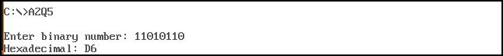

1. **Write and test a program to divide a 16 bit number by a 8 bit number.**

.model small

.stack 300h

.data

msg1 db 0AH,0DH,'ENTER 1ST NUMBER: $'

msg2 db 0AH,0DH,'ENTER 2ND NUMBER: $'

msg3 db 0AH,0DH,'THE RESULT AFTER DIVIDING IS: $'

val1 dw ?

val2 dw ?

|  |  |  |  |
| --- | --- | --- | --- |
| .code |  |  |  |
| print macro msg | | |  |
| push ax | |  |  |
| push dx | |  |  |
| mov | ah, | 09h |  |
| lea | dx, | msg |  |
| int | 21h |  |  |
| pop | dx |  |  |
| pop | ax |  |  |
| endm |  |  |  |
| main proc |  |  |  |
| mov | ax,@data | |  |
| mov | ds,ax | |  |
| print msg1 | | |  |
| call readnum | | | ;read first number |
| mov | val1, ax | |  |
| print msg2 | | |  |
| call readnum | | | ; read second number |
| mov | val2, ax | |  |
| print msg3 | | |  |
| mov | ax, | val1 |  |
| mov | bx, | val2 |  |
| div | bx |  | ; dividing first number by second number |
| call writenum | | | ; printing the result |
| mov | ah, | 4ch |  |
| int | 21h |  |  |

main endp

Roll numbers – 73 – 77 GROUP – C Page 28 of 45

readnum proc near

* this procedure will take a number as input from user and store in AX
* input : none
* output : AX

push bx

push cx

mov cx,0ah

mov bx,00h

loopnum:

mov ah,01h

int 21h

cmp al,'0'

jb skip

cmp al,'9'

ja skip

sub al,'0'

push ax

mov ax,bx

mul cx

mov bx,ax

pop ax

mov ah,00h

add bx,ax

jmp loopnum

skip:

mov ax,bx

pop cx

pop bx

ret

readnum endp

writenum proc near

* this procedure will display a decimal number
* input : AX
* output : none

push ax

push bx

push cx

push dx

xor cx, cx

mov bx, 0ah

@output:

xor dx, dx

div bx

push dx

inc cx

or ax, ax

jne @output

; divide AX by BX

; push remainder onto the STACK

mov ah, 02h

; set output function

@display:

pop dx

or dl, 30h

int 21h

loop @display

; pop a value(remainder) from STACK to DX ; convert decimal to ascii code

pop dx

pop cx

pop bx

Roll numbers – 73 – 77

GROUP – C

Page 29 of 45

pop ax

ret

writenum endp

end main

**OUTPUT :**

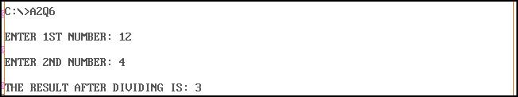

1. **Write and test a program to Print Fibonacci series up to 10 terms.**

.model small

.stack 300h

.data

msg1 db 0AH,0DH,'Enter number of steps: $'

msg2 db 0AH,0DH,'Fibonacci sequence: $'

space db ' $'

endl db 0AH,0DH,'$'

|  |  |  |  |
| --- | --- | --- | --- |
| val db ? |  |  |  |
| .code |  |  |  |
| print macro msg | |  | ; macro to print a string |
| push ax | |  |  |
| push dx | |  |  |
| mov | ah, 09h |  |  |
| lea | dx, msg |  |  |
| int | 21h |  |  |
| pop | dx |  |  |
| pop | ax |  |  |
| endm |  |  |  |
| main proc |  |  |  |
| mov | ax,@data |  |  |
| mov | ds,ax |  |  |
| print msg1 | |  |  |
| call readnum | | ; read the number of terms to be printed | |
| mov | val, al |  |  |
| mov | bx, 00h |  |  |
| mov | dx, 01h |  |  |
| mov | cl, val |  |  |
| mov | ch, 00h |  |  |
| mov | ax, 00h |  |  |
| print msg2 | |  |  |
| print endl | |  |  |
| loop1: | |  |  |
|  | mov ax, bx |  |  |
|  | call writenum | | ; printing each term |
|  | print space |  |  |
|  | add ax, dx |  |  |
|  | mov dx, bx |  |  |
|  | mov bx, ax |  |  |
| loop loop1 | |  | ; loop n times ( n is stored in cl ) |

Roll numbers – 73 – 77 GROUP – C Page 30 of 45

exit:

mov ah, 4ch

int 21h

main endp

readnum proc near

* this procedure will take a number as input from user and store in AX
* input : none
* output : AX

push bx

push cx

mov cx,0ah

mov bx,00h

loopnum:

mov ah,01h

int 21h

cmp al,'0'

jb skip

cmp al,'9'

ja skip

sub al,'0'

push ax

mov ax,bx

mul cx

mov bx,ax

pop ax

mov ah,00h

add bx,ax

jmp loopnum

skip:

mov ax,bx

pop cx

pop bx

ret

readnum endp

writenum proc near

* this procedure will display a decimal number
* input : AX
* output : none

push ax

push bx

push cx

push dx

xor cx, cx

mov bx, 0ah

@output:

xor dx, dx

div bx

push dx

inc cx

or ax, ax

jne @output

; divide AX by BX

; push remainder onto the STACK

mov ah, 02h

; set output function

@display:

pop dx

or dl, 30h

; pop a value(remainder) from STACK to DX ; convert decimal to ascii code

Roll numbers – 73 – 77

GROUP – C

Page 31 of 45

int 21h

loop @display

pop dx

pop cx

pop bx

pop ax

ret

writenum endp

end main

**OUTPUT :**

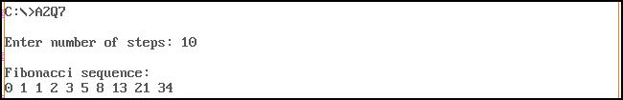

1. **Write and test a program for sub-string deletion from a given string.**

.MODEL SMALL

.STACK 100H

.DATA

MESS1 DB 10,13, "Enter your string : $"

MESS2 DB 10,13, "Enter your substring that you want to be delete : $"

MESS3 DB 10,13, "The string after deletion is : $"

MESS4 DB 10,13, "Substring is not contained in string.$"

STRING DB 50 DUP(?)

SUBSTRING DB 50 DUP(?)

NUM DW ?

LEN1 DB ?

LEN2 DB ?

STARTINDEX DW ?

ENDINDEX DW ?

.CODE

MOV AX, @DATA

MOV DS, AX

LEA DX, MESS1

MOV AH, 09H

INT 21H

MOV SI, 0

MOV CX, 0

MOV AH, 01H

IN1: INT 21H

CMP AL, 0DH

JE OUT1

MOV STRING[SI], AL

INC SI

INC CX

JMP IN1

OUT1:

MOV LEN1, CL

LEA DX, MESS2

MOV AH, 09H

INT 21H

MOV SI, 0

MOV CX, 0

Roll numbers – 73 – 77 GROUP – C Page 32 of 45

|  |  |  |  |  |
| --- | --- | --- | --- | --- |
| MOV | AH, | 01H |  |  |
| IN2: INT 21H | | |  |  |
|  |  | CMP AL, 0DH | |  |
|  |  | JE OUT2 |  |  |
|  |  | MOV SUBSTRING[SI], AL | |  |
|  |  | INC SI |  |  |
|  | INC | CX |  |  |
| JMP | IN2 |  |  |  |
| OUT2: |  |  |  |  |
| MOV LEN2, | | CL |  |  |
| MOV DH, 0 | |  |  |  |
| MOV DL, LEN1 | | |  |  |
| SUB DL, LEN2 | | |  |  |
| ADD DL, 1 | |  |  |  |
| MOV CH, 0 | |  |  |  |
| MOV CL, LEN2 | | |  |  |
| MOV SI, 0 | |  |  |  |
| EQUL: MOV | | STARTINDEX, SI | |  |
|  | MOV | AL, STRING[SI] | |  |
|  | MOV | BL, SUBSTRING[0] | |  |
|  | CMP | AL, BL |  |  |
|  | JNE | NEXXTT |  |  |
|  | MOV | DI, 0 |  |  |
|  | EQULN: | |  |  |
|  |  | MOV AL, STRING[SI] | |  |
|  |  | MOV BL, SUBSTRING[DI] | |  |
|  |  | CMP AL, BL | |  |
|  |  | JNE NEXT | |  |
|  |  | ADD SI, 1 | |  |
|  |  | ADD DI, 1 | |  |
|  |  | LOOP EQULN | |  |
|  | NEXT: CMP CX, 0 | | |  |
|  |  | JBE FIND | |  |
|  |  | ;MOV NUM, SI | |  |
|  |  | ;CALL OUTPUT | |  |
|  |  | MOV SI, STARTINDEX | |  |
|  | NEXXTT: | | INC SI |  |
|  |  | MOV CH, 0 | |  |
|  |  | MOV CL, LEN2 | |  |
|  |  | DEC DX |  |  |
|  | JNE | EQUL |  |  |
| JMP NOTFIND | | |  |  |
| FIND: MOV | | CL, LEN1 |  |  |
|  | MOV | BH, LEN2 |  |  |
|  | CMP | CL, BH |  |  |
|  | JB NOTFIND | |  |  |
|  | LEA | DX, MESS3 | |  |
|  | MOV | AH, 09H |  |  |
|  | INT | 21H |  |  |
|  | SUB | SI, 1 |  |  |
|  | MOV | ENDINDEX, SI | | ;ENDINDEX WILL BE SI+LENGTH OF |
| SUBSTRING |  |  |  |  |
|  | MOV | CH, 0 |  |  |

Roll numbers – 73 – 77 GROUP – C Page 33 of 45

MOV CL, LEN1

MOV DI, 0

MOV AH, 02H

PRINT: CMP DI, STARTINDEX

JB PRINTC

CMP DI, ENDINDEX

JA PRINTC

JMP NEXTT

PRINTC:MOV DL, STRING[DI]

INT 21H

NEXTT: ADD DI, 1

LOOP PRINT

JMP EXITT

NOTFIND: LEA DX, MESS4

MOV AH, 09H

INT 21H

EXITT: MOV AH, 4CH

INT 21H

OUTPUT PROC

PUSH AX

PUSH BX

PUSH CX

PUSH DX

MOV AX, NUM

AND AL, 00001111B

MOV BH, AL

MOV AX, NUM

AND AL, 11110000B

RCR AL, 1

RCR AL, 1

RCR AL, 1

RCR AL, 1

MOV AH, 02H

MOV DL, AL

ADD DL, 30H

INT 21H

MOV DL, BH

ADD DL, 30H

INT 21H

MOV DL, 0AH

INT 21H

MOV DL, 0DH

INT 21H

POP DX

POP CX

POP BX

POP AX

RET

OUTPUT ENDP

END

**OUTPUT :**

Roll numbers – 73 – 77 GROUP – C Page 34 of 45

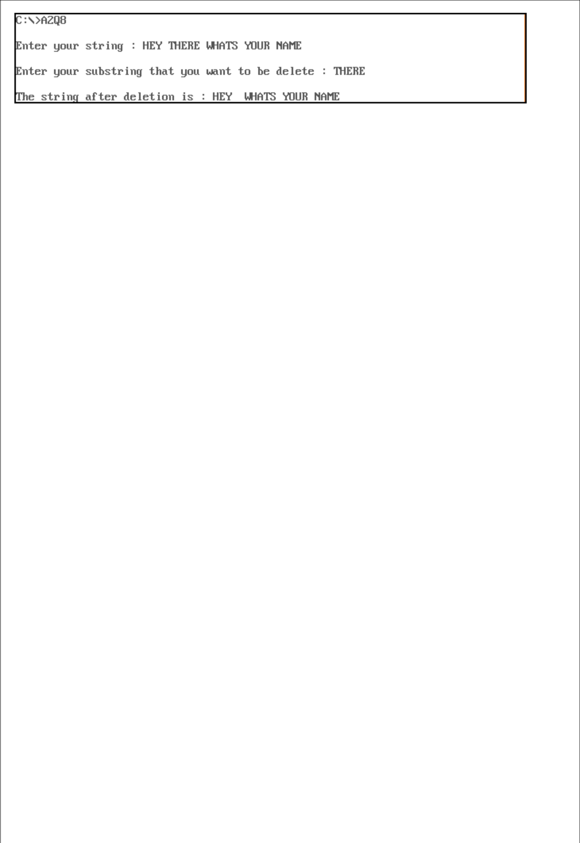

1. **Write and test a program to identify the GCD and LCM of three numbers.**

.model small

.stack 300h

.data

msg1 db 0AH,0DH,'Enter 3 numbers: $'

msg2 db 0AH,0DH,'GCD: $'

msg3 db 0AH,0DH,'LCM: $'

space db ' $'

endl db 0AH,0DH,'$'

val1 dw ?

val2 dw ?

val3 dw ?

num1 dw ?

num2 dw ?

num3 dw ?

|  |  |  |  |  |
| --- | --- | --- | --- | --- |
| .code |  |  |  |  |
| print macro msg | |  | ; macro to print a string |  |
| push ax | |  |  |  |
| push dx | |  |  |  |
| mov | ah, 09h | |  |  |
| lea | dx, msg | |  |  |
| int | 21h |  |  |  |
| pop | dx |  |  |  |
| pop | ax |  |  |  |
| endm |  |  |  |  |
| main proc |  |  |  |  |
| mov | ax,@data | |  |  |
| mov | ds,ax |  |  |  |
| print msg1 | |  |  |  |
| call readnum | | | ; read first number |  |
| mov | val1, | ax |  |  |
| call readnum | | | ; read second number |  |
| mov | val2, | ax |  |  |
| call readnum | | | ; read third number |  |
| mov | val3, | ax |  |  |
| mov | dx, 0000h | |  |  |
| mov | bx, val1 | |  |  |
| mov | cx, val2 | |  |  |
| loopgcd: | |  |  |  |
|  | mov | ax, bx |  |  |
|  | mov | dx, 0000h |  |  |
|  | div | cx |  |  |
|  | cmp | dx,0000h |  |  |
|  | jz ans | |  |  |
|  | mov | bx,cx |  |  |
|  | mov | cx,dx |  |  |
|  | cmp | cx, 0001h |  |  |
| Roll numbers – 73 – 77 | | | GROUP – C | Page 35 of 45 |

jnz loopgcd

ans:

mov num1, cx ; storing gcd of 2 numbers in num1

mov dx, 0000h

mov bx, val3

loopgcd1:

mov ax, bx

mov dx, 0000h

div cx

cmp dx, 0000h

jz ans1

mov bx, cx

mov cx, dx

cmp cx, 0001h

jnz loopgcd1

ans1:

print msg2

mov ax, cx ; gcd of 3 numbers is stored in CX

call writenum ; printing gcd of 3 numbers

mov ax, val1

mov bx, val2

mul bx

mov bx, num1 ; calculating lcm of 2 numbers by (val1*val2)/gcd(val1,val2)

div bx

mov bx, val3 ; then lcm of 3 numbers is [lcm(val1,val2)*val3]/final gcd

mul bx

div cx

print msg3

call writenum

exit:

mov ah, 4ch

int 21h

main endp

readnum proc near

* this procedure will take a number as input from user and store in AX
* input : none
* output : AX

push bx

push cx

mov cx,0ah

mov bx,00h

loopnum:

mov ah,01h

int 21h

cmp al,'0'

jb skip

cmp al,'9'

ja skip

sub al,'0'

push ax

mov ax,bx

mul cx

mov bx,ax

pop ax

mov ah,00h

Roll numbers – 73 – 77 GROUP – C Page 36 of 45

add bx,ax

jmp loopnum

skip:

mov ax,bx

pop cx

pop bx

ret

readnum endp

writenum proc near

* this procedure will display a decimal number
* input : AX
* output : none

push ax

push bx

push cx

push dx

xor cx, cx

mov bx, 0ah

@output:

xor dx, dx

div bx ; divide AX by BX

push dx ; push remainder onto the STACK

inc cx

or ax, ax

jne @output

mov ah, 02h ; set output function

@display:

pop dx ; pop a value(remainder) from STACK to DX

or dl, 30h ; convert decimal to ascii code

int 21h

loop @display

pop dx

pop cx

pop bx

pop ax

ret

writenum endp

end main

**OUTPUT :**

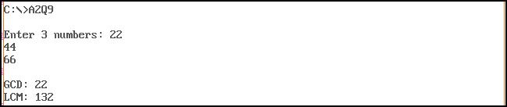

1. **Write and test a program to Implement Linear search.**

.MODEL SMALL

.STACK 300H

Roll numbers – 73 – 77 GROUP – C Page 37 of 45

.DATA

ARRAY1 DB 11,22,33,44,55

MSG4 DB 0AH,0DH,'Enter size of the array: $'

MSG1 DB 0AH,0DH,'Enter number to be searched: $'

MSG2 DB 0AH,0DH,'FOUND AT POSITION $ '

MSG3 DB 0AH,0DH,'NOT FOUND$'

ENDL DB 0AH,0DH,'$'

SE DB 33H

COUNT DB 00H

|  |  |  |
| --- | --- | --- |
| .CODE |  |  |
| PRINT MACRO MSG | | ; macro to print a string |
| push ax | |  |
| push dx | |  |
| mov | AH, 09H |  |
| lea | DX, MSG |  |
| int | 21H |  |
| ;int 3 | |  |
| pop | dx |  |
| pop | ax |  |
| ENDM |  |  |
| MAIN PROC |  |  |
| MOV | AX,@DATA |  |
| MOV | DS,AX |  |
| START: |  |  |
| PRINT MSG4 | |  |
| call readnum | | ; read size of array |
| mov | COUNT, al |  |
| mov | cl, COUNT |  |
| mov | bx, 00h |  |
| rdnxt: | |  |
|  | PRINT ENDL |  |
|  | call readnum | ; read the array elements |
|  | mov ARRAY1[BX],AL | |
|  | inc BX |  |
| loop rdnxt | |  |
| mov | cl, COUNT |  |
| PRINT MSG1 | |  |
| call readnum | | ; read the value to be searched |
| mov | se,al |  |
| mov | al,se |  |
| mov | ah,00h |  |
| LEA | SI, ARRAY1 |  |
| mov | bh, 00h |  |
| UP: |  |  |
| MOV | BL,[SI] |  |
| CMP | AL, BL |  |
| JZ FO | |  |
| INC | SI |  |
| inc | bh |  |
| loop UP | |  |
| PRINT MSG3 | | ; print ‘not found’ message |
| JMP | END1 |  |
| FO: |  |  |
| PRINT MSG2 | | ; print ‘found’ message |
| mov | al, bh |  |
| call writenum | | ; print the position of the found element |
| END1: |  |  |
| mov | ah, 4ch |  |

Roll numbers – 73 – 77 GROUP – C Page 38 of 45

int 21h

MAIN ENDP

readnum proc near

* this procedure is to read a decimal number
* input : none
* output : AX

push bx

push cx

mov cx,0ah

mov bx,00h

loopnum:

mov ah,01h

int 21h

cmp al,'0'

jb skip

cmp al,'9'

ja skip

sub al,'0'

push ax

mov ax,bx

mul cx

mov bx,ax

pop ax

mov ah,00h

add bx,ax

jmp loopnum

skip:

mov ax,bx

pop cx

pop bx

ret

readnum endp

writenum PROC near

* this procedure will display a decimal number
* input : AX
* output : none

|  |  |  |  |
| --- | --- | --- | --- |
| push bx | ; push | BX onto | the STACK |
| push cx | ; push | CX onto | the STACK |
| push dx | ; push | DX onto | the STACK |
| XOR CX, CX | ; clear CX | |  |
| MOV BX, 10 | ; set BX=10 | |  |
| @OUTPUT: | ; loop | label |  |
| XOR DX, DX | ; clear DX | |  |
| DIV BX | ; divide AX by | | BX |
| PUSH DX | ; push | DX onto | the STACK |
| INC CX | ; increment CX | |  |
| OR AX, AX | ; take | OR of Ax with AX | |
| JNE @OUTPUT | ; jump | to label @OUTPUT if ZF=0 | |
| MOV AH, 2 | ; set output function | | |
| @DISPLAY: | ; loop | label |  |
| POP DX | ; pop a value from STACK to DX | | |
| OR DL, 30H | ; convert | decimal | to ascii code |
| INT 21H | ; print a character | | |
| LOOP @DISPLAY | ; jump to label @DISPLAY if CX!=0 | | |
| POP DX | ; pop a | value from STACK into DX | |
| POP CX | ; pop a | value from STACK into CX | |

Roll numbers – 73 – 77 GROUP – C Page 39 of 45

POP BX ; pop a value from STACK into BX

RET ; return control to the calling procedure

writenum ENDP

END MAIN

**OUTPUT :**

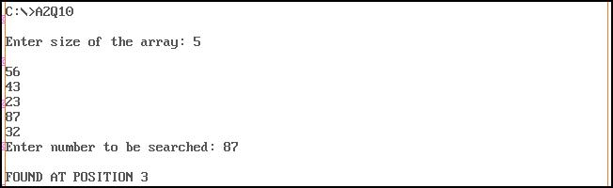

**ASSIGNMENT - 3**

1. **Write and test a MASM program to Implement Binary search. Show the steps. Each**

**step will be succeeded by “Enter” key.**

.MODEL SMALL

.STACK 300H

.DATA

ARRAY1 DB 11,22,33,44,55

MSG1 DB 0AH,0DH,'Enter size of the array: $'

MSG2 DB 0AH,0DH,'Enter a number to be searched: $'

MSG3 DB 0AH,0DH,'Current array: $'

MSG4 DB 0AH,0DH,'Element found.$ '

MSG5 DB 0AH,0DH,'Element not found.$'

space db ' $'

ENDL DB 0AH,0DH,'$'

key dw ?

mididx dw ?

left dw ?

right dw ?

SE DB 33H

COUNT DB 00H

.CODE

PRINT MACRO MSG

push ax

push dx

|  |  |
| --- | --- |
| mov | AH, 09H |
| lea | DX, MSG |
| int | 21H |
| pop | dx |
| pop | ax |
| ENDM |  |
| MAIN PROC |  |
| MOV | AX,@DATA |
| MOV | DS,AX |

Roll numbers – 73 – 77 GROUP – C Page 40 of 45

|  |  |  |  |
| --- | --- | --- | --- |
| START: |  |  |  |
| PRINT MSG1 | |  |  |
| call readnum | |  |  |
| mov | COUNT, al | |  |
| mov | cl, COUNT | |  |
| mov | bx, 00h |  |  |
| rdnxt: | |  |  |
|  | PRINT ENDL | |  |
|  | call readnum | |  |
|  | mov ARRAY1[BX],AL | | |
|  | inc BX |  |  |
| loop rdnxt | |  |  |
| print msg2 | |  |  |
| call readnum | |  |  |
| mov | key, ax | ;key to be searched | |
| mov | dx, bx | ;last index | |
| mov | bx, 0 | ;first index | |
| LEA | SI, ARRAY1 | |  |
| call binsearch | | | ;calling proc to perform binary search |
| mov | ah, 4ch |  |  |
| int | 21h |  |  |
| MAIN ENDP |  |  |  |
| binsearch | proc |  |  |
| ;input - | |  |  |
| ;bx | - left index | |  |
| ;dx | - right index | |  |
| push ax | |  |  |
| push bx | |  |  |
| push cx | |  |  |
| push dx | |  |  |
| push si | |  |  |
| mov | cx,key |  |  |
| dec | dx |  |  |
| @startsearch: | | |  |
| mov | left, bx |  |  |
| mov | right, dx | |  |
| inc | dx |  |  |
| mov | ah,01h |  |  |
| int | 21h |  |  |
| @l1: |  |  |  |
|  | xor ah,ah | |  |
|  | mov al,array1[bx] | | |
|  | call writenum | | |
|  | print space | |  |
|  | inc bx |  |  |
|  | cmp bx,dx | |  |
|  | jne @l1 | |  |
| print endl | |  |  |
| mov | bx,left |  |  |
| mov | dx,right |  |  |
| cmp | bx, dx |  |  |
| jg @notfound | |  |  |
| mov | ax, bx |  |  |
| add | ax,dx | ;ax = bx+dx | |
| shr | ax,1 | ; ax = (l+r)/2 | |
| mov | left, bx |  | ; left = bx |
| mov | mididx,ax | | ;mididx = ax |
| mov | bx, ax | ; bx = ax | |
| cmp | cl, array1[bx] | | ;compare key with midval |

Roll numbers – 73 – 77 GROUP – C Page 41 of 45

je @found

jg @bigpivot

jmp @smallpivot

@bigpivot:

mov ax, mididx

mov bx, left

inc ax

mov bx, ax ;left index = mididx + 1

jmp @startsearch

@smallpivot:

mov ax, mididx

mov bx, left

dec ax

mov dx, ax ; right index = mididx - 1

jmp @startsearch

@notfound:

print msg5

jmp @endsearch

@found:

print msg4

@endsearch:

pop si

pop dx

pop cx

pop bx

pop ax

ret

binsearch endp

readnum proc near

push bx

push cx

mov cx,0ah

mov bx,00h

loopnum:

mov ah,01h

int 21h

cmp al,'0'

jb skip

cmp al,'9'

ja skip

sub al,'0'

push ax

mov ax,bx

mul cx

mov bx,ax

pop ax

mov ah,00h

add bx,ax

jmp loopnum

skip:

mov ax,bx

pop cx

pop bx

ret

readnum endp

writenum PROC near

; this procedure will display a decimal number

Roll numbers – 73 – 77 GROUP – C Page 42 of 45

* input : AX
* output : none

|  |  |  |  |
| --- | --- | --- | --- |
| push bx | ; push BX | onto the STACK |  |
| push cx | ; push CX | onto the STACK |  |
| push dx | ; push DX | onto the STACK |  |
| XOR CX, CX | ; clear CX |  |  |
| MOV BX, 10 | ; set BX=10 | |  |
| @OUTPUT: | ; loop label | |  |
| XOR DX, DX | ; clear DX |  |  |
| DIV BX | ; divide AX by BX | |  |
| PUSH DX | ; push DX | onto the STACK |  |
| INC CX | ; increment CX | |  |
| OR AX, AX | ; take OR | of Ax with AX |  |
| JNE @OUTPUT | ; jump to | label @OUTPUT if ZF=0 | |
| MOV AH, 2 | ; set output function | |  |
| @DISPLAY: | ; loop label | |  |
| POP DX | ; pop a value from STACK | | to DX |
| OR DL, 30H | ; convert | decimal to ascii code | |
| INT 21H | ; print a | character |  |
| LOOP @DISPLAY | ; jump to | label @DISPLAY | if CX!=0 |
| POP DX | ; pop a value from STACK | | into DX |
| POP CX | ; pop a value from STACK | | into CX |
| POP BX | ; pop a value from STACK | | into BX |
| RET | ; return control to the calling procedure | | |

writenum ENDP

END MAIN

**OUTPUT –**

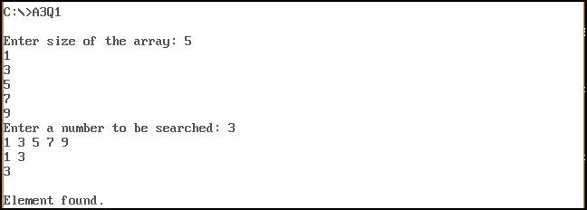

1. **Write and test a MASM program to Implement Selection Sort. Show the steps. Each step will be succeeded by “Enter” key. The Program will terminate when the “Esc” key is**

**pressed.**

print macro msg ;macro to print a string

lea dx,msg

mov ah,09h

int 21h

endm

read macro n,j1,j2 ;macro to read a number

j1: mov ah,01h

int 21h

Roll numbers – 73 – 77 GROUP – C Page 43 of 45

cmp al,0dh

je j2

sub al,30h

mov bl,al

mov ax,n

mov dx,0ah

mul dx

xor bh,bh

add ax,bx

mov n,ax

jmp j1

j2: nop

endm

printmul macro n1,l2,l3 ;macro to print a number

mov bx,000ah

mov ax,n1

xor cx,cx

l2: xor dx,dx

div bx

push dx

inc cx

cmp ax,0000h

jne l2

l3: pop dx

add dl,30h

mov ah,02h

int 21h

loop l3

endm

.model small

.stack 100h

.data

num dw 100 dup(0)

n dw 0

m dw 0

msg1 db 'Enter the number of elements:$'

msg2 db 'Enter an element:$'

msg3 db 'Current array:$'

msg4 db ' $'

msg6 db 10,13,' $'

exitmsg db 10,13,'Program executed.$'

.code

main proc

mov ax,@data

mov ds,ax

print msg1

read n,jump1,jump2 ;read the size of array

mov cx,n

mov ax,n

dec ax

mov m,ax

mov si,0000h

loop1: print msg2

read num[si],jump3,jump4 ;read array elements

add si,02h

loop loop1

print msg3

call display ;printing original array

print msg6

mov si,0000h

xor cx,cx

outerloop: mov ax,num[si]

mov di,si

push cx

push si

Roll numbers – 73 – 77 GROUP – C Page 44 of 45

mov si,di

innerloop:

add si,02h

cmp ax,num[si]

jl check

mov ax,num[si]

mov di,si

check: inc cx

cmp cx,m

jl innerloop

pop si

pop cx

mov bx,num[si]

mov num[di],bx

mov num[si],ax

push cx

push si

mov ah,01h ;enter a character

int 21h

cmp al,27 ;ascii value of esc key

je exit

print msg3

call display ;printing current array

print msg6

pop si

pop cx

add si,02h

inc cx

cmp cx,m

jl outerloop

exit: print exitmsg

mov ah,4ch ; terminate program

int 21h

main endp

display proc ; procedure to print the array

mov cx,n

mov si,00h

l4: push cx

print msg4

printmul num[si],l5,l6

add si,02h

pop cx

loop l4

ret

display endp

end main

**OUTPUT –**

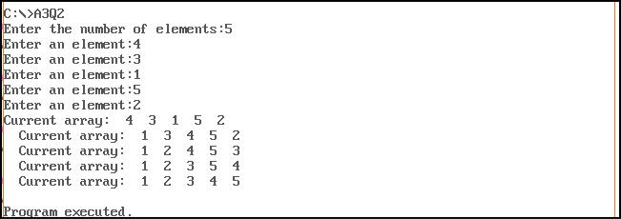

Roll numbers – 73 – 77 GROUP – C Page 45 of 45