Nikhil Badyal

BCSE III | JU

Lexical Analyzer

Lex TOOL

001810501069

**Lex is a computer program that generates lexical analyzers ("scanners" or "lexers").**

• The lexical analyzer is a program that transforms an input stream into a sequence of tokens.

• It reads the input stream and produces the source code as output through implementing the lexical analyzer in the C program.

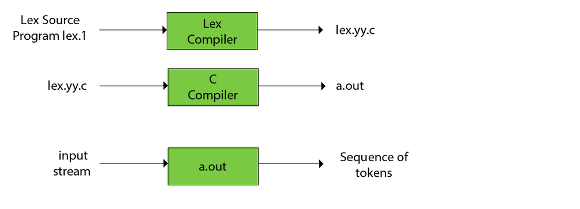

**Program 1**

**Input Data**

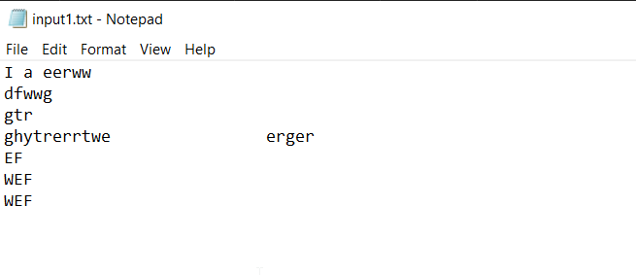

**Lex File**

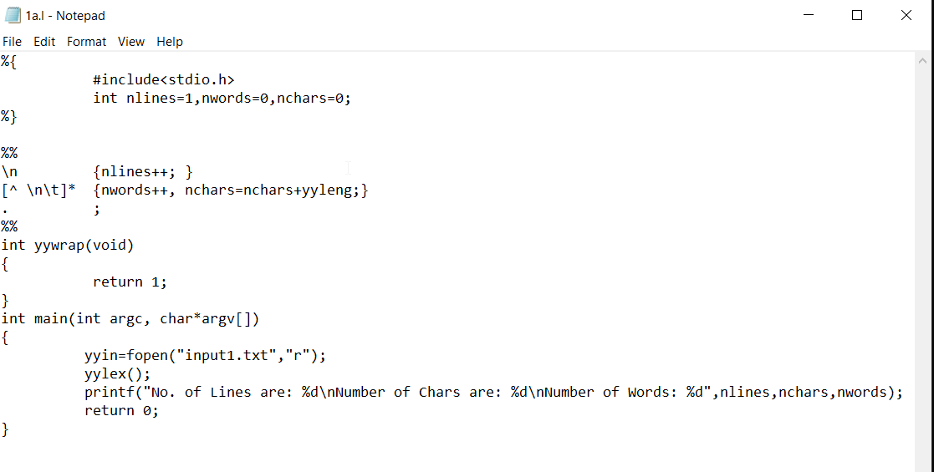

**Output**

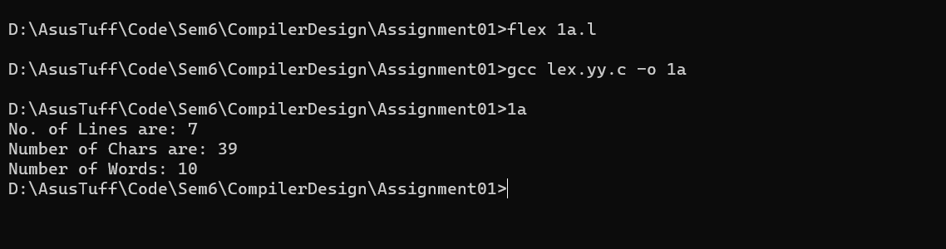

**PROGRAM 2**

**Input Data**

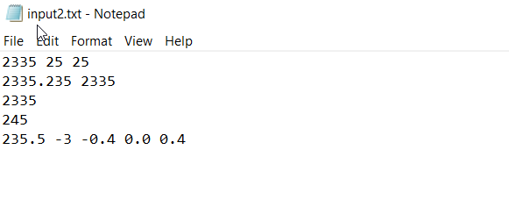

**Lex File**

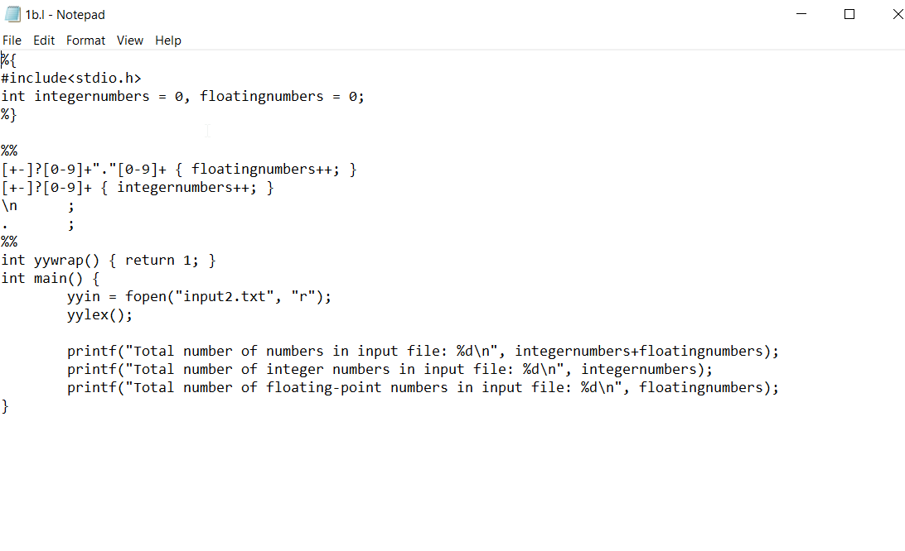

**Output**

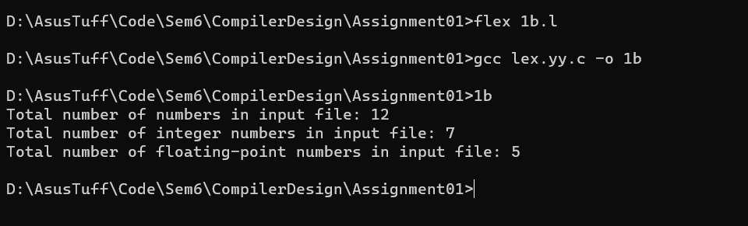

**PROGRAM 3**

**Input Data**

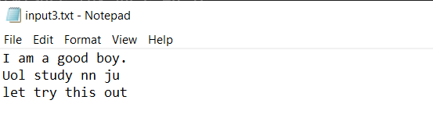

**Lex File**

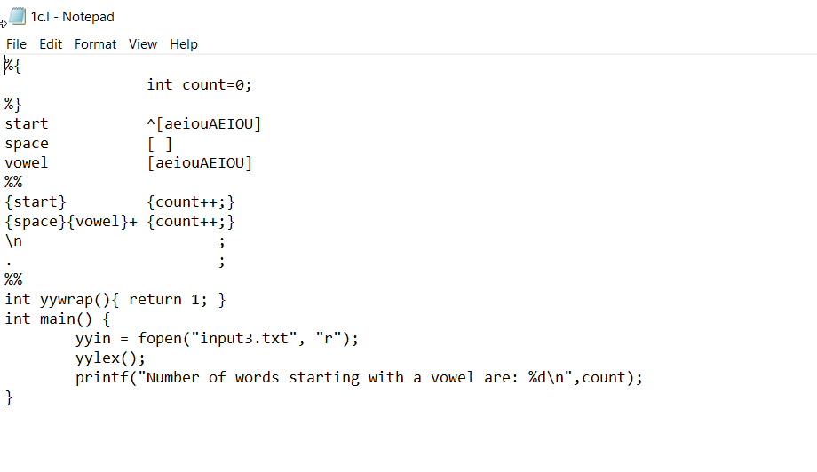

**Output**

