ASSIGNMENT-1 LAB REPORT

DBMS

Nikhil Badyal

001810501069

Q1.

# Develop an application using Visual Basic as follows.

# User will enter two numbers. Provide button to add or to find the difference. Depending on the option result will be shown in result box. Add a suitable title to the screen. Whenever the form is loaded, also display current date in the title bar

## LAYOUT: -

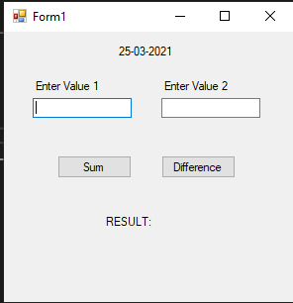

## COMPONENTS USED: -

Here I have used two input fields which are used to take two numbers, two button which are used to print the result (sum or difference) and two labels which are used to print result and date.

## EVENT HANDLERS: -

The Buttons have event-Handlers associated with them. After the user types the input and clicks the button the event handler associated with them is called and the answer prints.

The event-handlers are show below: -

Private Sub sumButton_Click(ByVal sender As System.Object, ByVal e As System.EventArgs) Handles sumButton.Click

Private Sub diffButton_Click(ByVal sender As System.Object, ByVal e As System.EventArgs) Handles diffButton.Click

## SPECIAL PROPERTIES

Here I am displaying the current date on the top of the form.

## RESULT: -

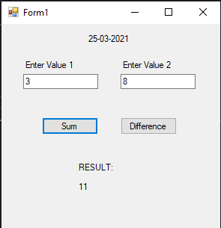

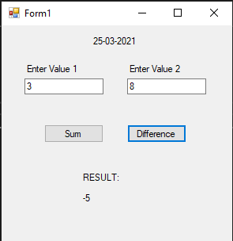

## Q1. Consider list of departments (dept code and name), list of students (roll, dept code, name, address and phone) preloaded in array. Now develop an application for the following.

## User may add/search/edit/delete/display all student record. While adding, ensure roll must be unique, a list of dept name to be shown from which user selects one and corresponding dept code to be stored. On collecting the data user may choose CANCEL/SAVE button to decide course of action. For searching user provides roll. If it exists details are shown else suitable message to be displayed. To delete user provides roll. If it does not exist then suitable message is to be displayed. To edit also user provides roll. If it exists user may be allowed to edit any field except roll. User may select CANCEL/SAVE to decide course of action. To display all records, at a time five records are to be shown. IT will also have PREV/NEXT button to display previous set and next set respectively. When first set is displayed PREV button must be disabled and at last set NEXT button must be disabled.

## SCHEMATIC DIAGRAM: -

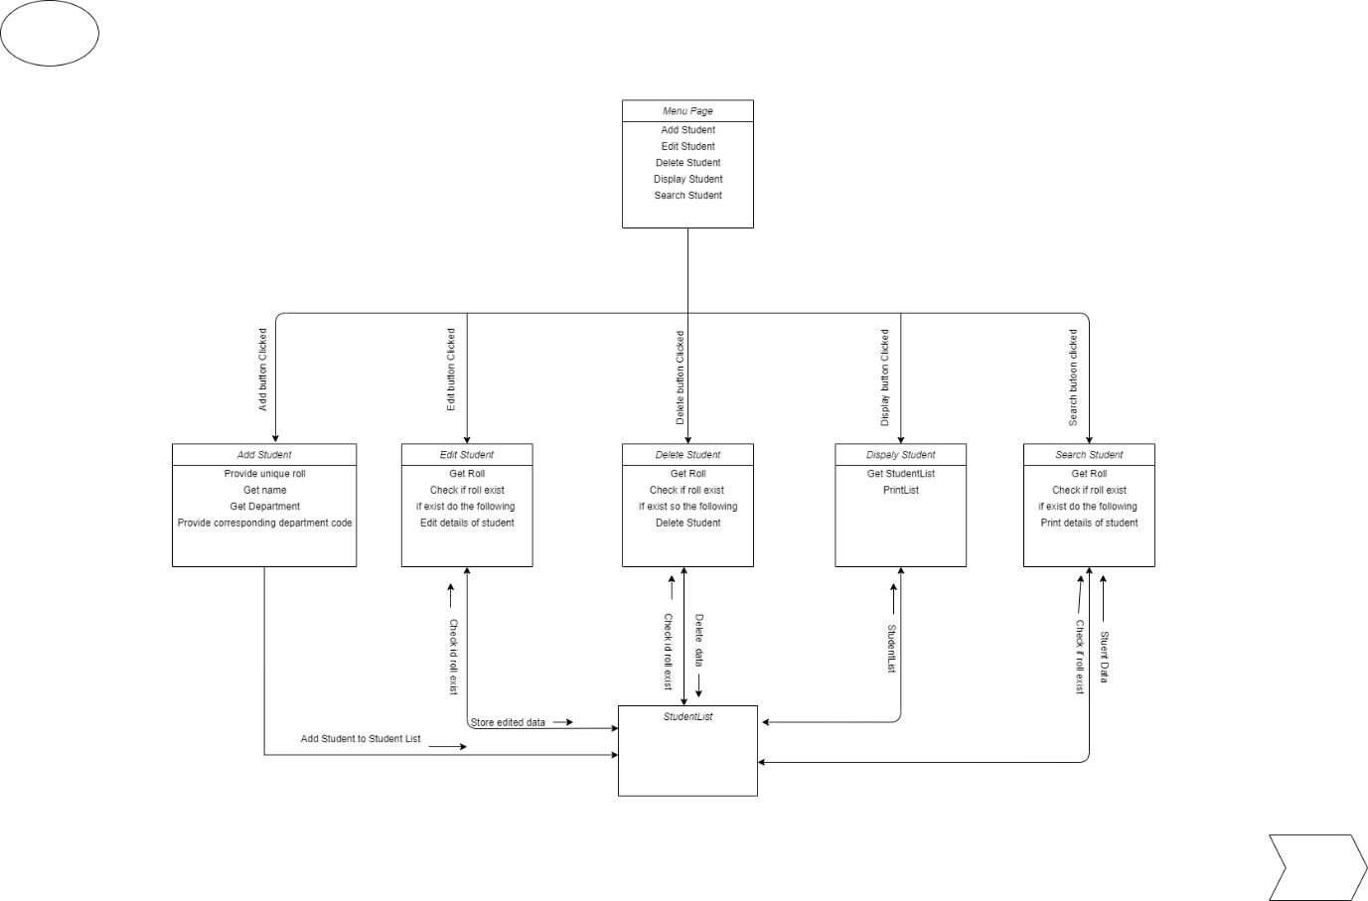

## LAYOUT:-

## MENU PAGE:-

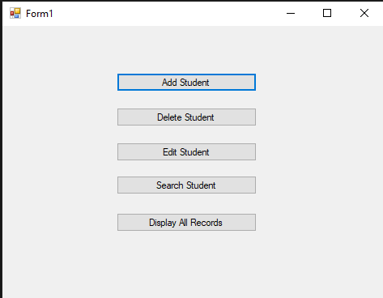

## DELETE STUDENT PAGE:-

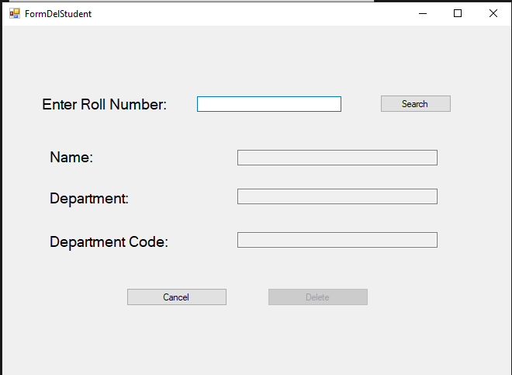

## EDIT STUDENT PAGE:-

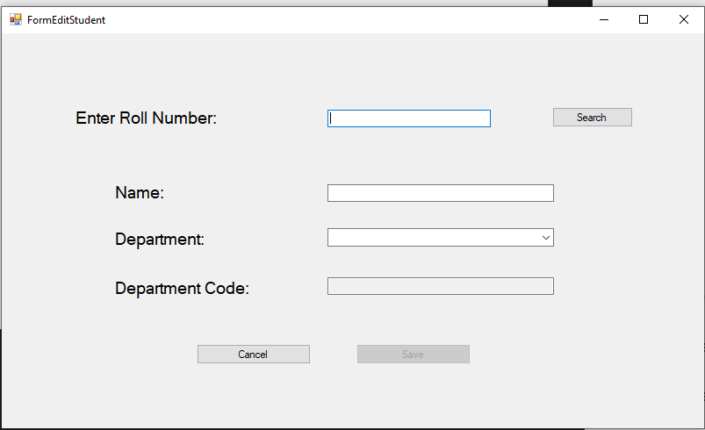

## SEARCH STUDENT PAGE:-

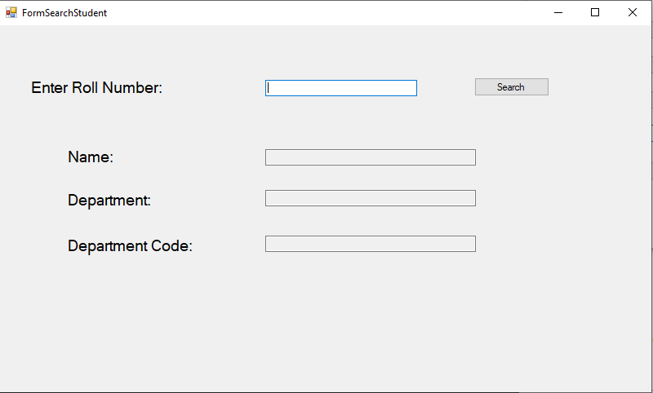

## DISPLAY PAGE:-

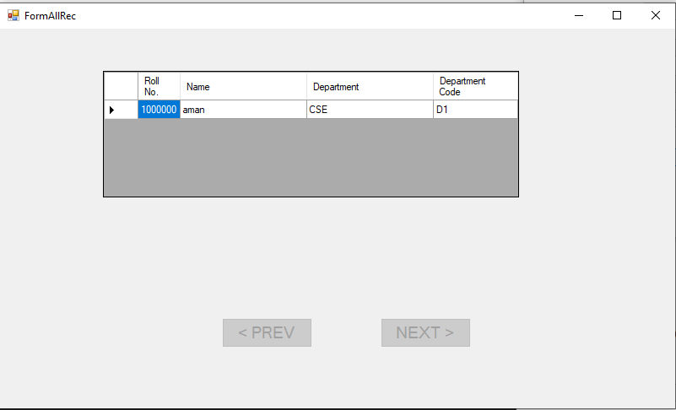

## ADD STUDENT PAGE:-

## 

## COMPONENTS USED:-

Here collectively I have used input fields (textbox and dropdown) which are used to take input from users, button which are used to print the result and two labels which are used to print result.

## EVENT HANDLERS:-

The Buttons have event-Handlers associated with them. After the user types the input and clicks the button the event handler associated with them is called and the answer prints.

The event-handlers are show below:-

MENU-PAGE

Private Sub addst_Click(sender As Object, e As EventArgs) Handles addst.Click

End Sub

Private Sub delst_Click(sender As Object, e As EventArgs) Handles delst.Click

End Sub

Private Sub editst_Click(sender As Object, e As EventArgs) Handles editst.Click

End Sub

Private Sub srchst_Click(sender As Object, e As EventArgs) Handles srchst.Click

End Sub

Private Sub Button1_Click(sender As Object, e As EventArgs) Handles Button1.Click

End Sub

Private Sub Form1_Load(sender As Object, e As EventArgs) Handles MyBase.Load

End Sub

ADD-PAGE

Private Sub FormAddStudent_Load(sender As Object, e As EventArgs) Handles MyBase.Load

End Sub

Private Sub dept_SelectedIndexChanged(sender As Object, e As EventArgs) Handles dept.SelectedIndexChanged

End Sub

Private Sub btn_cancel_Click(sender As Object, e As EventArgs) Handles btn_cancel.Click

End Sub

Private Sub btn_save_Click(sender As Object, e As EventArgs) Handles btn_save.Click

End Sub

DELETE-PAGE

Private Sub search_del_Click(sender As Object, e As EventArgs) Handles search_del.Click

End Sub

Private Sub del_cancel_Click(sender As Object, e As EventArgs) Handles del_cancel.Click

End Sub

Private Sub del_save_Click(sender As Object, e As EventArgs) Handles del_save.Click

End Sub

Private Sub FormDelStudent_Load(sender As Object, e As EventArgs) Handles MyBase.Load

End Sub

DISPLAY-PAGE

Private Sub prev_btn_Click(sender As Object, e As EventArgs) Handles prev_btn.Click

End Sub

Private Sub next_btn_Click(sender As Object, e As EventArgs) Handles next_btn.Click

End Sub

Private Sub FormAllRec_Load(sender As Object, e As EventArgs) Handles MyBase.Load

End Sub

Private Sub records_CellContentClick(sender As Object, e As DataGridViewCellEventArgs) Handles records.CellContentClick

End Sub

EDIT-PAGE

Private Sub search_edit_Click(sender As Object, e As EventArgs) Handles search_edit.Click

End Sub

Private Sub edit_cancel_Click(sender As Object, e As EventArgs) Handles edit_cancel.Click

End Sub

Private Sub edit_save_Click(sender As Object, e As EventArgs) Handles edit_save.Click

End Sub

Private Sub edit_dept_SelectedIndexChanged(sender As Object, e As EventArgs) Handles edit_dept.SelectedIndexChanged

End Sub

Private Sub FormEditStudent_Load(sender As Object, e As EventArgs) Handles MyBase.Load

End Sub

SEARCH-PAGE

Private Sub search_Click(sender As Object, e As EventArgs) Handles search.Click

End Sub

## SPECIAL PROPERTIES

Any error msg will be shown in a message dialogue box and if user enters a roll that does not exist in case editing, deleting or searching record of a student.