**Internet Technology Lab Report**

**Assignment 3**

Name – **Nikhil Badyal**

Roll – **001810501069**

Class – **BCSE 3rd year**

Group – **A2**

Assignment Numbers – **3**

Implement a web application for “Travel Thru Air” using servlets to support the following two use cases

1. A list of current special deals must appear on the home page. Each special deal must display the departure

city, the arrival city, and the cost. These special deals are set up by the marketing department and change

during the day, so it can’t be static. Special deals are only good for a limited amount of time.

2. A user may search for flights, given a departure city, time and an arrival city. The results must display

the departure city, the arrival city, the total cost, and how many legs the flight will have.

State and explain why and where you have used design patterns.

**Features**

|  |  |
| --- | --- |
| User Panel | ✅ |
| Admin Panel | ✅ |
| Booking Support | ✅ |
| Deals list | ✅ |
| Login | ✅ |
| Logout | ✅ |
| Session Management | ✅ |
| Database integration (MySQL) | ✅ |
| Security (HTTPS/SSL) | ✅ |
| Search Flights | ✅ |
| Design Pattern | (MVC) |
| Backend DB | MySQL |

**User Interaction**

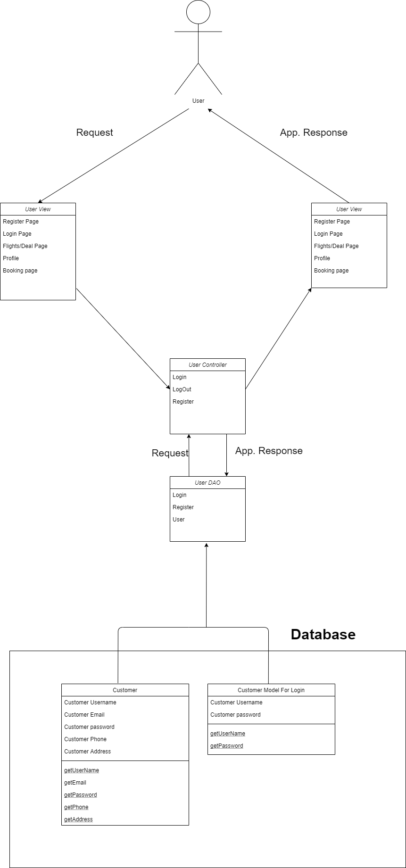

**Manager Interaction**

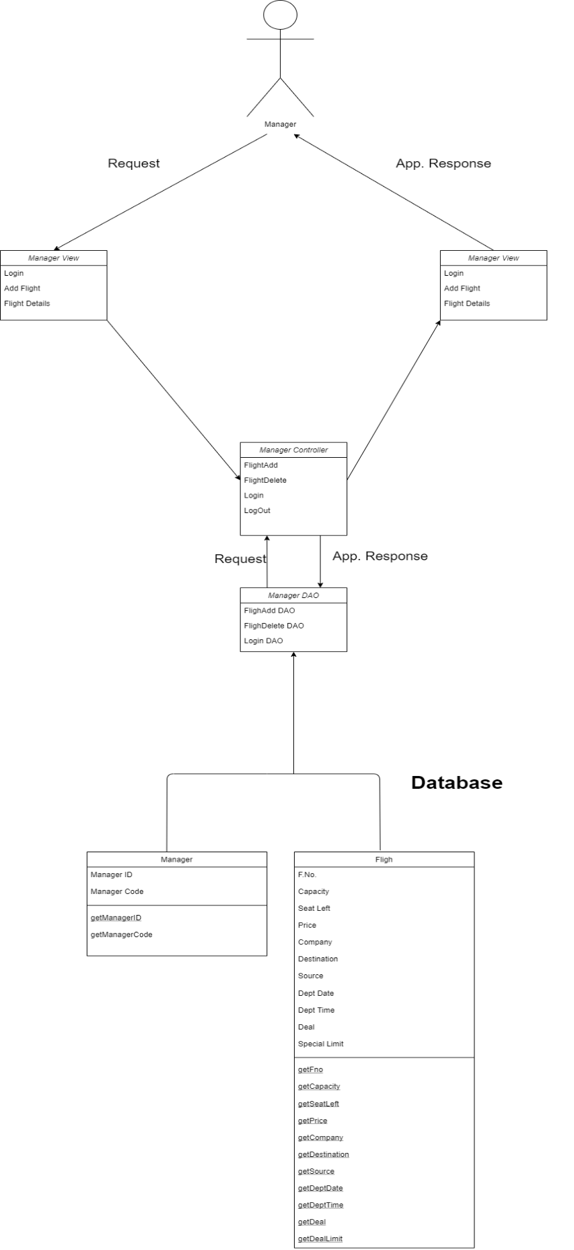

**Website Workflow**

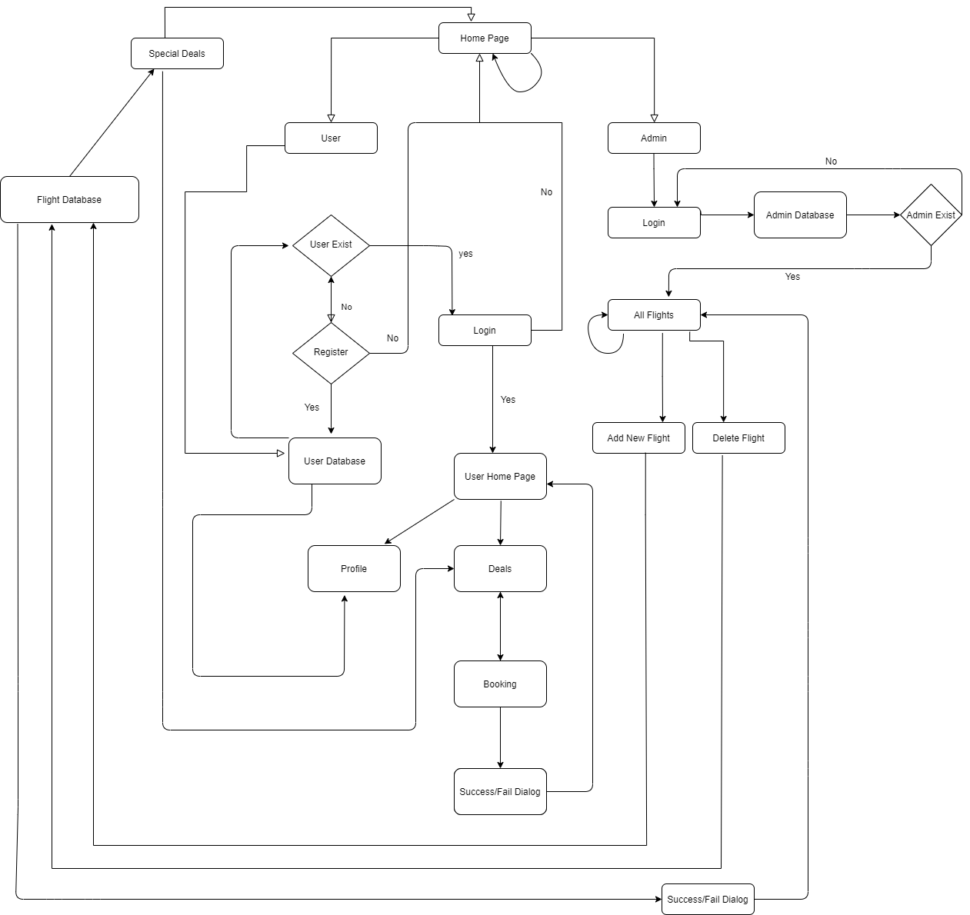

**Session Management**

To manage session, we are using contexts getSesssion Method. Whenever a website user(admin/user) successfully logs to the system. I add his credential as a session object. And while visiting any sensitive page. I ask for that user unique identification and if that exist only then the user is allowed to visit otherwise, he/she is thrown to the login or home page as per the status of the user.

**Login Page**

**Controller**

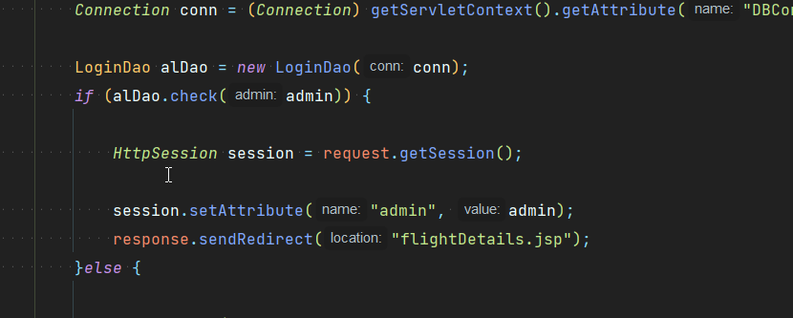

**View**

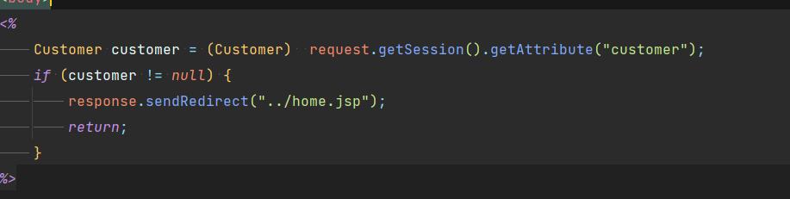

**User Booking**

Before allowing user to book I check whether user is allowed to book the website or not.

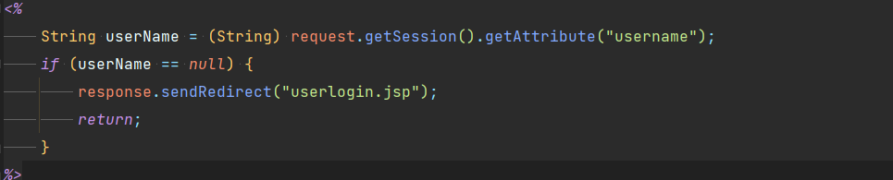

**Manager Login**

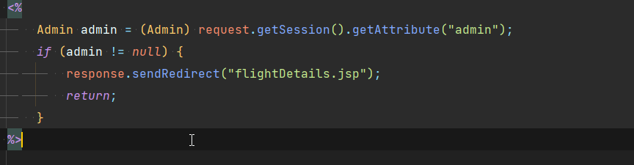

**Add Flight**

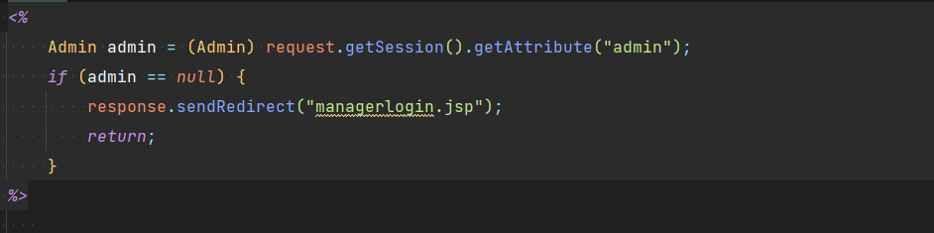

**Flight Details**

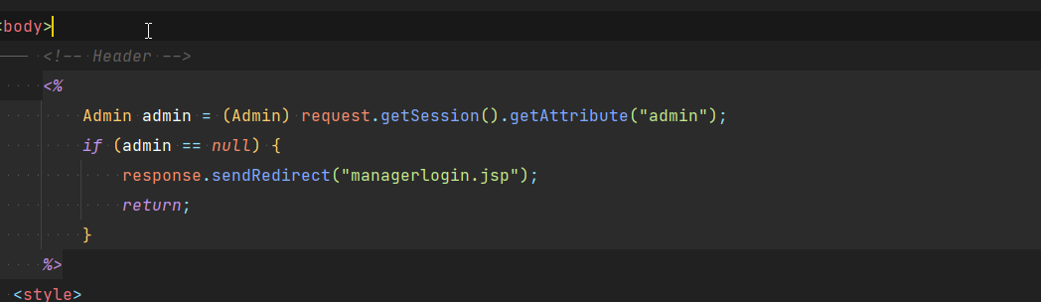

**MVC**

I have 2 modals for the website. One representing user and other representing admin.

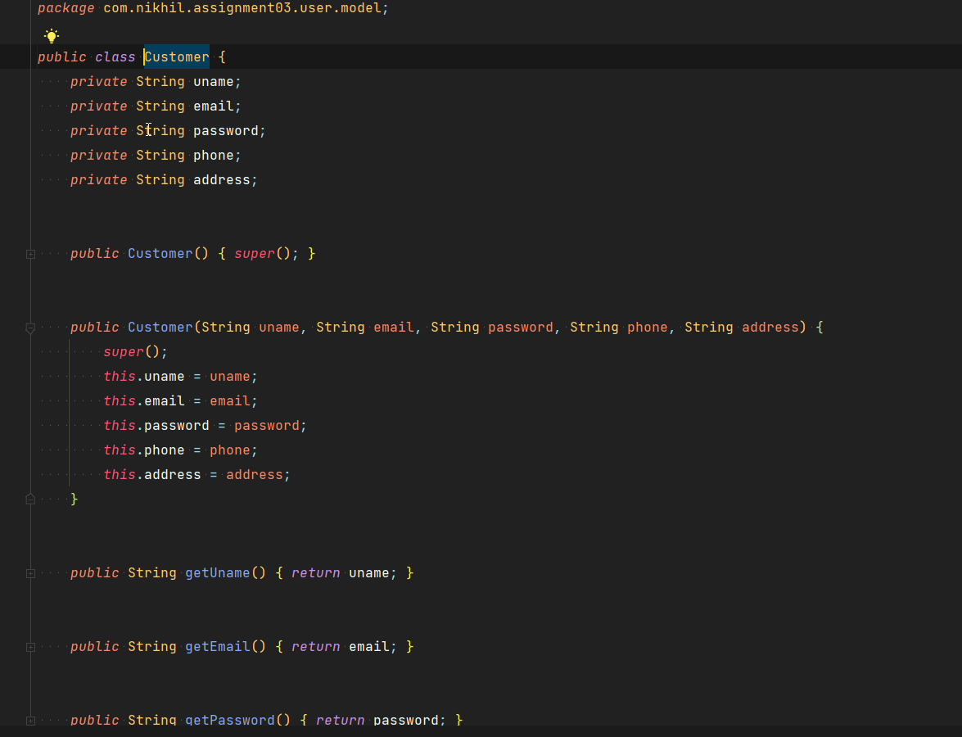

**Admin Modal**

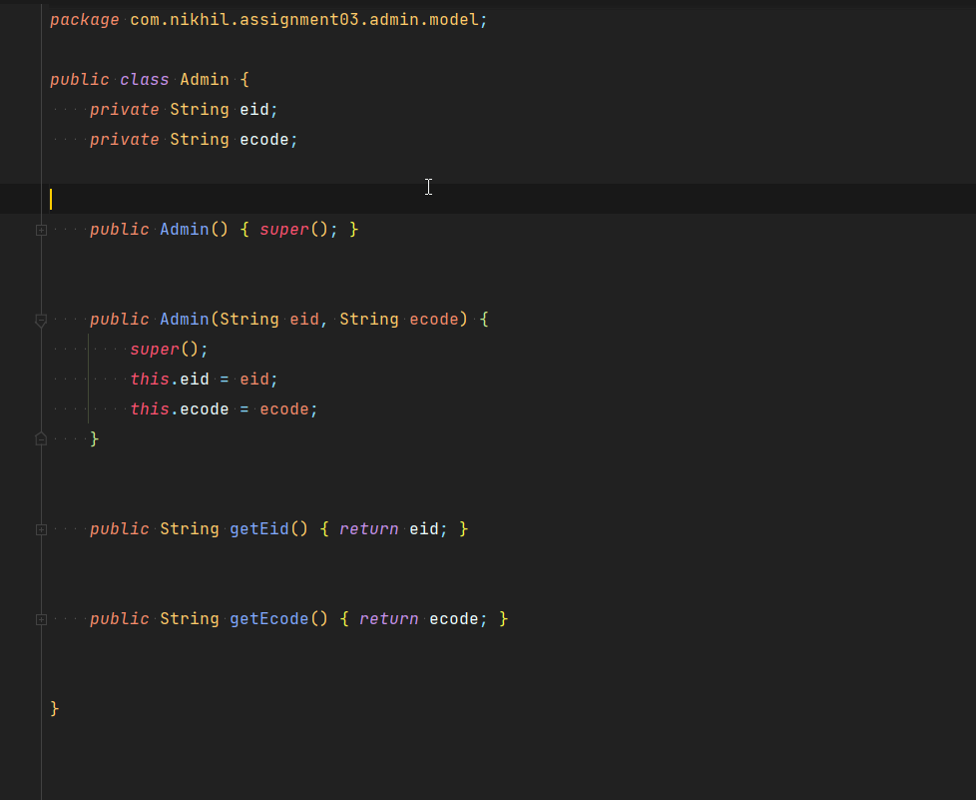

**Admin MVC**

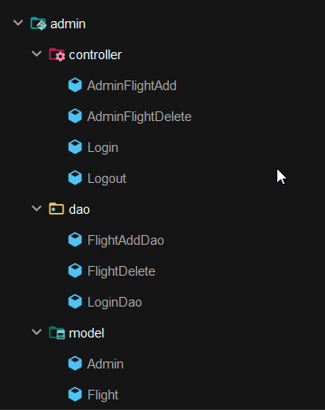

**User MVC**

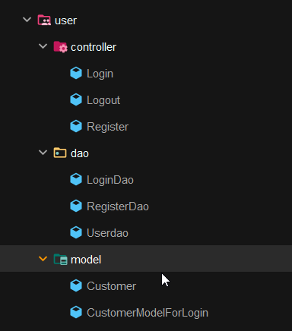

**DB Connection**

To avoid multiple connections to the db. I’m creating connection once and then saving it for future use.

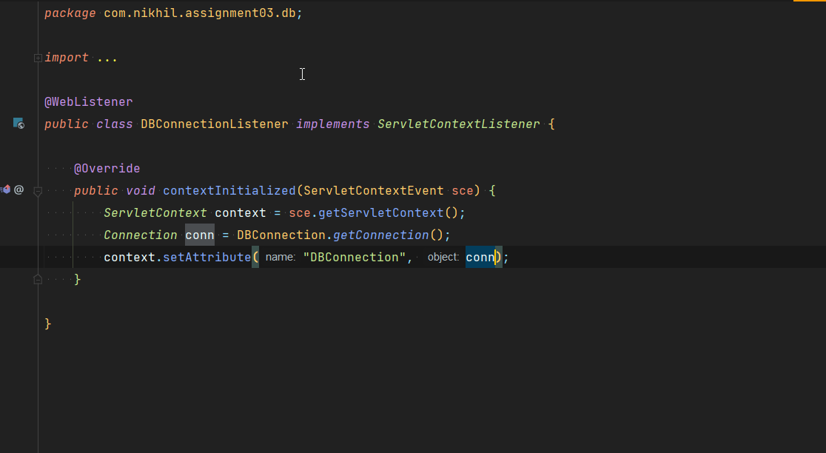

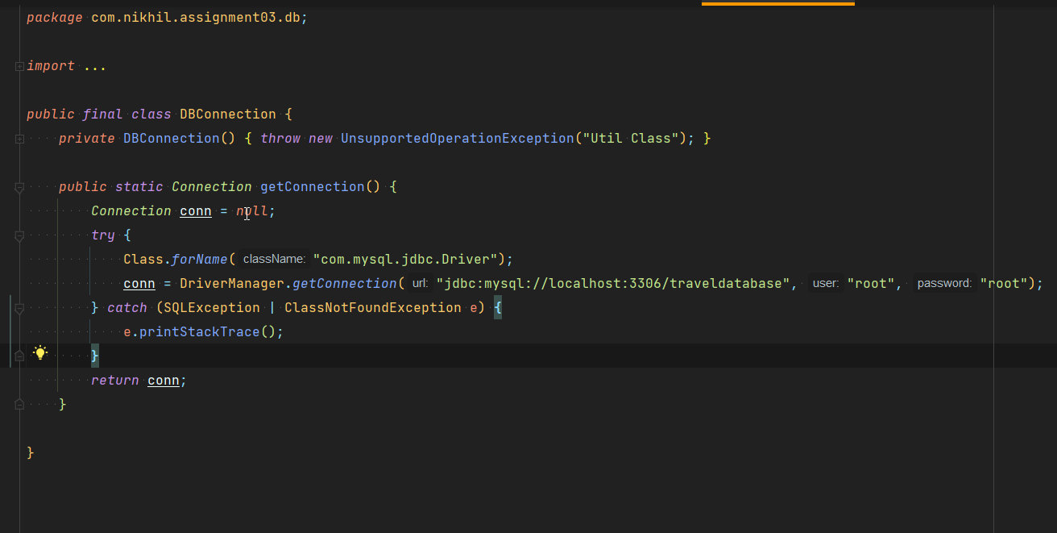

**Login Page**

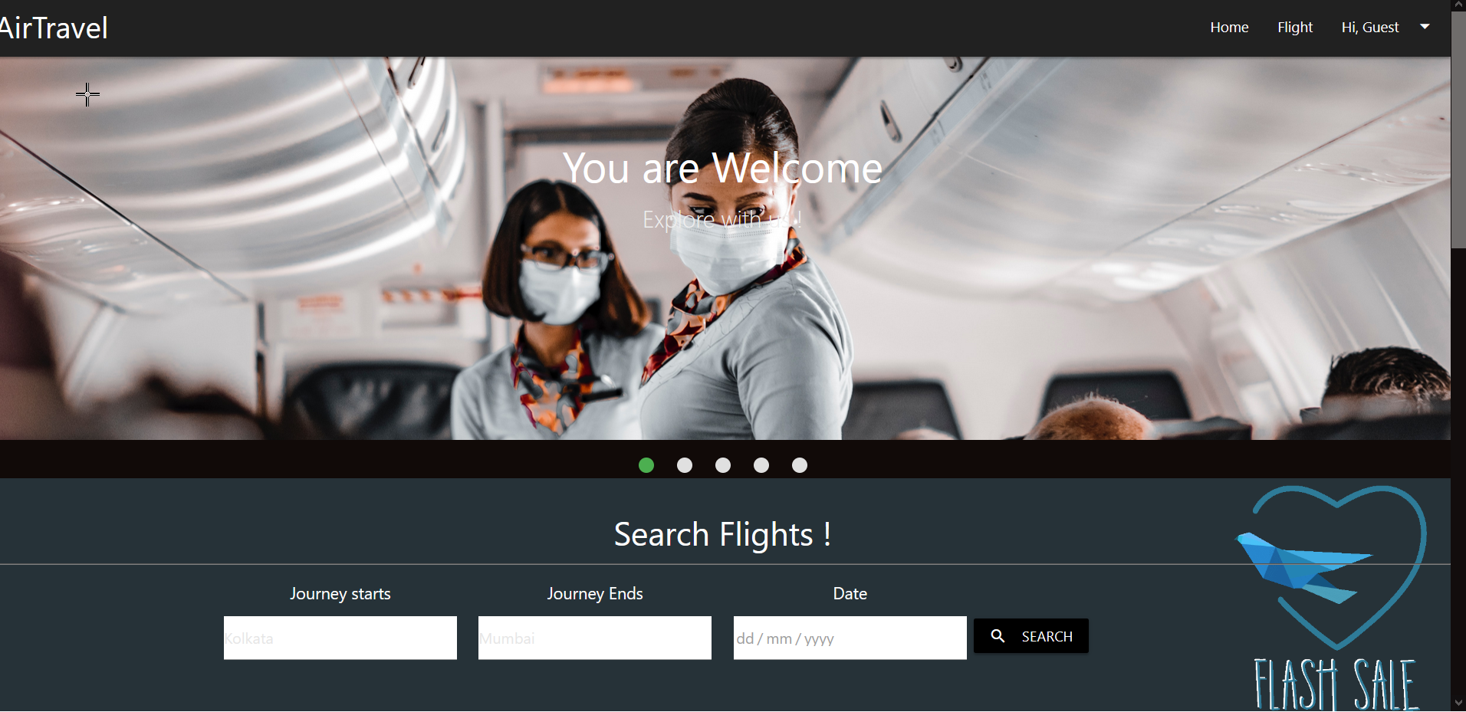

**Home UI**

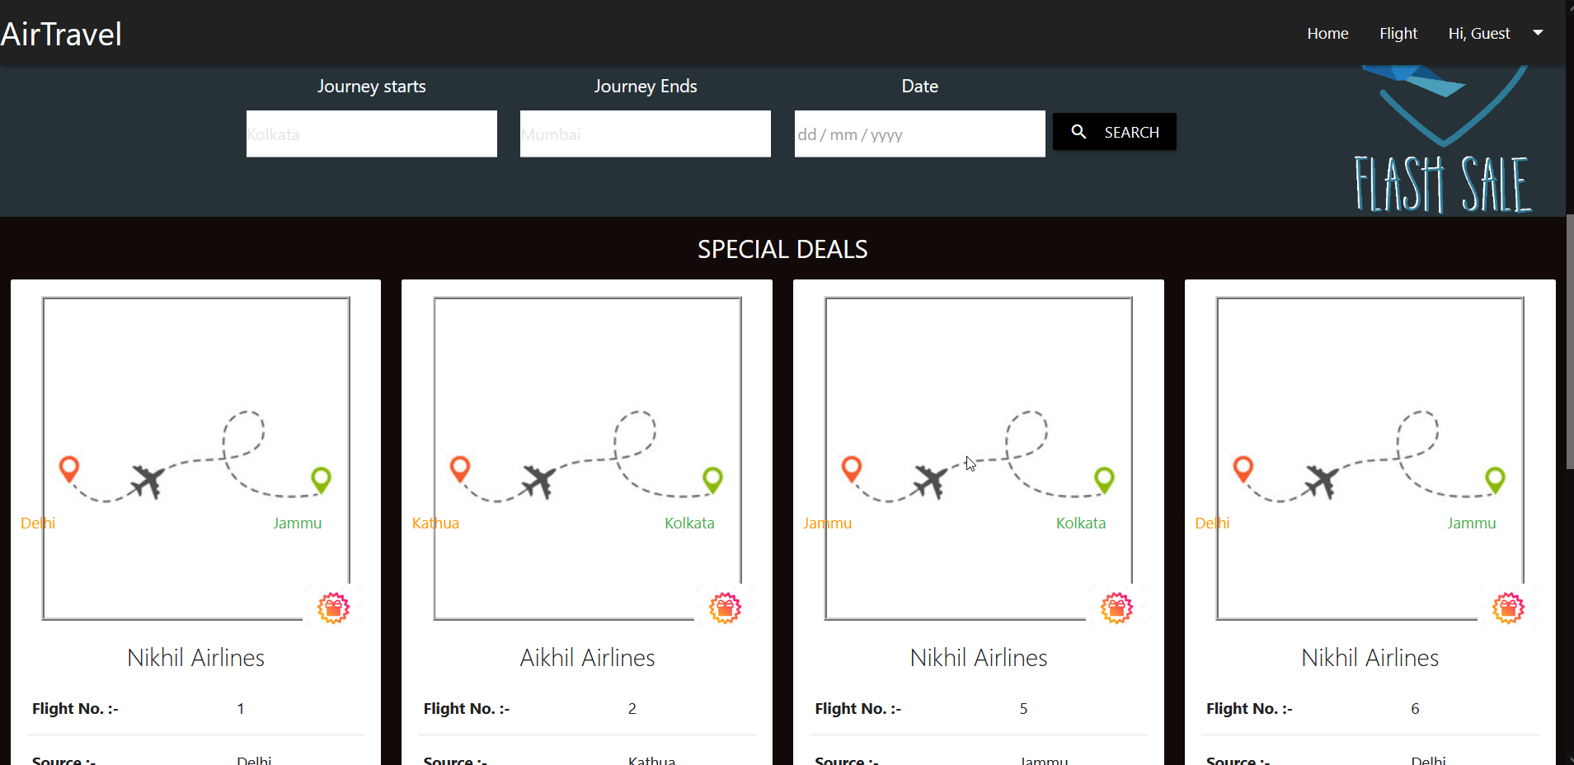

**User Login**

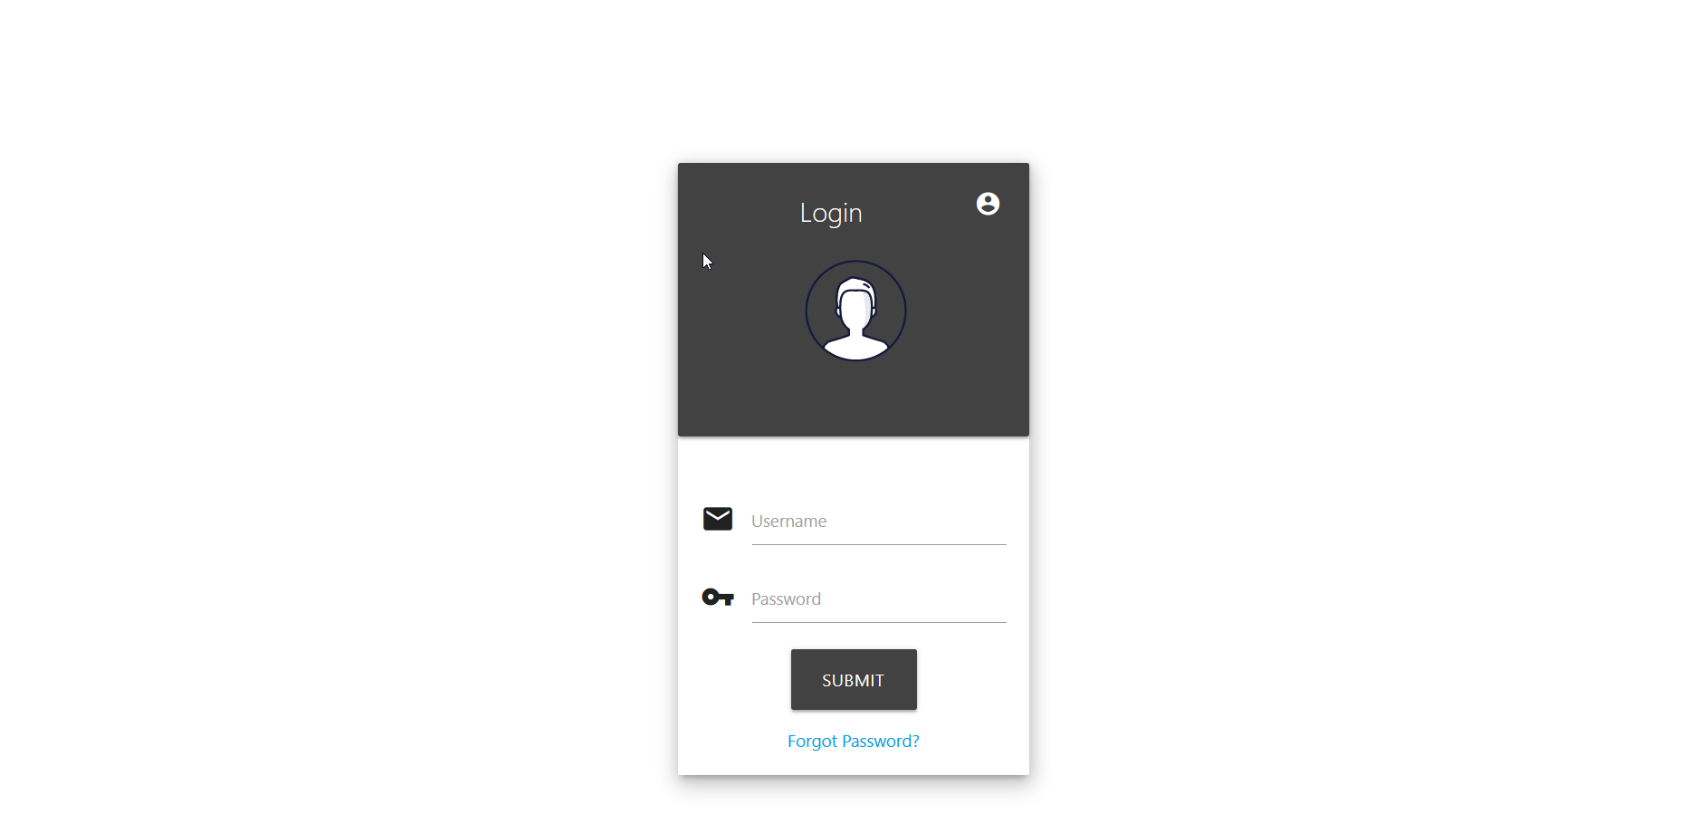

**Manager Login** 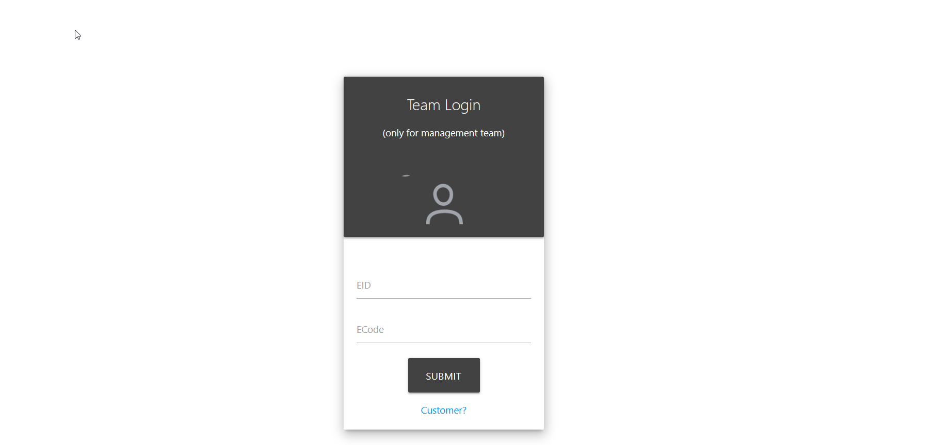

**Flight View**

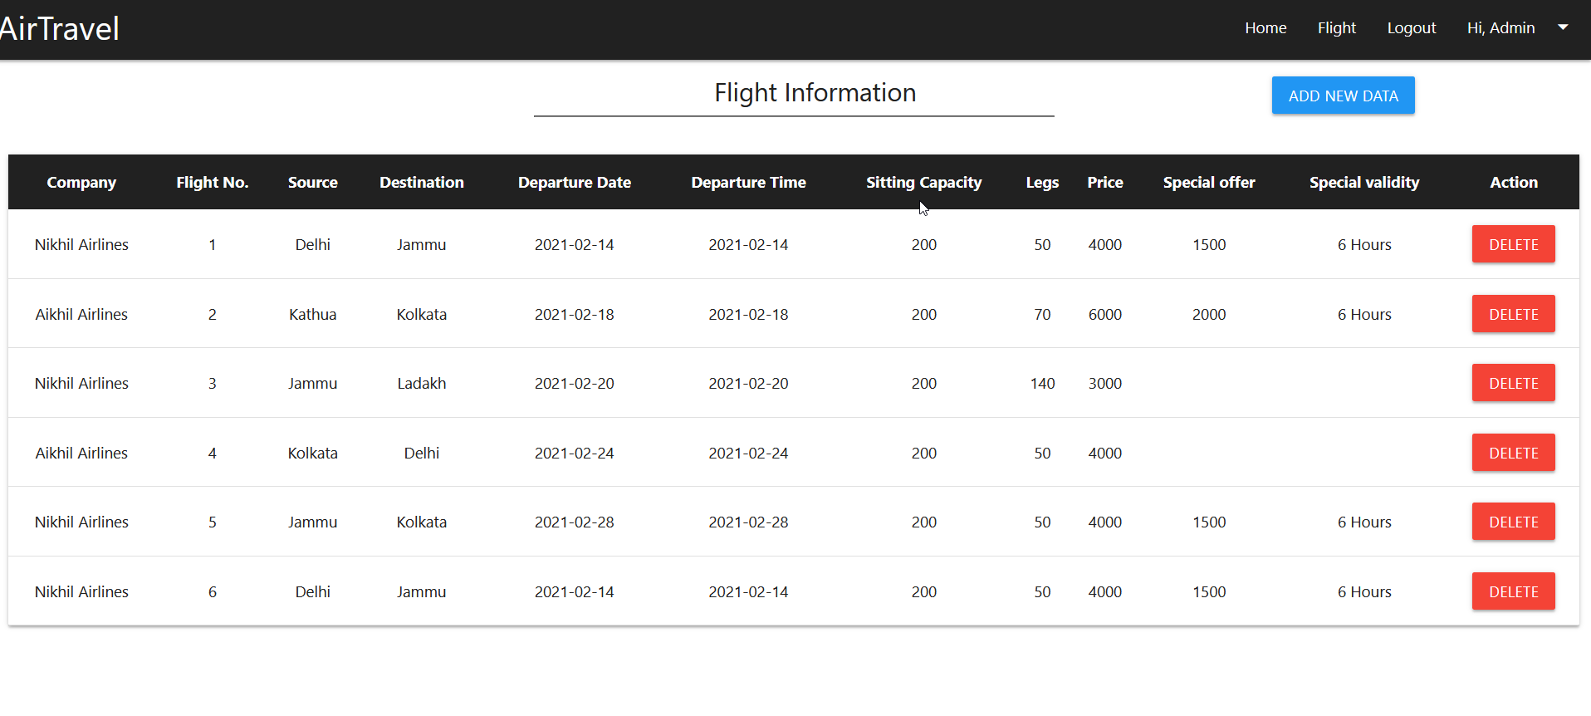

**Add Flight**

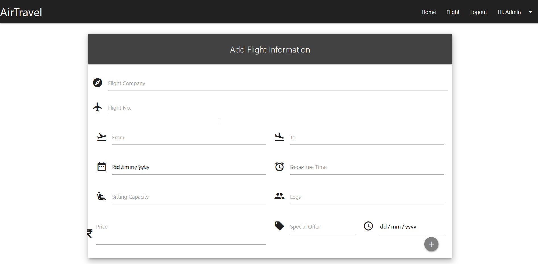

**User Profile**

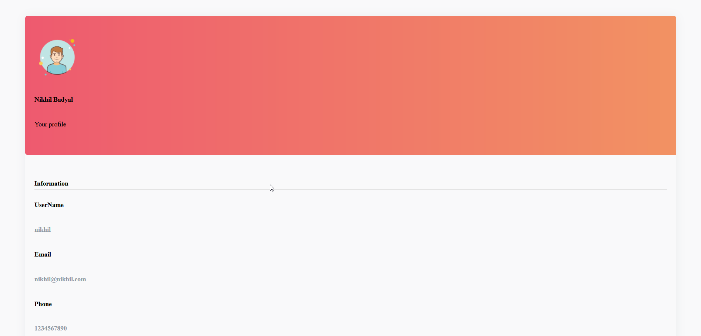’

**Search UI**

