GOA UNIVERSITY
Department of Computer Science & Technology
Master of Computer Applications (MCA)
Object-Oriented Technology (OOT) Lab
PROJECT REPORT
RENTSPHERE
Peer-to-Peer Asset Rental Marketplace
with 8×8 Smart Locker and Parking Hub
Submitted By
Student Name | Roll No.
Deepak Devan | 2665
Farris Khan | 2664
Nikhil Baiju | 2665
Ketan Naik | 2623

Academic Year 2026–2027

CERTIFICATE

This is to certify that the mini-project report entitled “RentSphere: Peer-to-Peer Equipment Rental Marketplace with 8×8 Simulated Smart Pickup Hub” has been prepared and submitted by the project team of the Master of Computer Applications (MCA) programme, Department of Computer Science & Technology, Goa University, as part of the Object-Oriented Technology laboratory work.
The report documents the project development process, including the problem identification, design decisions, object-oriented modelling, implementation, testing, working-product evidence and future scope.

DECLARATION

We hereby declare that the project titled “RentSphere: Peer-to-Peer Equipment Rental Marketplace with 8×8 Simulated Smart Pickup Hub” is our academic mini-project work carried out for the Object-Oriented Technology laboratory.
The report presents the system design, implementation, testing and evaluation of the project based on the submitted source code and project documentation. The report is intended for academic submission and records the major development activities and technical decisions associated with the project.
The project team has contributed to analysis, design, implementation, testing, debugging, documentation or review of the system.

ACKNOWLEDGEMENT

We would like to express our sincere gratitude to Goa University and the Department of Computer Science & Technology for providing the academic environment and facilities required to complete this Object-Oriented Technology mini-project.
We are grateful to our project guide and faculty members for their guidance, technical suggestions and feedback during the development of RentSphere. The discussions on object-oriented design, software architecture, testing and documentation helped us understand how classroom concepts can be applied to a practical software system.
We also thank our classmates and friends who provided suggestions during testing and demonstration. Finally, we acknowledge the efforts of every member of the project team for contributing to the analysis, implementation, verification and preparation of this report.

CONTENTS

Chapter / Particulars | Page No.
Abstract | 01
Chapter 1 – Introduction | 02–07
1.1 Background | 03
1.2 Aim and Objectives | 04
1.3 Problem Statement | 05
1.4 Current Gaps and Proposed Solution | 06
1.5 Scope | 07
Chapter 2 – Brainstorming and Project Selection | 08–11
2.1 Brainstorming and Design Alternatives | 09
2.2 Accepted and Reduced/Rejected Directions | 10
2.3 Final Project Concept | 11
Chapter 3 – Technologies Used | 12–18
3.1 Java | 13
3.2 HTML, CSS and JavaScript | 14
3.5 OOT Concepts Used | 17
3.6 Development Environment | 18
Chapter 4 – System Analysis and Workflow | 19–31
4.1 Workflow Description | 20
4.2 Use Case Diagram | 21
4.3 5-Tier Object-Oriented Class Hierarchy | 22
4.4 Statechart Diagram – Mandatory Quarantine Invariant | 23
4.5 4-Gate Fail-Fast Verification Pipeline | 24
4.6 Object Diagram | 25

CONTENTS — CONTINUED

Chapter / Particulars | Page No.
4.7 Brainstorming Map | 26
4.8 Entity Relationship Diagram | 27
4.9 System Architecture Diagram | 28
4.10 Component Diagram | 29
4.11 Local Deployment Diagram | 30
4.12 Product Workflow Summary | 31
Chapter 5 – Object-Oriented Design and Implementation | 32–41
5.1 Encapsulation, Inheritance, Polymorphism and Abstraction | 33
5.2 Interfaces and Composition | 34
5.3 Design Patterns | 35
5.4 Backend Implementation | 36
5.5 Frontend Implementation | 37
5.6 Authentication and Security | 38
5.7 Persistence, Payment and Escrow | 39
5.8 Smart Hub and Physical Workflow | 40
5.9 Administrative and Support Functions | 41
Chapter 6 – Working Product and Screenshots | 47–51
6.1 Marketplace and Reservation Screens | 47
6.2 Smart Pickup Hub | 48
6.3 Escrow, Host, Admin and Support Screens | 49–51
Chapter 7 – Testing and Development Activities | 52–54
7.1 Testing Strategy and Results | 52
7.2 Development Activities and Issues | 53
7.3 Improvements During Development | 54
Chapter 8 – Future Scope and Conclusion | 55
References | 56
Appendix – Final Evidence Checklist and Team Details | 57

ABSTRACT
RentSphere is a full-stack peer-to-peer asset rental application developed as an Object-Oriented Technology mini-project. The system provides a structured marketplace in which users can browse rental assets, reserve equipment, complete a simulated payment, collect an asset from a smart locker hub, return it for inspection and receive a security-deposit settlement. Hosts can maintain rental listings, while administrative and support functions handle disputes and assistance.
The backend is primarily implemented in Java and uses object-oriented domain models, services, interfaces and state objects. The asset hierarchy demonstrates inheritance and polymorphism. The State pattern manages the rental lifecycle, while Prototype cloning supports duplication of rental listings. A fail-fast verification pipeline checks identity, state legality, escrow solvency and locker-space rules before important operations are allowed.
The web interface uses HTML, CSS and JavaScript and communicates with the Java HTTP server. The project also includes authentication, PBKDF2-HMAC-SHA256 password hashing, session tokens, role-based access control, OTP protection, a simulated payment adapter, flat-file persistence and automated verification.
The current project verification report records 163 automated tests across 17 verification suites with all reported tests passing. The project therefore demonstrates how OOP principles can be combined with practical security, state management, persistence, payment and physical-workflow modelling in a single academic system.

CHAPTER 1
INTRODUCTION

1. INTRODUCTION
RentSphere is designed as a peer-to-peer rental marketplace for physical assets such as cameras, event equipment, power tools and mobility vehicles. The central idea is to model the complete rental lifecycle rather than treating a rental as a simple database record.
A normal rental process includes several connected activities: finding an asset, checking availability, reserving it, confirming payment and security deposit, collecting the asset, using it, returning it, inspecting its condition and resolving any dispute. RentSphere brings these activities into one software model.
The project was developed primarily to demonstrate Object-Oriented Technology. The system therefore separates responsibilities into domain objects, services, state objects, interfaces and persistence components. This separation allows the project to demonstrate concepts such as encapsulation, inheritance, polymorphism, abstraction and design patterns in a realistic context.

1.1 BACKGROUND
Traditional peer-to-peer rental arrangements may depend on messages, manual payment confirmation and informal tracking of asset condition. These approaches can make it difficult to maintain a reliable history of reservations, deposits, returns and disputes.
RentSphere introduces explicit software representations for these activities. The asset has a lifecycle state, the rental amount and security deposit are represented separately, the pickup location is associated with a smart-hub compartment, and returned assets move into an inspection stage before they can become available again.

1.2 AIM AND OBJECTIVES
The main aim of RentSphere is to develop an object-oriented rental marketplace that demonstrates a complete asset-rental workflow, including reservation, payment, escrow, smart pickup, return inspection and dispute handling.
- To model rental assets using a reusable object-oriented hierarchy.
- To demonstrate encapsulation, inheritance, polymorphism and abstraction in a practical system.
- To apply State and Prototype patterns to the rental domain.
- To represent payment and refundable security deposits through an escrow subsystem.
- To model an 8×8 smart pickup and parking hub with 64 logical bays.
- To provide authentication, role-based access and secure password handling.
- To validate business rules through a fail-fast verification pipeline.
- To maintain persistent information without requiring a conventional relational database.
- To provide testing evidence for functional, security and object-oriented components.

Development Activities Covered
- Problem identification and project concept selection.
- Requirements and feature identification.
- System modelling and UML preparation.
- Backend and frontend implementation.
- Integration of payment, escrow, locker and security modules.
- Testing, debugging, refinement and final documentation.

1.3 PROBLEM STATEMENT
Peer-to-peer rental processes often involve several disconnected steps. A renter may find an item through one channel, communicate with the owner through another, make a payment separately and arrange physical collection manually. This makes the complete rental history difficult to manage.
A software system that stores only availability is also insufficient. The system must prevent invalid reservations, maintain the correct rental state, ensure that sufficient funds are available, associate the asset with a valid pickup location and handle the condition of the item after return.
Physical collection introduces another requirement. The software must represent where an item is stored and how a renter is authorized to collect it. In RentSphere, this is modelled through the 8×8 smart hub, simulated locker devices and OTP-based pickup.
The project therefore addresses the problem of designing a single object-oriented system that connects marketplace operations, lifecycle states, escrow, physical pickup, inspection, disputes, security and support.

1.4 CURRENT GAPS AND PROPOSED SOLUTION

Current Gaps
- Rental status can become inconsistent when state transitions are handled only through simple flags.
- Payment, security deposits and rental charges may not be clearly separated.
- Physical pickup and return locations are often outside the software model.
- Damage inspection and dispute handling may be treated as separate manual activities.
- Simple prototypes may not include password hashing, session protection or OTP lockout.
- A rental application may not enforce business invariants before state-changing operations.

Proposed Solution
- Use explicit State objects for the rental lifecycle.
- Use an escrow subsystem to separate rental payment and refundable collateral.
- Use an 8×8 hub model to represent physical pickup and return locations.
- Use a fail-fast pipeline before important reservation and pickup operations.
- Use PBKDF2-HMAC-SHA256 password hashing and secure sessions.
- Use role-based access control for visitor, renter, host and administrator functions.
- Use quarantine after return so that inspection happens before an asset becomes available.

How RentSphere Addresses the Gaps
The proposed design keeps business rules close to the domain and service layers. This reduces dependence on the user interface and makes the rules testable. The result is a more structured rental workflow suitable for an OOT mini-project.

1.5 SCOPE
The scope of the implemented system includes the following areas:
Area | Scope
Marketplace | Browse and manage rental assets across multiple categories.
Rental Lifecycle | Reservation, active lease, return, inspection and dispute states.
Escrow | Rental payment and refundable security-deposit accounting.
Smart Hub | 64 logical bays, locker allocation and OTP pickup simulation.
Authentication | Registration/login, password hashing and sessions.
Authorization | Visitor, renter, host and admin roles.
Persistence | Flat-file ledgers and audit records.
Support | Support tickets and grievance/dispute workflows.
Testing | Automated verification and browser walkthrough coverage.
The system is an academic implementation. Production hardware, production payment credentials, enterprise identity verification and a production relational database are outside the present implementation and are identified as future enhancements.

CHAPTER 2
BRAINSTORMING AND PROJECT SELECTION

2.1 BRAINSTORMING AND DESIGN ALTERNATIVES
The project documentation supplied with RentSphere does not contain a dated meeting-by-meeting brainstorming log. To avoid inventing project history, this section records the major design alternatives and decisions that are visible in the implemented system and its documented limitations.
The development direction focused on choosing a project that could demonstrate multiple OOP concepts while still representing a realistic application. A rental marketplace was suitable because it naturally contains objects, relationships, states, services, interfaces, security rules and physical-world constraints.

Initial Design Questions
- Should the system model only marketplace listings or the complete rental lifecycle?
- Should rental states be represented with flags or State objects?
- Should the application depend on a relational database or use lightweight persistence?
- Should payment be connected to a real gateway or simulated safely for academic testing?
- Should the smart locker be represented only visually or through a device abstraction?
- How should returned assets be handled before they become available again?

Result of Brainstorming
The implemented design chose a complete lifecycle model, explicit state objects, flat-file persistence, a sandbox payment adapter, a locker-device abstraction and mandatory inspection quarantine. These decisions make the project more suitable for demonstrating OOP and software design.

2.2 ACCEPTED AND REDUCED / REJECTED DIRECTIONS
The following table records major alternatives reflected in the project design. “Rejected/reduced” means the approach was not used in the current academic implementation; it does not claim that a formal meeting vote occurred.
Alternative | Decision | Reason
Simple availability flag for rental status | Reduced / rejected | Explicit State objects provide clearer legal transitions.
Direct return to AVAILABLE | Rejected | Returned assets must enter inspection quarantine first.
Production payment gateway | Reduced to sandbox | A sandbox adapter is safer and appropriate for academic demonstration.
Physical locker hardware | Reduced to simulation | The project models the device through an interface and simulated device.
SQL database | Deferred | Flat-file persistence keeps the academic system lightweight.
Generic asset class only | Rejected | Specialized categories better demonstrate inheritance and polymorphism.
Single service for all operations | Reduced | Separate services improve responsibility separation and testing.

Important Development Decision
The most important design decision was to treat the rental lifecycle as a set of explicit states. This makes the rule “active return must first enter inspection quarantine” part of the system design rather than merely a user-interface instruction.

2.3 FINAL PROJECT CONCEPT
The final concept selected for implementation is RentSphere: a peer-to-peer asset rental marketplace with an integrated 8×8 smart locker and parking hub.

Core Modules
- Marketplace — assets, categories, pricing and listing operations.
- Rental Lifecycle — reservation, active lease, return and inspection.
- Escrow Wallet — payment, collateral and settlement records.
- Smart Hub — locker allocation, pickup and physical-location rules.
- Host Studio — listing management, cloning and diagnostics.
- Admin & Grievance Hub — disputes, support and administrative operations.

Why the Concept Fits OOT
The concept naturally maps real-world entities to software objects. Assets have identity and behaviour; categories can inherit from common base classes; payment and locker devices can be represented through interfaces; states encapsulate lifecycle behaviour; and services coordinate larger workflows.

Final Development Direction
The project was therefore developed as a Java-based web application with a browser frontend, a Java HTTP server, object-oriented backend packages, flat-file persistence and automated tests. The physical smart-hub is simulated but follows defined allocation and security rules.

CHAPTER 3
TECHNOLOGIES USED

3.1 JAVA
Java is the primary backend language of RentSphere. The project uses Java SE facilities for the HTTP server, file handling, cryptography, reflection, collections and Swing-based locker console.
- Java classes represent domain entities, services, states, payment objects and security components.
- Interfaces are used for replaceable behaviours such as payment gateways and locker devices.
- Collections are used for in-memory runtime state.
- Java file APIs support the flat-file persistence engine.
- Cryptography APIs support secure password derivation and session-related security.
- Reflection APIs support runtime inspection of the object model.
- Swing is used for the standalone locker console component.

Java Version / Build Note
The project POM is configured for Java source/target compatibility level 17. A newer installed JDK may still be used if the local environment supports the configured compiler settings, but the project itself targets Java 17.

3.2 HTML, CSS AND JAVASCRIPT
The browser frontend provides the user-facing layer of the application. The frontend is separated into an HTML entry point, CSS styling and JavaScript application logic.

HTML
HTML defines the structure of the marketplace, smart-hub, escrow, host and administrative views.

CSS
CSS controls layout, spacing, typography, component presentation and responsive visual structure.

JavaScript
JavaScript handles browser-side interaction and communication with the Java server endpoints. It updates views, sends requests and presents returned data to the user.

Frontend–Backend Relationship
The frontend does not replace the backend domain logic. Important validation and business rules remain on the server side, allowing the application to enforce security and lifecycle constraints independently of the browser.

3.3 MAVEN AND JUNIT
The project includes a Maven POM that identifies the project as com.rentsphere:rentsphere-core. Maven is used to describe the build configuration and test dependency.
Component | Role
Maven | Build and dependency management.
maven-compiler-plugin | Java compilation configuration.
JUnit 5 | Automated testing framework.
Java SE APIs | Runtime functionality without external application dependencies.

Testing
The current TEST_REPORT records 163 automated tests distributed across 17 verification suites. The tests cover domain behaviour, state lifecycle, smart hub rules, reflection and cloning, trust scoring, persistence, authentication, payment, OTP security, disputes and related workflows.

Why this setup was selected
The project intentionally keeps runtime dependencies lightweight. This makes the mini-project easier to run locally and keeps the focus on object-oriented design rather than infrastructure configuration.

3.4 PROJECT STRUCTURE
The project is organized into backend, frontend, supporting files, documentation and test-related areas.
Folder / File | Purpose
backend/src/rentsphere/api | HTTP server and API entry point.
auth | Authentication, password hashing, accounts and sessions.
model | Core rental asset domain hierarchy.
state | Rental lifecycle state objects.
escrow | Escrow accounts and transactions.
payment | Payment gateway abstraction and sandbox adapter.
locker | Locker compartments, grid and device simulation.
pipeline | Fail-fast verification gates.
persistence | Flat-file persistence engine.
dispute / support / policy | Operational and administrative functions.
meta | Repository, cloning, reflection and trust scoring.
frontend | index.html, CSS and JavaScript browser interface.
data | Persistent ledger files used by the application.
docs | UML and project documentation.
The package separation is important for OOP because it prevents the complete application from becoming one large class. Each package represents a related responsibility.

3.5 OOT CONCEPTS USED
Concept | How it appears in RentSphere
Encapsulation | Domain classes keep data and related behaviour together.
Inheritance | Rental asset classes extend common base classes.
Polymorphism | Common services operate on base types while concrete asset types provide specialized behaviour.
Abstraction | Interfaces such as PaymentGateway and LockerDevice define contracts.
Composition | Services contain or use collaborating domain objects.
State Pattern | Rental lifecycle behaviour is represented by state objects.
Prototype Pattern | Rental listings can be cloned and then modified independently.
Generics | GenericRepository provides reusable repository behaviour.
Reflection | ReflectionInspector examines object structure at runtime.
These concepts are not included only for theory. They are connected to actual project classes and workflows so that the design can be demonstrated during an OOT viva.

3.6 DEVELOPMENT ENVIRONMENT
The project is intended to run as a local Java web application with a browser frontend. The application can be compiled using the Java compiler or the Maven configuration provided in the project.

Required Environment
- JDK compatible with the project build; the POM targets Java 17.
- Maven for the standard project build and test lifecycle.
- A modern web browser for the frontend.
- A local filesystem with write permission for the data directory.

Execution Components
- Java HTTP server entry point: rentsphere.api.MainServer.
- Frontend entry point: frontend/index.html.
- Persistent records: text files in the data area.
- Locker simulation: Java locker/device classes and the optional Swing console.

Academic Demonstration
For demonstration, the main focus should be on the complete rental workflow, the OOP class structure, the state transitions, the smart-hub model and the test evidence.

CHAPTER 4
SYSTEM ANALYSIS AND WORKFLOW

4.1 WORKFLOW DESCRIPTION
The RentSphere workflow begins with marketplace discovery. A renter selects an available asset and initiates a reservation. Before the state changes, the fail-fast pipeline checks the required conditions.
- KYC / identity gate checks whether the required identity condition is satisfied.
- State legality gate checks whether the asset is in a state that permits the requested operation.
- Escrow solvency gate checks whether sufficient funds or collateral are available.
- Locker spatial gate checks whether the selected physical location is valid for the asset.
- If all gates succeed, the rental can proceed and the asset moves into the appropriate state.
- Pickup is authorized through the smart-hub workflow and a six-digit OTP.
- During an active lease, the asset remains associated with the renter.
- On return, the asset enters inspection quarantine rather than becoming immediately available.
- Inspection can result in a clean return or a damage-related deduction/dispute.

Rental State Lifecycle
AVAILABLE → RESERVED_ESCROW → ACTIVE_LEASE → INSPECTION_QUARANTINE → AVAILABLE, with DISPUTED used when a damage or settlement issue requires dispute handling.

Figure 1 — Use Case Diagram
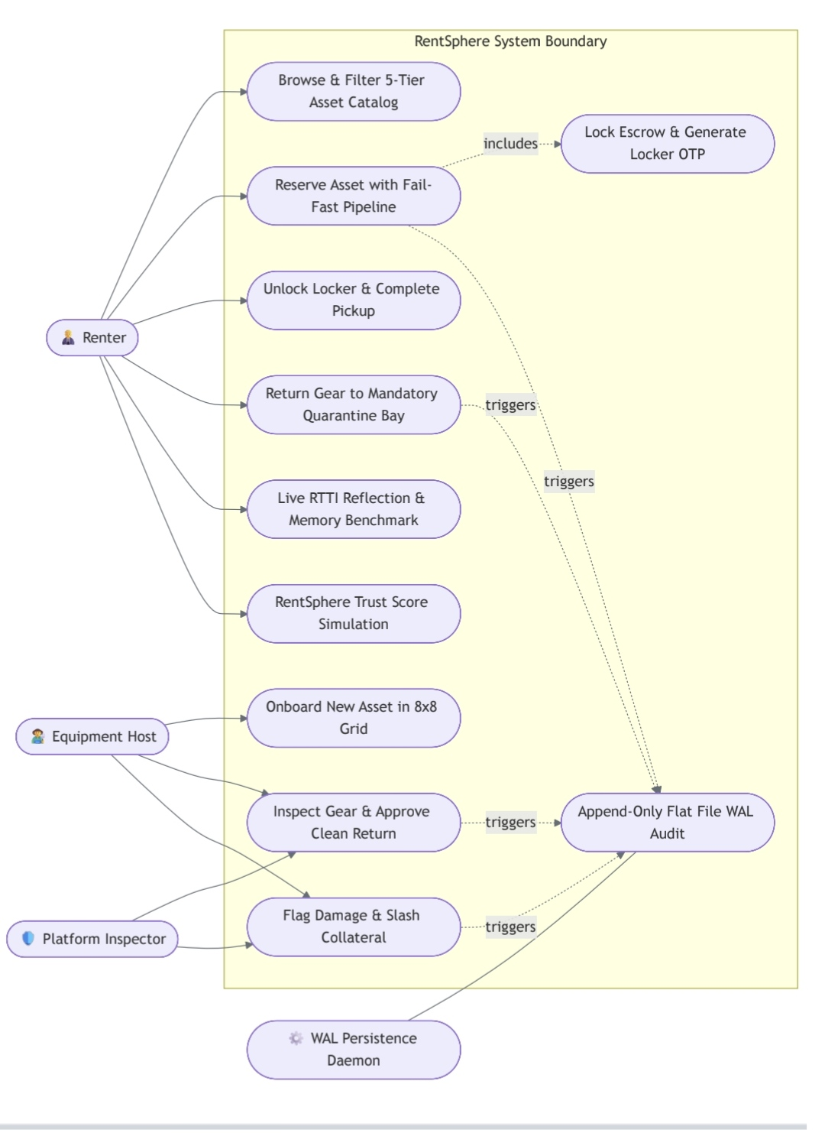

Figure 2 — 5-Tier Object-Oriented Class Hierarchy Diagram
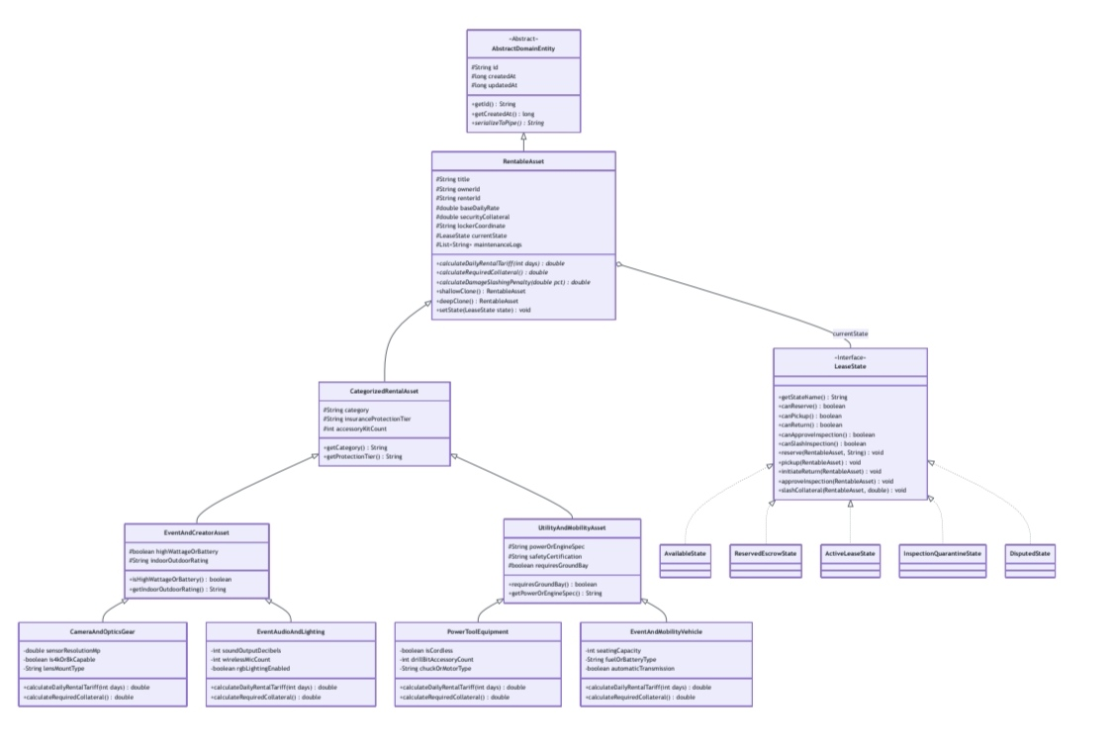

Figure 3 — GoF 4-Stage Statechart Diagram (Mandatory Quarantine Invariant)
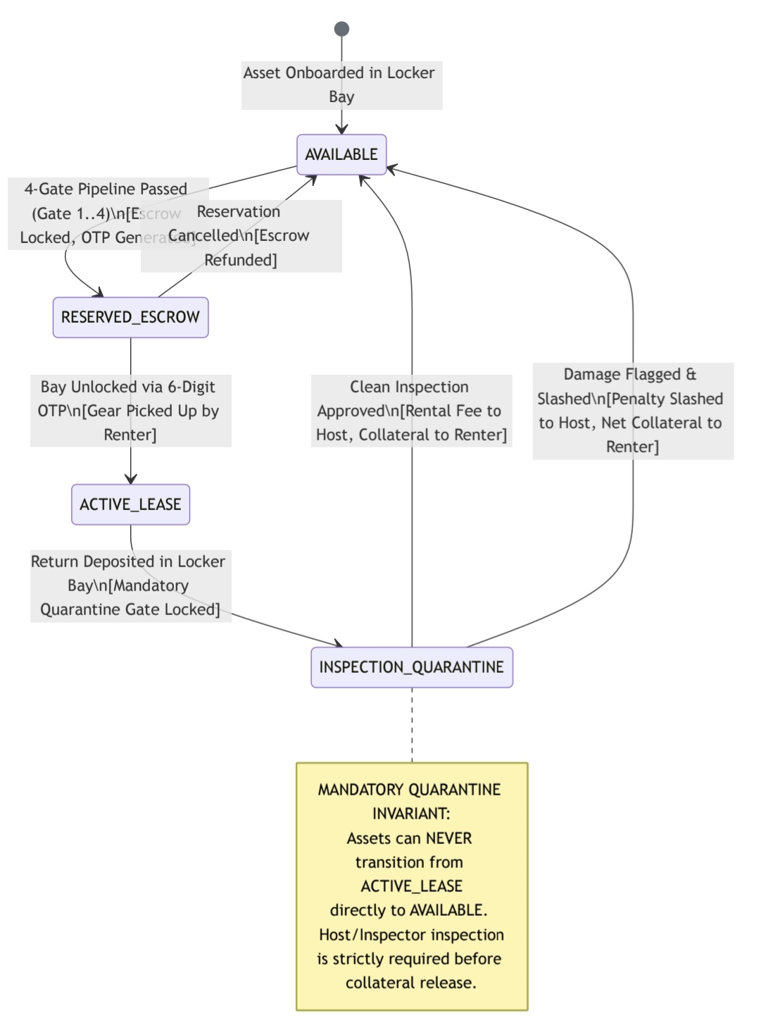

Figure 4 — 4-Gate Fail-Fast Verification Pipeline Sequence Diagram
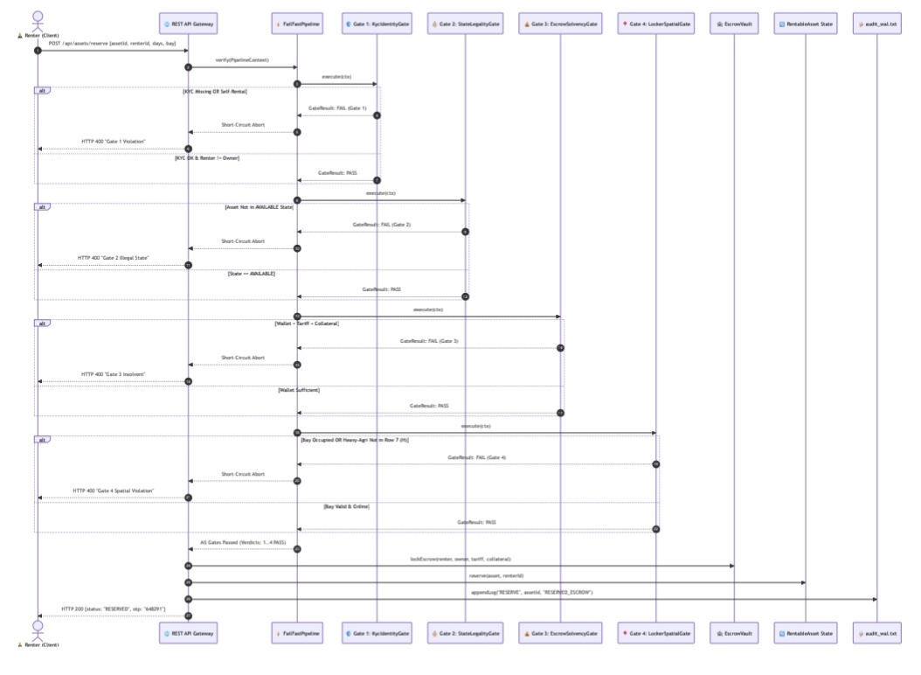

Figure 5 — Object Diagram
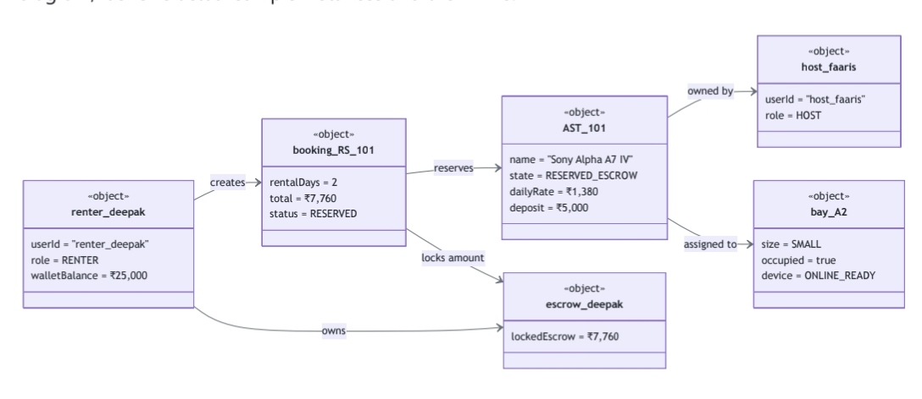

Figure 6 — Brainstorming Map
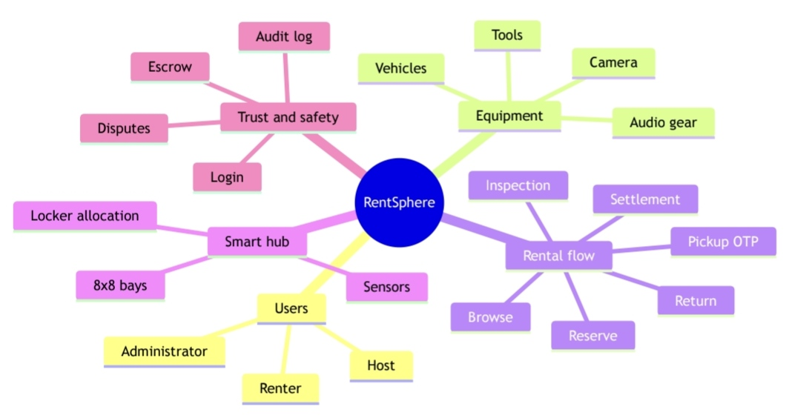

Figure 7 — Entity Relationship Diagram
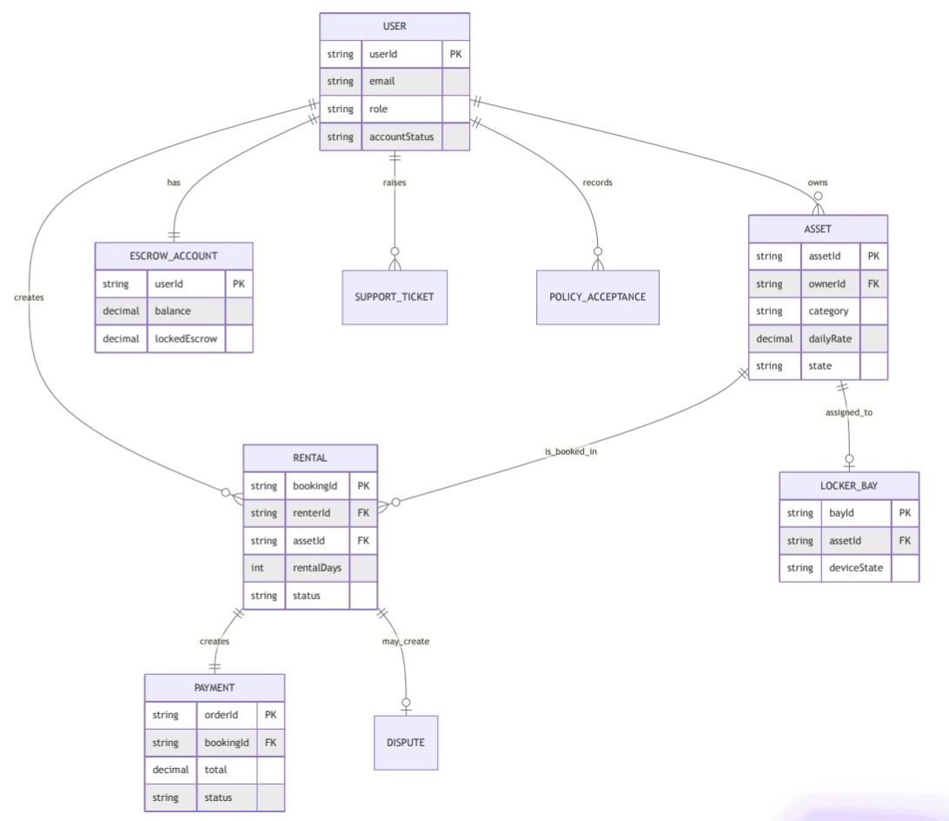

Figure 8 — System Architecture Diagram
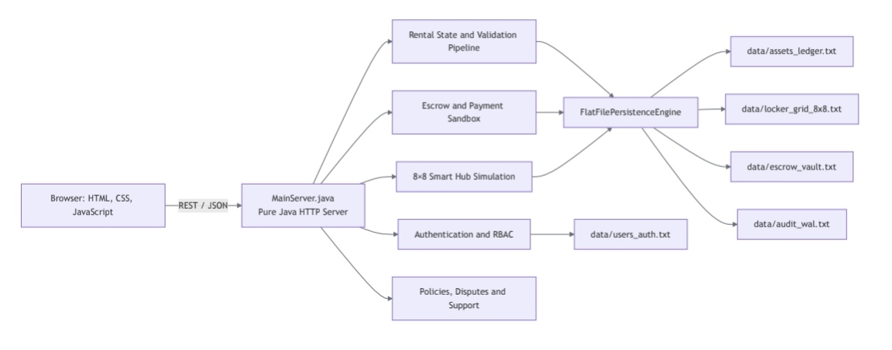

Figure 9 — Component Diagram
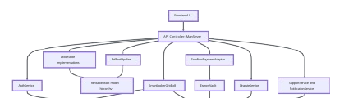

Figure 10 — Local Deployment Diagram
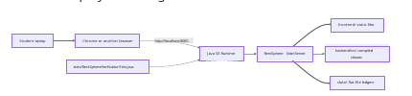

4.12 PRODUCT WORKFLOW SUMMARY
Stage | System Behaviour
Discovery | User browses marketplace assets and categories.
Reservation | Renter selects duration and starts a protected reservation.
Verification | Fail-fast gates validate identity, state, escrow and locker rules.
Payment | Sandbox payment adapter records the payment order.
Escrow | Security deposit and rental amounts are represented in escrow records.
Pickup | Locker allocation and OTP protect physical collection.
Active Lease | Asset is associated with the renter until return.
Return | Asset is returned through the defined return workflow.
Inspection | Asset enters quarantine before it can become available.
Settlement | Clean return releases funds according to the implemented rules; damage can lead to deduction/dispute.
This workflow is the central integration point of the project. It connects OOP classes, design patterns, persistence, security and the simulated physical environment.

CHAPTER 5
OBJECT-ORIENTED DESIGN AND IMPLEMENTATION

5.1 ENCAPSULATION, INHERITANCE, POLYMORPHISM AND ABSTRACTION

Encapsulation
RentSphere keeps domain data and the operations that act on that data within relevant classes. This reduces direct manipulation of internal state and allows validation to remain close to the object that owns the rule.

Inheritance
The project uses a multi-level asset hierarchy beginning with AbstractDomainEntity, followed by RentableAsset and CategorizedRentalAsset, and then specialized branches such as EventAndCreatorAsset and UtilityAndMobilityAsset before reaching concrete rental classes.

Polymorphism
Services can operate on the common RentableAsset abstraction while the concrete asset class determines specialized behaviour. This allows the marketplace to handle cameras, event equipment, power tools and mobility vehicles through common interfaces.

Abstraction
Interfaces such as PaymentGateway and LockerDevice define what a payment or locker device must do without forcing the rest of the application to depend on a particular implementation.

5.2 INTERFACES AND COMPOSITION

Interfaces
PaymentGateway separates payment operations from the sandbox implementation. This makes it possible to replace the sandbox adapter with a production gateway later. LockerDevice similarly separates the application from a specific locker implementation.

Composition
Higher-level services coordinate multiple objects. For example, reservation and return workflows use asset state, escrow, payment, locker and verification components together rather than placing all responsibilities inside the asset class.

Why this design matters
- It reduces coupling between modules.
- It allows simulated components to be replaced later.
- It improves unit-level testing.
- It makes the object model easier to explain during an OOT viva.
- It keeps the domain model separate from infrastructure concerns.

5.3 DESIGN PATTERNS
Pattern / Technique | Project Use
State | Represents legal rental lifecycle states and transitions.
Prototype | Creates independent copies of rental listings.
Fail-Fast Pipeline | Runs KYC, state, escrow and locker gates before protected operations.
Generic Repository | Provides reusable repository-style operations using generics.
Reflection | Inspects objects and hierarchy at runtime.
Composition | Builds workflows from collaborating services and domain objects.

State Pattern
The State pattern is particularly important because it prevents the rental lifecycle from becoming a large collection of conditional statements. Each state can represent the behaviour that is legal at that point in the lifecycle.

Prototype Pattern
Prototype cloning is useful for hosts who want to create a new listing based on an existing asset configuration. The cloned object can then be changed without modifying the original listing.

5.4 BACKEND IMPLEMENTATION
The backend is implemented in Java and is divided into packages according to responsibility.
Package | Representative Classes / Responsibility
api | MainServer and HTTP/API entry point.
model | AbstractDomainEntity, RentableAsset and concrete asset classes.
state | AvailableState, ReservedEscrowState, ActiveLeaseState, InspectionQuarantineState, DisputedState.
escrow | EscrowAccount, EscrowTransaction and EscrowVault.
payment | PaymentGateway, PaymentOrder and SandboxPaymentAdapter.
locker | LockerCompartment, LockerDevice, SmartLockerGrid8x8 and simulator.
pipeline | Verification gates and pipeline context.
auth | UserAccount, AuthService, PasswordHasher and UserSession.
persistence | FlatFilePersistenceEngine.
dispute/support | Dispute and support workflows.
The backend therefore provides the business rules while the browser frontend provides the user interaction layer.

5.5 FRONTEND IMPLEMENTATION
The frontend is a browser-based interface located in the frontend directory. The main entry point is index.html, supported by CSS and JavaScript files.

Main Views
- Marketplace.
- 8×8 Smart Pickup Hub and Parking Grid.
- Escrow Wallet, Returns and Inspection.
- Host Studio and Diagnostics.
- Admin and Grievance Hub.

Frontend Responsibilities
- Present asset information and marketplace actions.
- Collect user inputs.
- Send requests to the Java server.
- Display validation and operation results.
- Present smart-hub, escrow and administrative information.

Backend Responsibility
The browser is not treated as the source of truth for important business rules. State legality, escrow solvency, identity checks, security and other invariants remain enforced in the backend.

5.6 AUTHENTICATION AND SECURITY

Password Protection
PasswordHasher uses PBKDF2 with HMAC-SHA256 and a cryptographically secure salt. The application verifies derived password values instead of storing or comparing plain-text passwords.

Session Security
Authenticated sessions use cryptographically random session tokens with an expiration window. Protected operations resolve authorization from the authenticated request.

Role-Based Access Control
Role | Typical Access
VISITOR | Public browsing and limited access.
RENTER | Rental, payment, pickup and return operations.
HOST | Listing, asset and inspection-related operations.
ADMIN | Dispute, support and administrative functions.

OTP Protection
Locker pickup uses a six-digit OTP. OTP values are protected from casual exposure and repeated incorrect attempts can trigger a temporary lockout. This demonstrates how a physical-access workflow can be protected in software.

5.7 PERSISTENCE, PAYMENT AND ESCROW

Flat-File Persistence
RentSphere intentionally avoids a conventional SQL database. Runtime state is maintained in Java collections while persistent information is written to pipe-delimited text files.
File | Purpose
assets_ledger.txt | Asset records.
users_auth.txt | User and authentication records.
payments_ledger.txt | Payment records.
escrow_vault.txt | Escrow account records.
disputes_ledger.txt | Dispute records.
locker_grid_8x8.txt | Locker allocation information.
support_tickets.txt | Support requests.
policy_acceptance.txt | Policy acceptance records.
audit_wal.txt | Audit / write-ahead records.

Payment and Escrow
The payment subsystem uses PaymentGateway and SandboxPaymentAdapter. Payment orders are represented separately from escrow. The sandbox flow includes HMAC-SHA256 signature verification and idempotent webhook handling.
The separation of payment and escrow demonstrates abstraction and composition while making it easier to replace the academic payment adapter with a production gateway in future work.

5.8 SMART HUB AND PHYSICAL WORKFLOW
The SmartLockerGrid8x8 models 64 logical bays arranged from A1 to H8. Row H is used for ground vehicle slots. The system also represents locker compartments, sizes, device state and simulated telemetry.
- 64 logical bays are represented.
- Different compartment sizes can be modelled.
- Ground vehicle slots are restricted by the spatial rule.
- Pickup uses a six-digit OTP.
- Repeated incorrect OTP attempts can trigger lockout.
- Locker operations are abstracted through a LockerDevice interface.

5.9 ADMINISTRATIVE AND SUPPORT FUNCTIONS
The project includes dispute, support and policy-related services. Administrators can work with grievances and operational records. The design keeps these functions outside the core asset model so that the domain remains modular.
This separation also demonstrates that a complete software system is more than a set of screens: it requires domain objects, services, persistence, security and administrative workflows.

CHAPTER 6 — WORKING PRODUCT AND SCREENSHOTS
MARKETPLACE
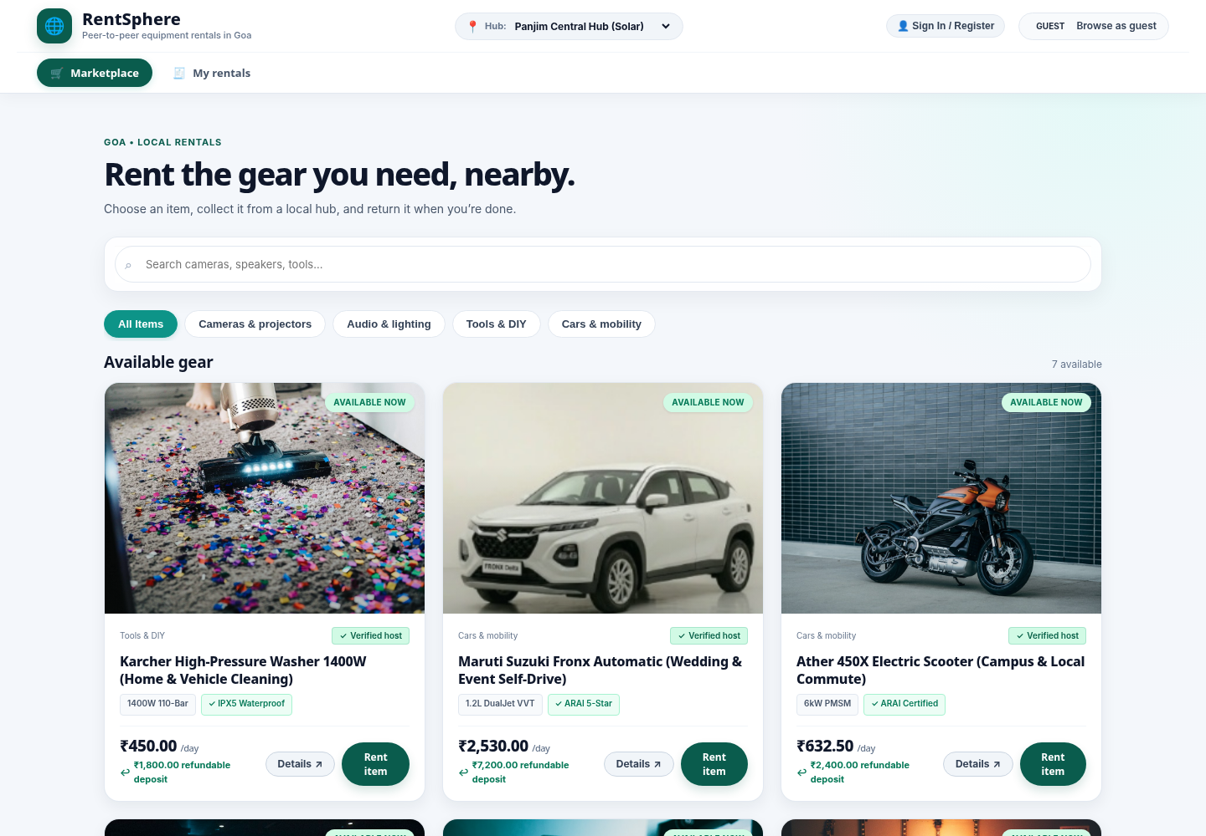
Figure: RentSphere Marketplace and Equipment Listing interface.

SCREENSHOT— SMART PICKUP HUB
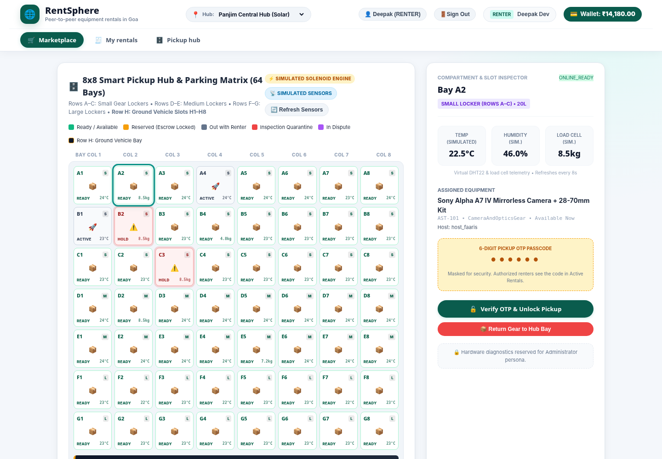
Figure: RentSphere 8×8 Smart Pickup Hub and Parking Matrix.

SCREENSHOT — ESCROW AND RETURN
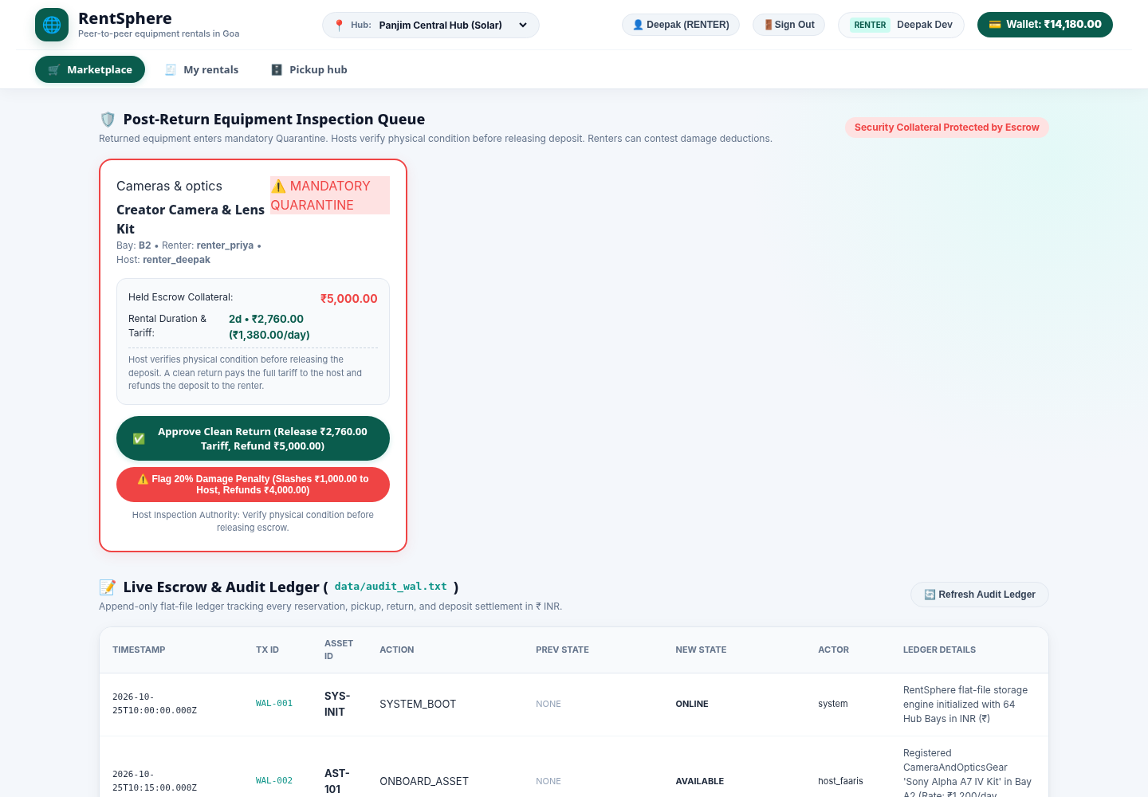
Figure: RentSphere Post-Return Inspection, Escrow and Audit Ledger interface.

SCREENSHOT— HOST STUDIO AND DIAGNOSTICS
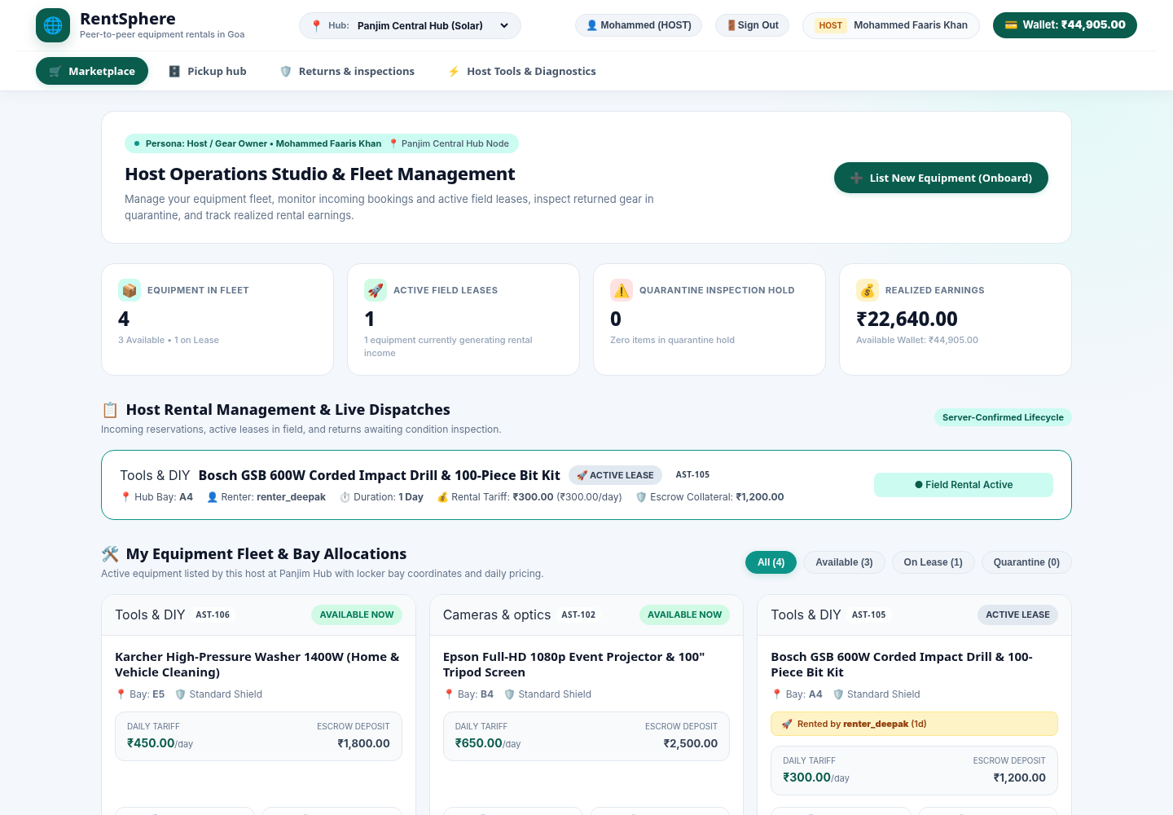
Figure: RentSphere Host Operations Studio, Fleet Management and OOT diagnostics.
SCREENSHOT— ADMIN AND SUPPORT
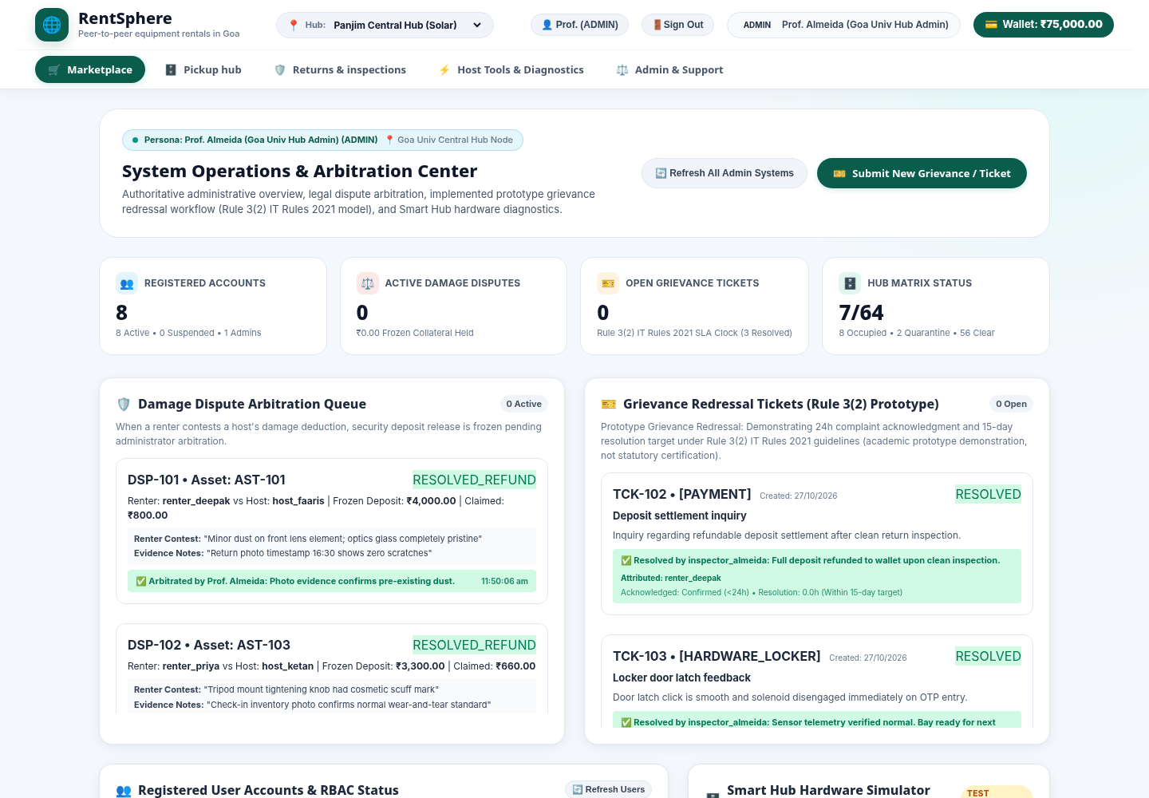
Figure: RentSphere System Operations, Dispute Arbitration and Grievance Support interface.

CHAPTER 7

7.1 TESTING STRATEGY AND RESULTS
Testing was carried out through the project verification suite. The current TEST_REPORT records 163 automated tests distributed across 17 verification suites, with a reported 100 percent pass result.

Testing Areas
- Asset hierarchy, pricing and collateral calculations.
- Reservation, pickup, return and inspection states.
- 64-bay smart hub rules and vehicle-slot restrictions.
- Reflection and deep-clone isolation.
- Trust-score calculations.
- Flat-file persistence and audit records.
- PBKDF2 authentication and session handling.
- Payment orders, HMAC verification and idempotent webhook handling.
- OTP generation, failure count and lockout.
- Disputes, quarantine and administrative functions.

Test Result
Metric | Recorded Result
Automated tests | 163
Test suites | 17
Reported passing | 163 / 163
Reported pass rate | 100%

7.2 DEVELOPMENT ACTIVITIES AND ISSUES
The development phase included the following activities. The sequence is presented as a practical development record based on the implemented project structure and documentation.
Phase | Activity / Deliverable
1. Problem Identification | Defined the rental workflow and major real-world constraints.
2. Concept Selection | Selected peer-to-peer rental with smart-hub integration.
3. Requirements | Identified marketplace, rental, escrow, locker, security and admin needs.
4. OOP Design | Created domain hierarchy, interfaces, services and state objects.
5. Architecture | Separated frontend, Java backend, persistence and simulated integrations.
6. Implementation | Developed model, service, state, payment, escrow, locker and support modules.
7. Frontend | Implemented browser views and API interaction.
8. Security | Added hashing, sessions, RBAC and OTP protection.
9. Testing | Built and executed automated verification suites.
10. Refinement | Checked invariants, persistence and end-to-end workflows.
11. Documentation | Prepared UML specifications, reports and test documentation.

Issues / Design Challenges
- Keeping state transitions legal across multiple workflows.
- Maintaining consistency between escrow, payment and rental state.
- Representing physical locker constraints in a software-only environment.
- Providing security controls suitable for an academic local deployment.
- Maintaining deterministic persistence without a conventional database.

7.3 IMPROVEMENTS DURING DEVELOPMENT
The project design includes several improvements that make the final implementation more robust than a simple CRUD rental prototype.
- Rental states were modelled explicitly instead of relying on one status flag.
- Returned active assets were forced into inspection quarantine.
- Payment and escrow were separated through dedicated classes and interfaces.
- Locker operations were abstracted so that a simulated device can later be replaced.
- Authentication uses derived password storage rather than plain-text comparison.
- Role-based access rules were introduced for different user categories.
- OTP lockout was included for repeated incorrect pickup attempts.
- Audit records were included for important operations.
- Automated tests cover business rules and security-sensitive behaviour.

CHAPTER 8

8.1 LIMITATIONS AND FUTURE SCOPE
Current Limitation | Future Enhancement
Payment is simulated. | Integrate a production payment gateway with secure server-side credentials and webhooks.
Locker hardware is simulated. | Connect ESP32/IoT hardware, electronic locks and sensors.
Flat files are used. | Migrate to PostgreSQL/MySQL or another production database.
KYC is represented by application logic. | Integrate an approved identity-verification provider.
Local single-server deployment. | Introduce containerization and cloud deployment.
Basic marketplace search. | Add recommendations, calendars and advanced filtering.
Academic trust scoring. | Calibrate scoring using production data and governance.
Local audit ledger. | Use centralized tamper-resistant logging in production.

8.2 CONCLUSION
RentSphere demonstrates how Object-Oriented Technology can be applied to a realistic peer-to-peer asset rental problem. The project models assets, rental states, payments, escrow, physical pickup, inspection and disputes as connected but separate responsibilities.
Encapsulation, inheritance, polymorphism and abstraction are visible in the domain and service design. The State and Prototype patterns add structure to lifecycle management and listing duplication. The fail-fast pipeline, authentication, security controls, persistence and automated testing strengthen the academic implementation.
Overall, the project provides a practical example of how OOP principles can be used to create a modular and testable software system while keeping the implementation suitable for a mini-project environment.

REFERENCES AND PROJECT DOCUMENTATION
- RentSphere project source code and project documentation supplied with the mini-project.
- README.md — project overview, architecture, feature catalogue and execution notes.
- docs/UML_DIAGRAMS.md — formal UML and architecture specifications.
- TEST_REPORT.md — automated verification and browser walkthrough report.
- IMPLEMENTATION_REPORT.md — implementation milestones and subsystem description.
- DEPLOYMENT.md — deployment and execution instructions.
- SECURITY_REVIEW.md — security controls and residual-risk analysis.
- PROJECT_AUDIT.md — project audit and feature review.
- Java SE documentation and Object-Oriented Technology course material.

